Supplementary Information for

A miniature of soluble methane monooxygenase enables Escherichia coli to rapidly produce methanol with high yield

Yeonhwa Yu¹, Yongfan Shi², Young Wan Kwon³, Yoobin Choi¹, Yusik Kim¹, Jeong-Geol Na², June Huh^{1¶}, Jeewon Lee^{1*}

¹ Department of Chemical and Biological Engineering, Korea University, Anam-Dong 5-1, Seongbuk-Gu, Seoul 02841, Republic of Korea.
² Department of Chemical and Biomolecular Engineering, Sogang University, Seoul, 04107, Republic of Korea.
³ KU-KIST Graduate School of Converging Science and Technology, Korea University, Anam-Dong 5-1, Seongbuk-Gu, Seoul 02841, Republic of Korea.
* Corresponding author. Email: leejw@korea.ac.kr.
¶Co-corresponding author. junehuh@korea.ac.kr

Supplementary Figures and Tables
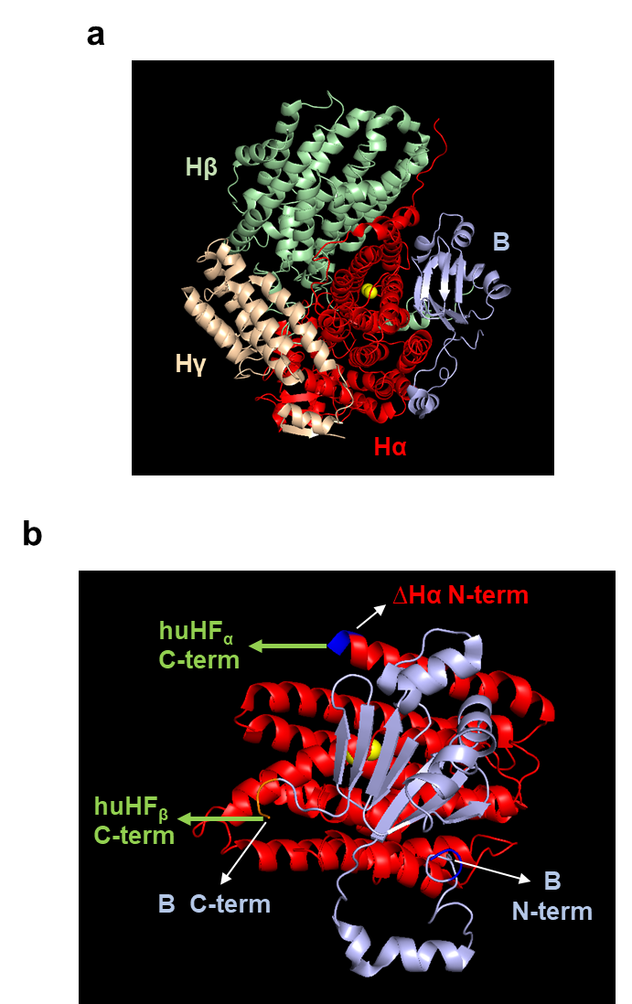

Supplementary Figure 1 | Native MMOH-MMOB complex structure. (a) The crystallographic complex structure of native MMOH (αβγ) protomer and MMOB (PDB ID code: 4GAM). (b) The crystallographic complex structure showing only the sub-structure of native MMOH (corresponding to ∆Hα) and MMOB in (a), showing the both the N-termini of ∆Hα and MMOB are facing the opposite direction. The green arrows indicate that the C-terminus of MMOB is linked to the C-terminus of huHF subunit (huHF_{α}), while the N-terminus of ∆Hα is linked to the C-terminal direction of another huHF subunit (huHF_{β}) to maintain the native direction of MMOH and MMOB in the complex structure.

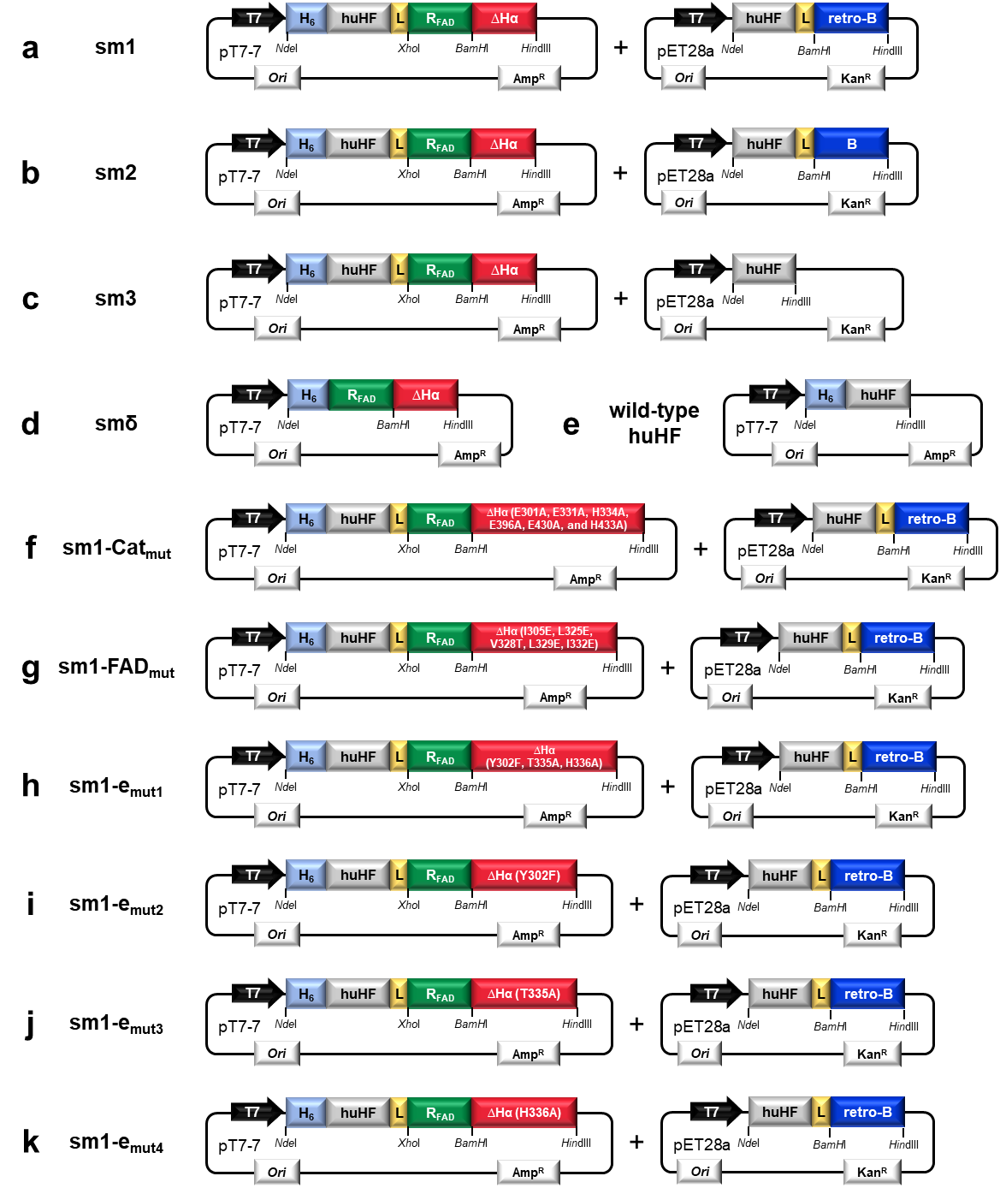
Supplementary Figure 2 | Plasmid expression vectors used for synthesizing sm1 to sm3, sm1-derived mutants, smδ, and wile-type huHF in recombinant E. coli. pT7-7 and pET28a plasmid backbone-based expression vectors including T7 promoter, replication origin (ori), antibiotic-resistance gene (Amp^{R}/Kan^{R}), and the coding sequence for synthesizing of (a) sm1, (b) sm2, (c) sm3, (d) smδ, (e) wild-type huHF, (f) sm1-Cat_{mut}, (g) sm1-FAD_{mut}, (h) sm1-e_{mut1}, (i) sm1-e_{mut2}, (j) sm1-e_{mut3} and (k) sm1-e_{mut4}. Except for the synthesis of smδ and wile-type huHF, E. coli was transformed with the two plasmid expression vectors to synthesize sm1 to sm3 and various sm1-derived mutants.
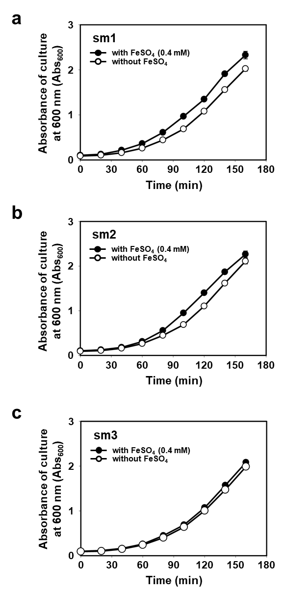
Supplementary Figure 3 | Effect of FeSO₄ (0.4 mM) in the medium on the growth of mini-sMMO (sm1 to sm3)-expressing recombinant E. coli. Time-course growth of the recombinant E. coli producing mini-sMMOs (sm1 to sm3), when the growth medium is supplemented with FeSO₄ (0.4 mM).

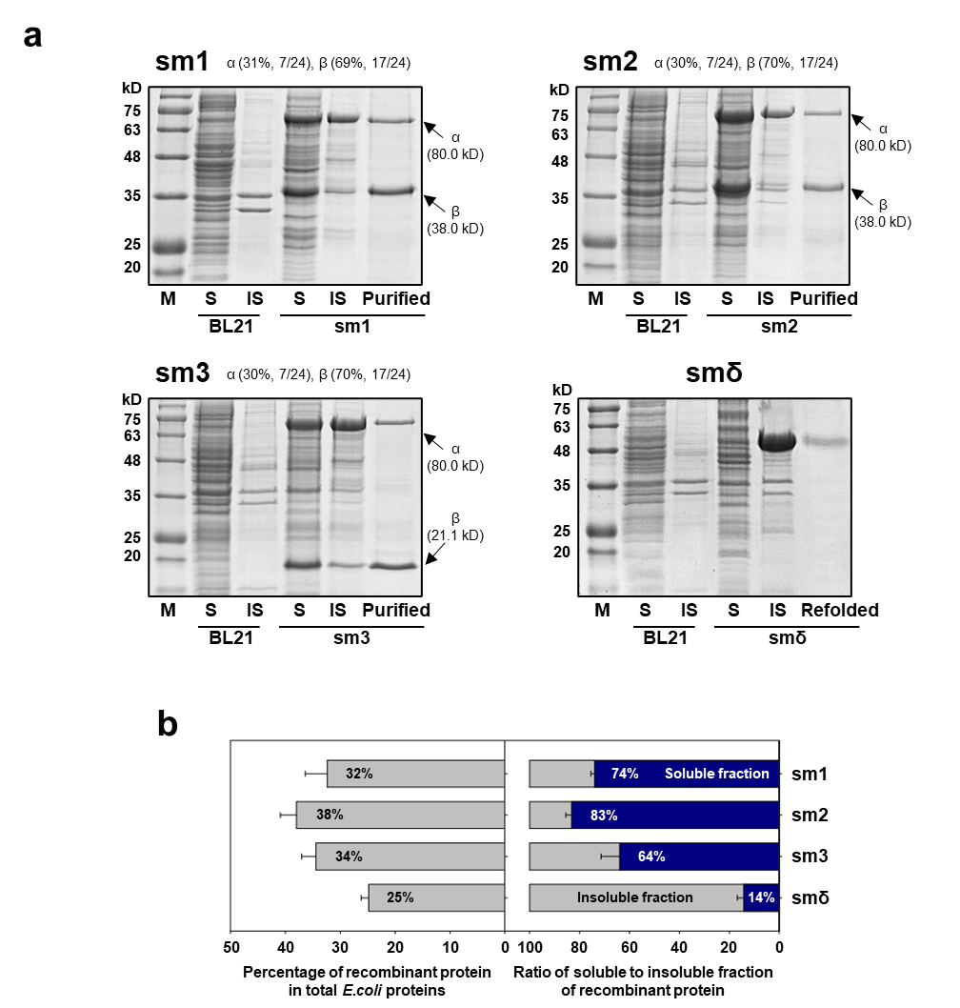

Supplementary Figure 4 | Heterologous expression of mini-sMMOs and smδ in E. coli. (a) Results of SDS-PAGE showing the expression level and cytoplasmic solubility of expressed mini-sMMOs (sm1 to sm3) and smδ. (M: protein marker (GangNam-STAIN), S and IS: soluble and insoluble fraction of expressed protein, respectively, Purified: mini-sMMO eluted from the Ni²⁺-affinity purification column loaded with soluble fraction, Refolded: smδ purified through the refolding step of insoluble aggregates, BL21: wild-type E.coli BL21(DE3)). (b) The expression level (left) and the cytoplasmic solubility (right) of mini-sMMOs (sm1 to sm3) and smδ.

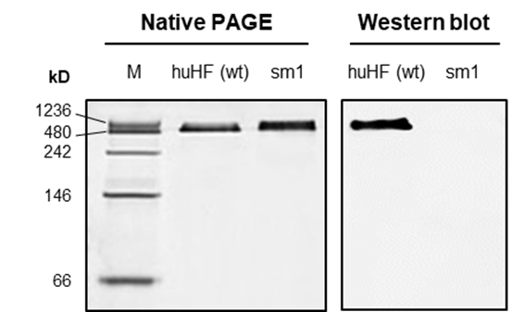

Supplementary Figure 5 | Native PAGE and Western blot analysis of sm1 and wild-type huHF. Results of Native-PAGE (left) and Western blot (right) of the purified wild-type huHF and sm1. For Western blotting, anti-huHF IgG was used as a pimary antibody (Methods). (M: native protein marker).

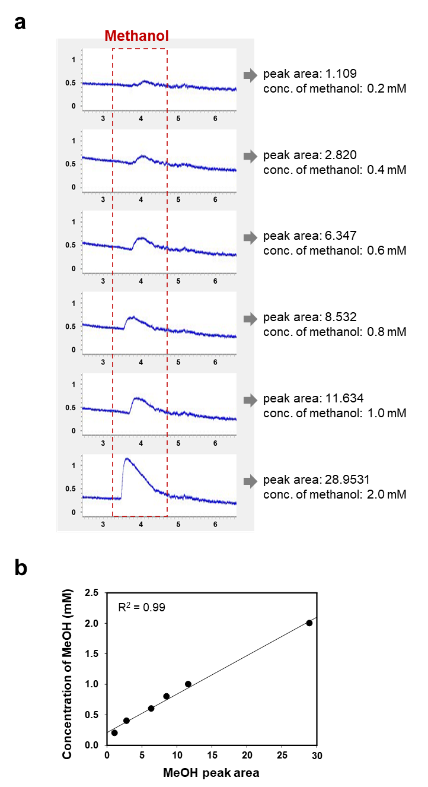
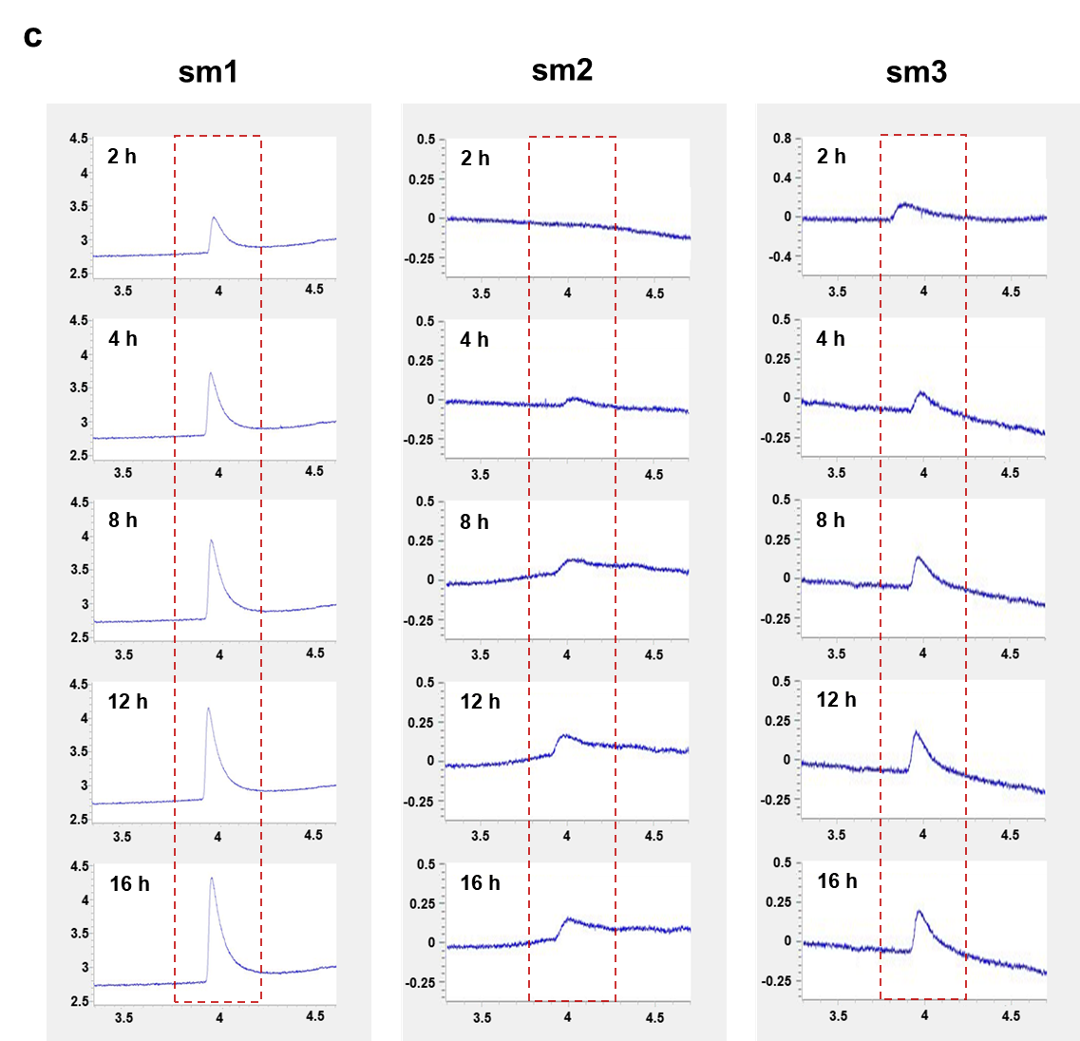

Supplementary Figure 6 | Raw data of GC analysis of methanol. (a) GC chromatograms for standard methanol at different concentration (0.2 to 2.0 mM). (b) Correlation between methanol concentration and methanol peak area of GC chromatogram of (a). (c) GC chromatograms of the sm1 to sm3 sampled from the methane-oxidizing solution at different time points.

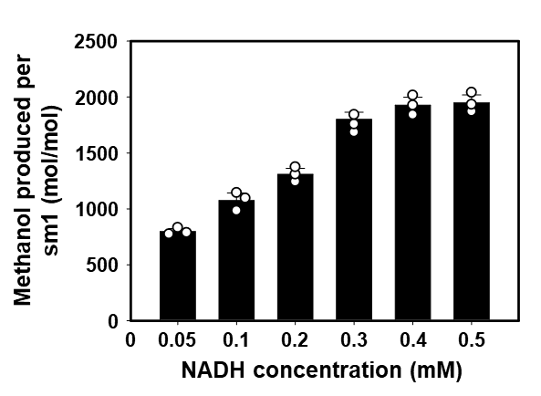

Supplementary Figure 7 | Methanol produced by sm1 with NADH at different concentrations (0.05 to 0.5 mM). The cumulative amount of methanol produced by sm1 for 16 h after the methane oxidation begins.
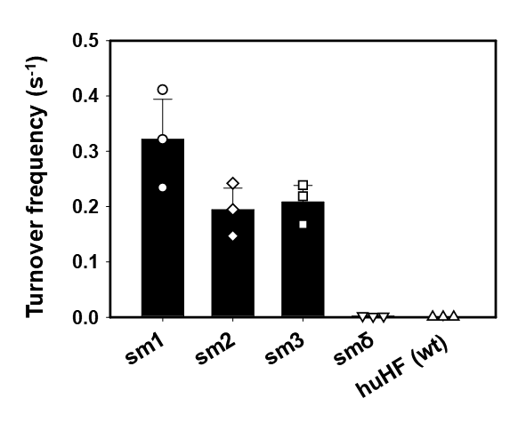
Supplementary Figure 8 | Turnover frequency of sm1 to sm3, smδ, and wild-type huHF. Turnover frequency (TF, s⁻¹) of mini-sMMOs (sm1 to sm3), smδ and wild-type huHF in the in vitro catalytic conversion of methane to methanol.
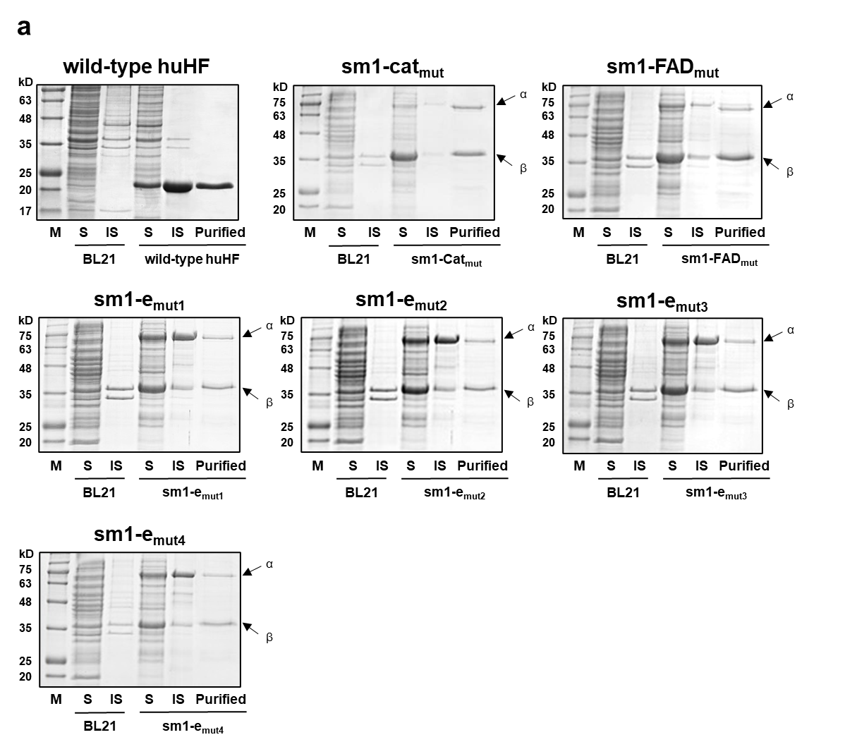
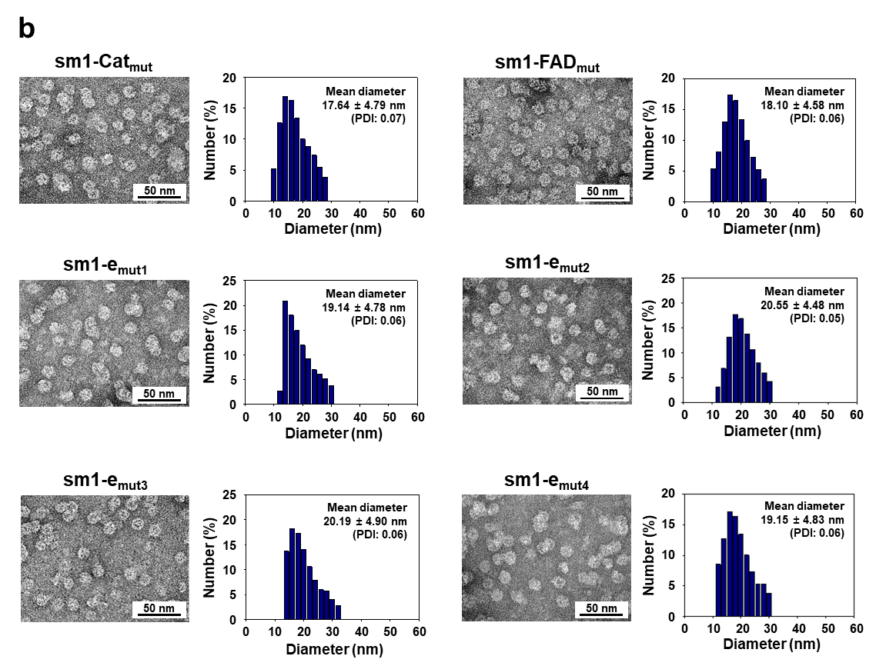

Supplementary Figure 9 | Heterologous expression of sm1-mutants and wild-type huHF. (a) SDS-PAGE analysis of recombinant E.coli expressing wild-type huHF, sm1-Cat_{mut}, sm1-FAD_{mut}, and sm1-e_{mut1} to sm1-e_{mut4}. (M: protein marker (GangNam-STAIN), S and IS: soluble and insoluble fraction of expressed protein, respectively, Purified: Ni²⁺-affinity purification elution of soluble fraction, BL21: wild-type E.coli BL21(DE3)) (b) TEM images (left) and DLS data (right) of synthesized mutants (sm1-Cat_{mut}, sm1-FAD_{mut}, and sm1-e_{mut1} to sm1-e_{mut4}).

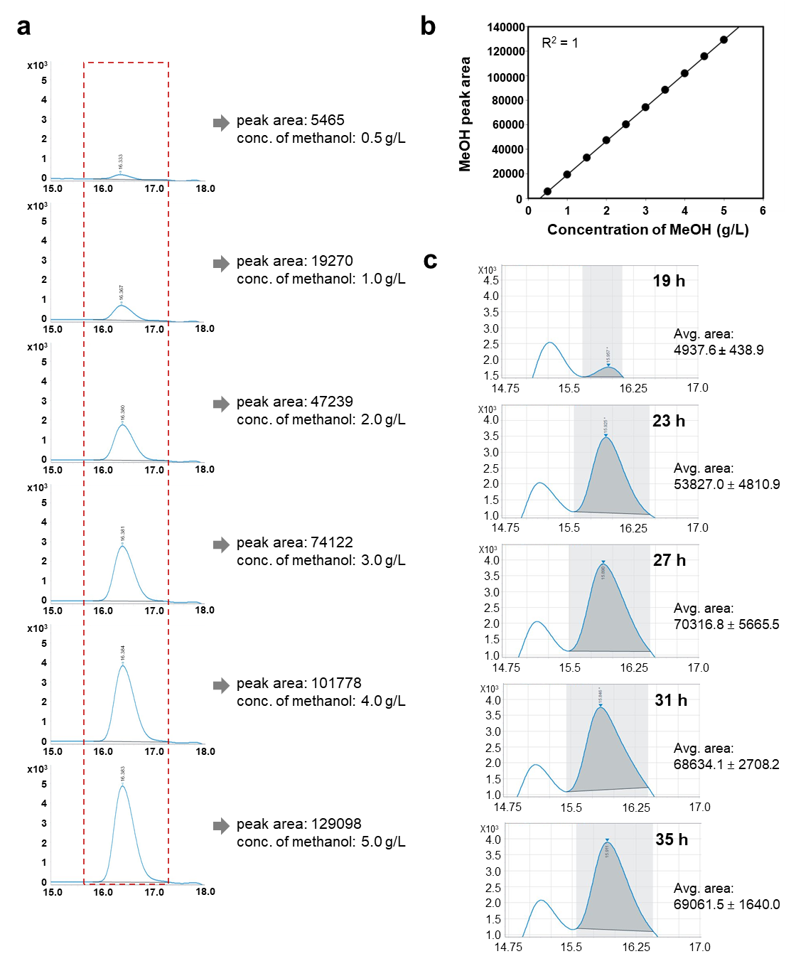
Supplementary Figure 10 | Raw data of HPLC analysis. (a) HPLC chromatograms of standard methanol at different concentrations (0.5 to 5.0 g/L). (b) Correlation between concentration and peak area of methanol, obtained from the HPLC chromatogram of (A). The correlation follows the equation: Y (peak area) = 27497.0 · X (methanol, g/L) - 8195.3, R²=1. (c) HPLC chromatograms showing the methanol peaks (i.e. the grey colored peaks in the shaded area), obtained through the HPLC analysis of the soluble fraction of the samples taken from the methane-oxidizing fed-batch cultures of sm1-expressing E. coli.
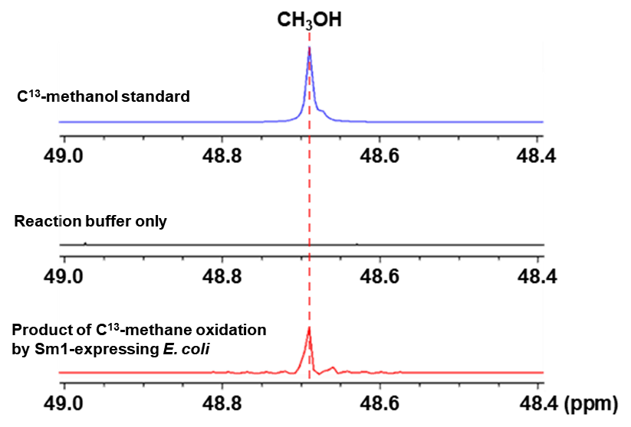
Supplementary Figure 11 | ¹³C-NMR spectroscopy analysis to verify methane oxidation by sm1-expressing E. coli. For ¹³C-NMR analysis, the whole cell-based methane oxidation was performed in a closed vial system (Methods).

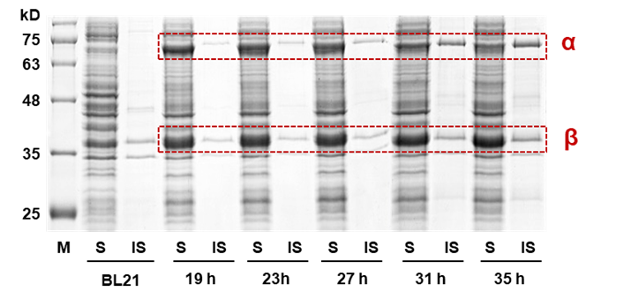

Supplementary Figure 12 | Results of SDS-PAGE of the samples taken from the fed-batch culture of sm1- expressing E. coli. The samples were taken at five time points after methane oxidation began by supplying methane and air mixture to the fed-batch culture in a fermenter with the working volume of 3 L. M: protein molecular marker (GangNam-STAIN), S and IS: soluble and insoluble fraction of expressed sm1, respectively, BL21: wild-type of E. coli BL21(DE3).

Supplementary Notes
Note 1
Supplementary Movie 1 | MD Simulation of R_{FAD}-ΔHα. The movie shows the stable localization of FAD for 300 ns at an interface between R_{FAD} and ΔHα represented in cartoon: red wires for hydrophobic residues of R_{FAD} and ΔHα; blue wires for hydrophilic residues of ΔHα; in-between grey wires for FAD; and light violet spheres for diiron of ΔHα.

