Table
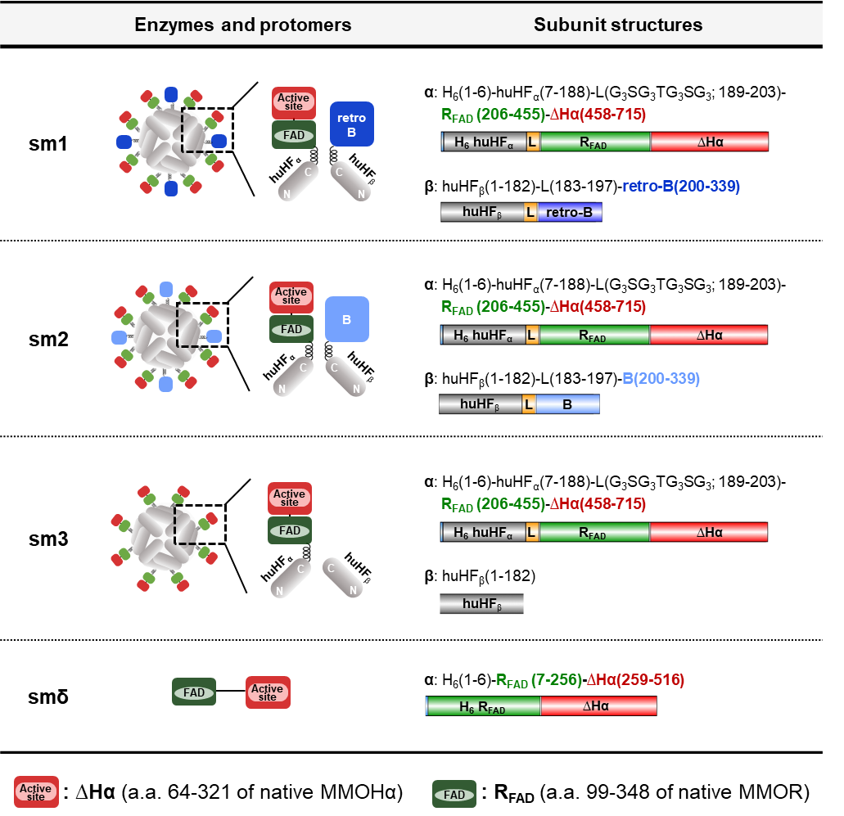

Table 1 | Schematics of the whole enzymes, protomers, and subunits of mini-sMMOs (sm1 to sm3) and smδ. sm1 and sm2 are comprised of both R_{FAD}-∆Hα and B/retro-B, while sm3 is comprised of R_{FAD}-∆Hα only. Each N-terminus of R_{FAD}-∆Hα, B, and retro-B is linked to the C-terminus of huHF subunit (huHF_{α} or huHF_{β}). In R_{FAD}-∆Hα, the N-terminus of ∆Hα (Ala64 to Leu321 of native MMOHα) is linked to the C-terminus of R_{FAD} (FAD binding domain of native MMOR). H₆ is inserted for Ni²⁺-affinity purification, and L in sm1 to sm3 represents a linker peptide (G₃SG₃TG₃SG₃). smδ is only R_{FAD}-∆Hα without linking to huHF subunit.

