Extended Data
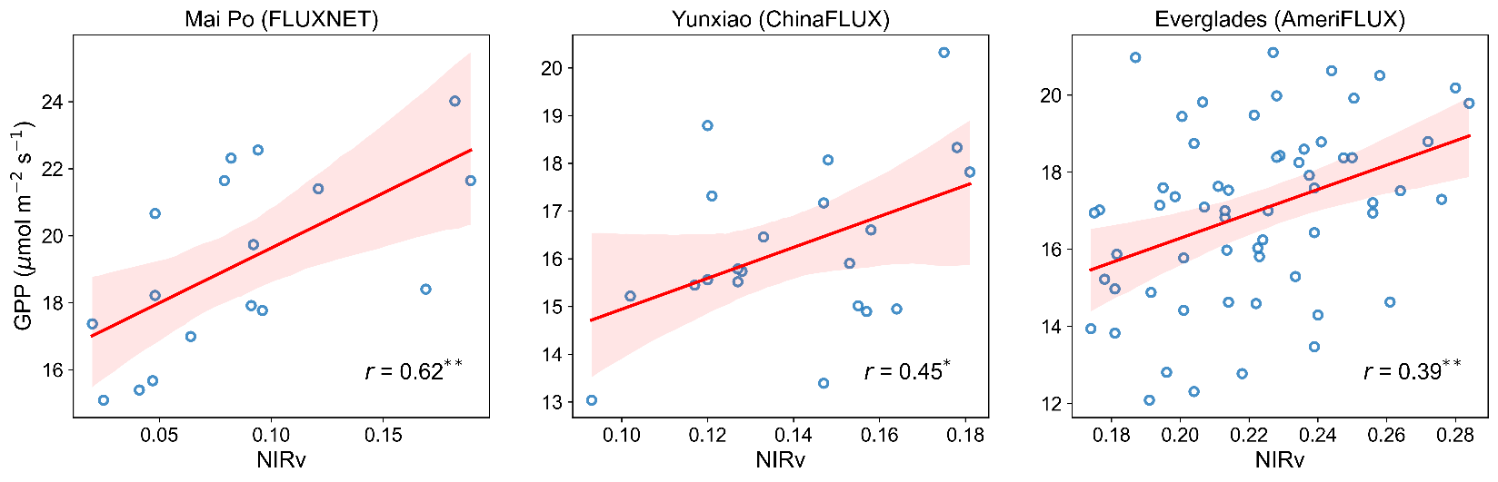
Extended Data Fig. 1 | The correlation between NIRv and GPP at three mangrove flux sites. Shading indicates the 95% confidence intervals estimated by bootstrapping. The symbol ** and * indicate statistically significant (P < 0.01 and P < 0.05, respectively) Pearson correlation coefficient between NIRv and GPP.
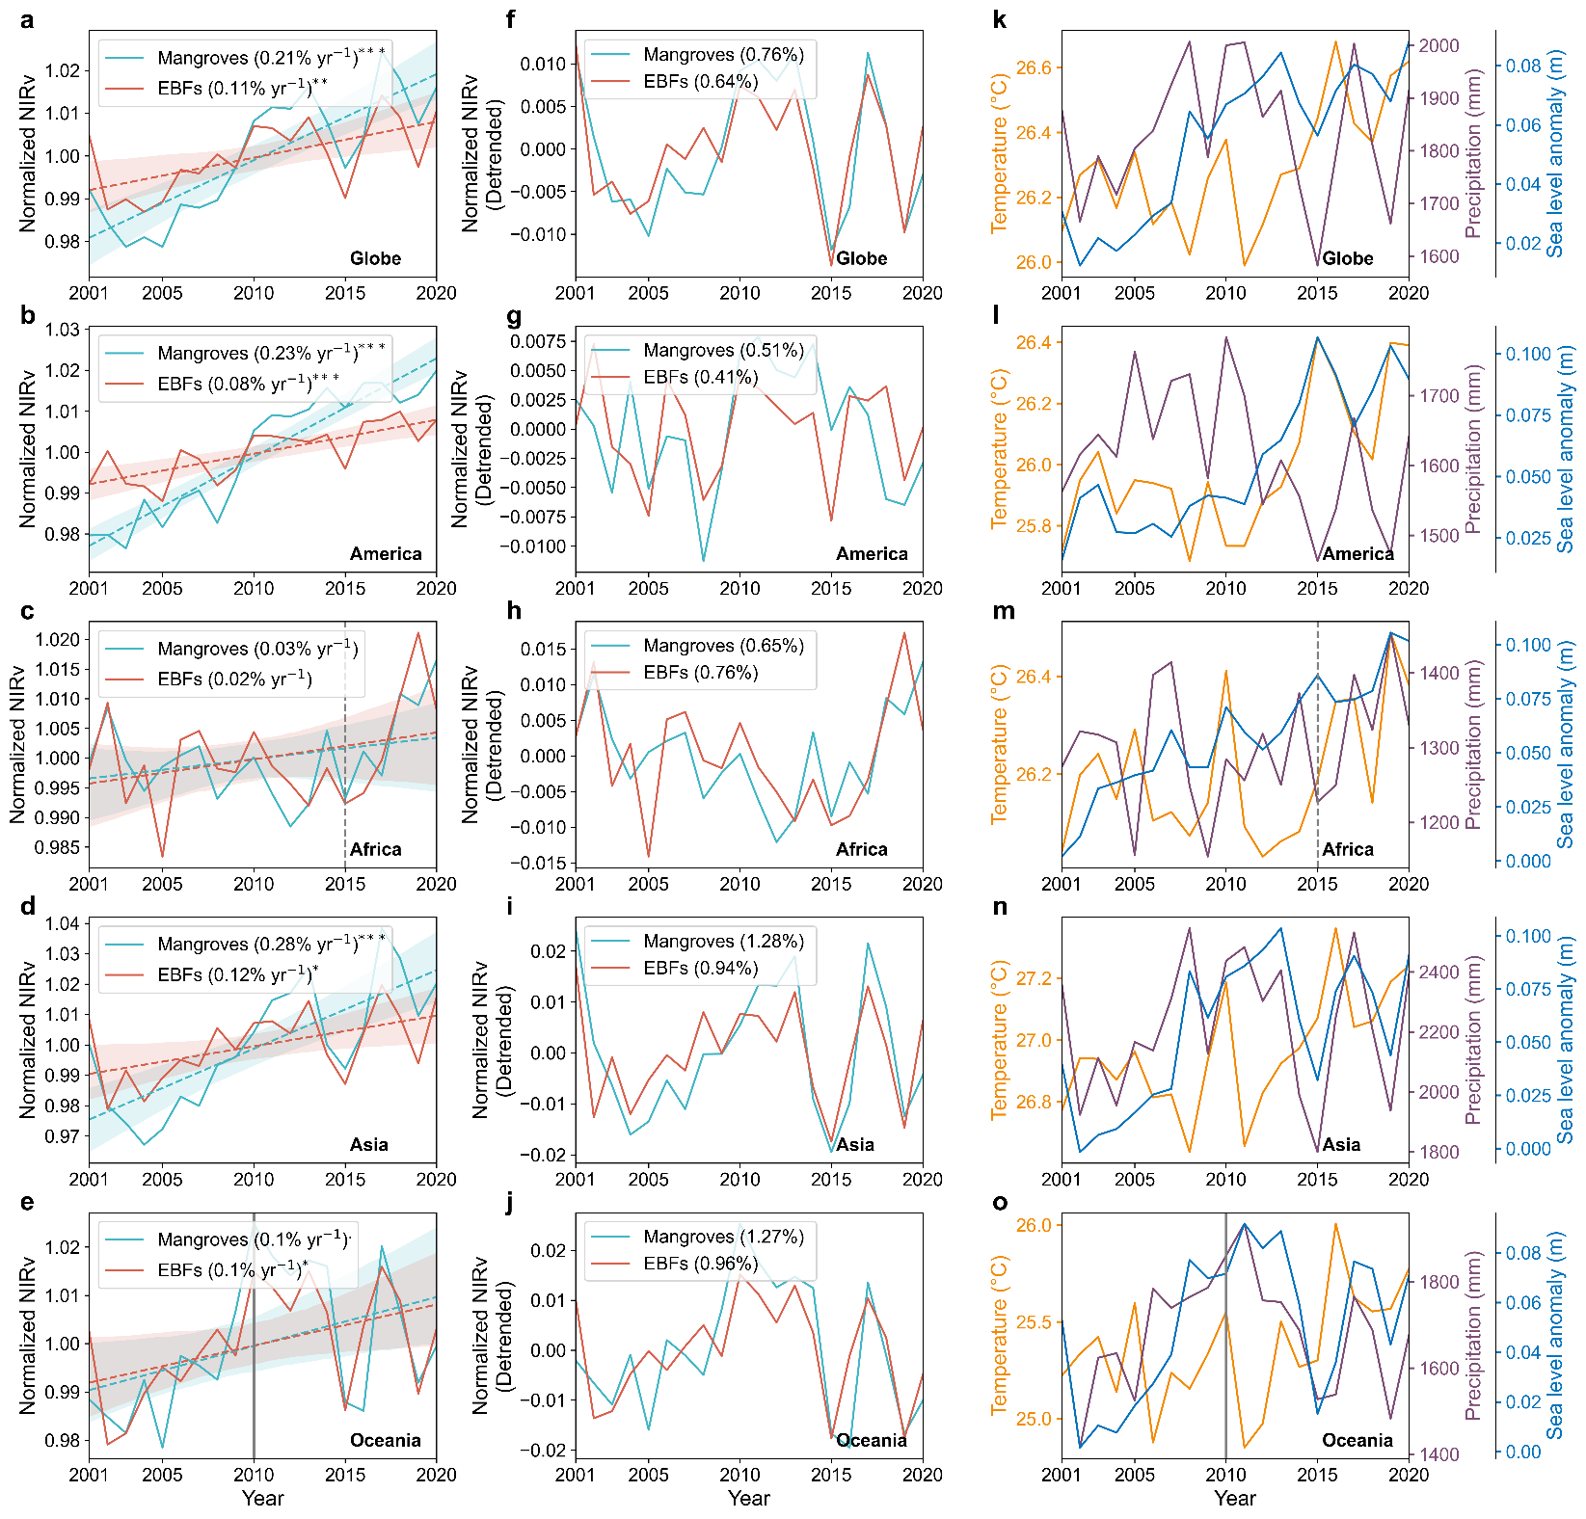
Extended Data Fig. 2 | Temporal variations in NIRv of mangroves and EBFs and environmental factors in coastal grids. a-e, Time variations in annual NIRv for mangroves and EBFs over the globe, America, Africa, Asia, and Oceania, respectively. NIRv are normalized by the long-term average. The trend rates in the legend were computed from the Theil-Sen slope estimator. Shading indicates the 95% confidence intervals estimated by bootstrapping. f-j, Interannual fluctuances in annual detrended NIRv for mangroves and EBFs over the globe, America, Africa, Asia, and Oceania, respectively. The numbers in the legend indicate the coefficient of variation of each NIRv time series to reflect the interannual variability. k-o, Time variations in annual temperature, precipitation and sea-level anomaly for the coastal grids over the globe, America, Africa, Asia, and Oceania, respectively. *** P < 0.001, ** P < 0.01, * P < 0.05, . P < 0.1.
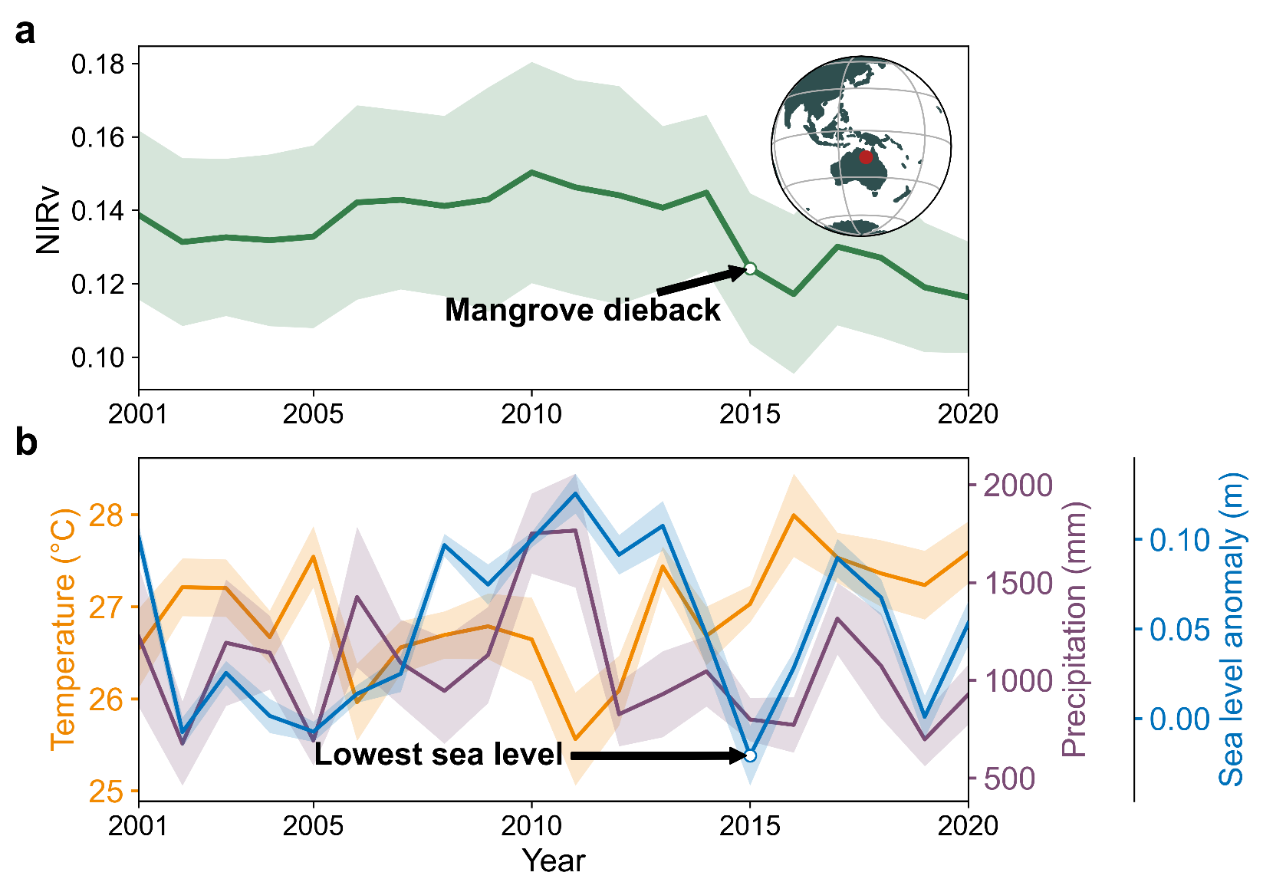
Extended Data Fig. 3 | Time series of annual NIRv and environmental factors (air temperature, precipitation, and sea-level anomaly) in the Gulf of Carpentaria, Australia. Temperature, precipitation and sea-level anomaly is from MERRA2, GPCP, and CMEMS datasets, respectively. Shaded areas show ±1 standard deviation of the mean.
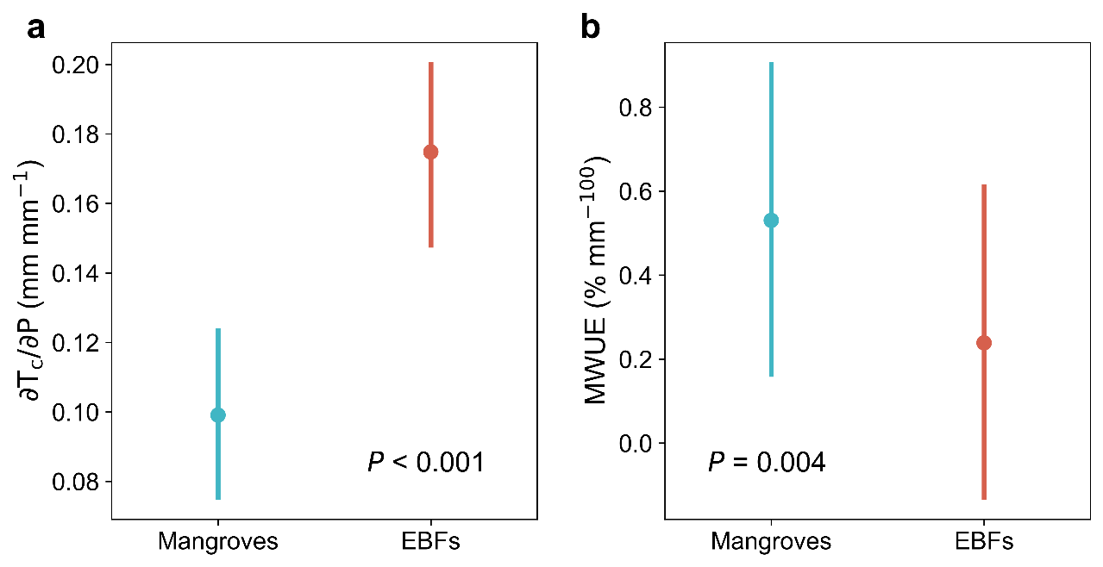
Extended Data Fig. 4 | The comparisons between mangroves and EBFs in their ecohydrological properties. Differences in (a) marginal biological water use fraction (∂Tc/∂P) and (b) marginal water use efficiency (MWUE). All comparisons were performed under controlled geographical conditions using the paired t-test to eliminate spatial mismatch. Error bars show 95% confidence intervals estimated by bootstrapping (n = 1000), and the dots represent the average values.

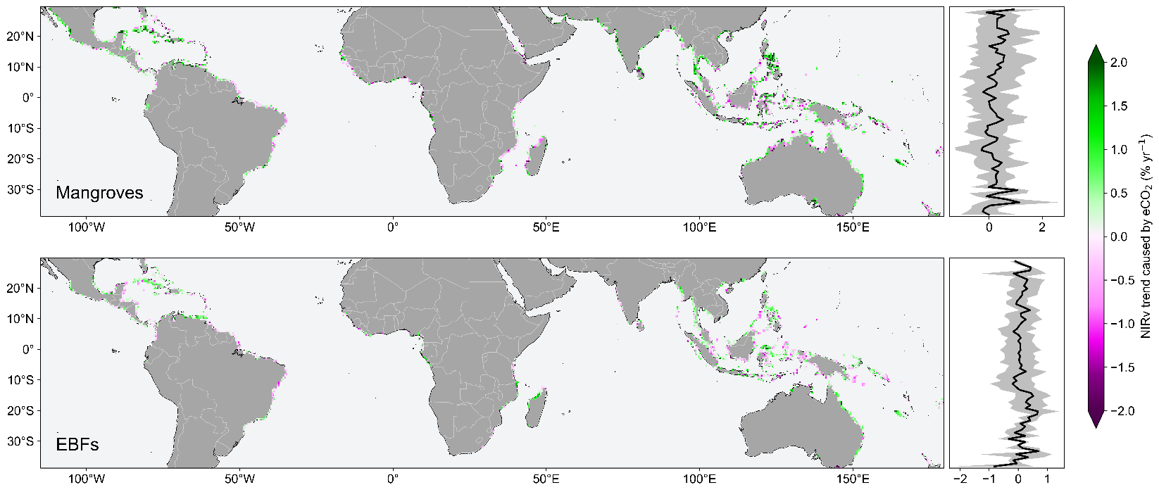
Extended Data Fig. 5 | eCO₂-induced NIRv trends calculated using factorial simulation. The right panels depict the latitudinal pattern of trends averaged per 1° latitude band.
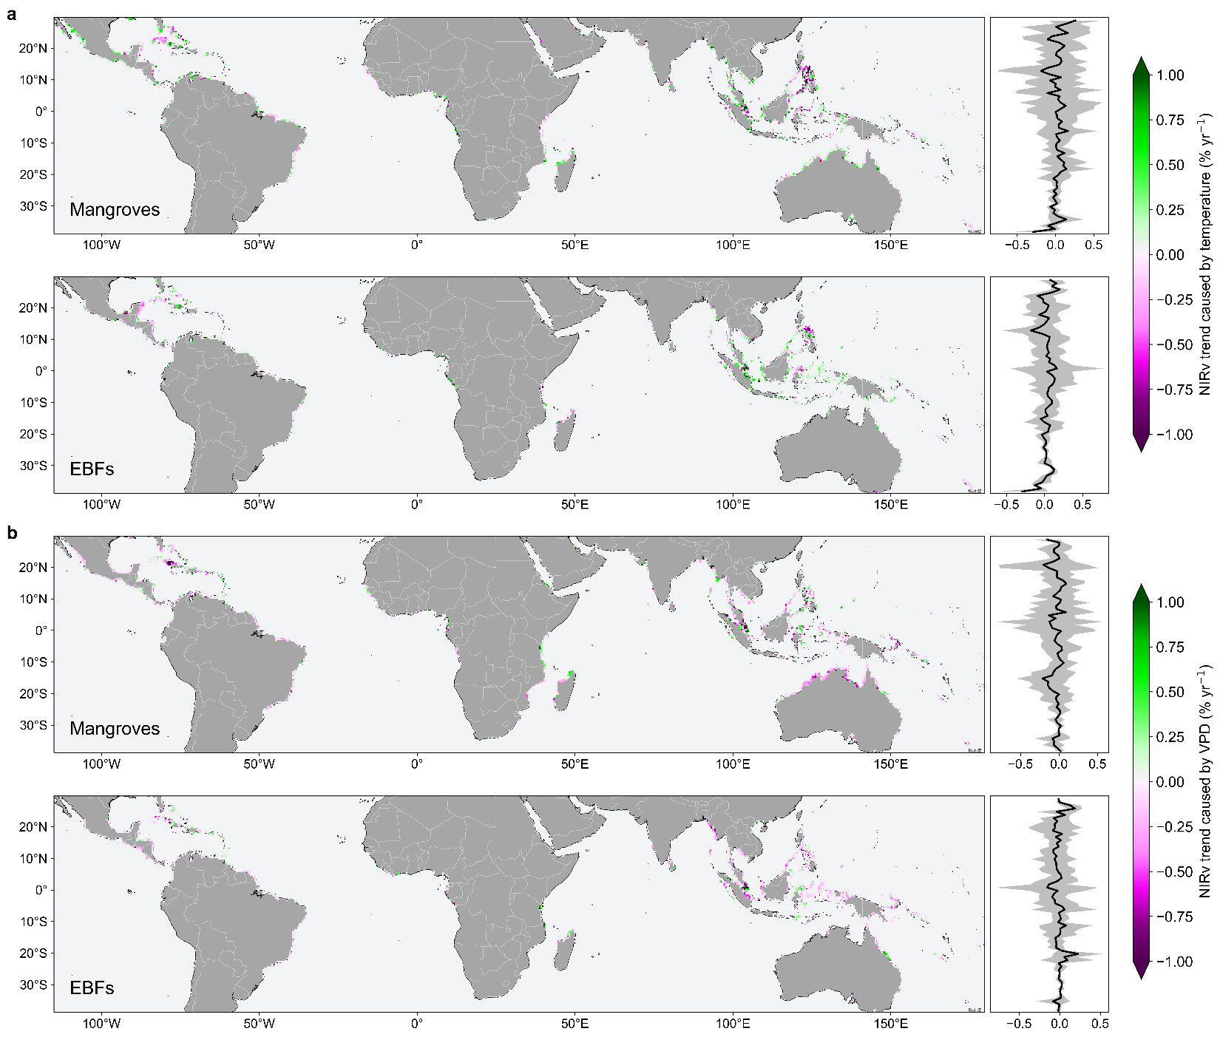
Extended Data Fig. 6 | Simulated NIRv trends for mangroves and EBFs, respectively. a, Temperature-contributed NIRv trends. b, VPD-contributed NIRv trends. The right panels depict the latitudinal pattern of trends averaged per 1° latitude band.
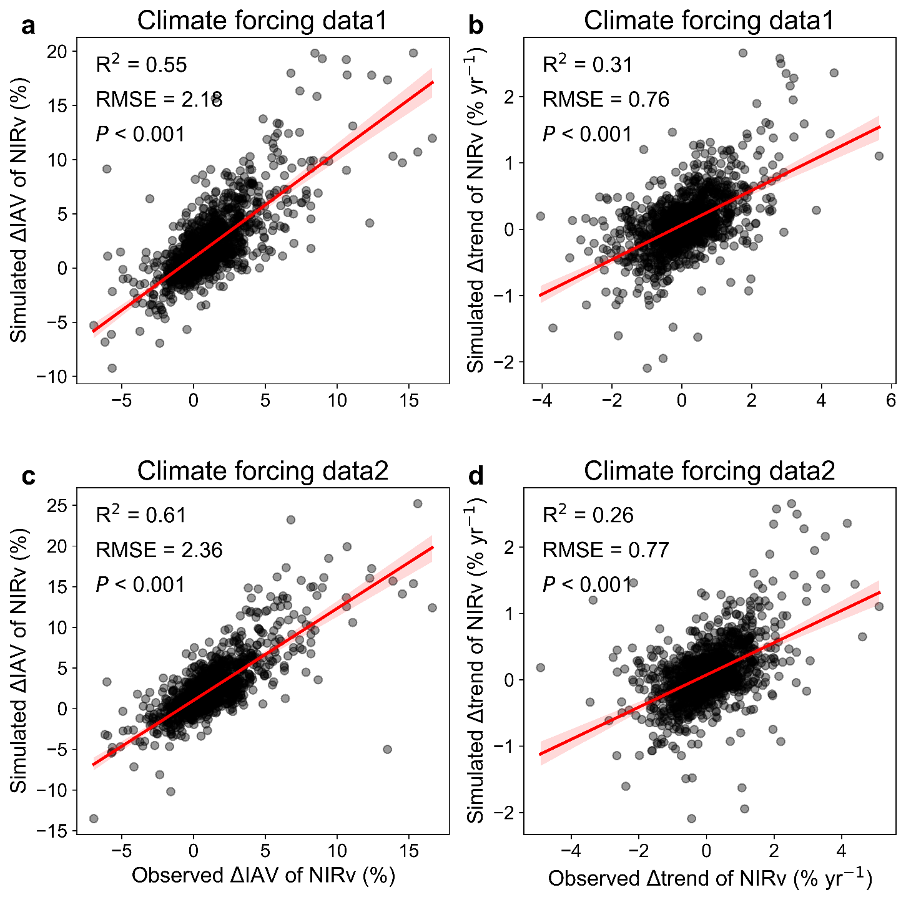
Extended Data Fig. 7 | Model performance in simulating observed difference in NIRv IAV and trend between mangroves and EBFs. Climate forcing data 1 represents factors from MERRA2, GPCP, and NOAA CarbonTracker CT2022 datasets. Climate forcing data 2 represents factors from ERA5, CHIRPS, TerraClimate and Mauna Loa observatory. Scatter refers to each paired coastal grid cell (n = 1475).

