HBV-miR-3 is related to HBV replication and predictive of HBeAg seroconversion in PegIFN-α treated patients
Author: Zhenyu Xu¹, Yun Xu¹, Zhenyu Wu¹, Sujuan wang¹, Min Zhang^{1*}, Yongfang Jiang^{1*}, Guiqiang Wang ^{2 *}, Guozhong Gong^{1*}

Supplementary data
Supplementary Methods 2
Supplementary Figures 4
Supplementary Tables 6

Supplementary Methods
HBV-miR-3 standard
A series of HBV-miR-3 standard stock solution (10-fold serial dilutions from 10⁸copies to 10² copies) was generated according to the formula to establish the dilution curve of the qPCR standard. Formula: Copy number was determined according to the equation: copy number/mL = 6.02×10²³ (copies/mol)×concentration (g/mL)/MW (g/mol). HBV-miR-3 template from the literature³⁰: TGCGACTGGATGTGTCTGCGGCGTTTGTCGTATCCAGTGCACCTCGGACCCTGCACTGG

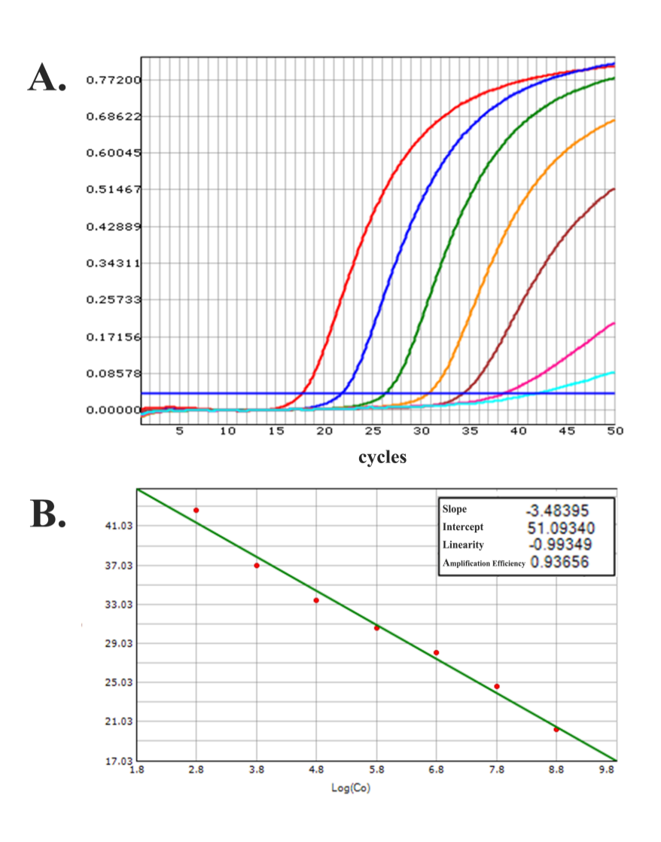
Figure S1.(A) Amplification curves of HBV-miR-3 that were measured by the replication cycles versus delta Rn. Amplification curves show the results of HBV-miR-3 at the concentrations from 6×10² to 6×10⁸ copies/mL. (B) Correlations between the cycle threshold (Ct) and the concentration of HBV-miR-3. The x-axis indicates the log10 values of HBV-miR-3 concentrations from 6×10² copies/mL to 6×10⁸ copies/mL, while the y-axis shows the cycle threshold. The correlation coefficient was -3.48395 with R²=0.99349.

Table S1 Detection of HBV-miR-3 in samples harboring the high concentrations of
HBV DNA treated with or without DNase I or before and after passing the column.
Absence of DNase I |  | Treated with DNase I |  | p-value  (a) vs. (b)
DNA | HBV-miR-3(a) | DNA | HBV-miR-3 (b) | p-value  (a) vs. (b)
3 | 2.78±0.09* | <LOD | 2.75±0.01 | 0.2526
4 | 3.90±0.02 | <LOD | 3.82±0.06 | 0.9526
5 | 4.50±0.03 | <LOD | 4.21±0.02 | 0.1756
before |  | after |  | p-value  (a) vs. (b)
RNA | HBV-miR-3(a) | pgRNA | HBV-miR-3 (b) | p-value  (a) vs. (b)
3.21±0.02* | 2.75±0.08 | <LOD | 2.79±0.11 | 0.1294
3.02±0.09* | 2.80±0.02 | <LOD | 2.78±0.06 | 0.2526
2.78±0.09* | 2.76±0.03 | <LOD | 2.69±0.02 | 0.1756
*: Mean ± standard deviation (n=3); LOD: Limit of detection for HBV DNA is 20
IU/mL. HBV DNA and HBV-miR-3 were quantified by log10 IU/mL and log10 copies/mL, respectively. *: Mean ± standard deviation (n=3); LOD: Limit of detection for HBV DNA is 300 copies/mL. HBV pgRNA and HBV-miR-3 were quantified by log10 copies/mL, respectively.

Supplementary Figures

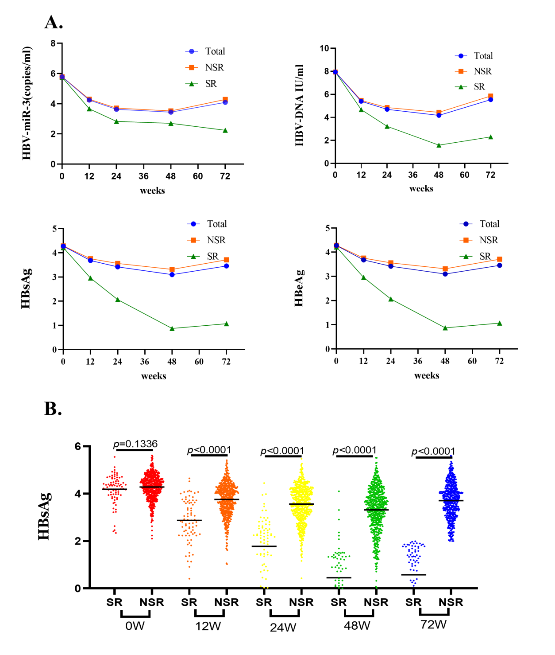
Figure S2
Figure S2 : HBV biomarker change between HBsAg≦100 IU/ml group and HBsAg>100 IU/ml group. A: Dynamic changes of HBV-miR3, HBV DNA, HBsAg, and HBeAg. B: Differences in HBV-miR3 between HBsAg≦100 IU/ml group and HBsAg>100 IU/ml group at different time.

Supplementary Tables

Table S2 Baseline analysis of patient characteristics for HBsAg <100 IU/ml
 | HBsAg<100  (n = 77) | HBsAg≧100  (n = 573) | p value
Age (years) | 25.95 ± 0.59 | 28.46 ± 0.29 | 0.02
Male gender | 48 (62.3%) | 421 (73.5%) | 0.06
Body weight | 61.01 ±1.27 | 64.08 ± 0.47 | 0.02
ALT (IU/mL) | 209.31 ± 16.1 | 189.55 ± 5.76 | 0.23
HBV genotypes
B/C | 42/35 | 200/367 | 0.001
HBV-miR-3 | 5.65 ± 0.14 | 5.78 ± 0.47 | 0.35
HBV RNA# | 6.11 ± 0.21 | 6.13 ± 0.07 | 0.92
HBV DNA# | 7.91 ± 0.71 | 7.94 ± 0.32 | 0.77
HBsAg# | 4.19 ± 0.07 | 4.28 ± 0.02 | 0.13
HBeAg# | 3.10 ± 0.05 | 3.00 ± 0.02 | 0.14
pegIFNα-2a/pegIFNα-2b | 27/50 | 194/379 | 0.83

Table S3 Univariate and Multivariate analyses for prediction of HBsAg <100IU/ml
 | Univariate Analyses |  |  |  | Multivariate Analyses
 | OR | (95% CI) | p-value |  | OR | (95% CI) | p-value
0 W
Male gender | 0.591 | 0.341 to 1.023 | 0.060
Genotypes | 0.425 | 0.251 to 0.719 | 0.001 |  | 0.384 | 0.216 to 0.681 | 0.001
Age | 0.929 | 0.884 to 0.976 | 0.004 |  | 0.934 | 0.885to 0.986 | 0.013
Body weight | 0.978 | 0.954 to 1.003 | 0.084
ALT | 1.001 | 0.954 to 1.003 | 0.216
HBV-miR-3 | 0.968 | 0.757 to 1.239 | 0.798
HBV RNA | 0.993 | 0.863 to 1.143 | 0.924
HBV DNA | 1.003 | 0.706 to 1.425 | 0.988
HBsAg | 0.786 | 0.482 to 1.283 | 0.336 |  | 0.397 | 0.168to 0.937 | 0.035
HBeAg | 1.314 | 0.808to 2.136 | 0.271
12W
HBV-miR-3 | 0.899 | 0.807 to1.002 | 0.001
HBV RNA | 0.870 | 0.789 to 0.960 | 0.005
HBV DNA | 0.816 | 0.712 to 0.935 | 0.003
HBsAg | 0.243 | 0.167 to 0.357 | 0.000 |  | 0.127 | 0.069 to 0.232 | 0.000
HBeAg | 0.857 | 0.676to 1.086 | 0.202 |  | 2.102 | 0.330 to 0.630 | 0.006
24W
HBV-miR-3 | 0.710 | 0.596 to 0.847 | 0.000
HBV RNA | 0.850 | 0.777 to 0.947 | 0.002 |  | 1.396 | 1.099 to 1.733 | 0.006
HBV DNA | 0.648 | 0.591 to 0.709 | 0.000 |  | 1.585 | 1.008 to 2.308 | 0.016
HBsAg | 0.154 | 0.102 to 0.233 | 0.000 |  | 0.054 | 0.026 to 0.112 | 0.000
HBeAg | 0.666 | 0.514 to 0.863 | 0.002

Table S4 Logistic regression analyses of predictors for HBeAg seroconversion in the PegIFN α-2a treatment group
 | Univariate Analyses |  |  |  | Multivariate Analyses
 | OR | (95% CI) | p-value |  | OR | (95% CI) | p-value
0 W
Male gender | 1.124 | 0.577 to 2.189 | 0.731
Genotypes | 0.377 | 0.204 to 0.697 | 0.002 |  | 0.406 | 0.206 to 0.8 | 0.009
Age | 0.913 | 0.862 to 0.968 | 0.002 |  | 0.905 | 0.847 to 0.967 | 0.003
Body weight | 0.982 | 0.954 to 1.011 | 0.215
ALT | 1 | 0.998 to 1.002 | 0.983
HBV-miR-3 | 0.779 | 0.581 to 1.046 | 0.097
HBV RNA | 0.846 | 0.72 to 0.994 | 0.042
HBV DNA | 0.958 | 0.644 to 1.424 | 0.832
HBsAg | 0.598 | 0.335 to 1.069 | 0.083
HBeAg | 0.672 | 0.389 to 1.161 | 0.154
12W
HBV-miR-3 | 0.416 | 0.264 to 0.657 | 0.000 |  | 0.579 | 0.34 to 0.987 | 0.045
HBV RNA | 0.731 | 0.638 to 0.836 | 0.000
HBV DNA | 0.675 | 0.568 to 0.803 | 0.000
HBsAg | 0.358 | 0.23 to 0.557 | 0.000
HBeAg | 0.495 | 0.364 to 0.674 | 0.000
24W
HBV-miR-3 | 0.557 | 0.413 to 0.753 | 0.000
HBV RNA | 0.791 | 0.697 to 0.899 | 0.000
HBV DNA | 0.684 | 0.585 to 0.800 | 0.000
HBsAg | 0.427 | 0.302 to 0.605 | 0.000
HBeAg | 0.377 | 0.263 to 0.540 | 0.000 |  | 0.196 | 0.087 to 0.444 | 0.000

Table S5 Logistic regression analyses of predictors for HBeAg seroconversion in the PegIFN α-2b treatment group
 | Univariate Analyses |  |  |  | Multivariate Analyses
 | OR | (95% CI) | p-value |  | OR | (95% CI) | p-value
0 W
Male gender | 0.725 | 0.461 to1.141 | 0.165
Genotypes | 0.509 | 0.338 to 0.766 | 0.001 |  | 0.463 | 0.283 to 0.755 | 0.000
Age | 0.956 | 0.925 to 0.989 | 0.009 |  | 0.946 | 0.909 to 0.985 | 0.000
Body weight | 0.982 | 0.954 to 1.011 | 0.215
ALT | 1 | 0.998 to 1.002 | 0.983 |  | 1.002 | 1.000 to 1.005 | 0.001
HBV-miR-3 | 0.534 | 0.408 to 0.698 | 0 |  | 0.477 | 0.345 to 0.659 | 0.000
HBV RNA | 1.206 | 1.019 to 1.427 | 0.029
HBV DNA | 1.149 | 0.759 to 1.738 | 0.511
HBsAg | 1.414 | 0.777 to 2.574 | 0.256
HBeAg | 0.464 | 0.3 to 0.718 | 0.001 |  | 0.411 | 0.254 to 0.664 | 0.000
12W
HBV-miR-3 | 0.431 | 0.350 to 0.531 | 0.000 |  | 0.540 | 0.417 to 0.699 | 0.000
HBV RNA | 0.719 | 0.656 to 0.789 | 0.000
HBV DNA | 0.631 | 0.576 to 0.710 | 0.000 |  | 1.316 | 1.01 to 1.716 | 0.042
HBsAg | 0.376 | 0.279 to 0.508 | 0.000
HBeAg | 0.368 | 0.295to 0.460 | 0.000 |  | 0.384 | 0.262 to 0.564 | 0.000
24W
HBV-miR-3 | 0.550 | 0.471 to 0.643 | 0.000 |  | 0.672 | 0.557 to 0.811 | 0.000
HBV RNA | 0.774 | 0.708 to 0.846 | 0.000 |  | 1.193 | 1.025to1.388 | 0.023
HBV DNA | 0.611 | 0.544 to 0.685 | 0.000
HBsAg | 0.440 | 0.345 to 0.562 | 0.000
HBeAg | 0.287 | 0.220 to 0.374 | 0.000 |  | 0.34 | 0.224 to 0.515 | 0.000

