Supplemental Figure 1- Patient Selection
Diagnosed 10/2008 – 12/2015: Assessed for eligibility (n = 282,795)
Primary NSCLC of the lung.
Total excluded in Step 1 (n = 2,254)
- Diagnosed at autopsy
- Could have zero days of follow-up
Total excluded in Step 2 (n = 69,504)
Prior malignancies
Total included after Step 3 (n = 202,485)
Total excluded in Step 3 (n = 8,552) Unknown AJCC Staging

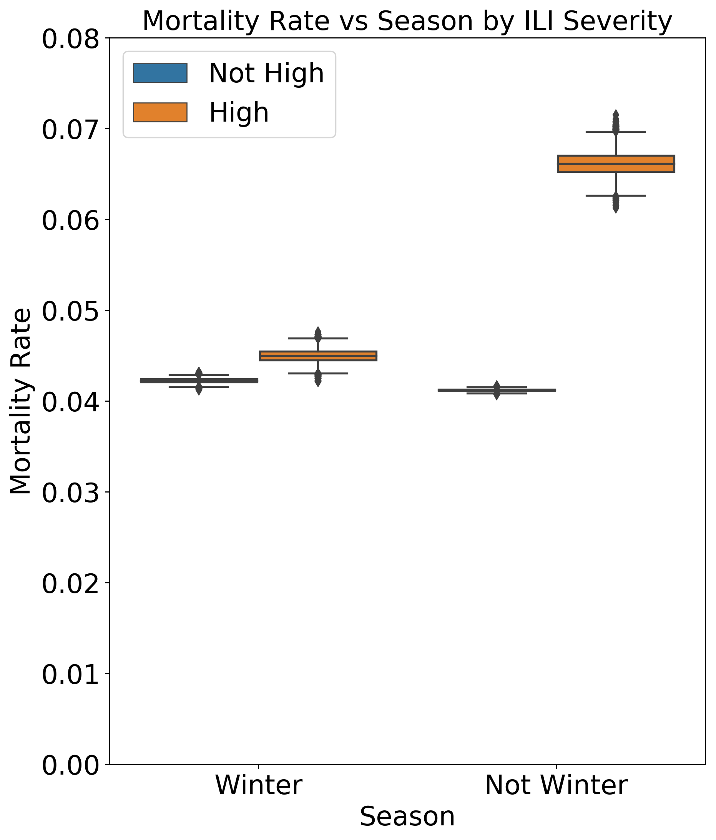
Supplemental Figure 2- Overall monthly mortality rates during winter and non-winter months. Boxes bound interquartile range. Error bars bound 95% confidence interval.

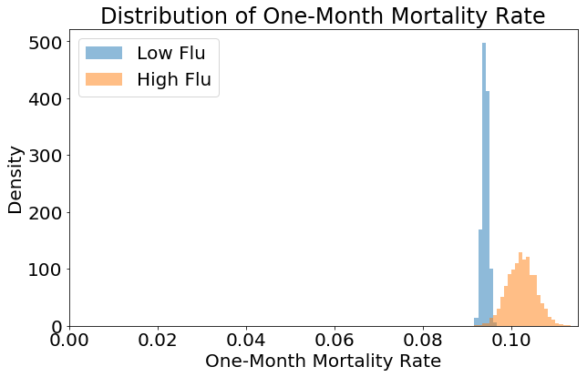
Probability
Supplemental Figure 3- One-monthly mortality rates during low and high flu months.

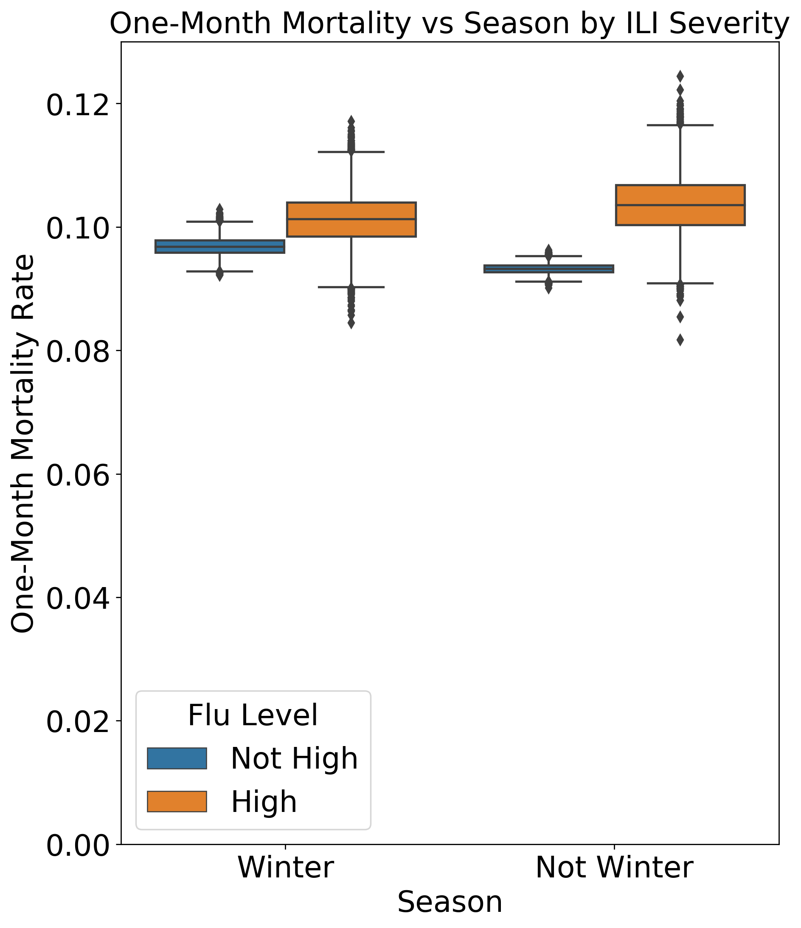
Supplemental Figure 4- One-month mortality rates for newly diagnosed cases during winter months. Boxes bound interquartile range. Error bars bound 95% confidence interval.

A.
B.

C.

Supplemental Figure 5- Risk ratio for one-month mortality rate during high flu months in subgroups stratified by state (A) and by individual patient (B) and regional (C) clinical and demographical features. Dotted line intersects x-axis at one. Error bars represent 95% confidence interval.

