Supplementary Figures
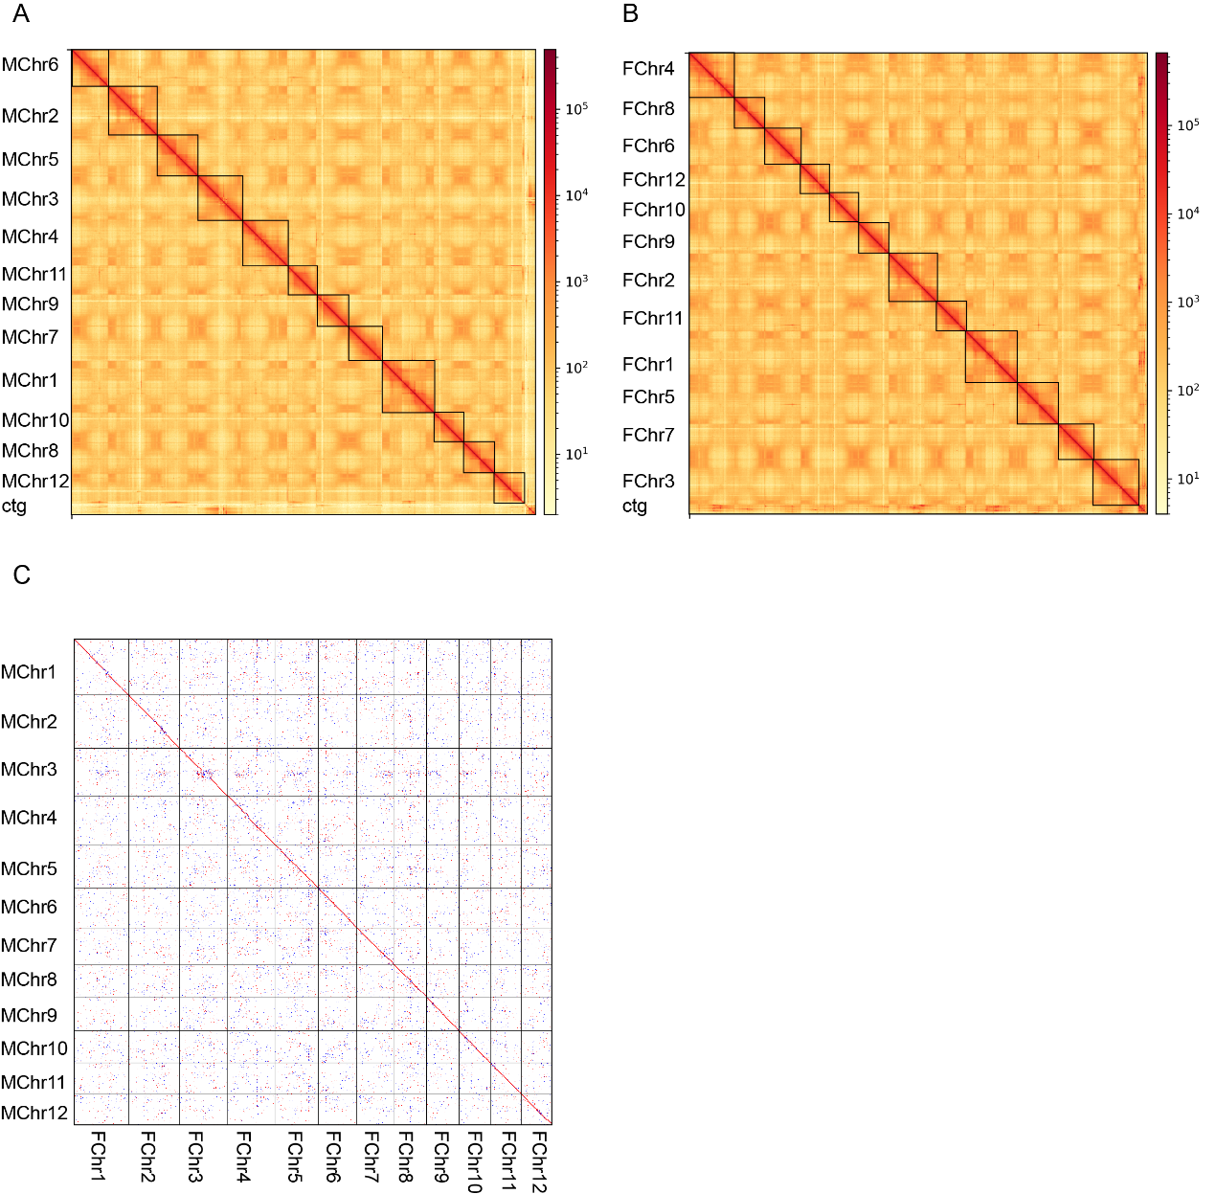
Figure S1. Features of the anchored assemblies of H. rhamnoides genomes. The Hi-C assisted assembly of the male (A) and the female (B) H. rhamnoides pseudomolecules. Darker red color indicates higher contact probability. Resolution :100 Kb. (C) Dot plots of synteny between the male and female genome of H. rhamnoides.

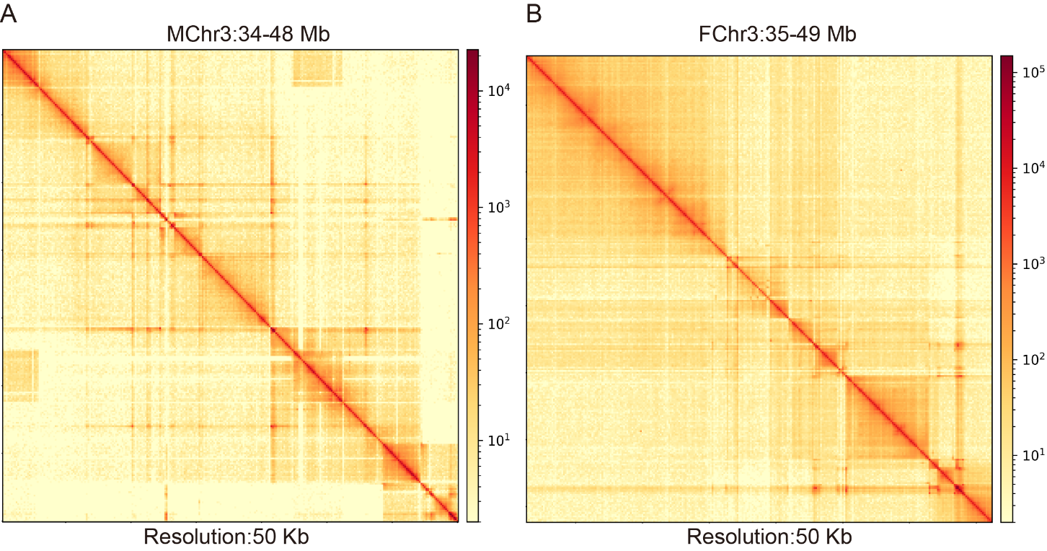
Figure S2. Hi-C interaction heatmap of structural variation regions in Chromosome 3 corresponding to the male (A) and female (B) genomes.

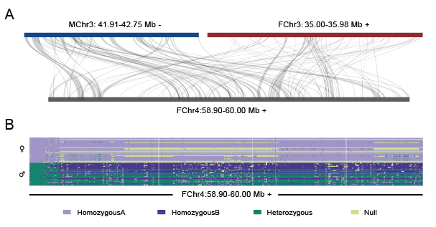
Figure S3. The collinearity and SNP distribution in the GWAS signals region on the Chr4 of female genome. A) High collinearity between the regions in female Chr4 with GWAS signals and the SDRs (X- and Y-SDR were highlighted in red and blue). B) SNP haplotype distribution of regions with GWAS signals in female Chr4.

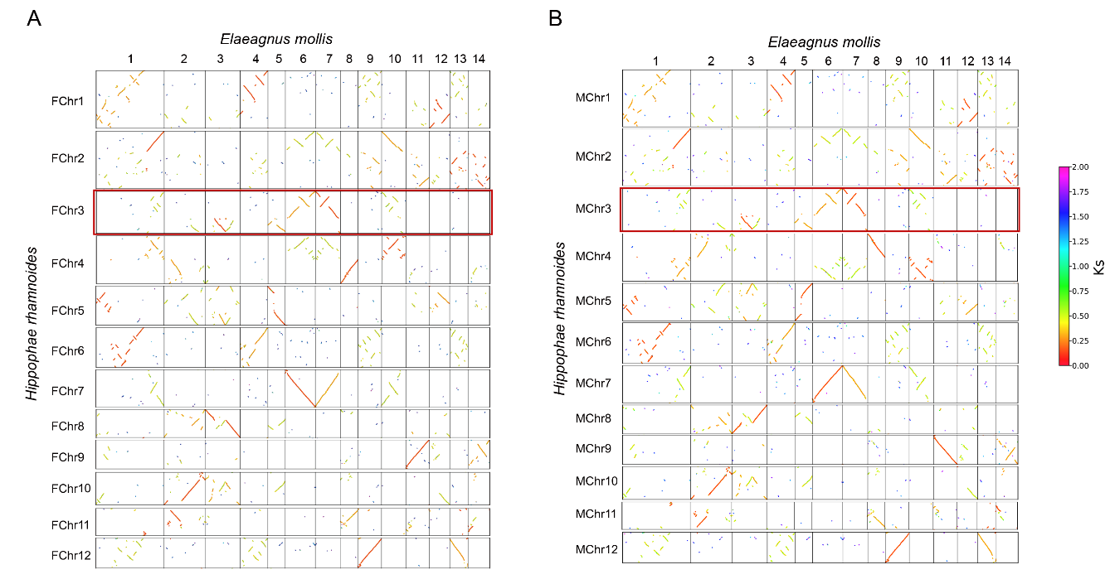
Figure S4. Synteny plot of the seabuckthorn (A) female and (B) male genomes compared with an outgroup species (Elaeaguns mollis). The colors of the points represent the average Ks value of the syntenic region, with orange and red points representing the two copies generated by the most recent whole genome duplication (WGD-β) event.

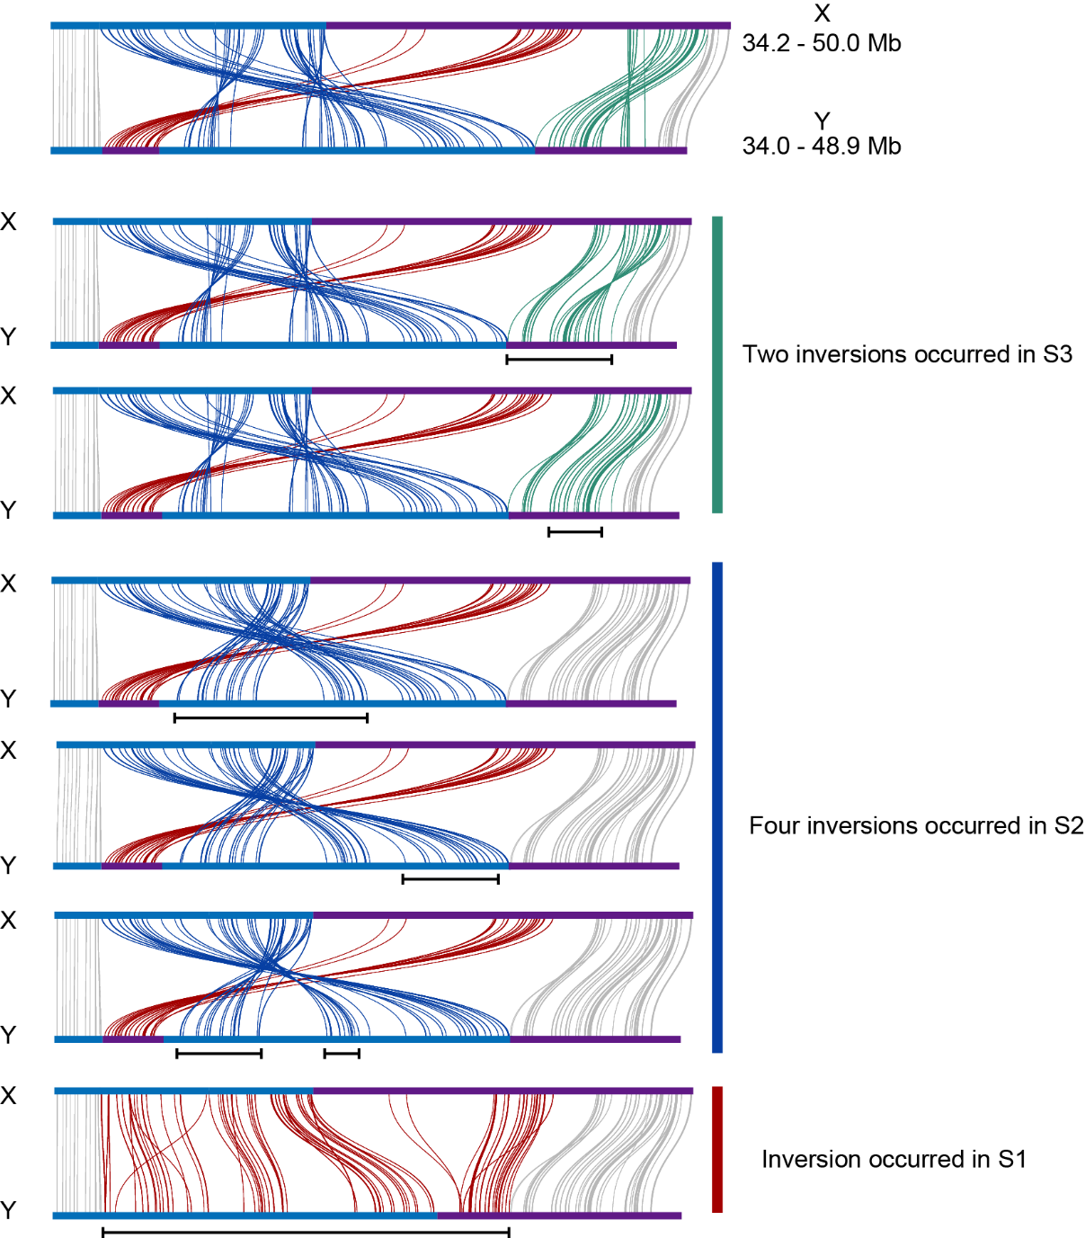

Figure S5. The cleanest model of inversions between XY after chromosome fusion. As X maintains an ancestral state similar to E. mollis, any inversions take place on Y and are maintained. The highlighted colours represent the corresponding three evolutionary layers in Figure 4A (Red: S1; Blue: S2; Green: S3). The region marked by the black line at the bottom represents the region on Y where each structural variation occurs.

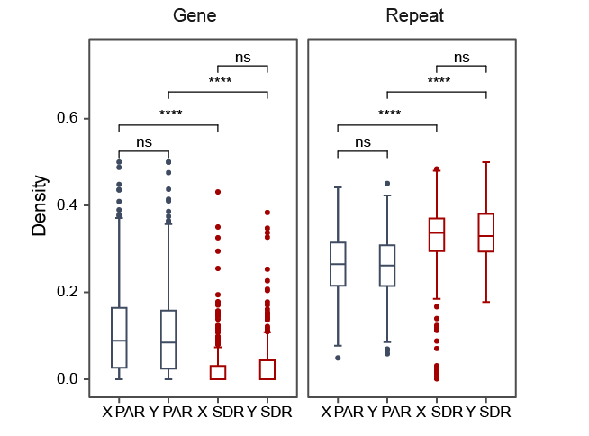
Figure S6. The gene and repetitive sequence content of the PAR (pseudoautosomal region) and SDR (sex-determining region) of the X and Y chromosomes.

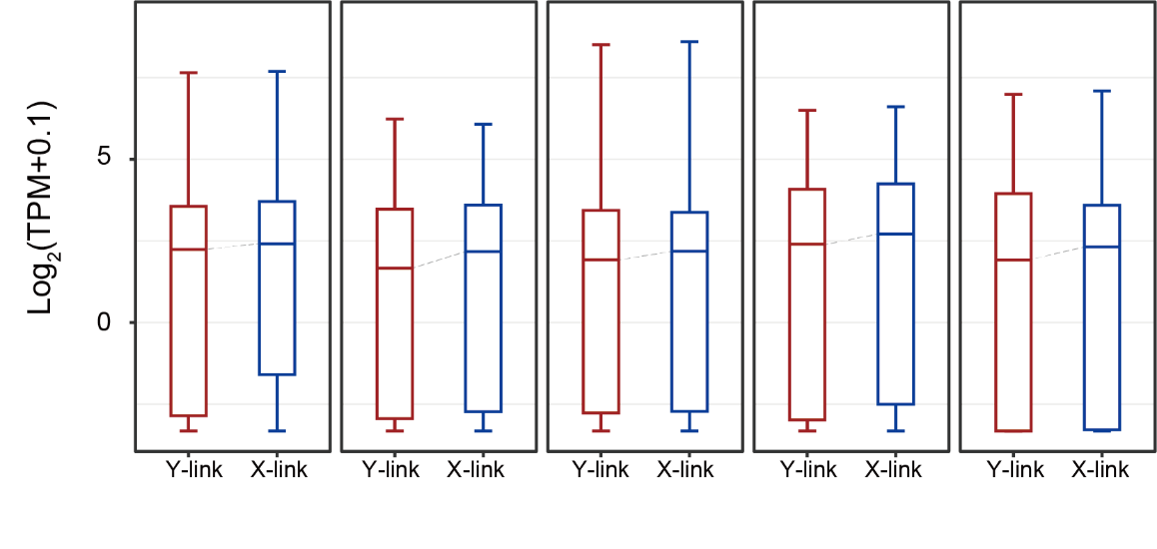
Figure S7. Expression of X- and Y-linked alleles in five tissues in male individuals.

