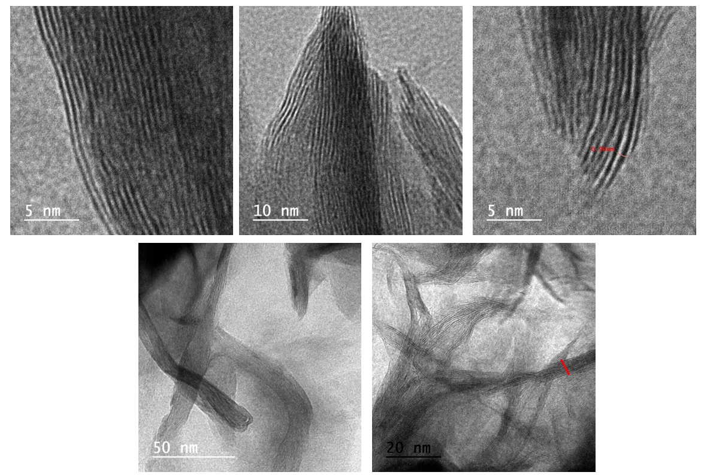
Fig.S1 TEM of MS

Co

Ni

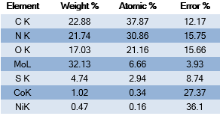
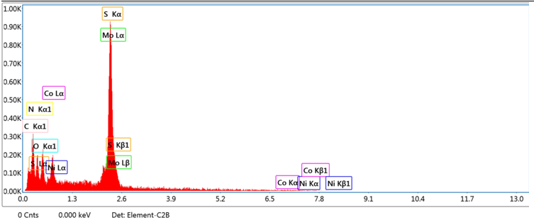
Fig.S2 EDX of Z67.Ni/MS3

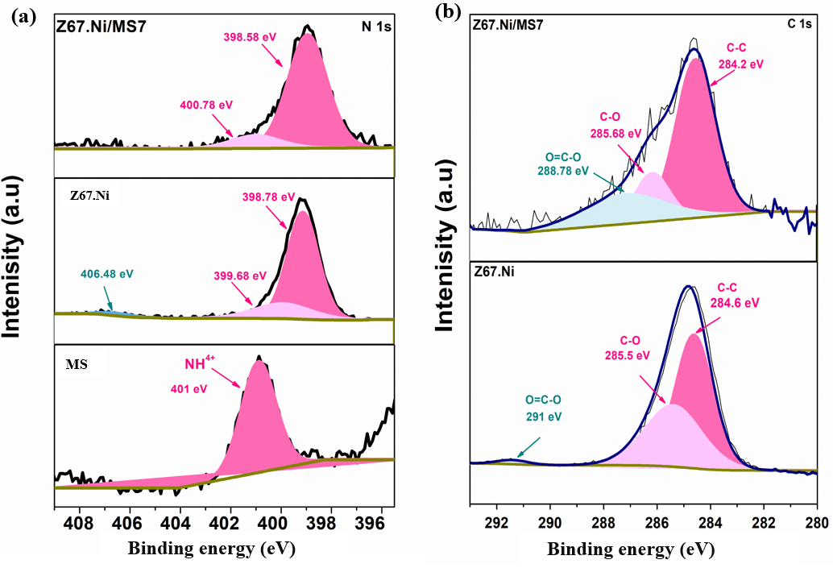

Fig.S3 XPS of MS and Z67.Ni/MS7 for high resolution spectrum of a) N1s b) C1s

