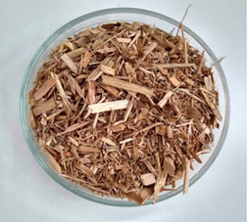
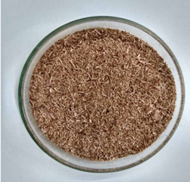
SUPPLEMENTARY ELECTRONIC INFORMATION
a
b
c

Assessment of the benefits of wort supplementation with inorganic nutrients in the bioethanol production process

Davi Gorla Montiel^{1,3}, Fernando Roberto Paz Cedeno¹, Michel Brienzo² and Fernando Masarin^{1*}

¹São Paulo State University (UNESP), School of Pharmaceutical Sciences (FCF), Department of Bioprocess Engineering and Biotechnology. Araraquara-SP, Brazil. 14800-903.

²São Paulo State University (UNESP), Bioenergy Research Institute (IPBEN), Rio Claro-SP, 13500-230, Brazil

³Solenis Especialidades Químicas Ltda, Araraquara-SP, 14803-685, Brazil

(*) corresponding author

Email addresses:
DGM: davi.bioambiental@gmail.com
FRPC: fernando.paz@unesp.br
MB: michel.brienzo@unesp.br
*FM: fernando.masarin@unesp.br

Table 1S. Chemical composition of products used as nutrients.
Composition (g.kg⁻¹) | Nitrofós Macro | Nitrofós Micro
Nitrogen | 221.13 | -
Phosphor | 282.24 | -
Magnesium | 10.08 | 9.0
Manganese | 15.02 | 15.5
Zinc | 3.15 | 10.0
Copper | - | 25.0

Table 2S. Fermentative parameters in bioethanol industrial process.
Crop Period (2021) | Total ethanol production (m³.dia⁻¹) | Fermentation efficiency  (%) | TA required  (tonne.h⁻¹) | Yeast produced (tonne.h⁻¹)
March | 355.27 | 87.31 | 29.74 | 0.89
April | 472.30 | 88.35 | 39.07 | 1.17
May | 566.05 | 88.75 | 46.61 | 1.40
June | 604.98 | 90.45 | 48.88 | 1.47
July | 694.57 | 91.25 | 55.62 | 1.67
September | 688.78 | 94.30 | 53.38 | 1.60
$Y_{\frac{P}{S}}$ Substrate (total sugars, TA) conversion factor to product (ethanol) = 0.4550 (tonne.tonne⁻¹, dry weight).
$Y_{\frac{X}{S}}$ = Substrate (total sugars, TA) conversion factor to product (yeast)) = 0.030 (tonne.tonne⁻¹, dry weight).
Ethanol specific mass = 0.79 (kg. L⁻¹).

Table 3S. “Ionic matrix” in bioethanol industrial process.
Ionic  base | Mass percentage | Minimal minerals (kg.h⁻¹)
Ionic  base | Mass percentage | March | April | May | June | July | September
Nitrogen | 1.50 | 13.40 | 17.60 | 21.00 | 22.00 | 25.00 | 24.00
Phosphorus | 2.00 | 17.85 | 23.45 | 28.00 | 29.35 | 33.40 | 32.00
Magnesium | 1.00 | 8.90 | 11.70 | 14.,00 | 14.70 | 16.70 | 16.00
Manganese | 0.50 | 4.50 | 5.90 | 8.00 | 7.30 | 8.35 | 8.00
Zinc | 0.17 | 1.50 | 2.00 | 2.40 | 2.50 | 2.85 | 2.70
Copper | 0.05 | 0.50 | 0.60 | 0.70 | 0.70 | 0.80 | 0.80

Table 4S. Flow in bioethanol industrial process.
Crop Period (2021) | Average flow (m³.h⁻¹)
Crop Period (2021) | Wort | Yeast | Wine
March | 155.35 | 57.45 | 188.00
April | 208.45 | 77.10 | 254.30
May | 251.65 | 93.10 | 304.60
June | 228.70 | 72.20 | 261.20
July | 305.15 | 113.00 | 369.00
September | 301.00 | 105.00 | 323.60

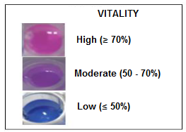
Figure 1S. Color chart for cell vitality comparison.
Source: Adapted from LIEVITO.

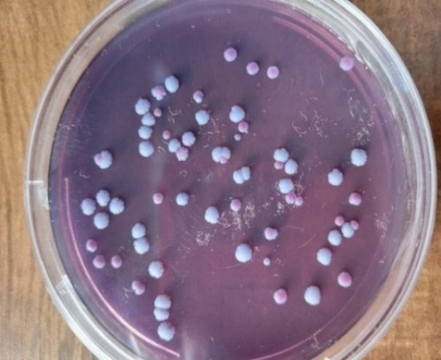
Figure 2S. Colony forming unit count (CFU/plate) in a plate containing LIEVITO selective medium.

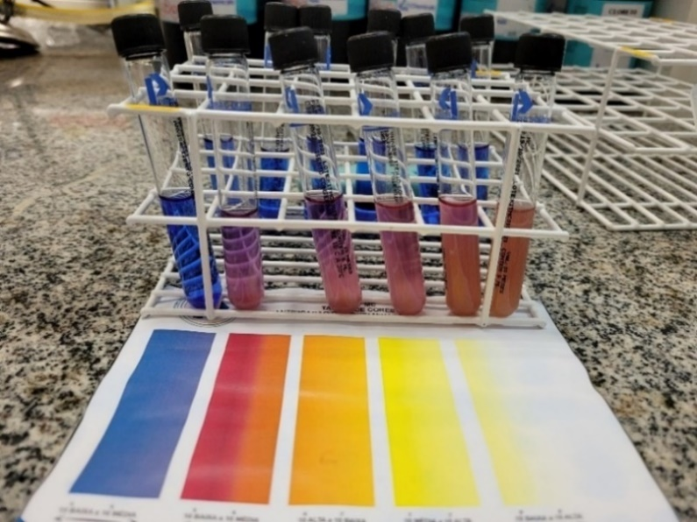
Figure 3S. Rapid diagnosis of bacterial contamination in bioethanol industrial process (TMKIT MC).

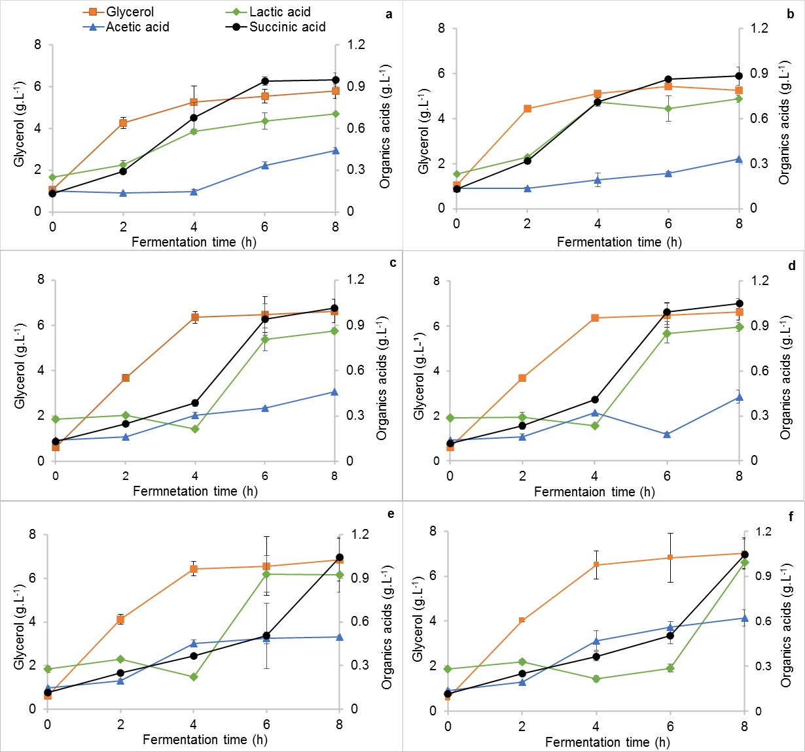
Figure 4S. Glycerol and organic acid contents as a function of fermentation time using the supplementary product (TMNitrofós) in laboratory scale with different °Brix conditions: 20° Brix (a) control (b) supplemented; 24° Brix (c) control (d) supplemented; 26° Brix (e) control (f) supplemented.
*Error bars correspond to the sample standard deviation. Overlapping error bar means the error is less than the symbol size. The results represent the average of 3 replicates for the control and supplemented groups.

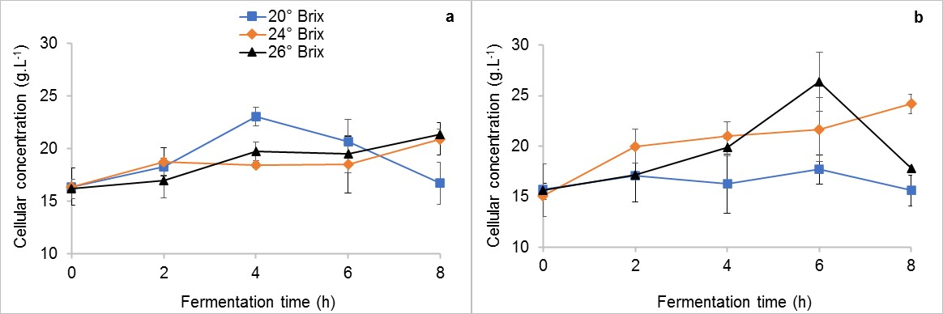
Figura 5S. Yeast cellular concentration as a function of fermentation time using the supplementary product (TMNitrofós) in laboratory scale with different °Brix conditions: (a) control (b) supplemented.
*Error bars correspond to the sample standard deviation. Overlapping error bars means the error is less than the symbol size. The results represent the average of 3 replicates for the control and supplemented groups.

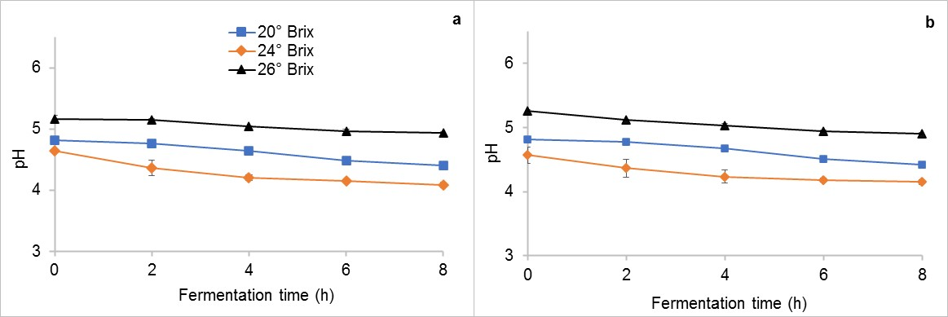
Figure 6S. pH as a function of time of fermentation using a supplementary product (TMNitrofós) in laboratory scale with different °Brix conditions: (a) control (b) supplemented.
*Error bars correspond to the sample standard deviation. Overlapping error bars means the error is less than the symbol size. The results represent the average of 3 replicates for the control and supplemented groups.

Appendix I: Calculations of the industrial bioethanol production plant
- Calculation for Total Ethanol Production.
$TOTAL ETHANOL={ETHANOL}_{hydrated}*0.95557+{ETHANOL}_{anhydrous}*0.99576\frac{m3}{dia}$ (1)
where:
Hydrated Ethanol to Total Ethanol: multiply by 0.95557
Anhydrous Ethanol to Total Ethanol: multiply by 0.99576

- Calculation of the total sugar (TS) required.
The amount of TS required for fermentation (tonne.h⁻¹)

${TS}_{required}=\frac{\left(TOTAL ETHANOL*0.78923\frac{kg}{m3}\right)}{\left(\frac{{Yield}_{ferm}}{100}*Y_{\frac{P}{S}}\right)*24} \frac{tonne}{h}$ (2)
where:
${Yield}_{ferm}$ = fermentation yield (%);
$Y_{\frac{P}{S}}$ = coefficient of the theoretical yield of a substrate (TS) to product (ethanol)= 0.4550 (tonne.tonne⁻¹);
Specific mass of Ethanol = 0.78923 (kg. L⁻¹);

- Content of yeast produced.
The yeast production (yeast cells) in the fermentation tanks can be known through the kinetic study of the fermentation, being the TS yield coefficient in dry mass can be of the order of:
$Y_{\frac{X}{S}}$ = coefficient of substrate yield (TS) in biomass = 0.030-tonne TS/tonne (dry weight).
Thus,
${Cell}_{prod}={TS}_{required}*Y_{\frac{X}{S}} \frac{tonne}{h}$ (3)

Appendix II. Mass calculation of minerals present in wort, yeast, and nutrients for laboratory fermentation supplementation.
- Concentration of minerals present in the wort and yeast (mg.L⁻¹)
Jun/21 | N | P | Mg | Mn | Zn | Cu
Wort | 69.2 | 133.0 | 169.7 | 1.0 | 0.6 | 0.2
Yeast | 97.6 | 455.2 | 171.8 | 1.8 | 4.2 | 0.7

- Conversion of minerals present in the wort and yeast to (g.L⁻¹):
N wort = 69.2 → N wort = 0.0692 g.L⁻¹
1000
- Concentration of minerals present in the wort and yeast (g.L⁻¹)
Minerals (g.L⁻¹) | N | P | Mg | Mn | Zn | Cu
Wort | 0.0692 | 0.1330 | 0.1697 | 0.0010 | 0.0006 |  | 0.0002
Yeast | 0.0976 | 0.4552 | 0.1718 | 0.0018 | 0.0042 |  | 0.0007

- Calculation of the mass of minerals present in the wort and yeast.
Considering a wort volume of 140 mL and a yeast volume of 60 mL used in laboratory fermentations, the mass of nitrogen in the wort is 0.0097 g. Applying this calculation to all minerals present in the wort and yeast, we have the mass (g) of the main ions:
Minerals (g) | N | P | Mg | Mn | Zn | Cu
Wort | 0.0097 | 0.0186 | 0.0238 | 0.0001 | 0.0001 |  | 0.000028
Yeast | 0.0059 | 0.0273 | 0.0103 | 0.0001 | 0.0003 |  | 0.000042
Total | 0.0156 | 0.0459 | 0.0341 | 0.0002 | 0.0003 |  | 0.000070

- Calculation of mass of minerals present in nutrients (TMNitrofós Macro and TMNitrofós Micro)
Supplementing the fermentation with 0.025 g of TMNitrofós Macro and 0.023 g of TMNitrofós Micro, the following total amount of each ion present in the nutrients is obtained:
Minerals (g) | N | P | Mg | Mn | Zn | Cu
NitrofósTM Macro | 0.0055 | 0.0071 | 0.0003 | 0.0004 | 0.0001
NitrofósTM Micro | - | - | 0.0002 | 0.0004 | 0.0002 |  | 0.0006
Total | 0.0055 | 0.0071 | 0.0005 | 0.0008 | 0.0003 |  | 0.0006

- Supplementation
Adding the total mass concentrations (wort, yeast, and nutrients), the total amount of minerals in fermentation is obtained:
Minerals | N | P | Mg | Mn | Zn | Cu
Wort and Yeast (g) | 0.0156 | 0.0459 | 0.0341 | 0.0002 | 0.0003 |  | 0.0001
Nutrients (g) | 0.0055 | 0.0071 | 0.0005 | 0.0008 | 0.0003 |  | 0.0006
Total Minerals (g) | 0.0211 | 0.0530 | 0.0345 | 0.0010 | 0.0006 |  | 0.0007

- Calculation in % supplementation of added nutrients:
N (%) = 0.0055 ×100 → N = 26.23%
0.0211
N (%) = 26.23 | Mn (%) = 74.70
P (%) = 13.32 | Zn (%) = 47.90
Mg (%) = 1.33 | Cu (%) = 89.15

