A Simple, Green Pathway to Covalently Transform Perfluorooctanoate (PFOA) to an Insoluble Ester

Supplementary Information

Susanna Maistoª, Doris Hongª, Alexandra Griffithª, and John Fortnerª*

ªDepartment of Chemical and Environmental Engineering, Yale University, New Haven, CT 06511, USA

Submitted to

Nature Water

Table of contents
Pages 3-9: NMR spectra and FTIR spectrum of ester product (19F NMR, 1H NMR, 19F-13C NMR, 13C NMR, 1H-1H NMR, FTIR)
Pages 10-13: In-situ NMR data: Delineating roles of DBSA, octanoic acid, and reaction stoichiometry
Pages 14-18: In-situ NMR methodology, NMR peak and shift identification, and relevant NMR spectra
Page 19: Computational K_{OW} calculations

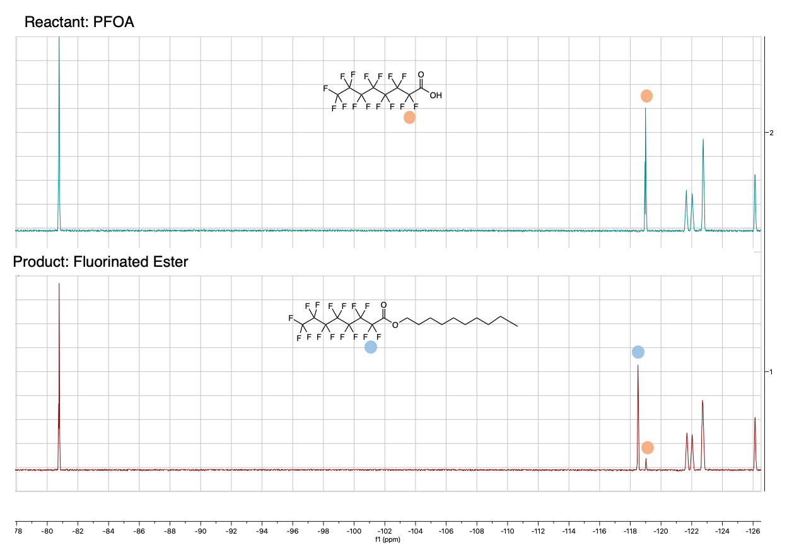
Figure S1. ¹⁹F NMR in CDCl₃ of PFOA (starting material) and reaction product. Ester generation is identified via new peak at -118.62 ppm and diminished PFOA peak at -119.03 ppm. Peak assignment is based off assignments detailed by Trang et. al.¹
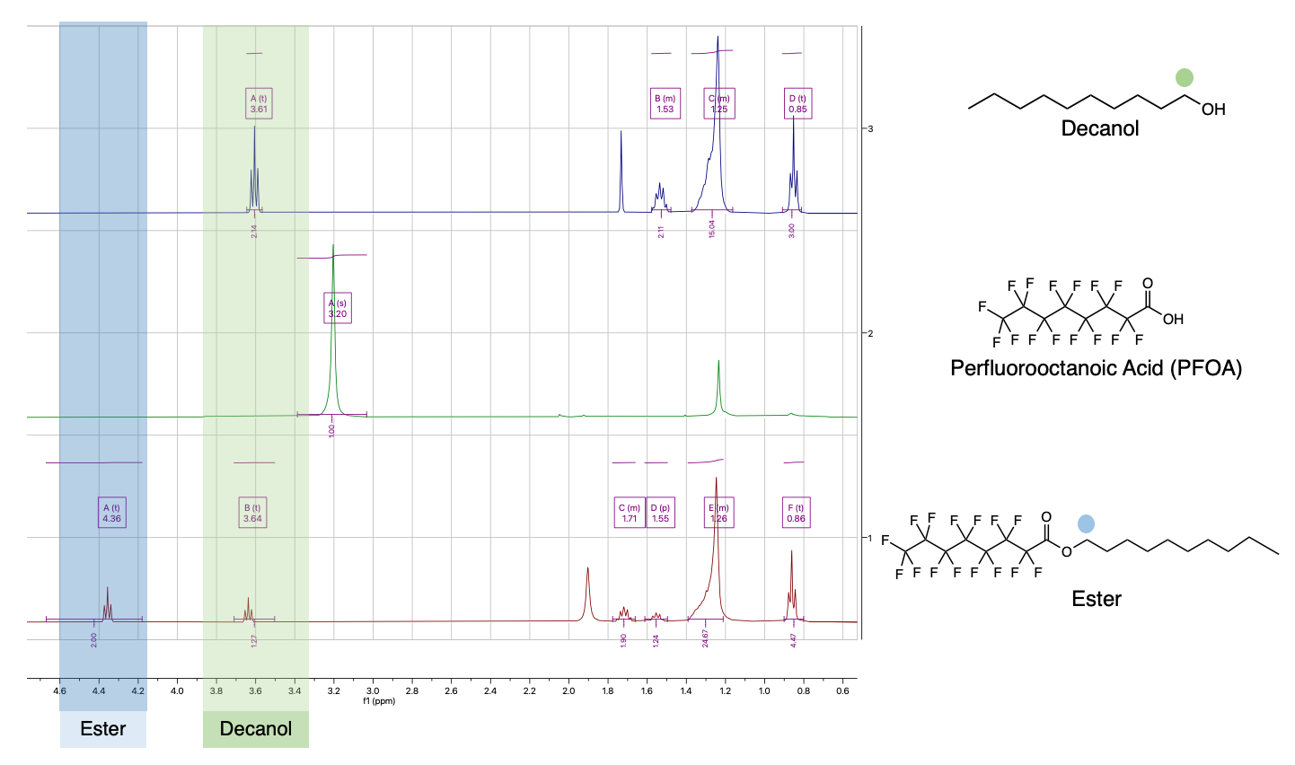
Figure S2. ¹H NMR spectra of starting reactants (decanol and PFOA) and esterification reaction product in CDCl₃. Ester generation is identified via new peaks at 4.36 and 1.71 ppm. Decanol and ester are tracked via triplet peaks at 3.61 ppm and 1.53 ppm, respectively.

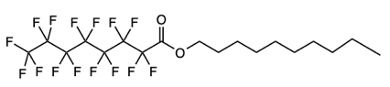

Figure S3. ¹⁹F-¹³C HSQC NMR of fluorinated ester. ¹⁹F-¹³C HSQC NMR allows for identification of carbon signals bonded to fluorine atoms (the fluorocarbon tail of the fluorinated ester), which are challenging to detect in 1D proton decoupled ¹³C NMR spectra due to extensive splitting from coupling to numerous ¹⁹F.

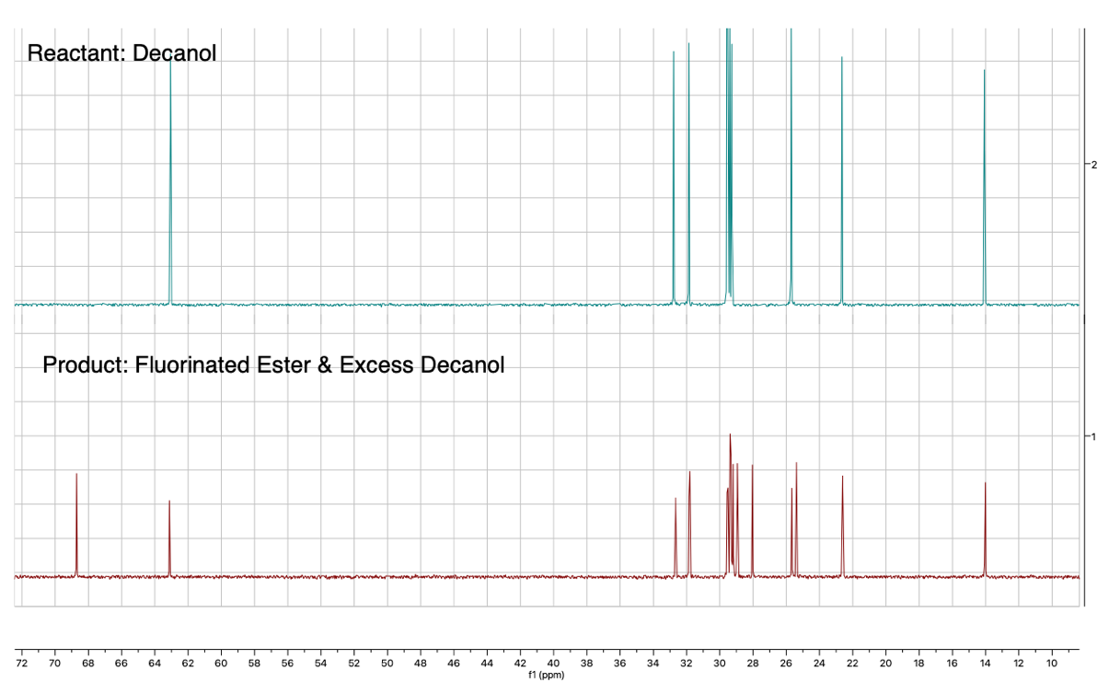
Figure S4. Proton decoupled ¹³C NMR of unreacted decanol and esterification reaction product. This region of the ¹³C NMR spectrum allows for identification of carbon atoms bonded to hydrogen atoms (the hydrocarbon tail of the fluorinated ester).

Figure S5. ¹H-¹H COSY NMR of fluorinated ester; cross-peaks indicate through-bond J-couplings. Couplings at 4.36 ppm and 1.71 ppm indicate that the two new ester peaks are connected to one another by covalent bond(s).
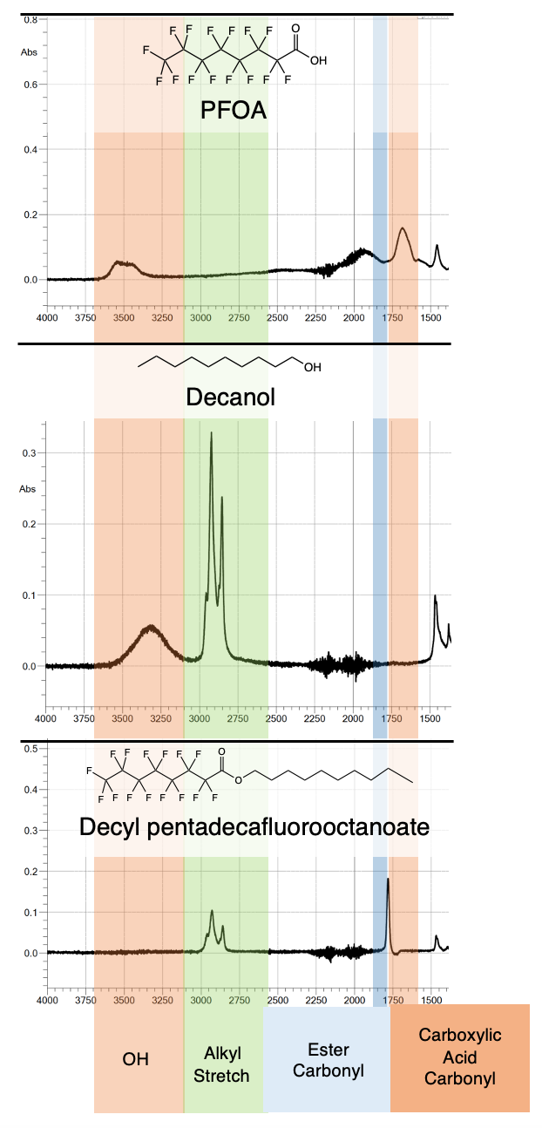
Figure S6. FTIR spectra of reaction starting materials (PFOA and decanol) and reaction product (decyl pentadecafluorooctanoate). Spectra demonstrate that, as the reaction proceeds, an -OH group is lost, an alkyl stretch is retained, and the carbonyl peak slightly shifts.

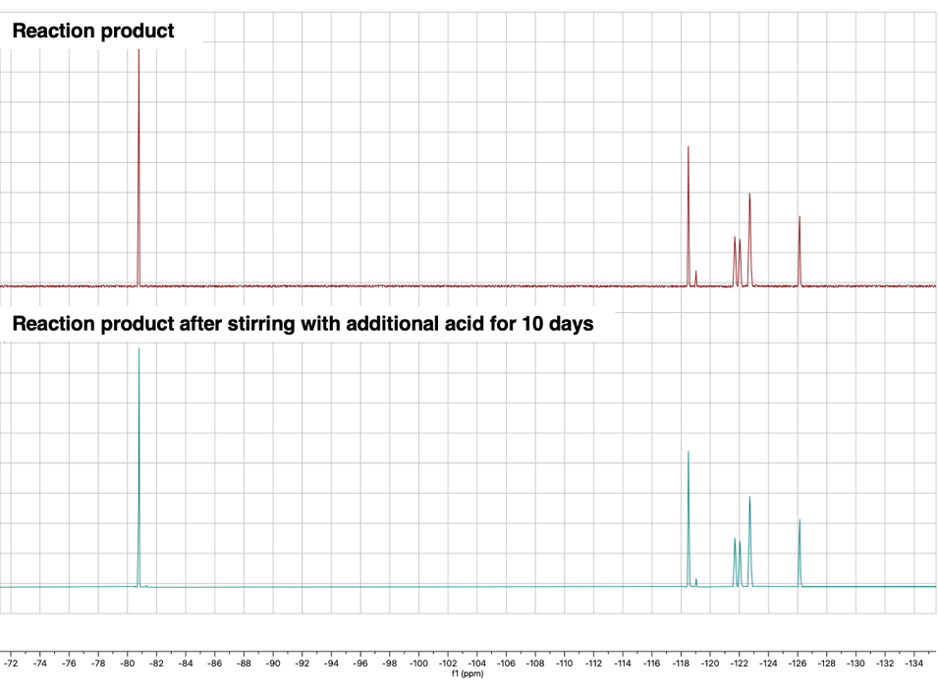
Figure S7a: Top: ¹⁹F NMR in CDCl₃ of reaction product. Bottom: ¹⁹F NMR in CDCl₃ of reaction product after stirring with additional acid (HCl, 2 molar equivalencies to ester concentration) for ten days. Retention of ester peak at -118.62 ppm demonstrates that the ester is stable after the end of the reaction and under acidic conditions.

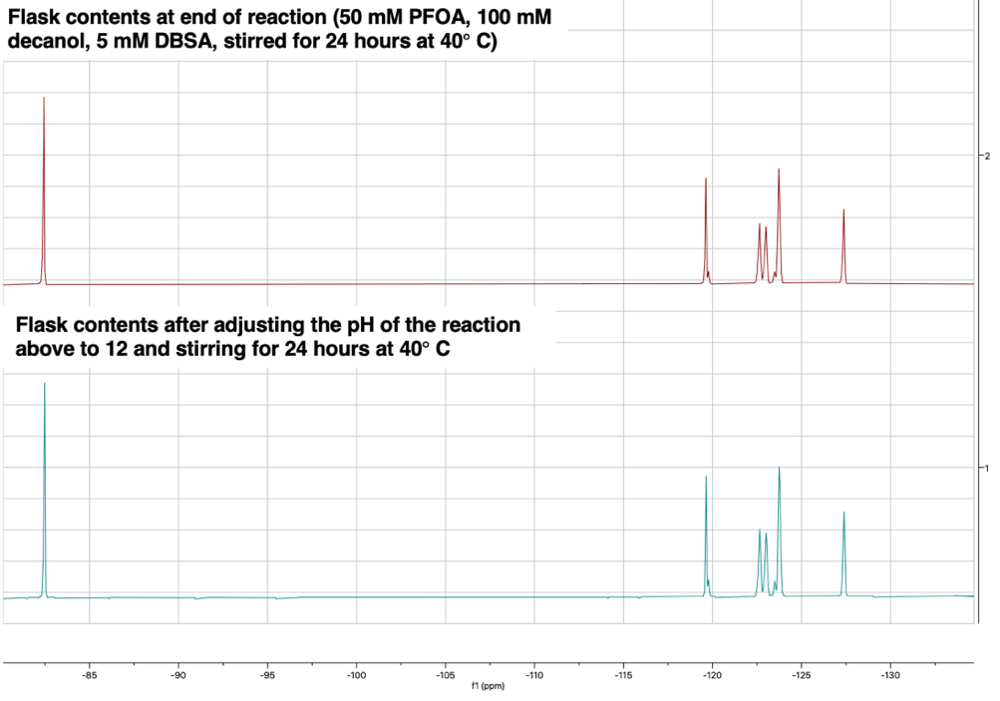

Figure S7b: Top: ¹⁹F NMR in D₂O of reaction contents at the end of 50 mM reaction (50mM PFOA, 5 mM DBSA, 100 mM decanol) Bottom: ¹⁹F NMR in D₂O of the same flask after the pH was adjusted to 12 and stirring continued at 40$°$ C for 24 hours. Identical NMR spectra indicate the ester is stable after the end of the reaction and under basic conditions.
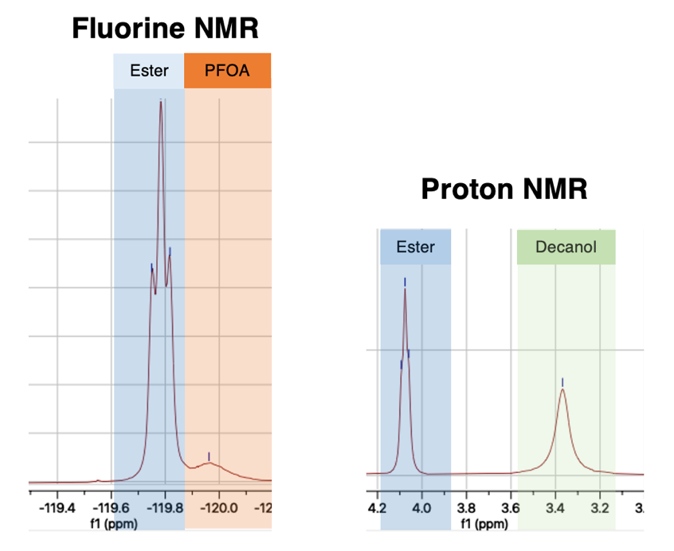
Figure S8. ¹⁹F and ¹H NMR of an aliquot of the esterification reaction in H₂O without DBSA after 24 hours. Even without inclusion of DBSA in the reaction, ¹⁹F NMR shows a large ester peak at -119.79 ppm and a diminished PFOA peak at -119.96 ppm. Proton NMR shows an ester peak at 4.08 ppm of nearly equal peak integration to the decanol peak at 3.38 ppm. Since initial reactants PFOA and decanol are present at a 1:2 molar ratio, nearly equal ester and decanol peak integrations indicates similar reaction progress as measured by ¹⁹F NMR.

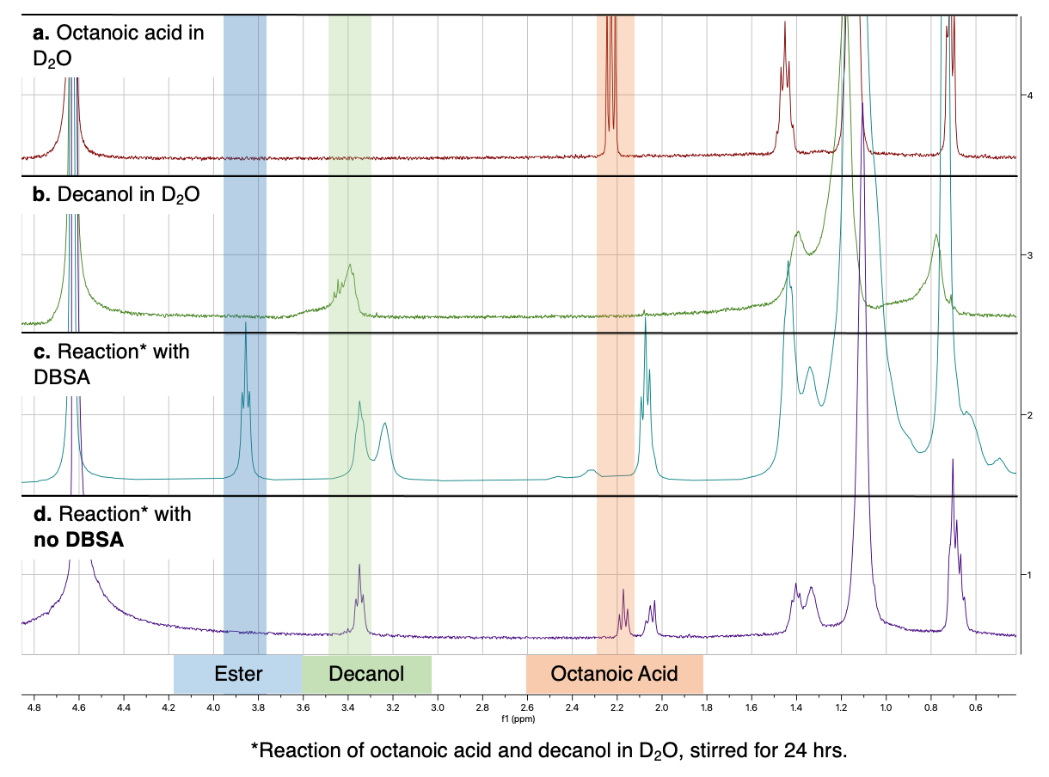
Figure S9. ¹H NMR spectra to observe the behavior of octanoic acid (nonfluorinated) in a parallel reaction system. Spectra are displayed of esterification starting materials (octanoic acid and decanol) and esterification products (when DBSA is included and omitted from the reaction). Ester formation is demonstrated by a novel triplet peak at 3.86 ppm. When DBSA is omitted from the reaction, ester formation is not observed, as there is no novel peak at 3.86 ppm. These results indicate that nonfluorinated octanoic acid does not have the surfactant and/or partitioning properties of PFOA, which enable the reaction to proceed without additional surfactant (DBSA).

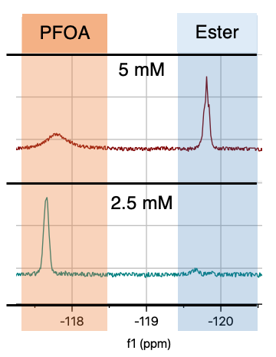
Figure S10. In-situ ¹⁹F NMR spectra of the esterification reaction in H₂O for 5 and 2.5 mM PFOA concentrations. Presence of ester peak at -119.79 ppm for the 5 mM reaction indicates that the esterification reaction proceeds at a concentration of 5 mM, while lack of ester peak at -119.79 ppm (and retention of a large PFOA peak at -117.76 ppm) for the 2.5 mM reaction indicates reaction limited conditions.
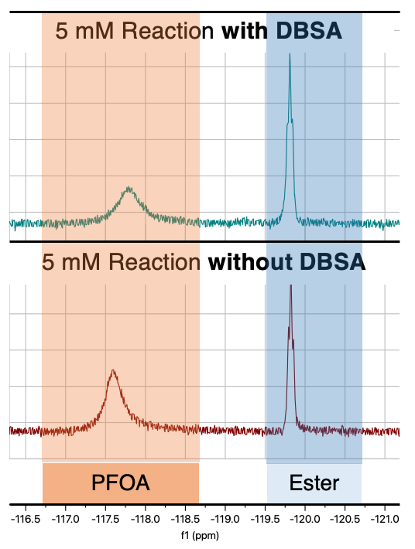
Figure S11. In-situ ¹⁹F NMR spectra of the esterification reaction in H₂O at an initial PFOA concentration of 5 mM, with and without DBSA. Retention of an ester peak at -119.79 ppm for both reactions with and without DBSA indicates that DBSA is not required for the reaction to progress, even at lower starting PFOA concentration (5 mM). Integration of PFOA and ester peaks demonstrates that presence of DBSA improves ester yield, as ester is produced at a 44% yield when DBSA is included, compared to 33% without DBSA.

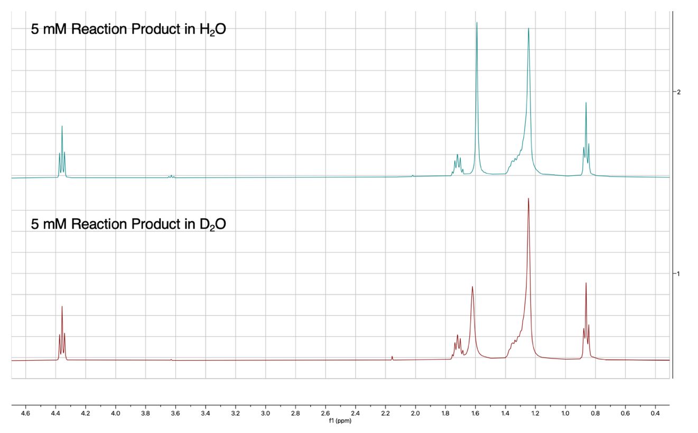
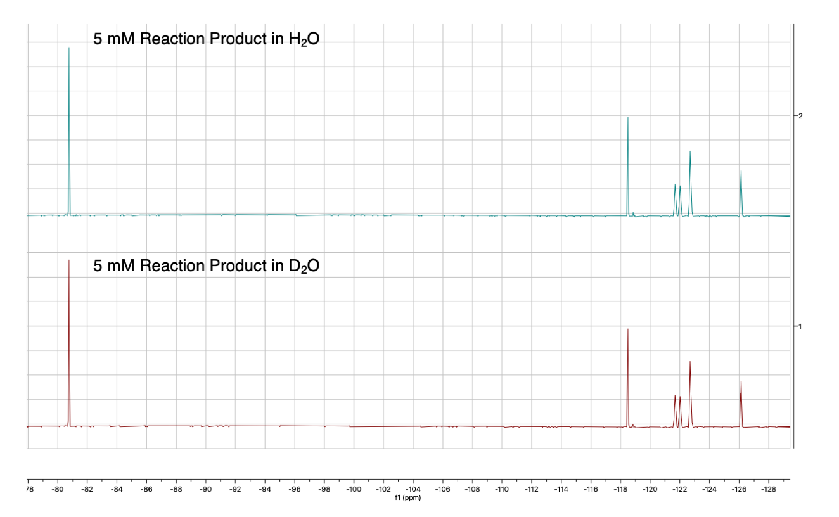
Figure S12. ¹H (top) and ¹⁹F (bottom) NMR comparison of products of reactions run in H₂O (top) and D₂O (bottom). Matching spectra confirms that D₂O is an appropriate substitution for H₂O. Reactions were performed under identical conditions (5mM PFOA, 72 hours). After 72 hours, reaction contents were centrifuged, aqueous layers were removed, and product was air-dried. After drying, product was re-dissolved in CDCl₃.

In-Situ ¹⁹F NMR for reaction monitoring and quantitation
In-situ ¹⁹F NMR studies were performed exclusively in water (100% D₂O or 90% H₂O and 10% D₂O). Similar to data presented by Trang et. al., we observe that the chemical shift(s) of the 2 fluorine atoms closest to the carbonyl group (in the range of -117 to -121 ppm) are sensitive to structural changes of the head group¹, and were used for reaction quantification. Internal standard trifluoroacetic acid (TFA) was added to NMR tubes in equal molar concentration to initial the PFOA concentration, as a benchmark allowing for quantitative ¹⁹F NMR data for total fluorine content ([PFOA] + [Ester]) equivalents to [TFA] ± 20%. Solutions of water and PFOA alone yielded poor quantitative data in the absence of a cosolvent. In a solution of water and PFOA alone, a PFOA signal typically appears at or near -117.76 ppm, with signal that is lower (integrated) compared to the internal standard TFA (Figure S13a). In a solution of H₂O and experimental concentrations of decanol, PFOA signal appeared around -119.96 ppm, which, when integrated, matched the internal standard trifluoroacetic acid (Figure S13b). Fluorinated ester was also visible on ¹⁹F NMR around -119.79 ppm (Figure S13c). Given that these peaks are in very close proximity, we included tandem ¹H NMR experiments for each ¹⁹F NMR experiment (Figure S14). Each NMR tube was analyzed via both ¹⁹F and ¹H NMR, and ester observed via ¹H NMR (peaks at 4.08 ppm and 1.48 ppm) was used to verify peak identification in ¹⁹F NMR. Similar ¹⁹F NMR chemical shift behavior was also reported by Oda et. al.²

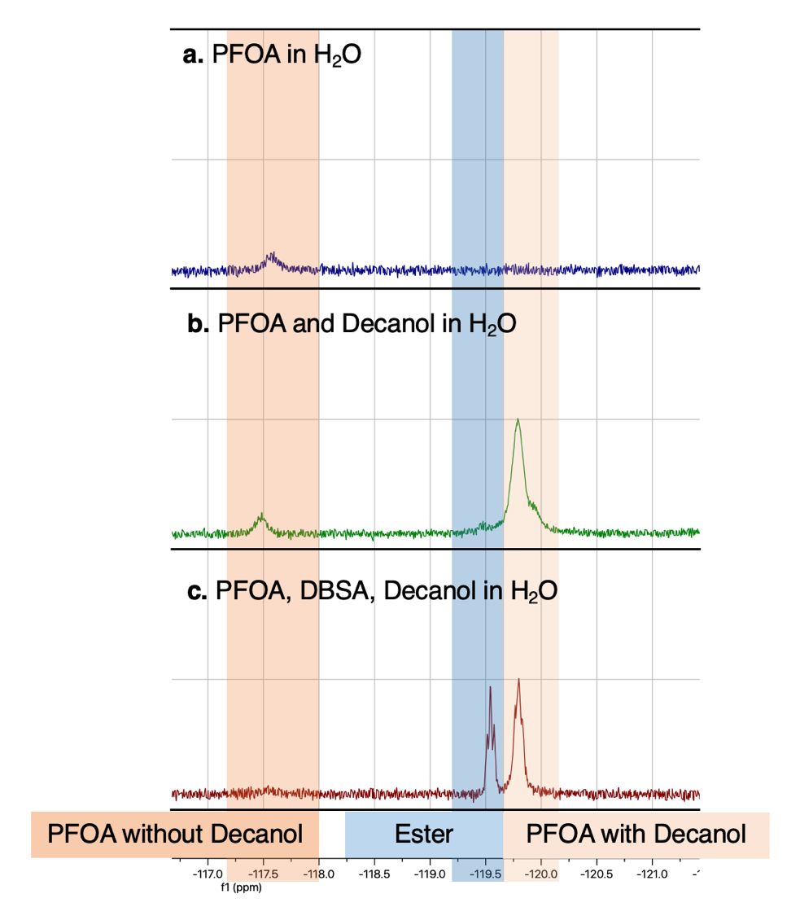
Figure S13. ¹⁹F NMR spectra of PFOA in (a) H₂O alone and upon the addition of (b) decanol and with (c) decanol and DBSA. All spectra were obtained by adding PFOA to H₂O at 40$°$ C, stirring for 15 minutes to allow full dissolution, and then sampling 400 uL (a) after adding decanol (b) or decanol and DBSA (c), letting the reaction stir for 30 seconds, and then taking a 400 uL sample. NMR samples were transferred to clean NMR tubes, into which 50 uL of D₂O (for NMR deuterium lock) and internal standard (trifluoroacetic acid) were also included. ¹⁹F NMR spectra demonstrate that when PFOA is alone in H₂O (a), it is not completely dissolved and the peak at -117.76 ppm fails to integrate to match the concentration of internal standard TFA. In the presence of decanol (b), the PFOA ¹⁹F NMR shift moves upfield from -117.76 ppm to -119.96 ppm. When DBSA and decanol are both added to solution and a sample is taken after 30 seconds, a small amount of ester is generated due to DBSA quickening the esterification reaction, corresponding to the ester peak at -119.79 ppm. Unreacted PFOA can be observed via the peak at -119.96 ppm. Given the proximity of the PFOA and ester peaks, quantitative ¹⁹F NMR was verified with ¹H NMR data: Relative integration of the ester peak at 4.08 ppm or 1.48 ppm compared to the decanol peak at 3.38 ppm or 1.32 ppm was used to confirm that ¹⁹F NMR peaks were properly assigned (Figure S14).

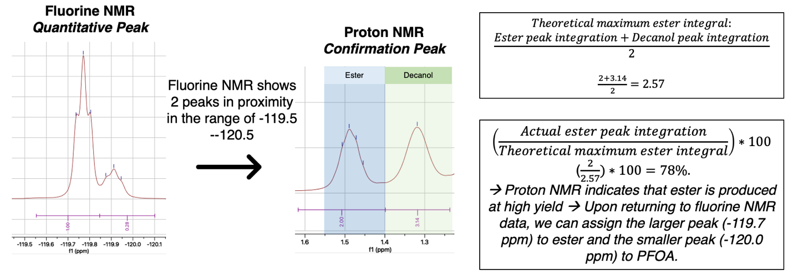
Figure S14. For samples run in D₂O or H₂O/D₂O, fluorine NMR shows 2 peaks in proximity in the range of -119.50 -- -120.50, thus proton NMR is employed for confirmation of peak assignments. Proton NMR of the same NMR tube shows ester yield in relation to decanol, as opposed to fluorine NMR, which shows ester yield in relation to PFOA. Given that the ratio of starting materials is 1:2 (PFOA:decanol), we assume that 100% ester yield would be indicated via ester peaks (4.08 or 1.48 ppm in H₂O) and decanol peaks (3.38 or 1.32 ppm in H₂O) which integrate equally. In this example, the ester peak at 1.48 ppm integrates to 2 and the decanol peak at 1.32 ppm integrates to 3.14, so theoretically, 100% ester yield would be realized if the ester peak integrated to $\frac{Ester peak integration+Decanol peak integration}{2}=\frac{2+3.14}{2}=2.57$. Given that the ester peak integrates to 2, we can calculate yield via $(\frac{Actual ester peak integration}{Theoretical maximum ester integral})*100=$($\frac{2}{2.57})*100=78\%.$Since proton NMR indicates that ester is produced at high yield, we can confirm that amongst the 2 neighboring peaks in fluorine NMR, the larger peak (-119.79 ppm) corresponds to ester and the smaller peak (-119.96 ppm) corresponds to PFOA. We can use these peak assignments to relate relative concentrations of ester and PFOA. Proton NMR peaks at 4.08 ppm (decanol) and 3.38 ppm (ester) can also be used as confirmation peaks. We do not use proton NMR for quantitative purposes because PFOA does not appear on proton NMR. Quantitative data is thus from fluorine NMR, as it detects and measures both ester and PFOA. Internal standard trifluoroacetic acid is used for all quantitative fluorine NMR experiments to confirm accurate fluorine mass balance; quantitative ¹⁹F NMR data was only used if total fluorine content ([PFOA] + [Ester]) was equivalent to [TFA] ± 20%.

NMR shifts in different solvents of peaks used for reactant and product identification

¹⁹F NMR Data
Solvent | Internal standard shift (ppm) | Ester shift (ppm) | PFOA shift (ppm) | PFOA shift without decanol (ppm)
CDCl₃ | -62.54  (2,4-Dichlorobenzotrifluoride) | -118.62 | -119.03 | n/a
H₂O / D₂O | -75.52 ppm  (Trifluoroacetic acid) | -119.79 | -119.96 | -117.76
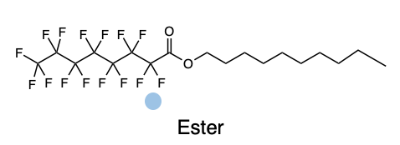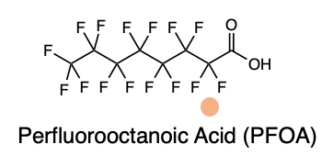

¹H NMR Data
Solvent | Shift of internal standard (ppm) | Ester shift (ppm) | Decanol shift (ppm)
CDCl₃ | 7.26 (CDCl₃) | 4.36  1.71 | 3.61  1.53
H₂O / D₂O | 4.79 (D₂O) | 4.08  1.48 | 3.38  1.32

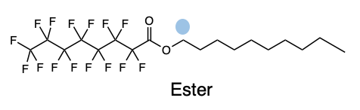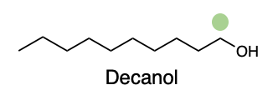

Computational predictions for physicochemical changes of PFOA after esterification
Table S1. We sought to predict the physicochemical changes of PFOA after esterification via computational estimators of octanol-water partitioning coefficient K_{OW}.^{3, 4, 5} We utilized two programs: Marvin (via ChemAxon) and KOWWIN (via EPISuite), as both of these programs give K_{OW} values for both charged (PFO-) and uncharged species (fluorinated ester). We then utilized K_{OW} to estimate aqueous solubilty C_{iw} via the formula as reported by Schwarzenbach et. al.⁶:
$$\log{K_{OW}= -a* \log{C_{iw}+b}}$$

 | PFO⁻ | PFOA | Fluorinated Ester | Solubility  Reduction in Going from PFOA to Fluorinated Ester
ChemAxon Marvin (Method: Consensus) | logK_{OW} = 1.58 | logK_{OW} = 5.11 | logK_{OW} = 9.25 | 99.9%
ChemAxon Marvin (Method: Consensus) | C_{iW} = 8.34 x 10⁴ mg/L | C_{iW} = 0.639 mg/L | C_{iW} = 7.16 x 10⁻⁴ mg/L | 99.9%
ChemAxon Marvin (Method: ChemAxon) | logK_{OW} = 2.09 | logK_{OW} = 5.95 | logK_{OW} = 9.57 | 99.1%
ChemAxon Marvin (Method: ChemAxon) | C_{iW} = 1.52 x 10⁴ mg/L | C_{iW} = 0.0387 mg/L | C_{iW} = 3.40 x 10⁻⁴ mg/L | 99.1%
EPISuite KOWWIN | logK_{OW} = 1.00 | logK_{OW} = 4.81 | logK_{OW} = 9.52 | 99.9%
EPISuite KOWWIN | C_{iW} = 5.78 x 10⁵ mg/L | C_{iW} = 1.739 mg/L | C_{iW} = 3.81 x 10⁻⁴ mg/L | 99.9%
Average | logK_{OW} = 1.56 | logK_{OW} = 5.29 | logK_{OW} = 9.45 | 99.7%

(1) Trang, B.; Li, Y.; Xue, X.-S.; Ateia, M.; Houk, K. N.; Dichtel, W. R. Low-temperature mineralization of perfluorocarboxylic acids. Science 2022, 377 (6608), 839-845. DOI: doi:10.1126/science.abm8868.
(2) Oda, R.; Huc, I.; Danino, D.; Talmon, Y. Aggregation Properties and Mixing Behavior of Hydrocarbon, Fluorocarbon, and Hybrid Hydrocarbon−Fluorocarbon Cationic Dimeric Surfactants. Langmuir 2000, 16 (25), 9759-9769. DOI: 10.1021/la0008075.
(3) Hammer, J.; Haftka, J. J. H.; Scherpenisse, P.; Hermens, J. L.; de Voogt, P. W. Fragment‐based approach to calculate hydrophobicity of anionic and nonionic surfactants derived from chromatographic retention on a C18 stationary phase. Environmental Toxicology and Chemistry 2017, 36 (2), 329-336.
(4) Armitage, J. M.; Arnot, J. A.; Wania, F.; Mackay, D. Development and evaluation of a mechanistic bioconcentration model for ionogenic organic chemicals in fish. Environmental toxicology and chemistry 2013, 32 (1), 115-128.
(5) Xiang, Q.; Shan, G.; Wu, W.; Jin, H.; Zhu, L. Measuring log Kow coefficients of neutral species of perfluoroalkyl carboxylic acids using reversed-phase high-performance liquid chromatography. Environmental Pollution 2018, 242. DOI: 10.1016/j.envpol.2018.08.009.
(6) Rene Schwarzenbach, P. G., Dieter Imboden. Environmental Organic Chemistry; John Wiley & Sons, Inc., 2017.

*Corresponding author John Fortner—Email john.fortner@yale.edu; Tel: +1-203-436-9066
For PFO- and PFOA, 0.69 was used for coefficient a and 1.1 was used for coefficient b. For fluorinated ester, 0.99 was used for coefficient a and 0.45 was used for coefficient b. (6) Rene Schwarzenbach, P. G., Dieter Imboden. Environmental Organic Chemistry; John Wiley & Sons, Inc., 2017.

