Appendices
Supplemental methods

Data Collection
Data on volumes of oncological activity in terms of hospital admissions, chemotherapy visits/outpatient treatments and Specialty visits/consultations were derived from the institutional electronic tracking system usually employed for administrative purposes; data were confirmed by examining the daily activity lists manually curated by the nursing staff.

Development of AMTRA and BAPIC:
Both the BAPIC- and AMTRA- systems are developed in collaboration with Remedus®, a home care service. The software was refined following previous experience with an in house electronic-tool that combined self-reporting of toxicity with self-management or care givers’ intervention. [17] AMTRA is used by patients to self-register toxicities relative to their treatment. The symptom questionnaire builder in the RemeCare® app is manipulable to include such specificity both for patients to register and for the system’s algorithm to respond to the toxicity profile associated with intravenous (IV) or oral chemotherapy, immunotherapy and targeted treatments. (Supplementary table 1). The clinical algorithm is developed to provide either self-management advice for toxicities graded as 1 or 2, or to alert a trained oncology nurse and the treating physician (care team) in case of severe (grade 3) or consecutive lower grade toxicity. The original protocol is described in a previous paper [18]
During the present SARS-Cov-2 pandemic this PRO-registration and interaction system was amended to also screen for signs or symptoms of SARS-CoV-2 (COrona REmecare Oncology: COREO). For sure SARS-CoV-2 related symptoms are routinely questioned by AMTRA’s question building/PRO system (fever, muscular pain, cough, shortness of breath). Thus, in case of fever (>38°C) alone or coinciding with the registration of the 3 aforementioned symptoms in a single day (regardless of severity) an alarm would ensue in which case, the patient would be contacted by the care team and screened at the hospital’s SARS-CoV-2 screening unit for formal PCR testing.
All data collected with the app were stored on the RemeCare® platform, which is password secured and linked to the Electronic Patient Report (EPR).
The technical components of the app and platform allowed secure transmission of data and storage in EPR. The app and the platform were attributed the CE label for medical devices class 2a by the Belgian Federal Agency for Medicines and Health Products in 2018. [19]
The BAPIC system provides transition of care by outsourcing certain clinical acts to the home care service, such as the screening for toxicities and the blood analysis prior to treatment.
The symptom questionnaire builder in the RemeCare® platform for BAPIC was not manipulable and the patients did not manage their own toxicities. A trained care giver from the care center will verify and respond / interact to toxicities that are either serious (grade 3) or progressive (in regard to prior registrations). If the toxicity registration and the blood results allow it, the patient will receive a message to further organize the in-house scheduled treatment.
During the SARS-CoV-2 pandemic this system allowed the trained nurse to screen for signs or symptoms of SARS-CoV-2.

Saliva tests:
From April 14th onward, we were able to offer our outpatients a routine testing through the use of throat washings. These tests were repeated every 2 weeks irrespective of symptoms; and during the time active oncologic therapy was ongoing.
Throat washings were harvested by asking patients to oscillate over the posterior pharyngeal wall with 10ml of sterile normal saline for 5-10 seconds, then to spit out the saline from their throat to a sterile container. The throat washings were transferred to a biosafety 2 laboratory and are subjected to a reverse transcription (PCR) for SARS-CoV-2 (COVID-19) detection. [20,21]

Patients:
Usual care and SARS-CoV-2 risk mitigating strategies.
Usual care includes a consultation with an oncologist before the start of any systemic treatment, to provide patients with verbal and written information on treatment benefits and expected toxicity; furthermore, instructions will be given on how to contact or attend the hospital for serious side effects.
Because of SARS-CoV-2 several mitigating risk strategies were implemented in routine cancer care from March 13th onward: Non-urgent visits such as follow-ups were postponed or replaced by teleconsultation. All oncologic systemic treatments were continued and administered on an outpatient basis when possible. BAPIC was routinely offered to all patients to enable home blood sampling; Additional throat washing every fortnight was implemented when available from April 14th onward. Both BAPIC and AMTRA were used for systematic toxicity and SARS-CoV-2 symptom registration. Furthermore, masks for patients and health care providers were obligatory, visitation regulations were restrictive and social distancing was practiced as much as possible.
Patients enlisted in the different patient centered PRO-registering systems from March 13th until onwards. The Patients received treatment in a tertiary cancer center in Belgium, the University Hospital of Antwerp. Patients were required to provide informed consent, to be literate in Dutch or French and able to operate a smartphone.
Baseline demographic, tumor and treatment data was uploaded in a care request to the homecare (nursing) organization (Remedus®). Patients were contacted within several days by the homecare nurse to organize a start-up visit at the patient’s home.
We refer to the published data and experience with the adapted toxicity registration and management e-tool by Rasschaert M et al. (23)

Data collection
Data on volumes of oncological activity in terms of hospital admissions of oncological patients, admissions for oncological procedures, chemotherapy visits, and follow-up visits, were derived from the Antwerp University Hospital’s institutional tracking system usually employed for administrative purposes.
Organization of systemic treatment during pandemic
Priority was given to avoiding ongoing systemic treatment interruptions; activation of new systemic treatments was subjected to the following priorities: treatment-emergent conditions; neo-adjuvant / adjuvant treatments, clinical trials, and first-line metastatic treatments with curative intent; first-line palliative treatments second- or further line palliative treatments.
Patient reported perception of organizational measures:
Three main areas were investigated: 1)organizations aspects (triage, telehelath, restricted access)2) Patient fears and anxiety and 3) awareness about infection risks, protective strategies, and rules to access oncology facilities.
Demographics were provided and reported below
The full questionnaire is reported below

Questionnaire : Hoe beleven oncologische patiënten de protectieve en preventieve SARS-CoV-Z (Corona)- maatregelen?

EPIDEMIOLOGISCHE GEGEVENS
GESLACHT: □ MAN □ VROUW
LEEFTIJD(jr): □ 18-30 □ 31-50 □ 51-70 □ > 70

SCHOLINGSGRAAD/HOOGSTE DIPLOMA:
□ SECUNDAIR
□ HOGE SCHOOL
□ UNIVERSITAIR

U BENT IN BEHANDELING OP DE DIENST ONCOLOGIE / HAEMATOLOGIE SINDS:
□ < 6 MND
□ 6-12 MND
□ 12-24 MND
□ > 24 MND

TUMOR TYPE
□ BORST
□ MAAG & DARM
□ NIER-PROSTAAT-BLAAS
□ LONG
□ MELANOMA
□ HOOFD & HALS
□ HAEMATOLOGIE
□ ANDERE

ORGANISATIE

- Werden de beschermingsmaatregelen op de oncologische afdeling duidelijke gecommuniceerd? | □ |  |  | □ |  |  |  | □
 | Ja |  |  | Neen |  |  |  | Geen mening
- Hoe werd u op de hoogte gesteld van deze regels? | □ |  |  | □ |  |  |  | □
- Hoe werd u op de hoogte gesteld van deze regels? | Telefonische info |  |  | Signalisatie aan de ingang |  |  |  | Triage info
- Denkt u dat triage* voorafgaand aan uw opname op het dagziekenhuis of consultatie een afdoende bescherming is?  *Triage = onderscheid maken (tussen mogelijks besmet al dan niet) | 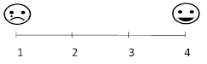
 | Neen Geen mening Misschien wel Ja
- Voelt u zich veilig wachtend op uw consultatie in de daartoe bestemde ruimtes?
 | Neen Geen mening Misschien wel Zeker wel
- Voelt u zich veilig wachtend op uw consultatie in de daartoe bestemde ruimtes?
 | Neen Geen meninig Misschien wel Zeker wel
- Vindt u het fysiek ontvangen van documenten of papier gedragen informatie een goede maatregel?
 | Neen Geen mening Misschien wel Zeker wel
- Vindt u het telefonisch uitvoeren van een follow-up een goede maatregel?
 | Zeker niet Geen mening Misschien wel Zeker wel
- Vindt u een elektronische/telefonische triage bij herevaluatie visite of zich herhalende opname een goede maatregel? | 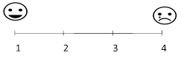
 | Nee Een beetje Nogal wat Ja
- Bent u bang – door het Corona virus – om de afdeling te bezoeken voor een behandeling?
 | Nee Een beetje Nogal wat Ja
- Bent u bang – door het Corona virus – om de afdeling te bezoeken voor een consultatie?
 | Nee Een beetje Nogal wat Ja
- Bent u bang dat chemotherapie uw kans op infectie met het Corona virus verhoogd?
 | Nee Een beetje Nogal wat Ja
- Zijn de specifieke risico’s op besmetting met het Corona virus (al dan niet) in relatie met uw aandoening duidelijk?
 | Onduidelijk |  | Niet zo duidelijk |  |  | Redelijk duidelijk |  |  | Duidelijk
- Zelfisolatie/quarantaine thuis | □  Ja |  |  |  | □  Nee |  | □  Geen mening
- Familiebubbel: 5 personen/dak | □  Ja |  |  |  | □  Nee |  | □  Geen mening
- ≤ 10 personen buiten bubbel | □  Ja |  |  |  | □  Nee |  | □  Geen mening
- Maskerplicht | □  Ja |  |  |  | □  Nee |  | □  Geen mening
- Is het voor u duidelijk wat u kan doen om de kans op infectie met het Corona virus te verminderen?
 | Onduidelijk | Niet zo duidelijk |  |  |  | Redelijk duidelijk |  |  | Duidelijk
- Hebt u problemen ondervonden om uw behandelend oncoloog te bereiken tijdens de lock down periode?
 | Geen enkel |  | Beperkt |  |  | Nogal wat |  |  | Absoluut

Supplemental Table 1: demographics of the patients who addressed the patient reported perception of structural and organizational measures.
 |  | Patients (n=119)
Sex – n
 | Male | 44
 | Female | 73
 | Missing | 2
Age in years – n (%)
 | 18 – 30 | 2 (1.7%)
 | 31 – 50 | 24 (20.2%)
 | 51 – 70 | 61 (51.3%)
 | >70 | 28 (23.5%)
 | Missing | 4 (3.4%)
Education – n (%)
 | High School | 52 (43.7%)
 | College | 39 (32.8%)
 | University | 23 (19.3%)
 | Missing | 5 (4.2%)
Tumor type – n (%)
 | Breast | 36 (30.3%)
 | Digestive | 19 (16%)
 | Head and Neck | 6 (5%)
 | Lung | 11 (9.2%)
 | Melanoma | 6 (5%)
 | Urology | 7 (5.9%)
 | Haematology | 1 (0.8%)
 | Other | 31 (26.1%)
 | Missing | 2 (1.7%)

Supplemental Figure 1: Anxiety and safety relative to the organization structure of the Oncology Unit, during the COVID 19 pandemic
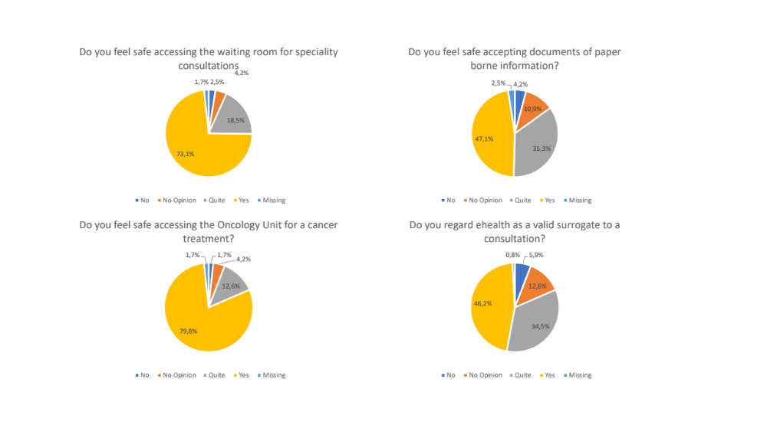

Supplemental Figure 2:Anxiety and safety relative to the administration of Cancer therapy during the COVID 19 pandemic.
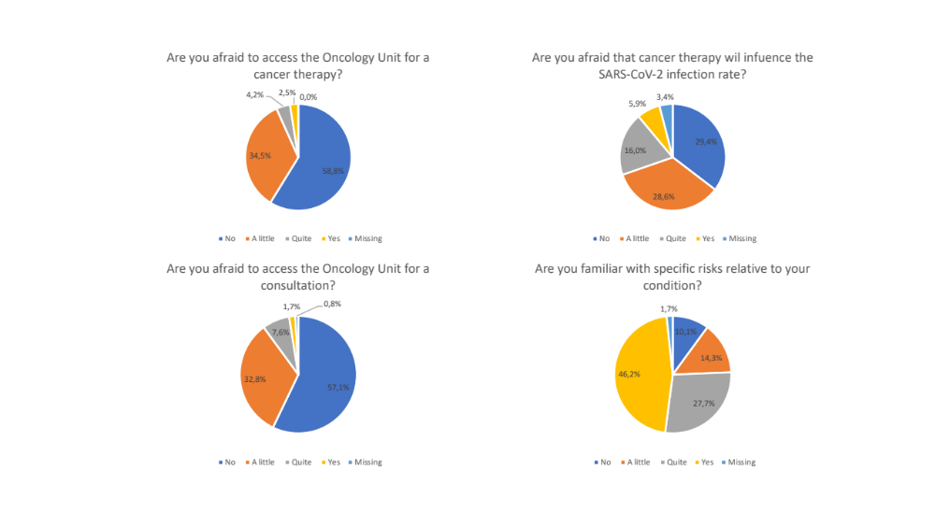

Supplemental Figure3: Knowledge of general risk mitigating measures and compliance to specific health measures concerning the prevention of SARS-CoV-2 transmission.

