Supplementary information

Sample location
The ferromanganese (Fe-Mn) crust sample analysed in this study was named WPI-C1, which was collected during the R/V Dayang Yihao research cruise (Voyage No. DY105-11) in 2001. The sample was collected by dredging from a brecciated basalt substrate in the West Pacific, near Il’ichev Island, Magellan Seamount, at water depths of 2070 m and 2110 m (Fig.S1).
The Magellan Seamount cluster formed on the ocean floor before the Late-Jurassic period¹. During the Cretaceous period in the southeastern Pacific², the Magellan seamounts were formed at 10–20 °S. Subsequently, due to thermal subsidence of the ocean floor, they started to sink and moved north-westward in conjunction with the motion of the Pacific plate³. Following that, they traversed the zone of high equatorial productivity between 70 and 65 Ma and finally formed at their current ocean depths between 59 and 45 Ma³.

Sample description
The thickness of this ferromanganese crust is approximately 130 mm (Fig.S2). It consists of three distinct macroscopic layers, each characterised by a compact seven-layer structure.
Part 1: The uppermost layer is black, dense, and is predominantly of botryoidal structure (Layer I; Fig.S3-A), laminated (interface of Layers I and II; Fig.S3-B), and columnar (Layer II; Fig.S3-C). The thickness of each layer is 40 mm. The uppermost few millimetres of the crust (Layer I) contain intricate globules and interstices, likely filled with yellow clayey material.
Part 2: the next layer is brown, exhibiting high porosity to vugginess, with elongated vugs perpendicular to the layers. These vugs are filled with pale non-ore material (Fig.S3-E), and the texture is dendritic (Layer III; Fig.S3-D) and mottled (Layer IV; Fig.S3-E). The thickness of the layer was 36 mm (range, 40–76 mm). Layer IV was relatively denser and more distorted than layer III.
Part 3-1: It is black and dense, with a massive texture (Layer V; Fig.S3-F). The upper surface of the layer in contact with the overlying Layer IV exhibits a laminated structure with partial distortion (Fig.S3-G), accompanied by a colour change from dark gray to pale.
Part 3-2: It is black, dense, and shows a laminated texture. It is impregnated with carbonate fluorapatite (CFA) and cut with CFA-filled veins. Layer VI displays a thin laminated structure with gaps as small as about 0.8 mm. This layer contained a high content of binding phosphate interlayers and crosscutting veinlets (Fig.S3-H). Layer VII exhibits a fine laminar structure with gaps much larger than Layer that of layer VI (0.8–2.5 mm, mostly around 2 mm). No phosphate filling was observed in the fissures of layer VII (Fig.S3-I).
In summary, the lower layers of the ferromanganese crust are characterised by intense phatisation, with the presence of CFA veins and lenses of phosphorites. The middle layers exhibit higher porosity, a brownish colouration, and columnar texture. In contrast, the upper layers consist of dense botryoidal, columnar, or laminated textures of black Fe-Mn oxides. No pervasive phosphorus-rich phase, except for isolated detrital grains of apatite and materials, such as fish bones, was observed in the intercolumn material >88 mm in the sample (middle and upper crust). The lowermost part of the core, near the substrate, has a complex history of crustal precipitation, diagenetic recrystallisation, erosion, the reworking of the crust, and infilling of fractures by CFA.
Some studies have revealed that the presence of mottled, columnar, botryoidal, and laminated textures in the ferromanganese crust probably reflects a gradual decrease in energy within the depositional environment. Further, these features are believed to develop as detrital material carried by currents accumulating in topographic lows, leading to their formation^{4,5}. However, Josso et al. (2020)⁶ provide a more convincing explanation. According to their perspective, high-energy currents remove particles, including biogenic and wind-derived detrital materials, thereby maintaining a sediment-free accretionary surface for crustal growth. Therefore, clastic-rich columnar and botryoidal textures in the crust indicate a lower energy regime.

The age of the crust
Fig.S4 A shows the Os isotope data regarding depth. The ¹⁸⁷Os/¹⁸⁸Os values record starts at approximately 0.5 at the base of the crust, followed by a steep decrease to the minimum of the profile (¹⁸⁷Os/ ¹⁸⁸Os = 0.399). Following this minimum, the values continuously increased to 0.61, followed by another clear minimum (¹⁸⁷Os/¹⁸⁸Os = 0.389) and another steep increase (¹⁸⁷Os/¹⁸⁸Os = 0.725). Subsequently, the ratios steadily increase to values of ¹⁸⁷Os/¹⁸⁸Os between 1.022 and 1.024 at the surface, very close to the ¹⁸⁷Os/¹⁸⁸Os value of present-day seawater (¹⁸⁷Os/¹⁸⁸Os = 1.057 ± 0.038)⁷ and surfaces of other hydrogenous crusts representing present-day seawater (¹⁸⁷Os/¹⁸⁸Os between 1.01 and 1.07)⁸.
To calibrate the age and identify growth hiatuses, we matched the measured ¹⁸⁷Os/¹⁸⁸Os to a known seawater curve^{9, 10}. First, we assigned an age of 0 Ma to the surface layer (0 mm), considering the similarity of the ¹⁸⁷Os/¹⁸⁸Os values in the outermost 0–3 mm layers to the present-day seawater value (¹⁸⁷Os/¹⁸⁸Os = 1.06)⁷, which continued to decline with depth in the crust. Three characteristic points characterised by significant negative excursions (or periods) can correspond to the known Os isotope seawater curve (Fig.S4 B): (1) The first negative excursion occurred at a depth of 41.2 mm, characterised by a ¹⁸⁷Os/¹⁸⁸Os ratio of 0.689, followed by a subsequent accelerated rise in the ratio, corresponding to the seawater ¹⁸⁷Os/¹⁸⁸Os records at ~10 and ~13 Ma¹¹. (2) At a depth of ~57 mm within the crust, another distinct negative excursion (¹⁸⁷Os/¹⁸⁸Os = 0.389) was observed, representing seawater ¹⁸⁷Os/¹⁸⁸Os at Eocene–Oligocene transition (E/O boundary) and dated to ~34.5 Ma¹². (3) A third negative excursion was observed at ~86.8 mm depth, with ¹⁸⁷Os/¹⁸⁸Os ratio of 0.399. This excursion value was not as evident as that in the previous observation (~0.12) at the K/T boundary (65.5 Ma)¹³. However, we did observe a decline in ¹⁸⁷Os/¹⁸⁸Os ratios from 102.4 mm to 89.07 mm depth, ranging from 0.650–0.45. This decline corresponds well with the major pulse of Deccan Volcanism (66.05 Ma to 65.6 Ma). Therefore, we believe that the extreme negative ^{187/188}Os value loss is probably attributed to insufficient sampling resolution or a brief depositional hiatus. Considering the age correlation, this negative point in the Fe-Mn crust corresponds to the K/T impact event (65.5 Ma). To determine the depositional ages of the other layers, we applied an average growth rate of 2.25 mm/Myr, determined through Co constant flux dating methods for the entire crust.
The crustal data exhibited a significant correlation with the existing ¹⁸⁷Os/¹⁸⁸Os seawater curve, considering three hiatuses (Fig.S4 B). The first hiatus, spanning 12 Myr, was assigned to the period between 16 and 28 Ma. The second hiatus, lasting 7 Myr, corresponded to the period between 41 and 48 Ma. The third hiatus, spanning 4 Myr, occurred between 54 and 50 Ma, and the final hiatus, lasting 6 Myr, took place between 55 and 61 Ma. Therefore, given the duration of the hiatuses and anchor points provided by the K/T boundary and E/O transition, the age of the crust base increased from 57 to 86 Ma.
Additionally, this crust grew in the open Pacific Ocean at similar water depths as CD29 and D11, which were re-examined for their Os isotope records by Nielsen et al. (2009)¹⁴. To ensure a more accurate age determination for the crust, we adopted the same methodology as described in Nielsen et al. (2009). We plotted the Os isotope compositions as a function of the fraction of the total depth from the top (Fig.S4 C) and observed similar Os isotope variations with depth. To better align the global Os isotope curve with the data for CD29 and D11, we made three minor adjustments to our age model (Fig.S4 D). First, at ~11–12Ma, we adjusted the growth rate to 2.25 mm/Ma from 0 to ~12 Ma for the end of the first major decline in the Os isotope curve. Second, during the growth hiatus between 16 Ma and 28 Ma, we adjusted the growth rate to 0.8 mm/Ma between 12 Ma and 20 Ma and 1.69 mm/Ma between 21 Ma and 34.5 Ma. The last adjustment was made between 59 Ma and 65.5 Ma, where we changed the growth rate to 1.16 mm/Ma to fit the curve data better. Refer to Zeng et al. (2023)¹⁵ for the corrected age data.

Diagenetic and post-diagenetic effects on δ^{98/95}Mo in crust
According to Menendez et al. (2019)¹⁶, Fe-Mn oxides can be hydrogenetic, characterised by an Mn/Fe ratio < 1, with relatively higher concentrations of Cu + Ni + Co than in other genetic types. In this study, no hydrothermal or volcanic influences were detected in the geochemical data, and all subsamples were of hydrogenetic origin (Fig.S5). The Fe-Mn crusts examined have lower Fe content (about 6–17%) than Mn content (about 10–20%), resulting in low Fe/Mn ratios ranging from 0.45–1.51. These Fe/Mn ratios are within the ranges reported for other hydrogenetic Fe-Mn crusts (0.4–1.2)¹⁷. Compared to hydrothermal crust, this hydrogenetic crust has no anomalous growth rate (0.8–2.3 mm/Myr, average of 1.9 mm/Myr).
The main metal oxide phases in Fe-Mn crusts are Mn and Fe oxides. The deposition of Mo into these crusts and their associated isotopic fractionation can be determined by considering the adsorption of dissolved Mo onto the surfaces of these metal oxide phases. Previous studies using X-ray absorption fine structure (XRFs) have revealed that Mo mainly occurs in the Mn phases of hydrogenetic Fe-Mn crusts¹⁷. Additionally, experiments investigating Mo adsorption onto Mn-oxides have shown similar Mo isotope fractionation patterns to those of the surface crust and seawater (Δ^{98/95}Mo_{crust-sw}= -3‰)¹⁸. The adsorption of Mo onto Fe oxyhydroxide accompanied by various Mo isotope fractionation (ranging between 1.0‰ and 2.6‰)¹⁹ may potentially influence the δ^{98/95}Mo values of the hydrogenetic crust during the deposition process. This is due to a substantial portion of Fe in Mn oxide. However, in this study, no significant correlation was observed between the Fe/Mn ratios and δ^{98/95}Mo values for those sub-profiles (Fig.S6 B). Specifically, the Fe/Mo ratio did not exhibit change correspondingly in the stratum where significant variations in δ^{98/95}Mo occurred (Fig. S6 A), suggesting variation in Fe/Mo ratios did not significantly affect the Mo isotope fractionation of the Fe-Mn crust.
Phosphating is an important post-diagenetic process that needs to be considered when analysing Fe-Mn crustal isotopes. During periods of global climate change throughout the Palaeogene, previously formed Fe-Mn crusts were impregnated with carbonate fluorapatite²⁰. The older part of this crust (below a depth of 40 mm from the surface) shows signs of phosphatization (Ca and P concentrations up to 11.79 % and 4.17 %, respectively), which is a common feature of aged Fe–Mn crusts found in the Pacific Ocean²¹. Preservation of a hydrogenetic signature (Fig.S7. positive Ce anomalies, (La/Sm)_{SN} ratios>1) in the phosphatised samples from the Magellan Seamount suggests that the primary trace element budget and signature have undergone minimal modifications compared to the more heavily phosphatised crust samples found in the Pacific Ocean²². In addition, no significant correlation between P₂O₅ content and δ^{98/95}Mo was observed, and no inflection point in the δ^{98/95}Mo curve was observed at the phosphatization boundary in the crust (~40 mm) (Fig. S6 A and C). This indicates that the δ^{98/95}Mo signature was not significantly affected by phosphatization. This conclusion is consistent with that of Siebert et al. (2003)²³, who proposed a closed system behaviour of Mo in Fe-Mn crusts based on Mo isotope analysis.

Assessing Mo isotope fractionation values in the Fe-Mn crust over the Cenozoic
To accurately reconstruct the Mo isotopic evolution history of the palaeo-ocean using Fe-Mn records, it is essential to establish relatively stable isotopic offsets between Fe-Mn crusts and seawater (Δ^{98/95}Mo_{crust-sw}) over time as previously described. Studies conducted in natural settings have shown that the fractionation factors between surface scrapings of crusts from different oceanic basins and that of present-day seawater are relatively similar (Δ^{98/95}Mo_{crust-sw} = -3 ‰)^{18, 24}. These findings indicate that water depth, salinity, or other physicochemical conditions of ambient seawater have minimal effect on Δ^{98/95}Mo_{crust-sw}, further verified by laboratory observations ^{25, 26}.
Our analysis of surface Fe-Mn crusts revealed δ^{98/95}Mo values (−0.58 ± 0.06 ‰, 1σ), indicating an isotope fractionation factor of −2.92 ‰ between Fe-Mn crust and modern seawater (+2.34 ‰), which is consistent with the previously reported value^{18, 24}. Additionally, as discussed earlier, the diagenetic and post-diagenetic effects on the overall tendency of δ^{98/95}Mo variation were insignificant. Therefore, we applied this isotope fractionation factor of −2.92 ‰ to all the analysed Fe-Mn crust samples.

Marine Mo isotope and mass balance model
The seawater δ^{98/95}Mo record offers insights into changes in the flux and/or isotopic composition of the input sources and the relative partitioning of Mo between oxidised and reduced buried reservoirs^{23, 27}. Here, we used a simple steady-state mass- and isotope-balance model to quantitatively explore the potential cause of changes in δ^{98/95}Mo during the early Eocene. Since the rate of Mo isotope change in Fe-Mn crusts occurs over million-year timescales, while the Mo residence time is ~440 kyr²⁸, any changes in sources (or sinks) that occurred during the Cenozoic will be almost instantaneous responses in the Mo isotopic system. Therefore, it is reasonable to infer that the oceans are in a steady state at any given point in time.
Therefore, two equations can be obtained:
δ^{98/95}Mo_{input} × f_{input} = δ^{98/95}Mo_{sw} – ∆^{98/95}Mo_{sw-oxic} × f_{oxic} + ∆^{98/95}Mo_{sw-OMZ} × f_{OMZ} + ∆^{98/95}Mo_{sw-eux} × f_{eux}) (1)
1 = f_{input} = f_{oxic} + f_{OMZ} + f_{eux} (2)
where f_{input} represents the Mo input flux fraction of river to the ocean; f_{oxic}, f_{OMZ}, and f_{eux} are the oxic, OMZ, and euxinic sink fractions, respectively; δ^{98/95}Mo_{input} and δ^{98/95}Mo_{sw} are the average Mo isotopic compositions of the input flux and seawater respectively; ∆^{98/95}Mo_{sw-oxic}, ∆^{98/95}Mo_{sw-OMZ}, and ∆^{98/95}Mo_{sw-eux} refer to Mo isotopic fractionation between seawater and oxic, OMZ, and euxinic sinks, respectively.
The primary sources of Mo inputs to the oceans include rivers, groundwater, and to a lesser extent, hydrothermal systems. Neely et al. (2018) provided an average estimate of the δ^{98/95}Mo value at 0.55 ‰ for the Mo input flux considering these sources, which we also used in this study²⁹. The oxic flux (f_{oxic}) is typically associated with Mo adsorption onto Mn oxides and Fe-Mn crusts, represented by a Mo isotope fractionation factor of ~3 ‰^{18, 24}. The euxinic flux (f_{eux}) denotes environments where sediments are deposited from highly sulfidic bottom waters ([H₂S]>11μM), and Mo removal from those bottom waters presents minor Mo isotopic fractionation. Mo sinks in modern highly sulfidic environments represent an average isotopic fractionation of ~0.3 ‰^{23, 30}. The OMZ flux (f_{OMZ}) represents environments with intermediate redox characteristics, ranging from mildly oxygenated to weakly euxinic bottom waters. The OMZ along the continental margin is the primary contributor to this type of Mo sink. Thus, the modern Mo isotopic fractionation value applied here is the statistical average value from continental margin sediments, which is 0.7 ‰²⁷.
By using these two equations, we can construct a redox evolution curve of seawater with a certain δ^{98/95}Mo_{sw} by plotting f_{oxic}/(f_{oxic}+f_{OMZ}) vs. f_{eux} (Fig.S8 A). The estimated f_{eux} for the modern ocean is approximately 6–15 %^{18, 23}. Therefore, the shaded area in Fig.S8 A can represent the relative redox proportions in the modern ocean, where f_{oxic} = 0.48–0.50 % and f_{OMZ} = 0.35–0.46 %. This model indicated that the δ^{98/95}Mo_{sw} variation can be influenced by three factors: (1) variations in f_{oxic}, f_{OMZ}, and f_{eux} values; (2) changes in ∆^{98/95}Mo_{sw-oxic}, ∆^{98/95}Mo_{sw-OMZ}, and ∆^{98/95}Mo_{sw-eux}; and (3) alterations in δ^{98/95}Mo_{river}.
As discussed in the main article, the decline in δ^{98/95}Mo during the early Eocene may be attributed to two scenarios. One scenario involves shrinkage of the OMZ Mo sinks (f_{OMZ}), and the other involves changes in the ∆^{98/95}Mo_{sw-OMZ}. Here, we conduct a quantitative analysis to explore the feasibility of these two scenarios.
Scenario 1: Caused by shrinkage of the OMZ Mo sinks.
As mentioned previously, the ∆^{98/95}Mo_{sw-OMZ} was lower than ∆^{98/95}Mo_{sw-oxic} and higher than ∆^{98/95}Mo_{sw-eux}. Therefore, if the shrinkage of OMZ Mo sinks caused the seawater δ^{98/95}Mo decline, the only possible scenario would involve the conversion of OMZ Mo sinks to euxinic Mo sinks, while any increase in oxic Mo sinks would result in higher seawater δ^{98/95}Mo. After 36.7 Ma, based on the average seawater δ^{98/95}Mo of ~2.34 ‰, which is consistent with that of modern seawater, we assumed that the marine redox state after 36.7 Ma is comparable to that of the contemporary ocean. Therefore, the maximum decrease in f_{OMZ} from 53 Ma to 36.7 Ma will be from 6–15 %. Thus, the f_{OMZ} before 53 Ma may range from 41 % to 50 %. By substituting f_{eux}= 0 and this range of f_{OMZ} into equations 1 and 2, the calculated seawater δ^{98/95}Mo_{sw} ranges from 2.36 –2.39 ‰ (Fig.S8 B), which is considerably lower than the estimated values from Fe-Mn crust (~2.80 ‰). The simulation results clearly indicate that the shrinkage of the OMZ Mo sinks cannot be the dominant factor controlling δ^{98/95}Mo decline in the early Eocene.
Scenario 2: Caused by the change of ∆^{98/95}Mo_{sw-OMZ}.
In this scenario, we first assumed that the relative proportions of oxic, OMZ, and euxinic Mo sinks remained constant from 50 Ma to 36.7 Ma; thus, the f_{oxic}, f_{OMZ}, and f_{eux} before 50 Ma were consistent with modern values. By substituting the seawater δ^{98/95}Mo value of 2.80 ‰ and the corresponding values of f_{oxic}, f_{OMZ}, and f_{eux} into equations, the calculated ∆^{98/95}Mo_{sw-OMZ} ranges from 1.72–2.02 ‰（Fig.S8 C）. This value is significantly higher than that of the ∆^{98/95}Mo_{sw-OMZ} in modern shallow continental shelf sediments (∆^{98/95}Mo_{sw-OMZ}=~1.02 ‰), but it closely matches the estimated ∆^{98/95}Mo_{sw-OMZ} value for the anoxic continental margin marine sediments around the Tethys Ocean at ~56 Ma (∆^{98/95}Mo_{sw-OMZ} = ~1.58 %)³¹. Further, assuming that 1.58 ‰ represents the average ∆^{98/95}Mo_{sw-OMZ}, we calculated the value of f_{oxic}, f_{OMZ}, and f_{eux} in the early Eocene, which ranges from 1.4–4 %, 48–50 %, and 46–51 %, respectively (Fig.S8 D). Here, we considered f_{oxic} to be relatively constant based on a previous study that argued against a f_{oxic} decrease over the past 66 Ma^{32, 33}.

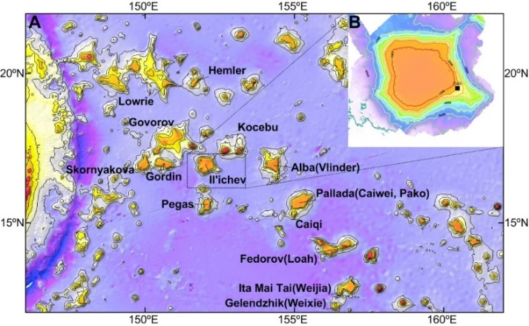
Fig.S1 Location of the ferromanganese crust sample analysed in this study

Fig.S2 Ferromanganese crust sample structure from the Il’ichev Guyot, Magellan Seamounts

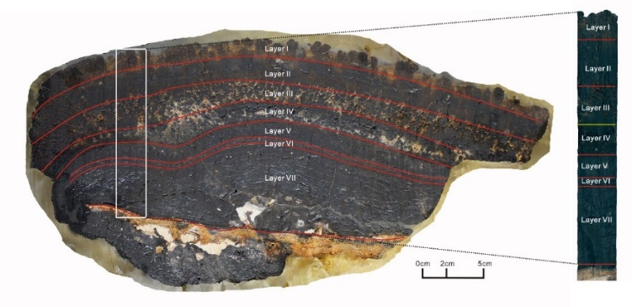

Fig.S3 Photomicrographs of representative structures in analysed ferromanganese crust samples. A. Layer I - botryoidal structure. B. Layer I & II - wavy lamination texture. C. Layer II columnar structure. D. Layer III - dendritic structure. E. Layer IV variegated structure. F. Layer V - massive structure. G. Layer IV- & V- lamination texture, colour changed from dark gray to pale. H. Layer VI - thin laminated structure with phosphate interlayer and crosscutting veinlets. I. Layer VII - laminar structure with its gaps are much larger than Layer VI (0.8–2.5 mm, mostly approximately 2 mm)
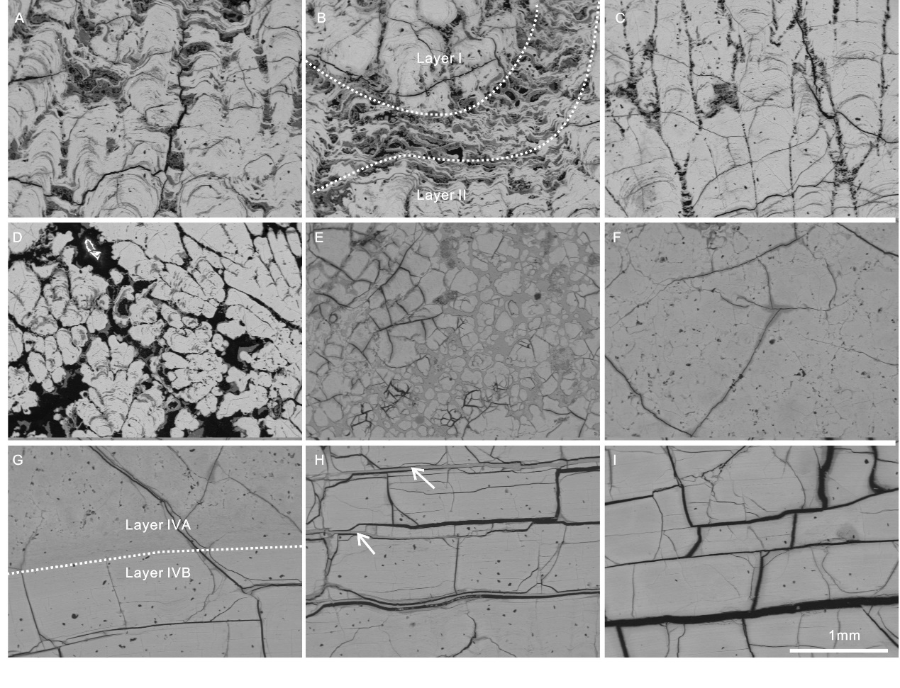

Fig. S4 Osmium isotope composition of the ferromanganese (Fe-Mn) crust in this study. A. Co-date B. model age with hiatus. C. fraction of total depth from the top of sample and D. revised age model. The fraction of total depth from the sample top and model of CD29 and D11 determined by Nielsen et al. (2009)¹⁴ are also plotted versus Osmium isotope composition in C and D.
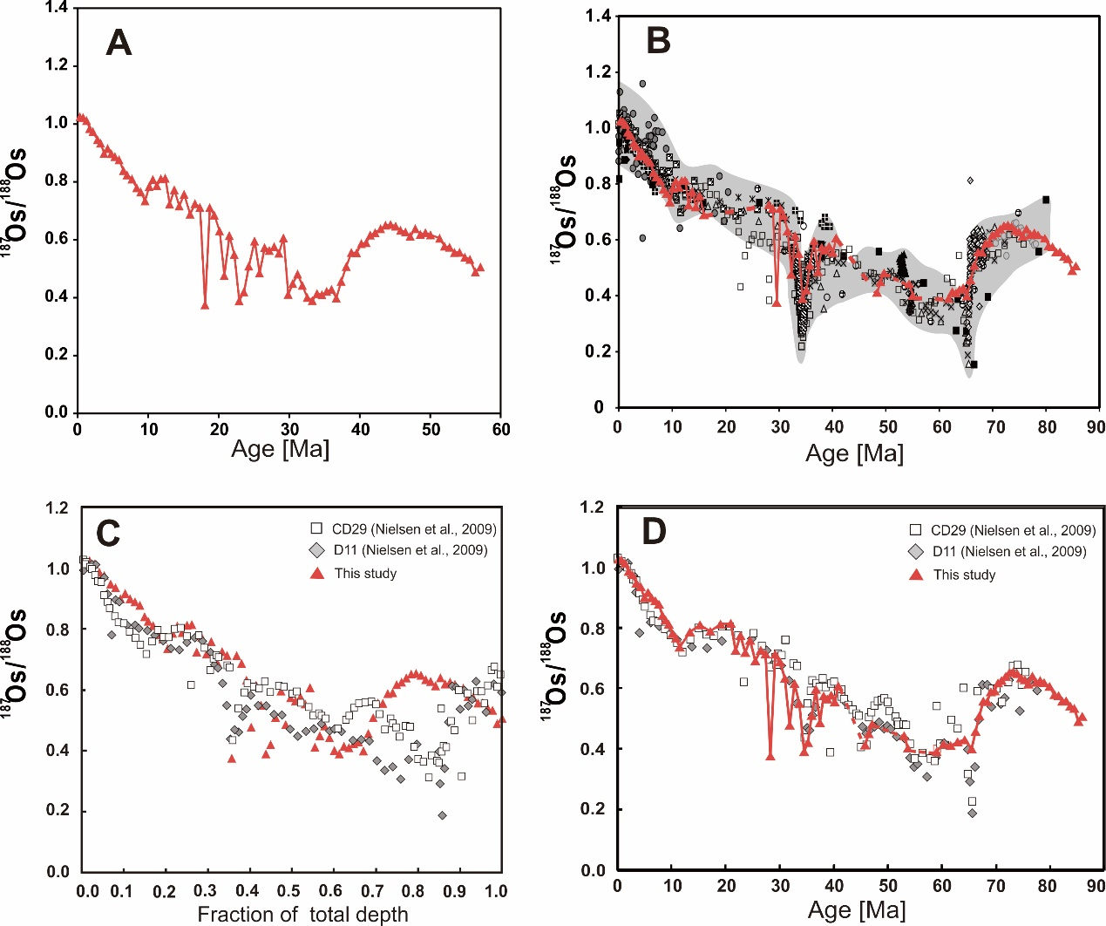

Fig.S5 Ternary diagrams. A. Mn: Fe: (Ni + Cu +Co) (with fields modified Menendez et al., 2019)¹⁶ and B. (Fe + Mn): (Cu + Ni): (Zr + Y + Ce) (with fields modified Josso et al., 2020)⁶ for all subsamples of the Fe-Mn crust analysed in this study. All the crust samples in this study are in the hydrogenetic area of the ternary diagram, indicating the hydrogenetic nature of the subsamples from the ferromanganese crust.
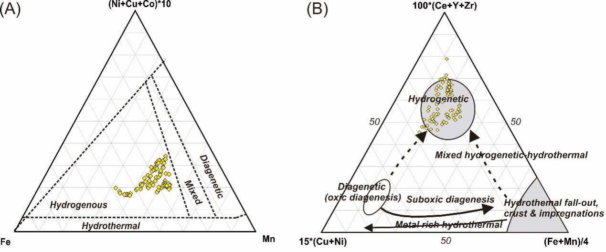

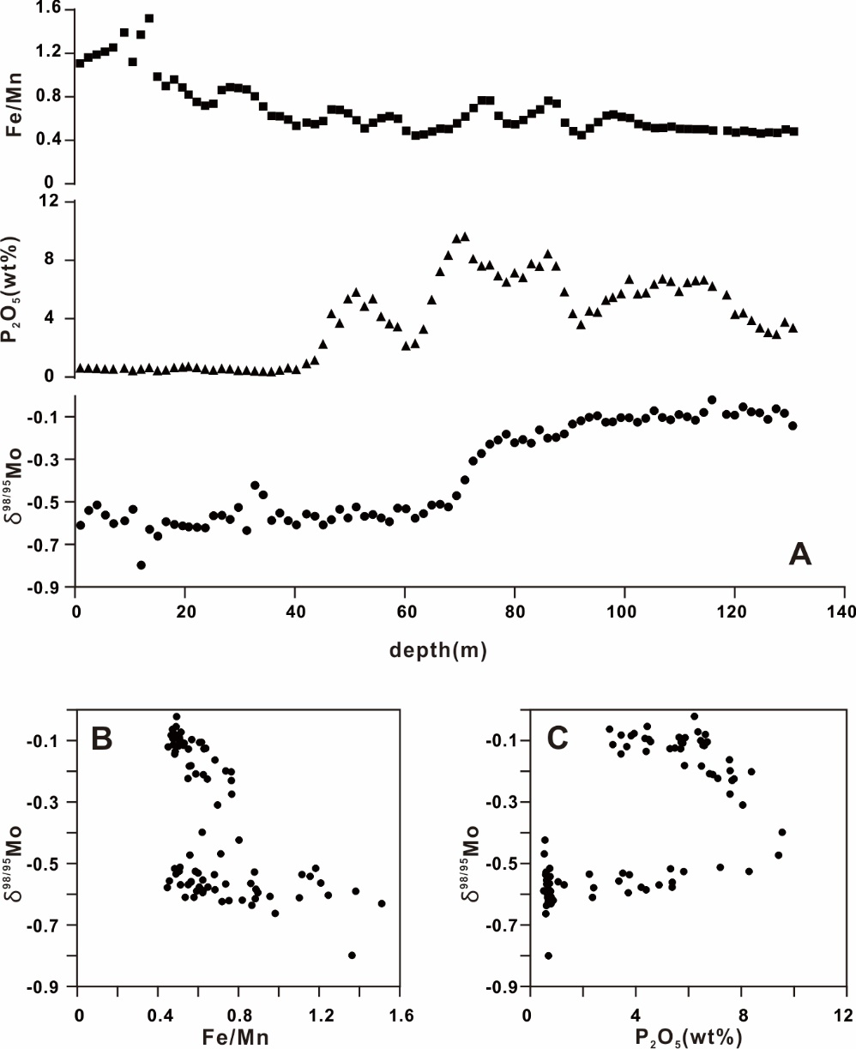
Fig.S6 A. Variation of δ^{98/95}Mo versus Fe/Mn ratios and P₂O₅ contents with depth in ferromanganese (Fe-Mn) crust. B and C. Plots of δ^{98/95}Mo vs. Fe/Mn and P₂O₅ for Fe-Mn crust sub-profile samples.

Fig.S7 NASC-normalised (Haskin et al., 1968) REE and Y composition. A. unaltered and B. phosphatised subsamples.
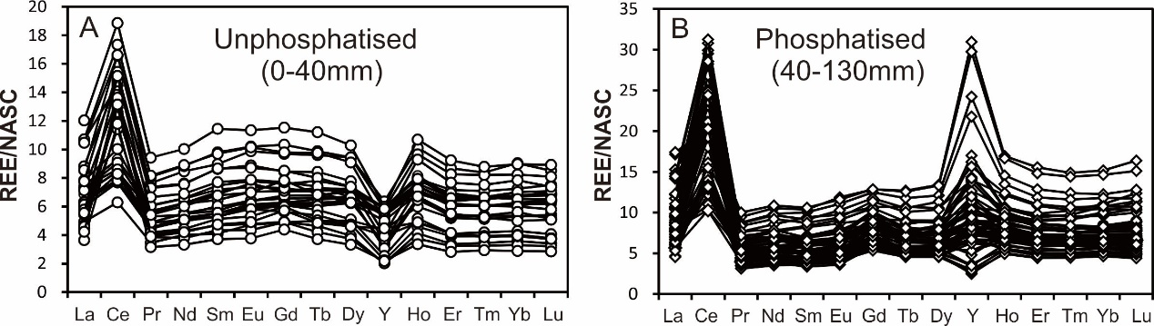

Fig.S8 A. Model of open ocean seawater δ^{98/95}Mo in response to various proportions of Mo sinks. Contours of seawater δ^{98/95}Mo as a function of the relative fluxes of the euxinic, OMZ, and oxic sinks, assuming a steady-state Mo cycle. The black segment on the blue line represents the modern Mo budget. B. Scenario where δ^{98/95}Mo decline is caused by OMZ Mo sink shrinkage and euxinic Mo sink expansion. The black line on the vertical axis represents the proportion of OMZ flux, assuming that all the euxinic Mo sinks in modern seawater are converted from OMZ Mo sinks. The yellow line represents the maximum value of δ^{98/95}Mo_{SW} in the early Eocene when modern feux = 6 %, while the grey line represents the maximum value of δ^{98/95}Mo_{SW} in the early Eocene when modern feux = 15 %. C. Scenario where f_{oxic}, f_{OMZ}, and f_{eux} remain constant, and δ^{98/95}Mo decline is caused by the change in Δ^{98/95}Mo_{SW-OMZ}. The yellow line through the black section represents the possible Δ^{98/95}Mo_{SW-OMZ} in the early Eocene, ranging from 1.72 ‰ to 2.02 ‰. D. Scenario where δ^{98/95}Mo decline results from a synergistic change in f_{OMZ}, feux, and Δ^{98/95}Mo_{SW-OMZ}. The black section on the yellow line represents the possible relative fluxes of the euxinic, OMZ, and oxic sinks in the early Eocene, assuming Δ^{98/95}Mo_{SW-OMZ} = 1.58 ‰.

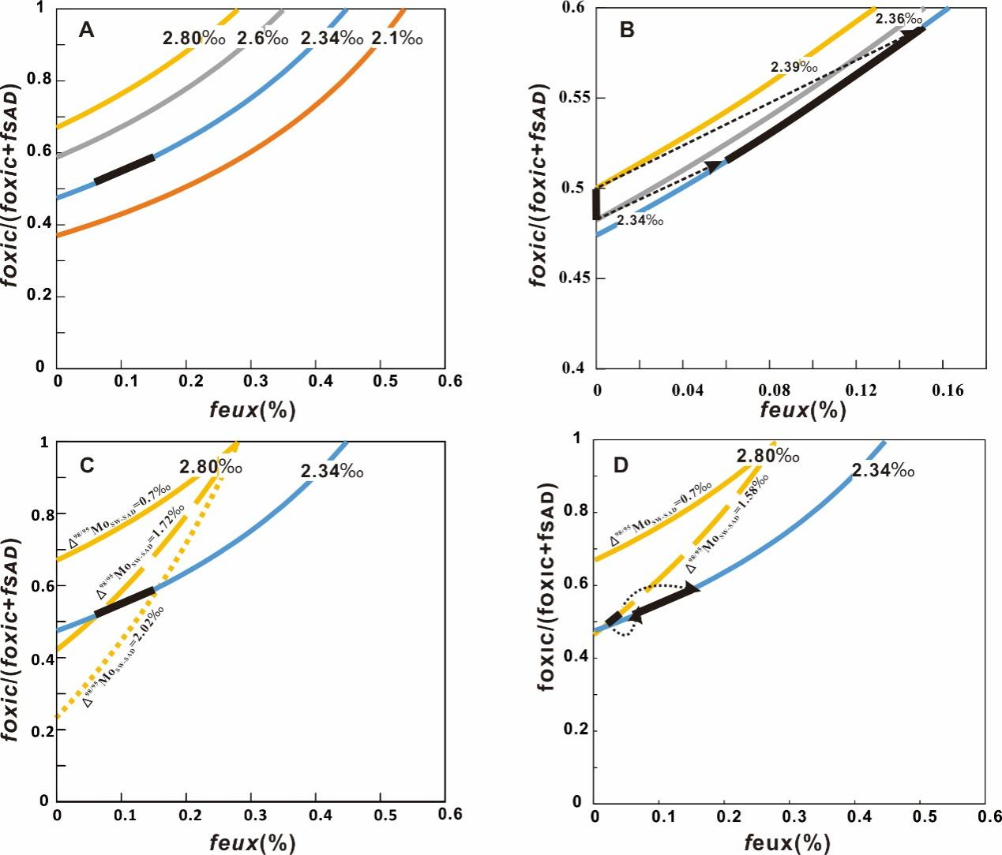

Reference
1 Clouard, V. Plates, plumes and paradigms Vol. 388 (Geological Society of America, 2005).
2 Nakanishi, M. & Gee, J. S. Paleomagnetic investigations of volcanic rocks: Paleolatitudes of the Northwestern Pacific guyots. Proc. ODP Sci. Results 144, 585–604. doi:10.2973/odp.proc.sr.144.022.1995 (1995).
3 Glasby, G. P., Ren, X., Shi, X. & Pulyaeva, I. A. Co-rich Mn crusts from the Magellan Seamount cluster: The long journey through time. Vol. 27 (2007).
4 Hein, J. R. et al. Variations in the fine-scale composition of a central pacific ferromanganese crust: Paleoceanographic implications. Paleoceanography 7, 63–77 (1992). doi:10.1029/91PA02936.
5 Hein, J. R. et al. Cobalt-Rich Ferromanganese Crusts in the Pacific (CRC Press, 2000).
6 Josso, P. et al. Late Cretaceous and Cenozoic paleoceanography from north-east Atlantic ferromanganese crust microstratigraphy. Marine Geology 422(2020). doi:10.1016/j.margeo.2020.106122.
7 Levasseur, S. et al. Direct measurement of femtomoles of osmium and the 187Os/186Os ratio. Science 282, 272–274 (1998). doi:10.1126/science.282.5387.272.
8 Burton, K. W. et al. Osmium isotope variations in the oceans recorded by FeMn crusts. Earth and Planetary Science Letters 171, 185–197 (1999). doi:https://doi.org/10.1016/S0012-821X(99)00139-9.
9 Burton, K. W. et al. Osmium isotope variations in the oceans recorded by FeMn crusts. Earth and Planetary Science Letters 171, 185–197 (1999). doi:https://doi.org/10.1016/S0012-821X(99)00139-9.
10 Burton, K. W. Global weathering variations inferred from marine radiogenic isotope records. Journal of Geochemical Exploration 88, 262–265 (2006). doi.org/10.1016/j.gexplo.2005.08.052.
11 Klemm, V. et al. Seawater osmium isotope evidence for a middle Miocene flood basalt event in ferromanganese crust records. Earth & Planetary Science Letters 273, 175–183 (2008). doi.org/10.1016/j.epsl.2008.06.028.
12 Dalai, T.K. et al. The late Eocene 187Os/188Os excursion: chemostratigraphy, cosmic dust fux and the early oligocene glaciation. Earth Planet. Sci. Lett. 241 (3–4), 477–492 (2006)
13 Ravizza, G., & Peucker-Ehrenbrink, B. Chemostratigraphic evidence of Deccan volcanism from the marine osmium isotope record. Science. 302, 1392–1396 (2003).
14 Nielsen, S. G. et al. Thallium isotope evidence for a permanent increase in marine organic carbon export in the early Eocene. Earth and Planetary Science Letters 278, 297–307 (2009). doi:https://doi.org/10.1016/j.epsl.2008.12.010.
15 Zeng, X. L. et al. A high-resolution Os-Nd-Pb isotopic record of a hydrogenous Fe–Mn crust from the Northwestern Pacific and its response to plate motion. Marine Geology 449, 107028 (2023). doi.org/10.1016/j.margeo.2023.107028.
16 Menendez, A. et al. Controls on the chemical composition of ferromanganese nodules in the Clarion-Clipperton Fracture Zone, eastern equatorial Pacific. Marine Geology 409, 1–14 (2019). doi:https://doi.org/10.1016/j.margeo.2018.12.004.
17 Kashiwabara, T. et al. A XAFS study on the mechanism of isotopic fractionation of molybdenum during its adsorption on ferromanganese oxides. Geochemical Journal 43, 31–e36 (2009). DOI:10.2343/geochemj.1.0060.
18 Barling, J. & Anbar, A. D. Molybdenum isotope fractionation during adsorption by manganese oxides. Earth and Planetary Science Letters 217, 315–329 (2004). doi.org/10.1016/S0012-821X(03)00608-3.
19 Goldberg, T. et al. Mo isotope fractionation during adsorption to Fe (oxyhydr)oxides. Geochimica Et Cosmochimica Acta 73, 6502–6516 (2009). doi.org/10.1016/j.gca.2009.08.004.
20 Hein, J.R. et al. Two major cenozoic episodes of phosphogenesis recorded in equatorial pacific seamount deposits. Paleoceanography 8, 293–311 (1993). doi:10.1029/93PA00320.
21 Koschinsky, A. et al. Effects of phosphatization on the geochemical and mineralogical composition of marine ferromanganese crusts. Geochimica Et Cosmochimica Acta 61, 4079–4094 (1997). doi.org/10.1016/S0016-7037(97)00231-7.
22 Bau, M. & Dulski, P. Distribution of yttrium and rare-earth elements in the Penge and Kuruman iron-formations, Transvaal Supergroup, South Africa. Precambrian Research 79, 37–55 (1996). doi:https://doi.org/10.1016/0301-9268(95)00087-9.
23 Siebert, C. et al. Molybdenum isotope records as a potential new proxy for paleoceanography. Earth and Planetary Science Letters 211, 159–171 (2003). doi.org/10.1016/S0012-821X(03)00189-4.
24 Barling, J. et al. Natural mass-dependent variations in the isotopic composition of molybdenum. Earth and Planetary Science Letters 193, 447–457 (2001). doi.org/10.1016/S0012-821X(01)00514-3.
25 Wasylenki, L. E. et al. Experimental investigation of the effects of temperature and ionic strength on Mo isotope fractionation during adsorption to manganese oxides. Geochimica Et Cosmochimica Acta 72, 5997–6005 (2008). doi.org/10.1016/j.gca.2008.08.027.
26 Kashiwabara, T. et al. A. Molecular-scale mechanisms of distribution and isotopic fractionation of molybdenum between seawater and ferromanganese oxides. Geochimica Et Cosmochimica Acta 75, 5762–5784 (2011). doi.org/10.1016/j.gca.2011.07.022.
27 Kendall, B. et al. The stable isotope geochemistry of molybdenum. Vol. 82 (2017).
28 Miller, C. A. et al. Re-assessing the surface cycling of molybdenum and rhenium. Geochimica et Cosmochimica Acta 75, 7146–7179 (2011). doi.org/10.1016/j.gca.2011.09.005.
29 Neely, R. A. et al. Molybdenum isotope behaviour in groundwaters and terrestrial hydrothermal systems, Iceland. Earth and Planetary Science Letters 486, 108–118 (2001). doi.org/10.1016/j.epsl.2017.11.053
30 Norrish, K. and Hutton, J.T. An accurate X-ray spectrographic method for the analysis of a wide range of geological samples. Geochimica et Cosmochimica Acta 33, 431–453 (1969). doi:10.1016/0016-7037(69)90126-4
31 Dickson, A. J. et al. Continental margin molybdenum isotope signatures from the Early Eocene. Earth and Planetary Science Letters 404, 389–395 (2014). 10.1016/j.epsl.2014.08.004.
32 Garcia, H. E. & Gordon, L. I. Oxygen solubility in seawater: Better fitting equations. Limnology and Oceanography 37, 1307–1312 (1992). 10.4319/lo.1992.37.6.1307.
33 Uramoto, G. I. et al. Significant contribution of subseafloor microparticles to the global manganese budget. Nature Communications 10, 400 (2019). 10.1038/s41467-019-08347-2, Pubmed:30728355.

