Supplementary Information
Size of exsolution
Exsolutions occur when concentrations of light elements in the core reach the supersaturation limit during the cooling process. The size of core exsolutions can be determined based on two key considerations. First, thermodynamic constraints dictate that the size of an exsolution must exceed the critical nucleus size to ensure its stable existence. Second, the buoyancy of the exsolution must overcome convective stirring in order for it to rise and ascend into the mantle.

For both homogeneous and heterogeneous nucleation, the critical nucleus size is
 | $$d_{nuc}=\frac{2σ}{∆G}$$ | (S1)
, where $σ$ is the interfacial energy between the oxides and core fluid; $∆G$ the Gibbs free energy difference between the liquid and solid phases of the exsolution per volume. The interfacial energies at the conditions of the outer core are not well-known. At 1 bar, interfacial energies are approximately 1.8 Jm⁻² for solid MgO/molten steel⁷³ and 1.6 Jm⁻² for solid SiO₂/liquid iron^{74,75}, respectively. $∆G$ can be estimated using the thermodynamic database⁴⁰. The resulting critical nucleus sizes are approximately 3 nm and 0.5 nm for MgO and SiO₂ crystals, respectively.

The outer core vigorously convects. Although MgO and SiO₂ are buoyant in the outer core, the strong convective motion may entrain exsolutions if convective entrainment outweighs gravitational force. Here we estimate the critical size of exsolution above which crystals would sediment towards the CMB by
 | $$d_{sed}={\left(\frac{η_{c}αgF}{C_{p}}\right)}^{1/2}\frac{1}{{∆ρ}_{c}gSh}$$ | (S2)
, where α, $η_{c}$, $C_{p}$ are the thermal expansion coefficient (2 ×10^{–5} K^{–1}) ⁷⁶, viscosity (0.01 Pa s)⁷⁷, and isobaric heat capacity (800 J kg^{–1} K^{–1})⁷⁶ of the outer core fluid, respectively; F (25 TW) the heat flux across the CMB ¹³; g (10 m s^{–2}) the gravitational acceleration; $∆ρ$ (~5 g/cm³) is the density difference between the core fluid and exsolutions^{26,27}. Sh is the non-dimensional Shields number, defined as the ratio of the tangential stress from convective flow over the buoyancy stress relative to the density difference between the crystals and the melt. When Sh is below 0.1-0.2, sedimentation occurs⁷⁸. The critical radius separating sedimentation and entrainment is around 2 nm. In other words, MgO will sediment immediately after exsolution, and SiO₂ will grow to around 2 nm until sedimentation.
In summary, the critical nucleus sizes ($d_{nuc}$) are of the same order of magnitude as the critical sizes that separate entrainment and sedimentation ($d_{sed}$). Therefore, the MgO and SiO₂ exsolution, upon nucleation to form nanoparticles, will rapidly sediment and ascend into the overlying magma ocean.

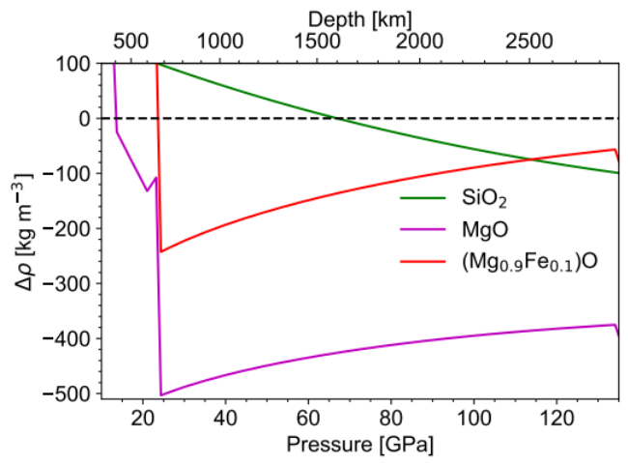
Fig. S1 | Density difference between exsolution and the PREM with $∆ρ=ρ_{exsolution}-ρ_{PREM}$ . The results for SiO₂ is taken from ref.³⁷. Densities of MgO periclase and (Mg_{0.9}Fe_{0.1})O are calculated using the thermodynamic parameters in ref.⁷⁹ along the mantle geotherm⁸⁰. $∆ρ=0$ is also shown as a reference (black dashed line).

Dissolution rate
Crystal dissolution in silicate melts is a critical igneous process that has been well studied both experimentally and theoretically. Here, we focus on the case of convective dissolution where a single spherical oxide exsolution crystal of diameter d rise in an infinite reservoir of melt driven by buoyancy⁸¹. The crystal dissolution rate is,

 | $$u=βD/δ$$ | (S3)

, where D (~10^{–9} m² s^{–1}) is the diffusivity of components of interest in the melt⁸²; $β$ a dimensionless parameter defined as

 | $$β=\frac{ρ_{m}(C_{0}-C_{∞})}{ρ_{ex}(C_{ex}-C_{0})}$$ | (S5)

, and $δ$ the effective boundary layer thickness by

 | $$δ=\frac{d}{2+0{.6Ra}^{1/4}}$$ | (S4)

, where $ρ_{m}$/$ρ_{ex}$ is the density of melt/exsolution in the magma ocean. $C_{ex}$ is the concentration of component of interest in the exsolution. We set $C_{ex}$ = 0.9 as exsolutions are relatively pure SiO₂ seifertite and (Mg,Fe)O ferropericlase^{23,26}. $C_{0}$ corresponds to the equilibrium-determining component at the interface and is assumed to be 0.7^{20,40}. $C_{∞}$ represents the concentration of component far away from the exsolution and evolves moderately with solidification (Fig. 2). For simplicity, we set $C_{∞}$ to 0.5 in our analysis. Ra is the Rayleigh number, defined as

 | $$Ra=\frac{gd^{3}{∆ρ}_{m}}{η_{m}D}$$ | (S6)

, where ${∆ρ}_{m}$ is the density difference between the silicate melts and exsolutions (Fig. S1). $η_{m}$ (0.1 Pa s) is the viscosity of silicate melts⁸². The resulting dissolution rate is shown in Fig. S2.

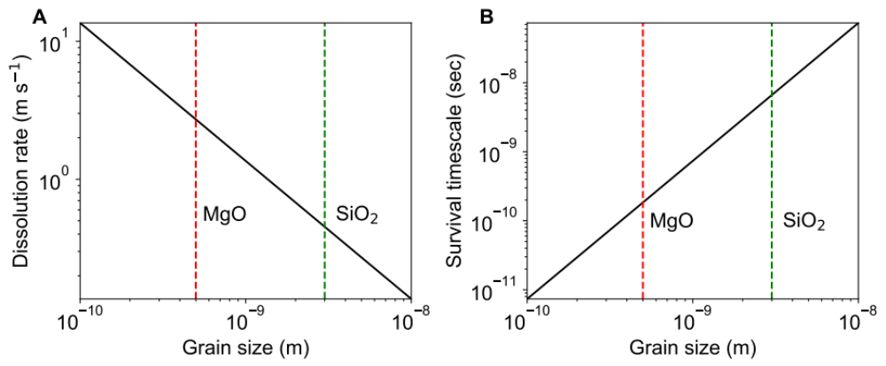
Fig. S2 | Dissolution of exsolution in a convective BECMO. (A) dissolution rate and (B) survival timescale as a function of the grain size of exsolution. The shaded vertical lines indicate the size of MgO (red) and SiO₂ (green) exsolution.

Detailed description of crystallization model

Several formation mechanisms have been proposed for a basal magma ocean (BMO). The BMO considered in this study is created as a result of the downward percolation of partial melt^{15,17}, but regardless of the formation mechanisms^{13,83}, Fe-rich and Si-depleted basal magma ocean is expected to emerge after the giant impact. In our scenario, a whole-mantle-scale magma ocean gradually becomes mushy (rheologically solid) from the bottom of the mantle as the magma ocean cools and the melt fraction reaches a critical value^{84,85}. Such a mushy layer separates into two phases through melt percolation (Fig. 1), and the downward melt percolation of melt would extract the Fe-rich melt out of the mushy layer. This would transport the iron-rich melt toward the core-mantle boundary, forming a BMO¹⁵. Our thermodynamic modeling suggests that a ∼500 km thick basal magma ocean can form as a result of melt extraction.

The evolution of a BMO or a BECMO would be characterized by slow cooling¹³, and compositional differentiation is expected to proceed with the fractionation of the first liquidus phase, i.e., bridgmanite^{20,86}. Mg-rich bridgmanite is lighter than the remaining melt layer, thus forming a fractionated layer at the top of the BMO/BECMO. This fractionated layer is likely to trap some partial melts because percolation and compaction are slow in general. As the BMO/BECMO is hotter than the overlying solidified mantle, such a newly formed fractionated layer is expected to be buoyant and be mixed with the upper layer. The downward percolation timescale,

 | $$τ_{perc}=\frac{h}{u_{per}}=\frac{hη_{m}}{k_{0}{∆ρ}_{m}g}\sim 20000 yr\left(\frac{h}{10 km}\right){\left(\frac{d}{1 mm}\right)}^{-2}{\left(\frac{ϕ}{0.1}\right)}^{-2}$$ | (S7)

is comparable to the Rayleigh-Taylor upwelling timescale to the overlying mantle layer,

 | $$τ_{RT}=\frac{26η_{s}}{∆_{RT}ρgh}\sim 20000 yr{\left(\frac{h}{10 km}\right)}^{-1}{\left(\frac{∆_{RT}ρ}{150 kg{ m}^{-3}}\right)}^{-2}exp⁡(-26(ϕ-ϕ_{c}))$$ | (S8)

. Therefore, the newly formed fractionated layer can be efficiently incorporated into the overlying mantle. Parameters shown above are the thickness of the newly formed fractionated layer ($h$), percolation velocity ($u_{per}$), melt ($η_{m}$) and solid viscosities ($η_{s}$), permeability ($k_{0}$), melt-solid (e.g., bridgmanite) density difference (∆ρ_{m}), gravitational acceleration (g), and grain size (d) and porosity ($ϕ$) of the mostly solidified but partially molten mantle. The potential density difference between the overlying mantle and the newly fractionated layer is denoted by $∆_{RT}ρ$.

Instead of varying all these variables, we simplify the model and consider the effect of melt trapping by considering a fixed amount of melt being trapped within the newly fractionated layer (~17% in Figs. 2 and 3). A smaller fraction of melt trapping would result in a stronger fractionation and thus a higher amount of iron remaining within the BMO/BECMO (Fig. S3). We note that, if percolation was extremely efficient and a strong fractionation occurred within the BMO/BECMO (<5% melt trapping), the lowermost mantle would contain a high degree of Fe, with the Mg# of the mid-mantle approaching nearly 97^{16,20}. Such strong fractionation, however, would be hard to eliminate by the subsequent mantle convection. The Mg# of fractionated layer that consists of solely bridgmanite thus contradicts that of the present-day mantle, indicating that some amount of melt trapping is expected to occur during the BMO/BECMO solidification. The mixing between the mantle and solidified BMO/BECMO would also have the same effect as melt trapping⁴⁴. As such, the trapping ratio above should effectively be regarded as the combined effects of melt trapping and the subsequent mantle mixing.

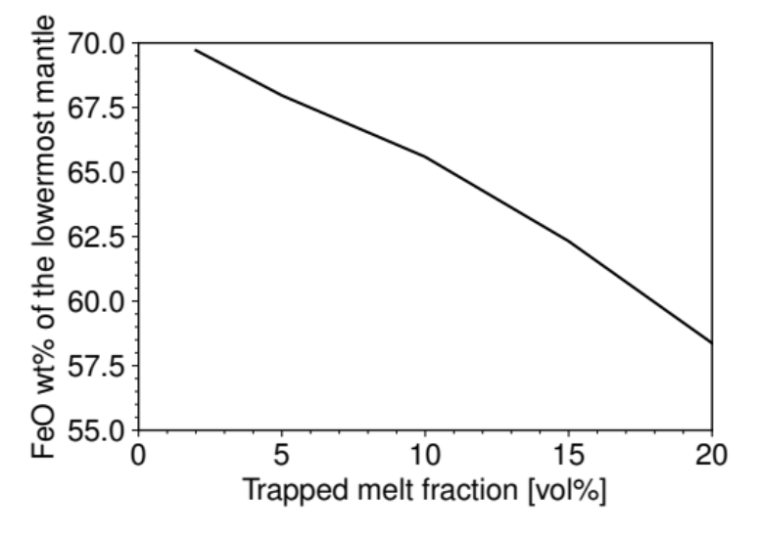

Fig. S3 | The average FeO content within the lowermost solidified mantle (3 GPa-thick layer) at the end of the BMO/BECMO solidification as a function of the volume fraction of the melt trapped within the fractionated layer.

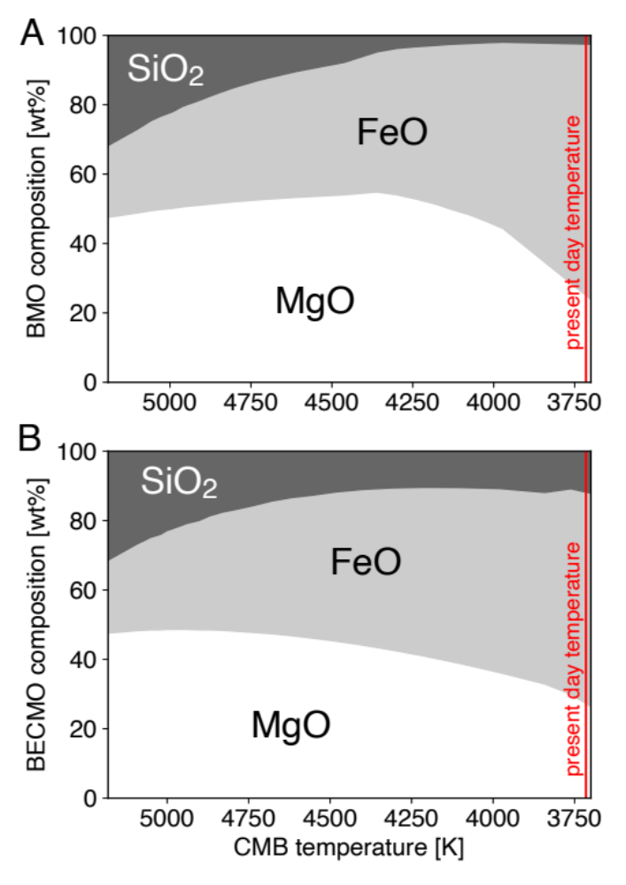

Fig. S4 | Evolution of the compositions of (A) BMO and (B) BECMO as a function of the core-mantle boundary temperature, where fractions of components in wt% are shown in white (MgO), gray (FeO), and black (SiO₂). A recent estimate for the present-day CMB temperature is shown in red⁸⁷. As FeO enriches in the BMO/BECMO, the cotectic point along the (Mg,Fe)O-SiO₂ system shifts towards a composition of lower SiO₂ contents^{20,40}, allowing for the continuous fractionation of bridgmanite even as SiO₂ becomes increasingly depleted in the basal magma ocean. The addition of SiO₂ deviates the bulk composition of magma ocean away from the cotectic point, and thus prolong the production of bridgmanite in BECMO.

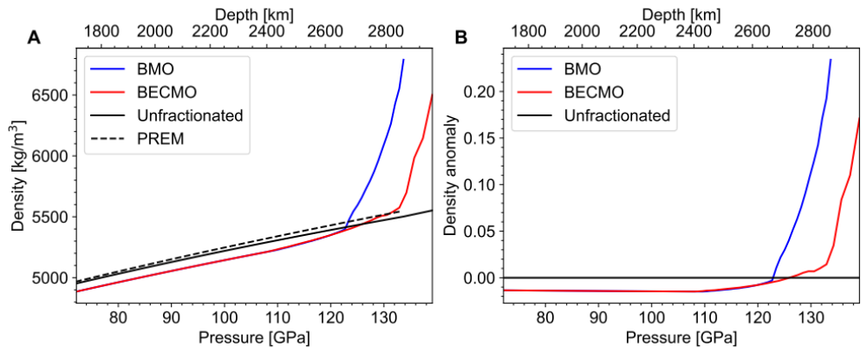
Fig. S5 | Density profiles of the solidified mantle along a geotherm⁸⁰. (A) Density profiles of solidified BMO (blue) and BECMO (red). The densities of the unfractionated model with no chemical differentiation and PREM⁴² are also shown for comparison. (B) Density anomalies of the solidified BMO and BECMO relative to the unfractionated mantle. The black curve denotes no fractionation. Below (above) this curve the mantle is lighter (heavier) than the unfractionated mantle.

Exsolution rate of MgO and SiO₂
The rate of oxide exsolution is given by
 | $${\dot{M}}_{ex}=M_{c}\frac{dc}{dT}\frac{dT}{dt}$$ | (S9)
, where M_{C} is the core’s mass; c the concentration by mass of a substance in the core; T temperature at the CMB; t time. The term dc/dT denotes the variation of MgO and/or SiO₂ contents in the core, namely the yield of exsolutions. dT/dt is the cooling rate of the core.
Exsolution rate and exsolution species depend on the initial composition of the core. Here we adopt a constant SiO₂ yield of 4.1×10^{–5} K^{–1} ^{26,37} and a temperature-dependent MgO yield ranging between 4×10^{–6} - 1×10^{–5} K^{–1} following ref. ³¹.

Si isotope composition of the core exsolution
We consider two steps of Si isotope fractionation: the first is the silicate-metal fractionation during the core formation at temperature T_{core_formation}, and the second is the SiO₂-metal fractionation during the exsolution at temperature T_{exsolution}. In both cases, the light Si isotope preferentially fractionates into the metallic phase, although the degree of fractionation is still controversial⁴⁸⁻⁵¹.
The metal-silicate fractionation factor is denoted as $∆{}_{}^{30}{Si}$ with $∆{}_{}^{30}{Si=δ}{}_{}^{30}{{Si}_{silicate}-}δ{}_{}^{30}{{Si}_{metal}}$ and $δ{}_{}^{30}{Si=[\frac{{\left({}_{}^{30}Si/{}_{}^{28}Si\right)}_{sample}}{{\left({}_{}^{30}Si/{}_{}^{28}Si\right)}_{reference}}}-1]×1000$. We assume that the experimentally determined metal-silicate fractionation factors apply to both steps, and consider two endmember cases of $∆{}_{}^{30}{Si=k/T^{2}}$ , where T is temperate and k is the fractionation constant, i.e., 7.6×10⁶ ⁵⁰ or 4.4×10⁶ ⁴⁹. It should be noted that in our assumptions, Si isotope fractionation is solely temperature sensitive and independent of pressure⁸⁸. Assuming that the core fluids equilibrate with the bulk silicate Earth (BSE) ($δ{}_{}^{30}{{Si}_{BSE}}$= –0.29±0.07‰)^{52,53}, the final Si isotope composition of the SiO₂ exsolution can be expressed as:
 | $$δ{}_{}^{30}{{Si}_{SiO2}=δ{}_{}^{30}{{Si}_{BSE}-k(\frac{1}{{T_{core_formation}}^{2}}-\frac{1}{{T_{exsolution}}^{2}})}}$$ | (S10)
Here we adopt a single stage core formation temperature of 3350 K⁸⁸ and set T_{exsolution} as the CMB temperature, which decreases from 5000 K to 3600 K over the past 4.5 billion years. The results are shown in Fig. S6. We note that a lower core formation temperature would cause a stronger negative Si isotope anomaly in exsolved SiO₂.

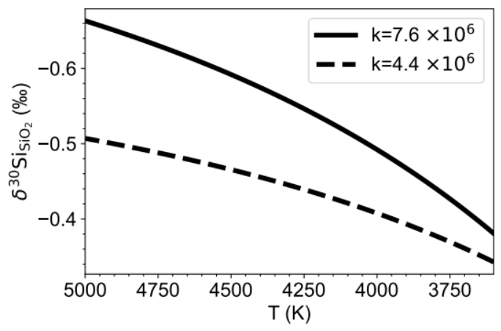

Fig. S6 | Si isotopic composition of SiO₂ exsolution $δ{}_{}^{30}{{Si}_{SiO2}}$. The solid and dashed lines represent two different Si isotopic fractionation constants^{49,50}.

