Supplementary Materials
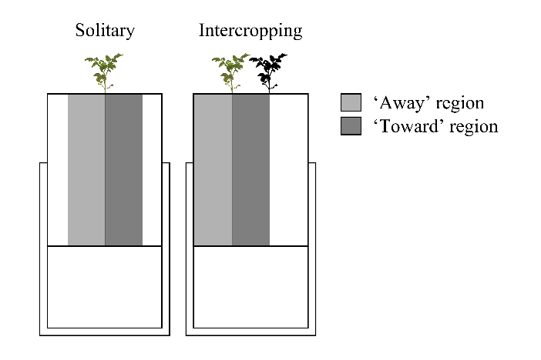
Fig. S1 Schematic diagram of intercropping experimental design and regions for the root-placement pattern analysis
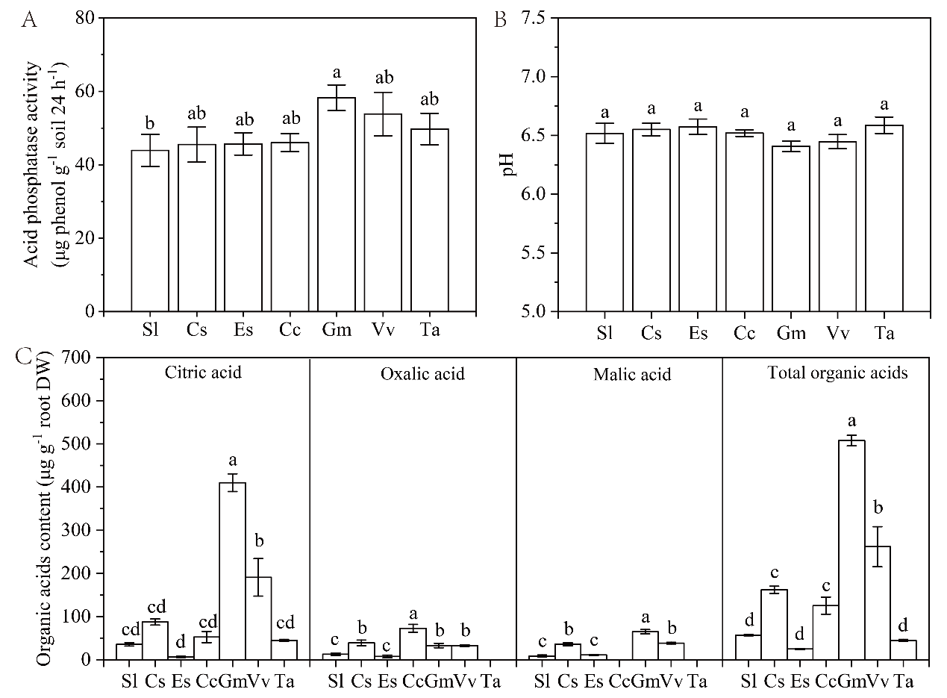
Fig. S2 The phosphorus mobilization ability of intercropping plants at low phosphorus level. (A) Acid phosphatase activity. (B) Soil pH. (C) Organic acid content of root exudates.

