Supplementary Information

SI 1 The research questionnaire that was shared with the participants Originally, the survey questions were in Persian, but here the English translations are also added.
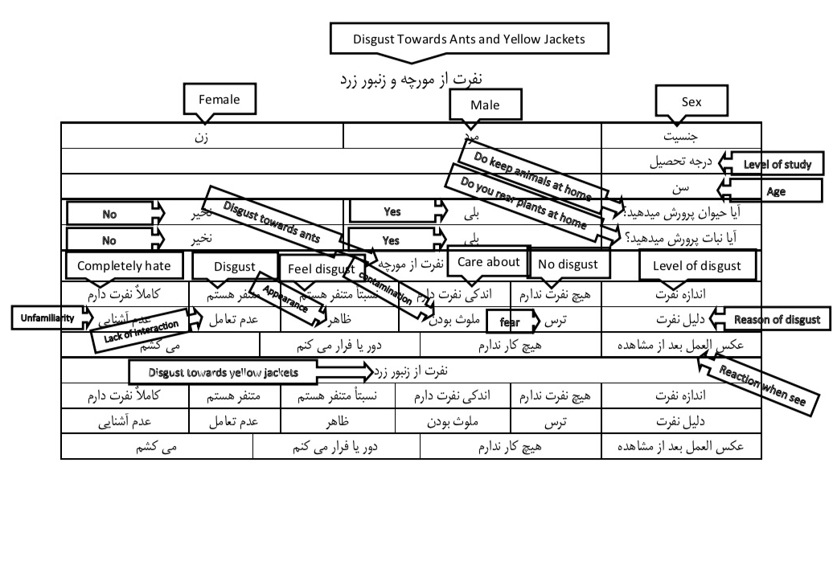

SI 2 Details of participant information in the survey
Variable | Percentage (%) | Number
Gender
Male | 62.09 | 678
Female | 37.91 | 414
Degree
Illiterate | 43.41 | 474
High school diploma (undergraduate) | 53.85 | 588
Bachler | 2.74 | 30
Age
18 – 20 | 12.64 | 138
21 – 30 | 62.64 | 684
31 – 40 | 17.03 | 186
41 – 50 | 4.94 | 54
51 – 60 | 1.10 | 12
61 – 70 | 1.65 | 18
Raising animal at home
Yes | 43.96 | 480
no | 56.04 | 612
Raising plants at home
yes | 71.43 | 780
no | 28.57 | 312

