Supplementary

Methodology
All analyses were performed in Python (except for the creation of the descriptive statistics tables, which were generated with R version 4.2.1) on a desktop with an AMD Ryzen 9 5950x 32-threaded CPU, Nvidia RTX 3090 GPU, and 64GB of RAM.

The data
The number of samples removed in each data preparation step is summarised in Fig S1. Table S1 shows which variables were included in this study, compared to the variables that were used in the original study of Castela Forte et al.
Fig S1. Flowchart illustrating the patient sample selection procedure with the patient sample count per step indicated by the number of patients (N) for the MUMC+ external validation dataset.

Table S1. Clustering variables present in the MUMC+ and SICS datasets in this study compared to the variables of the original SICS cohort. Variables from the original SICS cohort that were excluded in this study are marked in red.
 | Clustering variables present in both the SICS and MUMC+ dataset | Original SICS cohort variables
Patient characteristics | age, sex, APACHE IV Score, SAPS II Score, BMI, surgical admission, previous admission to ICU | age, sex, APACHE IV Score, SAPS II Score, BMI, surgical admission, previous admission to ICU
Clinical examination | Hemodynamic parameters  atrial fibrillation, heart rate at admission, urine output in previous 6h, central venous pressure (CVP), diastolic blood pressure (DBP), systolic blood pressure (SBP), mean arterial pressure (MAP)  Respiratory parameters  worsened respiratory condition after 24 h assessed by physician, tidal volume (Vt), Respiratory rate of ventilator, positive end-expiratory pressure (PEEP) of ventilator, mechanical ventilation after 24 h (categorical), mechanical ventilation at admission (categorical), respiratory rate, lowest FiO₂ (%) during ICU stay  Other  EMV score | Hemodynamic parameters  cardiac index, mottling, atrial fibrillation, heart rate at admission, urine output in previous 6h, prolonged capillary refill time, central venous pressure (CVP), diastolic blood pressure (DBP), systolic blood pressure (SBP), mean arterial pressure (MAP)  Respiratory parameters  worsened respiratory condition after 24 h assessed by physician, tidal volume (Vt), Respiratory rate of ventilator, positive end-expiratory pressure (PEEP) of ventilator, mechanical ventilation after 24 h (categorical), mechanical ventilation at admission (categorical), respiratory rate, lowest FiO₂ (%) during ICU stay  Other  EMV score
Co-morbidities and medical history (categorical) | history of cardiovascular disease (CVD), history of chronic kidney disease (CKD), history of cirrhosis, history of chronic obstructive pulmonary disease (COPD), history of diabetes, history of haematological malignancy, history of metastatic disease, history of myocardial infarction, history of respiratory insufficiency, history of immune insufficiency, previous dialysis | history of cardiovascular disease (CVD), history of chronic kidney disease (CKD), history of cirrhosis, history of chronic obstructive pulmonary disease (COPD), history of diabetes, history of haematological malignancy, history of metastatic disease, history of myocardial infarction, history of respiratory insufficiency, history of acquired immunodeficiency syndrome (AIDS), history of immune insufficiency, previous dialysis
Laboratory variables (for which the mean and standard deviation were taken over the first 48 since the first measurement) | Routinely collected  ALAT, ASAT, albumin, ALP, bilirubin (total), gamma-GT, CK, CRP, calcium, chloride, magnesium, sodium, phosphate, potassium, fibrinogen, haemoglobin, haematocrit, creatinine, LDH, leukocytes, thrombocytes, total protein, urea | Routinely collected  ALAT, ASAT, albumin, amylase, ALP, bilirubin (total), gamma-GT, CK, CRP, calcium, chloride, magnesium, MCV, sodium, phosphate, potassium, fibrinogen, haemoglobin, haematocrit, creatinine, LDH, leukocytes, thrombocytes, troponin T, total protein, urea  Arterial point of care  ionized calcium, glucose, haemoglobin, potassium, lactate, sodium, arterial HCO₃, arterial pCO₂, arterial pH, arterial pO₂, arterial saturation, methylated haemoglobin, HbCO

Imputation
Missing data were imputed based on Multiple Imputation by Chained Equations using the Python package “miceForest.” Categorical and discrete variables were imputed with mean matching, each using ten mean matching candidates following the kdtree classification function. All input variables (Table 1) were available for the imputation of each variable. When imputing the mean of a laboratory value, the standard deviation of that laboratory value was excluded in the imputation process and vice versa. Also, for the imputation of a given variable, any other variable that was always missing in conjunction was excluded for the imputation of that given variable. As a result, some variables were excluded for imputing other variables, as indicated in Table S2. The lightbm hyperparameters were tuned using the built-in function of the miceForest package with ten optimisation steps. Finally, imputation was performed with ten iterations, generating 100 imputed sets. All analyses described in this paper were performed on the first imputed set. The other imputed sets were only used to gain insight into the imputation process. The degree of missingness of each variable for the two datasets prior to imputation is visualised in Fig S2.

Table S2. Variables excluded for imputing other variables.
Imputed variables | Variables excluded for the imputation
Haemoglobin | Haematocrit
Haematocrit | Haemoglobin
Ureum | Albumin, calcium, chloride, and total protein
FiO2 low | Tidal volume and mechanical respiratory ventilation
Gender | Total protein
MAP | SBP, DBP, Urine output, and magnesium
DBP | SBP, MAP, urine output, and magnesium
SBP | DBP, MAP, urine output, and magnesium

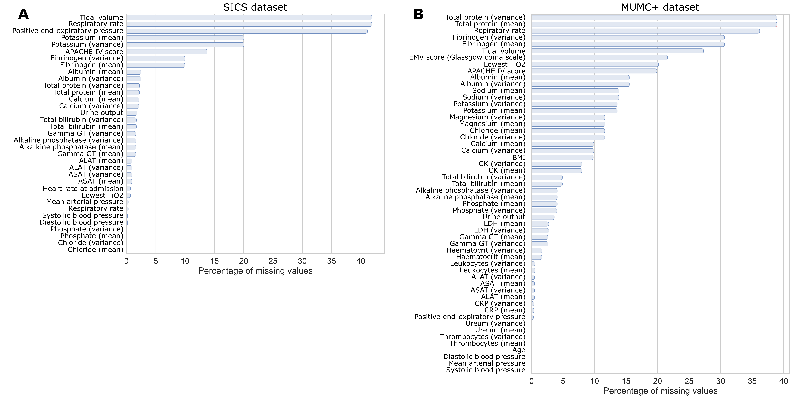
Fig S2. Bar chart of the degree of missingness per variable per dataset. a, The degree of missingness for the variables in the SICS dataset. b, The degree of missingness for the variables in the MUMC+ dataset. The x-axis shows the percentage of how many were missing for a given variable. The y-axis shows the variables for which data was missing. variables without any missing data are not shown.

The recreated DEC model
The recreated DEC model was based on an existing GitHub repository (https://github.com/piiswrong/dec¹⁷). The Keras and TensorFlow Python packages were used for building the autoencoder. The encoder was set up to contain two dense layers with ReLU activation functions, the first had an l1 regularisation of 10e-5 and 64 neurons, and the second contained 8 neurons. The decoder layer contained one dense layer with ReLU activation with 64 neurons and the final output dense layer with sigmoid activation function. The autoencoder was optimised using the Adam optimiser, minimising the mean squared error as loss score. When fitting the autoencoder, 500 epochs were performed, and the batch size was set to 64. After initialising the autoencoder, K-means was performed on the latent features with 20 initialisations. Subsequently, the soft labels and target distribution were computed, and 140 iterations of stochastic gradient descent, with a learning rate of 0.01 and momentum of 0.9 on batches of 256 samples. After each 140th iteration, soft labels and target distribution are recomputed, if at least 1% of samples changed cluster membership (up to a maximum of 8,000 iterations), another 140 iterations were performed.

The X-DEC model
The DEC model contains an X-shaped Variational Autoencoder (XVAE) (Figure 4), based on previous work¹⁸ (https://github.com/CancerAI-CL/IntegrativeVAEs). The numerical variables (input S1) and categorical variables (input S2) are supplied separately to the model. Both sets have an individual hidden layer, which are subsequently combined into a single hidden layer that feeds into the encoding layer, which produces the latent variables used by the clustering model. The decoder mirrors the encoder in the attempt to recreate the two original input sets. All layers use ELU activation functions except for the output layers, which use a linear activation function for the numerical variables and a sigmoid for the categorical variables. Reconstruction loss is computed as mean squared error for the numerical variables and as binary cross entropy for categorical variables. The reconstruction losses are computed per set and scaled by the number of variables present in each set to mitigate the potential over-representation of variables in the smaller set. The XVAE was trained using the Adam optimiser. The final reconstruction loss is the average of the scaled losses of the two sets. The hyperparameters of XVAE in the X-DEC model were optimised through a grid search. A complete list of the evaluated hyperparameter combinations and their resulting stability scores can be found in the supplementary Table S7, stored in an additional file. For each combination of hyperparameter values, 10-fold repeated cross-validation was performed with 3 repeats, the entire X-DEC pipeline was performed on each fold. Finally, the hyperparameter values that resulted in the highest mean Jaccard stability coefficient were picked, and the final X-DEC model was trained on the full SICS dataset. Hyperparameter optimisation took ~85 hours. For more information on X-DEC, see the publicly available code (https://github.com/DAM-IC/Deep-Embedded-Clustering-generalisability-and-adaptation-for-mixed-data-types).
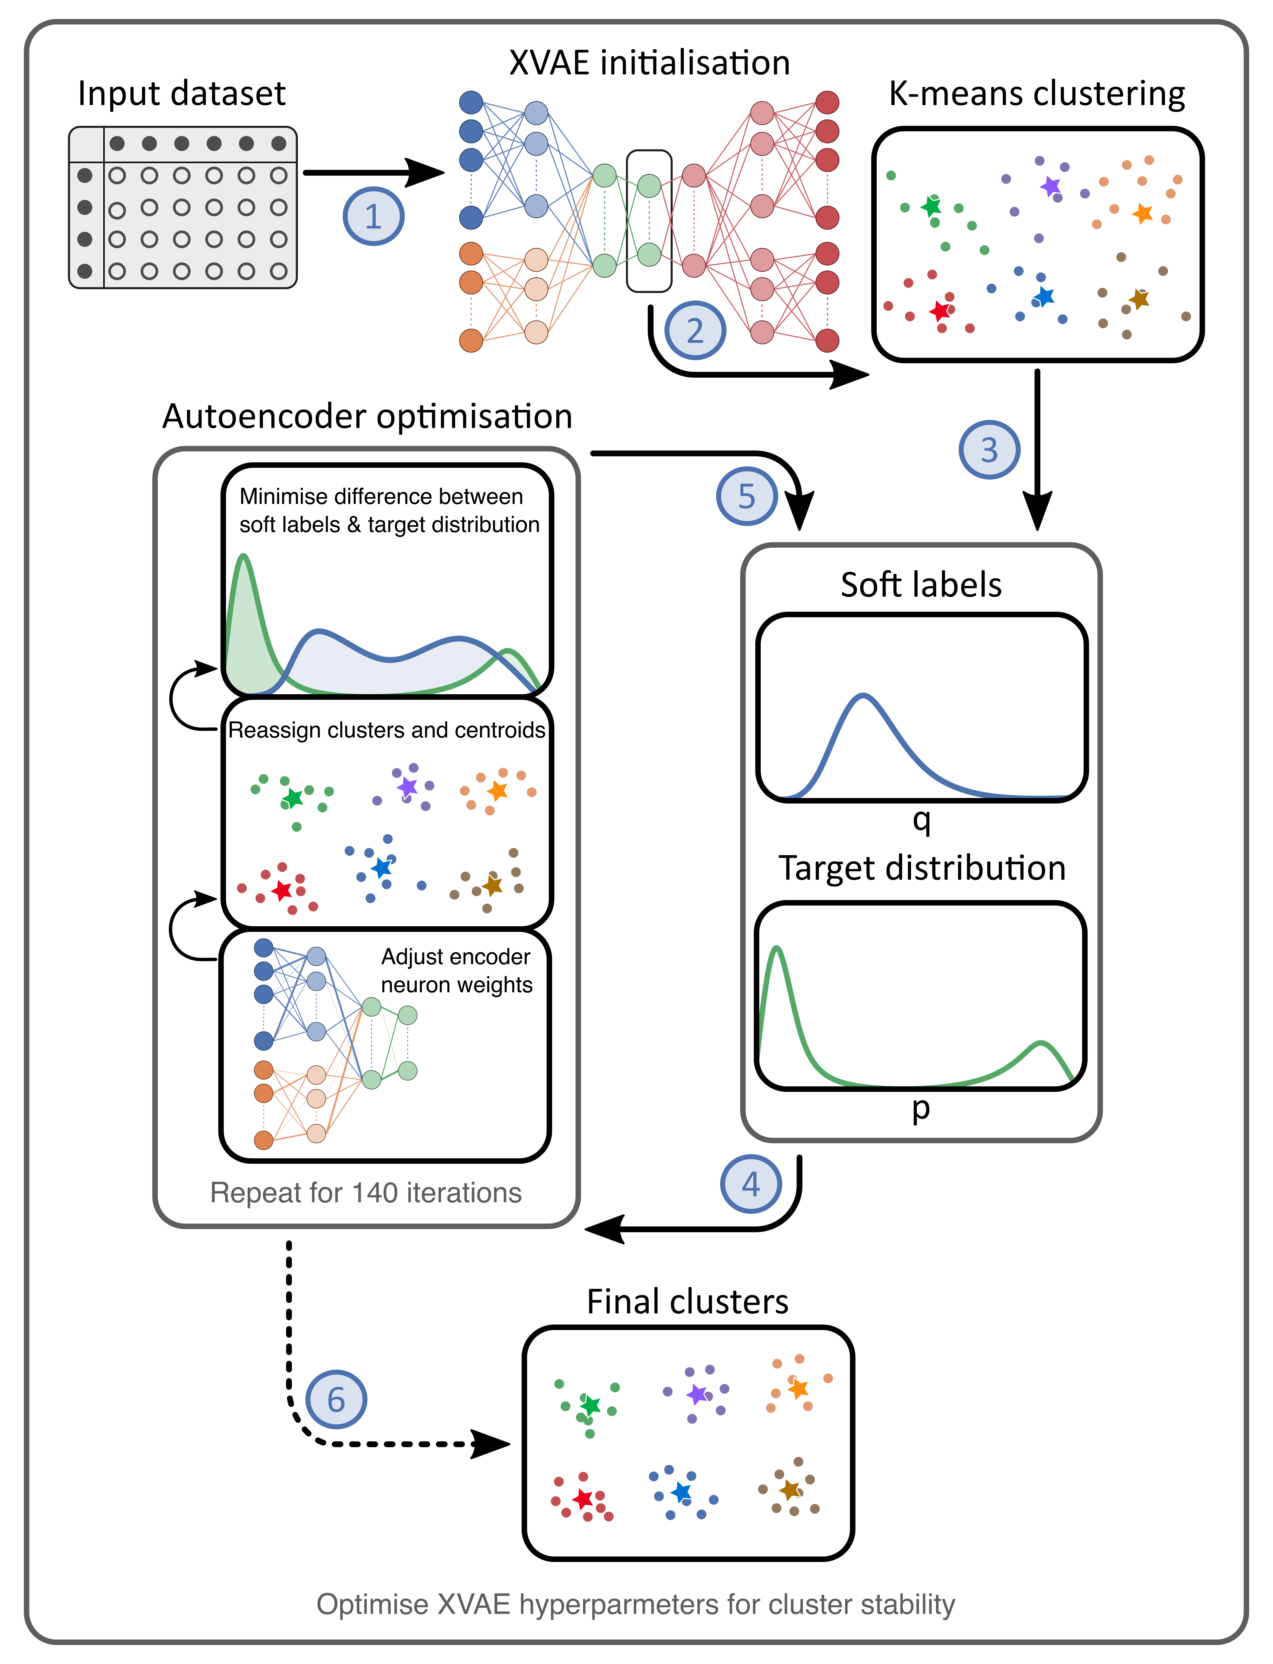
Fig S3. Architecture of the X-DEC algorithm. Based on the input dataset, the X-shaped variational autoencoder (XVAE) is initialised and maps the original variables into the latent features (step 1). K-means clustering is performed on the latent features (step 2). Then, six soft labels are computed for each patient sample, and the target distribution is calculated, maximising the separation of high and low soft labels (step 3). Subsequently, the encoder of the XVAE is optimised to minimise the Kullback-Leibler divergence loss between the soft labels and target distribution over 140 iterations (step 4). If at least 1% of all patient samples change cluster membership, the soft labels and target distribution are recomputed, and the optimisation of the encoder of the XVAE continues (step 5). Otherwise, clustering is finalised (step 6). This procedure is repeated many times for different architectures of the X-shape variational autoencoder on random subsets of the data to determine which settings result in the most stable clustering.

Results

Descriptive statistics
The descriptive statistics are large tables (Table S2-S6) and are thus stored in separate files.

Cluster generalisability
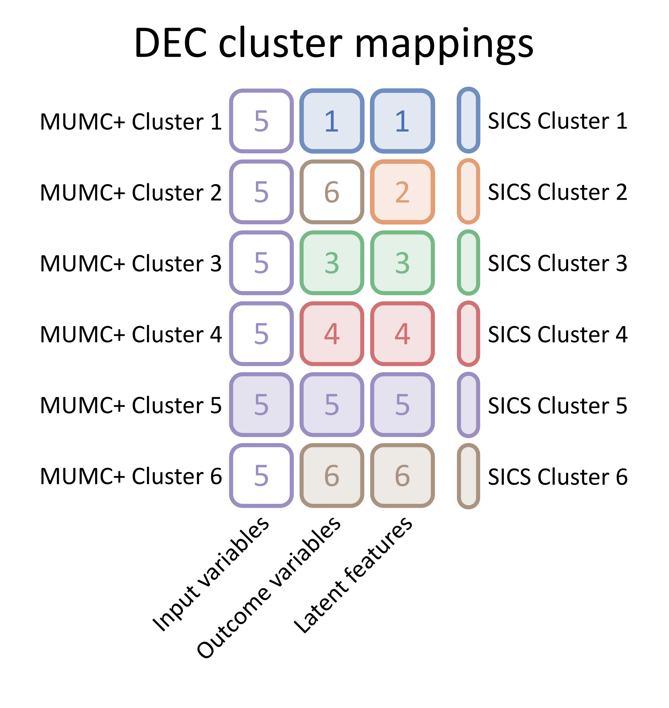
Fig S4. Colour map of cluster mappings between MUMC+ and SICS clusters from the recreated original SICS model based on the input variables, outcomes variables, and the latent feature space. Each row corresponds to a MUMC+ cluster, each column to the variables used for mapping, and each cell colour and number to the SICS cluster it was mapped to, as indicated by the legend on the right.
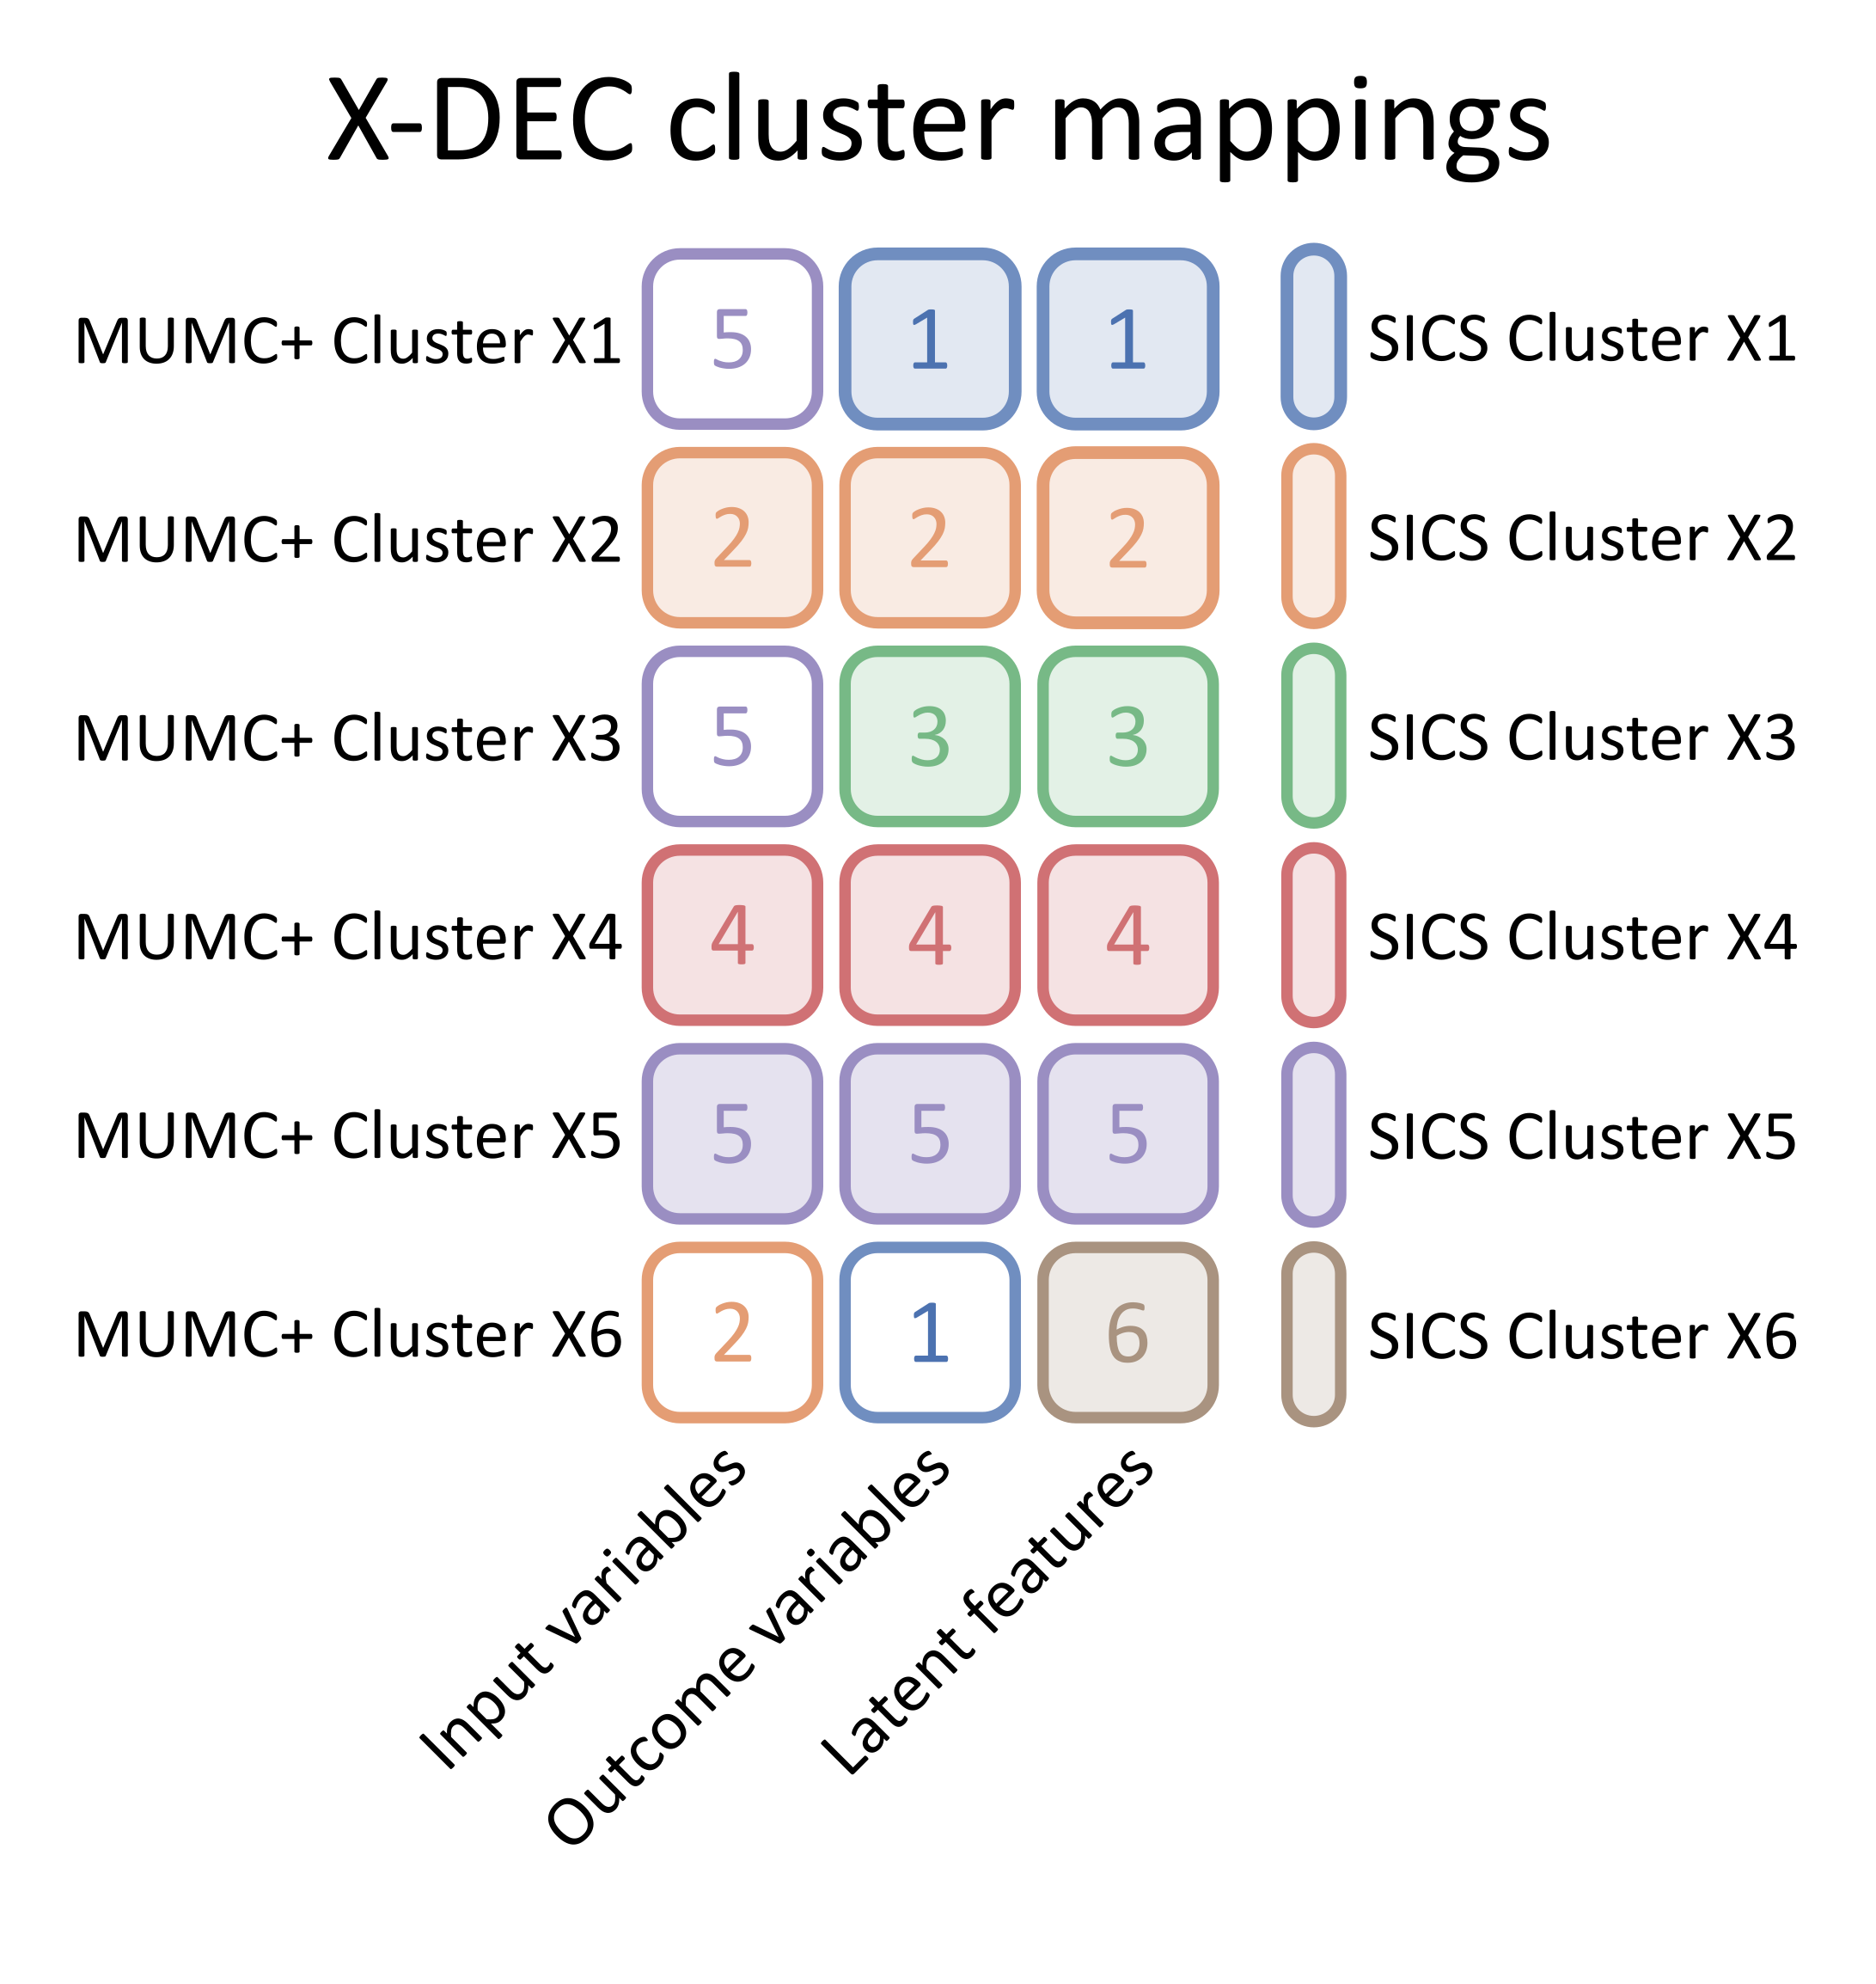
Fig S5. Colour map of cluster mappings between MUMC+ and SICS clusters from the X-DEC model based on the input variables, outcomes variables, and the latent feature space. Each row corresponds to a MUMC+ cluster, each column to the variables used for mapping, and each cell colour and number to the SICS cluster it was mapped to, as indicated by the legend on the right.

