Alleviation of apple replant disease in sandy soils by clay amendments increasing plant available silicon

Jessica Schimmel¹, Norman Gentsch¹, Jens Boy¹, Daniel Uteau², Annmarie-Deetja Rohr^{3,7}, Traud Winkelmann³, Belnaser Busnena⁴, Benye Liu⁴, Jiem Krueger¹, Stephan Kaufhold⁵, Dieter Rammlmair, Stefan Dultz¹, Philipp Maurischat⁶, Ludger Beerhues⁴, and Georg Guggenberger^{1, *}

¹ Institute of Soil Science, Gottfried Wilhelm Leibniz Universität Hannover, Herrenhäuser Str. 2, 30419 Hannover, Germany
² Department of Soil Science, Faculty of Organic Agricultural Sciences, University of Kassel, Nordbahnhofstr. 1a, 37213 Witzenhausen, Germany
³ Institute of Horticultural Production Systems, Woody Plant and Propagation Physiology Section, Gottfried Wilhelm Leibniz Universität Hannover, Herrenhäuser Str. 2, 30419 Hannover, Germany
⁴ Institute of Pharmaceutical Biology, Technische Universität Braunschweig, 38106 Braunschweig, Germany
⁵ Federal Institute for Geosciences and Natural Resources, Stilleweg 2, 30655 Hannover, Germany
⁶ Carl von Ossietzky University of Oldenburg, Institute for Biology and Environmental Sciences, Ammerländer Heerstr. 114-118, 26129 Oldenburg
⁷ Institute for Plant Protection in Horticulture and Urban Green, Julius Kuehn-Institute, Messeweg 11/12, 38104 Braunschweig
* Corresponding author: guggenberger@ifbk.uni-hannover.de

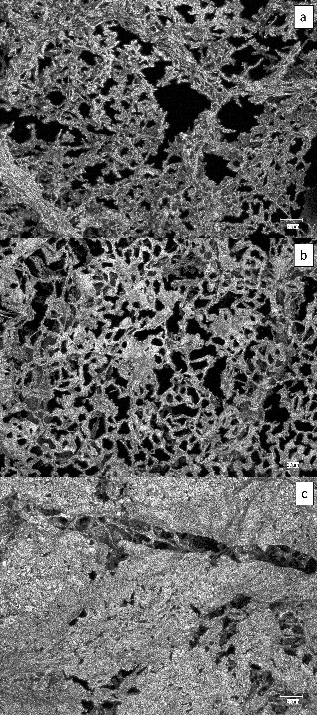
Figure S 1: Confocal laser scanning microscope images of bottom leaf surfaces ashed at 600 °C. ‘M26’ Apple plants were grown in ARD soil (a), ARD heat (b), and ARD 18B (c).

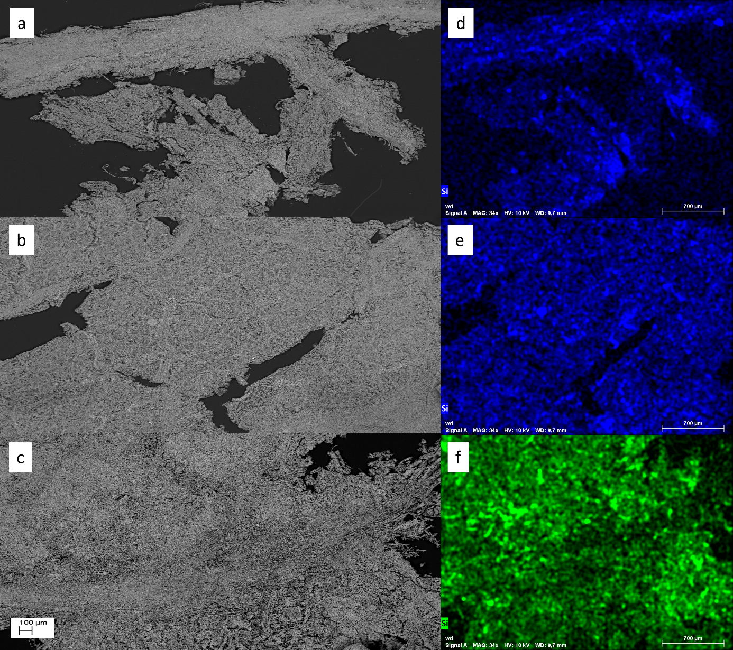
Figure S 2: SEM-EDX images of leaf cuttings (ashed at 600 °C) of ‘M26’ apple plants grown in ARD soil (a), heat disinfected ARD soil (b), and ARD soil with 18 % bentonite amendment. On the right side the corresponding Si maps are shown (d: ARD; e: ARD heat; f: ARD 18B).

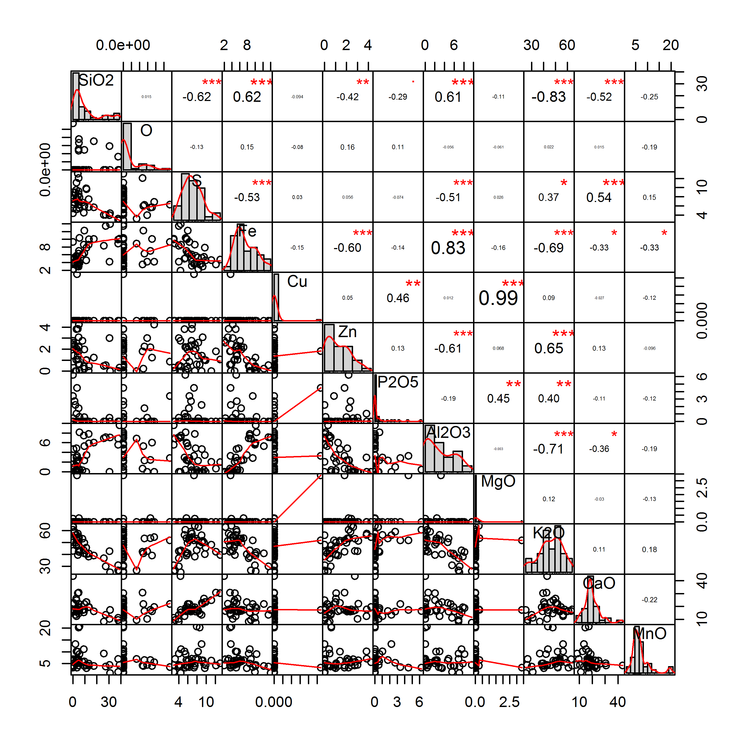
Figure S 3: Pearson correlation matrix of the elemental variables inside the roots of `M26` apple seedling grown in soils with different treatments; results were determined by µEDXRF.

Table S 1: Transformation criterion λ for shoot and root dry weight.
Variable | global lambda¹ | local lambda² | applied lambda³
Shoot dry weight | 0.505 | 1.959 (ARD heat) | 1.2
Root dry weight | 0.3838 | 1.757 (ARD heat) | 1.05
¹Transformation criterion calculated following Box and Cox (1964) for all groups
²Local lambda was applied for elements that did not meet normal distribution criterion after group lambda application
³Applied lambda presents the iterative solution for all groups

Table S 2: Evaluation of the impact of water content at harvest day on gene expression. The effects were analysed with a linear mixed effects model (R package lme4) using water content as fixed predictor variable and treatment variant as random variable.
Gene expression |  | Estimate | Std. Error | df | t-value | p-value | Correlation with water content
B4H | Intercept | 3.70 | 0.76 | 19.24 | 4.87 | 1.03E-04 | -0.852
 | water content | -0.14 | 0.05 | 25.75 | -3.01 | 5.71E-03
 | Intercept
BIS3 | water content | 22.24 | 3.89 | 19.61 | 5.72 | 1.46E-05 | -0.879

Table S 3:
Table S 3: Mean element content in mg g⁻¹ dry soil after Mehlich3 extraction.
Variant | Al_mean | Ca_mean | Cu_mean | Fe_mean | K_mean | Mg_mean | Mn_mean | Na_mean | Ni_mean | P_mean | Si_mean | Zn_mean
concentration in mg g ⁻¹ dry soil
ARD | 1.09 | 1.10 | 0.0051 | 0.3774 | 0.224 | 0.075 | 0.019 | 0.004 | 0.000094 | 0.35 | 0.0333 | 0.0137
ARD heat | 0.94 | 1.08 | 0.0043 | 0.3218 | 0.163 | 0.083 | 0.027 | 0.006 | 0.000028 | 0.39 | 0.0377 | 0.0114
ARD 6B | 1.01 | 1.43 | 0.0051 | 0.3539 | 0.204 | 0.158 | 0.017 | 0.004 | 0.000090 | 0.38 | 0.0696 | 0.0100
ARD 18B | 0.93 | 2.28 | 0.0039 | 0.3126 | 0.213 | 0.369 | 0.015 | 0.007 | 0.000352 | 0.35 | 0.1534 | 0.0059
ARD 6F | 1.04 | 1.08 | 0.0050 | 0.3776 | 0.320 | 0.129 | 0.035 | 0.003 | 0.000318 | 0.43 | 0.0619 | 0.0087
ARD 18F | 1.07 | 1.81 | 0.0056 | 0.4221 | 0.236 | 0.281 | 0.053 | 0.005 | 0.000938 | 0.43 | 0.1766 | 0.0077
ARD 6S | 1.05 | 1.03 | 0.0062 | 0.4021 | 0.226 | 0.062 | 0.019 | 0.003 | 0.000263 | 0.44 | 0.0402 | 0.0124
ARD 18S | 0.91 | 0.97 | 0.0051 | 0.3592 | 0.262 | 0.069 | 0.019 | 0.004 | 0.000264 | 0.40 | 0.0416 | 0.0114
Grass | 1.05 | 0.82 | 0.0050 | 0.3166 | 0.294 | 0.069 | 0.021 | 0.004 | 0.000206 | 0.42 | 0.0289 | 0.0131
Grass 6B | 1.09 | 1.35 | 0.0046 | 0.3247 | 0.248 | 0.184 | 0.016 | 0.004 | 0.000176 | 0.43 | 0.0834 | 0.0110
Grass 18B | 0.33 | 1.28 | 0.0016 | 0.0931 | 0.124 | 0.240 | 0.008 | 0.005 | 0.00 | 0.16 | 0.0638 | 0.0034
Grass 6F | 0.53 | 0.75 | 0.0019 | 0.1403 | 0.194 | 0.111 | 0.017 | 0.004 | 0.00 | 0.18 | 0.0394 | 0.0063
Grass 18F | 0.49 | 1.01 | 0.0018 | 0.1215 | 0.128 | 0.185 | 0.021 | 0.006 | 0.000074 | 0.17 | 0.0760 | 0.0043

Table S 4: Significant letters to the corresponding mean element content in Table S3.
Variant | Al | Ca | Cu | Fe | K | Mg | Mn | Na | P | Zn
ARD | e | abc | cd | d | abcd | bg | bcd | cdef | abc | f
ARD heat | ab | abc | ab | ab | ab | ab | a | ab | ab | a
ARD 6B | ac | ad | abcd | ac | ac | cd | bc | acdef | a | b
ARD 18B | b | e | a | b | c | e | d | b | a | c
ARD 6F | cd | ab | cd | d | abcde | ac | a | c | ab | d
ARD 18F | de | f | c | e | cd | f | e | abd | b | e
ARD 6S | cde | bc | cd | cde | c | g | bcd | ce | b | af
ARD 18S | b | bcg | bcd | cd | acd | bg | bc | cef | ab | a
Grass | cd | gh | bcd | b | d | g | b | ce | b | f
Grass 6B | cde | d | abd | ab | cd | d | cd | e | b | ab
Grass 18B | f | ad | e | f | e | f | f | adf | c | g
Grass 6F | g | h | e | g | ac | c | bcd | ce | c | c
Grass 18F | g | c | e | g | be | d | bc | abcdef | c | h

