Supplementary Figures
Supplementary Figure 1. Visualization and summary of our dynamic functional connectivity results for RSNs and different groups using different window sizes.
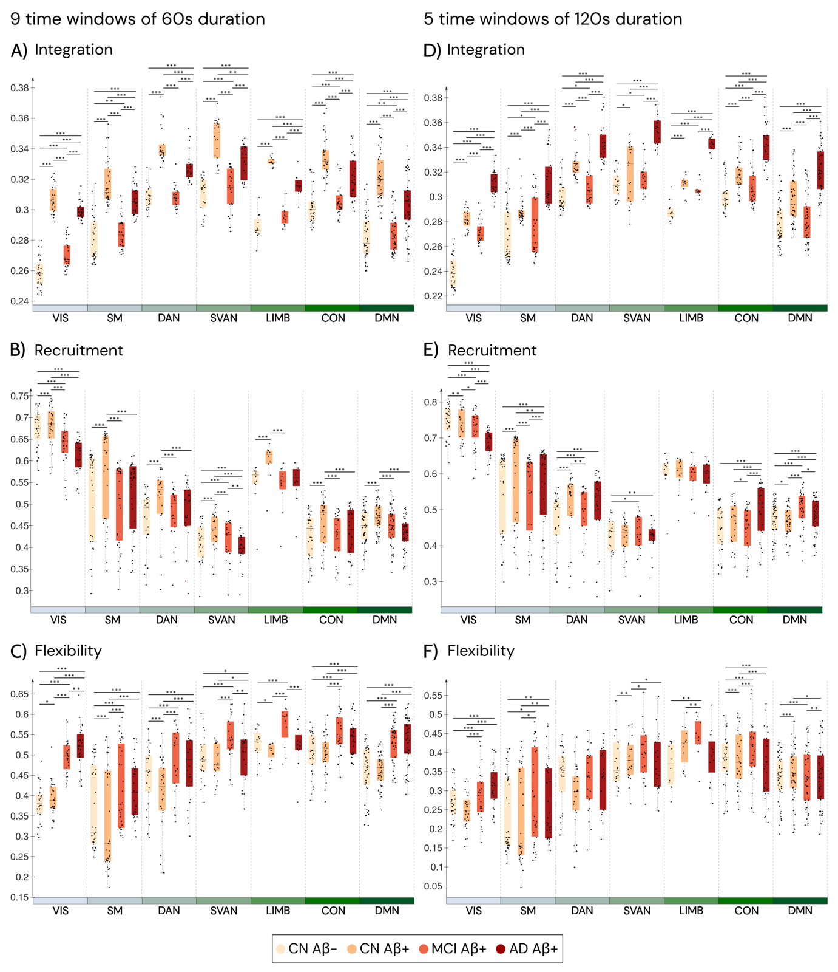
Visualization of summary statistics for resting-state network-specific a) integration, b) recruitment, and c) flexibility across the 9 time windows of 60s duration and d) integration, e) recruitment, and f) flexibility across the 5 time windows of 120s duration. The center black lines represent the median.
CON – control network; DMN – default mode network; DAN – dorsal attention network;
SVAN – salience ventral attention network; LIMB – limbic network; SM- somatomotor; VIS – visual networks.
Supplementary Figure 2. Module Allegiance matrices.
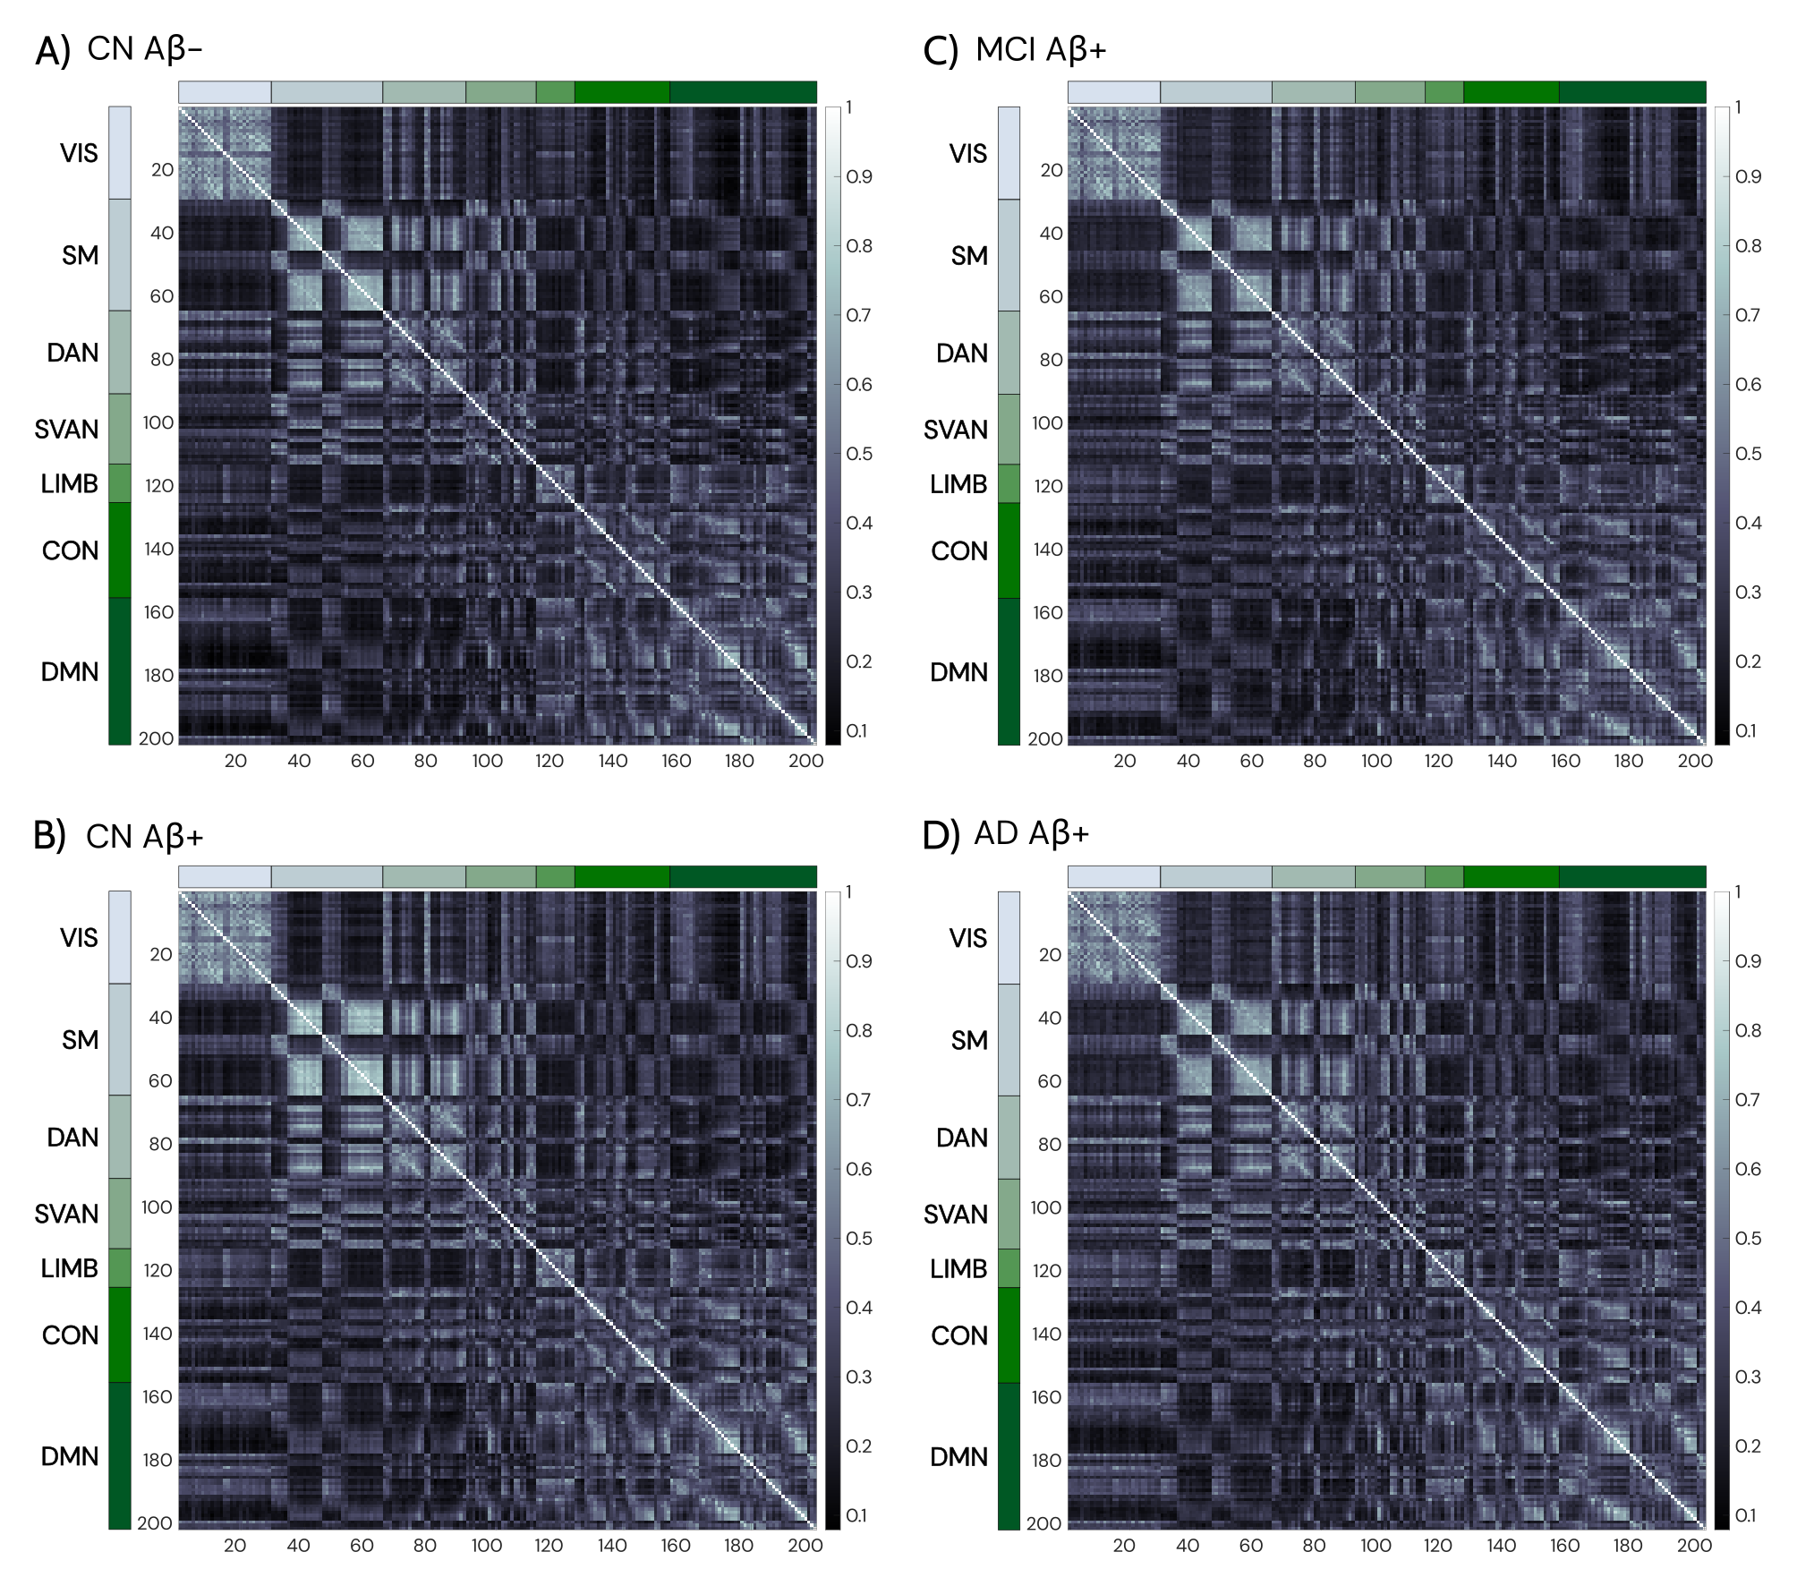
Module allegiance matrices for CN Aβ- (a), CN Aβ+ (b), MCI Aβ+ (c), and AD Aβ+ (d) groups obtained from the calculation of multilayer communities in the 19 layers using 100 optimizations.
CON – control network; DMN – default mode network; DAN – dorsal attention network; SVAN – salience ventral attention network; LIMB – limbic network; SM- somatomotor; VIS – visual networks.

Supplementary Figure 3. Models’ comparison.
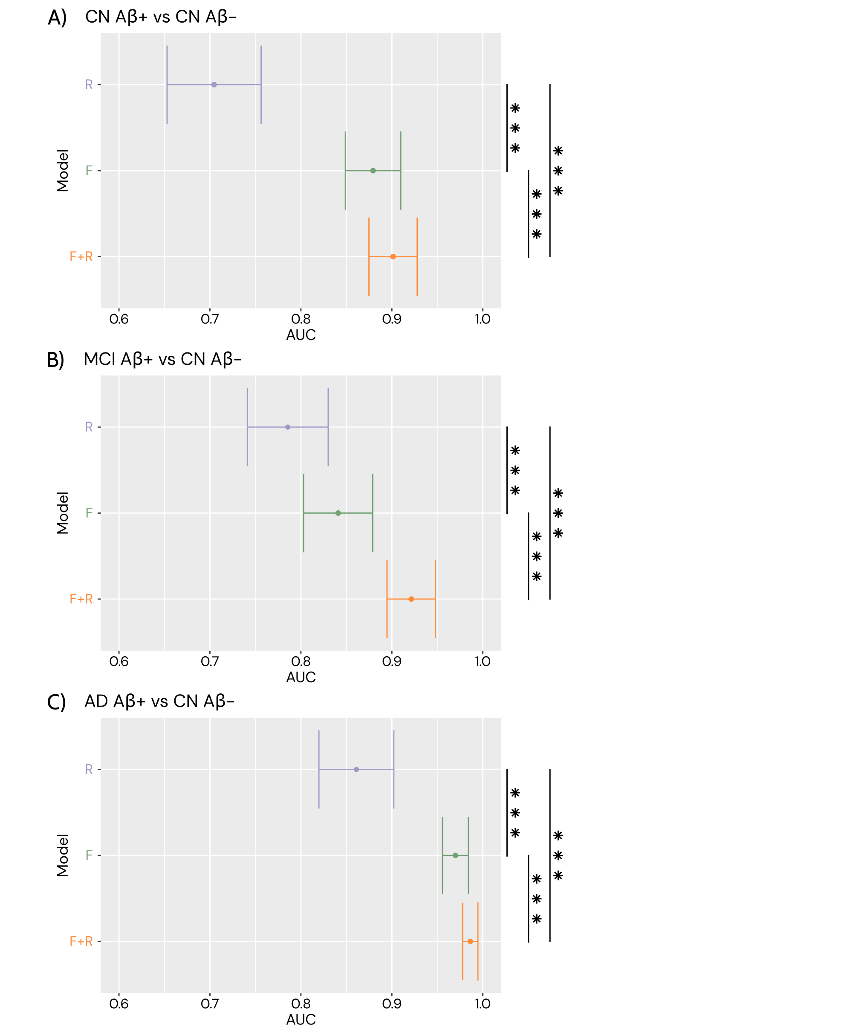
Comparison of the three models for each classification: CN Aβ+ and CN Aβ- (A), MCI Aβ+ and CN Aβ- (B), AD Aβ+ and CN Aβ- (C) groups. (A) Model R has an AUC of 0.70 (std 0.052), model F an AUC of 0.88 (std 0.031), and model F+R an AUC of 0.90 (std 0.028). (B) Model R has an AUC of 0.79 (std 0.045), model F an AUC of 0.84 (std 0.037), and model F+R an AUC of 0.92 (std 0.026). (C) Model R has an AUC of 0.86 (std 0.039), model F an AUC of 0.97 (std 0.015), and model F+R an AUC of 0.99 (std 0.008). In all classifications, all models are statistically different (<0.001).

Supplementary Figure 4. Explained variance of the individual components for the different PLS models.
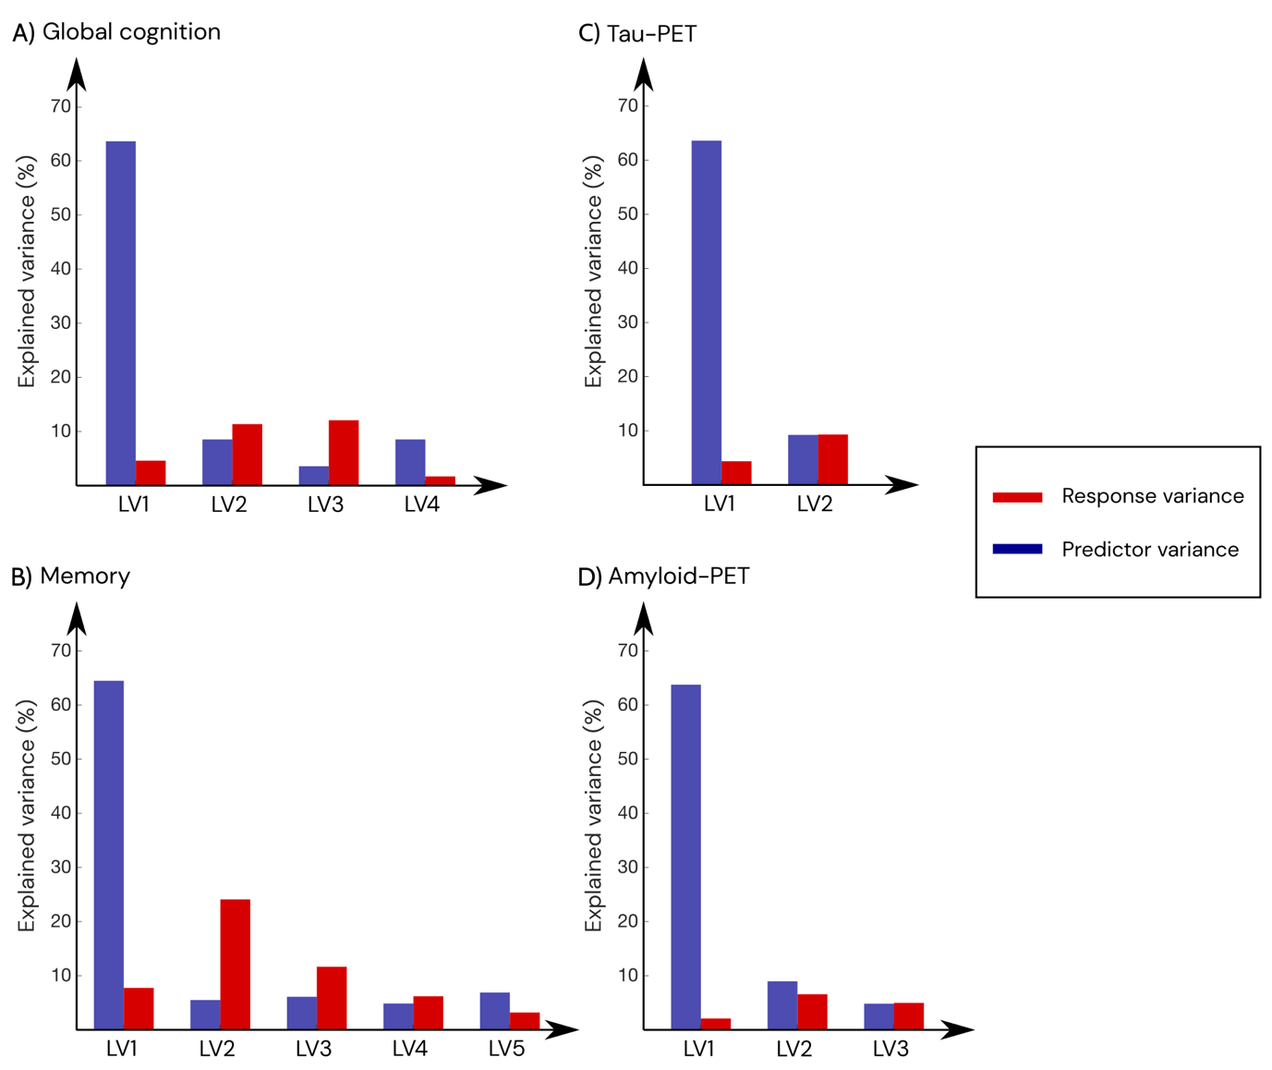
Explained predictor (in blue) and response (in red) variance by each latent variable (LV) in global cognition (a), memory (b), tau-PET (c), and amyloid-PET (d) PLS models.

