Dissecting the genetic bases of resistance to Soil-Borne Cereal Mosaic Virus in durum wheat by biparental mapping and GWAS.
Martina Bruschi¹, Matteo Bozzoli¹, Claudio Ratti¹, Giuseppe Sciara¹, Ellen Goudemand², Pierre Devaux², Danara Ormanbekova¹, Cristian Forestan¹, Simona Corneti¹, Sandra Stefanelli¹, Sara Castelletti¹, Elisabetta Frascaroli¹, Jad Novi¹, Matteo Campana¹, Elena Fusari¹, Concepcion Rubies-Autonell¹, Dragan Perovic³, Agata Gadaleta⁴, Maccaferri Marco^{1*}, Silvio Salvi¹, Maria Corinna Sanguineti¹, Tuberosa Roberto¹
National Key Laboratory of Crop Genetic Improvement, Ministry of Agriculture Key Laboratory of Crop Ecophysiology and Farming System in the Middle Reaches of the Yangtze River, College of Plant Science and Technology, Huazhong Agricultural University, Wuhan, Hubei, 430070, China
ORCID iDs:
Marco Maccaferri, https://orcid.org/0000-0002-1935-3282
*Author for correspondence:
Marco Maccaferri, marco.maccaferri@unibo.it Tel.: +39-0512096645

Supplemental Information (SI)

Supplemental Tables, Figures and Methods

Table S1. SNPs used to develop KASP® markers. cM (= centiMorgans) are reported as cumulative genetic distances on chromosome 2B according to the consensus map. RILs maps represent mapping populations in which the SNP resulted polymorphic.
Marker ID code | Marker name | Consensus map position (cM)ª | Svevo genome assembly position (bp) | Polymorphisms in RIL maps^{b}
IWB61884 | RAC875_rep_c109471_154 | 7.9 | 9,766,826 | LT×MG_5323, CL×LD, MR×CD, MH×CR, SV×CC
IWB73347 | Tdurum_contig76118_145 | 8.4 | 9,986,862 | LT×MG_5323, CL×LD, MR×CD, MH×CR, SV×CC, SV×ZV
IWB11421 | BS00085748_51 | 11.6 | 13,011,332 | LT×MG_5323, CL×LD, MR×CD, SM×LV, MH×CR, SV×CC, SV×ZV
IWB23029 | Excalibur_c1787_1037 | 11.6 | 15,643,691 | CL×LD, MR×CD, SM×LV, SV×CC
IWB42660 | Kukri_c22513_1780 | 11.6 | 13,011,658 | LT×MG_5323, CL×LD, MR×CD, SM×LV, MH×CR, SV×CC, SV×ZV
IWB28973 | Excalibur_c8093_82 | 12.2 | 16,235,907 | CL×LD, MR×CD, MH×CR, SV×CC
IWB45152 | Kukri_c41556_619 | 12.2 | 15,713,309 | CL×LD, MR×CD, MH×CR, SV×CC
IWB41644 | Kukri_c16758_443 | 12.2 | 16,183,711 | SM×ML, CL×LD, MR×CD, MH×CR, SV×CC
IWB8328 | BS00043055_51 | 12.3 | 15,805,908 | LT×MG_5323, CL×LD, MR×CD, SM×LV, MH×CR, SV×CC
IWB29097 | Excalibur_c841_609 | 12.3 | 16,185,445 | SM×ML, CL×LD, MR×CD, MH×CR, SV×CC
IWB35524 | IAAV8700 | 12.3 | 16,184,325 | SM×ML, CL×LD, MR×CD, MH×CR, SV×CC
IWB23330 | Excalibur_c19499_948 | 12.4 | 16,957,139 | CL×LD, MR×CD, SV×CC
IWB24939 | Excalibur_c30167_531 | 12.4 | 16,954,167 | SM×ML, CL×LD, MR×CD, MH×CR, SV×CC
IWB6204 | BS00010318_51 | 19.0 | 24,308,711 | MR×CD, SM×LV, MH×CR, SV×CC, SV×ZV
IWB10512 | BS00070900_51 | 19.0 | 24,313,744 | MR×CD, SM×LV, MH×CR, SV×CC, SV×ZV
IWB8390 | BS00045163_51 | 19.3 | 24,798,904 | LT×MG_5323, CL×LD, SM×LV, MH×CR

a Tetraploid wheat consensus map published in Maccaferri et al. (2015)
^{b} LT = Latino, MG_5323 = MG5323, CL = Colosseo, LD = Lloyd, MR = Meridiano, CD = Claudio, MH = Mohawk, CR = Cocorit69, SV = Svevo, CC = Ciccio, ZV = Zavitan, SM = Simeto, LV = Levante, ML = Molise Colli.

Table S2a. Primers designed for KASP® assays. Each assay was composed by three primers: two allele-specific primers (A) and (B) and a common primer (C). Allele-specific primers A and B presented the probe sequence respectively for FAM (5’ GAAGGTGACCAAGTTCATGCT 3’) and HEX (5’ GAAGGTCGGAGTCAACGGATT 3’) at 5’ end. For each developed assay, information about its codominance is reported.
SNP IDª | KASP marker^{b} | Primer allele specific A (5’ FAM) | Primer allele specific B (5’ HEX) | Primer common C | Codominant
IWB28973 | KUBO-001 | GAAGGTGACCAAGTTCATGCTcgtcttgttggtcagctgT | GAAGGTCGGAGTCAACGGATTcgtcttgttggtcagctgC | gcagctgtgacacgaacatta | yes
IWB28973 | KUBO-038 | GAAGGTGACCAAGTTCATGCTccgtcttgttggtcagctgT | GAAGGTCGGAGTCAACGGATTccgtcttgttggtcagctgC | gcagagcagctgtgacacg | yes
IWB8328 | KUBO-003 | GAAGGTGACCAAGTTCATGCTtgaagtggaggaactagaagcT | GAAGGTCGGAGTCAACGGATTtgaagtggaggaactagaagcC | gagaaggtgctgacatcattttc | yes
IWB24939 | KUBO-005 | GAAGGTGACCAAGTTCATGCTcaaaatctggggcatgctcA | GAAGGTCGGAGTCAACGGATTcaaaatctggggcatgctcG | agagctagggtggtttcagg | yes
IWB6204 | KUBO-006 | GAAGGTGACCAAGTTCATGCTgacaaagttggtggtaaattctcttaC | GAAGGTCGGAGTCAACGGATTggacaaagttggtggtaaattctcttaT | gcaagcatgccttccaccaccaa | yes
IWB10512 | KUBO-008 | GAAGGTGACCAAGTTCATGCTatcagaatatgtacaattattatgccaagaT | GAAGGTCGGAGTCAACGGATTcagaatatgtacaattattatgccaagaC | ggcggaaattctcttcctttccttattta | yes
IWB10512 | KUBO-009 | GAAGGTGACCAAGTTCATGCTaggatgcgttgtttgccaactctA | GAAGGTCGGAGTCAACGGATTggatgcgttgtttgccaactctG | gccatccaccaccaccataagtta | yes
IWB73347 | KUBO-012 | GAAGGTGACCAAGTTCATGCTggctgacagggacattgcT | GAAGGTCGGAGTCAACGGATTggctgacagggacattgcC | ctgtaaacggactctcgaca | yes
IWB73347 | KUBO-013 | as KUBO-012_A | as KUBO-012_B | gtgcatttcaaaattcattttctc | yes
IWB73347 | KUBO-014 | GAAGGTGACCAAGTTCATGCTgcatctctgacattctcagaacA | GAAGGTCGGAGTCAACGGATTgcatctctgacattctcagaacG | cggggacggtttcagg | yes
IWB61884 | KUBO-015 | GAAGGTGACCAAGTTCATGCTaaggagtgaaaccaagcgtaT | GAAGGTCGGAGTCAACGGATTaaggagtgaaaccaagcgtaC | caccaactctgacactggc | yes
IWB61884 | KUBO-016 | as KUBO-015_A | as KUBO-015_B | tgacatcacccaccttatcgt | yes
IWB61884 | KUBO-017 | GAAGGTGACCAAGTTCATGCTccccaagcgctgacG | GAAGGTCGGAGTCAACGGATTccccaagcgctgacA | ggagcatggtatgacagacatc | yes
IWB11421 | KUBO-026 | GAAGGTGACCAAGTTCATGCTtaaacaatcactcgctaataagcaaC | GAAGGTCGGAGTCAACGGATTtaaacaatcactcgctaataagcaaT | aaagtaggtgcacagcctgag | yes
IWB11421 | KUBO-027 | as KUBO-026_A | as KUB-O26_B | gccatatgctgtgactgctg | yes
IWB23029 | KUBO-029 | GAAGGTGACCAAGTTCATGCTgctggaggaactagaagctgaG | GAAGGTCGGAGTCAACGGATTgctggaggaactagaagctgaT | aacagagcattgcaaaaccta | yes
IWB23029 | KUBO-031 | as KUB-O29_A | as KUB-O29_B | ggagtcagttggtgcattcg | yes
IWB29097 | KUBO-040 | GAAGGTGACCAAGTTCATGCTGaTGCTcctTtTaTcccaggaA | GAAGGTCGGAGTCAACGGATTGaTGCTcctTtTaTcccaggaG | tcgaatcatgaggacctggg | yes
IWB35524 | KUBO-041 | GAAGGTGACCAAGTTCATGCTtgtGcattgtgaaggtgatttaaA | GAAGGTCGGAGTCAACGGATTtgtGcattgtgaaggtgatttaaG | acttgcagacgaaccatgtag | yes
IWB23330 | KUBO-004 | GAAGGTGACCAAGTTCATGCTtgcaccccttgttctttgaaT | GAAGGTCGGAGTCAACGGATTtgcaccccttgttctttgaaC | aaacaagacaagataatgcaagtct | no
IWB10512 | KUBO-007 | GAAGGTGACCAAGTTCATGCTaggatgcgttgtttgccaactctA | GAAGGTCGGAGTCAACGGATTggatgcgttgtttgccaactctG | gccatccaccaccaccataagtta | no
IWB8390 | KUBO-010 | GAAGGTGACCAAGTTCATGCTcctctgcaacgccgccgC | GAAGGTCGGAGTCAACGGATTcctctgcaacgccgccgT | tatgcgggtcggcgatgacgtt | no
IWB8390 | KUBO-011 | GAAGGTGACCAAGTTCATGCTagagtcaaggaactcccacG | GAAGGTCGGAGTCAACGGATTagagtcaaggaactcccacA | gtgtgaatgagagaatctttgacg | no
IWB8390 | KUBO-012 | GAAGGTGACCAAGTTCATGCTccgatactaatcctaggaattacgG | GAAGGTCGGAGTCAACGGATTccgatactaatcctaggaattacgA | aggaagtcatgagtccttggta | no
IWB11421 | KUBO-028 | as KUBO-026_A | as KUBO-026_B | tttctgcacctgccatatgc | no
IWB23029 | KUBO-030 | as KUBO-029_A | as KUBO-029_B | cgtcgagaagaatttgacagaa | no
IWB42660 | KUBO-032 | GAAGGTGACCAAGTTCATGCTttggcctgtaaaaggctatcG | 5' HEX GAAGGTGACCAAGTTCATGCTttggcctgtaaaaggctatcA | gatgagcataatctacttcctgatg | no
IWB42660 | KUBO-033 | as KUBO-032_A | as KUBO-032_B | tcctgatgccctagagagtgac | no
IWB42660 | KUBO-034 | as KUBO-032_A | as KUBO-032_B | ctatgttctcaatagtcatgaggc | no
IWB41644 | KUBO-035 | GAAGGTGACCAAGTTCATGCTaagtgcaggcatgtgttgagataA | GAAGGTCGGAGTCAACGGATTaagtgcaggcatgtgttgagataC | cggcgacattactgtcttaacc | no
IWB41644 | KUBO-036 | as KUBO-035_A | as KUBO-035_B | ggctggagcttgactgagaat | no
IWB41644 | KUBO-037 | as KUBO-035_A | as KUBO-035_B | ccagccctgctcctgatc | no
IWB28973 | KUBO-039 | GAAGGTGACCAAGTTCATGCTgaggcgtcgtgctgcctA | GAAGGTCGGAGTCAACGGATTgaggcgtcgtgctgcctG | tcgcaccgcatgtatggt | no
IWB45152 | KUBO-002 | GAAGGTGACCAAGTTCATGCTacaaacgaagaacaacacggT | GAAGGTCGGAGTCAACGGATTacaaacgaagaacaacacggC | tcgccctcccctttcctg | no
IWB45152 | KUBO-042 | as KUBO-002_A | as KUBO-002_B | ccctttcctggtgacagtga | no

ªSNP ID = ID code of the SNP on which the KASP® assay was developed.
^{b}KASP® marker = name and number of the developed KASP® assay developed at UNIBO.

Table S2b. Primers designed for the DART marker wPt-2106 assay converted to allele-specific oligonucleotide PCR and high-resolution melting PCR.

Primer name | Oligonucleotide sequence
wPt-2106 Allele Specific Oligonucleotide (ASO, separation in horizontal electrophoresis)
wPt-2106_ASO_Forward_Resistant | GCAACATCCTCTTGCAGGCA
wPt-2106_ASO_Forward_susceptible (M13 tail) | CACGACGTTGTAAAACGACATCCTCTTGCAGGCGGAA
wPt-2106_Reverse_common | CGCATAGAACATTATAAAGGCTGGC
wPt-2106 high resolution melting (HRM)
wPt-2106_HRM_Forward | GGAGACCAGAGGAGGAACTTT
wPt-2106_HRM_Reverse | AAAACGGCGGTTCAGAAG

Method S1. KASP® marker development
The developed KASP® markers were assayed on the parental lines of the RIL populations used in the study (MrxCd and SvxCc). Artificial heterozygous samples were produced by mixing the same amount of DNA of a resistant and of a susceptible parent. Each KASP® assay was tested on several replicates of the four parental lines and the heterozygous samples.
PCR for KASP® assays were set up in 96-wells optical plates in a total volume of 10 μL per reaction, containing 2 μL of genomic DNA at a concentration of 20 ng/μL, 5 μL of KASP master mix (2X), 0.14 μL of primer mix and 2.86 μL of Milli-Q water. Primer mix was composed by 12 μL of primer A, 12 μL of primer B, 30 μL of primer C (each primer at 100 μM) and 46 μL of Milli-Q water (total volume = 100 µL).
PCR reaction protocol and thermal cycling program were used as proposed by the “KASP genotyping chemistry User guide and manual” available at the website https://www.lgcgroup.com/products/kasp-genotyping-chemistry (PCR protocol was adjusted for the quantity of DNA/water per reaction). Primer mix was prepared as reported in Yuan et al. (2014).
The KASP® thermal cycling program used is reported herein.
In order to better discriminate allele separation, further recycling steps are needed repeating Step3 for additional 10 cycles.
Once the PCR thermal cycling program was completed, optical plates were read on an ABI 7500, Applied BiosystemsTM instrument. This stage of the process consisted in performing a thermal recycling program composed of three cycles as follows: denaturation at 95 °C for 30 sec, annealing/elongation at 55 °C for 60 sec and post-PCR read at 30 °C for 60 sec. The recycling program was repeated several times until three defined genotyping clusters were outlined in the output graphical plot.
Functional KASP® assays were manually selected based on the output graphical plot and on the correct clustering of controls.
Thermal cycling program used for KASP assays as proposed by the “KASP genotyping chemistry User guide and manual” available at the website https://www.lgcgroup.com/products/kasp-genotyping-chemistry

Stage | Temperature and length specifications | Cycle type and number | Number of cycles
1 | 94°C for 15 minutes | Hot-start activation | 1
2 | 94°C for 20 seconds | Denaturation | 10
2 | 61-55°C for 60 seconds | Annealing: dropping 0.6°C per cycle to reach a final annealing temperature of 55°C | 10
3 | 94°C for 20 seconds | Denaturation | 26
3 | 55°C for 60 seconds | Annealing | 26

Method S2. Genotyping of Durum Panel and bi-parental cross RIL populations. Validation of KASP® markers

Newly developed KASP® markers were used to genotype the Durum Panel UNIBO with the aim of validating the assays. DNA samples of the panel accessions were already available at the Plant Genetics Laboratory at UNIBO. PCR reactions were performed following the protocol previously described for KASP markers. The same accessions were genotyped with marker wPt-2106. PCR reactions for wPt-2106 were set up in 96-well plates, in a total volume of 20 µL per reaction composed as following: 5 µL of genomic DNA at 20 ng/µL, 4 µL of buffer (5X), 1.6 µL of MgCl₂, 0.16 µL of dNTPs, 0.05 µL of Taq Polymerase, 2.4 µL of primer mix and 6.79 µL of Milli-Q water. Primer mix was composed by 100 µL of primer forward Meridiano, 100 µL of primer forward Claudio and 100 µL of primer reverse (each primer at 100 µM) and 700 µL of Milli-Q water (total volume = 1 mL). The thermal cycling program used was the following: 5 min at 94 °C, 45 sec at 94° C, 45 sec at 60 °C, 1 min at 72 °C, 10 min at 72 °C and ∞ at 12 °C for 35 cycles. PCR products were electrophoresed in 2.5% agarose gel and visualized after staining with ethidium bromide. For each marker, two DNA samples of Sv, two of Cc and two of artificial Sv-Cc-heterozygous were used as control.

Figure S1. Agarose and high resolution melting PCR assays obtained for the DArT® wPt2106, tagging Sbm2 in durum wheat

wPt2106_ASO, Allele Specific Oligonucleotide PCR assay for separation in standard horizontal electrophoretic gels.

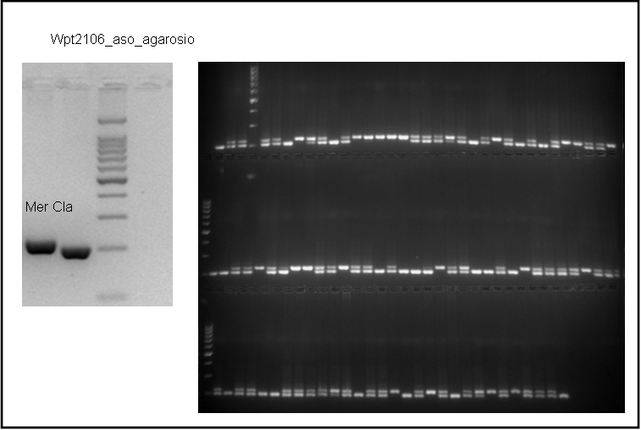

wPt2106_HRM, high resolution melting assay, for fluorescent detection

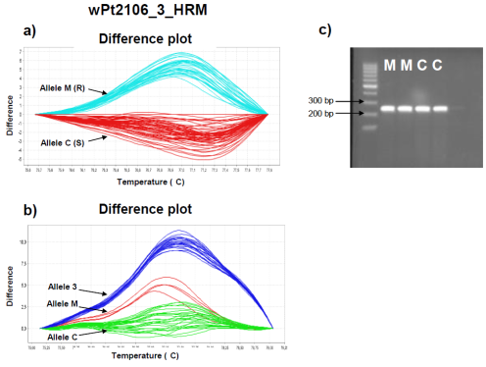

Figure S2. Amplification plots for KUBO-001, KUBO-003, KUBO-027, KUBO-029, KUBO-040, KUBO-041 KASP® assays developed by UNIBO laboratory and obtained from the corresponding haplotype tagger Illumina SNP IWB28973, IWB8328, IWB11421, IWB23029, IWB29097 and IWB35524, respectively.

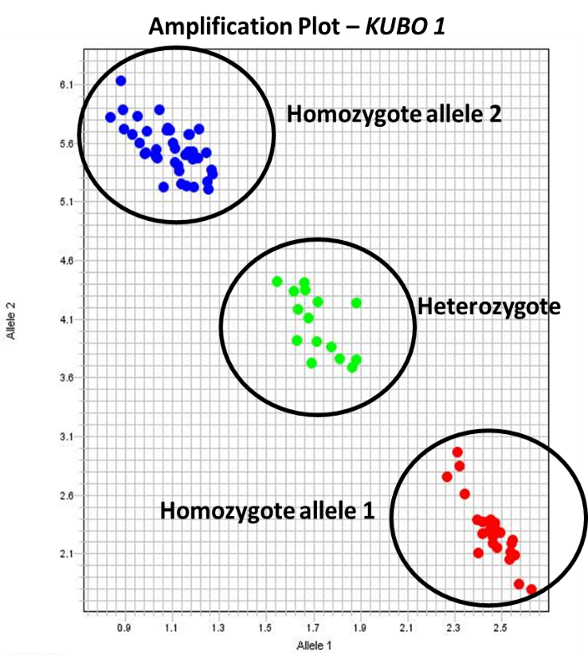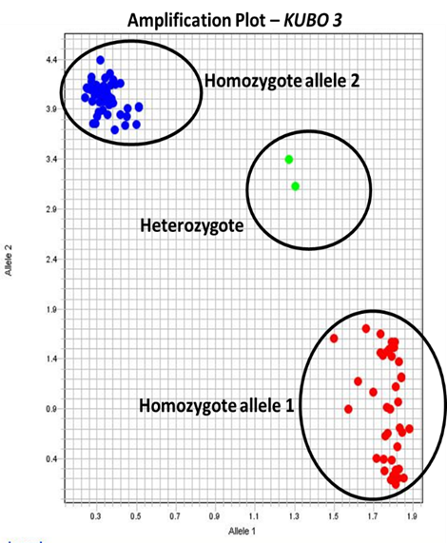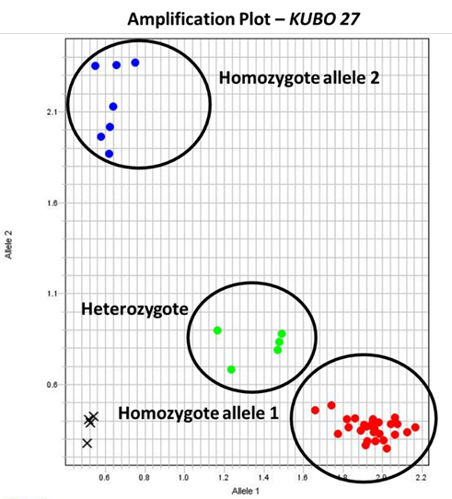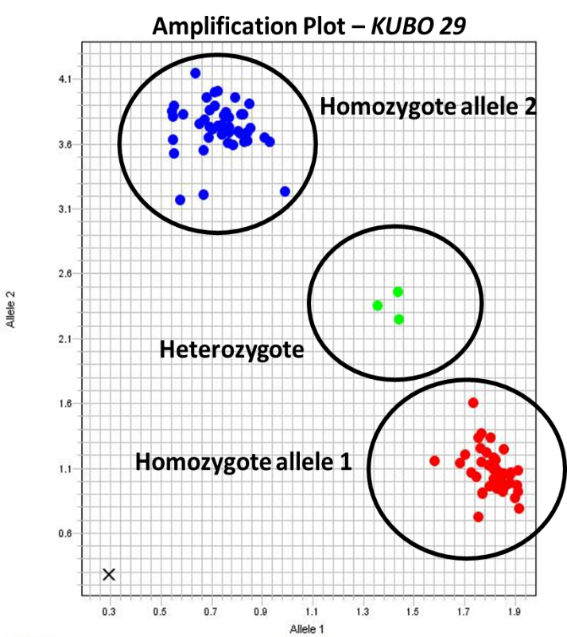
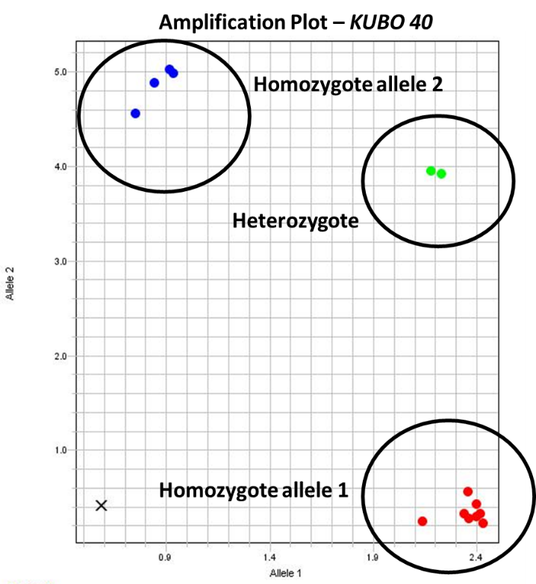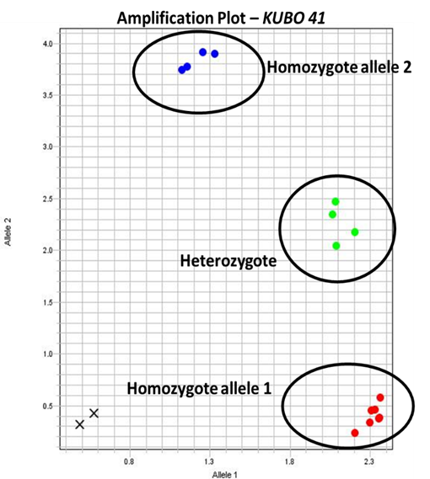

Genotyping of RIL population
The Sv x Cc RIL population (3,075 lines) were genotyped with two distal KASP markers flanking the QSbm.ubo-2BS region, KUBO-13 and KUBO-9, aimed at selecting RILs recombinant between the two markers. RILs DNA was isolated from lyophilized leaf tissue using a CTAB DNA isolation protocol for 96-well plates. PCR reactions were performed on the isolated RILs DNA following the protocol already described in previous section.
The Sv x Cc RILs selected through MAS were sown in two seasons (2015/2016 and 2015/2017) in a field experiment aimed at measuring the severity of SBCMV infection in Cadriano (Bologna, Italy, 44°35’ N 11°27’ E). The experimental design was a randomized complete block design with controls included in each block and was performed in two or three replicates depending on the season. Sowing density was 300 seeds/m². Phenotyping and data analysis was carried out as described for the durum panel. Tables reporting scoring dates for Sv x Cc trial is showed in Supplementary material section (Supplemental Table 3).
RILs sown in the experimental fields were successively genotyped with seven markers located between the flanking markers KUBO-3 and KUBO-9 (i.e., KUBO-1, KUBO-3, KUBO-27, KUBO-29, KUBO-40, KUBO-41 and wPt-2106) with the aim of selecting lines presenting a recombination inside the interested interval. An ELISA test was performed on the sole seven lines presenting a recombination event inside this interval, to measure the virus concentration in the leaves.
Based on the Mr x Cl linkage map from Maccaferri et al. (2015), 30 RILs presenting recombination between the SNPs used to design KUBO-13 and KUBO-9 or immediately outside this interval were selected and genotyped with KASP markers KUBO-1, KUBO-3, KUBO-9, KUBO-13, KUBO-27, KUBO-29, KUBO-40 and KUBO-41.
Genotypic data obtained for Sv x Cc and Mr x Cl RIL populations were used to construct a genetic map for each population using the software JoinMap v. 4 (Van Ooijen, 2006). Marker order and genetic distances between markers were calculated using the Maximum Likelihood algorithm and the Haldane’s mapping function. The two maps were compared to check the order of KASP® markers in the region between KUBO-13 and KUBO-9. Once markers order was determined, genotypic data were integrated with phenotypic data to evaluate the presence of informative recombination events between markers and to define the interval where QSbm.ubo-2BS was most probably confined. SBCMV resistance mapping by single-marker analysis was carried out in Windows QTL Cartographer v. 2.5 (Wang et al., 2012). Interval mapping (IM) analysis was also carried out to calculate the LOD score in the interval between KUBO-13 and KUBO-9. Threshold value was set at 3.0 (rounded) via permutations. Walk speed was set at 0.5 cM.

Validation of KASP® markers

A comparison of the genotypic calls obtained with the Illumina 90K SNPs (data already available) and the newly developed KASP markers is reported in Table S3. Overall, the percentage of conflicts was low, with a maximum of 2.71% and 2.50 for KUBO-40 and KUBO-9 and zero conflicts for KUBO-27. The highest percentage of missing data resulted from KUBO-1 (9.88%), while the lowest was detected for KUBO-27 and KUBO-29 (2.71%). Overall, KUBO-27 seemed to be the most efficient among the developed markers. Wpt-2106 ASO and HRM assays performed as excellent markers.

Table S3 Accuracy of KASP® KUBO markers versus the original Illumina 90K SNP array on the UNIBO Durum Panel (% calculated on 258 DNA samples).

Marker | KUBO-13 | KUBO-27 | KUBO-29 | KUBO-1 | KUBO-3 | KUBO-41 | KUBO-40 | KUBO-9 | wPt-2106_  ASO | wPt-  2106_  HRM
Conflicts (%) | 1.55 | 0.00 | 0.78 | 0.39 | 1.16 | 1.55 | 2.71 | 2.50 | 0.50 | 0.65
Missing (%) | 5.04 | 2.71 | 2.71 | 9.88 | 9.30 | 3.10 | 8.72 | 4.07 | 1.60 | 1.52

Table S4: Scoring dates for SBCMV symptom severity evaluation of the RIL population Sv x Cc in years 2016 and 2017 in Cadriano (Bologna, Italy). For each field, dates in which the evaluation was performed are marked with an “X”.
Sv x Cc trials | Visual score dates
 | 2016
 | March 14th | March 17th | March 30th
Field 1 (Cadriano, SvxCc RIL) | x |  | x
Field 2 (Cadriano, SvxCc RIL) |  | x | x
 | 2017
 | March 17th | March 21st | March 23rd | March 28th | April 3rd
Field 1 (Cadriano, SvxCc RIL) | x | x |  | x | x
Field 2 (Cadriano, SvxCc RIL) |  |  | x | x | x

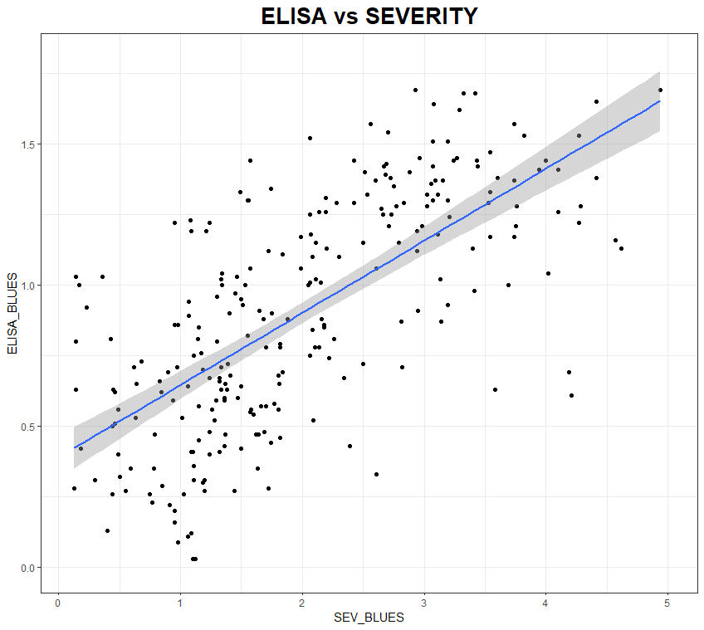
R²= 0.47
Figure S3: scatterplot of ELISA versus Visual severity (SEV) BLUES data across years obtained from the UNIBO Durum Panel of 258 cultivars and breeding lines, as evaluated in Cadriano SBCMV nursery.

Method S3. Comparison of markers order in Sbm2 region among genomes

Marker order between IWB73347 (KUBO-13, position: 9,986,862 bp) and IWB10512 (KUBO-9 position: 24,313,794 bp) were compared in Svevo, in Chinese Spring bread wheat reference genome (CS, IWGSC RefSeq V2.1; Zhu et al., 2021) and in the wild emmer Zavitan genome (WEW_v2.0; Zhu et al., 2019). This physical region comprises IWB10512 (KUBO-9, position on Svevo genome: 24,313,744), the marker flanking Qsbm.ubo-2BS along with KUBO-13.
Marker physical position on the durum wheat genome assembly (Maccaferri et al., 2019) was determined by blastn analysis. BLAST version 2.11.0 was run using the flanking marker sequences as queries with an e-value threshold of 10⁻¹⁰ threshold. To solve multiple hits issues due to homoelogs/paralogs matches, for each query, the best hit was defined as the hit with the smallest e-value and the longest High-scoring Segment Pair (HSP) alignment. Hits of markers in the confidence interval were manually cross-checked. Similar blast analyses were applied to determine the physical position of markers on the Wild Emmer Wheat Zavitan WEWSeq v2.0 (Zhu et al., 2019) and the Wheat Chinese Spring IWGSC RefSeq v2.1 (Zhu et al., 2021) genome assemblies.
The co-linearity among intervals was compared using MUMmer4 (“MUMmer4: A fast and versatile genome alignment system” Marçais et al., PLoS computational biology (2018), 14(1): e1005944.). Corresponding intervals for the three reference genomes were extracted using bedtools v2.30.0 software. The alignment was performed using nucmer command from MUMmer4 software, using Svevo as reference genomes for the comparison with Chinese Spring and Zavitan.
Nucmer was used with the --mum parameter and the output delta file was filtered using the delta-filter command with the following options: -l 5000 to keep alignments longer that 5kb between reference and query and -r and -q, which retain only alignment that form the long consistent set for reference and query respectively. The filtered output was used to generate the plot with the mummerplot command and the following options: --large to set the output size, and --layout in order to orient and order the sequences such that the largest alignments hit the plot cluster near the main diagonal. The output plot shows the reference sequence (x axis) and the query sequence (y axis) where the bp distance is reported, if the alignment is colinear the dots are displayed in purple, whereas inversions are shown in blue.

Table S5. Peak markers of minor QTLs other than Sbm2 resulting from GWAS performed on Durum Panel UNIBO with BLUEs of spatially corrected visual score (SEV) (A) and ELISA (B) data collected in Cadriano (Bologna, Italy) in 2005, 2007 and 2010. QTL peaks confirmed by the SEV covariate analysis (Table 11) are in italic. Common QTL peaks between SEV and ELISA are in bold. Genetic positions (cM) are reported as in the consensus map of Maccaferri et al. (2015). Physical positions (bp) are reported as the start positions obtained by blasting the marker sequence on the durum wheat genome reference Svevo (Maccaferri et al., 2019). The Strand defines the direction of the marker sequence.
Table S5a. Minor QTL for disease severity (SEV) score
Marker | Chr | Position (cM) | Position (bp) | Strand | -Log10 (P) | R² (%) | Allele | Allele frequency | Associated significant markers | Interval (cM)
IWB6984 | 1A | 98.2 | 526,410,713 | + | 3.45 | 4.1 | C/T | 0.75/0.25 | IWB26708, IWB11161, IWB11161, IWB12454, IWB60140, IWB6995, IWB31771 | 98.2-99.8
IWB71381 | 2A | 206.5 | 768,804,948 | - | 3.56 | 4.3 | A/G | 0.66/0.34 | IWB6580, IWB71583, IWB71381, IWB1939 | 206.2-206.8
IWB6584 | 2B | 12.3
IWB48240 | 2B | 67.6 | 109,386,560 | + | 3.78 | 4.6 | C/T | 0.29/0.71 | IWB45048, IWB59095, IWB24241 | 67.6-68.7
IWB27191 | 3B | 163.2
IWA603 | 4A | 35.1 | 37,138,471 | - | 3.36 | 4.0 | A/G | 0.86/0.14 | IWA603, IWB71863, | 35.1-36.1
IWB6276 | 4A | 147.4 | 698,244,266 | - | 4.37 | 5.5 | A/G | 0.43/0.57 | IWB7898, IWA7765, IWB22582, IWB73460, wPt-4596, IWB47812, IWB8487, IWB60429, IWB73853, IWB11713, IWB5747, IWB9122 | 147.0-154.0
IWB37657 | 4A | 156.90 | 707,180,653 | - |  |  | A/G | 0.52/0.48 | IWB37657, wPt-9162, wPt-2331, IWB42403, IWB59017, IWB7370, IWB24067, IWB5461, IWB61457 | 156.9-160.2
IWB14680 | 5A | 194.9 | 639,652,609 | + | 3.35 | 4.0 | A/G | 0.42/0.58 | IWB7282, IWB71385, IWB4836, IWB14445, IWB4261 | 194.9-199.0
IWB67284 | 5B | 53.8 | 411,136,220 | + | 3.77 | 4.6 | C/T | 0.63/0.37 | IWA6526, IWB69519, IWB72308, IWB70171, IWB71912, IWB33231, IWA5742, IWB35030 | 52.2-59.2
WPt-9589 | 6B | 153.8 | 689678232 | / |  |  | +/- | 0.69/31 | IWA1046, wPt-6116 | 153.1-153.8
IWB67175 | 7A | 14.1 |  |  | 4.37 | 5.5 | A/G | 0.64/0.36 | IWB13845, IWB26796, IWB4929, IWB54678, IWB68596, IWB68597, IWB71783, IWB72082, IWB67174 | 14.1-14.2
IWB64582 | 7A | 30.9 | 30,563,270 | + | 4.44 | 5.6 | A/G | 0.08/0.92 | IWB44377, IWB65343 | 30.9-30.9
IWB72581 | 7A | 102.4 | 147,862,030 | - | 3.35 | 4.0 | C/T | 0.14/0.86 | IWA7500, IWB11693, IWB34318, IWB34718, IWB34968, IWB43994, IWB60270, IWB60652, IWB30521, IWB67852, IWB71715, IWB72581 | 100.6-102.4
IWB71789 | 7B | 146.2 | 703,441,815 |  |  |  | T/C | 0.60/040 | IWB68926, IWB73350, IWB72357, wPt-3533, IWB70061, IWB41479, IWB41483, IWB71789, IWB9853 | 142.5-147.0
wPt-7191 | 7B | 159.7 | 669,481,736 | / | 3.55 | 4.3 | A/T | 0.60/0.40 | wPt-7351, IWB68458, IWA2369, IWA6532, IWB7099 | 157.0-161.7

Table S5b. Minor QTL for disease ELISA value

Marker | Chr | Position (cM) | Position (bp) | Strand | -Log10(P) | R² (%) | Allele | Allele frequency | Associated significant markers | Interval (cM)
IWB71381 | 2A | 206.5 | 768,804,948 | - | 3.56 | 4.3 | A/G | 0.66/0.34 | IWB6580, IWB71583, IWB71381, IWB1939 | 206.2-206.8
IWB6584 | 2B | 12.3
IWB48240 | 2B | 67.6 | 109,386,560 | + | 3.78 | 4.6 | C/T | 0.29/0.71 | IWB45048, IWB59095, IWB24241 | 67.6-68.7
IWB41739 | 2B | 127.6 | 126,353,132 |  |  |  |  |  | IWB10507, IWB38099, IWB39865, IWB6524, IWB73199, IWB47474, IWB71648, IWB2008, IWB41739, IWB72409, IWB72410 | 126.6-127.6
IWB26062 | 4A | 41.3 | 47,970,400 |  |  |  |  |  | IWB43503, IWB48136, IWB48137, IWB50371, IWB65359, IWB26062, IWA7521, IWA7537, IWB26513 | 41.3-42.7
IWB6276 | 4A | 147.4 | 698,244,266 | - | 4.37 | 5.5 | A/G | 0.43/0.57 | IWB7898, IWA7765, IWB22582, IWB73460, wPt-4596, IWB47812, IWB8487, IWB60429, IWB73853, IWB11713, IWB5747, IWB9122 | 147.0-154.0
IWB42403 | 4A | 156.90 |  |  |  |  | A/G | 0.52/0.48 | IWB37657, wPt-9162, wPt-2331, IWB42403, IWB59017, IWB7370, IWB24067, IWB5461, IWB61457 | 156.9-160.2
IWB71493 | 4B | 59.5 | 481,368,463 | + | 3.77 | 5.3 | G/T | 0.18/0.82 | IWB29213, IWB31142, IWB70363, IWB72279, IWB28921, IWB67265, IWB73838 | 56.1-60.4
IWB8425 | 6B | 145.3 | 681,667,256 | + | 3.42 | 4.7 | C/T | 0.19/0.81 | IWB13510, IWB42949, IWB5463, IWB57608, IWB74861, IWB8425, wPt-1325, IWB26763, IWB9416 | 145.3-145.9
WPt-9589 | 6B | 153.8 |  |  |  |  | +/- | 0.69/31 | IWA1046, wPt-6116, | 153.1-153.8
IWB63084 | 7A | 90.2 | 113,472,467 | + | 4.68 | 6.8 | A/G | 0.47/0.53 | IWB4104, IWB47061, IWB53919, IWB65392, IWB65659, IWB72815, IWB72952, IWB62086, IWB63084, IWB26977, IWB62888, IWB72813 | 89.6-92.9
IWB72581 | 7A | 102.4 | 147,862,030 | - | 3.35 | 4.0 | C/T | 0.14/0.86 | IWA7500, IWB11693, IWB34318, IWB34718, IWB34968, IWB43994, IWB60270, IWB60652, IWB30521, IWB67852, IWB71715, IWB72581 | 100.6-102.4
IWB71789 | 7B | 146.2 |  |  |  |  | T/C | 0.60/040 | IWB68926, IWB73350, IWB72357, wPt-3533, IWB70061, IWB41479, IWB41483, IWB71789, IWB9853 | 142.5-147.0

Table S6. Population structure effect and GLM full model including Sbm2 and minor QTL for SBCMV response including symptom severity (SEV) and virus quantification in leaves (ELISA) in the UNIBO Durum Panel of 258 worldwide cultivars and breeding lines. P values and R² are presented for the structure alone and for Sbm2 and the additional 21 putative minor QTL, and their interactions with Sbm2.

 |  | SEV |  |  |  | ELISA
 | cM | p-value |  | R² (%) |  | p-value |  | R² (%)
Q1_Italian_ICARDA_old (WestAsian_Haurani_Founder) |  | 7.35E-01 | NS | 0.04 |  | 2.7E-01 | NS | 0.48
Q2_ICARDADryland  (Omrabi group) |  | 8.45E-02 | NS | 1.16 |  | 4.3E-02 | * | 1.59
Q3_ICARDA_temperate |  | 3.42E-05 | **** | 6.50 |  | 5.3E-05 | **** | 6.19
Q4_CIMMYT60_ICARDA  (YoriC69_Founder) |  | 2.37E-01 | NS | 0.55 |  | 4.5E-01 | NS | 0.22
Q5_CIMMYT70  (YavarosC79_Founder) |  | 1.03E-03 | ** | 4.13 |  | 1.0E-02 | * | 2.55
Q6_Italian  (Valnova_Founder) |  | 1.14E-01 | NS | 0.97 |  | 2.2E-01 | NS | 0.58
Q7_CIMMYT80  (AltarC84_Founder) |  | 9.36E-06 | **** | 7.40 |  | 1.8E-02 | * | 2.15
Q8_NorthAmerica_France |  | 1.09E-03 | ** | 4.09 |  | 1.7E-02 | * | 2.19
Population structure Global R² |  |  |  | 21.50 |  |  |  | 13.26
IWB6984_1A | 98.2 | 3.48E-05 | **** | 6.49 |  | 2.17E-03 | ** | 3.61
IWB71381_2A | 206.5 | 2.35E-02 | * | 1.99 |  | 1.69E-01 | NS | 0.74
IWB6584_2B (=Sbm2) | 12.3 | 8.08E-46 | **** | 54.62 |  | 4.47E-37 | **** | 46.9
IWB48240_2B | 67.6 | 3.99E-01 | NS | 0.28 |  | 1.87E-01 | NS | 0.68
IWB41739_2B | 127.6 | 4.59E-01 | NS | 0.21 |  | 3.23E-02 | * | 1.78
IWB27191_3B | 163.2 | 2.32E-02 | * | 2.00 |  | 5.87E-02 | * | 1.39
IWA603_4A | 35.1 | 1.33E-06 | **** | 8.74 |  | 5.34E-02 | * | 1.45
IWB26062_4A | 41.3 | 2.70E-01 | NS | 0.47 |  | 1.73E-01 | NS | 0.72
IWB6276_4A | 147.4 | 1.50E-04 | *** | 5.47 |  | 7.66E-04 | *** | 4.33
IWB37657_4A | 156.9 | 8.62E-03 | ** | 2.66 |  | 1.22E-02 | * | 2.43
IWB42403_4A |  | 5.15E-03 | ** | 3.02 |  | 3.08E-04 | *** | 4.97
IWB71493_4B | 59.5 | 2.84E-02 | * | 1.86 |  | 2.72E-04 | *** | 5.05
IWB14680_5A | 194.9 | 7.70E-05 | **** | 5.93 |  | 9.38E-03 | ** | 2.61
IWB67284_5B | 53.8 | 4.94E-04 | *** | 4.64 |  | 4.50E-03 | ** | 3.11
IWA6276_6A | - | 4.39E-03 | ** | 3.13 |  | 6.56E-02 | * | 1.32
IWB8425_6B | 145.3 | 4.75E-03 | ** | 3.07 |  | 1.78E-04 | *** | 5.35
wPt-9589_6B | 153.8 | 1.01E-01 | NS | 1.05 |  | 5.36E-02 | * | 1.45
IWB67175_7A | 14.1 | 9.69E-01 | NS | 0.01 |  | 9.24E-01 | NS | 0.01
IWB64582_7A | 30.9 | 8.67E-03 | ** | 2.66 |  | 8.26E-02 | * | 1.17
IWB63084_7A | 90.2 | 4.27E-01 | NS | 0.25 |  | 8.75E-03 | ** | 2.65
IWB72581_7A | 102.4 | 6.28E-03 | ** | 2.88 |  | 1.72E-02 | * | 2.20
IWB71789_7B | 146.2 | 2.99E-03 | ** | 3.39 |  | 9.70E-04 | *** | 4.17
IWB6584* IWB6984_1A |  | 1.28E-01 | NS | 0.68 | * IWB6984_1A | 1.75E-02 | * | 1.17
IWB6584* IWB71381_2A |  | 7.63E-01 | NS | 1.19 | * IWB41739_2B | 1.31E-01 | NS | 1.79
IWB6584* IWB27191_3B |  | 1.33E-01 | NS | 0.65 | * IWB27191_3B | -
IWB6584_2B*IWA603_4A |  | 1.47E-02 | * | 2.90 | * IWA603_4A | -
IWB6584_2B*IWB6276_4A |  | 7.23E-03 | ** | 1.92 | * IWB6276_4A | 8.58E-01 | NS | 0.46
IWB6584_2B*IWB37657_4A |  | 1.87E-06 | **** | 4.41 | * IWB37657_4A | 1.37E-01 | NS | 1.01
IWB6584_2B*IWB42403_4A |  | 6.58E-02 | * | 1.20 | * IWB42403_4A | 2.17E-01 | NS | 2.12
IWB6584_2B*IWB71493_4B |  | 5.15E-01 | NS | 0.18 | * IWB71493_4B | 5.83E-01 | NS | 1.74
IWB6584_2B*IWB14680_5A |  | 3.47E-02 | * | 2.38 | * IWB14680_5A | 8.90E-01 | NS | 0.28
IWB6584_2B*IWB67284_5B |  | 1.09E-01 | NS | 1.32 | * IWB67284_5B | 9.17E-05 | **** | 3.48
IWB6584_2B*IWA6276_6A |  | 1.36E-02 | * | 1.20 | * IWA6276_6A | -
IWB6584_2B*IWB8425_6B |  | 7.00E-01 | NS | 0.06 | * IWB8425_6B | 8.02E-01 | NS | 0.79
IWB6584_2B*IWB64582_7A |  | 3.75E-01 | NS | 1.32 | *IWB63084_7A | 1.01E-02 | * | 1.82
IWB6584_2B*IWB72581_7A |  | 1.27E-01 | NS | 0.67 | *IWB72581_7A | 1.45E-01 | NS | 0.59
IWB6584_2B* IWB71789_7B |  | 4.55E-01 | NS | 0.60 | * IWB71789_7B | 6.74E-01 | NS | 1.03
global R² (single markers, no pop structure as covariate) |  |  |  | 62.34 |  |  |  | 52.06
global R2 (single markers and marker interactions, no pop structure as covariate) |  |  |  | 67.56 |  |  |  | 54.73

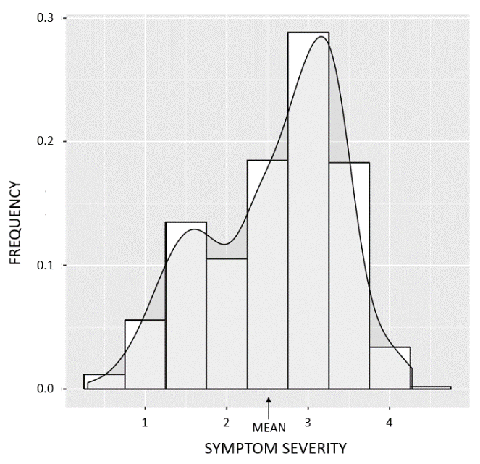

Figure S4. Frequency distribution of BLUEs obtained from symptom severity scores (SEV) data collected in 2016 (3 dates) and 2017 (5 dates) in Cadriano (Bologna, Italy) for Sv x Cc RILs and spatially corrected according to the moving mean of genotypic effects model.

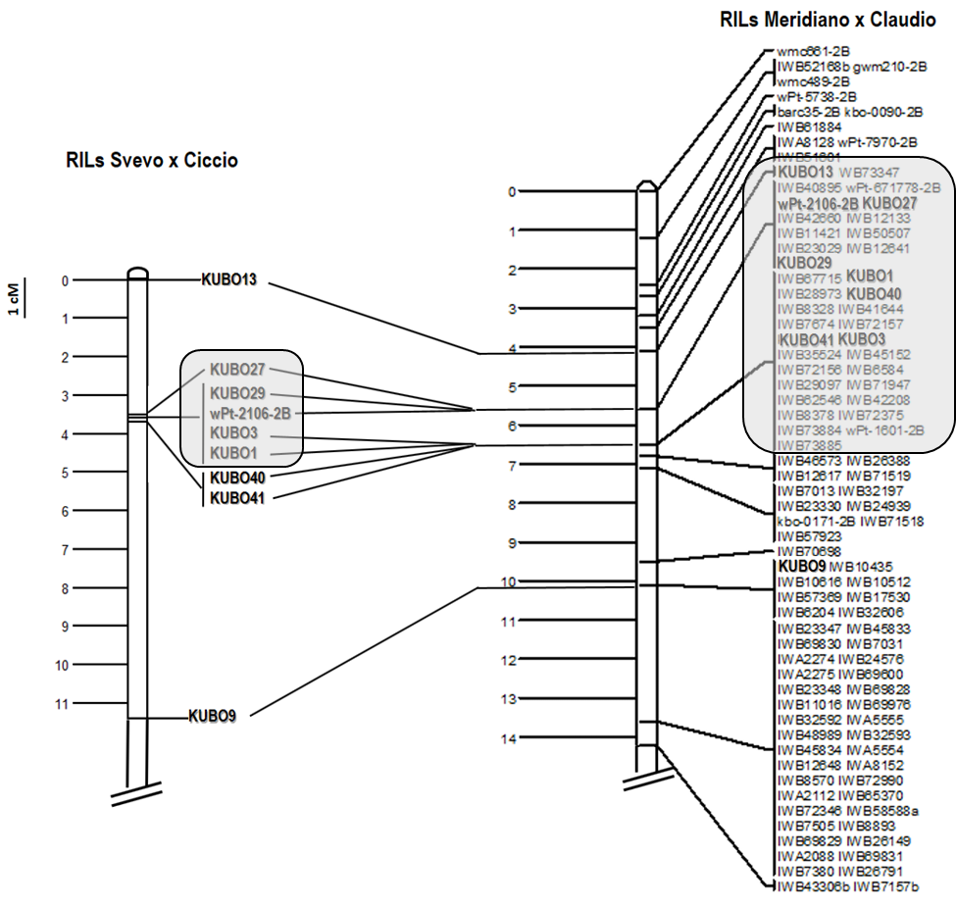

Figure S5. Genetic maps of RIL populations SvxCc and MrxCl obtained with the software JoinMap. Red squares delineate Sbm2 support interval.

Table S7. Genotyping results of SvxCc and MrxCl RILs carrying recombinations in Sbm2 region. A) Genotyping results of SvxCc RILs selected by MAS; B) Genotyping and phenotypic results of RILs carrying a recombination event between KUBO-27 and KUBO-40. A) and B) Phenotypic values are represented in a color scale from red (susceptible) to green (resistant). Red square indicates the interval where most probably Sbm2 is located.

ª Marker name,
^{b} Genetic positions (cM) reported as calculated by the software JoinMap,
^{c} Physical positions (bp) obtained by blasting the marker sequence on the durum wheat genome reference Svevo (Maccaferri et al., 2019),
^{d} Direction of the maker sequence,
^{e} SEV BLUEs data collected in 2016 (3 dates) and 2017 (5 dates) in Cadriano (Bologna, Italy) for Sv x Cc RILs and spatially corrected according to the moving mean of genotypic effects model,
^{f} B = Cc allele = susceptible,
^{g} A = Sv allele = resistant.
^{h} Number of individuals presenting a specific haplotype.
^{i} ELISA data obtained from sample of informative Sv x Cc RILs (2 replicates) collected in Cadriano (Bologna, Italy) in 2016 and 2017.

Table S7. Genotyping results of SvxCc and MrxCl RILs carrying recombinations in Sbm2 region. C) Genotyping results of MrxCl RILs selected by MAS. Phenotypic values are represented in a color scale from red (susceptible) to green (resistant). Red square indicates the interval where most probably Sbm2 is located.
ª Marker name,
^{b} Genetic positions (cM) reported as calculated by the software JoinMap,
^{c} Physical positions (bp) obtained by blasting the marker sequence on the durum wheat genome reference Svevo (Maccaferri et al., 2019),
^{d} Direction of the maker sequence,
^{e} BLUEs of Symptom Severity scores based on phenotypic data of Maccaferri et al. (2011) adjusted according to the method used to record Sv x Cc symptom severity scores (for ease of comparison),
^{f} Number of individuals presenting that specific haplotype,
^{g} A = Mr allele = resistant,
^{h} B = Cl allele = susceptible.

Method S4. Comparison of marker and gene order in Sbm2 region among genomes
A graphical comparison of marker order in Sbm2 region among the three Zavitan, Svevo and Chinese Spring genomes is shown in Figure S4. Order inconsistencies among physical maps of the three genomes regarded 26 markers, mostly located in a few regions that showed rearrangements among assemblies, including a group of eight markers had their start position inverted between Svevo and Zavitan in a region of two kb in Svevo and of three kb in Zavitan (IWB71947, IWB35524, IWB72156, IWB62546, IWB41644, IWB73884, IWB29097 and IWB72157).

Two markers were positioned inconsistently among the three genomes (IWB45152 and wPt-1601), one marker was positioned differently in Chinese Spring in respect to the other two genomes (IWB28973), three markers showed inconsistency in Zavitan in respect to the other two genomes (IWB57923 and IWA5772) and up to twelve markers were positioned differently in Svevo in respect to the other two genomes (wPt-2106, IWB50507, IWB71519, IWB45885, IWB4596, IWA7545, IWB26871, IWB26232, IWA3589, IWB26233, IWB65752, IWB8851). These rearrangements occurred in a region of 6.5 – 8 Mb depending on the genome. A group of eight markers had their start position inverted between Svevo and Zavitan in a region of two kb in Svevo and of three kb in Zavitan (IWB71947, IWB35524, IWB72156, IWB62546, IWB41644, IWB73884, IWB29097 and IWB72157).

The three wheat genome assemblies including Svevo, Chinese Spring (CS) v2.0, and Zavitan (Zv) v2.1 pseudomolecules were compared for collinearity in the interval IWB73347 (KUBO-13, position: 9,986,862 bp) and IWB10512 (KUBO 9, position: 24,313,794 bp), including Sbm2 (Figure S4). As regards to Svevo (as reference) versus CS v2.0 (Figure S5A), assemblies are co-linear with the exception of three main inversions on the Svevo in the intervals 10,631,152 -10,952,254 bp, 14,322,568-14,781,844 bp, and 17,971,448-18,480,002 bp. The first two inversions do not include molecular markers from Illumina 90K SNP Chip array. On the other hand, the third inversion includes the markers already detected with Pretzel software confirming those results, namely IWB45885, IWB4596, IWA7545, IWB26871, IWB26232, IWA3589, IWB26233. The random dots detected in the plot reported duplication or inversion of 5-7 kb size.
More differences among assemblies were detected using Zavitan as query and Chinese Spring or Svevo as references (Figure S5B and S5C). Both comparisons showed more duplications and alignment gaps. In addition, major inversions were detected between Zavitan and Svevo where two of them corresponded to the first and third inversions previously reported between Svevo and Chinese Spring. No inversions were detected between Zavitan and Chinese Spring assemblies, indicating that the local inversions in Svevo genomes could be artifacts.

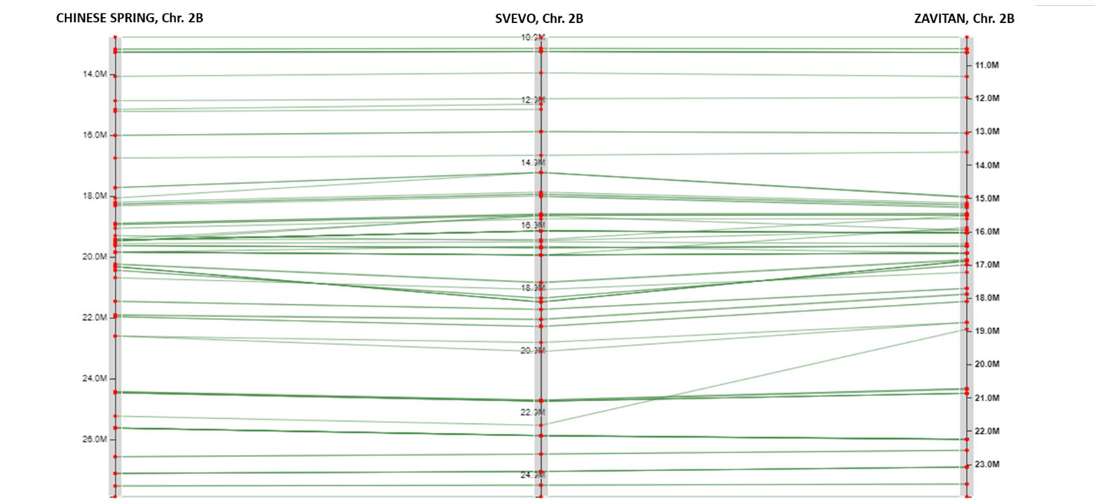

Figure S6. Comparison of marker order in Sbm2 region among three physical maps: Chinese Spring genome (bread wheat), Svevo genome (durum wheat) and Zavitan genome (wild emmer wheat). Markers are represented by red dots. Green lines connect markers with the same name in different genomes. Positions are expressed in bp and were retrieved blasting marker sequences against the reference genome sequences.

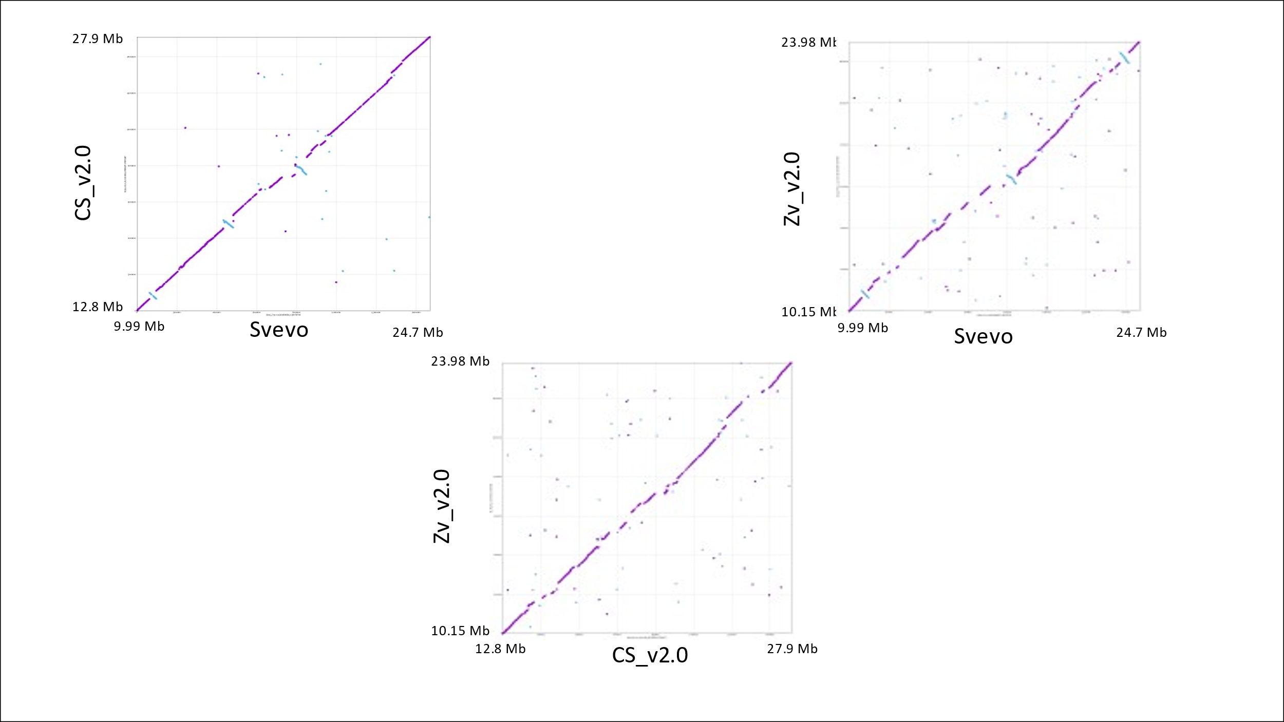
C
A
B

Figure S7. Mummer dot plot reporting the comparison between A) CS v2.0 and Svevo , B) Zv v2.0 and Svevo and C) Zv v2.1 and CS v2.0. The linearity between sequences is reported along the plot diagonal with purple dots, inversions are reported in light blue.

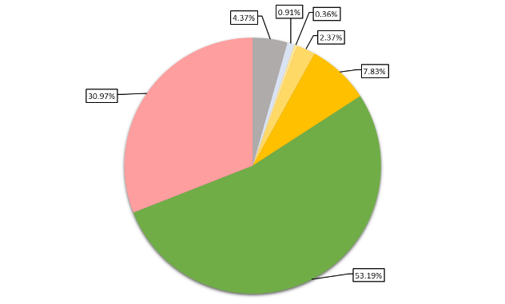
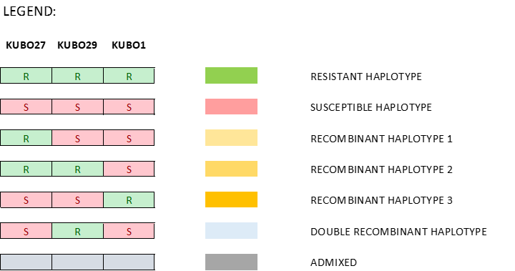

Figure S8: Proportion of different haplotypes at Sbm2 composing the complete panel of 549 durum wheat accessions. The haplotype refers to three markers (KUBO-27, KUBO-29 and KUBO-1) and includes the support interval of the QTL.

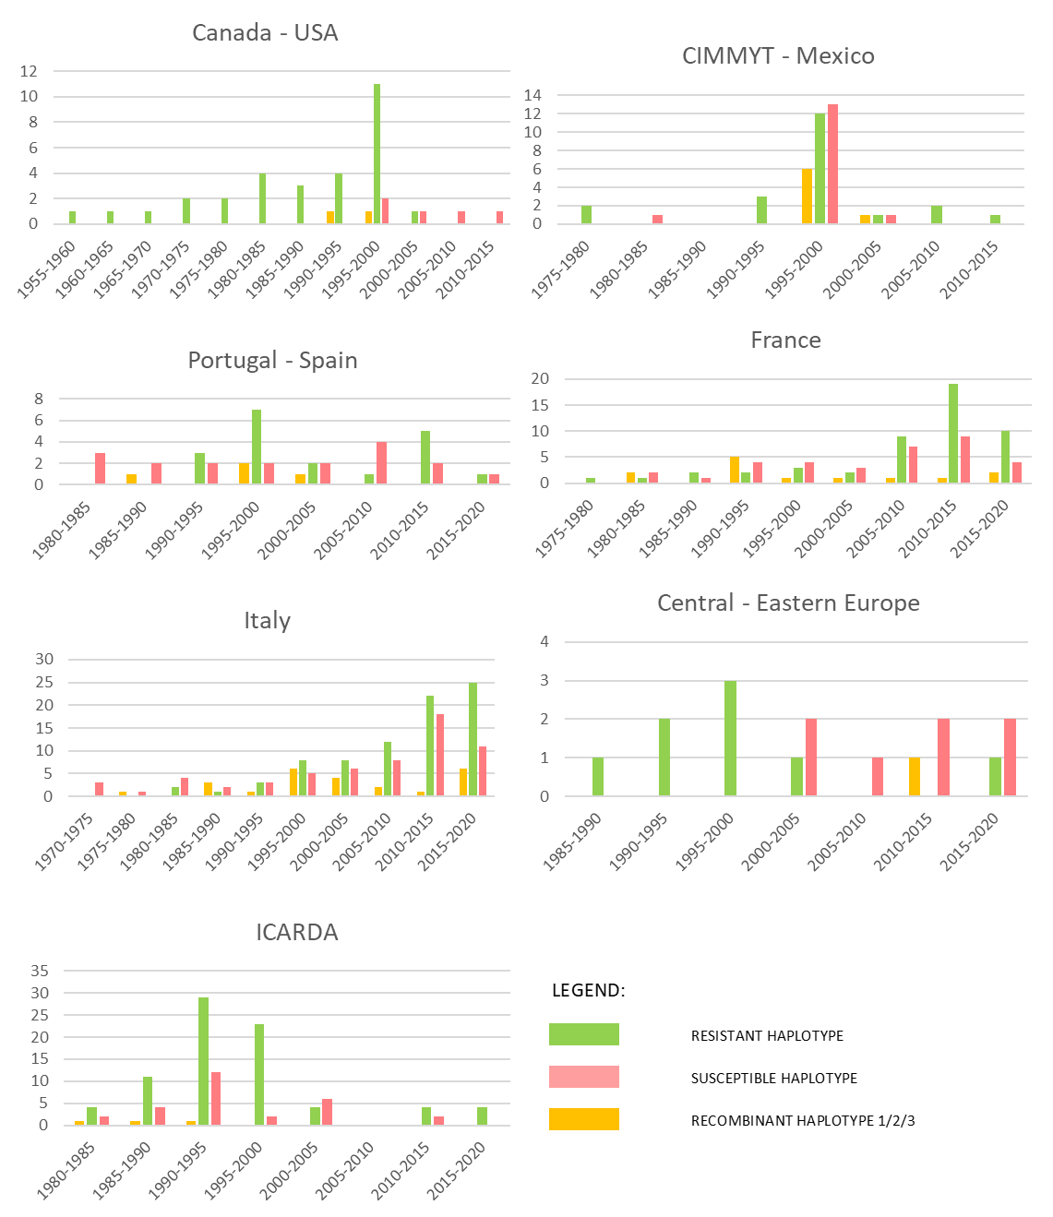

Figure S9. Histograms showing Sbm2 haplotypes trends across intervals of 5 years based on the years of release of the accessions and on their origin. The haplotype refers to three markers (KUBO-27, KUBO-29 and KUBO-1) and includes the support interval of Sbm2. Two accessions of Central – Eastern Europe, respectively resistant and released in 1926 and recombinant and released in 1950, and three accessions of Italian origin, respectively recombinant and released in 1915 and susceptible and released in 1930 and 1940, are not reported in the histograms.

Table S8. Description and number of genes associated to each description present in the support interval of Sbm2, based on the physical map of the Svevo genome.

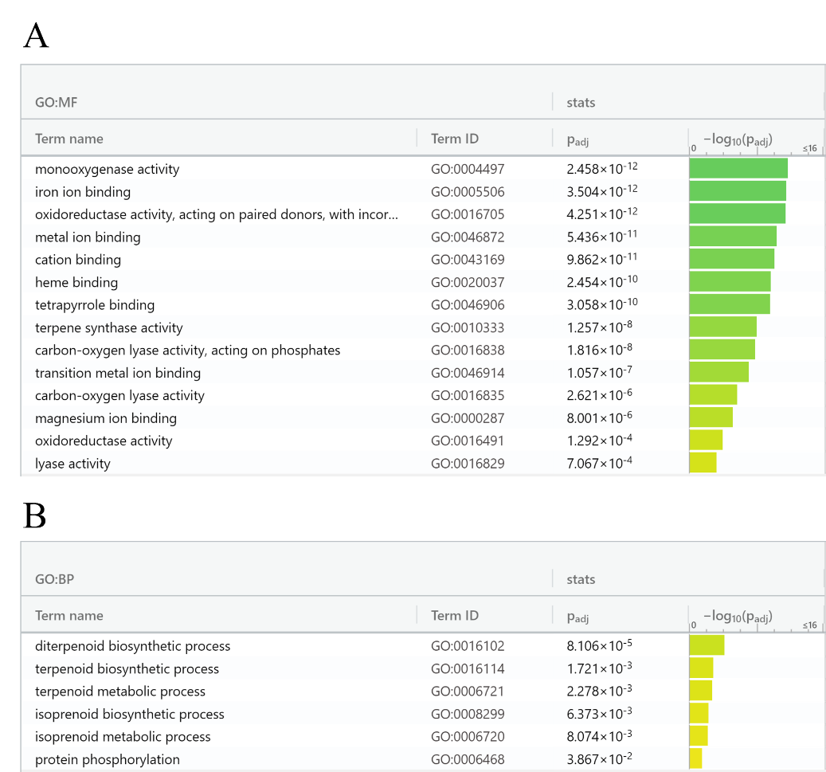

Figure S10. Molecular function (A) and Biological processes (B) of GO enrichment analysis. The logarithm of adjusted P value was reported for every molecular function or biological process.

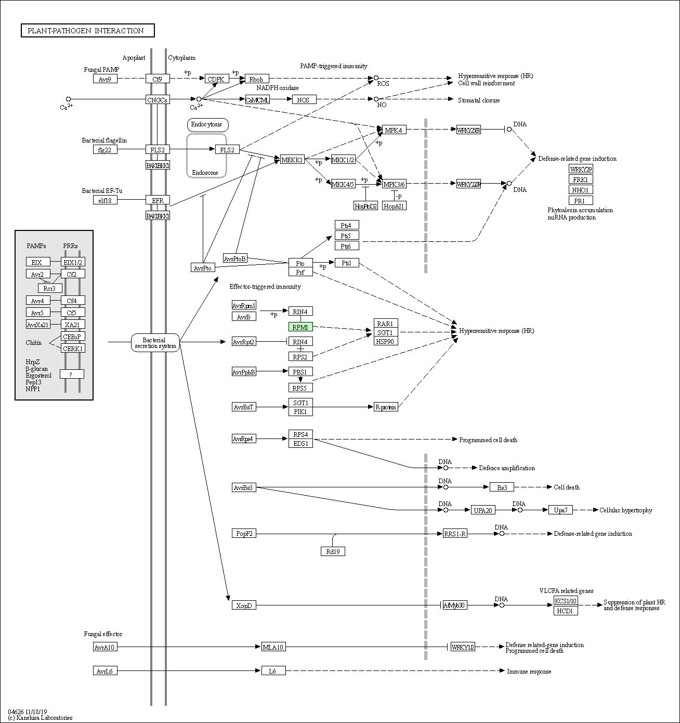

Figure S11. Plant-pathogen interaction pathways identified by BlastKoala analysis, corresponding to organismal system KEGG category. The gene RPM1 (TRITD2Bv1G007240) is mainly involved in the recognition of the avirulence pathogen protein (Avr) into the host organism.

