Extended data Fig 1.

a
 | Plasma findings - read counts and coverages | Liver findings - read counts and coverages
Patient 1 | Centrifuge¹:  HAdVC 459 reads, PCR Ct-value 36.3  Alphatorque (including TTV28) 169 reads, PCR Ct-value 27.9 | None
Patient 2 | GenomeDetective:  AAV-2 994,335 reads, 100% coverage, PCR Ct-value 24  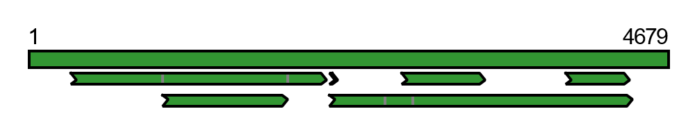  Centrifuge:  HHV7 100 reads² | Genome Detective:  AAV-2 1,488,305 reads, 99.9% coverage  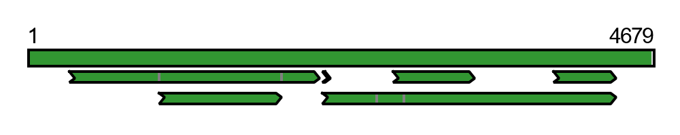  HHV-6 6,286 reads, 13% coverage, PCR Ct-value 30.6 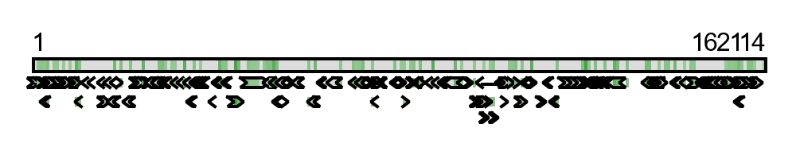  HHV7 252 reads, 1.4% coverage, PCR Ct-value 36.8  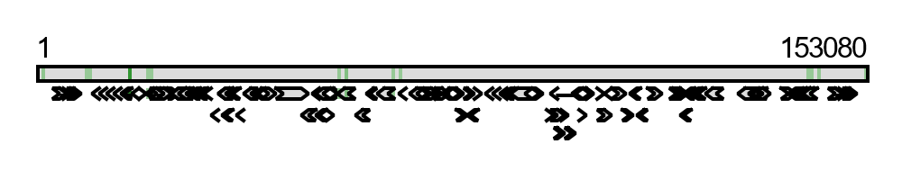  HPyV 292 reads, 12.2% coverage  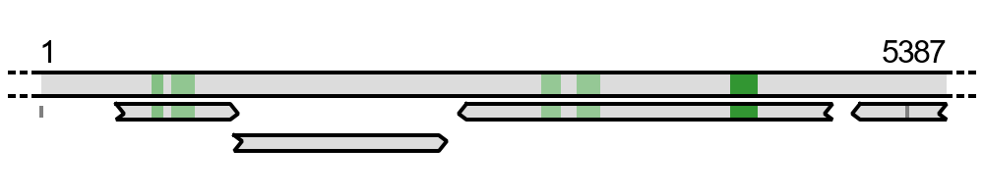
Patient 3 | None | Centrifuge:  EBV 173 reads PCR Ct-value 34.7
Patient 4 | GenomeDetective:  EBV 237,721 reads, 11.4% coverage, PCR Ct-value 32.3  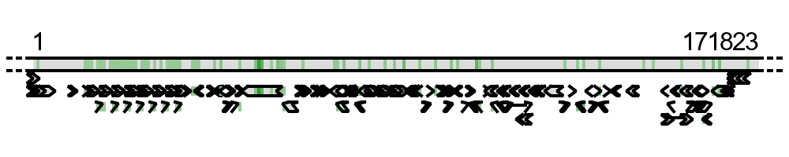 | No biopsy material available
Patient 5 | GenomeDetective:  AAV-2 14,937,373 reads, 98.8% coverage, PCR Ct-value 26  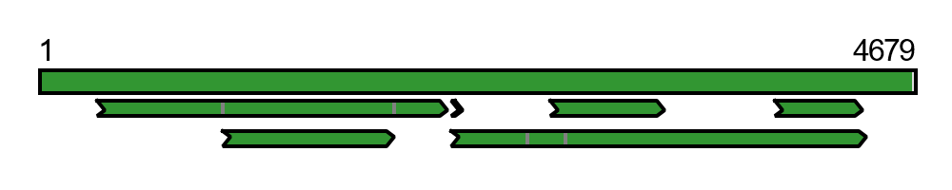  VZV 3,244,606 reads, 16.6% coverage, PCR Ct-value 30.1  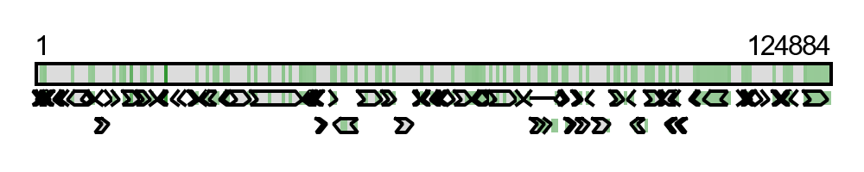  HPyV 747 reads, 1,8% coverage  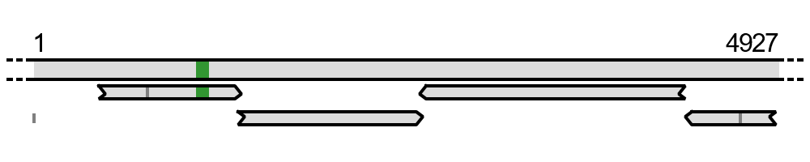  Centrifuge:  TTV10 8,512 reads, PCR Ct-value 28.6, 6.5 log₁₀ c/ml | GenomeDetective:  AAV-2 464,469 reads, 99.4% coverage  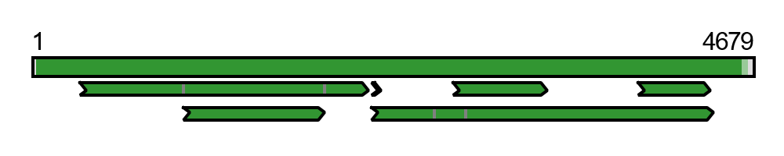  HHV6 7,593 reads, 16% coverage, PCR Ct-value 28.7  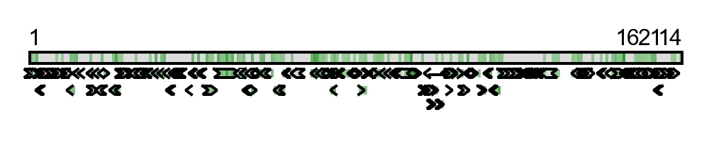  TTV5 301 reads, 25.5% coverage, PCR Ct-value 30.5, 5.9 log₁₀ c/ml  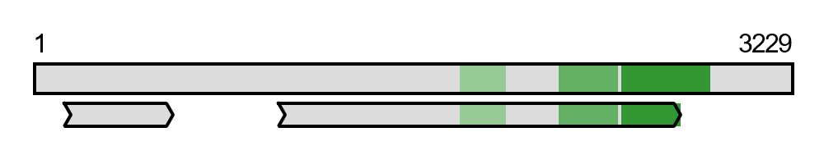  HAdV40/41 104 reads, 0.8% coverage, PCR Ct-value 34.5  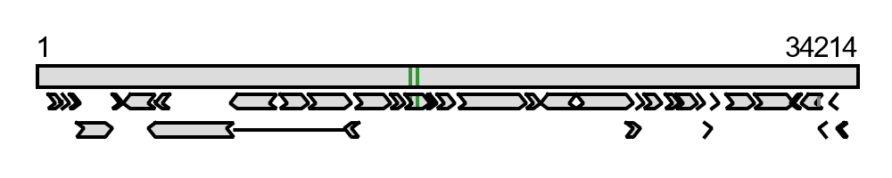
¹ no coverage bars available by Centrifuge classification, ² no residual material available for PCR testing,

b

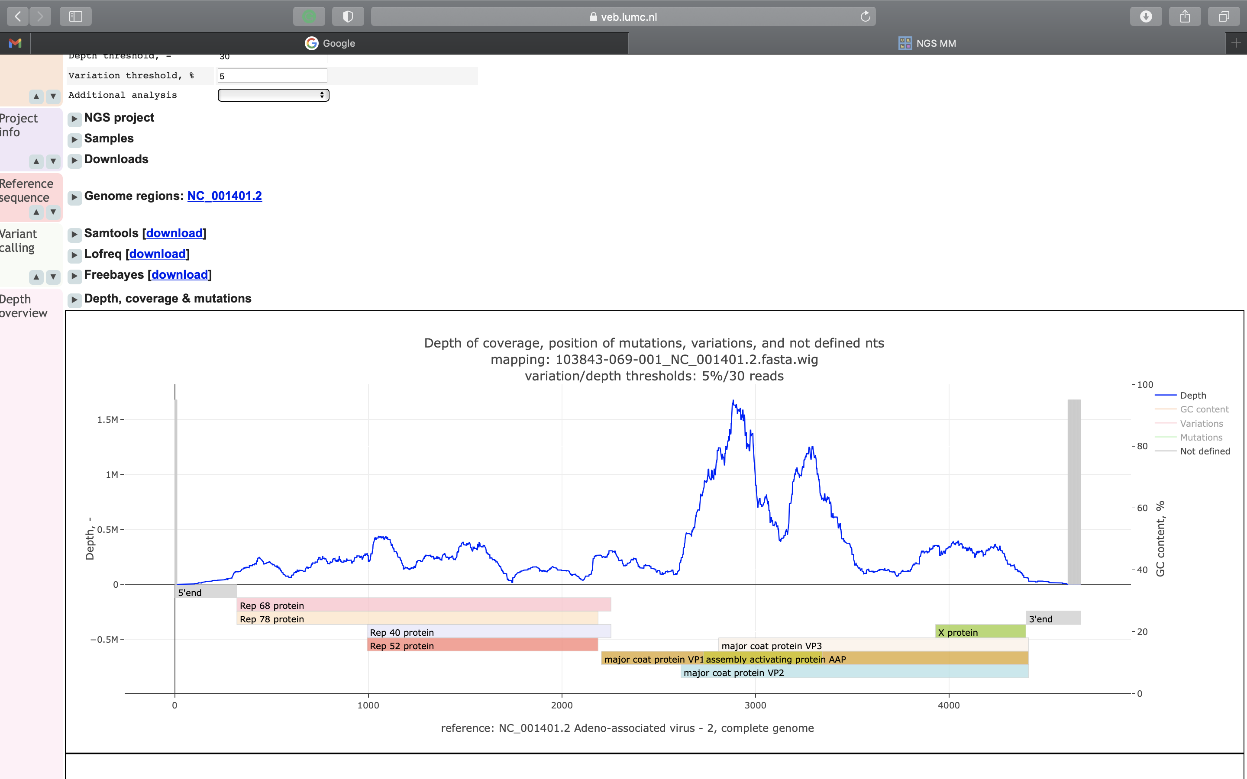
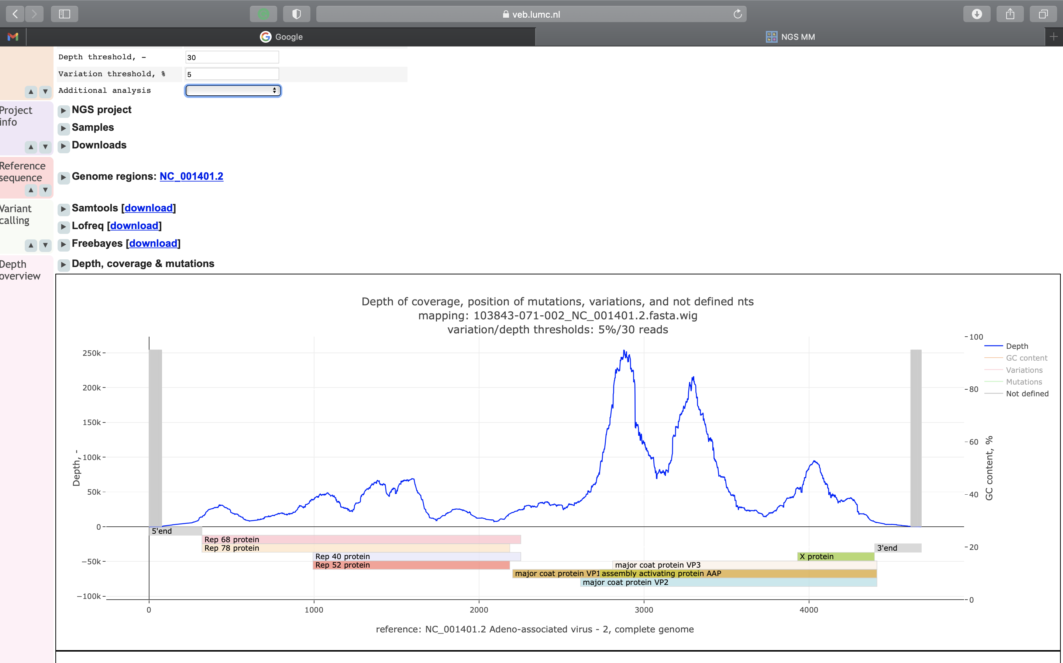
Patient 2 Plasma
Patient 2 Liver
(bp)
(bp)
Mean Depth: 308,423x Coverage: 98.40%
Mean Depth: 47,283x Coverage: 97.03%

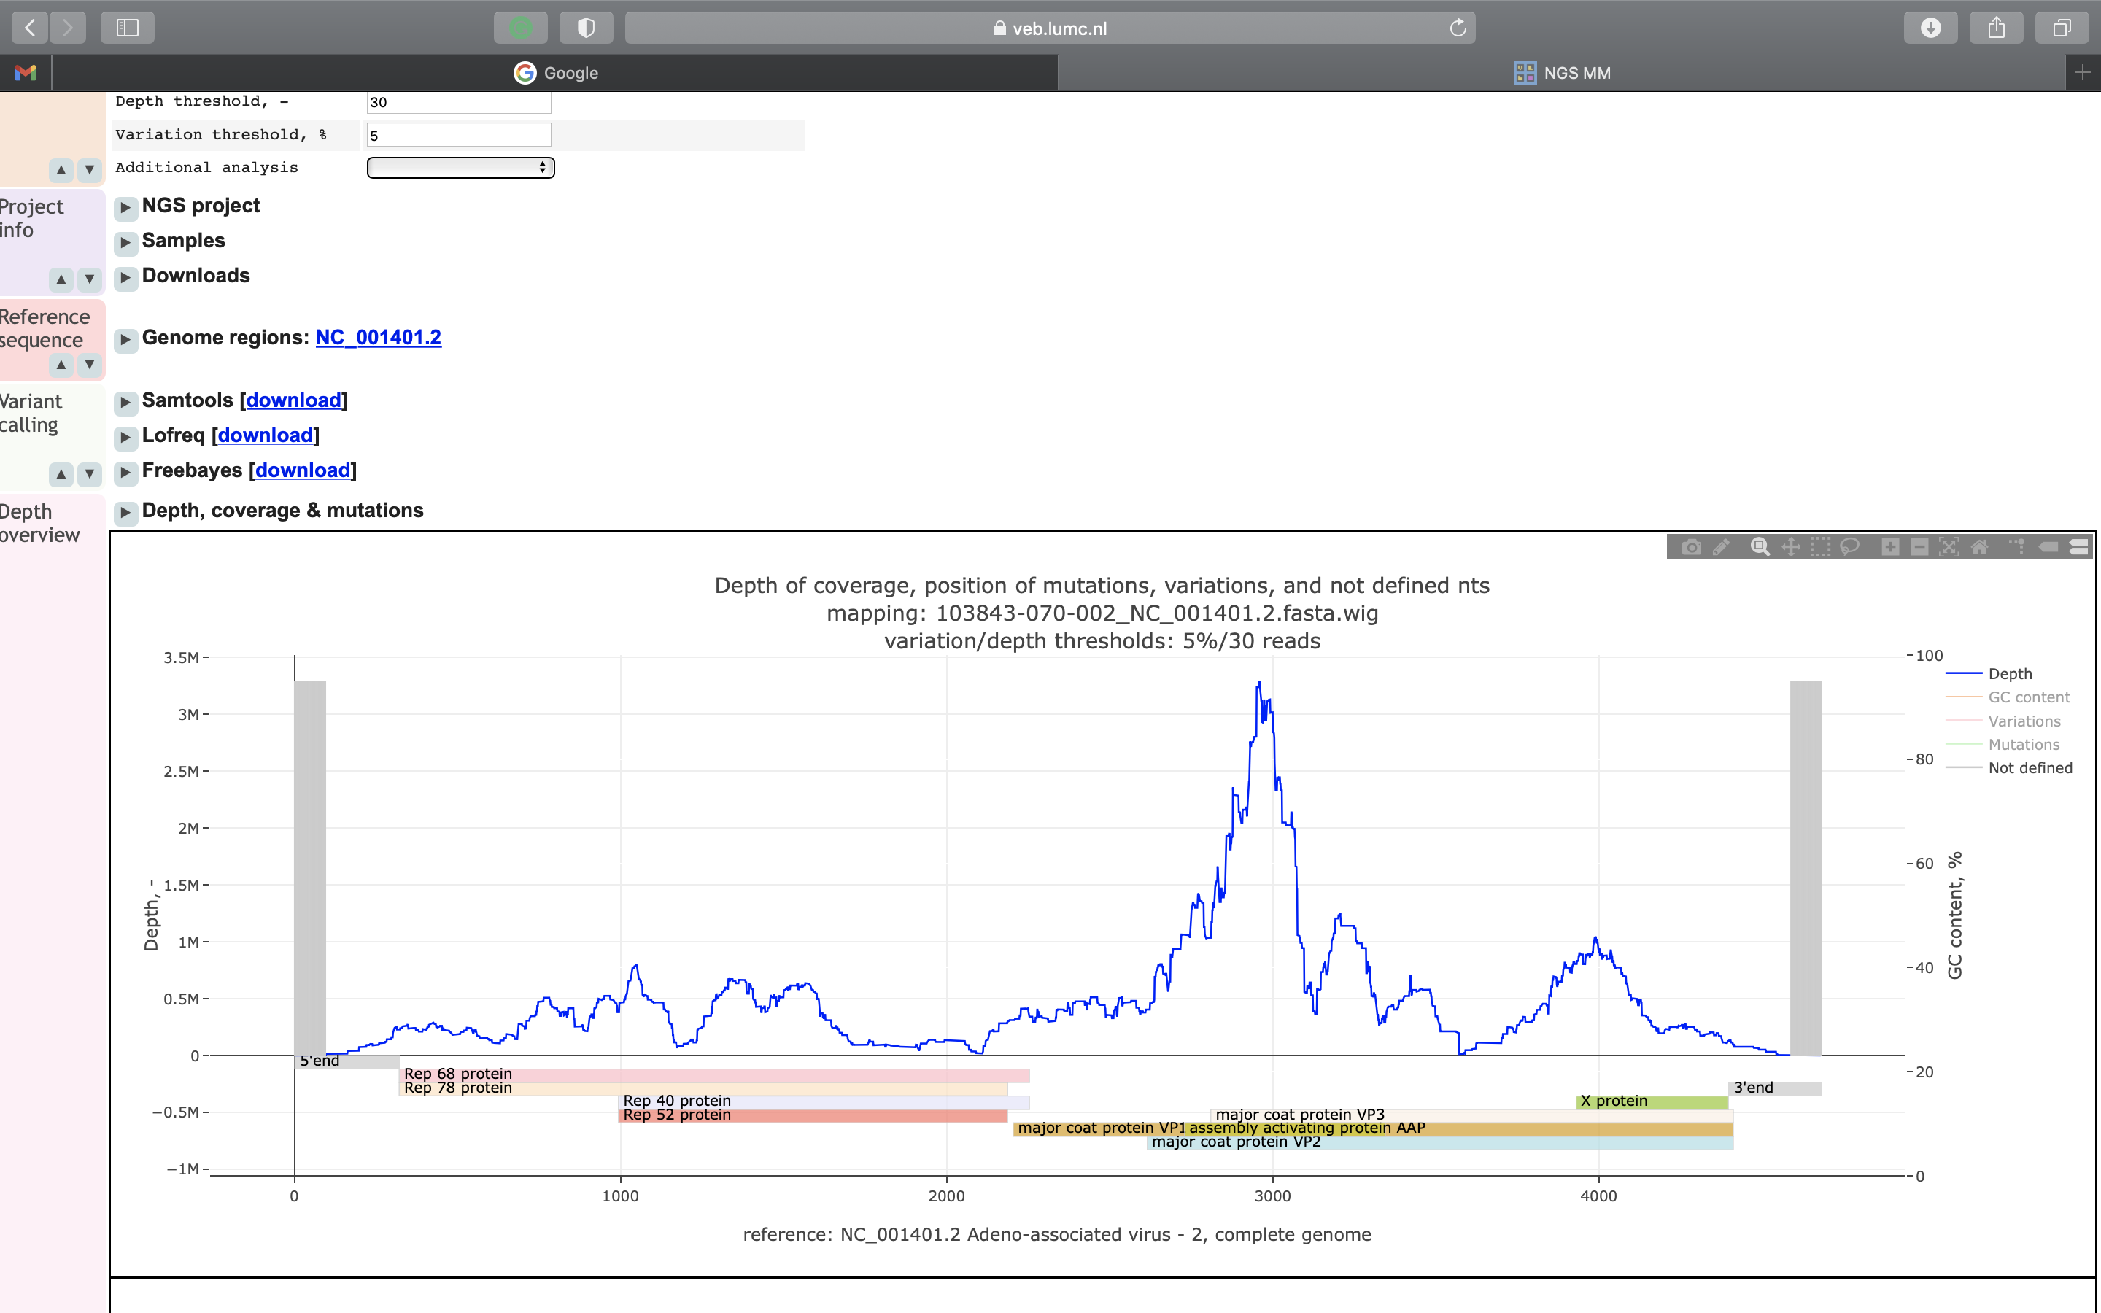
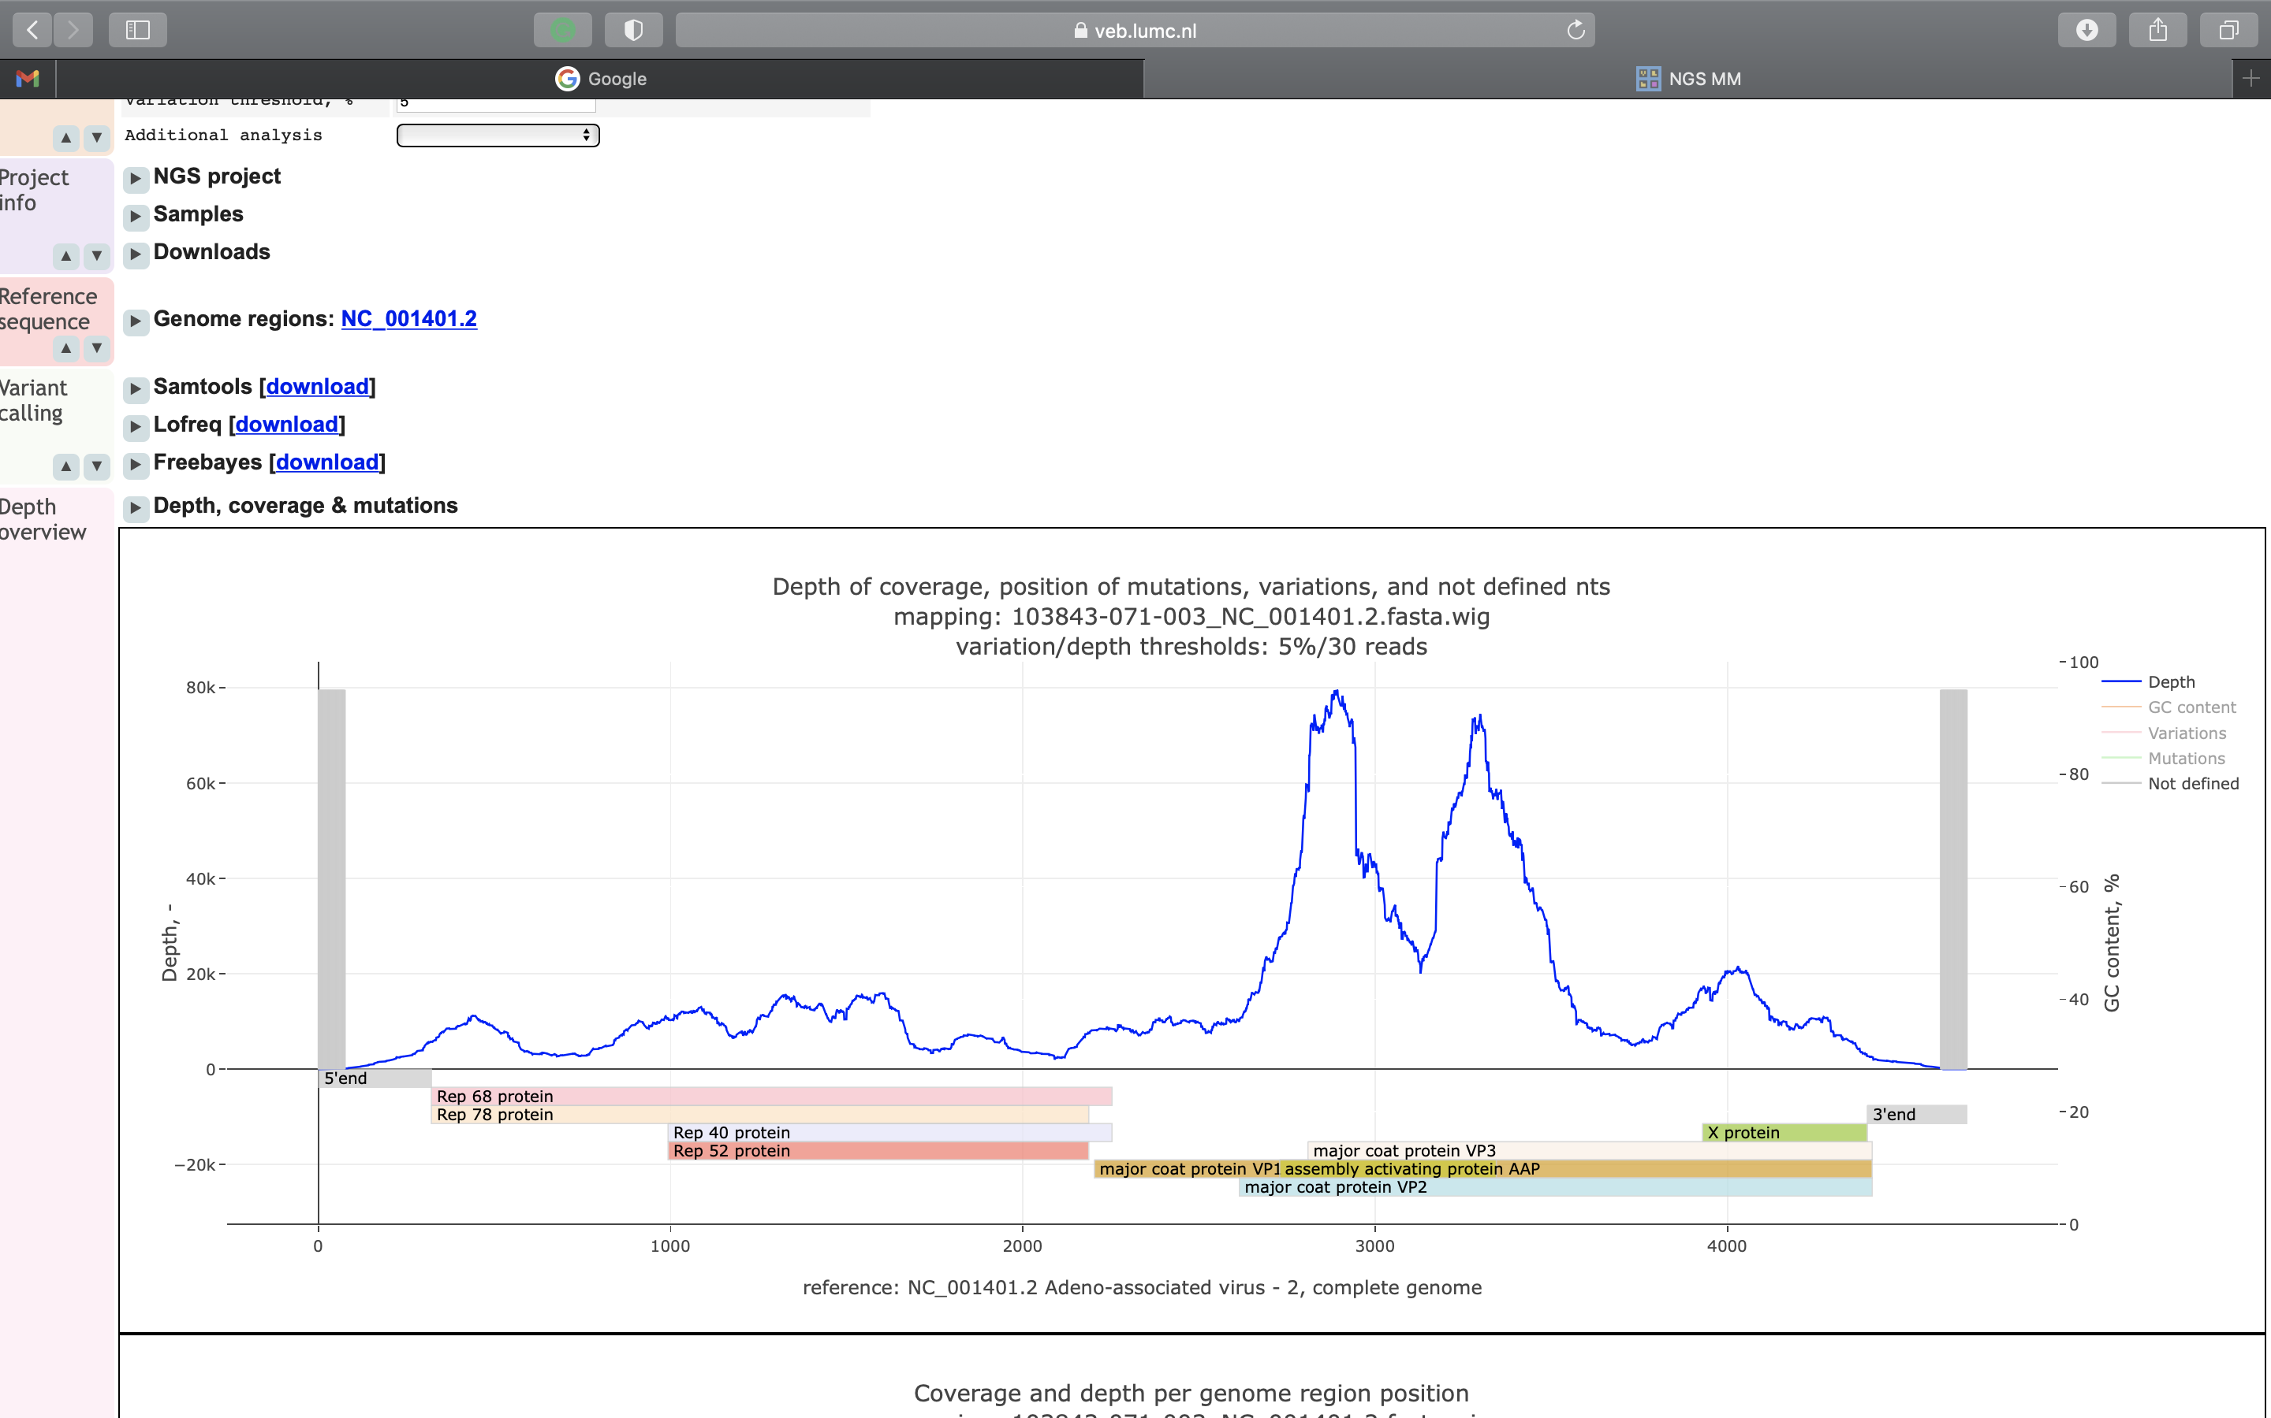
Patient 5 Plasma
Patient 5 Liver
(bp)
(bp)
Mean Depth: 14,799x Coverage: 96.82%
Mean Depth: 466,870x Coverage: 96.05%

Sequence read coverages plots of main virus findings and of AAV2 genome from paediatric cases of acute liver failure. a, Results of read counts and coverage plots. b, Mapping of sequence reads obtained from cases by viral metagenomics to AAV2 reference genome NC_001401.2.

