World War II effects on prevalence and pattern of multimorbidity in older adults: Results from the KORA-Age study

Arshadipour A^{1,2*}, Thorand B^{1,6}, Linkohr B¹, Rospleszcz S^{1,2}, Ladwig K.H.^{1,3}, Heier M^{1,4}, Peters A^{1,2,5,6}
- Institute of Epidemiology, Helmholtz Zentrum München, German Research Center for Environmental Health, Neuherberg, Germany.
- Institute for Medical Information Processing Biometry and Epidemiology (IBE), Ludwig-Maximilians-Universität München, Munich, Germany.
- Department for Psychosomatic Medicine and Psychotherapy, Klinikum Rechts der Isar, Technical University of Munich, Munich, Germany.
- KORA Study Centre, University Hospital of Augsburg, Augsburg, Germany.
- German Center for Cardiovascular Disease Research (DZHK), Munich Heart Alliance, Munich, Germany.
- German Center for Diabetes Research (DZD), München-Neuherberg, Germany.

Journal: BMC Geriatrics

§ Corresponding author
Ava Arshadipour,
Institute of Epidemiology, Helmholtz Zentrum München, German Research Center for Environmental Health, Ingolstädter Landstraße 1, 85764 Munich, Germany
Tel.: +49 89 3187-49281, +49 1777369163
Email: a.arshadipour@campus.lmu.de, azam.arshadipour@helmholtz-muenchen.de

Figure S1. Predicted probability of MM stratified by birth phases and sex

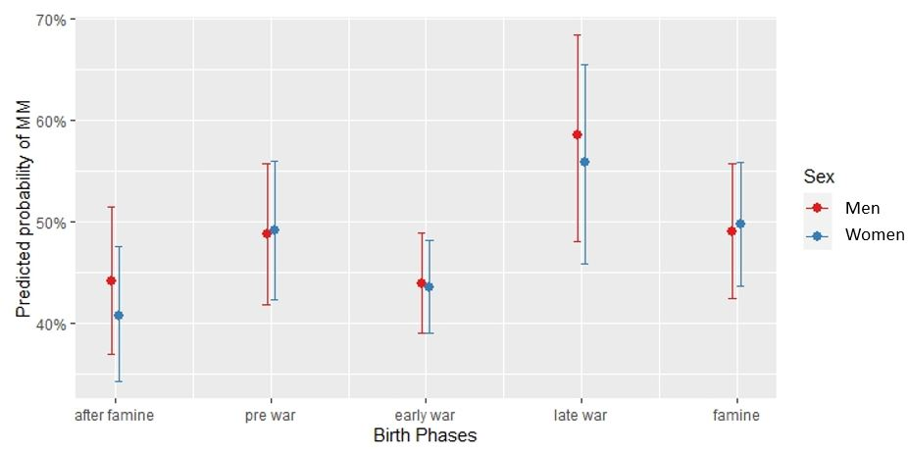

The interaction of sex and birth phases for predicted probability of MM based on multiple logistic regression adjusted for age, sex, education, alcohol use, physical activity, BMI, smoking behavior and cognitive status. There were no significant differences (p < 0.05) in all levels of birth phases between men and women.

Figure S2. Prevalence of multimorbidity and single chronic diseases stratified by sex for all participants (n=3,377) from KORA-Age 1 and KORA-Age 3.

Figure S3. Dendrogram based on the hierarchical clustering of chronic diseases using the average linkage method and Yule-Q coefficient for men.
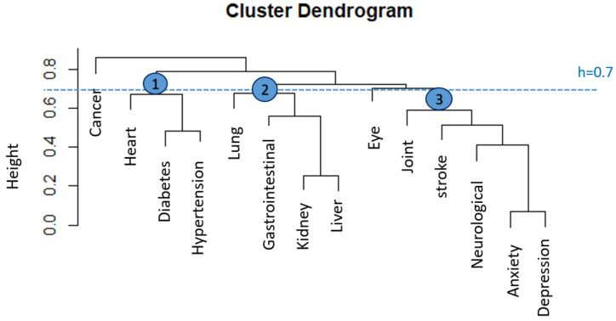

The threshold (dotted line. h=0.7) was used to specify three main clusters.

Figure S4. Dendrogram based on the hierarchical clustering of chronic diseases using the average linkage method and Yule-Q coefficient for women.
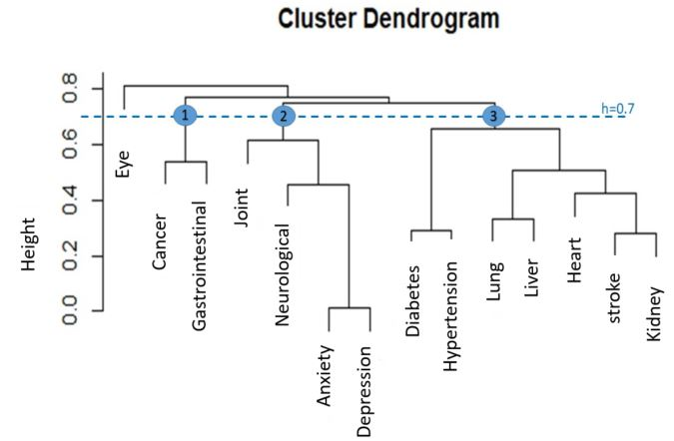

The threshold (dotted line. h=0.7) was used to specify three main clusters.

Figure S5. Dendrogram based on the hierarchical clustering of chronic diseases without hypertension for all participants using average linkage method and Yule-Q coefficient (Sensitivity analysis).
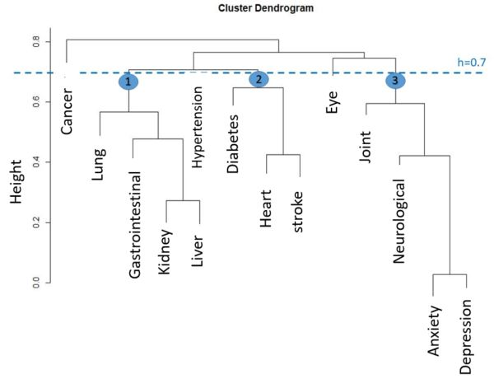

The threshold (dotted line. h=0.7) was used to specify three main clusters.

Figure S6. Dendrogram based on the hierarchical clustering of chronic diseases for all participants using the single linkage method and Yule-Q coefficient (sensitivity analysis).
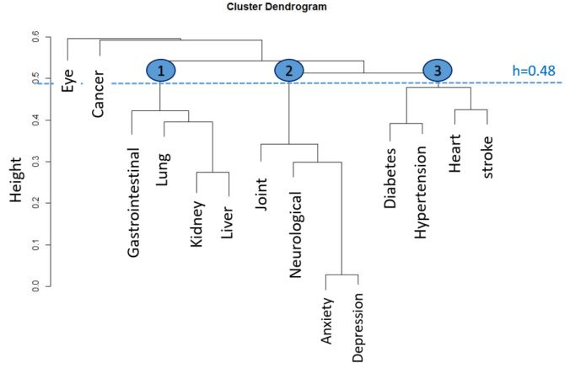

The threshold (dotted line. h=0.7) was used to specify three main clusters.

Figure S7. Dendrogram based on the hierarchical clustering of chronic diseases for all participants using Ward.d linkage method and Yule-Q coefficient (sensitivity analysis). 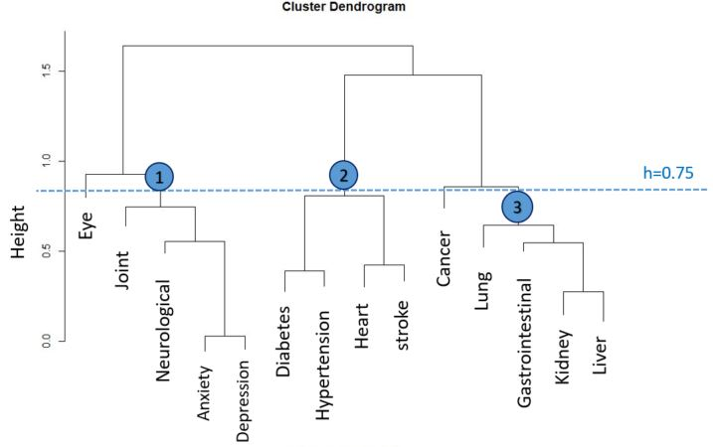

The threshold (dotted line. h=0.7) was used to specify three main clusters.

Table S1. The number of chronic diseases stratified by sex and birth phase variable for the whole data from KORA-Age 1 and Kora-Age 3.
Number of diseases | Total |  |  | Phase 1 |  |  | Phase 2 |  |  | Phase 3 |  |  | Phase 4 |  |  | Phase 5
Number of diseases | Total (3,377) | Male (1,616) | Female (1,761) | Total (684) | Male (327) | Female (357) | Total (1,236) | Male (608) | Female (628) | Total (283) | Male (136) | Female (147) | Total (574) | Male (267) | Female (307) | Total (600) | Male (278) | Female (322)
0 | 638 (18.9%) | 312 (19.3%) | 326 (18.5%) | 112 (16.4%) | 56 (17.1%) | 56 (15.7%) | 243 (19.7%) | 128 (21.1%) | 115 (18.3%) | 42 (14.8%) | 21 (15.4%) | 21 (14.3%) | 97 (16.9%) | 38 (14.2%) | 59 (19.2%) | 144 (24%) | 69 (24.8%) | 75 (23.3%)
1 | 1,072 (31.7%) | 516 (31.9%) | 556 (31.6%) | 202 (29.5%) | 99 (30.3%) | 103 (28.9%) | 432 (35%) | 207 (34%) | 225 (35.8%) | 65 (23%) | 30 (22.1%) | 35 (23.8%) | 167 (29.1%) | 90 (33.7%) | 77 (25.1%) | 206 (34.3%) | 90 (32.4%) | 116 (36.0%)
2 | 873 (25.9%) | 404 (25.0%) | 469 (26.6%) | 186 (27.2%) | 84 (25.7%) | 102 (28.6%) | 311 (25.2%) | 149 (24.5%) | 162 (25.8%) | 85 (30%) | 41 (30.1%) | 44 (29.9%) | 151 (26.3%) | 71 (26.6%) | 80 (26.1%) | 140 (23.3%) | 59 (21.2%) | 81 (25.2%)
>=2 (Multi  morbidity) | 1,667 (49.4%) | 788 (48.8%) | 879 (49.9%) | 370 (54.1%) | 172 (52.6%) | 198 (55.5%) | 561 (45.4%) | 273 (44.9%) | 288 (45.9%) | 176 (62.2%) | 85 (62.5%) | 91 (61.9%) | 310 (54%) | 139 (52.1%) | 171 (55.7%) | 250 (41.7%) | 119 (42.8%) | 131 (40.7%)
>=3 | 794 (23.5%) | 384 (23.8%) | 410 (23.3%) | 184 (26.9%) | 88 (26.9%) | 96 (26.9%) | 250 (20.2%) | 124 (20.4%) | 126 (20.1%) | 91 (32.2%) | 44 (32.4%) | 47 (32%) | 159 (27.7%) | 68 (25.5%) | 91 (26.9%) | 110 (18.3%) | 60 (21.6%) | 50 (15.5%)
>=4 | 320 (9.5%) | 147 (9.1%) | 173 (9.8%) | 78 (11.4%) | 37 (11.3%) | 41 (11.5%) | 104 (8.4%) | 48 (7.9%) | 56 (8.9%) | 35 (12.4%) | 16 (11.8%) | 19 (12.9%) | 62 (10.8%) | 25 (9.4%) | 37 (12.1%) | 41 (6.8%) | 21 (7.6%) | 20 (6.2%)
>=5 | 124 (3.7%) | 57 (3.5%) | 67 (3.8%) | 30 (4.4%) | 12 (3.7%) | 18 (5%) | 44 (3.6%) | 22 (3.6%) | 22 (3.5%) | 17 (6%) | 9 (6.6%) | 8 (5.4%) | 21 (3.7%) | 10 (3.7%) | 11 (3.6%) | 12 (2%) | 4 (1.4%) | 8 (2.5%)
>=6 | 50 (1.5%) | 24 (1.5%) | 26 (1.5%) | 12 (1.8%) | 4 (1.2%) | 8 (2.2%) | 21 (1.7%) | 11 (1.8%) | 10 (1.6%) | 6 (2.1%) | 3 (2.2%) | 3 (2%) | 9 (1.6%) | 4 (1.5%) | 5 (1.6%) | 2 (0.3%) | 2 (0.7%) | 0 (0.0%)
Phases were defined based on participant’s critical developmental age (prenatal gestation or the first two years of life) and the World War II situation in Germany. Phase 1: pre-War; Phase 2: Early War; Phase 3: Late War; Phase 4: Famine; Phase 5: After famine.

Table S2. Hierarchical Logistic regression for multimorbidity without hypertension (Sensitivity analysis)
characteristics |  | model 1 | model 2 | model 3 | model 4
age |  | 1.11 (0.95-1.15) |  | 1.10 (0.96-1.15) | 1.10 (0.96-1.15)
Birth phases (ref: Phase 5) | Phase 1 |  | 1.64 (1.28-2.09) | 1.44 (0.96-2.16) | 1.64 (1.07-2.49)
Birth phases (ref: Phase 5) | Phase 2 |  | 1.21 (0.96-1.52) | 1.17 (0.92-1.49) | 1.21 (0.94-1.56)
Birth phases (ref: Phase 5) | Phase 3 |  | 2.3 (1.69-3.1) | 1.98 (1.22-3.19) | 2.14 (1.29-3.52)
Birth phases (ref: Phase 5) | Phase 4 |  | 1.68 (1.30-2.17) | 1.56 (1.12-2.15) | 1.52 (1.08-2.14)
Female (ref: male) |  |  |  |  | 0.91 (0.75-1.08)
Education (ref: Low) | Middle |  |  |  | 0.99 (0.76-1.3)
Education (ref: Low) | High |  |  |  | 0.87 (0.65-1.18)
Alcohol consumption (ref: never or rare use) | Once a week |  |  |  | 0.99 (0.78-1.24)
Alcohol consumption (ref: never or rare use) | Daily use |  |  |  | 0.66 (0.55-0.8)
Physical Activity (active) | Inactive |  |  |  | 1.44 (1.22-1.69)
BMI (ref: Underweight or normal ) | Overweight |  |  |  | 1.05 (0.87-1.27)
BMI (ref: Underweight or normal ) | Obesity grade I |  |  |  | 1.46 (1.16-1.84)
BMI (ref: Underweight or normal ) | Obesity grade II or III |  |  |  | 2.11 (1.52-2.91)
Smoking behavior(ref: never) | Active smoker |  |  |  | 1.28 (0.97-1.67)
Smoking behavior(ref: never) | Ex-smoker |  |  |  | 1.41 (1.19-1.68)
Cognitive status(ref: good) | Mildly impaired |  |  |  | 1.7 (1.27-2.27)
Cognitive status(ref: good) | Impaired |  |  |  | 1.31 (0.80-2.17)
AIC |  | 4,107.9 | 4,103.6 | 4,105 | 3,873.2

Phases were defined based on participant’s critical developmental age (prenatal gestation or the first two years of life) and the World War II situation in Germany. Phase 1: pre-War; Phase 2: Early War; Phase 3: Late War; Phase 4: Famine; Phase 5: After famine.

