World War II effects on prevalence and pattern of multimorbidity in older adults: Results from the KORA-Age study

Arshadipour A^{1,2*}, Thorand B^{1,6}, Linkohr B¹, Rospleszcz S^{1,2}, Ladwig K.H.^{1,3}, Heier M^{1,4}, Peters A^{1,2,5,6}
- Institute of Epidemiology, Helmholtz Zentrum München, German Research Center for Environmental Health, Neuherberg, Germany.
- Institute for Medical Information Processing Biometry and Epidemiology (IBE), Ludwig-Maximilians-Universität München, Munich, Germany.
- Department for Psychosomatic Medicine and Psychotherapy, Klinikum Rechts der Isar, Technical University of Munich, Munich, Germany.
- KORA Study Centre, University Hospital of Augsburg, Augsburg, Germany.
- German Center for Cardiovascular Disease Research (DZHK), Munich Heart Alliance, Munich, Germany.
- German Center for Diabetes Research (DZD), München-Neuherberg, Germany.

Journal: European Journal of Epidemiology

§ Corresponding author
Ava Arshadipour,
Institute of Epidemiology, Helmholtz Zentrum München, German Research Center for Environmental Health, Ingolstädter Landstraße 1, 85764 Munich, Germany
Tel.: +49 89 3187-49281, +49 1777369163
Email: a.arshadipour@campus.lmu.de, azam.arshadipour@helmholtz-muenchen.de
Additional figure 1. Prevalence of multimorbidity and single chronic diseases stratified by sex for all participants (n=3,377) from KORA-Age 1 and KORA-Age 3.

Additional figure 2. Dendrogram based on the hierarchical clustering of chronic diseases using the average linkage method and Yule-Q coefficient for men. the threshold (dotted line. h=0.7) was used to specify three main clusters.
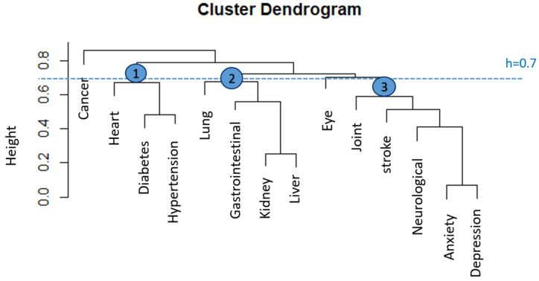

Additional figure 3. Dendrogram based on the hierarchical clustering of chronic diseases using the average linkage method and Yule-Q coefficient for women. the threshold (dotted line. h=0.7) was used to specify three main clusters.
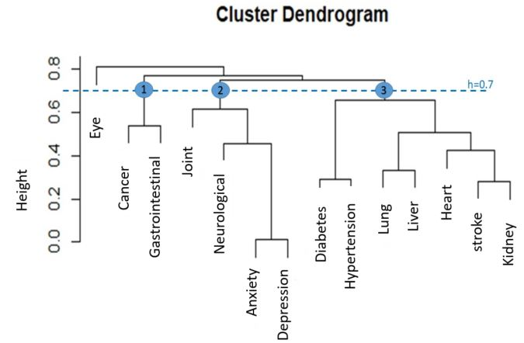
Additional figure 4. Dendrogram based on the hierarchical clustering of chronic diseases without hypertension for all participants using average linkage method and Yule-Q coefficient (Sensitivity analysis). The threshold (dotted line. h=0.7) was used to specify three main clusters.
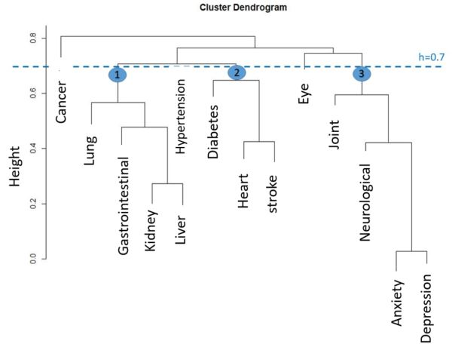
Additional figure 5. Dendrogram based on the hierarchical clustering of chronic diseases for all participants using the single linkage method and Yule-Q coefficient (sensitivity analysis). The threshold (dotted line. h=0.48) was used to specify three main clusters.
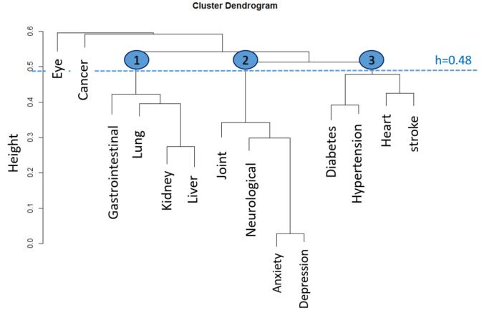
Additional figure 6. Dendrogram based on the hierarchical clustering of chronic diseases for all participants using Ward.d linkage method and Yule-Q coefficient (sensitivity analysis). The threshold (dotted line. h=0.75) was used to specify three main clusters.
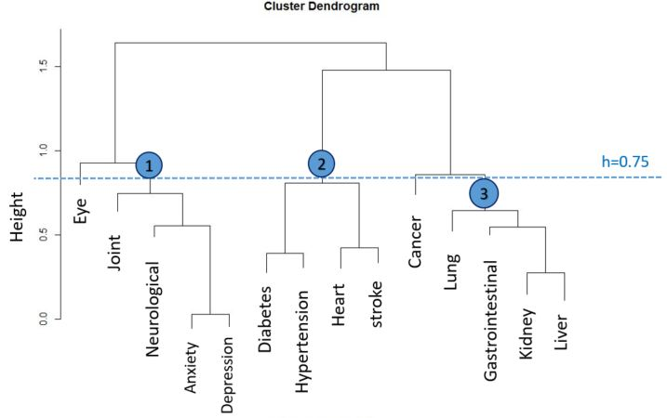

Additional table 1. The number of chronic diseases stratified by sex and birth phases variable for the whole data from Kora-Age1 and Kora-Age1.
Number of diseases | Total |  |  | Phase 1 |  |  | Phase 2 |  |  | Phase 3 |  |  | Phase 4 |  |  | Phase 5
Number of diseases | Total(3,377) | Male(1,616) | Female(1,761) | Total (684) | Male (327) | Female (357) | Total (1,236) | Male (608) | Female (628) | Total (283) | Male (136) | Female (147) | Total (574) | Male (267) | Female (307) | Total (600) | Male (278) | Female (322)
0 | 638(18.9%) | 312(19.3%) | 326(18.5%) | 112(16.4%) | 56(17.1%) | 56(15.7%) | 243(19.7%) | 128(21.1%) | 115(18.3%) | 42(14.8%) | 21(15.4%) | 21(14.3%) | 97(16.9%) | 38(14.2%) | 59(19.2%) | 144(24%) | 69(24.8%) | 75(23.3%)
1 | 1,072(31.7%) | 516(31.9%) | 556(31.6%) | 202(29.5%) | 99(30.3%) | 103(28.9%) | 432(35%) | 207(34%) | 225(35.8%) | 65(23%) | 30(22.1%) | 35(23.8%) | 167(29.1%) | 90(33.7%) | 77(25.1%) | 206(34.3%) | 90(32.4%) | 116(36.0%)
2 | 873(25.9%) | 404(25.0%) | 469(26.6%) | 186(27.2%) | 84(25.7%) | 102(28.6%) | 311(25.2%) | 149(24.5%) | 162(25.8%) | 85(30%) | 41(30.1%) | 44(29.9%) | 151(26.3%) | 71(26.6%) | 80(26.1%) | 140(23.3%) | 59(21.2%) | 81(25.2%)
>=2 (Multi  morbidity) | 1,667(49.4%) | 788(48.8%) | 879(49.9%) | 370(54.1%) | 172(52.6%) | 198(55.5%) | 561(45.4%) | 273(44.9%) | 288(45.9%) | 176(62.2%) | 85(62.5%) | 91(61.9%) | 310(54%) | 139(52.1%) | 171(55.7%) | 250(41.7%) | 119(42.8%) | 131(40.7%)
>=3 | 794(23.5%) | 384(23.8%) | 410(23.3%) | 184(26.9%) | 88(26.9%) | 96(26.9%) | 250(20.2%) | 124(20.4%) | 126(20.1%) | 91(32.2%) | 44(32.4%) | 47(32%) | 159(27.7%) | 68(25.5%) | 91(26.9%) | 110(18.3%) | 60(21.6%) | 50(15.5%)
>=4 | 320(9.5%) | 147(9.1%) | 173(9.8%) | 78(11.4%) | 37(11.3%) | 41(11.5%) | 104(8.4%) | 48(7.9%) | 56(8.9%) | 35(12.4%) | 16(11.8%) | 19(12.9%) | 62(10.8%) | 25(9.4%) | 37(12.1%) | 41(6.8%) | 21(7.6%) | 20(6.2%)
>=5 | 124(3.7%) | 57()3.5% | 67(3.8%) | 30(4.4%) | 12(3.7%) | 18(5%) | 44(3.6%) | 22(3.6%) | 22(3.5%) | 17(6%) | 9(6.6%) | 8(5.4%) | 21(3.7%) | 10(3.7%) | 11(3.6%) | 12(2%) | 4(1.4%) | 8(2.5%)
>=6 | 50(1.5%) | 24(1.5%) | 26(1.5%) | 12(1.8%) | 4(1.2%) | 8(2.2%) | 21(1.7%) | 11(1.8%) | 10(1.6%) | 6(2.1%) | 3(2.2%) | 3(2%) | 9(1.6%) | 4(1.5%) | 5(1.6%) | 2(0.3%) | 2(0.7%) | 0(0.0%)

Additional table 2. Hierarchical Logistic regression for multimorbidity without hypertension (Sensitivity analysis)
characteristics |  | model 1 | model 2 | model 3 | model 4
age |  | 1.11 (0.95-1.15) |  | 1.10 (0.96-1.15) | 1.10 (0.96-1.15)
Birth phases (ref: Phase 5) | Phase 1 |  | 1.64 (1.28-2.09) | 1.44 (0.96-2.16) | 1.64 (1.07-2.49)
Birth phases (ref: Phase 5) | Phase 2 |  | 1.21 (0.96-1.52) | 1.17 (0.92-1.49) | 1.21 (0.94-1.56)
Birth phases (ref: Phase 5) | Phase 3 |  | 2.3 (1.69-3.1) | 1.98 (1.22-3.19) | 2.14 (1.29-3.52)
Birth phases (ref: Phase 5) | Phase 4 |  | 1.68 (1.30-2.17) | 1.56 (1.12-2.15) | 1.52 (1.08-2.14)
female (ref: male) |  |  |  |  | 0.91 (0.75-1.08)
Education (ref: Low) | Middle |  |  |  | 0.99 (0.76-1.3)
Education (ref: Low) | High |  |  |  | 0.87 (0.65-1.18)
alcohol consumption (ref: never or rare use) | once a week |  |  |  | 0.99 (0.78-1.24)
alcohol consumption (ref: never or rare use) | daily use |  |  |  | 0.66 (0.55-0.8)
Physical Activity (active) | Inactive |  |  |  | 1.44 (1.22-1.69)
BMI (ref: Underweight or normal ) | Overweight |  |  |  | 1.05 (0.87-1.27)
BMI (ref: Underweight or normal ) | Obesity grade I |  |  |  | 1.46 (1.16-1.84)
BMI (ref: Underweight or normal ) | Obesity grade II or III |  |  |  | 2.11 (1.52-2.91)
Smoking behavior(ref: never) | active smoker |  |  |  | 1.28 (0.97-1.67)
Smoking behavior(ref: never) | ex-smoker |  |  |  | 1.41 (1.19-1.68)
Cognitive status(ref: good) | mildly impaired |  |  |  | 1.7 (1.27-2.27)
Cognitive status(ref: good) | impaired |  |  |  | 1.31 (0.80-2.17)
AIC |  | 4,107.9 | 4,103.6 | 4,105 | 3,873.2

