Supplementary Information
Characterization of Pt-Nd co-doped Ti/SnO₂-Sb nanosphere electrodes prepared using the hydrothermal method

Environmental Science and Pollution Research

Yang Li¹ · Hairun Ma² · Qianwei Li² · Guangxu Yan² · Shaohui Guo¹*

¹ State Key Laboratory of Heavy Oil Processing, College of Science, China University of Petroleum-Beijing, Beijing 102249, China
² College of Chemical Engineering and Environment, China University of Petroleum-Beijing, Beijing 102249, China

Corresponding author: Shaohui Guo
Email address: cupgsh@163.com
Phone number: +86-13701395332

List of Supporting Information:

Text S1 Physical and electrochemical characterization of the prepared electrodes

Text S2 Calculation details of active sites

Fig. S1 Effect of doping ratios on the catalytic degradation of nitrobenzene using modified electrodes
Fig. S2 Effect of doping ratios on accelerated service life using modified electrodes

Table S1 Element composition of the prepared electrode surfaces
Table S2 Binding energy of the O 1s, Sb 3d, and Sn 3d spectra of the prepared electrodes
Table S3 Atomic ratios of the prepared electrodes
Table S4 Voltammetric charge results of the prepared electrodes
Table S5 Simulated parameters of the electrochemical impedance spectroscopy curves of the prepared electrodes

Supplementary information Text S1:
The micro-morphologies and elemental composition of electrodes were assessed using a field-emission scanning electron microscope (FE-SEM, SIGMA300, Germany) equipped with an energy-dispersive X-ray spectroscope (EDX). The crystal structure of the electrode layers was characterized by an X-ray diffraction system (XRD, D8 FOUS, Germany), using Cu-Kα ray (λ = 0.15418 nm) and 10–80° of 2θ scan range. The crystal size was measured with a MDI Jade 6 using XRD data. The element composition and atomic valence state on the electrode surface were measured by X-ray photoelectron spectroscope (XPS, Thermo Scientific Escalab 250XI, USA) with Al-Kα ray (hν=1486.6 eV), correcting charge with C 1s peak at 284.8 eV as standard.
The electrochemical characterizations were conducted in an electrochemical workstation (CHI660E, Shanghai Chenhua Instrument Co., Ltd., China) using a classical three-electrode system. The counter electrode, reference electrodes, and working electrode were platinum (3 × 3 cm), SCE, and prepared (Ti/SnO₂-Sb or Ti/SnO₂-Sb-Nd-Pt) electrodes, respectively. Linear sweep voltammetry (LSV) was implemented to get the OEP, using potentials of 1.0-3.0 V and scan rates of 20 mV/s. Cyclic voltammetry (CV) was performed to obtain the voltammetric charges (q*) at potentials ranging from 0.4 to 1.7 V and scan rates from 20 mV/s to 1000 mV/s. Electrochemical impedance spectroscopy (EIS) was done at a potential of 1.8 V with a range of 10⁵ Hz to 0.1 Hz and an amplitude signal of 5 mV, and the result was fitted using the ZView program. All electrochemical experiments were carried out in a 0.5 M H₂SO₄ aqueous solution.

An accelerated service life test was performed at 500 mA/cm² in 1.0 M H₂SO₄ solution at 40℃ to assess the stability of electrodes, in which the prepared electrode was employed as the anode and an untreated Ti plate with the same size was used as the cathode. When the anode potential was increased by 5.0 V, the electrode is often considered expired.
Supplementary information Text S2:
In Fig. 3b, the reciprocal of q* presents a good linear dependence with the square root of different sweep rates (ν^{1/2}) of the prepared electrodes. q_{T}* is related to the total active surface area of the electrodes and can be obtained by extrapolating the linear plots using ν = 0 according to Eq. (S1).
(S1)
q_{T}* comprises two parts, q_{o}* and q_{i}*, as shown in Eq. (S2).
(S2)
In Fig. 3c, q* also presents a good linear dependence with the reciprocal of the square root of different sweep rates (v^{-1/2}) of the prepared electrodes. q_{o}* is the charge related to the electro-active sites closest to the external electrolyte and can be obtained by extrapolating v to ∞ according to Eq. (S3).
(S3)
q_{i}* is the charge related to the electro-active sites not close to the electrode surface and can be obtained from Eq. (S2).
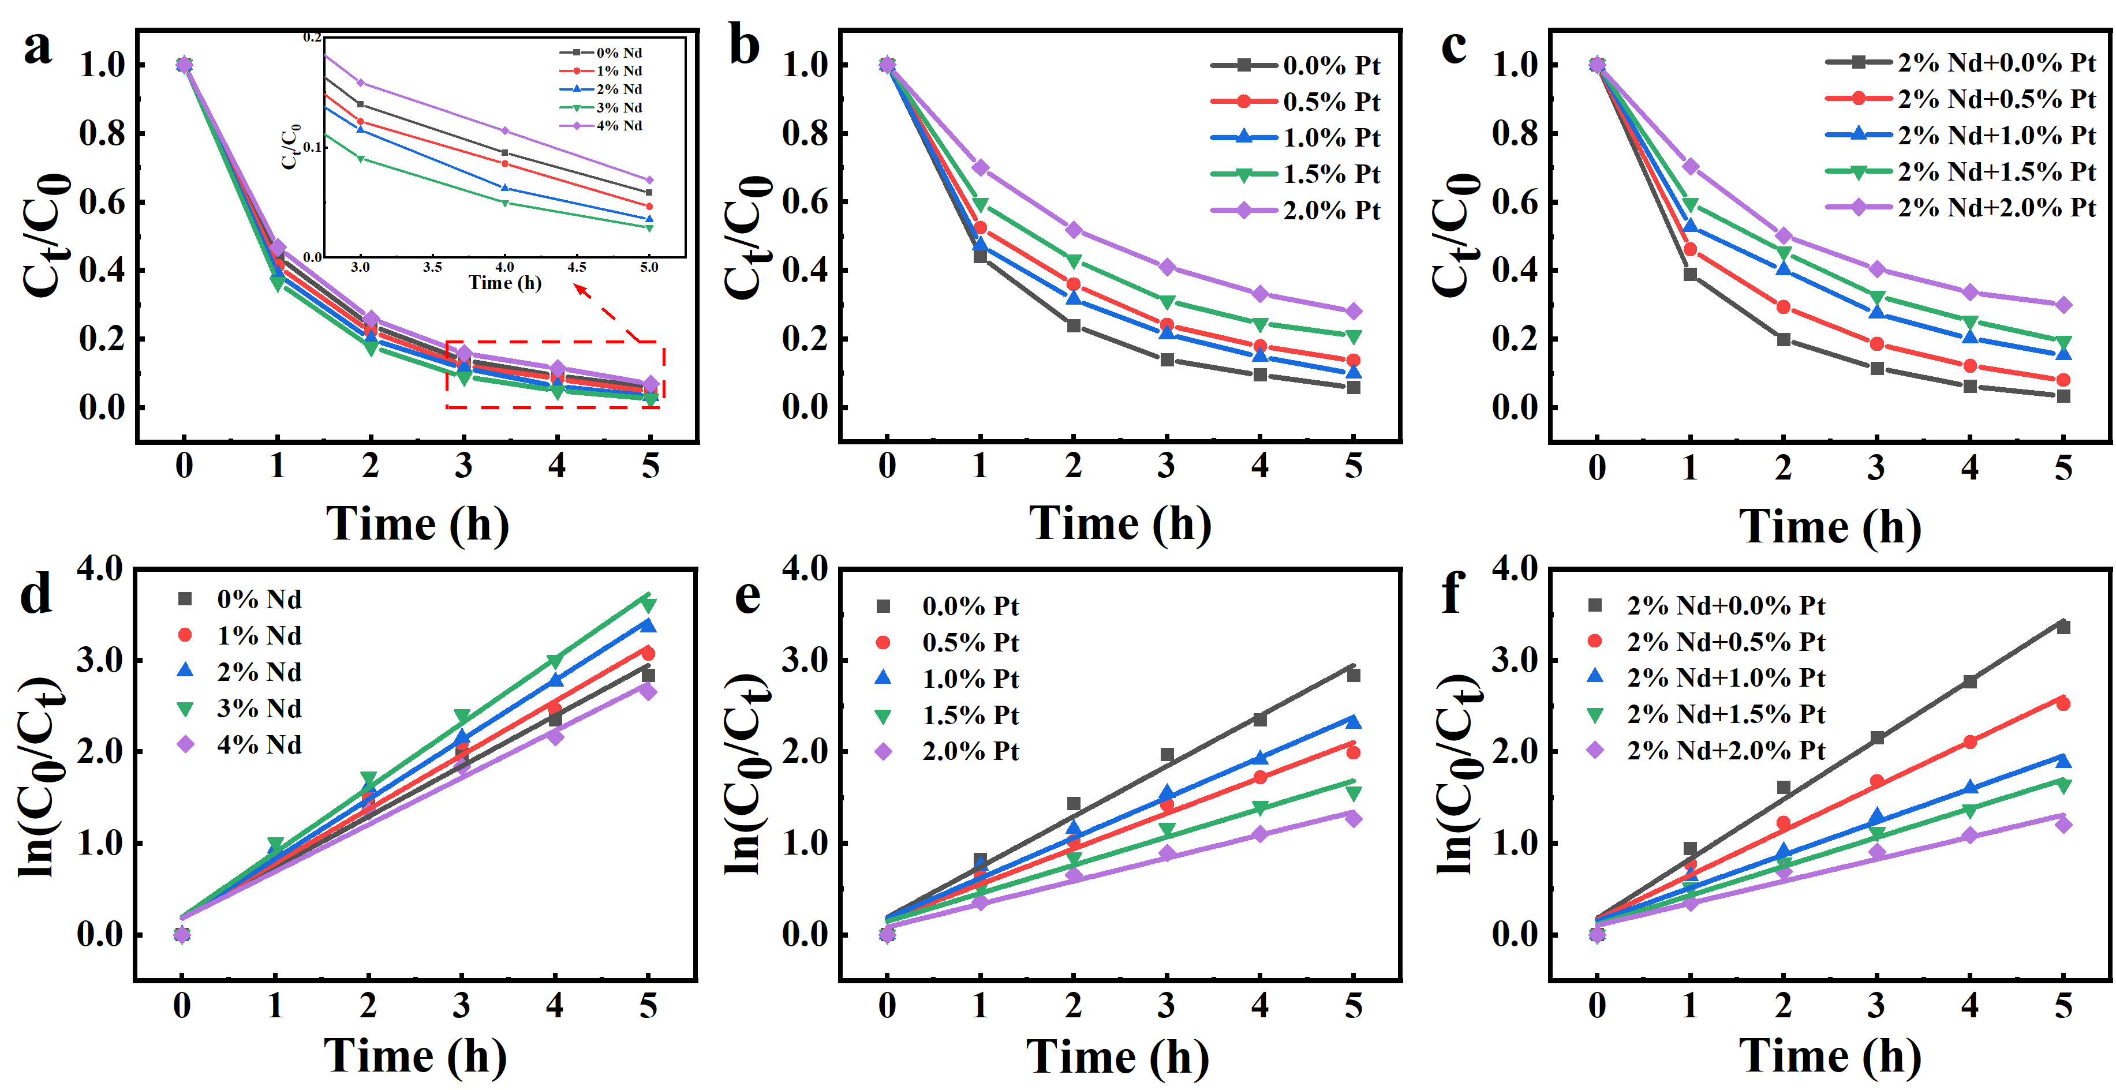
Fig. S1 Effect of doping ratios on the catalytic degradation of nitrobenzene using modified electrodes
(a) and (d) are the influence of Nd doping ratios and the corresponding kinetic analysis curves; (b) and (e) are the influence of Pt doping ratios and the corresponding kinetic analysis curves; and (c) and (f) are the influence of Pt doping ratios in the case of Pt-Nd co-doping and the corresponding kinetic analysis curves.

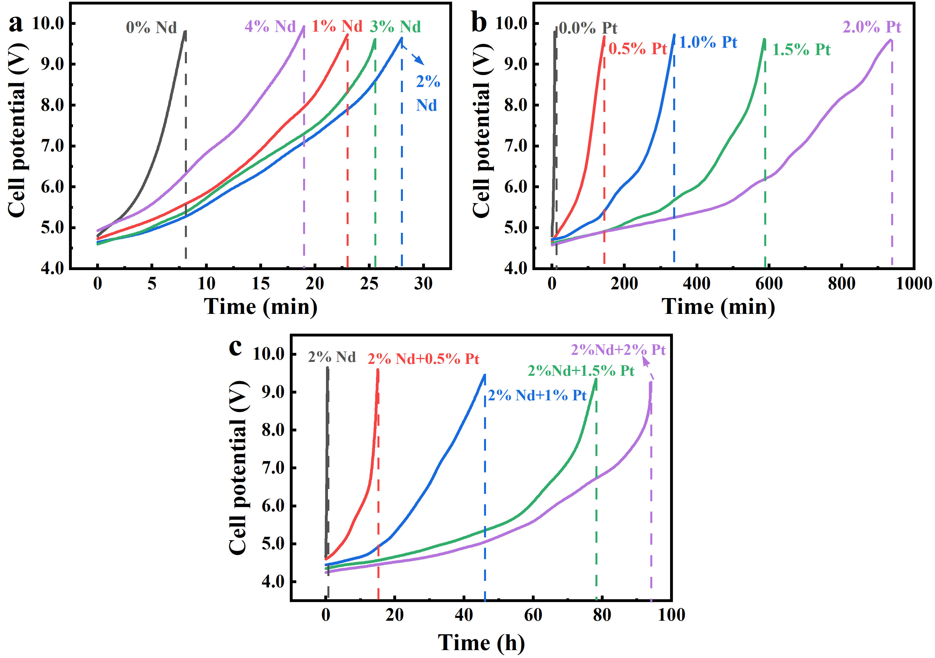
Fig. S2 Effect of Nd doping ratios (a), Pt doping ratios (b), and Pt doping ratios for Pt-Nd co-doping (c) on the electrode accelerated service life (500 mA cm⁻², 0.5 M H₂SO₄)

Table S1
Element composition of the prepared electrode surfaces
Anodes | Atomic ratio
Anodes | Sn | Sb | Ti | O | Nd | Pt
Ti/SnO₂-Sb | 25.31 | 2.91 | 2.23 | 69.55 | - | -
Ti/SnO₂-Sb-Nd-Pt | 24.46 | 2.78 | 0.81 | 70.54 | 0.89 | 0.52

Table S2
Binding energy of the O 1s, Sb 3d, and Sn 3d spectra of the prepared electrodes
Anodes | Binding energy e/V
Anodes | O_{lat} | O_{ads} | Sb 3d_{5/2} | Sb 3d_{3/2} | Sn 3d_{5/2} | Sn 3d_{3/2}
Ti/SnO₂-Sb | 530.65 | 532.51 | 531.47 | 540.13 | 485.01 | 493.43
Ti/SnO₂-Sb-Nd-Pt | 530.61 | 532.22 | 531.28 | 540.26 | 485.18 | 493.61

Table S3
Atomic ratios of the prepared electrodes
 | Atomic ratio
Electrodes | O_{ads}:O_{lat} | Sb⁵⁺:Sb³⁺
Ti/SnO₂-Sb | 0.426 | 1.270
Ti/SnO₂-Sb-Nd-Pt | 0.237 | 0.828

Table S4
Voltammetric charge results of the prepared electrodes
Electrodes | q_{T}* (mC/cm²) | q_{o}* (mC/cm²) | q_{i}* (mC/cm²)
Ti/SnO₂-Sb | 6.22 | 2.28 | 3.94
Ti/SnO₂-Sb-Nd-Pt | 3.77 | 1.09 | 2.68

Table S5
Simulated parameters of the electrochemical impedance spectroscopy curves of the prepared electrodes
Electrodes | R_{s} (Ω) | CPE (mF) | R_{ct} (Ω)
Ti/SnO₂-Sb | 3.51 | 1.42 | 20.71
Ti/SnO₂-Sb-Nd-Pt | 4.02 | 0.85 | 11.50
R_{s}, R_{ct,} and CPE represent the solution resistance, charge transfer resistance, and the constant phase element, respectively

