Supplementary Figure Title and Legend
Figures S1-S5. Results of the effect value analysis of BMI and five psychiatric disorders; A: Depression, B: Bipolar disorder, C: Schizophrenia, D: Autism, E: Anxiety disorder
(The horizontal axis represents the effect value and the vertical axis represents each instrumental variable. If the effect value is >0, the exposure factor is a risk factor for the outcome and the risk of developing the outcome tends to increase as the exposure factor increases; if the effect value is <0, the exposure factor is a protective factor for the outcome and the risk of developing the outcome tends to decrease as the exposure factor increases. Finally, the effect of exposure factors on outcomes can be assessed by a combination of both MR Egger and Inverse variance weighted methods).

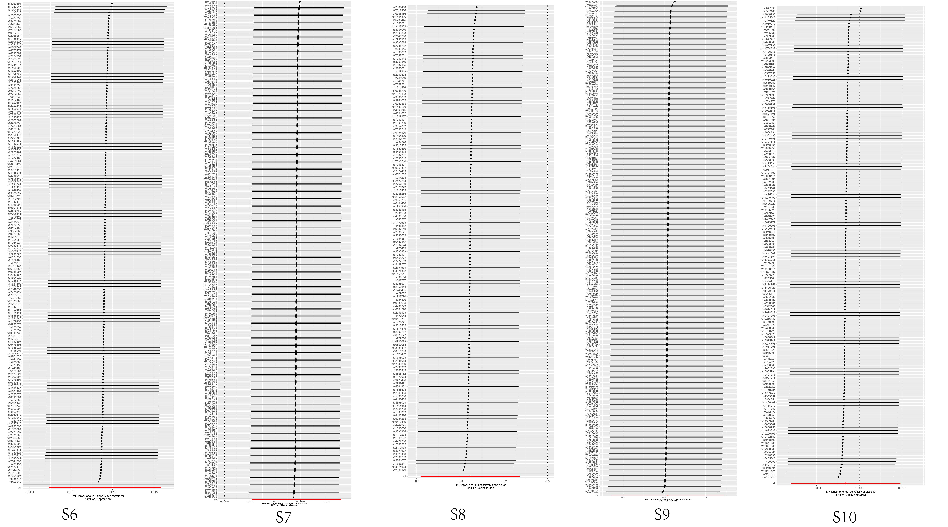
Figures S6-S10. Sensitivity analysis of the leave-one-out method of BMI in five psychiatric disorders A: Depression, B: Bipolar disorder, C: Schizophrenia, D: Autism, E: Anxiety disorders
(The horizontal axis represents the effect value and the vertical axis represents each instrumental variable. Comparing the effect value of removing a SNP with the red line segment represented by the effect values of all SNPs, if the range of fluctuation is not large, it means that removing this SNP did not have an excessive effect on Mendelian randomization; and if all SNPs are to the left or to the right of the dotted line of β=0, it also means that removing a SNP did not have an excessive effect on Mendelian randomization, and vice versa)

