Supplementary Information for
High-strength and crack-free welding of unweldable aluminum alloys via novel Zr-core-Al-shell wires
Jun Jin¹, Shaoning Geng^{1,*}, Leshi Shu¹, Ping Jiang^{1,*}, Xinyu Shao¹, Chu Han¹, Liangyuan Ren¹, Yuantai Li¹, Lu Yang¹ & Xiangqi Wang²
The State Key Laboratory of Digital Manufacturing Equipment and Technology, School of Mechanical Science and Engineering, Huazhong University of Science & Technology, Wuhan, Hubei, 430074, China. ² Jihua Laboratory Testing Center, Jihua Laboratory, Foshan, PR China.

*email: sngeng@163.com; jiangping@hust.edu.cn

1. The phase filed (PF) modelling
Supplementary Fig. 1 shows the temperature histories of weld centre at different locations. The average cooling rate was used for phase field (PF) modelling.
Supplementary Fig. 1 Temperature histories of weld centre with experimental measurement
The phase-field (PF) model developed by Takaki and Ohno^{1,2} was adopted in this study. The governing equations of ϕ and u of the PF are as follows:
(1)
(2)
Eq. (1) represents the time evolution of the PF. ${\text{τ}}_{\text{0}}\text{ = }{\text{a}}_{\text{2}}\text{λ}{\text{W}}_{\text{0}}\text{/}{\text{D}}_{\text{l}}$is the relaxation time, ${\text{W}}_{\text{0}}$ is the interface thickness, and$\text{λ = }{\text{a}}_{\text{1}}{\text{W}}_{\text{0}}\text{/}{\text{d}}_{\text{0}}$ is the coupling constant associated with the thermodynamic driving force. The numerical constants${\text{a}}_{\text{1}}$ and ${\text{a}}_{\text{2}}$ are ${\text{a}}_{\text{1}}\text{= }\text{0.8839}$and ${\text{a}}_{\text{2}}\text{=}\text{ 0.6267}$. ${\text{d}}_{\text{0}}\text{= }\text{kГ}\text{/}\left[\left|\text{m}\right|\text{(}\text{1} \text{-} \text{k}\text{)}{\text{c}}_{\text{0}}\right]$ is the chemical capillary length, where k is the partition coefficient, m is the liquidus slope, c₀ is the initial concentration in the liquid, and $\text{Г}$ is the Gibbs–Thomson coefficient.${\text{a}}_{\text{s}}\text{(}\vec{\text{n}}\text{)}$ is the crystalline anisotropy, which is given as:
(3)
where ε₄ is the anisotropic strength. ${\text{u}}^{\text{'}}\text{ = }\text{(}\text{T}\text{ - T}\text{s}\text{)/}\text{(}\text{T}\text{l}\text{ - T}\text{s}\text{)}$ is the nondimensional temperature undercooling. The polynomials f(ϕ) and g(ϕ) are given as df(ϕ)/dϕ = −ϕ + ϕ³ and dg(ϕ)/dϕ = (1 − ϕ²)². According to the mixture rule, the local concentration c is given by $\text{c = }\text{[(}\text{1} \text{+} \text{ϕ}\text{)}{\text{c}}_{\text{s}} \text{+} \text{(}\text{1} \text{-} \text{ϕ}\text{)}{\text{c}}_{\text{l}}]\text{/}\text{2}$, where c_{l} and c_{s} are the solute concentration in the liquid and solid phases, respectively. c_{l} and c_{s} satisfy the relation$\text{k =}{\text{ c}}_{\text{s}}^{\text{e}}\text{/}{\text{c}}_{\text{l}}^{\text{e}}\text{ = c}\text{s}\text{/}c_{l}$, where${\text{ c}}_{\text{s}}^{\text{e}}$ and ${\text{c}}_{\text{l}}^{\text{e}}$ are the equilibrium concentrations in the solid and liquid, respectively. Eq. (2) represents the time of the solute diffusion equation. Dimensionless supersaturation u is defined as follows:
(4)
D_{l} and D_{s} are the solute diffusivities in liquids and solids, respectively.is the anti-trapping current, which is given by ${\text{j}}_{\text{AT}}\text{ = -(1-}\text{k}{\text{D}}_{\text{s}}\text{/}{\text{D}}_{\text{l}}\text{)}\text{(2/}\sqrt{\text{2}}\text{)}{\text{W}}_{\text{0}}\text{[1+(1-}\text{k}\text{)}\text{u}\text{](∂}\text{ϕ}\text{/}\text{∂}\text{t}\text{)}\text{∇}\text{ϕ}\text{/}\left|\text{∇}\text{ϕ}\right|$. $\text{q}\text{(}\text{ϕ}\text{)}$is an interpolating function given by$\text{q}\text{(}\text{ϕ}\text{)}\text{ = }\text{[}\text{k}{\text{D}}_{\text{s}}\text{+}{\text{D}}_{\text{l}}\text{+}\text{(}\text{k}{\text{D}}_{\text{s}}\text{-}{\text{D}}_{\text{l}}\text{)]}\text{ϕ}\text{/(}\text{2}{\text{D}}_{\text{l}}\text{)}$. J is the fluctuating current of a random Gaussian number.

2. Estimating the strengthening contributions
Supplementary Table 1: Estimates of the various strengthening contributions for the
fusion zone
Materials | σ₀ (MPa) | Δσ_{gb} (MPa) | Δσ_{ppt} (MPa) | Δσ_{ss}  (MPa) | Δσ_{dis} (MPa) | Δσ_{y}^{Cal} (MPa)
FZ | 10 | 125 | 6 | 67.3 | 56.3 | 265

Supplementary Fig. 2: Engineering stress-strain curves of the base materials. (Dashed line shows their 0.2% yield point)
Supplementary Fig. 3: Engineering stress-strain curves of the different filler materials
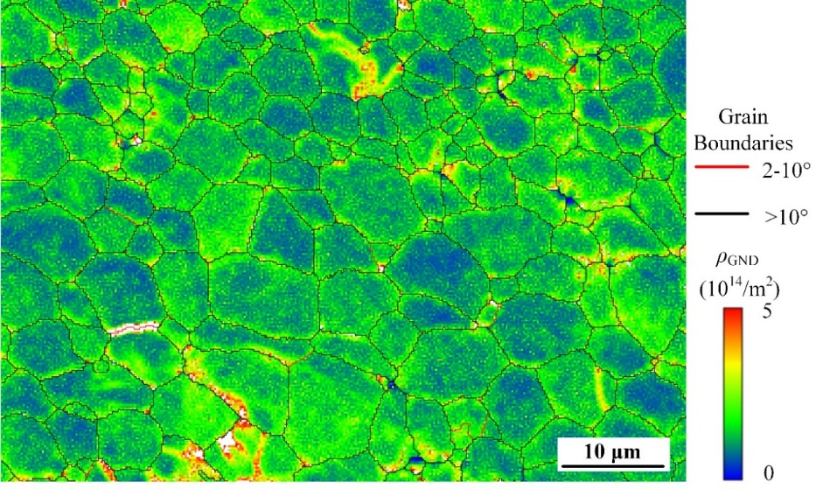
Supplementary Fig. 4: Distribution of the GND density of the welds

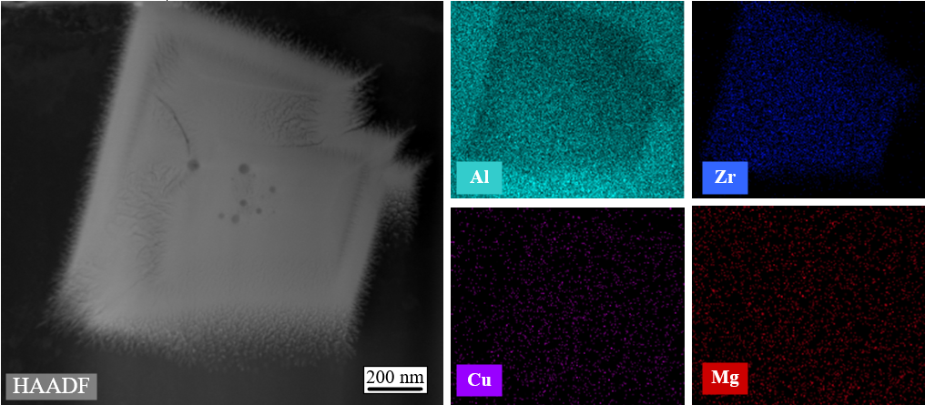
Supplementary Fig. 5: TEM-EDX characteristics of precipitates in the interiors of
grains in the FQZ. a, STEM-HAADF mode. b, Corresponding EDX mapping image
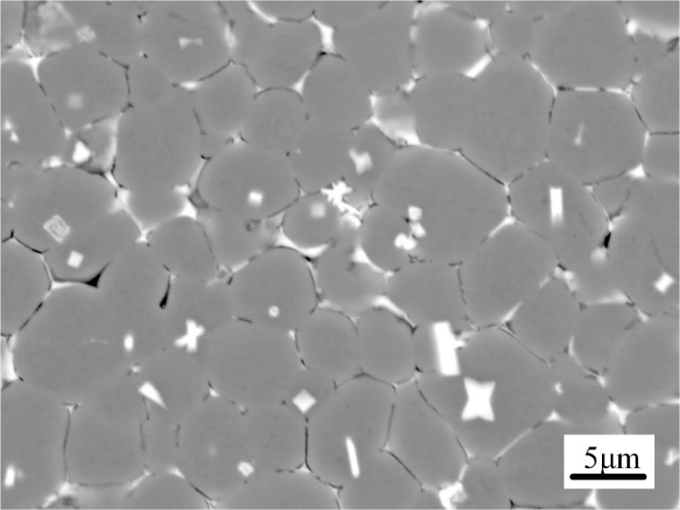
Supplementary Fig. 6: SEM (BSE mode) characteristics of the fusion zone
Supplementary Fig. 7: SEM-EDS characteristics of the fusion zone. a, SEM image. b, c, d, e, f, EDS spectra of the substrate.

Supplementary References
- Takaki, T. et al. Competitive grain growth during directional solidification of a polycrystalline binary alloy: Three-dimensional large-scale phase-field study. Materialia. 1, 104-113 (2018).
- Takaki, T. et al. Two-dimensional phase-field simulations of dendrite competitive growth during the directional solidification of a binary alloy bicrystal. Acta Mater. 81, 272-283 (2014).

