Additional Files

Development of a SARS-CoV-2 cross-neutralization antibody with a potent neutralizing effect against SARS-CoV-2 variants

Hae Li Ko^{a¶}, Deuk-ki Lee^{a¶}, Younghyeon Kim^{a,b}, Hui Jeong Jang^{c}, Youn Woo Lee^{c}, Sang-Hyuk Seok^{d}, Jin-Kyung Limb^{e}, Da In On^{e,f}, Jun-Won Yun^{f}, Jun Won Park^{d}, Ho-Young Lee^{c}, Je Kyung Seong^{e,f,h}*and Sungjin Leeª*

Additional Figure 1
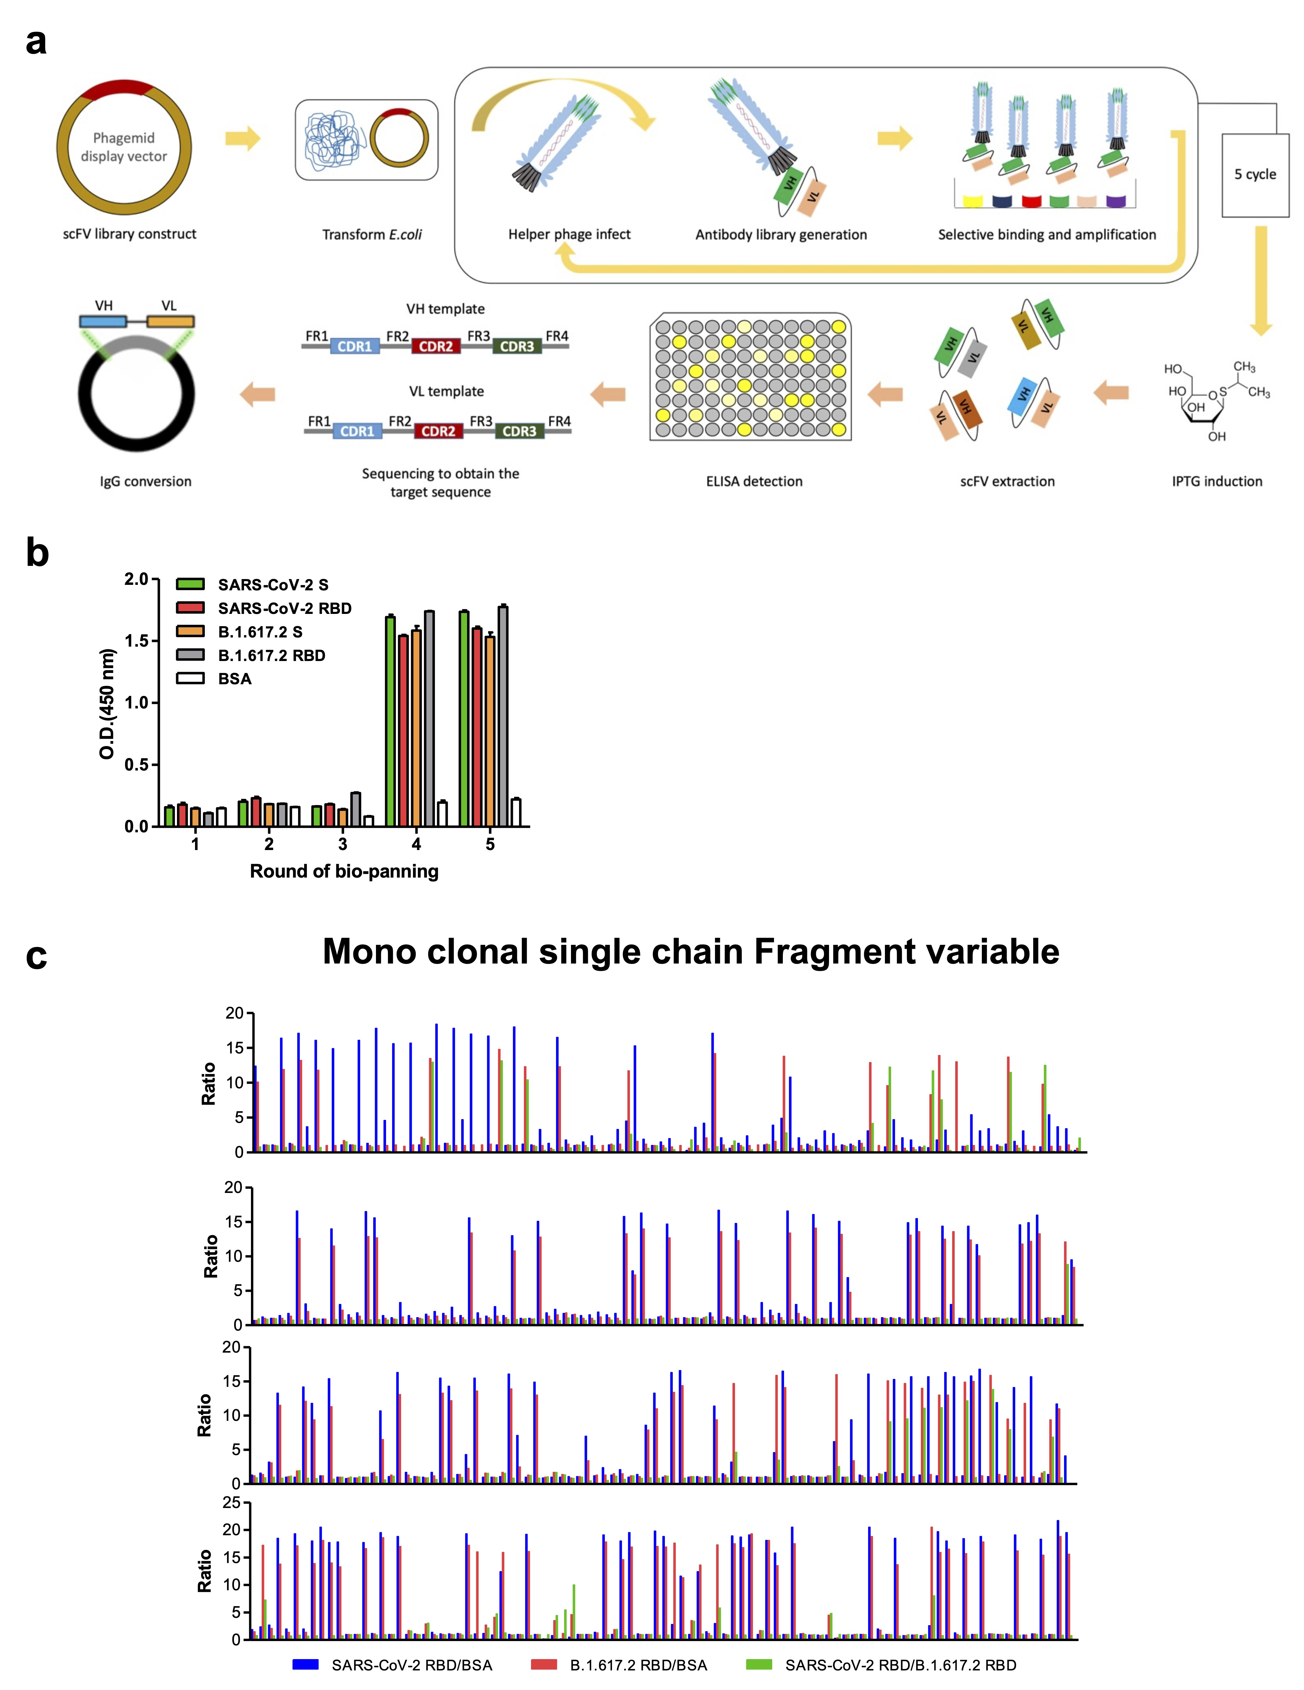
Identification of antibodies for targeting the RBD S protein of SARS-CoV-2 VOC by bio-panning. (a) Schematic of the bio-panning process. (b) Verification of the ability of the polyclonal scFv phage to bind to the B.1.617.2 RBD of SARS-CoV-2 using phage groups after five rounds. (c) Confirmation of binding ability through ELISA of monoclonal scFv phage of the 5th bio-panning. SARS-CoV-2, severe acute respiratory syndrome coronavirus 2; RBD, receptor-binding domain; S, spike; VOC, variant of concern.

Additional Figure 2
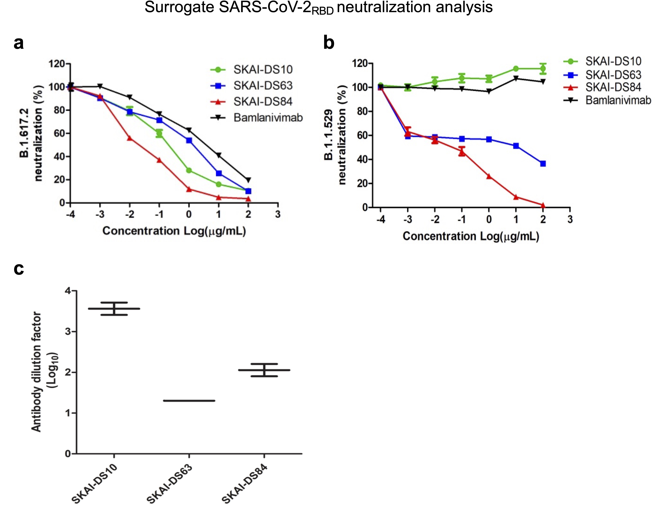
Neutralization effect of SKAI-DS10, SKAI-DS63, and SKAI-DS84 on surrogate neutralization kits and authentic viruses. Dose-dependent effects of SKAI-DS10, SKAI-DS63, SKAI-DS84, and bamlanivimab on SARS-CoV-2. (a) B.1.612.7 and (b) B.1.1.529 neutralization were determined by measuring the relative inhibition of SARS-CoV-2 RBD–hACE2 interaction with increasing concentrations of either SKAI-DS10, SKAI-DS63, SKAI-DS84, or bamlanivimab. (c) The data show the neutralizing effect of SKAI-DS10, SKAI-DS63, and SKAI-DS84 on the SARS-CoV-2 authentic virus in VeroE6 cells. SARS-CoV-2, severe acute respiratory syndrome coronavirus 2; RBD, receptor-binding domain.

Additional File 3
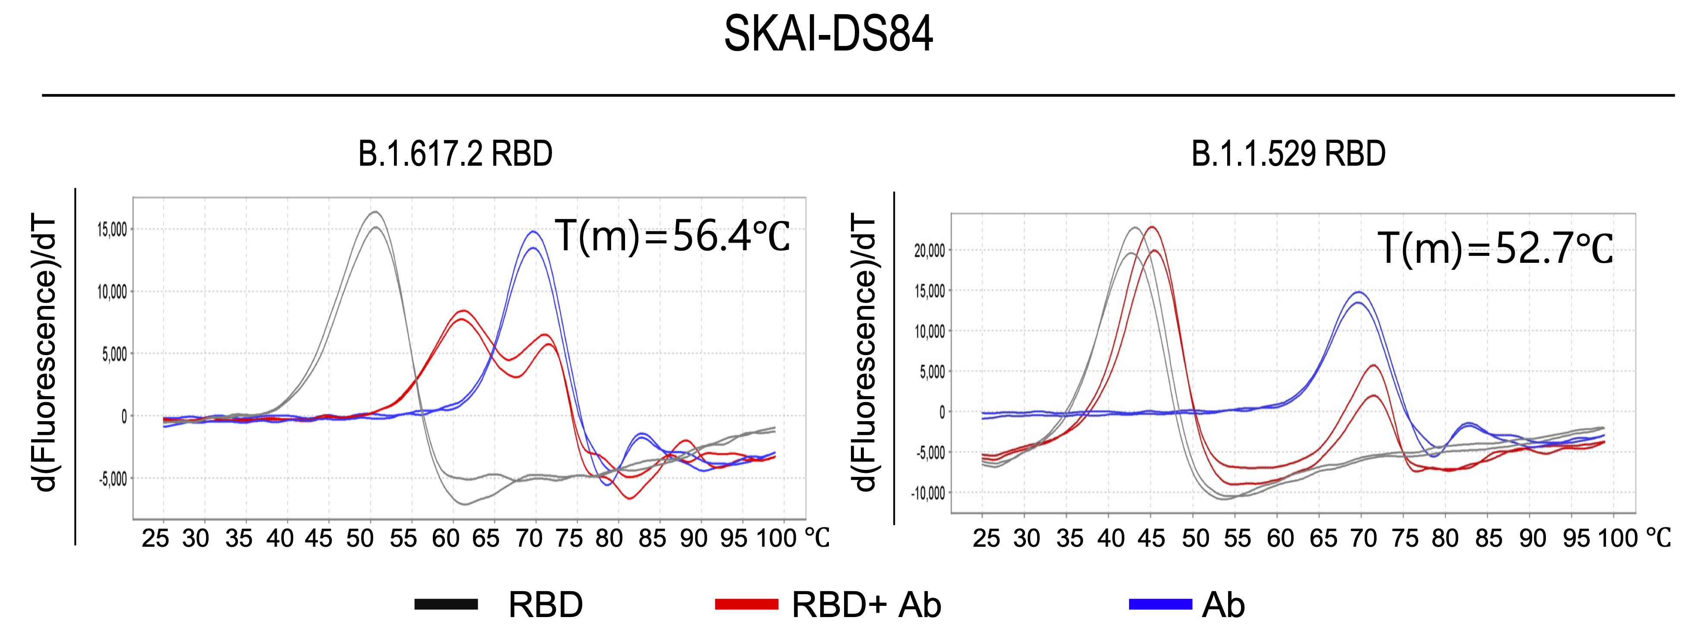
The fluorescence-based thermal shift assay for protein binding to SKAI-DS10, SKAI-DS63, and SKAI-DS84. The curve shows a shift as the T_{m} increases when the protein binds to the antibody. Black; SARS-CoV-2 VOC RBD protein only, Red; SARS-CoV-2 VOC RBD protein with SKAI-DS84, Blue; SKAI-DS84 only. SARS-CoV-2, severe acute respiratory syndrome coronavirus 2, RBD, receptor-binding domain; T_{m}, melting temperature; VOC, variant of concern.

