SNP | chr | effect_allele | other_allele | pval | se | beta | eaf | F statistic
rs2000228 | 1 | C | T | 2.10E-10 | 1.12E-03 | 7.13E-03 | 3.13E-01 | 4.04E+01
rs11184994 | 1 | T | C | 1.20E-08 | 1.13E-03 | 6.45E-03 | 6.94E-01 | 3.25E+01
rs7536987 | 1 | G | A | 1.90E-08 | 1.16E-03 | -6.54E-03 | 2.77E-01 | 3.15E+01
rs35789697 | 2 | A | G | 5.00E-10 | 1.08E-03 | -6.72E-03 | 3.69E-01 | 3.87E+01
rs1439252 | 2 | A | G | 1.30E-09 | 1.08E-03 | -6.58E-03 | 3.73E-01 | 3.68E+01
rs2678897 | 2 | A | G | 2.50E-10 | 1.07E-03 | 6.77E-03 | 6.08E-01 | 4.00E+01
rs10210512 | 2 | G | T | 1.30E-09 | 1.06E-03 | 6.41E-03 | 4.20E-01 | 3.68E+01
rs13085679 | 3 | A | G | 4.20E-11 | 1.04E-03 | 6.87E-03 | 5.01E-01 | 4.35E+01
rs600011 | 3 | C | A | 8.40E-10 | 1.14E-03 | 6.97E-03 | 3.01E-01 | 3.77E+01
rs13434208 | 3 | G | A | 7.60E-09 | 1.05E-03 | -6.05E-03 | 5.25E-01 | 3.34E+01
rs931235 | 3 | C | A | 9.40E-09 | 1.06E-03 | -6.11E-03 | 5.93E-01 | 3.30E+01
rs11720128 | 3 | T | C | 3.50E-08 | 1.08E-03 | -5.96E-03 | 4.48E-01 | 3.04E+01
rs11728841 | 4 | C | A | 2.90E-08 | 1.05E-03 | 5.85E-03 | 5.56E-01 | 3.08E+01
rs67970900 | 4 | T | G | 3.20E-09 | 1.13E-03 | -6.68E-03 | 3.09E-01 | 3.51E+01
rs72660658 | 4 | T | C | 6.90E-09 | 1.18E-03 | -6.83E-03 | 2.67E-01 | 3.36E+01
rs77087420 | 4 | G | A | 3.00E-08 | 2.29E-03 | -1.27E-02 | 5.46E-02 | 3.07E+01
rs6895295 | 5 | T | C | 2.60E-08 | 1.27E-03 | 7.07E-03 | 2.16E-01 | 3.10E+01
rs11168048 | 5 | C | T | 6.30E-09 | 1.05E-03 | -6.13E-03 | 4.19E-01 | 3.37E+01
rs28517342 | 6 | G | T | 3.50E-08 | 1.19E-03 | -6.57E-03 | 2.57E-01 | 3.04E+01
rs12530421 | 6 | C | A | 5.20E-09 | 2.08E-03 | 1.22E-02 | 6.67E-02 | 3.41E+01
rs67447472 | 6 | T | G | 2.80E-10 | 1.75E-03 | 1.10E-02 | 9.96E-02 | 3.98E+01
rs2503775 | 6 | G | A | 6.40E-09 | 1.56E-03 | -9.03E-03 | 8.71E-01 | 3.37E+01
rs6460902 | 7 | A | G | 8.10E-10 | 1.05E-03 | 6.48E-03 | 4.19E-01 | 3.77E+01
rs2483509 | 7 | A | G | 8.40E-10 | 1.05E-03 | 6.43E-03 | 4.50E-01 | 3.77E+01
rs7818437 | 8 | C | T | 1.80E-13 | 1.24E-03 | 9.12E-03 | 2.36E-01 | 5.42E+01
rs1962104 | 8 | C | T | 5.50E-12 | 1.06E-03 | 7.29E-03 | 5.58E-01 | 4.75E+01
rs56116032 | 9 | G | A | 2.40E-13 | 1.26E-03 | -9.24E-03 | 2.19E-01 | 5.36E+01
rs10983775 | 9 | T | C | 5.10E-11 | 1.05E-03 | -6.89E-03 | 5.34E-01 | 4.31E+01
rs7047280 | 9 | T | C | 7.80E-09 | 1.07E-03 | -6.17E-03 | 6.05E-01 | 3.33E+01
rs4836789 | 9 | C | T | 1.50E-11 | 1.06E-03 | 7.18E-03 | 5.96E-01 | 4.56E+01
rs999483 | 9 | G | T | 7.40E-09 | 1.20E-03 | 6.96E-03 | 2.49E-01 | 3.34E+01
rs1055710 | 9 | A | G | 2.30E-09 | 1.11E-03 | -6.61E-03 | 3.32E-01 | 3.57E+01
rs11599236 | 10 | C | T | 3.60E-09 | 1.07E-03 | -6.31E-03 | 4.11E-01 | 3.48E+01
rs297343 | 11 | G | T | 2.10E-11 | 1.09E-03 | -7.28E-03 | 6.38E-01 | 4.48E+01
rs11039154 | 11 | T | C | 8.80E-14 | 1.16E-03 | 8.68E-03 | 2.78E-01 | 5.56E+01
rs4309187 | 11 | C | A | 1.40E-15 | 1.12E-03 | 8.97E-03 | 6.82E-01 | 6.37E+01
rs61937595 | 12 | T | C | 2.80E-08 | 1.82E-03 | 1.01E-02 | 9.41E-02 | 3.09E+01
rs771998 | 12 | C | T | 4.80E-08 | 1.17E-03 | 6.38E-03 | 2.76E-01 | 2.98E+01
rs7954112 | 12 | A | G | 3.10E-08 | 1.06E-03 | 5.88E-03 | 4.19E-01 | 3.06E+01
rs28655666 | 12 | A | G | 2.40E-11 | 1.05E-03 | -6.99E-03 | 5.52E-01 | 4.47E+01
rs9517313 | 13 | C | G | 1.80E-09 | 1.07E-03 | 6.45E-03 | 3.81E-01 | 3.62E+01
rs3012850 | 13 | G | C | 6.80E-14 | 1.24E-03 | 9.29E-03 | 2.39E-01 | 5.61E+01
rs4899532 | 14 | G | A | 6.40E-11 | 1.20E-03 | 7.82E-03 | 7.45E-01 | 4.27E+01
rs2016851 | 14 | C | T | 4.50E-08 | 1.15E-03 | 6.30E-03 | 7.03E-01 | 2.99E+01
rs4243048 | 15 | A | G | 2.30E-09 | 1.07E-03 | -6.39E-03 | 5.57E-01 | 3.57E+01
rs1050863 | 16 | A | G | 5.80E-13 | 1.05E-03 | -7.60E-03 | 5.67E-01 | 5.19E+01
rs35856211 | 16 | A | G | 4.40E-10 | 1.05E-03 | -6.56E-03 | 5.40E-01 | 3.89E+01
rs55774086 | 16 | G | C | 2.50E-10 | 1.22E-03 | 7.69E-03 | 2.43E-01 | 4.00E+01
rs7202252 | 16 | C | T | 4.90E-10 | 1.18E-03 | 7.33E-03 | 7.32E-01 | 3.87E+01
rs1724411 | 17 | C | T | 4.20E-21 | 1.24E-03 | 1.17E-02 | 2.29E-01 | 8.89E+01
rs11665070 | 18 | A | G | 2.60E-14 | 1.11E-03 | -8.44E-03 | 6.67E-01 | 5.80E+01
rs12963231 | 18 | A | C | 3.50E-13 | 1.11E-03 | 8.10E-03 | 3.29E-01 | 5.29E+01
rs613872 | 18 | T | G | 1.80E-15 | 1.38E-03 | 1.09E-02 | 8.26E-01 | 6.33E+01
rs17411061 | 18 | T | C | 4.10E-11 | 1.06E-03 | 6.99E-03 | 4.20E-01 | 4.36E+01
rs1688000 | 19 | G | A | 4.40E-09 | 1.08E-03 | -6.33E-03 | 6.25E-01 | 3.44E+01
rs6103271 | 20 | G | A | 5.70E-11 | 1.38E-03 | -9.06E-03 | 8.25E-01 | 4.29E+01
rs926914 | 22 | T | C | 2.30E-12 | 1.15E-03 | 8.09E-03 | 2.88E-01 | 4.92E+01
Supplementary Table 1. Instrumental variants (IVs) selected to product MR analysis.
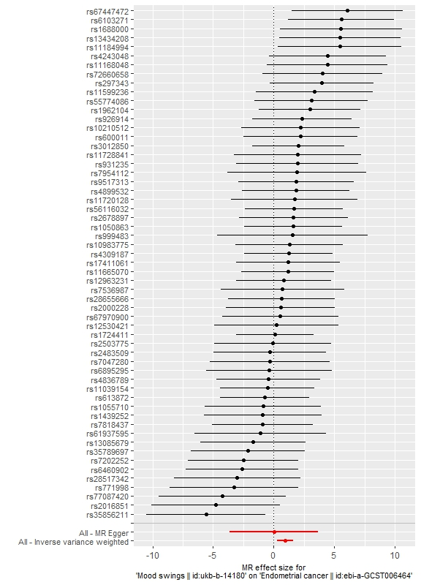
Supplementary Figure 1. Forest plot of MR effect for mood swing on endometrial cancer.

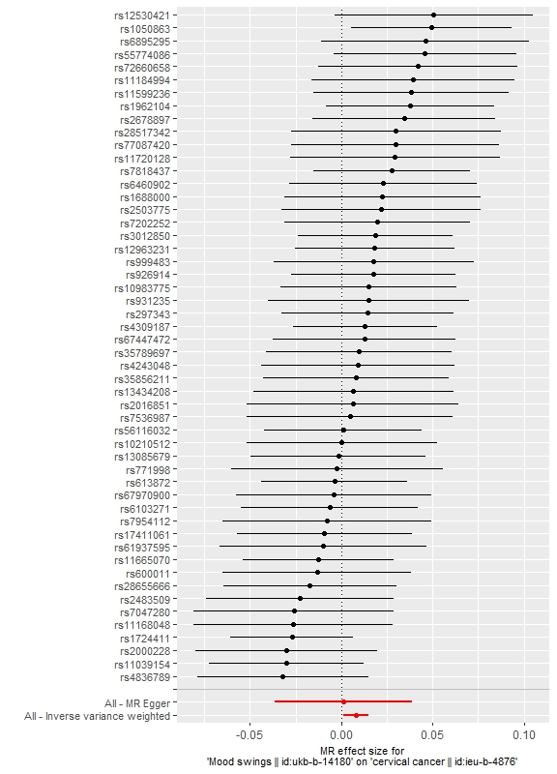
Supplementary Figure 2. Forest plot of MR effect for mood swing on cervical cancer.

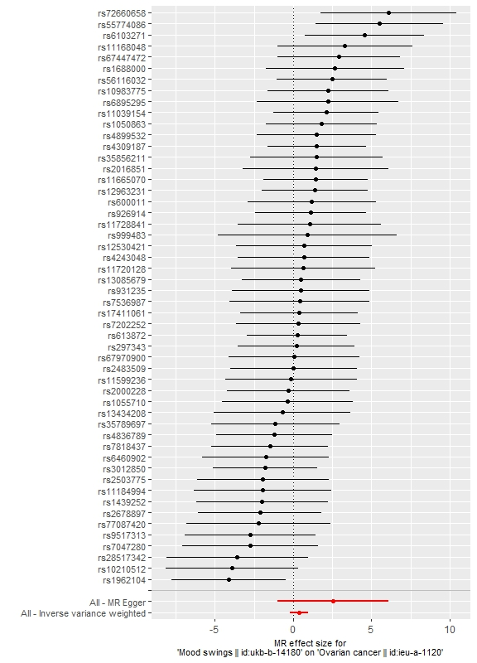
Supplementary Figure 3. Forest plot of MR effect for mood swing on ovarian cancer.

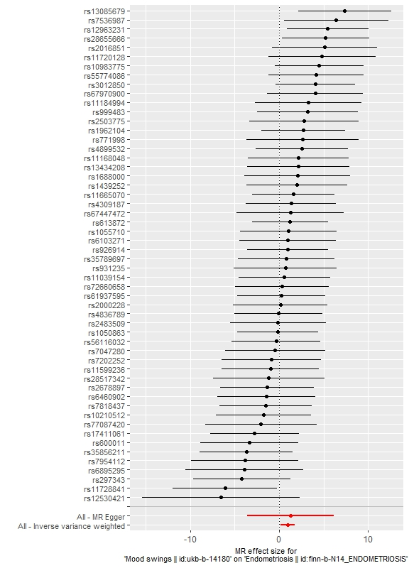
Supplementary Figure 4. Forest plot of MR effect for mood swing on endometriosis.

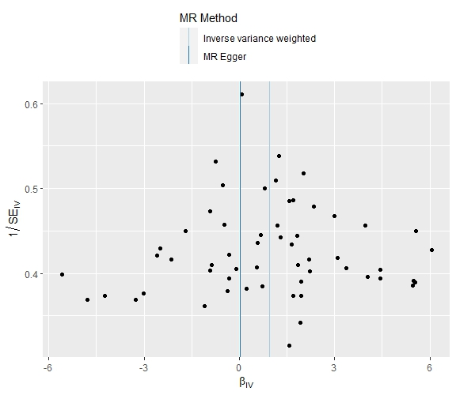
Supplementary Figure 5. Funnel plot of MR effect for mood swing on endometrial cancer.

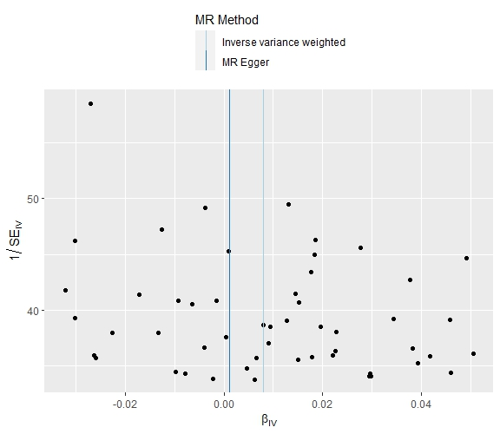
Supplementary Figure 6. Funnel plot of MR effect for mood swing on cervical cancer.

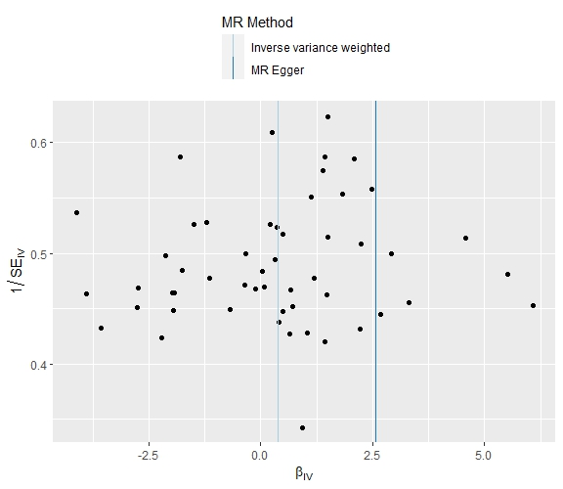
Supplementary Figure 7. Funnel plot of MR effect for mood swing on ovarian cancer.

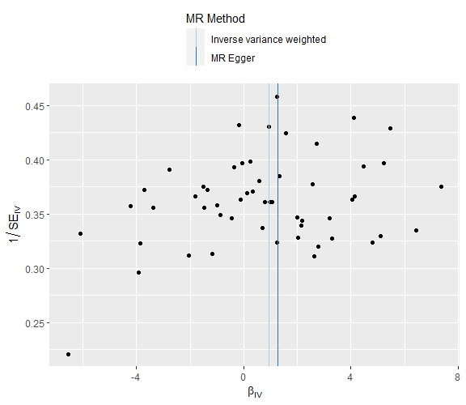
Supplementary Figure 8. Funnel plot of MR effect for mood swing on endometriosis.

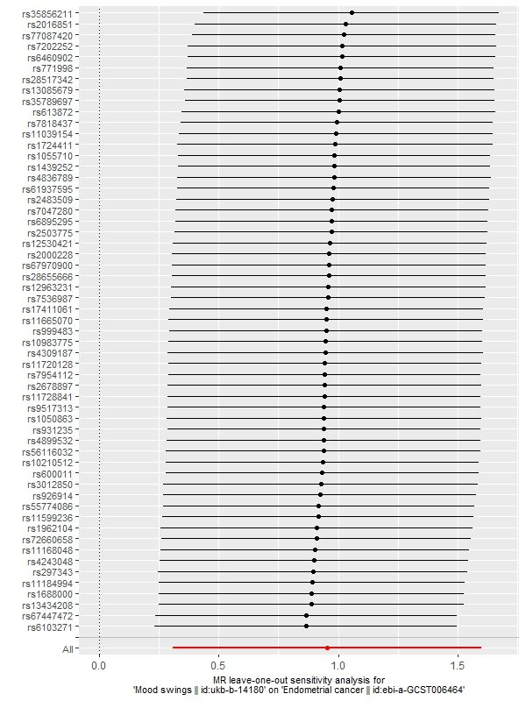
Supplementary Figure 9. Leave-one-out sensitivity analysis of MR effect for mood swing on endometrial cancer.

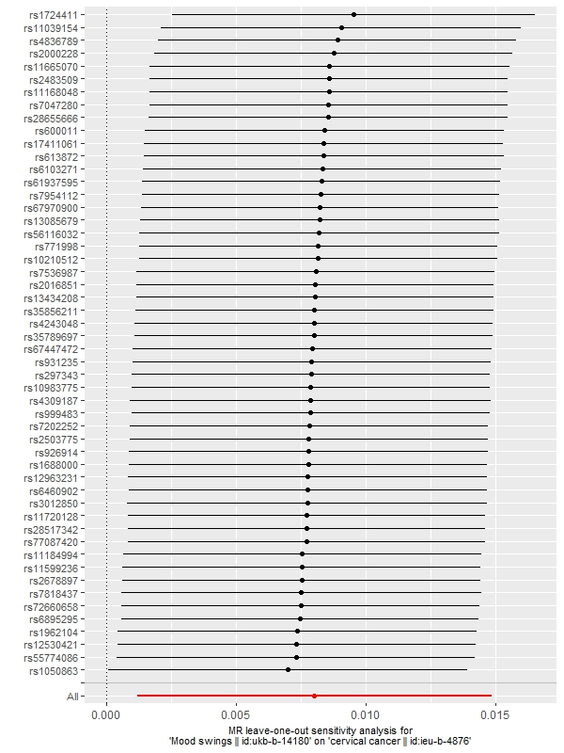
Supplementary Figure 10. Leave-one-out sensitivity analysis of MR effect for mood swing on cervical cancer.

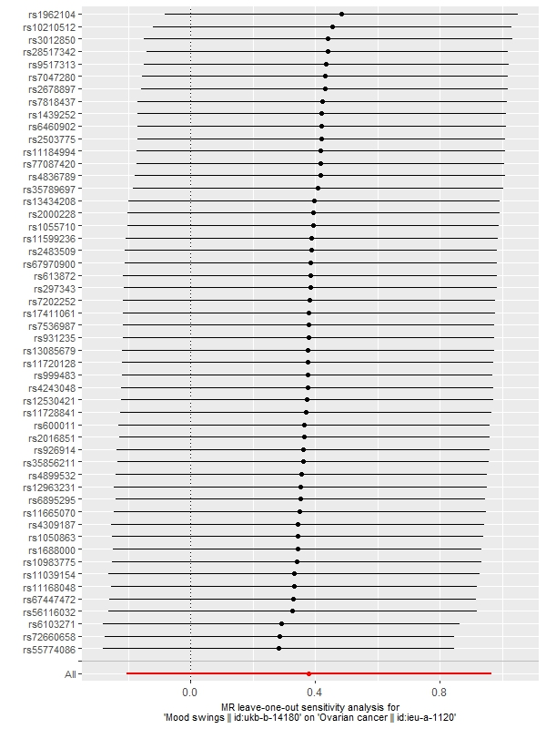
Supplementary Figure 11. Leave-one-out sensitivity analysis of MR effect for mood swing on ovarian cancer.
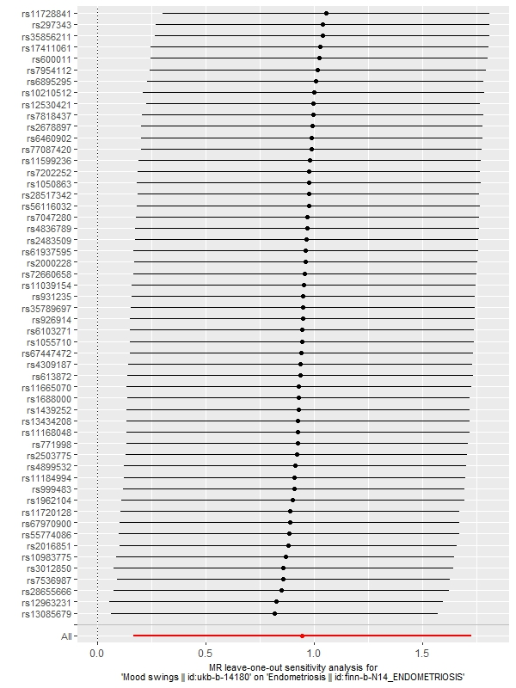
Supplementary Figure 12. Leave-one-out sensitivity analysis of MR effect for mood swing on endometriosis.

