Supporting information
for
Cathode regeneration processes enabled transition from spent batteries to lithium-ion alternatives
Tingzhou Yang^{1,2}, Dan Luo^{1,2}, Xinyu Zhang¹, Shihui Gao¹, Rui Gao², Qianyi Ma², Hey Woong Park², Tyler Or², Yongguang Zhang^{1,}*, and Zhongwei Chen^{1,2}*
¹Dalian Institute of Chemical Physics, Chinese Academy of Sciences, Dalian 116023, China.
²Waterloo Institute for Nanotechnology, Department of Chemical Engineering, University of Waterloo, 200 University Ave. W., Waterloo, ON, N2L 3G1, Canada.
*Correspondence and requests for materials should be addressed to Y.Z. (email: ygzhang@dicp.ac.cn) Z.C. (email: zwchen@dicp.ac.cn).

Figure S1. Our optimized preprocessing process. According to the United States Advanced Battery Consortium (USABC), the battery pack cannot meet the requirements of the electric vehicle when the capacity drops to 80% of the nominal capacity. Ideally, retired batteries can be reused in less demanding applications, such as power grids, power tools, and stationary storage. When retired batteries are no longer suitable for repurposing, the spent batteries should be recycled. Stabilization is the first step for battery recycling, where the residual energy in spent LIBs could lead to fire and explosion. A very simple method is to immerse the spent cells into a salt solution or brine (such as NaCl/KCl solution or seawater) for several days. In Canada, some companies crush the retired LIBs under a water spray and an inert atmosphere to produce a slurry. Some other methods, such as freezing the battery with liquid nitrogen and crushing it under an inert atmosphere, have been reported to improve the safety of recycling processes. The following steps are to strip the metal shell and separate various components in spent batteries, including washing, dismantling, crushing, screening, and magnetic separation. The outer aluminum shells and plastic can be easily separated after the first crushing process. The electrolyte needs to be properly recycled, where the volatilization of electrolytes can cause safety concerns and is greatly harmful to the health of workers. Ultrasonic cleaners can be used to help strip the active materials from the electrodes. The principle of gravity separation based on density differences can be used to sort the different materials with the same particle size. The hydrophobic graphite anode and hydrophilic cathode can be preliminarily separated through a flotation process. Finally, Black mass is obtained, including a blend of spent cathode powder, anode powder, conductive carbon materials, binders, and unseparated copper/aluminum powder.

Figure S2. Photograph of the colour change when LCO and NCM are dissolved to the acetic acid solution with the support of H₂O₂ reducing agents at different temperatures.

Figure S3. Comparison of solubility and reaction temperature for different leaching agents. In early research, the leaching agents were divided into corrosive mineral acid and alkaline solution^{S1-S3}. Since the alkaline solution is not suitable for the subsequent coprecipitation reaction, it will not be discussed here. As environmentally benign alternatives for chemical synthesis, deep eutectic solvents (DESs) and organic acid exhibit an ability to digest metal oxides^{S4-S6}, which can even rival the performance of mineral acid leaching agents. However, a relatively high reaction temperature with a long time is required for DES-based leaching agents accompanied by long reaction time and low leaching rate during the Black mass leaching processes, which is not applicable to the current large-scale recycling operation. Although mineral acid has a strong leaching ability for cathode materials, some impurities that have not been screened from Black mass, such as Al and Cu powders, will be dissolved in a thermal mineral acid solution^{S7,S8}.

Figure S4. a. Laboratory (vacuum-assisted DigiFILTER assembly) and b, industrial (high-efficiency bag filters) leachate filtration equipment.

Figure S5. a, Low-magnification and b, high-magnification SEM images of the obtained transition metal complex precursors. Scale bars in a and b are 5.0 μm and 1.0 μm.

Figure S6. SEM images of regenerated NCM powder. Scale bar, 2.0 μm.

Figure S7. 2D synchrotron GIXRD images of obtained transition metal complex precursors.

Figure S8. XRD patterns of R-NCM, commercial NCM, and precursors.

Figure S9. XPS spectrum of R-NCM powder.

Figure S10. The high-resolution XPS spectrum of a, Co 2p, b, Mn 2p, c, Ni 2p, and d, O 1s for R-NCM powder.

Figure S11. a, Co and b, Mn K-edge XANES spectra of the samples.

Figure S12. EIS Nyquist plots of the cell before and after cycles.

Figure S13. Rate performance of regenerated NCM cathode materials.

Figure S14. Coulombic efficiency with different active material loadings at 0.5 C.

Figure S15. Galvanostatic charge/discharge profiles for a, 10th and b, 100th cycles with different active material loadings.

Figure S16. Cycling performance of Li metal-based pouch cell (eight layers) with regenerated NCM electrode at 0.1 C.

Figure S17. FIB-SEM image of cross-sectioned R-NMC electrodes before cycles. Scale bar, 1.0 μm.

Figure S18. TOF-SIMS 3D reconstruction of the representative a, LiF₂⁻, b, NiF₃⁻, c, CoF₃⁻, d, MnF₂⁻, e, C₂HO⁻, and f, O₂⁻ species of CEI layers on the surface of the electrode.

Figure S19. TOF-SIMS curves of the representative species of CEI layers formed at the surface of regenerated NCM electrode.

Figure S20. a, SEM image and b, TEM image of C-PBAs. Scale bars in a and b are 500 nm and 200 nm.

Figure S21. SEM image of NCM-PBAs. Scale bar, 4.0 μm.

Figure S22. a, SEM image and b, TEM image of CM-PBAs. Scale bars in a and b are 500 nm and 200 nm.

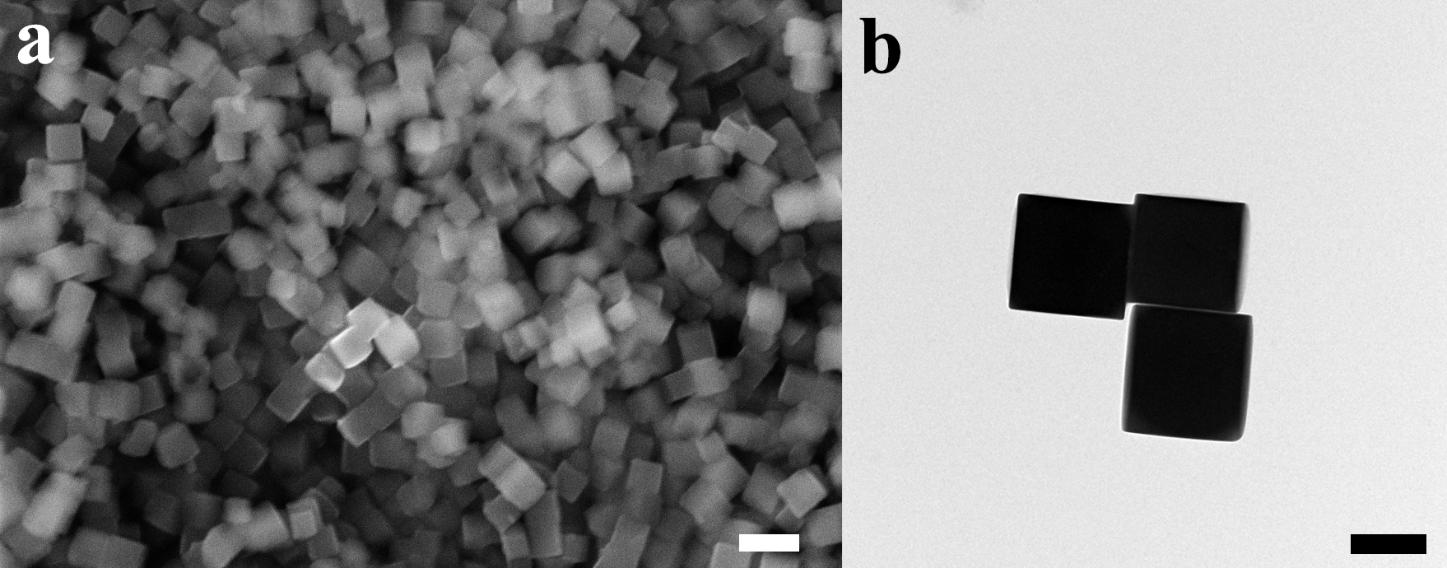
Figure S23. a, SEM image and b, TEM image of MNC-PBAs. Scale bars in a and b are 500 nm and 200 nm.

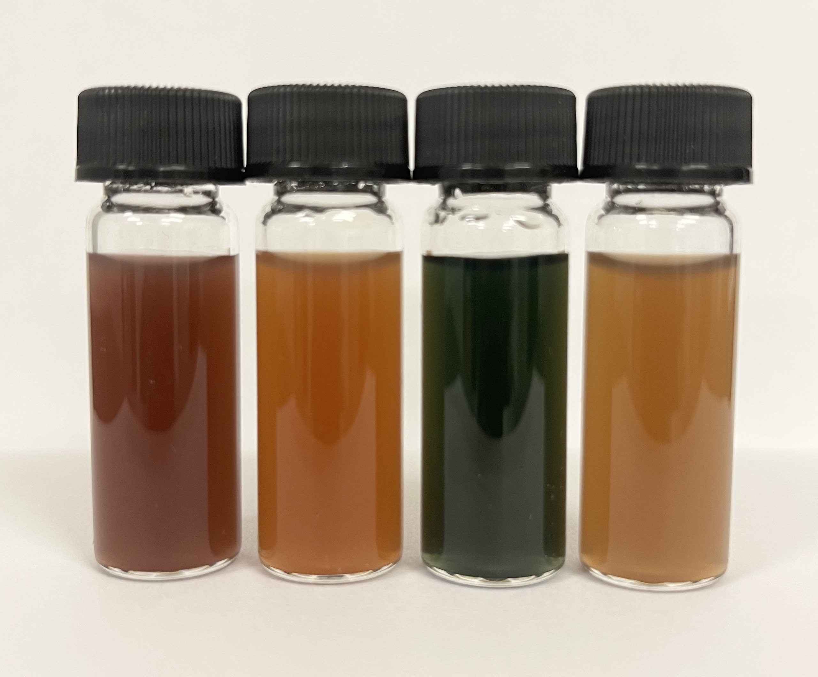
Figure 24. Dispersion liquid of C-PBAs (left), NCM-PBAs, CM-PBAs, and MNC-PBAs (right).

Figure S25. a, High-resolution TEM image of NCM-PBAs. b, Selected area electron diffraction pattern of NCM-PBAs. Scale bars in a and b are 5.0 nm and 0.5 nm.

Figure S26. HAADF-STEM image of NCM-PBAs. Scale bar, 50 nm.

Figure S27. XRD patterns of different regenerated PBAs for SIBs and ZIBs.

Figure S28. 2D synchrotron GIXRD images of a, C-PBAs, b, CM-PBAs, and c, MNC-PBAs

Figure 29. The high-resolution XPS spectrum of a, Co 2p and b, Fe 2p for regenerated C-PBA cubes.

Figure 30. a, Co and b, Fe K-edge XANES spectra of the samples.

Figure S31. The high-resolution XPS spectrum of a, Co 2p, b, Ni 2p, c, Mn 2p, and d, Fe 2p for regenerated NCM-PBA cubes.

Figure S32. a, Co, b, Mn, and c, Fe K-edge XANES spectra of the samples.

Figure S33. The electrochemical performance of ZIBs using different regenerated PBAs and liquid electrolytes. a, CV curves of ZIBs at a scan rate of 0.1 mV s⁻¹. According to previous studies, Zn ions can be reversibly intercalated and extracted through the tunnels of PBAs, accompanied by the transition between monoclinic and cubic phases. Compared with NCM-PBAs, the CM-PBAs show poorly defined pairs of redox peaks with much lower current density. b, Rate performance of MNC-PBA electrode, which delivers capacities of 116.9, 98.3, 89.8, 76.3, 61.0, and 50.8 mAh g⁻¹ at the current densities of 0.1, 0.2, 0.3, 0.5, 1.0, and 2.0 A g⁻¹. c, Long-term cycling performance of CM-PBA and MNC-PBA electrodes at 1.0 A g⁻¹ after the first 12 cycle activation process at 0.3 A g⁻¹, where the NCM-PBA electrode exhibits excellent cycling stability with a capacity retention of 82.1% over 2000 cycles.

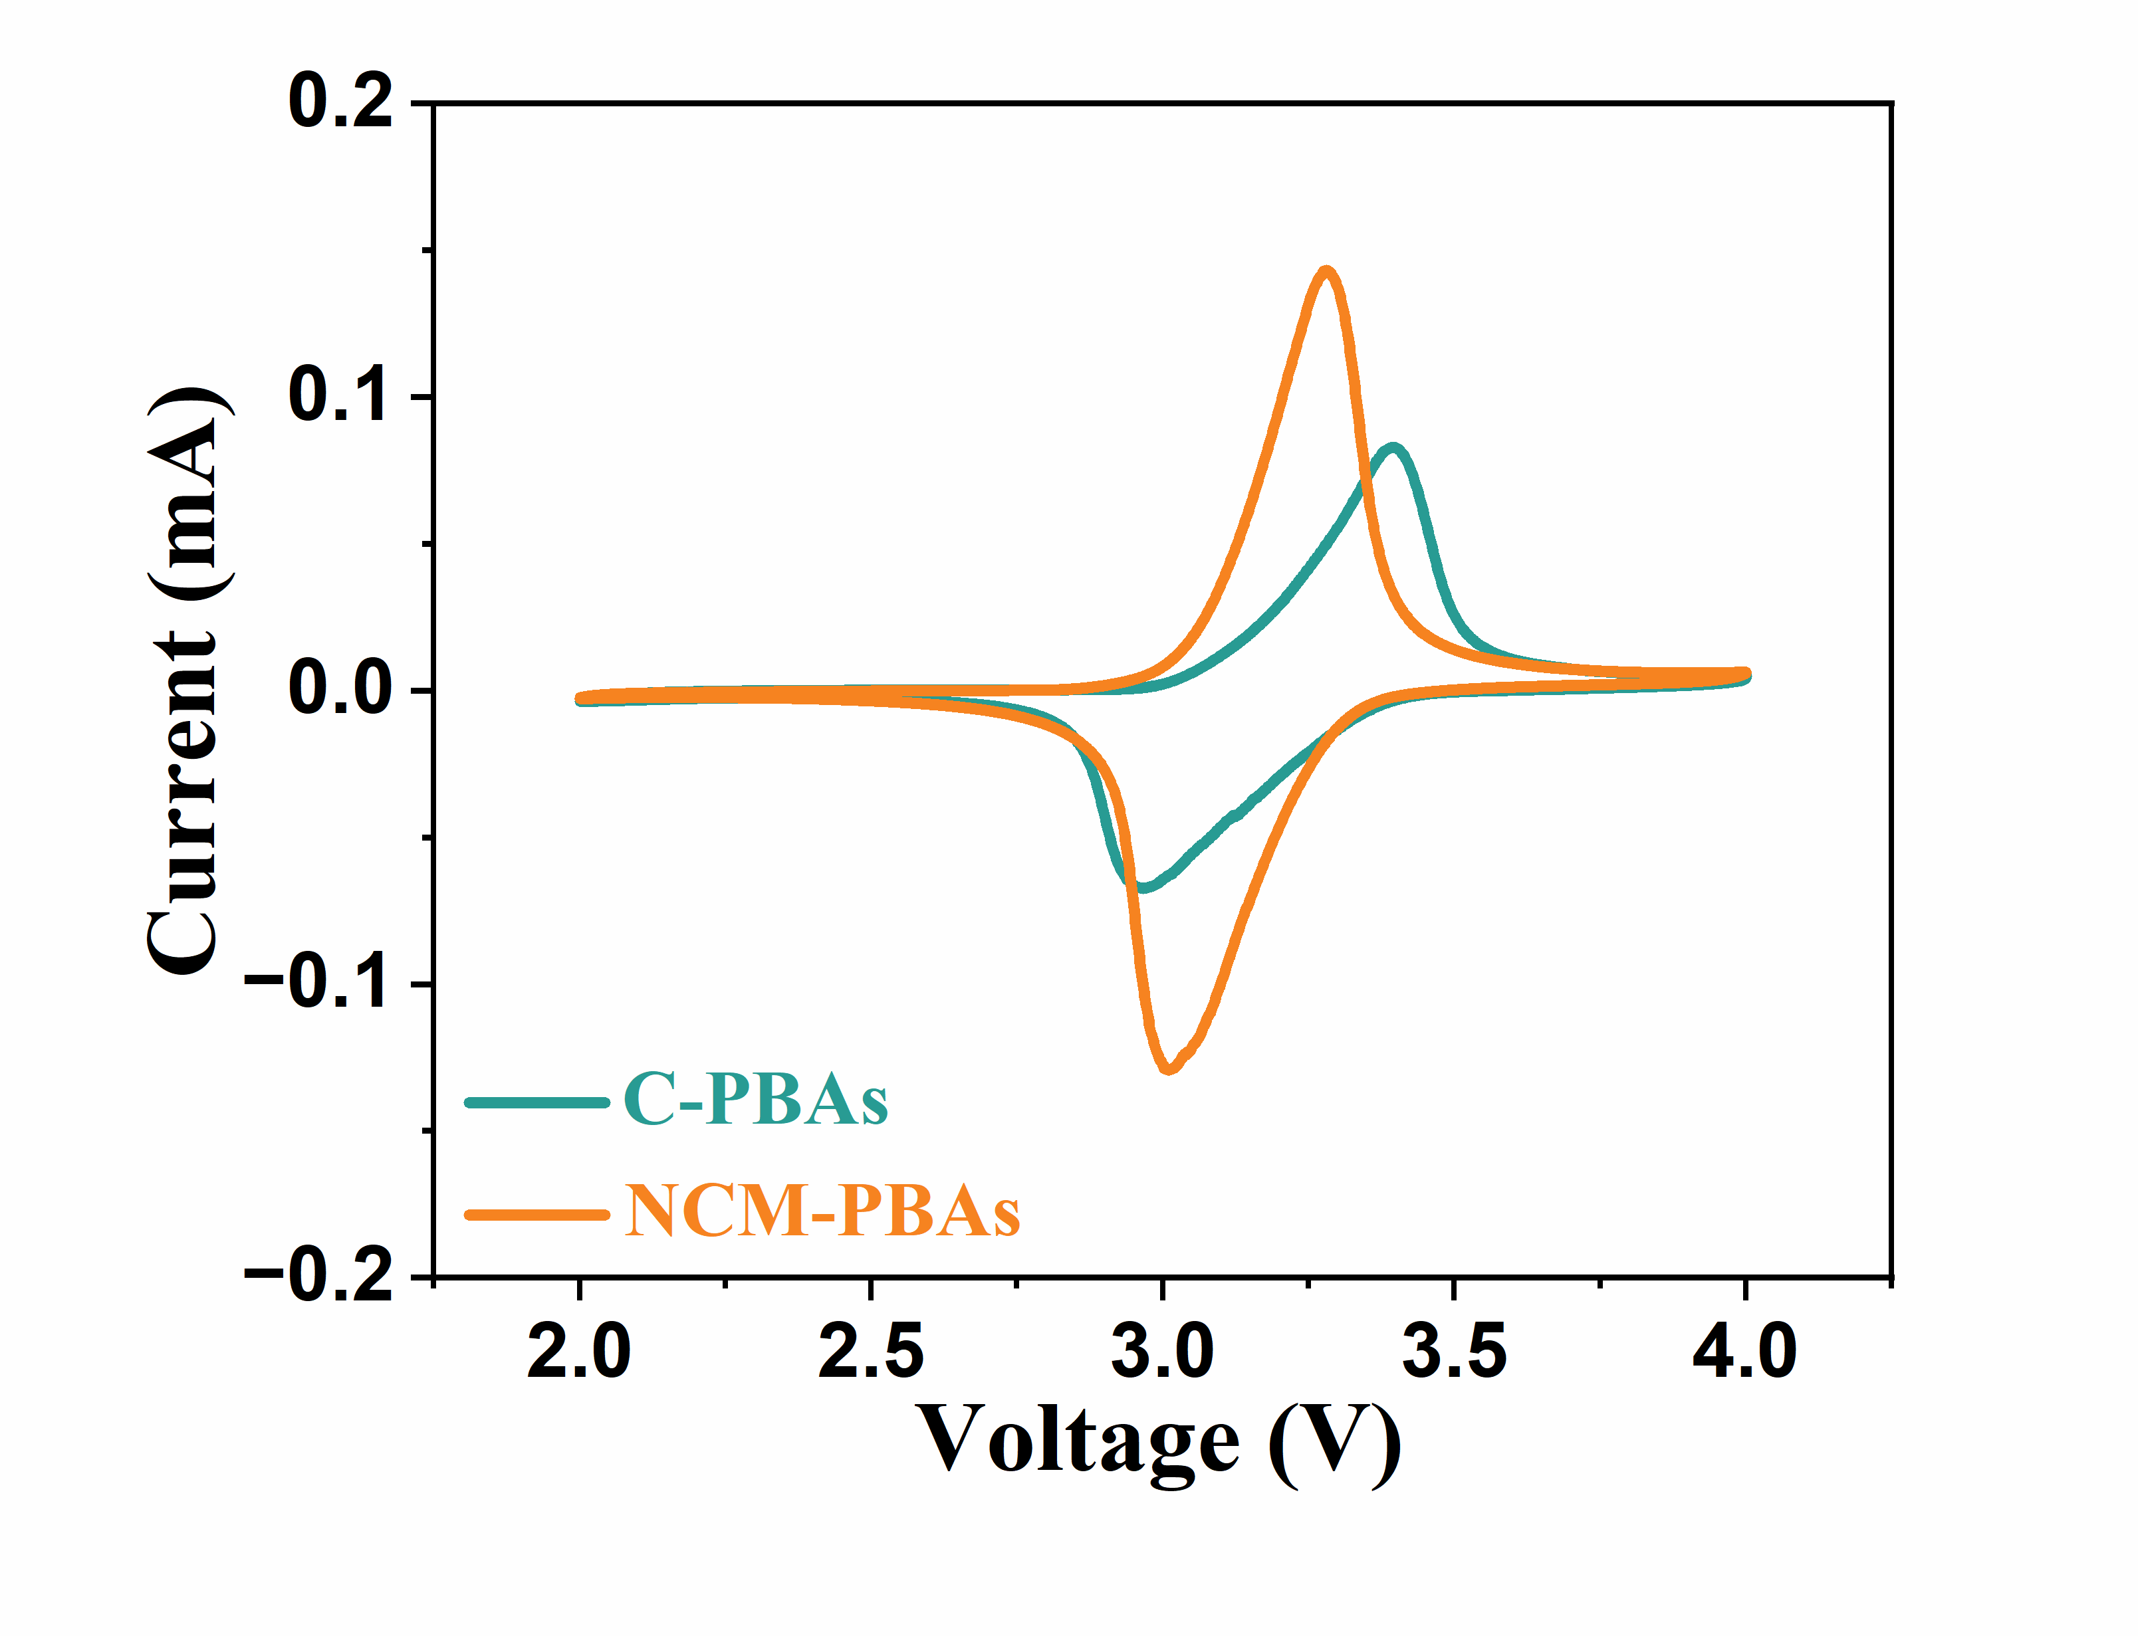
Figure S34. CV curves of SIBs with regenerated C-PBA and NCM-PBA electrodes scanned at a rate of 0.1 mV s⁻¹.

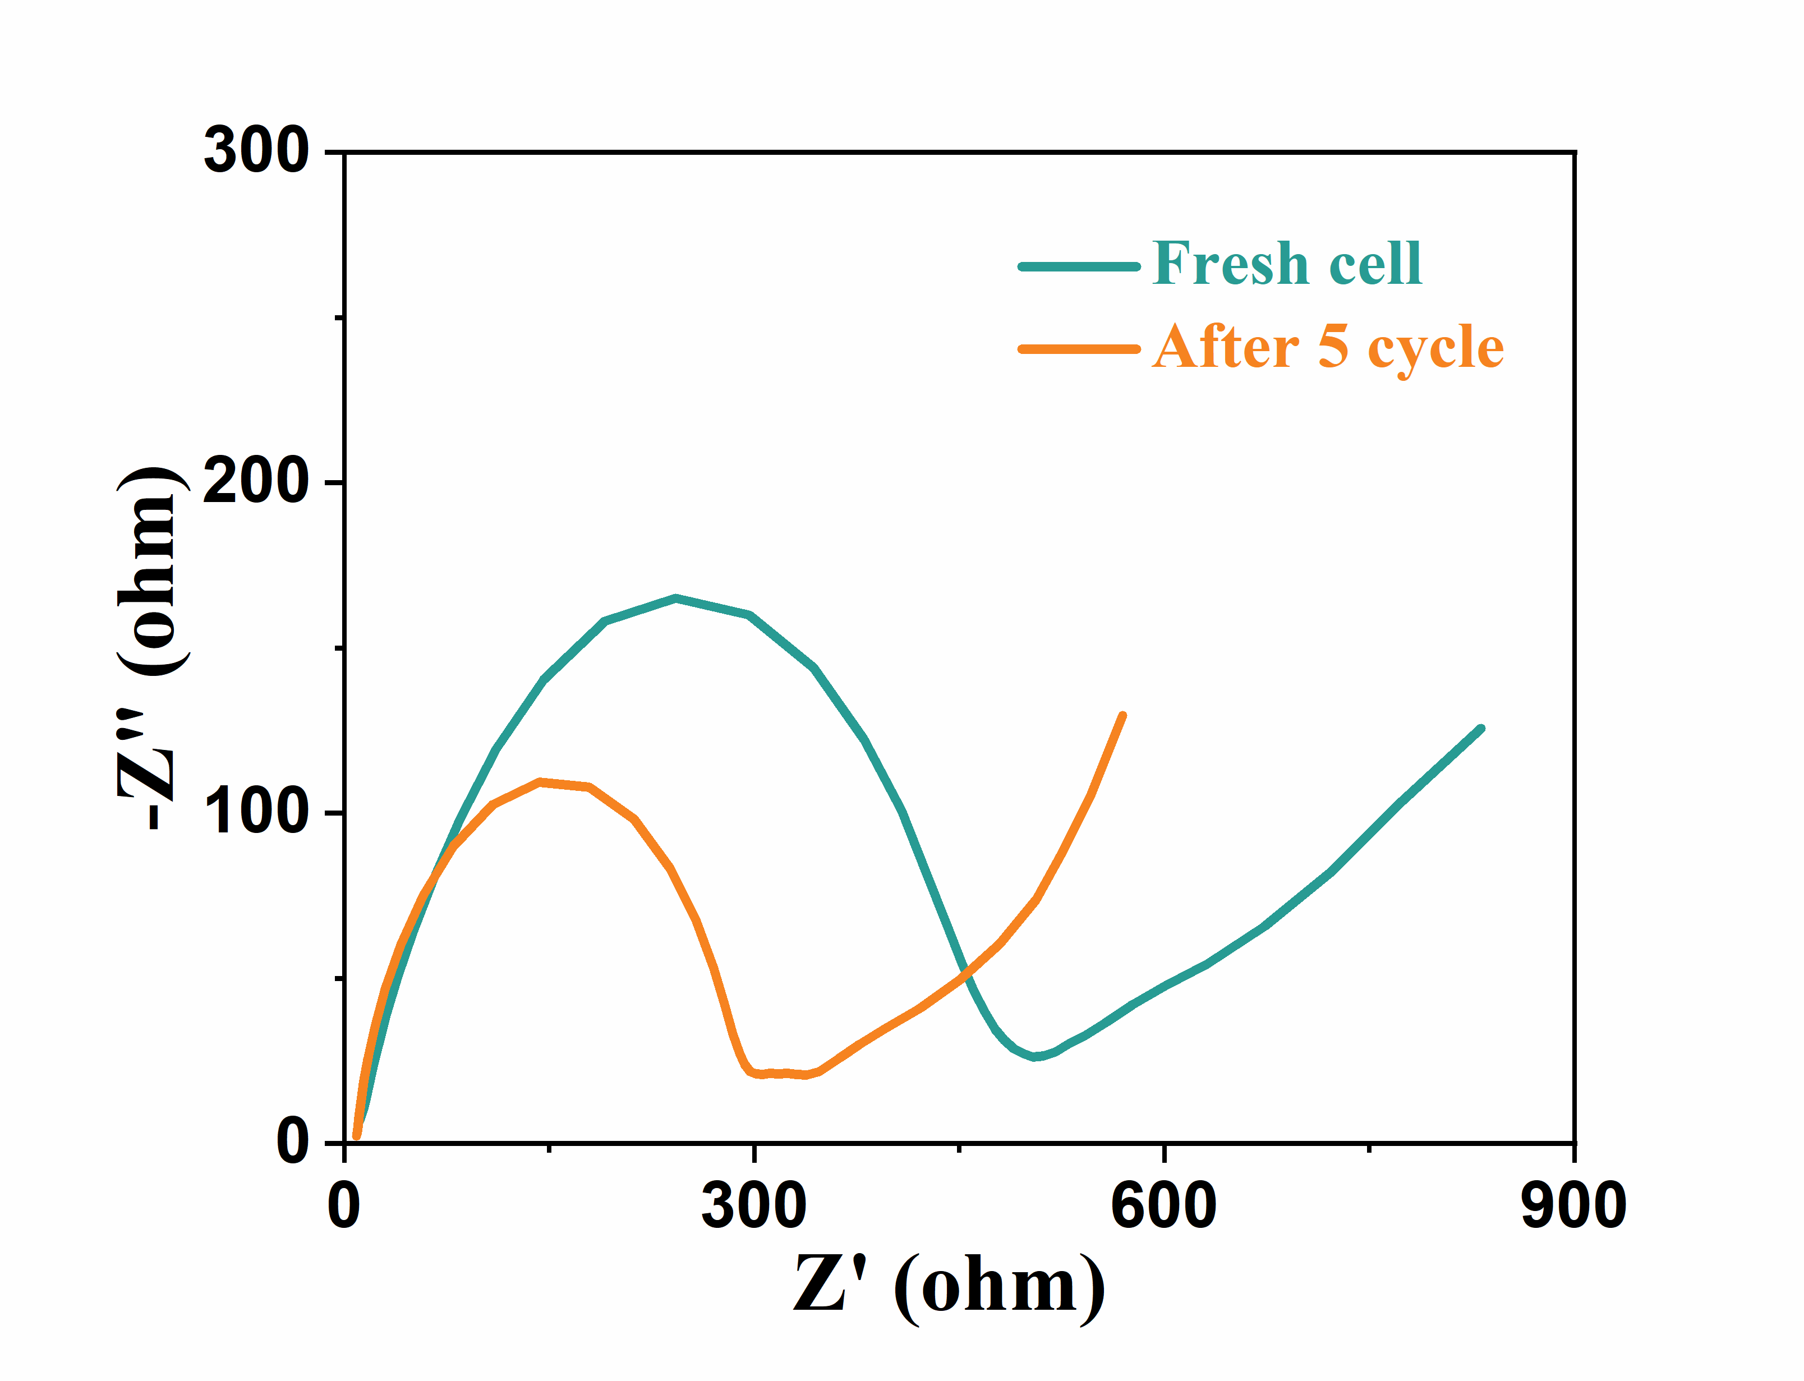
Figure S35. EIS Nyquist plots of SIB with regenerated NCM-PBA electrode before and after cycles.

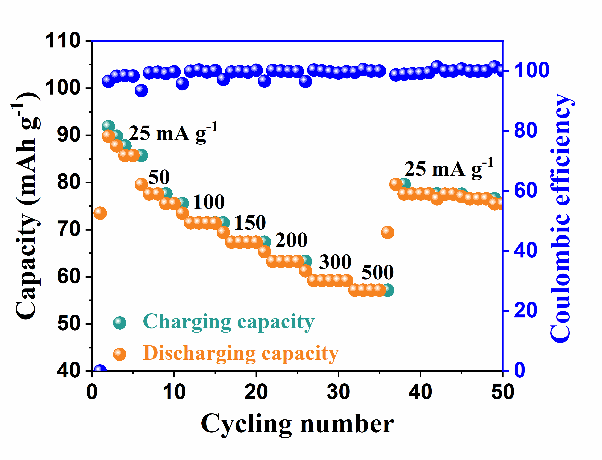
Figure S36. Rate performance based on regenerated NCM-PBA electrode.

Figure S37. Cycling performance of one-layer and twelve-layer Na metal pouch cells.

Figure S38. SEM image of NCM-PBA electrode after cycles. Scale bar, 400 nm.

Figure S39. TOF-SIMS 3D reconstruction of the representative a, CoF₃⁻, b, MnF₂⁻, and c, C₃HO⁻species of CEI layers on the surface of the electrode.

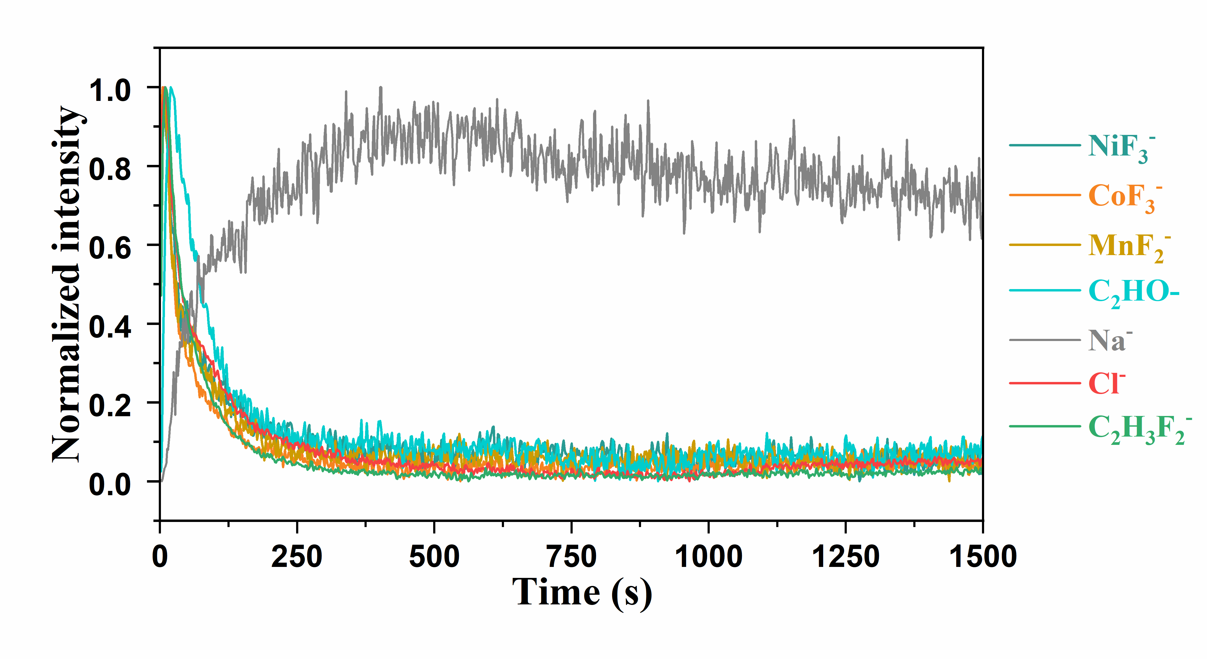
Figure S40. TOF-SIMS curves of the representative species of CEI layers formed at the surface of regenerated NCM-PBA electrode.

Figure S41. Cycling performance of LIBs with regenerated Li_{1.01}Ni_{0.79}Co_{0.11}Mn_{0.10}O₂ electrode.

Table S1. ICP results for leaching efficiency of main high-value elements for LCO with different pulp densities at 70 ℃ after diluting 100,000 times.
Pulp density (kg L⁻¹) | Li (ppm) | Co (ppm)
10 | 6.91 | 57.58
30 | 11.39 | 93.56
50 | 12.27 | 100.24
70 | 13.45 | 108.53
90 | 14.05 | 112.21
110 | 14.27 | 114.95

Table S2. ICP results for leaching efficiency of main high-value elements for NCM with different pulp densities at 70 ℃ after diluting 100,000 times.
Pulp density (kg L⁻¹) | Li (ppm) | Ni (ppm) | Co (ppm) | Mn (ppm)
10 | 7.19 | 19.69 | 19.84 | 18.89
30 | 21.44 | 58.43 | 59.23 | 56.28
50 | 33.59 | 90.25 | 91.09 | 85.54
70 | 37.95 | 97.91 | 97.74 | 91.78
90 | 38.92 | 99.77 | 100.51 | 93.15
110 | 41.19 | 105.01 | 105.67 | 97.01

Table S3. ICP results for selected solubility of main elements in LIBs by representative 3.0 M nitric acid (HNO₃), 3.0 M sulfuric acid (H₂SO₄), and 3.0 M acetic acid with the support of 5.0 wt% H₂O₂ at 100 ml solution with commercial NCM, Cu powder, and Al powder.
Solution | Ni (ppm) | Co (ppm) | Mn (ppm) | Al (ppm) | Cu (ppm) | Li (ppm)
HNO₃ | 1856.65 | 1875.07 | 1730.94 | 645.34 | 656.99 | 642.25
H₂SO₄ | 1926.09 | 1917.02 | 1805.74 | 597.97 | 666.62 | 670.25
Acetic acid | 1914.30 | 1911.09 | 1793.84 | 0.07 | 0.13 | 661.50

Table S4. ICP results of different diluted leaching solutions during the sustainable regeneration processes as cathode materials for LIBs.
 | Na (ppm) | Li (ppm) | Ni (ppm) | Co (ppm) | Mn (ppm)
Leaching solution | 0.06 | 3.72 | 8.71 | 8.92 | 9.54
Leaching solution after balancing | 0.05 | 3.97 | 10.13 | 9.95 | 9.41
Raffinate after coprecipitation | 158.19 | 3.68 | 0.01 | 0.02 | 0.01

Table S5. ICP results of different diluted leaching solutions during the sustainable regeneration processes as cathode materials for SIBs.
 | Li (ppm) | Ni (ppm) | Co (ppm) | Mn (ppm) | Na (ppm) | K (ppm) | Fe (ppm)
Leaching solution | 3.57 | 9.43 | 9.23 | 8.63 | 0.02 | 0.01 | 0.01
Raffinate after coprecipitation | 3.35 | 0.10 | 0.01 | 0.33 | 8.50 | 11.03 | 8.60

Table S6. ICP results for different cathode materials stoichiometry ratio and impurities content.
 | Li | Ni | Co | Mn | Cu | Al | Na | K | Fe
R-NCM | 1.04 | 0.34 | 0.32 | 0.34 | 0.00 | 0.00 | 0.00 | 0.00 | 0.00
R-NCM811 | 1.01 | 0.79 | 0.11 | 0.10 | 0.00 | 0.00 | 0.00 | 0.00 | 0.00
C-PBAs | 0.00 | 0.00 | 1.64 | 0.00 | 0.00 | 0.00 | 0.02 | 1.97 | 1.00
NCM-PBAs | 0.00 | 0.42 | 0.58 | 0.42 | 0.00 | 0.00 | 0.01 | 2.36 | 1.00
CM-PBAs | 0.00 | 0.00 | 0.20 | 1.14 | 0.00 | 0.00 | 0.01 | 2.18 | 1.00
MNC-PBAs | 0.00 | 0.28 | 0.31 | 0.90 | 0.00 | 0.00 | 0.01 | 2.00 | 1.00

Table S7. The total energy consumption, water consumption, and harmful gas emissions for preparing 1 kg of NCM cathode materials using raw materials.
 | Energy  (MJ/Kg) | CO₂  (kg/kg) | SO_{X}  (g/kg) | NO_{X}  (g/kg) | PM10  (g/kg) | Water  (L/kg)
NiSO₄ | 27.07 | 1.82 | 244.18 | 7.82 | 2.86 | 27.56
CoSO₄ | 55.96 | 3.79 | 25.35 | 5.79 | 13.04 | 72.37
MnSO₄ | 3.06 | 0.36 | 7.14 | 0.32 | 0.65 | 1
Li₂CO₃ | 16.23 | 1.46 | 2.38 | 5.11 | 0.18 | 2.85
NaOH | 27.37 | 1.82 | 2.52 | 1.6 | 0.01 | 12.15
NH₄OH | 2.4 | 0.15 | 0.05 | 0.14 | 0.66 | 0.17
Coprecipitation | 46.97 | 2.94 | 0.48 | 3.09 | 0.16 | 0.19
Calcination | 52.23 | 3.76 | 6.12 | 2.26 | 0.41 | 18.03
Total | 231.28 | 16.11 | 288.22 | 26.12 | 17.97 | 135.28

Table S8. The total energy consumption, water consumption, and harmful gas emissions for preparing 1 kg of R-NCM cathode materials using Black mass for LIBs.
 | Energy  (MJ/Kg) | CO₂  (kg/kg) | SO_{X}  (g/kg) | NO_{X}  (g/kg) | PM10  (g/kg) | Water  (L/kg)
NiSO₄ | 0.03 | 0 | 0.24 | 0.01 | 0 | 0.03
CoSO₄ | 0.11 | 0.01 | 0.05 | 0.01 | 0.02 | 0.15
MnSO₄ | 0 | 0 | 0 | 0 | 0 | 0
Li₂CO₃ | 4.38 | 0.39 | 0.64 | 1.38 | 0.05 | 0.77
NaOH | 27.37 | 1.82 | 2.52 | 1.6 | 0.01 | 12.15
NH₄OH | 2.4 | 0.15 | 0.05 | 0.14 | 0.66 | 0.17
Coprecipitation | 46.97 | 2.94 | 0.48 | 3.09 | 0.16 | 0.19
Calcination | 52.23 | 3.76 | 6.12 | 2.26 | 0.41 | 18.03
Total | 133.49 | 9.07 | 10.1 | 8.49 | 1.31 | 31.49

Table S9. The total energy consumption, water consumption, and harmful gas emissions for preparing 1 kg of NCM-PBA cathode materials using Black mass for SIBs.
 | Energy  (MJ/Kg) | CO₂  (kg/kg) | SO_{X}  (g/kg) | NO_{X}  (g/kg) | PM10  (g/kg) | Water  (L/kg)
NiSO₄ | 0.29 | 0.02 | 2.59 | 0.08 | 0.03 | 0.29
CoSO₄ | 0.06 | 0 | 0.03 | 0.01 | 0.01 | 0.08
MnSO₄ | 0.12 | 0.01 | 0.27 | 0.01 | 0.02 | 0.04
Li₂CO₃ | 0 | 0 | 0 | 0 | 0 | 0
Na₃C₆H₅O₇ | 6.48 | 1.42 | 0.14 | 0.02 | 0.03 | 1.08
K₃[Fe(CN)₆] | 21.33 | 2.54 | 1.9 | 1.6 | 0.01 | 9.17
Coprecipitation | 46.97 | 2.94 | 0.48 | 3.09 | 0.16 | 0.19
Calcination | 0 | 0 | 0 | 0 | 0 | 0
Total | 75.25 | 6.93 | 5.41 | 4.81 | 0.26 | 10.85

References:
S1. Chen, Y. et al. Thermal treatment and ammoniacal leaching for the recovery of valuable metals from spent lithium-ion batteries. Waste Manage. 75, 469–476 (2018).
S2. Ku, H. et al. Recycling of spent lithium-ion battery cathode materials by ammoniacal leaching. J. Hazard. Mater. 313, 138–146 (2016).
S3. Wang, H. et al. Recovery of Lithium, Nickel, and Cobalt from Spent Lithium-Ion Battery Powders by Selective Ammonia Leaching and an Adsorption Separation System. ACS Sustainable Chem. Eng. 5, 11489–11495 (2017).
S4. Smith, E. L., Abbott, A. P. & Ryder, K. S. Deep eutectic solvents (DESs) and their applications. Chem. Rev. 114, 11060–11082 (2014).
S5. Tran, M. K., Rodrigues, M.-T. F., Kato, K., Babu, G. & Ajayan, P. M. Deep eutectic solvents for cathode recycling of Li-ion batteries. Nat. Energy 4, 339–345 (2019).
S6. Wang, S., Zhang, Z., Lu, Z. & Xu, Z. A novel method for screening deep eutectic solvent to recycle the cathode of Li-ion batteries. Green Chem. 22, 4473–4482 (2020).
S7. Zeng, X., Li, J. & Shen, B. Novel approach to recover cobalt and lithium from spent lithium-ion battery using oxalic acid. J. Hazard. Mater. 295, 112–118 (2015).
S8. Chen, X., Fan, B., Xu, L., Zhou, T. & Kong, J. An atom-economic process for the recovery of high value-added metals from spent lithium-ion batteries. J. Clean. Prod. 112, 3562–3570 (2016).

