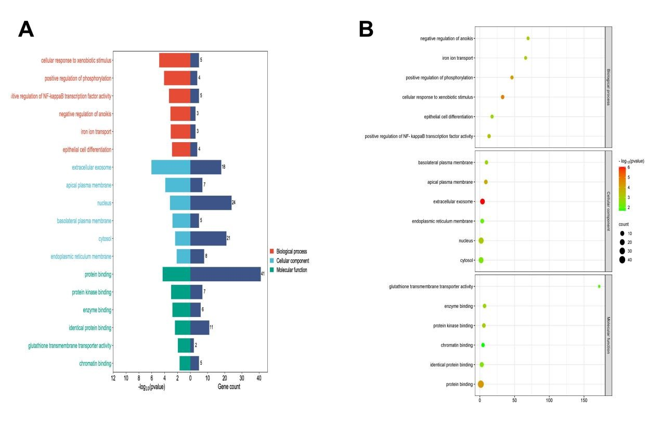
Supplementary Figure 1. Enrichment analysis of common differential genes. (A) A histogram of Gene Ontology (GO) enrichment analysis, where the ordinate was Go term and the abscise was -log10 (p-value) and count value of enrichment in each term. (B) A bubble diagram of GO enrichment analysis. The color depth of the nodes represented the corrected P-value and the size of the nodes referred to the number of genes involved.

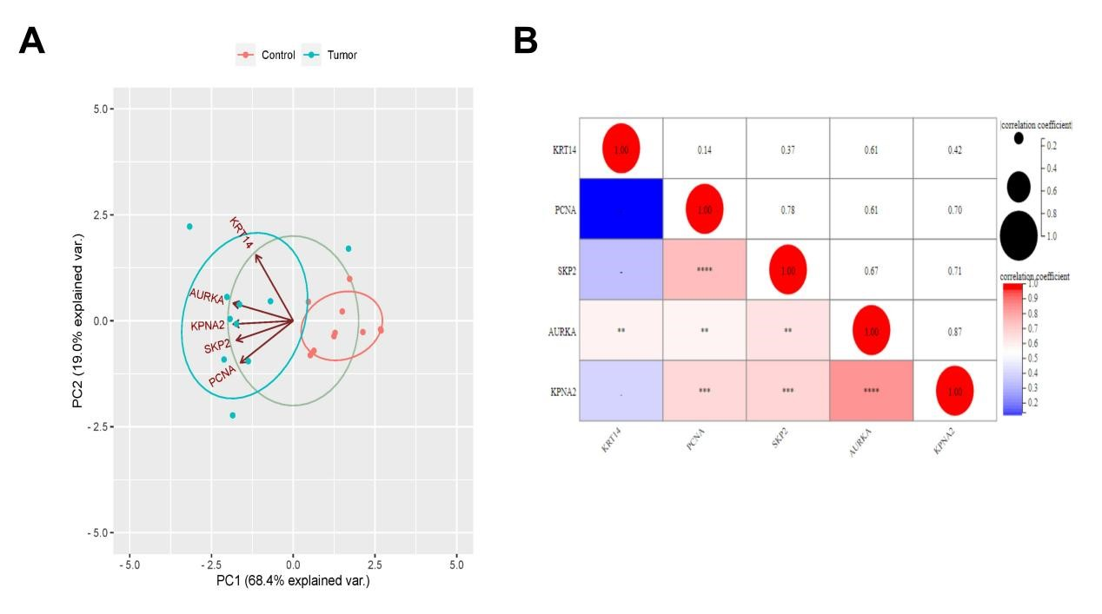
Supplementary Figure 2. Hub genes analysis. (A) The principal component analysis diagram of Hub genes. The axes PC1 and PC2 in the figure were the first and second principal components (i.e., the explanation rate of variance by potential variables). Dots represented samples, and different colors represented different groups. (B) Matrix Correlation analysis chart. Matrix analysis was used to show the correlation between data matrices and visualization.

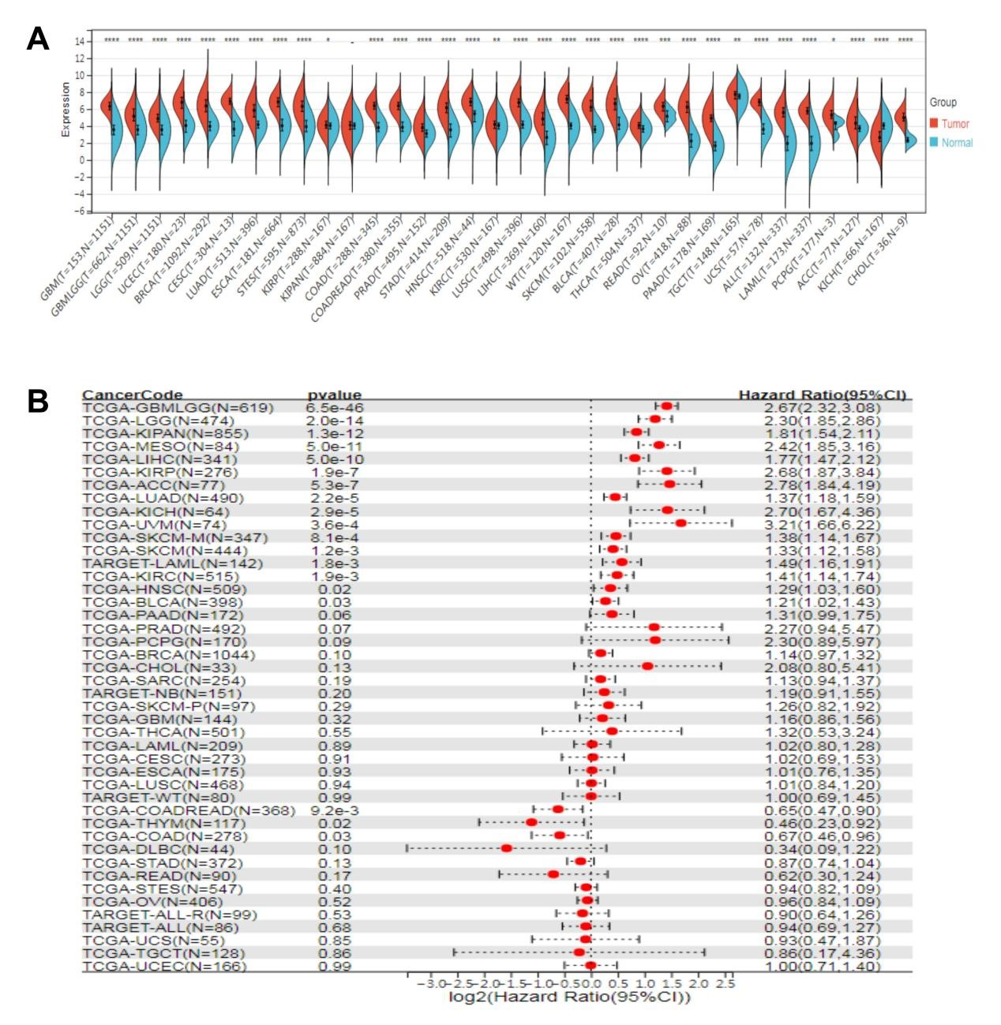
Supplementary Figure 3. Expression and prognosis of KPNA2 in pan-cancer. (A) Differential expression analysis of KPNA2 in pan-cancer. (B) Prognostic analysis of KPNA2 in pan-cancer.

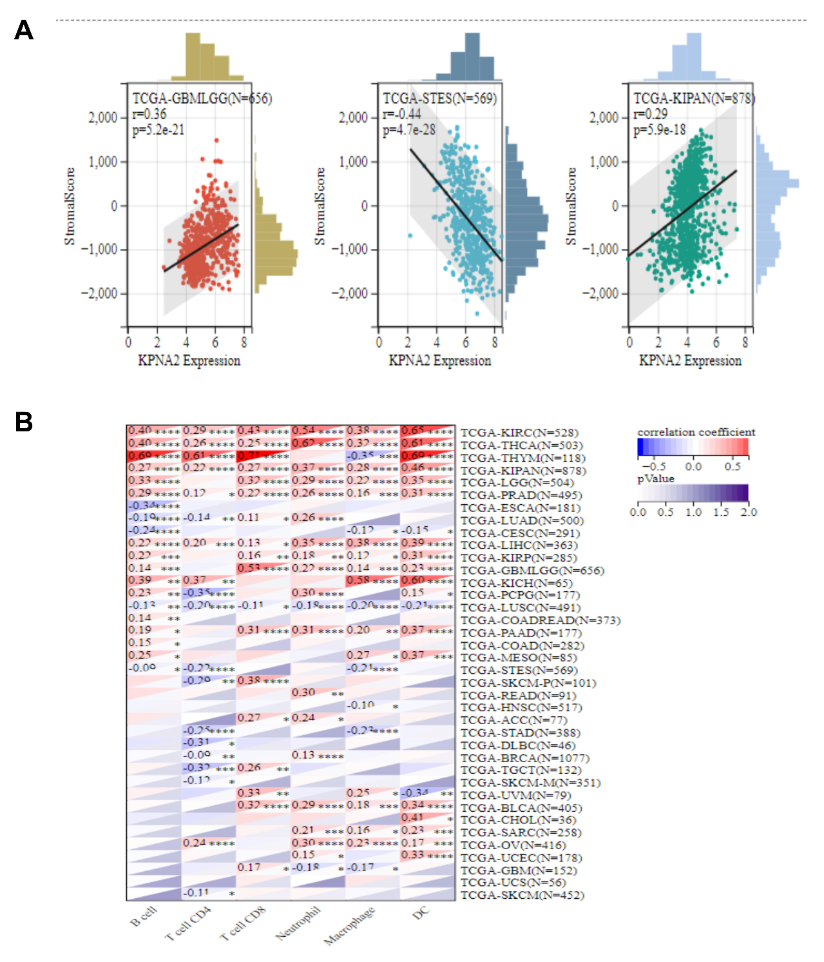
Supplementary Figure 4. Correlation between KPNA2 expression and immune cell infiltration. (A) Analysis of correlation between KPNA2 and immune infiltration in pan-cancer. (B) Analysis of correlation between KPNA2 and different immune cells in pan-cancer.

