General information:
IR spectra were recorded on a Perkin-Elmer FT-IR 240-C spectrophotometer using KBr optics. ¹H NMR spectra were recorded on Bruker AV 300 MHz in CDCl₃ & DMSO-d₆ using TMS as internal standard. ESI spectra were recorded on Micro mass, Quattro LC using ESI⁺ software with capillary voltage 3.98 kV and ESI mode positive ion trap detector. All high-resolution spectra were recorded on QSTARXL hybrid MS/MS system (Applied Biosystems, USA) under electrospray ionization. All the reactions were monitored by thin layer chromatography (TLC) on precoated silica gel 60 F₂₅₄; spots were visualized with UV light. Merck silica gel (60-120 mesh) was used for column chromatography.
Preparation of 6-methyl-4-(trifluoromethyl)pyridin-2(1H)-one (1)
2-Oxo-6-methyl-4-(trifluoromethyl)-1,2- dihydropyridine-3-carbonitrile (10 g, 0.03 mol) was slowly added to 150 mL of 50% sulfuric acid. The reaction mixture was heated with stirring for 10 h, at 148°C. The reaction mixture was allowed to cool and poured on to crushed ice. White solid was formed and filtered.
Preparation of 6-methyl-4-(trifluoromethyl)pyridin-2-amine (2)
The 3-cyano-4-trifluoromethyl-6-substituted- 2(1H)-pyridone 1 (2.8 mmol) was dissolved in dry
acetone (50 mL). To the homogeneous solution, 2-chloroacetamide (0.245 g, 2.6 mmol), potassium carbonate (0.730 g, 5.3 mmol) and a pinch of sodium iodide (0.014 g) were added. The reaction mixture was refluxed for 6–8 h at 60°C and cooled to room temperature. The separated salt was filtered off and washed with acetone (30 mL). The total filtrate was concentrated under vacuum and the residue was treated with water. The separated white solid was filtered, dried and recrystallized from ethyl alcohol.
Preparation of diethyl 2-(((6-methyl-4-(trifluoromethyl)pyridin-2-yl) amino) methylene)malonate (3)
The 6-methyl-4-(trifluoromethyl) pyridin-2-amine (0.500 g, 0.002 mol) and diethyl 2-(ethoxymethylene) malonate (0.450 g, 0.002 mol) were taken in absolute ethanol and it was refluxed for 10 h. After completion of the reaction, ethanol was completely removed under vacuum, washed with n-hexane and dried to afford diethyl 2-(((6-methyl-4-(trifluoromethyl)- pyridin-2-yl) amino) methylene) malonate 4.

Prepartion of ethyl 6-methyl-4-oxo-8-(trifluoromethyl)-4H-pyrido[1,2-a]pyrimidine-3-carboxylate (4)
The diethyl 2-(((6-methyl-4-(trifluoromethyl) pyridin-2-yl)- amino) methylene) malonate 4 (0.500 g, 0.001 mol) was taken in 5 mL of phosphorus oxychloride (POCl₃), and the reaction mixture was refluxed for 4–5 h at 140°C. After completion of the reaction, the excess POCl₃ was distilled under vacuum and the residue was treated with crushed ice. Yellow color solid was formed, filtered and washed with excess water.
Preparation of 6-methyl-4-oxo-8-(trifluoromethyl)-4H-pyrido[1,2-a]pyrimidine-3-carbohydrazide (5)
ethyl 6-methyl-4-oxo-8-(trifluoromethyl)-4H-pyrido[1,2-a]pyrimidine-3-carboxylate was taken in 95% ethanol (30 ml) and hydrazine hydrate (5 ml) was added. The mixture was refluxed for 3-4 hrs. After cooling to room temperature the ethanol was removed under vacuum. The residue was stirred with water and filtered, washed with n-hexane and dried under vacuum to give a yellow solid which was pure enough.
6-Methyl-4-(trifluoromethyl)pyridin-2(1H)-one (2a)
White solid; Yield 96%; IR (KBr, cm⁻¹): 3326, (CONH), 1655 (CO); ¹H NMR (CDCl₃, 300 MHz): δ 2.36 (s, 3H, -CH₃), 6.39 (s, 1H, Ar-H), 6.62 (s, 1H, Ar-H); MS (ESI): m/z [(M+H)⁺]: 178; Anal. calc. for C₇H₆F₃NO: C 47.47, H 3.41, N 7.91 %. Found: C 47.48, H 3.42, N 7.93%.
6-Ethyl-4-(trifluoromethyl)pyridin-2(1H)-one (2b)
White solid; Yield 96%; IR (KBr, cm⁻¹): 3325, (CONH), 1656 (CO); ¹H NMR (CDCl₃, 300 MHz): δ 1.19 (t, 3H, -CH₃), 2.48 (q, 2H, -CH₂), 6.33 (s, 1H, Ar-H), 6.68 (s, 1H, Ar-H); MS (ESI): m/z [(M+H)⁺]: 192; Anal. calc. for C₈H₈F₃NO: C 50.27, H 4.22, N 7.33 %. Found: C 50.28, H 4.21, N 7.35%
6-Methyl-4-(trifluoromethyl)pyridin-2-amine (3a)
White solid; Yield 82%; IR (KBr, cm⁻¹): 3374, 3492 (NH₂), 1631 (CO); ¹H NMR (CDCl₃, 300 MHz): δ 4.68 (br, 2H), 2.36 (s, 3H, -CH₃), 6.38 (s, 1H, Ar-H), 6.66 (s, 1H, Ar-H); MS (ESI): m/z [(M+H)⁺]: 177; Anal. calc. for C₇H₇F₃N₂: C 47.73, H 4.01, N 15.90 %. Found: C 47.74, H 4.03, N 15.92%.

6-Ethyl-4-(trifluoromethyl)pyridin-2-amine (3b)
White solid; Yield 80%; IR (KBr, cm⁻¹): 3371, 3489 (NH₂), 1632 (CO); ¹H NMR (CDCl₃, 300 MHz): δ 4.70 (br, 2H), 1.18 (t, 3H, -CH₃), 2.46 (q, 2H, -CH₂), 6.32 (s, 1H, Ar-H), 6.69 (s, 1H, Ar-H); MS (ESI): m/z [(M+H)⁺]: 191; Anal. calc. for C₈H₉F₃N₂: C 50.53, H 4.77, N 14.73 %. Found: C 50.54, H 4.78, N 14.72%.
Diethyl 2-(((6-methyl-4-(trifluoromethyl)pyridin-2-yl)amino)methylene)malonate (4a)
White solid; Yield 86%; IR (KBr, cm⁻¹): 1731 (CO); ¹H NMR (CDCl₃, 300 MHz): δ 1.38 (t, 6H, –CH₃), 2.36 (s, 3H, -CH₃), 4.31 (q, 4H, –CH₂–), 6.39 (s, 1H, Ar-H), 6.81 (s, 1H, Ar-H), 9.28 (d, J=12.46 Hz, 1H, –NCH=), 11.30 (d, J=12.46 Hz, 1H, –NHC=); MS (ESI): m/z [(M+H)⁺]: 347; Anal. calc. for C₁₅H₁₇F₃N₂O₄: C 52.02, H 4.95, N 8.09 %. Found: C 52.04, H 4.96, N 8.10%.
Diethyl 2-(((6-ethyl-4-(trifluoromethyl)pyridin-2-yl)amino)methylene)malonate (4b)
White solid; Yield 79%; IR (KBr, cm⁻¹): 1732 (COOEt); ¹H NMR (CDCl₃, 300 MHz): δ 1.17 (t, 3H, -CH₃), 1.37 (t, 6H, –CH₃), 2.41 (q, 2H, -CH₃), 4.32 (q, 4H, –CH₂–), 6.38 (s, 1H, Ar-H), 6.82 (s, 1H, Ar-H) 9.29 (d, J=12.46 Hz, 1H, –NCH=), 11.30 (d, J=12.46 Hz, 1H, –NHC=); MS (ESI): m/z [(M+H)⁺]: 361; Anal. calc. for C₁₆H₁₉F₃N₂O₄: C 53.33, H 5.31, N 7.77 %. Found: C 53.34, H 5.32, N 7.79 %.
Ethyl 6-methyl-4-oxo-8-(trifluoromethyl)-4H-pyrido[1,2-a]pyrimidine-3-carboxylate (5a)
Yellow solid; Yield 75%; IR (KBr, cm⁻¹): 1725 (COOEt); ¹H NMR (CDCl₃, 300 MHz): δ 1.28 (t, 3H, -CH₃), 2.39 (s, 3H, -CH₃), 4.21(q, 2H, -CH₂), 6.81 (s, 1H, Ar-H), 7.71(s, 1H, Ar-H), 8.10(s, 1H, Ar-H); MS (ESI): m/z [(M+H)⁺]: 301; Anal. calc. for C₁₃H₁₁F₃N₂O₃: C 52.01, H 3.69, N 9.33 %. Found: C 52.02, H 3.71, N 9.36 %.
Ethyl 6-ethyl-4-oxo-8-(trifluoromethyl)-4H-pyrido[1,2-a]pyrimidine-3-carboxylate (5b)
Yellow solid; Yield 70%; IR (KBr, cm⁻¹): 1728 (COOEt); ¹H NMR (CDCl₃, 300 MHz): δ 1.21 (t, 3H, -CH₃), 1.24 (t, 3H, -CH₃), 2.40 (q, 2H, -CH₂), 4.29 (q, 2H, -CH₂), 6.73 (s, 1H, Ar-H), 7.69 (s, 1H, Ar-H), 8.096 (s, 1H, Ar-H); MS (ESI): m/z [(M+H)⁺]: 315; Anal. calc. for C₁₄H₁₃F₃N₂O₃: C 53.01, H 3.69, N 9.33 %. Found: C 53.02, H 3.71, N 9.36 %.
6-Methyl-4-oxo-8-(trifluoromethyl)-4H-pyrido[1,2-a]pyrimidine-3-carbohydrazide (6a)
White solid; Yield 71%; IR (KBr, cm⁻¹): 3372, 3493 (NH₂), 3210 (CONH), 1682 (CO); ¹H NMR (DMSO-d₆, 300 MHz): δ 2.51 (s, 3H, -CH₃), 4.15 (br. s, 2H, N-NH₂), 6.91(s, 1H, Ar-H), 7.36 (s, 1H, Ar-H), 7.72 (s, lH, CONH), 8.98 (s, 1H, Ar-H); MS (ESI): m/z [(M+H)⁺]: 287; Anal. calc. for C₁₁H₉F₃N₄O₂: C 46.16, H 3.17, N 19.58 %. Found: C 46.17, H 3.18, N 19.59 %.
6-Ethyl-4-oxo-8-(trifluoromethyl)-4H-pyrido[1,2-a]pyrimidine-3-carbohydrazide (6b)
White solid; Yield 66%; IR (KBr, cm⁻¹): 3378, 3491 (NH₂), 3212 (CONH), 1690 (CO); ¹H NMR (DMSO-d₆, 300 MHz): δ 1.25 (t, 3H, -CH₃), 2.81(q, 2H, -CH₂), 4.18 (br, 2H, N-NH₂), 6.95(s, 1H, Ar-H), 7.38 (s, 1H, Ar-H), 7.70 (s, lH, CONH), 8.91 (s, 1H, Ar-H); MS (ESI): m/z [(M+H)⁺]: 301; Anal. calc. for C₁₂H₁₁F₃N₄O₂: C 48.00, H 3.69, N 18.66 %. Found: C 48.02, H 3.71, N 18.65 %.
General procedure for praparation of 7a-7l
6-Methyl/ethyl-4-oxo-8-(trifluoromethyl)-4H-pyrido[1,2-a]pyrimidine-3-carbohydrazide 6 (0.004 mol) was taken in POCl₃ (5.0 mL) and aromatic acid (0.004 mol) was added. The mixture was refluxed for 4-6 hrs and after cooling to room temperature, poured into crushed ice and neutralized with sat. NaHCO₃. Extracted with ethyl acetate, the organic layer was separated and dried over anhydrous Na₂SO₄ and concentrated. The crude product was purified by colum chromatography using mixture of ethyl acetate and n-hexane as eluents.

6-Methyl-3-(5-phenyl-1,3,4-oxadiazol-2-yl)-8-(trifluoromethyl)-4H-pyrido[1,2-a]pyrimidin-4-one (7a)
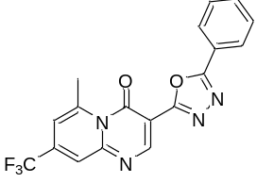
Yellow solid; Yield 79%; IR (KBr, cm⁻¹): 1620 (CO); ¹H NMR (CDCl₃, 300 MHz): δ 2.51 (s, 3H, -CH₃), 7.50-7.64 (m, 3H, Ar-H), 7.81 (s, 1H, Ar-H), 7.93 (s, 1H, Ar-H), 8.05 (s, 1H, Ar-H), 8.15-8.22 (m, 2H, Ar-H); ¹³C NMR (CDCl₃, 75 MHz) δ ppm : 25.3, 121.0, 123.0, 124.5, 125.8, 126.8,127.7, 128.4, 129.4, 130.6, 131.9, 132.5, 133.5, 139.8, 141.8, 160.5; MS (ESI): m/z [(M+H)⁺]: 373. HRMS m/z Calcd. for C₁₈H₁₁F₃N₄O₂ [(M+H)⁺]: 373.0025, Found 373.0027.
6-Methyl-3-(5-(p-tolyl)-1,3,4-oxadiazol-2-yl)-8-(trifluoromethyl)-4H-pyrido[1,2-a]pyrimidin-4-one (7b)
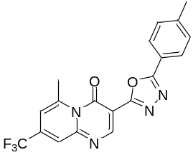
Yellow solid; Yield 71%; IR (KBr, cm⁻¹): 1618 (CO); ¹H NMR (CDCl₃, 300 MHz): δ 2.32 (s, 3H, -CH₃), 2.52 (s, 3H, Pyridine-CH₃), 7.72 (d, 2H, Ar-H), 7.91 (s, 1H, Ar-H), 8.03 (d, 2H, Ar-H), 8.23(s, 1H, Ar-H), 8.38 (s, 1H, Ar-H); ¹³C NMR (CDCl₃, 75 MHz) δ ppm : 21.4, 25.3, 123.0, 123.6, 124.8, 125.6, 126.5, 127.3, 128.1, 129.4, 130.9, 132.2, 133.3, 135.8, 137.1, 143.3, 158.7; MS (ESI): m/z [(M+H)⁺]: 387. HRMS m/z Calcd. for C₁₉H₁₃F₃N₄O₂ [(M+H)⁺]: 387.0306, Found 387.0308.
3-(5-(4-Chlorophenyl)-1,3,4-oxadiazol-2-yl)-6-methyl-8-(trifluoromethyl)-4H-pyrido[1,2-a]pyrimidin-4-one (7c)
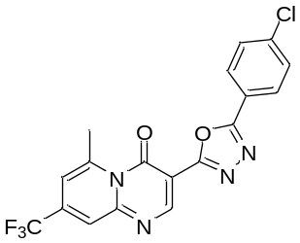
Yellow solid; Yield 82%; IR (KBr, cm⁻¹): 1623 (CO); ¹H NMR (CDCl₃, 300 MHz): δ 2.53 (s, 3H,-CH₃), 7.68 (d, 2H, Ar-H), 7.82 (s, 1H, Ar-H), 7.93 (d, 2H, Ar-H), 8.16 (s, 1H, Ar-H), 8.30 (s, 1H, Ar-H); ¹³C NMR (CDCl₃, 75 MHz) δ ppm : 25.4, 122.8, 123.5, 124.9,125.6, 126.2, 128.2, 129.9, 130.1, 132.0, 133.2, 135.4, 137.4, 138.8, 142.8, 158.9; MS (ESI): m/z [(M+H)⁺]: 407. HRMS m/z Calcd. for C₁₈H₁₀ClF₃N₄O₂ [(M+H)⁺]: 407.0248, Found 407.0251.

3-(5-(4-Methoxyphenyl)-1,3,4-oxadiazol-2-yl)-6-methyl-8-(trifluoromethyl)-4H-pyrido[1,2-a]pyrimidin-4-one (7d)
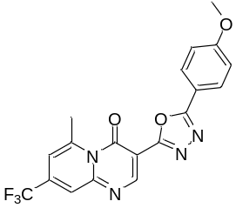
Light Yellow solid; Yield 82%; IR (KBr, cm⁻¹): 1623 (CO); ¹H NMR (CDCl₃, 300 MHz): δ 2.52 (s, 3H,-CH₃), 3.82 (s, 3H,-OCH₃), 7.45 (d, 2H, Ar-H), 7.62 (s, 1H, Ar-H), 7.73 (d, 2H, Ar-H), 7.92 (s, 1H, Ar-H), 8.08 (s, 1H, Ar-H); ¹³C NMR (CDCl₃, 75 MHz) δ ppm : 25.4, 55.5, 121.9, 122.9, 123.6, 125.0, 125.4, 126.1, 126.8, 128.1, 129.8, 131.5, 131.8, 132.5, 133.8, 140.3, 156.8; MS (ESI): m/z [(M+H)⁺]: 403. HRMS m/z Calcd. for C₁₉H₁₃F₃N₄O₃ [(M+H)⁺]: 403.0115, Found 403.0117.
6-Methyl-8-(trifluoromethyl)-3-(5-(3-(trifluoromethyl)phenyl)-1,3,4-oxadiazol-2-yl)-4H-pyrido[1,2-a]pyrimidin-4-one (7e)
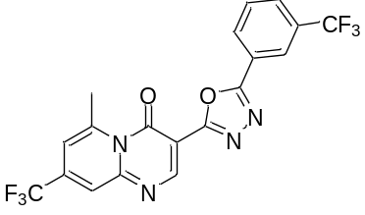
Yellow green solid; Yield 75%; IR (KBr, cm⁻¹): 1625 (CO); ¹H NMR (CDCl₃, 300 MHz): δ 2.51 (s, 3H,-CH₃), 7.51-7.59 (m, 3H, Ar-H), 7.72 (s, 1H, Ar-H), 7.92 (s, 1H, Ar-H), 8.10 (s, 1H, Ar-H), 8.22 (s, 1H, Ar-H); ¹³C NMR (CDCl₃, 75 MHz) δ ppm : 25.4, 121.7, 123.0, 123.7, 124.5, 125.3, 126.4, 127.1, 129.0, 130.0, 130.6, 131.0, 133.8, 136.4, 139.0, 140.7, 145.2, 156.5; MS (ESI): m/z [(M+H)⁺]: 441. HRMS m/z Calcd. for C₁₉H₁₀F₆N₄O₂ [(M+H)⁺]: 441.0347, Found 441.0350.
3-(5-(4-Bromophenyl)-1,3,4-oxadiazol-2-yl)-6-methyl-8-(trifluoromethyl)-4H-pyrido[1,2-a]pyrimidin-4-one (7f)
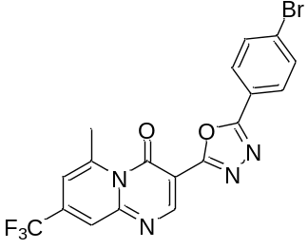
Yellow solid; Yield 68%; IR (KBr, cm⁻¹): 1628 (CO); ¹H NMR (CDCl₃, 300 MHz): δ 2.52 (s, 3H,-CH₃), 7.71 (d, 2H, Ar-H), 7.80 (s, 1H, Ar-H), 7.93 (d, 2H, Ar-H), 8.15 (s, 1H, Ar-H), 8.23 (s, 1H, Ar-H); ¹³C NMR (CDCl₃, 75 MHz) δ ppm : 25.0, 121.7, 123.0, 123.6, 124.8, 125.6, 126.5, 127.3, 128.1, 129.4, 130.9, 132.2, 133.3, 137.1, 143.3, 158.7; MS (ESI): m/z [(M+H)⁺]: 451. HRMS m/z Calcd. for C₁₈H₁₀BrF₃N₄O₂ [(M+H)⁺]: 451.0145, Found 451.0148.
6-Ethyl-3-(5-phenyl-1,3,4-oxadiazol-2-yl)-8-(trifluoromethyl)-4H-pyrido[1,2-a]pyrimidin-4-one (7g)
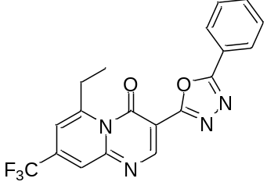
Yellow solid; Yield 76%; IR (KBr, cm⁻¹): 1618 (CO); ¹H NMR (CDCl₃, 300 MHz): δ 1.24 (t, 2H, -CH₂-), 2.82 (q, 3H, -CH₃), 7.46-7.54 (m, 3H, Ar-H), 7.63-7.69 (m, 2H, Ar-H), 7.92 (s, 1H, Ar-H), 8.05 (s, 1H, Ar-H), 8.16 (s, 1H, Ar-H); ¹³C NMR (CDCl₃, 75 MHz) δ ppm : 15.5, 28.7, 122.4, 123.2, 124.8, 125.5, 126.3, 126.8, 128.0, 129.1, 130.5, 131.2, 131.4, 133.4, 137.4, 143.4, 159.3; MS (ESI): m/z [(M+H)⁺]: 387. HRMS m/z Calcd. for C₁₉H₁₃F₃N₄O₂ [(M+H)⁺]: 387.0567, Found 387.0568.
6-Ethyl-3-(5-(p-tolyl)-1,3,4-oxadiazol-2-yl)-8-(trifluoromethyl)-4H-pyrido[1,2-a]pyrimidin-4-one (7h)
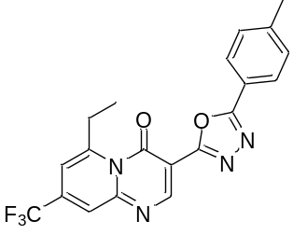
Yellow solid; Yield 69%; IR (KBr, cm⁻¹): 1619 (CO); ¹H NMR (CDCl₃, 300 MHz): δ 1.28 (t, 3H, -CH₃), 2.38 (s, 3H, Pyridine-CH₃), 2.86 (q, 2H, -CH₂-), 7.19 (d, 2H, Ar-H), 7.52 (d, 2H, Ar-H), 7.75 (s, 1H, Ar-H), 7.84 (s, 1H, Ar-H), 7.98 (s, 1H, Ar-H); ¹³C NMR (CDCl₃, 75 MHz) δ ppm : 15.8, 21.3, 28.7, 122.9, 124.1, 125.0, 125.7, 126.3, 127.4, 129.5, 129.8, 130.6, 131.8, 133.0, 135.8, 137.0, 143.2, 159.8; MS (ESI): m/z [(M+H)⁺]: 401. HRMS m/z Calcd. for C₂₀H₁₅F₃N₄O₂ [(M+H)⁺]: 401.0058, Found 401.0056.
6-Ethyl-3-(5-(4-methoxyphenyl)-1,3,4-oxadiazol-2-yl)-8-(trifluoromethyl)-4H-pyrido[1,2-a]pyrimidin-4-one(7i)
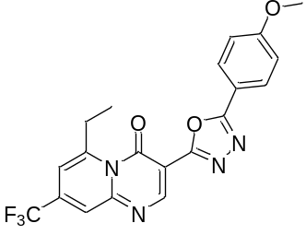
Yellow solid; Yield 86%; IR (KBr, cm⁻¹): 1621 (CO); ¹H NMR (CDCl₃, 300 MHz): δ 1.25 (t, 3H, -CH₃), 2.85 (q, 2H,-CH₂-), 3.85 (s, 3H,-OCH₃), 7.46 (d, 2H, Ar-H), 7.61 (s, 1H, Ar-H), 7.72 (d, 2H, Ar-H), 7.92 (s, 1H, Ar-H), 8.09 (s, 1H, Ar-H); ¹³C NMR (CDCl₃, 75 MHz) δ ppm : 15.6, 21.6, 55.4, 122.1, 123.2, 124.0, 125.3, 126.0, 126.7, 128.7, 130.2, 130.7, 132.8, 135.0, 135.9, 138.0, 144.1, 158.2; MS (ESI): m/z [(M+H)⁺]: 417. HRMS m/z Calcd. for C₂₀H₁₅F₃N₄O₃ [(M+H)⁺]: 417.0758, Found 417.0760.

3-(5-(4-Chlorophenyl)-1,3,4-oxadiazol-2-yl)-6-ethyl-8-(trifluoromethyl)-4H-pyrido[1,2-a]pyrimidin-4-one (7j)
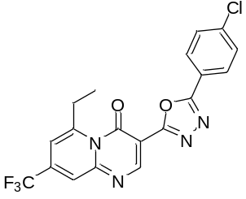
Yellow solid; Yield 70%; IR (KBr, cm⁻¹): 1615 (CO); ¹H NMR (CDCl₃, 300 MHz): δ 1.39 (t, 3H, -CH₃), 2.88 (q, 2H,-CH₂-), 7.44 (d, 2H, Ar-H), 7.60 (s, 1H, Ar-H), 7.70 (d, 2H, Ar-H), 7.93 (s, 1H, Ar-H), 8.04 (s, 1H, Ar-H); ¹³C NMR (CDCl₃, 75 MHz) δ ppm : 15.6, 21.8, 121.3, 122.8, 123.3, 124.4, 125.4, 126.5, 127.1, 128.0, 129.0, 130.6, 132.2, 133.8, 136.1, 143.7, 158.4; MS (ESI): m/z [(M+H)⁺]: 421. HRMS m/z Calcd. for C₁₉H₁₂ClF₃N₄O₂ [(M+H)⁺]: 421.0105, Found 421.0107.
6-Ethyl-8-(trifluoromethyl)-3-(5-(3-(trifluoromethyl)phenyl)-1,3,4-oxadiazol-2-yl)-4H-pyrido[1,2-a]pyrimidin-4-one (7k)
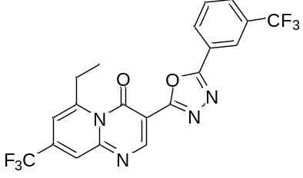
Dark Yellow solid; Yield 71%; IR (KBr, cm⁻¹): 1619 (CO); ¹H NMR (CDCl₃, 300 MHz): δ 1.31 (t, 3H, -CH₃), 2.84 (q, 2H,-CH₂-), 7.51-7.58 (m, 3H, Ar-H), 7.71 (s, 1H, Ar-H), 7.93 (d, 2H, Ar-H), 8.11 (s, 1H, Ar-H), 8.23 (s, 1H, Ar-H); ¹³C NMR (CDCl₃, 75 MHz) δ ppm : 15.3, 21.4, 119.6, 120.3, 121.6, 122.1, 123.2, 124.0, 125.3, 126.0, 126.7, 128.7, 130.2, 130.7, 132.8, 135.0, 135.0, 135.9, 138.0, 139.2, 141.1, 143.3, 158.2; MS (ESI): m/z [(M+H)⁺]: 455. HRMS m/z Calcd. for C₂₀H₁₂F₆N₄O₂ [(M+H)⁺]: 455.0154, Found 455.0157.

3-(5-(4-Bromophenyl)-1,3,4-oxadiazol-2-yl)-6-ethyl-8-(trifluoromethyl)-4H-pyrido[1,2-a]pyrimidin-4-one (7l)
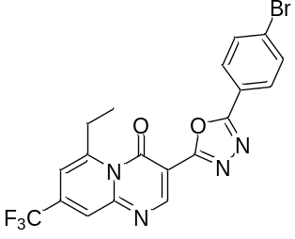
Yellow solid; Yield 62%; IR (KBr, cm⁻¹): 1618 (CO); ¹H NMR (CDCl₃, 300 MHz): δ 1.29 (t, 3H, -CH₃), 2.85 (q, 2H,-CH₂-), 7.48 (d, 2H, Ar-H), 7.59 (s, 1H, Ar-H), 7.62 (d, 2H, Ar-H), 7.92 (s, 1H, Ar-H), 8.05 (s, 1H, Ar-H); ¹³C NMR (CDCl₃, 75 MHz) δ ppm : 15.4, 21.8, 119.4, 120.7, 123.6, 124.0, 125.3, 126.3, 127.6, 128.0, 130.9, 130.7, 133.7, 136.1, 138.1, 139.7, 141.3, 158.5; MS (ESI): m/z [(M+H)⁺]: 465. HRMS m/z Calcd. for C₁₉H₁₂BrF₆N₄O₂ [(M+H)⁺]: 465.00025, Found 465.0027.

6-Methyl-3-(5-phenyl-1,3,4-oxadiazol-2-yl)-8-(trifluoromethyl)-4H-pyrido[1,2-a]pyrimidin-4-one (7a)

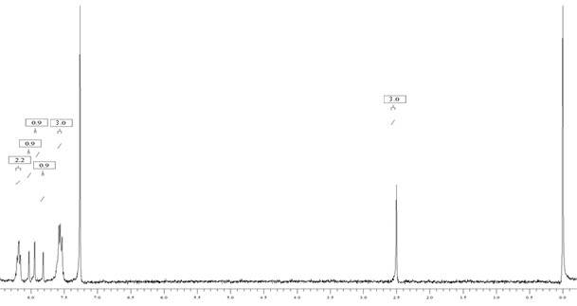

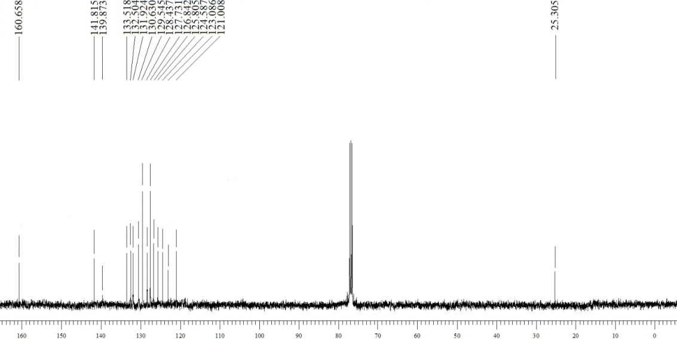

6-Methyl-3-(5-(p-tolyl)-1,3,4-oxadiazol-2-yl)-8-(trifluoromethyl)-4H-pyrido[1,2-a]pyrimidin-4-one (7b)
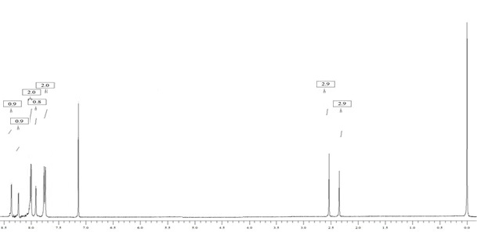

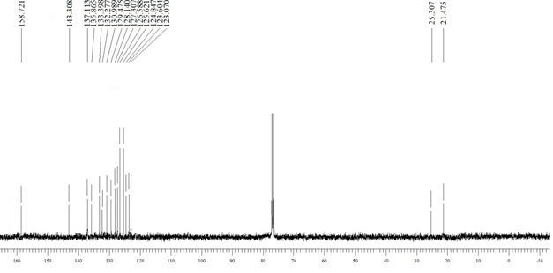

3-(5-(4-Methoxyphenyl)-1,3,4-oxadiazol-2-yl)-6-methyl-8-(trifluoromethyl)-4H-pyrido[1,2-a]pyrimidin-4-one (7c)

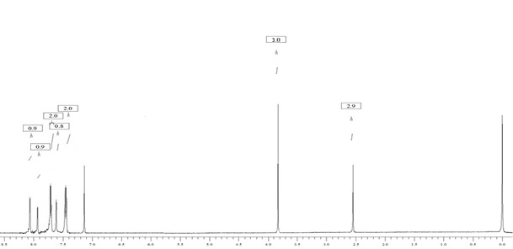

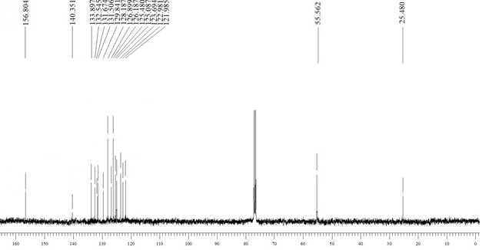

3-(5-(4-Chlorophenyl)-1,3,4-oxadiazol-2-yl)-6-methyl-8-(trifluoromethyl)-4H-pyrido[1,2-a]pyrimidin-4-one (7d)

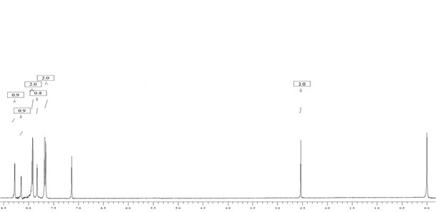

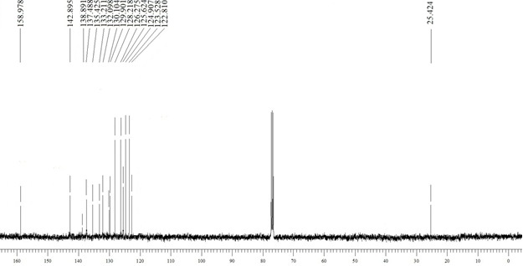

6-Methyl-8-(trifluoromethyl)-3-(5-(3-(trifluoromethyl)phenyl)-1,3,4-oxadiazol-2-yl)-4H-pyrido[1,2-a]pyrimidin-4-one (7e)
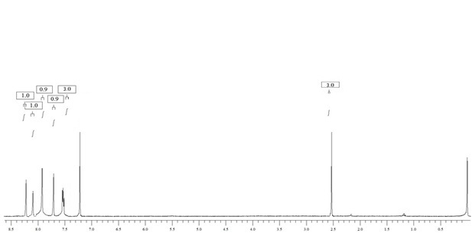

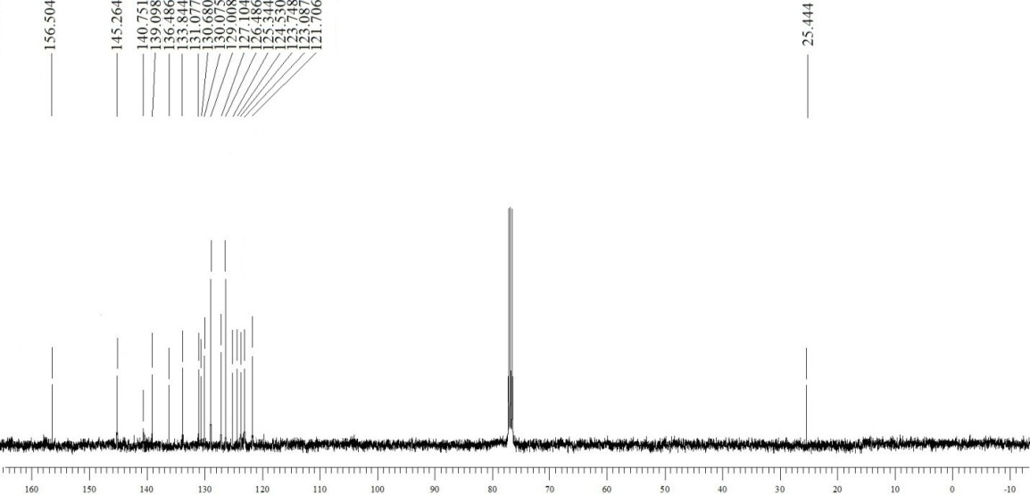

3-(5-(4-Bromophenyl)-1,3,4-oxadiazol-2-yl)-6-methyl-8-(trifluoromethyl)-4H-pyrido[1,2-a]pyrimidin-4-one (7f)
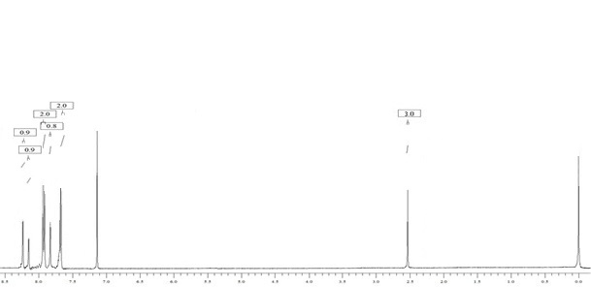

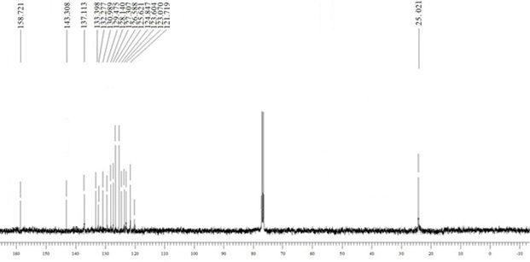

6-Ethyl-3-(5-phenyl-1,3,4-oxadiazol-2-yl)-8-(trifluoromethyl)-4H-pyrido[1,2-a]pyrimidin-4-one (7g)
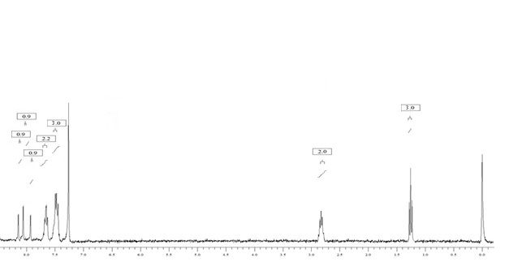

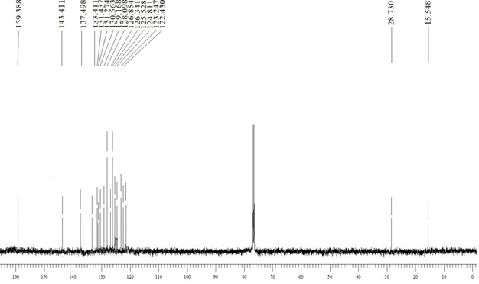

6-Ethyl-3-(5-(p-tolyl)-1,3,4-oxadiazol-2-yl)-8-(trifluoromethyl)-4H-pyrido[1,2-a]pyrimidin-4-one (7h)

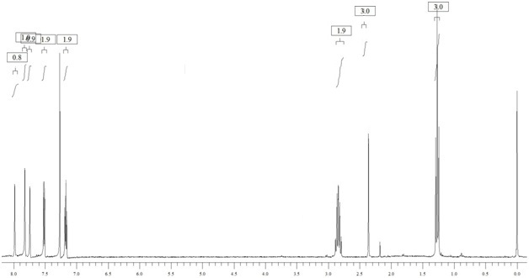

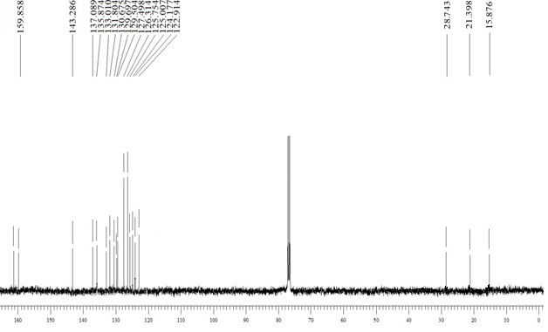

6-Ethyl-3-(5-(4-methoxyphenyl)-1,3,4-oxadiazol-2-yl)-8-(trifluoromethyl)-4H-pyrido[1,2-a]pyrimidin-4-one(7i)
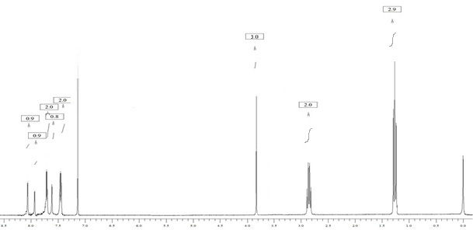

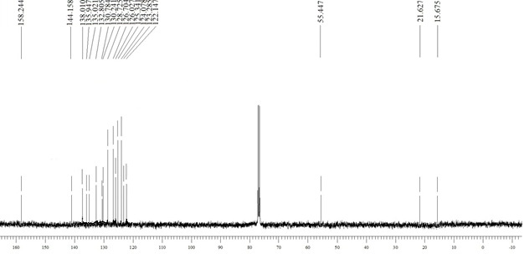

3-(5-(4-Chlorophenyl)-1,3,4-oxadiazol-2-yl)-6-ethyl-8-(trifluoromethyl)-4H-pyrido[1,2-a]pyrimidin-4-one (7j)

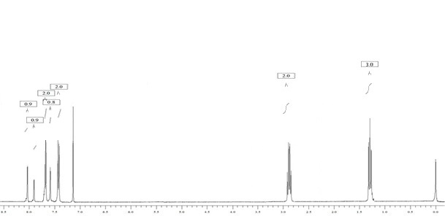

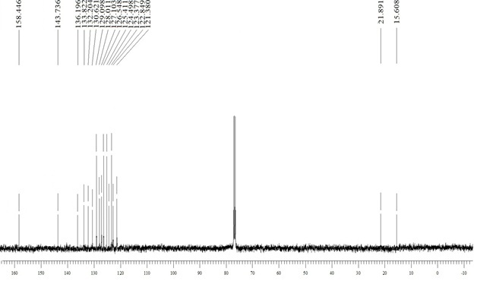

6-Ethyl-8-(trifluoromethyl)-3-(5-(3-(trifluoromethyl)phenyl)-1,3,4-oxadiazol-2-yl)-4H-pyrido[1,2-a]pyrimidin-4-one (7k)

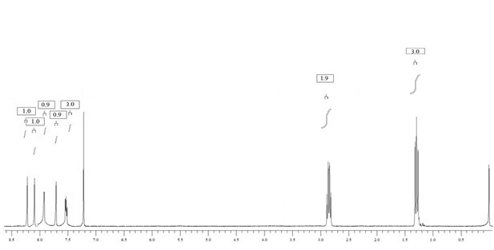

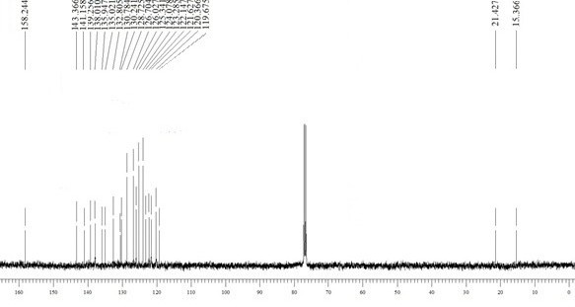

3-(5-(4-Bromophenyl)-1,3,4-oxadiazol-2-yl)-6-ethyl-8-(trifluoromethyl)-4H-pyrido[1,2-a]pyrimidin-4-one (7l)
