Appendix

Appendix E1

Study Design and Patient Selection
This retrospective study comprises participants from the Sino Longitudinal Study of Cognitive Decline (SILCODE) cohort [1] between September 2009 and October 2022. All participants or their legal guardians provided written informed consent. All procedures were approved by the Medical Research Ethics Committee and Institutional Review Board of Xuanwu Hospital. Cohorts are registered with ClinicalTrials.gov (SILCODE: NCT02225964).

Clinical Assessment
For each participant, clinical data were collected, including age, gender, years of education, and apolipoprotein E (APOE) genotype. Neuropsychological assessments focus on global cognitive function: Mini-Mental State Examination (MMSE) and Montreal Cognitive Assessment-Basic Version (MoCA-B)[2].
Blood samples (2 ml venous blood) were taken between 7: 00 and 8: 00 in the morning after an overnight fast using EDTA tubes, and blood samples were collected in the following manner. Supernatants were collected as plasma after being centrifuged several times for 15 min at 4°C (speed: 2500 g/min). All plasma samples were stored at −80°C and immediately thawed on ice prior to assay. Plasma levels of β-amyloid, p-tau181, GFAP, and NFL were measured using the Single Molecule Array (Simoa™) platform (Quanterix Corporation, Billerica, MA, USA) following the manufacturer's instructions. The Simoa assays were performed using the following commercially available kits: β-amyloid (1-42) (Aβ42) and β-amyloid (1-40) (Aβ40) - Simoa™ β-Amyloid 42 (1-42) and β-Amyloid 40 (1-40) Advantage Kits, phosphorylated tau at threonine 181 (ptau181) Simoa™ p-tau181 Advantage Kit, Glial Fibrillary Acidic Protein (GFAP) Simoa™ GFAP Discovery Kit and Neurofilament light chain (NfL) - Simoa™ NF-light® Advantage Kit. All assays were performed in duplicate, and the average concentration values were reported. Sample concentrations below the lower limit of quantification (LLOQ) were assigned a value of half the LLOQ.

Appendix E2

Image Acquisition
In the SILCODE cohort, MRI data were acquired using an integrated simultaneous 3.0 T TOF PET/MR (SIGNA PET/MR, GE Healthcare, Milwaukee, Wisconsin, USA) at the Xuanwu Hospital of Capital Medical University, Beijing, China. About SMRI, the parameters for T1-weighted 3D brain structural images are as follows: SPGR sequence, FOV=256×256mm², matrix=256×256, slice thickness=1mm, gap=0, slice number=192, repetition time (TR)=6.9 ms, echo time (TE)=2.98 ms, inversion time (TI)=450 ms, flip angle=12°, voxel size=1×1×1mm³. The DTI data were obtained with a single-shot spin-echo diffusion-weighted echo planar imaging (EPI) sequence with the following parameters: FOV=224×224mm², data matrix=112×112, slice thickness=2mm, gap=0, slice number=70, slice order=interleaved, TR=16500 ms, TE=95.6 ms, 30 gradient directions (b=1000s/mm²) and 5 b0 images, voxel size=2×2×2mm³.

Preprocessing
The preprocessing of diffusion MRI data involved denoising, head motion correction, and eddy current correction. Specifically, we first denoised the raw diffusion data with the dwidenoise command from MRtrix3 software (http:// https://mrtrix.readthedocs.io/)[3], which produced a denoised diffusion-weighted data file. The fslroi command was then used to extract a single volume from the denoised data, which was used as the reference image for head motion correction and brain extraction. The bet2 command was applied to this reference image to obtain the brain mask. Finally, eddy current correction was performed using the eddy_openmp command with the denoised data, brain mask, and gradient information as inputs.

Appendix E3

Brain structural network construction
To construct the individual structural network, we used bet command to extract the brain and fast command to segment it into different tissue types on the T1-weighted image with FSL software (http://https://fsl.fmrib.ox.ac.uk/)[4] . The WM segmentation in T1 space was transformed into diffusion space and used as a seed mask for further tractography. Bedpostx command was then performed on the preprocessed diffusion MRI data to generate distributions on diffusion parameters at each voxel, with three fibres modeled per voxel, burn-in period set to 3000, and deconvolution model with sticks. Deterministic tractography was performed using a track command from CAMINO software (http://http://camino.cs.ucl.ac.uk/)[5] with the "bedpostx_dyad" input model and various parameters, including nearest-neighbor interpolation, Fourth-order Runge-Kutta method as the tracking algorithm, and tracking step size set to 2mm. Compartments with a mean volume fraction below 0.1 were discarded, and tracking was terminated if curvature exceeded 45 degrees at each 5 mm interval, and fibers with a length below 20mm or above 250mm were removed. To define network node, the BNA template were applied and transformed into individual diffusion space to parcellate the brain into 246 regions (http:// https://atlas.brainnetome.org/)[6]. Tractography and brain parcellation were combined to generate a fiber-number weighted connectivity matrix with conmat command, representing the individual WM structural network.

Network efficiency computation
Based on the brain structural network, we calculated three network efficiency measures with BCT toolbox (http://https://www.nitrc.org/projects/bct/)[7], including global efficiency, local efficiency, and generalized local efficiency. Each measure was calculated at both regional and network levels. Here are the detailed descriptions of network efficiency measures:

Global efficiency reflects the integration of region i, which was calculated as
$E_{glob}\left(i, N\right)=\frac{1}{n-1}\sum_{jϵN, j≠i}{\frac{1}{L_{i,j}}}$,
where the $L_{i,j}$ is the shortest path length between node i and node j within the network N.
Local efficiency captures region i's segregation and fault tolerance capabilities, which was computed as the mean of global efficiency across all nodes encompassed within i's neighborhood:
$E_{loc}\left(i,N\right)=\frac{1}{|N_{i}|}\sum_{j∈N_{i}}{E_{glob}(j, N_{i})}$,
where $N_{i}$ is the sub-network of node i comprising i’s neighbors with the connections among them (Fig 3B).
Generalized local efficiency enhances robustness against irrelevant factors and establishes weight-scale invariance[8], as calculated with
$E_{loc}^{Z}\left(i,N\right)=\frac{1}{\max{{\left(W\right)}^{\frac{1}{3}}}}\frac{\sum_{j,h}{w_{ij}^{1/3}w_{ih}^{1/3}{\left[d_{jh}^{w}\left(N_{i}'\right)\right]}^{-1}}}{\sum_{j,h}{w_{ij}^{1/3}w_{ih}^{1/3}}}$,
where w_{i,j} is the weight (fibre-number) between region i and j, and $d_{jh}^{w}\left(N_{i}'\right)$ is the adapted shortest distance between region j and h, calculated as the shortest distance in the network $N_{i}'$ containing all neighbors of i excluding node i while considering a replacement of the weight of the edge (j, h) to ${w'}_{jh}=w_{jh}^{1/3}$.

Appendix E4

Statistical Analysis
The demographic variables were analyzed using ANOVA for continuous variables, including age, years of education, MMSE, MOCA, levels of plasma markers, and network efficiency. For discrete variables like sex, chi-squared tests were employed. These statistical analyses were performed across four diagnostic groups (NC, SCD, MCI, and AD) separately on three datasets: plasma, imaging, and combined datasets.
Trend analyses were performed on plasma markers, regional and whole-brain network efficiency, and cognitive performance among four diagnostic groups. For measures with significant linear or quadratic trends, post-hoc comparisons were performed with two sample t-tests. Plasma markers and network efficiency were analyzed separately within the plasma dataset and imaging dataset.
Correlation analyses were conducted among plasma markers, network efficiency, and cognitive performance across the AD continuum. Specifically, we evaluated the correlation between plasma markers and cognitive performances (MMSE and MOCA score) in the plasma dataset. In the combined set, we computed partial correlations between network efficiency, plasma markers, and cognitive performances controlling for covariates. Brain regions with a significant linear trend (p < 0.05, FDR corrected) were defined as AD-Progression-related Regions (ADPRs). Then we extracted the first principal component of generalized local efficiency across ADPRs with the principal function from the psych package [9]. The number of components was set to 1 suggested by a prior parallel analysis with 10,000 iterations.
Furthermore, we tested the mediation of the network efficiency component on the relationship between plasma markers and cognition using the mediation package [10]. Bootstrapping procedures with 10,000 re-samplings were used to obtain the indirect effects' significance and 95% confidence intervals. We also considered the partial correlation between the efficiency component and plasma biomarker and cognitive performances. In contrast, these analyses were re-done for whole-brain averaged efficiency as well.
All statistical analyses were performed using R (version 4.1.1). Covariates of age, sex, years of education, scanning date and APOE4 status were removed in all the above analyses. On regional statistics, false discovery rate (FDR) corrections were applied in trend analyses and regional correlations. For post-hoc comparisons, Bonferroni corrections were applied. We considered significance at a nominal 5% level for corrected p-values. Mediation effects were considered significant if the 95% confidence intervals of indirect effect did not include zero. A detailed reference can be found in the online code.

References
1. Li X, Wang X, Su L, Hu X, Han Y. Sino Longitudinal Study on Cognitive Decline (SILCODE): protocol for a Chinese longitudinal observational study to develop risk prediction models of conversion to mild cognitive impairment in individuals with subjective cognitive decline. BMJ Open. 2019;9:e028188.
2. Chen K-L, Xu Y, Chu A-Q, Ding D, Liang X-N, Nasreddine ZS, et al. Validation of the Chinese Version of Montreal Cognitive Assessment Basic for Screening Mild Cognitive Impairment. J Am Geriatr Soc. 2016;64:e285–90.
3. Tournier JD, Smith R, Raffelt D, Tabbara R, Dhollander T, Pietsch M, et al. MRtrix3: A fast, flexible and open software framework for medical image processing and visualisation. Neuroimage. 2019;202:116137.
4. Jenkinson M, Beckmann CF, Behrens TEJ, Woolrich MW, Smith SM. FSL. NeuroImage. 2012;62:782–90.
5. Cook PA, Bai Y, Nedjati-Gilani S, Seunarine KK, Hall MG, Parker GJ, et al. Camino: Open-Source Diffusion-MRI Reconstruction and Processing.
6. Fan L, Li H, Zhuo J, Zhang Y, Wang J, Chen L, et al. The Human Brainnetome Atlas: A New Brain Atlas Based on Connectional Architecture. Cereb Cortex. 2016;26:3508–26.
7. Rubinov M, Sporns O. Complex network measures of brain connectivity: uses and interpretations. Neuroimage. 2010;52:1059–69.
8. Wang Y, Ghumare E, Vandenberghe R, Dupont P. Comparison of Different Generalizations of Clustering Coefficient and Local Efficiency for Weighted Undirected Graphs. Neural Comput. 2017;29:313–31.
9. psych: Procedures for Personality and Psychological Research [Internet]. 2017 [cited 2023 Jul 14]. Available from: https://CRAN.R-project.org/package=psych
10. Keele L, Tingley D, Yamamoto T. IDENTIFYING MECHANISMS BEHIND POLICY INTERVENTIONS VIA CAUSAL MEDIATION ANALYSIS: Methods for Policy Analysis. J Policy Anal Manage. 2015;34:937–63.

Supplementary Tables
All | NC | SCD | MCI | AD | Statistics
N=287 | N=129 | N=112 | N=17 | N=7
age | 66.1 (5.37) | 65.0 (6.33) | 67.5 (9.32) | 69.2 (8.24) | 1.278(N.S)
sex |  |  |  |  | 7.074(N.S)
f | 81 (64.3%) | 73 (67.6%) | 9 (52.9%) | 6 (85.7%)
m | 45 (35.7%) | 35 (32.4%) | 8 (47.1%) | 1 (14.3%)
Global efficiency | 5.91 (4.75) | 5.23 (3.64) | 5.46 (3.63) | 5.27 (5.25) | 0.472(N.S)
Local efficiency | 11.9 (9.79) | 10.5 (7.16) | 11.2 (7.39) | 11.2 (9.25) | 0.512(N.S)
generalized Local efficiency | 0.246 (0.0175) | 0.243 (0.0165) | 0.247 (0.0204) | 0.219 (0.0202) | 3.971(****)
Table E1 Sample characteristics in the imaging dataset
Continuous data were presented as mean ± SD. Analyses of variance were utilized for continuous variables, while chi-square tests were employed for categorical variables across NC, SCD, MCI, and AD. Abbreviations: APOE, apolipoprotein E; MMSE, Mini-Mental State Examination; MoCA-B, Montreal cognitive assessment basic; NC, normal controls; SCD, subjective cognitive decline; MCI, mild cognitive impairment; AD, Alzheimer's disease.
marker | adjusted R² | p value of linear trend | t value of linear trend | p value of quadratic trend | t value of quadratic trend
Aβ42 | 0.064636854 | 0.037750762 | -2.087493477 | 0.040227077 | -2.061027111
Aβ40 | 0.098230617 | 0.403713923 | 0.836278474 | 0.943039462 | 0.071514575
Aβ42/Aβ40 | 0.100533643 | 0.001266844 | -3.256593558 | 0.097631657 | -1.662020997
pTau/Aβ42 | 0.130106064 | 2.11E-05 | 4.327246286 | 4.34E-04 | 3.561202963
pTau181 | 0.345988015 | 1.61E-15 | 8.451847044 | 1.05E-09 | 6.316169036
NfL | 0.329329001 | 2.90E-10 | 6.541657235 | 1.22E-04 | 3.896114292
GFAP | 0.475081321 | 3.59E-24 | 11.16438534 | 2.25E-13 | 7.708415329
Table E2 Trend analyses for plasma markers. Aβ, β-amyloid; GFAP, glial fibrillary acidic protein; NfL, Neurofilament light chain; p-tau181, phosphorylated tau181.

efficiency | P value of linear effect | P value of quadratic effect | T of linear effect | T of quadratic effect
global efficiency | 0.745 | 0.79 | -0.325 | 0.267
local efficiency | 0.831 | 0.717 | -0.214 | 0.363
generalized local efficiency | 0.025 | 0.011 | -2.251 | -2.577
Table E3 Trend analyses for whole-brain network efficiencies. Analyses were conducted in the imaging dataset.Only generalized local efficiency exhibited significant trends.
BNA246 region | efficiency | adjusted R² | p value of linear trend | t value of linear trend | p value of quadratic trend | t value of quadratic trend | Adjusted p value of linear trend | Adjusted p value of quadratic trend
143 | generalised local efficiency | 0.12813854 | 6.13E-07 | -5.1158932 | 3.34E-05 | -4.223879605 | 1.51E-04 | 0.003460069
164 | generalised local efficiency | 0.08407065 | 1.72E-05 | -4.3810892 | 1.08E-05 | -4.48859315 | 0.002120131 | 0.002668082
51 | generalised local efficiency | 0.0962442 | 4.15E-05 | -4.1711969 | 4.22E-05 | -4.167283595 | 0.003404904 | 0.003460069
171 | generalised local efficiency | 0.07306264 | 8.09E-05 | -4.0063487 | 0.00565155 | -2.790925598 | 0.004974365 | 0.08316406
139 | generalised local efficiency | 0.07871785 | 2.86E-04 | -3.678581 | 0.00230209 | -3.079130773 | 0.010458154 | 0.07078915
228 | generalised local efficiency | 0.04377872 | 2.86E-04 | 3.67845093 | 0.00369038 | 2.93045012 | 0.010458154 | 0.08316406
129 | generalised local efficiency | 0.0589709 | 2.98E-04 | -3.6677678 | 0.00594691 | -2.773885968 | 0.010458154 | 0.08316406
227 | generalised local efficiency | 0.0982962 | 3.41E-04 | 3.63125961 | 0.01636534 | 2.416620076 | 0.010473886 | 0.143594253
88 | generalised local efficiency | 0.03343102 | 4.07E-04 | -3.582955 | 0.00196283 | -3.128103021 | 0.011113145 | 0.068979354
163 | generalised local efficiency | 0.09727465 | 6.87E-04 | -3.4367232 | 2.99E-04 | -3.666191554 | 0.014674612 | 0.012272791
98 | generalised local efficiency | 0.0580596 | 7.15E-04 | -3.4255323 | 6.46E-05 | -4.062538657 | 0.014674612 | 0.003972493
87 | generalised local efficiency | 0.04206397 | 7.16E-04 | -3.4250266 | 0.01072928 | -2.570235641 | 0.014674612 | 0.115583843
86 | generalised local efficiency | 0.08504023 | 9.06E-04 | -3.3576326 | 9.61E-05 | -3.962878808 | 0.017138531 | 0.00472778
22 | generalised local efficiency | 0.02275984 | 0.00136583 | -3.2373113 | 0.00600414 | -2.770673106 | 0.023294214 | 0.08316406
90 | generalised local efficiency | 0.0374889 | 0.00142038 | -3.2256579 | 0.01382824 | -2.478777989 | 0.023294214 | 0.130836461
54 | generalised local efficiency | 0.0344686 | 0.00244284 | -3.0607448 | 0.00315095 | -2.980882341 | 0.037558677 | 0.08316406
80 | generalised local efficiency | 0.05083183 | 0.00275795 | -3.0228847 | 0.1301004 | -1.518587268 | 0.039909173 | 0.400058745
Table E4 Trend analyses for regional efficiencies. Regions with significant trends (FDR p < 0.05) are presented.

Supplementary Figures
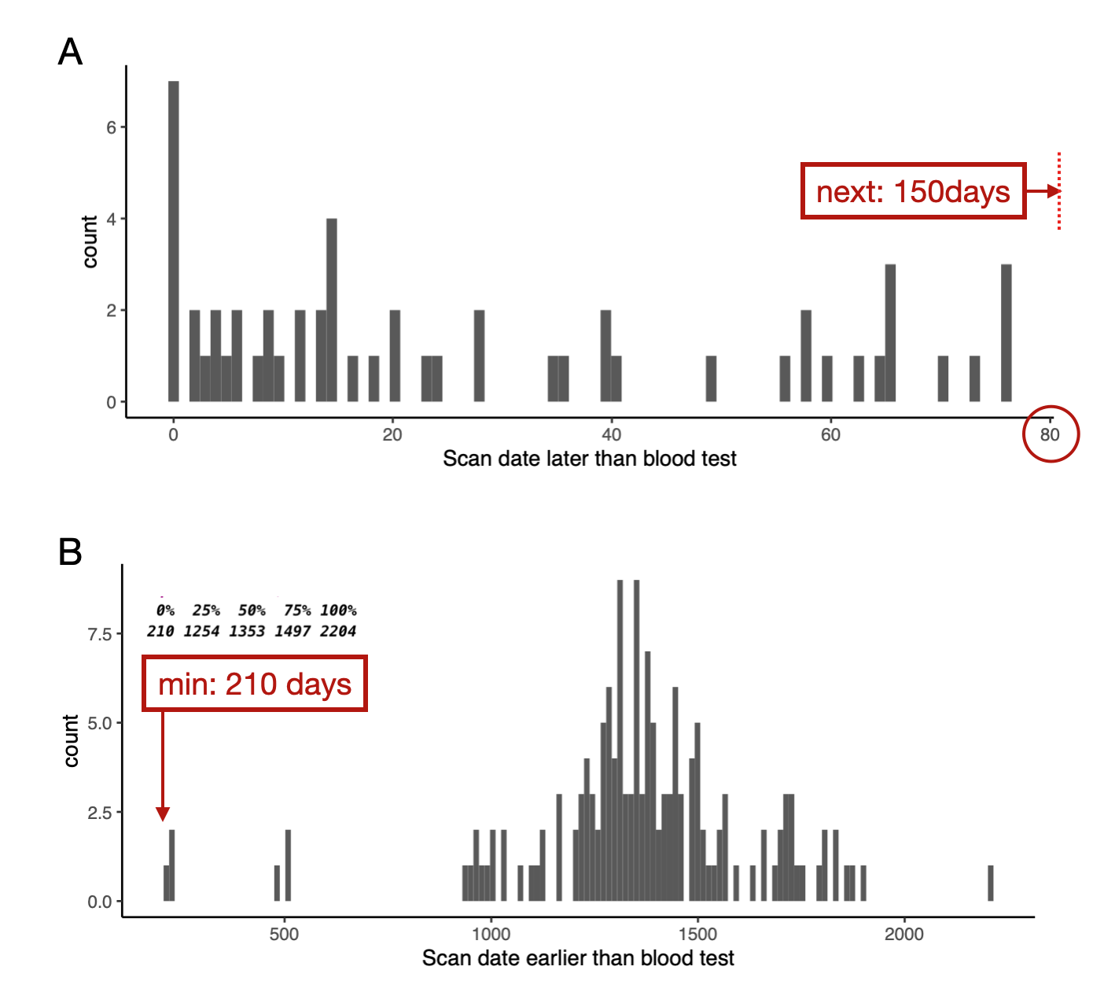
Figure E1 Matching window of days between plasma dataset and imaging dataset. Determining the matching interval between the plasma dataset and imaging dataset to create the combined dataset. Participants in the first two datasets who matched plasma and imaging time differences of not more than 80 days.
Fig E2 Partial Correlations between Plasma Markers and General Cognition. Correlations were controlled for Age, Sex, Years of Education, Scanning Date, and APOE4 Status (Upper Panel: MMSE; Lower Panel: MOCA). MMSE, Mini-Mental State Examination; MOCA, Montreal Cognitive Assessment; Aβ, β-amyloid; GFAP, glial fibrillary acidic protein; NfL, Neurofilament light chain; p-tau181, phosphorylated tau181; NC, normal controls; SCD, subjective cognitive decline; MCI, mild cognitive impairment; AD, Alzheimer's disease.
Fig E3 Partial correlation of the component of generalized local efficiency among ADPRs and bio-measures. Correlations were controlled for age, sex, years of education, scanning date, and APOE4 status. ADPR, AD-Progression-related Regions; MMSE, Mini-Mental State Examination; MOCA, Montreal Cognitive Assessment; Aβ, β-amyloid; GFAP, glial fibrillary acidic protein; NfL, Neurofilament light chain; p-tau181, phosphorylated tau181; NC, normal controls; SCD, subjective cognitive decline; MCI, mild cognitive impairment; AD, Alzheimer's disease.

