S1. Calculation of solar to evaporation rate.
The solar evaporation rate was calculated by the equation below:
ν=dm/(dt×s) (1)
where m is the mass of evaporated water, s is the illuminated area, t is time, and v is evaporation rate.

S2. DSC measurement of evaporation enthalpy.
In order to prove that the evaporation enthalpy of water in the CHG was reduced, DSC measurement was used to measure the vaporization energy of pure water and water in these CHG. During the enthalpy of evaporation measurements, the CHG was placed in an open Al crucible and performed at a linear heating rate of 5 ℃ min⁻¹, under nitrogen flow flux (20 ml min⁻¹) at the temperature range from 30 to 180 °C. It was revealed that the calculated evaporation enthalpy of water in CHG obviously below that of pure water. The measured enthalpy of water is 2274 J g⁻¹, which is very close to the theoretical value of water (2260 J g⁻¹), indicating the accuracy of our measurements to some extent.

S3. Photothermal conversion efficiency.
The photothermal conversion efficiency (η) was calculated using the following equation:
η=νh_{ν}/(C_{opt}P₀) (2)
h_{ν} is the vaporization enthalpy of the water in the hydrogel, P₀ is the solar irradiation power of one sun (1 kW m⁻²),and C_{opt} refers to the optical concentration on the absorber surface.

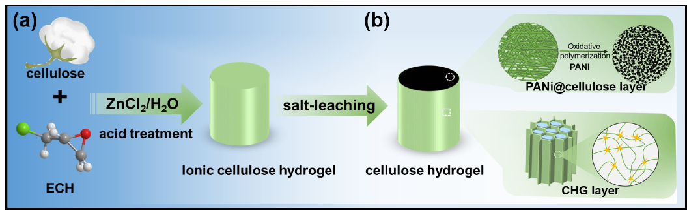
Fig. S1. Schematic illustration of preparation of a hydrogel evaporator.

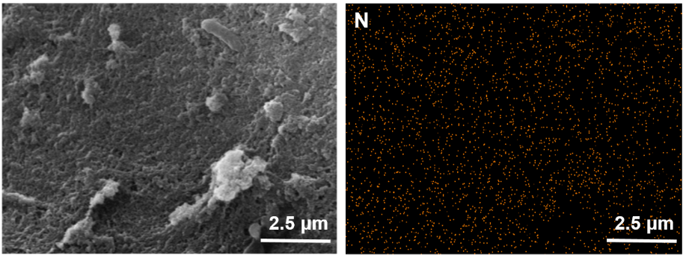
Fig. S2. EDS mapping of N element on surface image of PANi@cellulose layer.

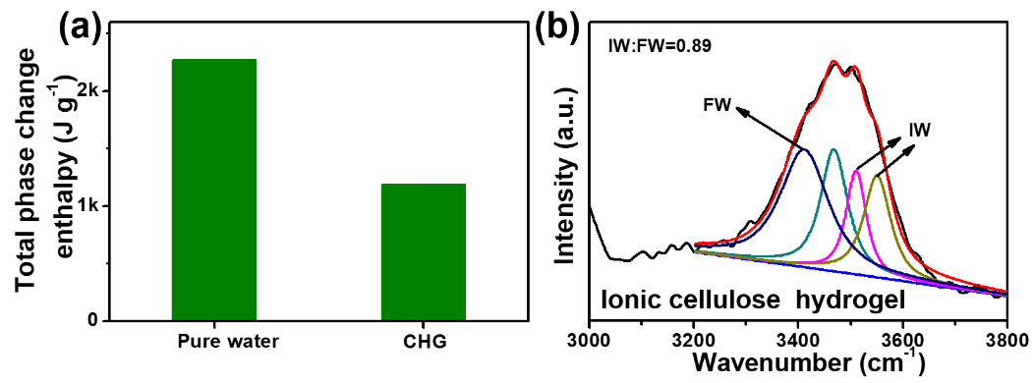
Fig. S3. The comparison between equivalent water vaporization enthalpy of bulk water and water in P-CHG (a). Raman spectra of O-H tensile mode energy region at ionic cellulose hydrogel (b).

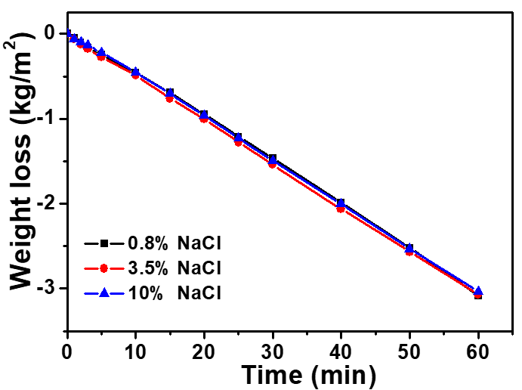
Fig. S4. The desalination performance of P-CHG was tested with 0.8 wt %, 3.5 wt % and 10 wt % NaCl solutions.

Fig. S5. Salt rejection experiment for P-CHG in seawater under 1 sun illumination. Images of the P-CHG evaporator performing solar evaporation from 0-12 h (a). Images of the P-CHG with additional NaCl (0.5 g) placed on the top surface from 0-120 min (b), where the NaCl completely dissolves after 120 min of solar irradiation.

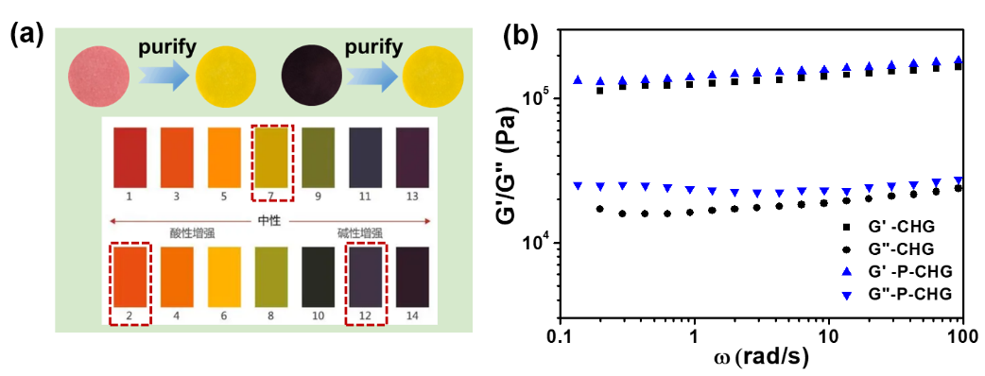
Fig. S6. Comparison of the pH before and after desalination (a). Dynamic mechanical analysis (b) showing storage modulus (G′) and loss modulus (G") of the CHG and P-CHG.

Table S1. Comparison of evaporation performance with solar photothermal evaporators in recent literature reports.
Materials | Evaporation Rate (kg m⁻² h⁻¹) | Energy efficiency (%) | Reference
Carbon/cellulose hydrogel | 1.58 | 91.4 | (Hu et al 2020)
GO/ Ti₃C₂T_{x} MXene hydrogel | 2.09 | 93.5 | (Li et al 2020)
Carbon/PVA hydrogel | 2.60 | 91.0 | (Guo et al 2019)
Chitosan/PAAm/PPy hydrogel | 2.41 | 92.0 | (Xu et al 2021)
PPy/Alg hydrogel | 1.15 | 54.1 | (Park et al 2021)
PDA/PVA/PVP hydrogel | 1.60 | 89.0 | (Chaule et al 2021)
PPY/BTA hydrogel | 1.90 | 89.0 | (Wu et al 2021)
PANi/cellulose hydrogel | 3.07 | 94.4 | This work

References
Chaule S, Hwang J, Ha S J, et al (2021) Rational design of a high performance and robust solar evaporator via 3D-printing technology. Adv Mater 33(38): e2102649.
Guo Y, Zhao F, Zhou X, et al (2019) Tailoring nanoscale surface topography of hydrogel for efficient solar vapor generation. Nano Lett 19(4): 2530-2536.
Hu N, Xu Y, Liu Z, et al (2020) Double-layer cellulose hydrogel solar steam generation for high-efficiency desalination. Carbohydr Polym 243: 116480.
Li W, Li X, Chang W, et al (2020) Vertically aligned reduced graphene oxide/Ti₃C₂T_{x} MXene hybrid hydrogel for highly efficient solar steam generation. Nano Research 13(11): 3048-3056.
Park S H, Park J H, Kim J, et al (2021) Simultaneous solar-driven seawater desalination and spontaneous power generation using polyvalent crosslinked polypyrrole/alginate hydrogels. Desalination 500.
Wu Y, Shen L, Zhang C, et al (2021) Polyacid doping-enabled efficient solar evaporation of polypyrrole hydrogel. Desalination 505.
Xu T, Xu Y, Wang J, et al (2021) Sustainable self-cleaning evaporator for long-term solar desalination using gradient structure tailored hydrogel. Chem Eng J 415.

