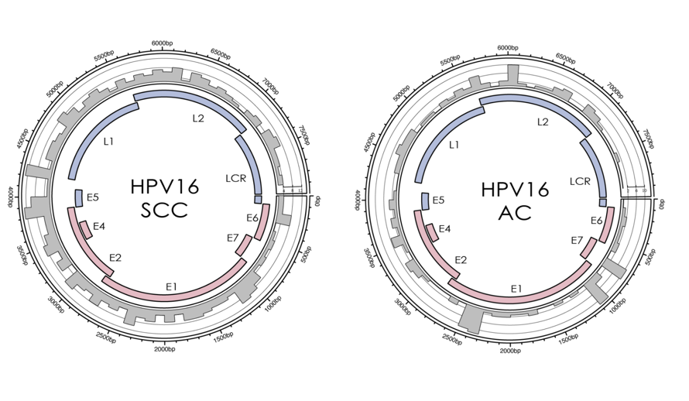
Supplementary Fig.S1 Distribution of integration breakpoints in the HPV16 genome. Histograms (grey) of frequency of breakpoints in the samples were constructed for 100-bp intervals. Histogram axis units represented numbers of breakpoints,and outer DNA numbering was given in bases. HPV genes with different functions were colored.

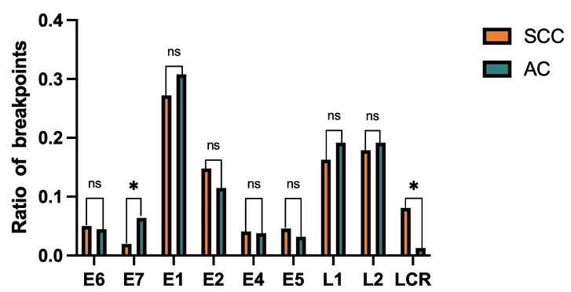
Supplementary Fig.S2 Comparison of SCC and AC numbers of breakpoints in the HPV16 genome. The y-axis represented the ratio of HPV breakpoints, while the x-axis represented HPV16 genome. The results revealed that HPV breakpoints were independent of viral genome. P-values were calculated by χ2test.

Table.S1 Relationship between genomic elements features of integration sites and HPV type.
 |  |  | AC |  |  |  |  |  | SCC
 |  |  | Negative |  | Positive |  |  |  | Negative |  | Positive
 | HPV type | total | num | % | num | % | Pvalue | total | num | % | num | % | Pvalue
DHS | HPV16 | 96 | 24 | 25 | 72 | 75 | 0.161 | 571 | 292 | 51.1 | 279 | 48.9 | 0.667
DHS | HPV18 | 64 | 25 | 39.1 | 39 | 60.9 | 0.161 | 21 | 9 | 42.9 | 12 | 57.1 | 0.667
DHS | others | 9 | 3 | 33.3 | 6 | 66.7 | 0.161 | 93 | 50 | 53.8 | 43 | 46.2 | 0.667
Enh | HPV16 | 96 | 79 | 82.3 | 17 | 17.7 | 0.722 | 571 | 526 | 92.1 | 45 | 7.9 | 0.446
Enh | HPV18 | 64 | 56 | 87.5 | 8 | 12.5 | 0.722 | 21 | 18 | 85.7 | 3 | 14.3 | 0.446
Enh | others | 9 | 8 | 88.9 | 1 | 11.1 | 0.722 | 93 | 87 | 93.5 | 6 | 6.5 | 0.446
TFBS | HPV16 | 96 | 32 | 33.3 | 64 | 66.7 | 0.204 | 571 | 313 | 54.8 | 258ª | 45.2 | 0.002
TFBS | HPV18 | 64 | 30 | 46.9 | 34 | 53.1 | 0.204 | 21 | 7 | 33.3 | 14ª | 66.7 | 0.002
TFBS | others | 9 | 4 | 44.4 | 5 | 55.6 | 0.204 | 93 | 65 | 69.9 | 28^{b} | 30.1 | 0.002
Tss | HPV16 | 96 | 91 | 94.8 | 5 | 5.2 | 0.443 | 571 | 547 | 95.8 | 24 | 4.2 | 0.087
Tss | HPV18 | 64 | 62 | 96.9 | 2 | 3.1 | 0.443 | 21 | 21 | 100 | 0 | 0 | 0.087
Tss | others | 9 | 8 | 88.9 | 1 | 11.1 | 0.443 | 93 | 93 | 100 | 0 | 0 | 0.087
H3K4me1 | HPV16 | 96 | 78 | 81.3 | 18 | 18.8 | 0.27 | 571 | 512 | 89.7 | 59 | 10.3 | 0.165
H3K4me1 | HPV18 | 64 | 55 | 37.9 | 9 | 14.1 | 0.27 | 21 | 17 | 81 | 4 | 19 | 0.165
H3K4me1 | others | 9 | 6 | 66.7 | 3 | 33.3 | 0.27 | 93 | 87 | 93.5 | 6 | 6.5 | 0.165
H3K4me2 | HPV16 | 96 | 83 | 86.5 | 13 | 13.5 | 0.499 | 571 | 534 | 93.5 | 37 | 6.5 | 0.268
H3K4me2 | HPV18 | 64 | 59 | 92.2 | 5 | 7.8 | 0.499 | 21 | 20 | 95.2 | 1 | 4.8 | 0.268
H3K4me2 | others | 9 | 8 | 88.9 | 1 | 11.1 | 0.499 | 93 | 91 | 97.8 | 2 | 2.2 | 0.268
H3K4me3 | HPV16 | 96 | 88 | 91.7 | 8 | 8.3 | 0.434 | 571 | 544 | 95.3 | 27 | 4.7 | 0.21
H3K4me3 | HPV18 | 64 | 61 | 95.3 | 3 | 4.7 | 0.434 | 21 | 21 | 100 | 0 | 0 | 0.21
H3K4me3 | others | 9 | 8 | 88.9 | 1 | 11.1 | 0.434 | 93 | 92 | 98.9 | 1 | 1.1 | 0.21
Supplementary Table.S1 The results revealed that only integration sites located in TFBS of SCC was associated with HPV type. Positive represented the integration sites located in the regions with the genomic elements features. P-values were calculated using a chi-square test and corrected using Fisher’s exact test.(**P<0.01)

Table.S2 Relationship between clinicopathological parameters of AC and SCC, and HPV integration.
 |  | HPV integrations of AC
 |  | Negative |  | Positive
Variable | Num of  Patientsª | Num | % | Num | % | P-value^{c}
Age
<40  40-49  >=50 | 25  24  17 | 8  2  3 | 32  8.3  17.6 | 17  22  14 | 68  91.7  82.4 | 0.115
Differentiation  Well  moderately | 22  5 | 3  2 | 13.6  40 | 19  3 | 86.4  60 | 0.221
Stage  CIS  Stage I  Stage II | 15  30  4 | 4  5  0 | 26.7  16.7  0 | 11  25  4 | 73.3  83.3  100 | 0.517
Type of HPV  HPV16  HPV18  Others | 35  24  4 | 6  4  1 | 17.1  16.7  25 | 29  20  3 | 82.9  83.3  75 | 0.884
Lymph metastasis^{b}  Positive  Negative | 1  29 | 1  4 | 100  13.8 | 0  25 | 0  86.2 | 0.167
Supplementary Table S2. ª Some clinical information of certain patients was incomplete. ^{b} Only patients accepting surgical treatment are analyzed. ^{c} P-value were calculated by χ²test.

