Supplementary Information (SI)
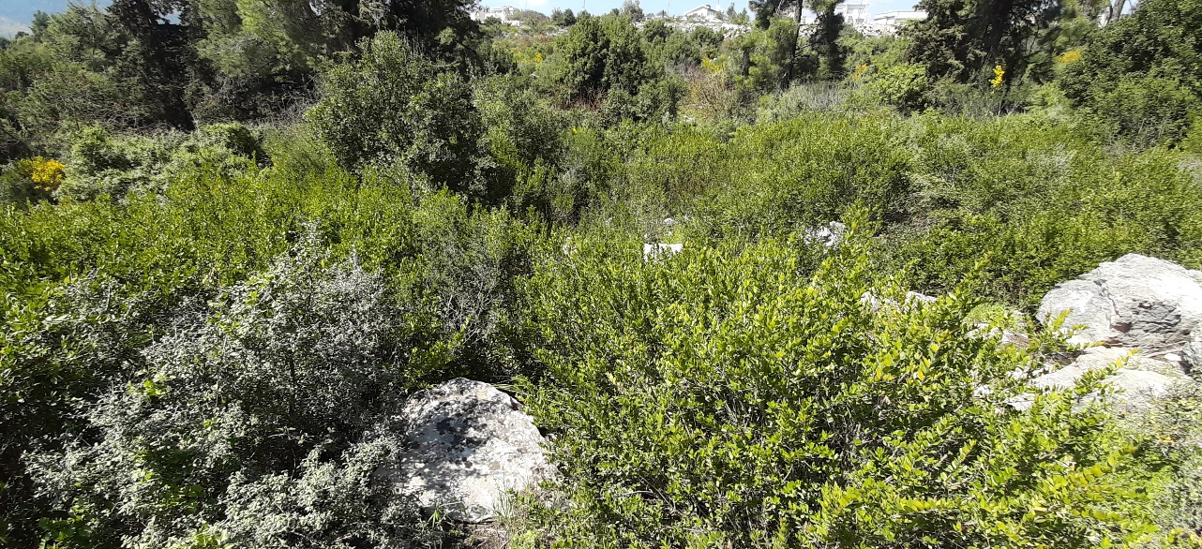
SI_1. Wild Myrtus communis in the upper Galilee, Bar Yochai shrubland, March 2021.
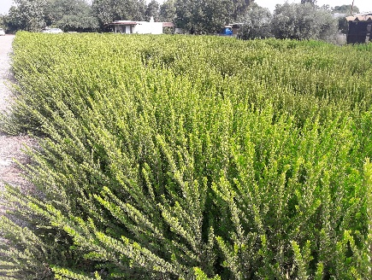 | 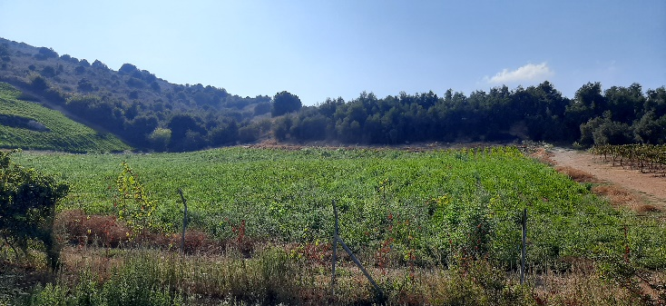
SI_2. Cultivated Myrtus communis field in Kfar Shamai, upper Galilee (left), and in Nov, Golan Heights (right).

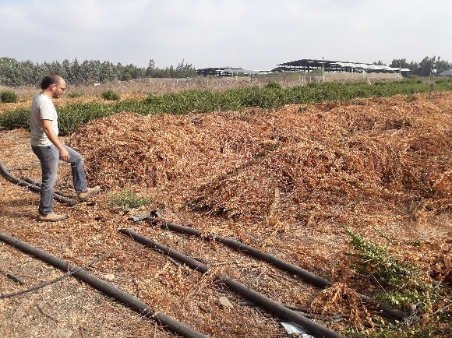 | 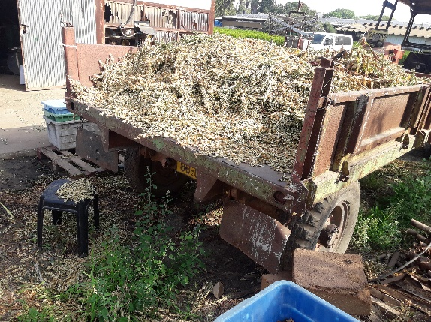
SI_3. Surplus Myrtus communis biomass on the truck (left), and in the field (right), Nov, Golan Heights.

SI_4. M. communis cultivars at the Agricultural Research Organization (ARO) breeding plot, April 2022. The letters on the green plant patches represent cultivar names. H = Hadur (33); D = David (15); K = Kfar Shamai (22); L = Levi (29); C = Chaim (20); M = Mutant (4); W = White fruit (4); U = Unknown (8). Red = missing plant (8), with the number in parenthesis indicating the number of individuals per cultivar.

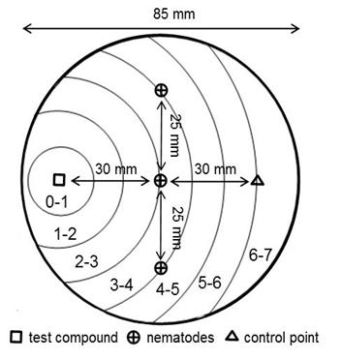

SI_5. Expulsion test for nematodes on an agar plate.
SI_6. Complete phytochemical data of the entire 3 years of the study. Phytochemical analyses of seasons 2020 and 2022 is added to the data presented in Table 1.

Compound | David |  |  |  | Levi |  |  |  | Hadur |  |  |  | Haim |  |  |  | Nov I
Compound | 2020 | 2021 | 2022 | SPME | 2020 | 2021 | 2022 | SPME | 2020 | 2021 | 2022 | SPME | 2020 | 2021 | 2022 | SPME | 2020 | 2021
α-thujene |  | 0.44 |  | 1.4 |  | 0.44 | 2.05 | 0.9 |  | 0.94 |  | 0.8 |  | 0.81 | 0.4 | 5.8 |  | 0.45
α-thujene |  | ±0.04 |  | 1.4 |  | ±0.01 | ±0.62 | 0.9 |  | ±0.7 |  | 0.8 |  | ±0.04 | ±0.03 | 5.8 |  | ±0.01
α-pinene | 4.52 | 23.92 | 21.62 | 36.0 | 0.96 | 9.63 | 6.17 | 41.2 | 14.1 | 20.65 | 20.9 |  | 15.3 | 22.54 | 27.76 |  | 13.92 | 25.83
α-pinene | ±0.12 | ±2.45 | ±6.78 | 36.0 | ±1.36 | ±0.12 | ±2.55 | 41.2 | ±0.43 | ±1.05 | ±1.71 |  | ±0.41 | ±0.30 | ±2.17 |  | ±0.78 | ±0.82
β-pinene |  | 0.68 | 0.29 | 1.1 |  | 0.35 | 0.16 | 1.5 |  | 0.61 | 0.29 | 0.9 |  | 0.6 | 0.31 |  |  | 0.81
β-pinene |  | ±0.06 | ±0.06 | 1.1 |  | ±0.01 | ±0.02 | 1.5 |  | ±0.03 | ±0.01 | 0.9 |  | ±0.01 | ±0.04 |  |  | ±0.02
myrcene | 1.18 | 0.85 | 0.78 | 0.3 |  | 0.63 | 0.79 |  |  | 0.56 | 0.4 | 0.1 | 0.92 | 0.28 |  |  | 1.62 | 0.85
myrcene | ±0.09 | ±0.06 | ±0.15 | 0.3 |  | ±0.02 | ±0.10 |  |  | ±0.08 | ±0.09 | 0.1 | ±0.01 | ±0.01 |  |  | ±0.16 | ±0.03
δ-3-carene |  | 0.51 |  |  |  | 0.95 | 0.34 | 2.4 | 0.92 | 1.95 | 0.66 | 0.3 | 0.79 | 1.91 | 0.55 | 0.2
δ-3-carene |  | ±0.04 |  |  |  | ±0.13 | ±0.11 | 2.4 | ±0.13 | ±0.07 | ±0.36 | 0.3 | ±0.01 | ±0.08 | ±1.04 | 0.2
α-terpinene |  | 0.17 |  | 0.3 |  | 0.28 |  | 2.5 |  |  |  | 26.1 |  |  | 2.85 | 18.3
α-terpinene |  | ±0.03 |  | 0.3 |  | ±0.01 |  |  |  |  |  |  |  |  | ±0.17 | 18.3
p-cymene |  |  |  | 1.9 |  | 0.66 | 1.01 | 4.1 |  |  |  | 55.1 |  |  | 3.17 | 66.7
 |  |  |  |  |  | ±0.08 | ±0.20 |  |  |  |  |  |  |  | ±0.39 | 66.7
limonene | 7.01 | 6.07 | 1.73 | 28.4 | 0.38 | 3.61 | 1.52 | 29.2 | 17.48 | 14.25 | 13.16 |  | 6.98 | 21.52 | 26.63 |  | 4.16 | 6.49
limonene | ±0.36 | ±0.65 | ±1.35 | 28.4 | ±0.20 | ±0.07 | ±0.37 | 29.2 | ±0.88 | ±1.82 | ±8.29 |  | ±0.38 | ±0.48 | ±2.44 |  | ±.0.17 | ±0.12
1-8-cineole | 25.47 | 21.82 | 42 | 4.3 | 20.34 | 12.4 | 23.12 |  | 25.34 | 20.49 | 36.61 |  | 11.11 | 14.82 | 21.43 |  | 16.01 | 23.65
1-8-cineole | ±1.29 | ±1.97 | ±8.46 | 4.3 | ±8.4 | ±0.21 | ±3.14 |  | ±1.28 | ±1.51 | ±12.12 |  | ±0.61 | ±0.35 | ±5.18 |  | ±0.55 | ±0.27
β-ocimene |  | 0.67 |  |  |  | 0.36 | 0.31 |  |  | 0.44 | 0.22 | 8.2 |  | 0.26 |  | 5.1 |  | 0.56
β-ocimene |  | ±0.05 |  |  |  | ±0.02 | ±0.02 |  |  | ±0.02 | ±0.03 | 8.2 |  | ±0.08 |  | 5.1 |  | ±0.03
γ- terpinene |  | 0.62 | 0.23 | 2.9 |  | 0.89 | 0.39 |  |  | 0.92 | 0.28 |  | 0.69 | 0.92 | 0.37 |  |  | 0.51
γ- terpinene |  | ±0.06 | ±0.03 | 2.9 |  | ±0.02 | ±0.11 |  |  | ±0.05 | ±0.08 |  | ±0.02 | ±0.06 | ±0.12 |  |  | ±0.03
linalool oxide | 0.76 | 0.33 |  |  |  |  |  |  |  |  |  | 1.2 |  |  |  | 1.0 |  | 0.21
linalool oxide | ±0.26 | ±0.03 |  |  |  |  |  |  |  |  |  |  |  |  |  |  |  | ±0.01
terpinolene |  | 0.66 | 0.33 | 0.6 |  | 0.69 | 0.34 | 0.3 | 0.61 | 0.77 | 0.28 | 1.3 | 0.46 | 0.45 | 0.29 |  | 1.15 | 0.54
terpinolene |  | ±0.15 | ±0.01 |  |  | ±0.03 | ±0.12 |  | ±0.26 | ±0.08 | ±0.10 |  | ±0.01 | ±0.07 | ±0.15 |  | ±0.04 | ±0.29
p-cymenene |  |  |  |  |  |  |  |  |  | 0.29  ±0.01 |  |  |  | 0.47  ±0.03
linalool | 19.92 | 15.4 | 17.02 | 17.9 | 12.48 | 12.15 | 14.25 |  | 17.93 | 12.7 | 12.49 |  | 11.16 | 4.27 | 3.14 |  | 16.53 | 14.03
linalool | ±1.03 | ±0.79 | ±2.64 |  | ±5.01 | ±0.34 | ±0.72 |  | ±0.66 | ±1.59 | ±1.35 |  | ±0.54 | ±0.29 | ±0.48 |  | ±0.76 | ±0.49
pinocarveol |  | 0.16 |  |  |  | 0.36 |  |  |  |  |  |  |  | 0.57 |  |  |  | 0.16
pinocarveol |  | ±0.01 |  |  |  | ±0.01 |  |  |  |  |  |  |  | ±0.03 |  |  |  | ±0.01
terpinen-4-ol |  | 0.75 | 0.4 |  |  | 1.06 | 0.55 |  | 1.27 | 1.34 | 0.56 |  | 0.98 | 1.23 | 0.41 |  |  | 0.75
terpinen-4-ol |  | ±0.04 | ±0.09 |  |  | ±0.02 | ±0.11 |  | ±0.03 | ±0.05 | ±0.09 |  | ±0.01 | ±0.61 | ±0.15 |  |  | ±0.03
α-terpineol | 13.01 | 8.7 | 7.17 |  |  |  |  |  | 8.1 | 6.83 | 5.89 |  | 12.41 | 4.64 | 3.82 |  | 10.57 | 8.27
α-terpineol | ±0.65 | ±1.09 | ±1.92 |  |  |  |  |  | ±0.43 | ±0.93 | ±4.10 |  | ±0.61 | ±0.14 | ±0.26 |  | ±0.31 | ±0.38
myrtenol |  |  |  |  | 24.83 | 19.02 | 19.44 |  |  |  |  |  | 3.67 | 0.56
 |  |  |  |  | ±10.18 | ±0.55 | ±3.32 |  |  |  |  |  | ±0.18 | ±0.07
nerol | 0.34 | 0.46 |  |  |  | 0.43 | 0.17 |  |  | 0.17 |  |  |  | 0.45 |  |  |  | 0.32
nerol | ±0.01 | ±0.09 |  |  |  | ±0.01 | ±0.03 |  |  | ±0.08 |  |  |  | ±0.12 |  |  |  | ±0.02
α-Gurjunene |  |  |  |  |  |  |  | 2.1
linalyl acetate |  | 2.52 |  |  |  | 2.82 | 1.79 |  |  | 0.52 |  |  | 3.77 | 0.26 |  |  | 3.44 | 2.57
linalyl acetate |  | ±0.38 |  |  |  | ±0.29 | ±0.83 |  |  | ±0.74 |  |  | ±0.19 | ±0.09 |  |  | ±0.84 | ±0.07
geraniol | 7.03 | 2.87 | 2.64 |  |  | 1.86 | 1.73 |  | 1.07 | 1.14 | 0.99 |  |  | 0.51 | 0.41 |  |  | 2.27
geraniol | ±0.31 | ±0.73 | ±0.48 |  |  | ±0.03 | ±0.59 |  | ±0.02 | ±0.24 | ±1.24 |  |  | ±0.06 | ±0.04 |  |  | ±0.13
myrtenyl acetate | 5.2 |  |  |  | 13.8 | 10.82 | 13.1 |  |  |  | 1.79 |  | 7.07 | 0.41
myrtenyl acetate | ±0.24 |  |  |  | ±5.52 | ±0.78 | ±1.76 |  |  |  | ±2.58 |  | ±0.36 | ±0.11
α-terpinyl acetate | 3 | 2.8 | 1.49 |  |  | 1.45 | 0.97 |  |  |  |  |  |  | 0.18 |  |  | 2.94 | 2.79
α-terpinyl acetate | ±0.14 | ±0.44 | ±0.29 |  |  | ±0.03 | ±0.13 |  |  |  |  |  |  | ±0.15 |  |  | ±0.17 | ±0.12
allo-aromadendrene |  |  |  |  |  |  |  | 10.7
neryl acetate | 0.89 |  | 0.29 |  |  |  | 0.5 |  |  |  |  |  | 0.77 |  |  |  | 0.77
neryl acetate | ±0.03 |  | ±0.06 |  |  |  | ±0.09 |  |  |  |  |  | ±0.01 |  |  |  | ±0.01
geranyl acetate | 2.29 | 1.62 | 1.06 |  | 1.12 | 2.06 | 1.95 |  | 2.32 | 2.36 | 1.58 |  | 2.11 | 3.99 | 2.89 |  | 2.39 | 1.74
geranyl acetate | ±0.09 | ±0.44 | ±0.31 |  | ±0.39 | ±0.09 | ±0.24 |  | ±0.09 | ±0.29 | ±0.33 |  | ±0.09 | ±0.24 | ±0.30 |  | ±0.05 | ±0.09
myrtanol acetate |  |  |  |  |  | 0.13
 |  |  |  |  |  | ±0.02
methyl eugenol | 0.37 | 0.13 |  |  | 1.45 | 1.78 | 1.64 |  | 1.18 | 1.15 | 0.49 |  | 1.91 | 1.57 | 0.69 |  |  | 0.12
methyl eugenol | ±0.01 | ±0.03 |  |  | ±0.52 | ±0.07 | ±0.14 |  | ±0.04 | ±0.15 | ±0.27 | 0.1 | ±0.07 | ±0.03 | ±0.14 |  |  | ±0.01
β-caryophyllene | 0.29 | 0.96 |  | 0.3 |  | 1.14 | 0.74 | 2.7 | 0.19 | 0.97 |  |  | 0.6 | 1.27 | 0.54 |  | 0.28 | 0.76
β-caryophyllene | ±0.01 | ±0.16 |  |  |  | ±0.05 | ±0.21 |  | ±0.02 | ±0.07 |  |  | ±0.02 | ±0.16 | ±0.01 |  | ±0.01 | ±0.05
α- humulene | 0.34 | 0.64 | 0.18 |  |  | 2.28 | 2.02 | 0.8 | 0.28 | 1.11 | 0.35 |  | 1.52 | 1.51 | 0.59 |  | 0.27 | 0.5
α- humulene | ±0.01 | ±0.14 | ±0.07 |  |  | ±0.09 | ±0.49 |  | ±0.01 | ±0.10 | ±0.17 |  | ±0.07 | ±0.15 | ±0.15 |  | ±0.02 | ±0.04
caryophyllene oxide | 0.35 | 0.23 |  |  |  | 0.3 |  |  |  | 0.32 |  |  | 0.33 | 0.95 | 0.43 |  | 0.23 | 0.2
caryophyllene oxide | ±0.01 | ±0.04 |  |  |  | ±0.02 |  |  |  | ±0.03 |  |  | ±0.01 | ±0.05 | ±0.07 |  | ±0.01 | ±0.01
Total | 91.97 | 93.54 | 97.23 | 95.6 | 75.36 | 88.11 | 93 | 98.3 | 90.79 | 89.54 | 96.94 | 94.1 | 82.55 | 86.14 | 96.28 | 97.2 | 74.28 | 93.93

