Supplementary Materials
Supplementary Figure 1
Supplementary Figure 1: Regional LocusZoom plots were utilized to visually demonstrate the genetic evidence of colocalization between COLONCANCER and various Cytokines, including (A) IFN_G at the chr1-ZBT40 locus; (B) IL2_RA at the chr10-IL2RA locus; (C)SCF at the chr1-F5 locus; and (D) TNF_B at the chr1-ZBT40 locus. Each data point on the plot corresponds to a SNP, with their positions along the x-axis reflecting their chromosomal location within 500-kb regions surrounding the lead SNP for each metabolite. The significance levels, presented as the negative logarithm of the p-value, are shown on the y-axis. The color of the data points indicates the linkage disequilibrium with the lead SNP, while the blue lines represent recombination rates. Gene locations are depicted at the bottom of the plot.

A
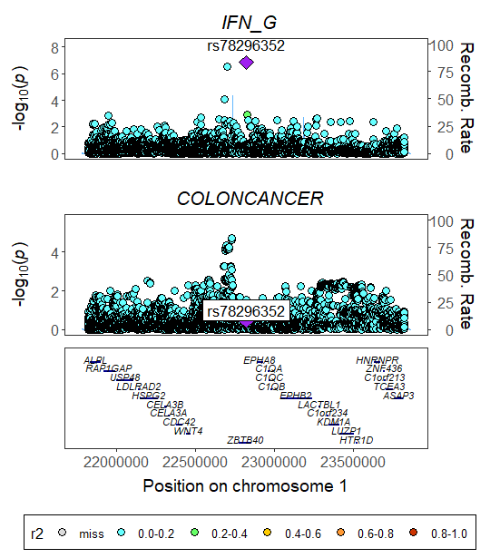

B
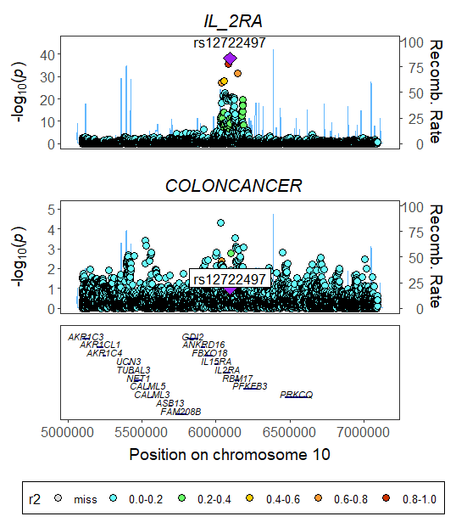

C
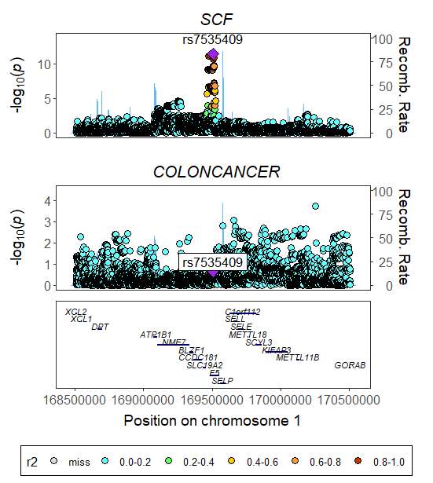

D
