Supplemental material
Supplemental text 1: Additional information on patient characteristics
As indicators of the burden of comorbidities, the quantity of medication, the Charlson Comorbidity Index (CCI) [1], the Elixhauser Comorbidity Index (EC) [2], the ASA (American Society of Anaesthesiologists) score [3] and the Functional Comorbidity Index (FCI)[4] were determined. The Parker Mobility Score (PMS) [5] , the living situation (independently, i.e., at home alone or with partner; at home with additional help; institutionalized), the use of walking aids at the time of admission, a list of twelve binary risk factors (Table 2 main text) and the occurrence of additional injuries were extracted from the records. The binary risk factors included oral anticoagulation, steroid medication, proton pump inhibitor treatment, previous fractures, previous malignancy, the established diagnosis of osteoporosis, neuromuscular pathology, the presence of peripheral arterio-vascular disease, rheumatoid arthritis, malnutrition, previous ipsilateral surgery for a proximal femur fracture, and smoking.
Supplemental text 2: Comparison of patients with a low-energy trauma and a high-energy-trauma.
The majority of patient suffered a low-energy trauma (n=138, 67%, see Supplemental Table 2). Patients suffering acetabular fractures after high-energy trauma were distinctly younger than those presenting after low-energy trauma. Bothe groups were predominantly male, which was more pronounced in the group of patients suffering high energy trauma (Table 1 main text). In consequence, the two patient populations differed already on admission in age-/gender-related characteristics like the use of walking aids, PMS, independence, comorbidities, the number of medications and ASA-score (Table 1 main text). Some of the observed differences between the patient populations though were directly attributable to the energetic impact: the majority of patients after high-energy trauma showed one or more additional injuries (high-energy trauma 95.7% vs. low-energy trauma 55.1%) and the average number of additional injuries was 2.49 vs 0.62. The most frequently observed additional injuries after high-energy trauma were pelvic fractures, fractures of the upper extremities and ribs or soft tissue injuries. After low-energy trauma acetabular fractures were most frequently accompanied by pelvic fractures and soft tissue injuries (see Supplemental Table 3). Time to surgery only differed slightly in patients after low- vs high energy trauma treated surgically (see Supplemental Table 2).
Supplemental text 3: Choice between conservative and surgical treatment
A systematic comparison of the predefined set of patient characteristics with the decision for surgical treatment indicated no association with age, energy level, comorbidities or the performance status of the patients (Supplemental Table 4). Only the use of steroids and the presence of osteoporosis implied a clear preference for surgical treatment. According to Supplemental Table 2, for most simple fracture patterns the conservative treatment was preferred.
Supplemental text 4: Comparison of conservative and surgical treatment
Supplemental Figure 3 shows the outcome comparison between conservatively and surgically treated patients. Overall, conservatively treated patients tended to have better outcomes than surgically treated patients. Not surprisingly, the biggest advantage was seen for outcomes related to complications, which rarely appear in conservatively treated patients given that they are typically treated with early mobilization and avoid the surgical trauma. The similarity between adjusted and unadjusted estimates here reflects the similarity in patient characteristics between the two groups.
Supplemental text 5: Outcome comparison between patients with a low-energy and a high-energy trauma
Supplemental Figure 4 shows the outcome comparison between patients treated after low- vs. high-energy trauma. After adjustment for age and gender no statistically significant group differences could be observed. The most distinct advantages for patient with low-energy trauma were observed for treatment at the intensive care unit (ICU) and a length of stay (LOS) of more than 14 days, which reflects the higher burden of injury after a high-energy trauma.
Supplemental Table 1: Age distribution for different trauma impacts and treatment approaches
 | Total | Low-energy trauma |  |  |  | High-energy trauma
Treatment  Patient  age | n=207 | total  (n=138) | ORIF+  THA (n=29) | ORIF (n=55) | cons. (n=54) | total  (n=69) | ORIF+  THA (n=4) | ORIF (n=34) | cons. (n=31)
≤65 years (n, %)  Female (n, %)  Male (n, %) | 77 (37.2)  52 (67.5)  25 (32.5) | 23 (16.7)  10 (43.5)  13 (56.5) | 0 (0)  0 (0)  0 (0) | 17 (22.1)  7 (13.5)  10 (40.0) | 6 (7.8)  3 (5.8)  3 (12.0) | 54 (78.3)  42 (77.8)  12 (22.2) | 1 (1.3)  0 (0)  1 (4.0) | 28 (36.4)  24 (46.2)  4 (16.0) | 25 (32.5)  18 (34.6)  7 (28.0)
66-80 years (n, %)  Female (n, %)  Male (n, %) | 57 (27.5)  24 (42.1)  33 (57.9) | 46 (33.3)  17 (37.0)  29 (63.0) | 8 (17.4)  3 (12.5)  5 (15.2) | 17 (29.8)  5 (22.8)  12 (36.4) | 21 (36.8)  9 (37.5)  12 (36.4) | 11 (15.9)  7 (63.6)  4 (36.4) | 1 (1.8)  1 (4.2)  0 (0) | 4 (7.0)  3 (12.5)  1 (0.3) | 6 (10.5)  3 (12.5)  3 (9.1)
≥81 years (n, %)  Female (n, %)  Male (n, %) | 73 (35.3)  33 (45.2)  40 (54.8) | 69 (50)  29 (42.0)  40 (58.0) | 21 (28.8)  13 (39.4)  8 (20.0) | 21 (28.8)  4 (12.1)  17 (42.5) | 27 (37.0)  12 (36.4)  15 (37.5) | 4 (5.8)  4 (100)  0 (0) | 2 (2.7)  2 (6.1)  0 (0) | 2 (2.7)  2 (6.1)  0 (0) | 0 (0)  0 (0)  0 (0)
Percentages for totals are based on the group total, percentages for the treatment approaches are based on the age group and gender

Supplemental Table 2:
Treatment decision by acetabular fracture patterns stratified by energy status.
 | Total |  |  | Low-energy trauma |  |  | High-energy trauma
Treatment  Fracture pattern | n=207 | total low-energy (n=138) | total high-energy (n=69) | ORIF+THA (n=29) | ORIF (n=55) | conservative (n=54) | ORIF+THA (n=4) | ORIF (n=34) | conservative (n=31)
Time to surgery [d]  (p10-p90) |  |  |  | 3.97  (1-8) | 4.35  (1-8) |  | 4.03  (1-8) | 6.25  (3-11)
Duration of surgery [min]  (p10-p90) |  |  |  | 170.10  (100-215) | 143.40  (87-218) |  | 172.5  (140-220) | 168.50  (96-267)
Simple fracture patters

Post. wall | 5.8% (12) | 8.3% (1)  0.7% (1) | 91.7% (11)  15.9% (11) | 0% (0) | 0% (0) | 8.3% (1) | 0% (0) | 33.3% (4) | 58.3% (7)
Post. column | 2.4% (5) | 60% (3)  2.1% (3) | 40% (2)  2.9% (2) | 20% (1) | 40% (2) | 0% (0) | 0% (0) | 20% (1) | 20% (1)
Ant. wall | 6.3% (13) | 69.2% (9)  6.5% (9) | 30.8% (4)  3.8% (4) | 0% (0) | 0% (0) | 69.2% (9) | 0% (0) | 7.7% (1) | 23.1% (3)
Ant. Column | 39.1% (81) | 70.4% (57)  41.3% (57) | 29.6% (24)  34.8% (24) | 7.4% (6) | 28.4% (23) | 34.6% (28) | 1.2% (1) | 6.2% (5) | 22.2% (18)
transverse | 2.9% (6) | 66.7% (4)  2.9% (4) | 33.3% (2)  2.9% (2) | 16.7% (1) | 33.3% (2) | 16.7% (1) | 0% (0) | 33.3% (2) | 0% (0)
Associated fracture patterns

T-shaped | 4.4% (9) | 77.8% (7)  5.1% (7) | 22.2% (2)  2.9% (2) | 22.2% (2) | 11.1% (1) | 44.4% (4) | 0% (0) | 22.2% (2) | 0% (0)
Post. column + post. wall | 3.4% (7) | 14.3% (1)  0.7% (1) | 85.7% (6)  8.7% (6) | 0% (0) | 14.3% (1) | 0% (0) | 14.3% (1) | 71.4% (5) | 0% (0)
Transverse + post. wall | 1.9% (4) | 50% (2)  1.4% (2) | 50% (2)  2.9% (2) | 0% (0) | 50% (2) | 0% (0) | 0% (0) | 50% (2) | 0% (0)
Ant. column/wall + post. hemitranverse | 8.7% (18) | 77.8% (14)  10.1% (14) | 22.2% (4)  5.8% (4) | 38.9% (7) | 27.6% (5) | 11.1% (2) | 0% (0) | 16.6% (3) | 5.6% (1)
Two-column | 25.1% (52) | 76.9% (40)  29.0% (40) | 23.1% (12)  17.4% (12) | 23.1% (12) | 36.5% (19) | 17.3% (9) | 3.8% (2) | 17.3% (9) | 1.9% (1)

In the most left column and in the lower triangles, percentages are relative to all patients or all patients with the given trauma energy level. In the upper triangles, percentages are relative to all patients with the specific fracture pattern. The same holds for the percentages in the right part.

Supplemental Table 3:
Rate of additional injuries after low- vs. high energy trauma
Type of injury | Low-energy trauma  (n=138) | High-energy trauma  (n=69) | Total  (n=207)
Overall | 76 (55.1%) | 66 (95.7%) | 142 (68.6%)
Fracture upper extremity | 14 (10.1%) | 28 (40.6%) | 42 (20.3%)
Fractures ipsilateral lower extremity | 2 (1.4%) | 15 (21.7%) | 17 (8.2%)
Fracture contralateral lower extremity | 0 (0%) | 4 (5.8%) | 4 (1.9%)
Additional pelvic fracture | 46 (33.3%) | 33 (47.8%) | 79 (38.2%)
Rib fracture | 1 (0.7%) | 28 (40.6%) | 29 (14%)
Soft tissue injury | 26 (18.8%) | 43 (62.3%) | 69 (33.3%)
Injury of inner organs | 0 (0%) | 8 (11.6%) | 8 (3.9%)
Other | 9 (5.2%) | 13 (18.8%) | 22 (10.6%)

Supplemental Table 4:
Association between predefined patient characteristics and the choice between conservative and surgical treatment.

 | OR | 95%-CI | p-value
Age | 1.04 | [0.85,1.27] | 0.712
High energy trauma | 0.79 | [0.44,1.41] | 0.425
Gender | 0.68 | [0.38,1.21] | 0.189
Use of walking aids | 1.14 | [0.47,2.76] | 0.777
ASA score | 0.86 | [0.48,1.54] | 0.602
Parker Mobility Score | 1.07 | [0.90,1.28] | 0.430
CCI | 0.98 | [0.89,1.09] | 0.763
ECI | 1.01 | [0.88,1.17] | 0.851
FCI | 0.96 | [0.82,1.14] | 0.667
Number of medications | 0.98 | [0.92,1.05] | 0.572
Oral anticoagulants | 1.32 | [0.60,2.92] | 0.494
Steroid medication | 0.32 | [0.11,0.97] | 0.045
PPI | 1.04 | [0.55,1.97] | 0.909
Previous fractures | 1.41 | [0.25,7.86] | 0.697
Osteoporosis | 0.30 | [0.14,0.67] | 0.003
Previous malignancy | 1.25 | [0.50,3.12] | 0.636
Neuromuscular pathology | 2.53 | [0.51,12.47] | 0.255
pAVD | 0.77 | [0.28,2.07] | 0.601
Rheumatoid disease | 0.40 | [0.09,1.74] | 0.223
Malnutrition | 5.11 | [0.62,42.35] | 0.130
Previous ipsilateral surgery | 1.05 | [0.41,2.69] | 0.919
Smoking | 0.89 | [0.37,2.15] | 0.803
Odds ratios > 1 indicate a preference for surgical treatment. The odds ratio for age refers to a 10-years change in age.

Supplemental Table 5:
Gender | Age on admission | ASA | PMS | CCI | ECI | FCI | Medications
Female N  mean  p25, 50, 75 | 38  75.53  62, 75.5, 83 | 38  2.71  2, 3, 3 | 34  8.5  9, 9, 9 | 38  4.66  4, 5, 6 | 38  2.61  1, 2, 4 | 38  1.89  1, 2, 2 | 38  5.21  1, 5.5, 8
Male N  mean  p25, 50, 75 | 84  71.65  60.5, 71.5, 88 | 83  2.53  2, 3, 3 | 80  8.5  9, 9, 9 | 84  3.88  2, 3, 5 | 84  1.79  0, 2, 3 | 84  1.13  0, 1, 2 | 83  3.35  0, 3, 5
Total N  mean  p25, 50, 75 | 122  72.86  62, 73, 85 | 114  2.59  2, 3, 3 | 121  8.5  9, 9, 9 | 122  4.12  2, 4, 6 | 122  2.04  0, 2, 3 | 122  1.37  0, 1, 2 | 121  3.93  0, 3, 7
Summary statistics N, mean, p25, p50, p75

Supplemental Figure 1: Flowchart of availability of follow-up data for surgically treated patients

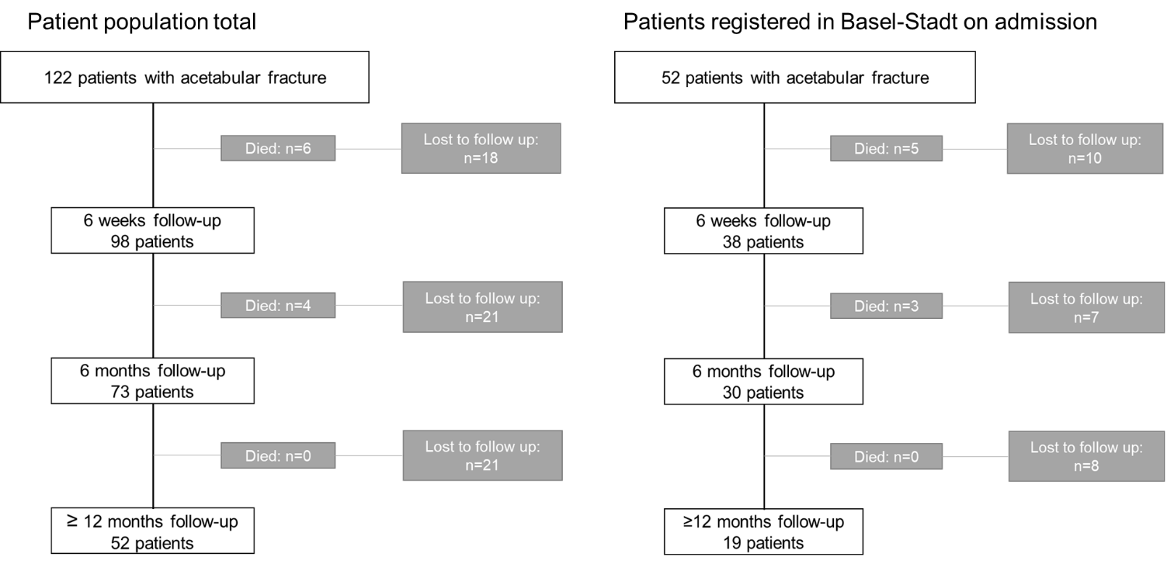

Figure 2A: Comparison of loss of independence and survival between the two surgical treatments

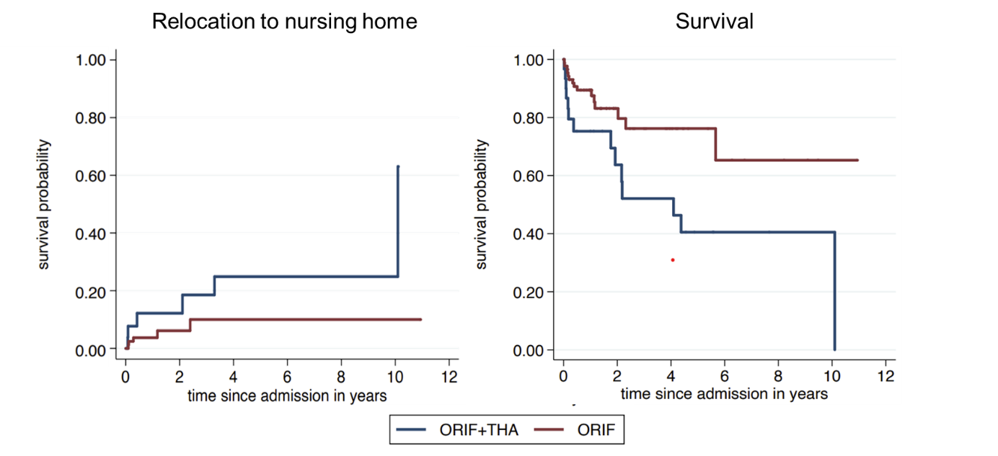

Supplemental Figure 2B: Unadjusted comparisons of secondary binary outcomes between the two surgical treatments.

ICU treatment remained undefined in case the patient had denied intensive care. Preferences though were documented only from 46 of the surgically treated patients with 12 denying intensive care.

Supplemental Figure 2C: Unadjusted and adjusted hazard ratios and odds ratios comparing the two surgical treatments.
adj = adjusted for gender and age

Supplemental Figure 3:
Unadjusted and adjusted hazard ratios and odds ratios comparing surgical with conservative treatment.
adj = adjusted for gender and age
.

Supplemental Figure 4:
Unadjusted and adjusted difference in outcomes between patients after low- vs high-energy trauma
adj = adjusted for gender and age; LE=low enery trauma; HE=high energy trauma

References:
1. Charlson ME, Pompei P, Ales KL, MacKenzie CR (1987) A new method of classifying prognostic comorbidity in longitudinal studies: Development and validation. J Chronic Dis 40:373–383. https://doi.org/10.1016/0021-9681(87)90171-8
2. Elixhauser a, Steiner C, Harris DR, Coffey RM (1998) Comorbidity measures for use with administrative data. Med Care 36:8–27. https://doi.org/10.1097/00005650-199801000-00004
3. Saklad M (1941) Grading for Patients for Surgical Procedures. Anesthesiology Vol.2:281–284
4. Groll DL, To T, Bombardier C, Wright JG (2005) The development of a comorbidity index with physical function as the outcome. J Clin Epidemiol 58:595–602. https://doi.org/10.1016/j.jclinepi.2004.10.018
5. Parker MJ, Palmer CR (1993) A new mobility score for predicting mortality after hip fracture. J Bone Jt Surg - Ser B. https://doi.org/10.1302/0301-620x.75b5.8376443

