eTable 1. (a) Association of GNRI with all-cause mortality
eTable 1. (b) Association of GNRI with mortality from malignant tumors
eTable 1. (c) Association of GNRI with Cardiovascular Mortality
eFigure 1.a Forest plots of associations between GNRI and all-cause mortality
eFgure 1.b Forest plots of associations between GNRI and mortality from malignant tumors
eFigure 1.c Forest plots of associations between GNRI with Cardiovascular Mortality

 | HR | CI95 | P
GNRI (No) | - | - | -
GNRI (Low) | 2.01 | 1.24 - 3.25 | 0.0046
GNRI(Mid) | 2.34 | 1.29 - 4.25 | 0.0051
GNRI(High) | 2.12 | 1.73 - 2.61 | p<0.001
Model 1

 | HR | CI95 | P
GNRI (No) | - | - | -
GNRI (Low) | 2.01 | 1.24 - 3.26 | 0.0047
GNRI(Mid) | 2.34 | 1.29 - 4.25 | 0.0052
GNRI(High) | 2.32 | 1.89 - 2.85 | p<0.001
Sex Fale | - | - | -
Sex Male | 1.30 | 1.13 - 1.5 | 0.0002
Mexican American | - | - | -
Non-Hispanic Black | 1.32 | 0.97 - 1.81 | 0.0760
Non-Hispanic White | 2.03 | 1.52 - 2.71 | p<0.001
Other Hispanic | 0.93 | 0.63 - 1.37 | 0.7219
Other Race - Including Multi-Racial | 0.73 | 0.49 - 1.08 | 0.1180
Model 2, Adding covariates sex, race-corrected model

 | HR | CI95 | P
GNRI (No) | - | - | -
GNRI (Low) | 2.28 | 1.32 - 3.92 | 0.0030
GNRI(Mid) | 2.12 | 0.99 - 4.54 | 0.0516
GNRI(High) | 1.65 | 1.22 - 2.23 | 0.0012
Sex
Sex Fale | - | - | -
Sex Male | 1.48 | 1.24 - 1.77 | p<0.001
Eth
Mexican American | - | - | -
Non-Hispanic Black | 1.36 | 0.92 - 2.03 | 0.1243
Non-Hispanic White | 2.52 | 1.74 - 3.64 | 0.0000
Other Hispanic | 0.78 | 0.47 - 1.31 | 0.3538
Other Race - Including Multi-Racial | 1.30 | 0.8 - 2.11 | 0.2925
Hyperlipidemia
No | - | - | -
Yes | 1.03 | 0.82 - 1.29 | 0.7879
Hypertension
No | - | - | -
Yes | 1.56 | 1.26 - 1.93 | 0.0000
Edu
9-11th grade (Includes 12th grade with no diploma) | - | - | -
College graduate or above | 0.68 | 0.49 - 0.92 | 0.0142
High school graduate/GED or equivalent | 0.90 | 0.7 - 1.17 | 0.4414
Less than 9th grade | 1.10 | 0.81 - 1.48 | 0.5490
Some college or AA degree | 0.71 | 0.54 - 0.93 | 0.0122
Smoke
Former | - | - | -
Never | 0.87 | 0.72 - 1.04 | 0.1284
Now | 0.85 | 0.64 - 1.13 | 0.2623
poverty | 0.85 | 0.8 - 0.91 | 0.0000
Model 3, Adding covariates Sex, Race, Hyperlipidemia, Hypertension, Education, Smoke, Poverty index correction model
- Association of GNRI with all-cause mortality

 | HR | CI95 | P
GNRI (No) | - | - | -
GNRI (Low) | 3.88 | 1.82 - 8.28 | p<0.001
GNRI(Mid) | 3.98 | 1.47 - 10.75 | 0.0064
GNRI(High) | 2.65 | 1.77 - 3.97 | p<0.001
Model 1, univariate cox regression, GNRI and tumor mortality

 | HR | CI95 | P
GNRI (No) | - | - | -
GNRI (Low) | 3.76 | 1.75 - 8.08 | 0.0007
GNRI(Mid) | 4.18 | 1.55 - 11.29 | 0.0048
GNRI(High) | 2.96 | 1.97 - 4.46 | p<0.001
Sex Fale | - | - | -
Sex Male | 1.48 | 1.11 - 1.98 | 0.0082
Mexican American | - | - | -
Non-Hispanic Black | 1.59 | 0.8 - 3.17 | 0.1839
Non-Hispanic White | 2.60 | 1.36 - 4.97 | 0.0039
Other Hispanic | 1.15 | 0.49 - 2.66 | 0.7510
Other Race - Including Multi-Racial | 1.07 | 0.48 - 2.39 | 0.8664
Model 2, Adding covariates sex, race-corrected model

 | HR | CI95 | P
GNRI (No) | - | - | -
GNRI (Low) | 4.70 | 1.99 - 11.09 | p<0.001
GNRI(Mid) | 1.68 | 0.23 - 12.27 | 0.6101
GNRI(High) | 2.49 | 1.4 - 4.41 | 0.0018
Sex
Sex Fale | - | - | -
Sex Male | 1.48 | 1.03 - 2.13 | 0.0351
Eth
Mexican American | - | - | -
Non-Hispanic Black | 1.50 | 0.6 - 3.76 | 0.3818
Non-Hispanic White | 3.15 | 1.34 - 7.43 | 0.0088
Other Hispanic | 1.31 | 0.45 - 3.8 | 0.6210
Other Race - Including Multi-Racial | 2.47 | 0.92 - 6.64 | 0.0729
Hyperlipidemia
No | - | - | -
Yes | 1.25 | 0.78 - 2.01 | 0.3563
Hypertension
No | - | - | -
Yes | 1.22 | 0.81 - 1.82 | 0.3373
Edu
9-11th grade (Includes 12th grade with no diploma) | - | - | -
College graduate or above | 0.59 | 0.31 - 1.12 | 0.1066
High school graduate/GED or equivalent | 0.89 | 0.52 - 1.52 | 0.6656
Less than 9th grade | 0.84 | 0.43 - 1.64 | 0.6052
Some college or AA degree | 0.83 | 0.49 - 1.41 | 0.4898
Smoke
Former | - | - | -
Never | 0.75 | 0.51 - 1.09 | 0.1322
Now | 0.79 | 0.45 - 1.38 | 0.4055
poverty | 0.87 | 0.77 - 0.99 | 0.0338
Model 3, Adding covariates Sex, Race, Hyperlipidemia, Hypertension, Education, Smoke, Poverty index correction model
- Association of GNRI with mortality from malignant tumors

 | HR | CI95 | P
GNRI (No) | - | - | -
GNRI (Low) | 1.55 | 0.49 - 4.84 | 0.4535
GNRI(Mid) | 5.66 | 1.4 - 22.79 | 0.0148
GNRI(High) | 6.86 | 3.91 - 12.03 | p<0.001
Model 1, univariate cox regression

 | HR | CI95 | P
GNRI (No) | - | - | -
GNRI (Low) | 1.50 | 0.48 - 4.7 | 0.4915
GNRI(Mid) | 4.76 | 1.17 - 19.31 | 0.0289
GNRI(High) | 6.79 | 3.86 - 11.94 | p<0.001
Sex Fale | - | - | -
Sex Male | 1.18 | 0.9 - 1.55 | 0.2389
Mexican American | - | - | -
Non-Hispanic Black | 1.27 | 0.74 - 2.2 | 0.3870
Non-Hispanic White | 1.64 | 0.98 - 2.72 | 0.0576
Other Hispanic | 0.51 | 0.23 - 1.14 | 0.0989
Other Race - Including Multi-Racial | 0.32 | 0.13 - 0.78 | 0.0115
Model 2, Adding covariates sex, race-corrected model

 | HR | CI95 | P
GNRI (No) | - | - | -
GNRI (Low) | 2.13 | 0.66 - 6.92 | 0.2082
GNRI(Mid) | 8.49 | 2.02 - 35.71 | p<0.001
GNRI(High) | 3.96 | 1.89 - 8.3 | p<0.001
Sex
Sex Fale | - | - | -
Sex Male | 1.59 | 1.13 - 2.24 | 0.0073
Eth
Mexican American | - | - | -
Non-Hispanic Black | 1.50 | 0.77 - 2.92 | 0.2306
Non-Hispanic White | 2.42 | 1.29 - 4.51 | 0.0056
Other Hispanic | 0.24 | 0.07 - 0.86 | 0.0285
Other Race - Including Multi-Racial | 0.75 | 0.28 - 2.04 | 0.5769
Hyperlipidemia
No | - | - | -
Yes | 1.12 | 0.72 - 1.76 | 0.6105
Hypertension
No | - | - | -
Yes | 1.71 | 1.12 - 2.61 | 0.0135
Edu
9-11th grade (Includes 12th grade with no diploma) | - | - | -
eduCollege graduate or above | 0.75 | 0.4 - 1.42 | 0.3773
eduHigh school graduate/GED or equivalent | 1.00 | 0.59 - 1.69 | 0.9962
eduLess than 9th grade | 1.90 | 1.08 - 3.32 | 0.0253
eduSome college or AA degree | 0.73 | 0.42 - 1.28 | 0.2727
Smoke
Former | - | - | -
Never | 1.29 | 0.9 - 1.83 | 0.1608
Now | 0.77 | 0.42 - 1.39 | 0.3836
poverty | 0.80 | 0.7 - 0.9 | 0.0005
Model 3, Adding covariates Sex, Race, Hyperlipidemia, Hypertension, Education, Smoke, Poverty index correction model
- Association of GNRI with Cardiovascular Mortality
eTable 1 | Association of GNRI with all-cause mortality, malignant tumor mortality, and cardiovascular mortality

eFigure 1 | Forest plots of associations between GNRI and all-cause mortality, malignant neoplasm mortality, and cardiovascular mortality

- Association of GNRI with all-cause mortality
Model 1
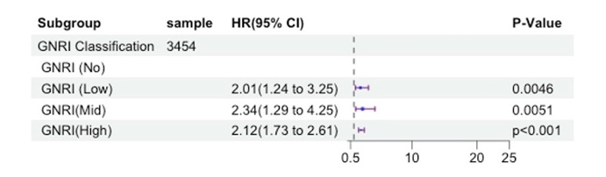
Model 2
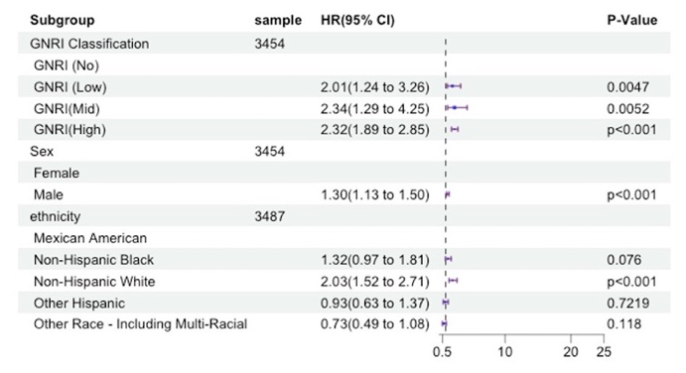
Model 3
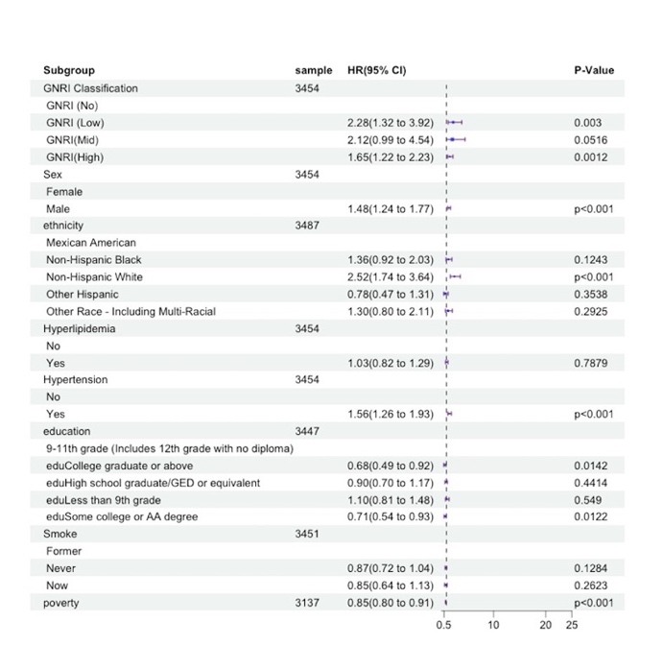
- Association of GNRI with mortality from malignant tumors
Model 1
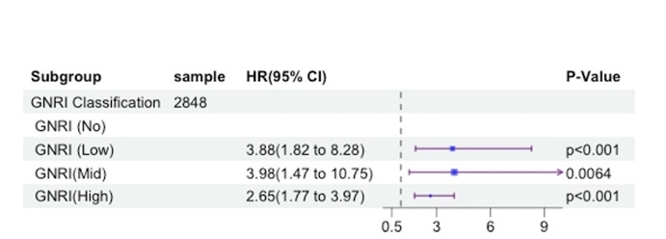
Model 2
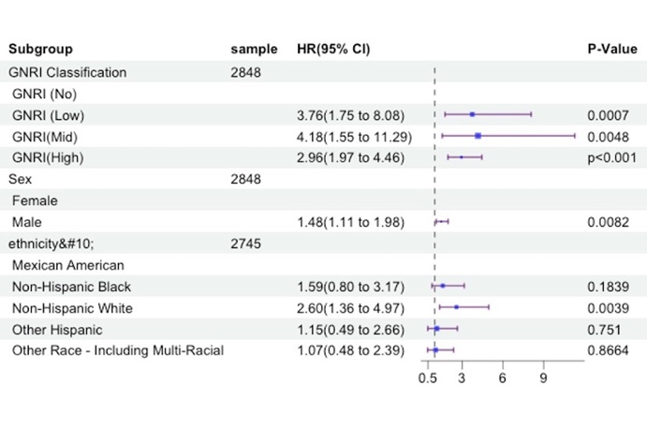
Model 3
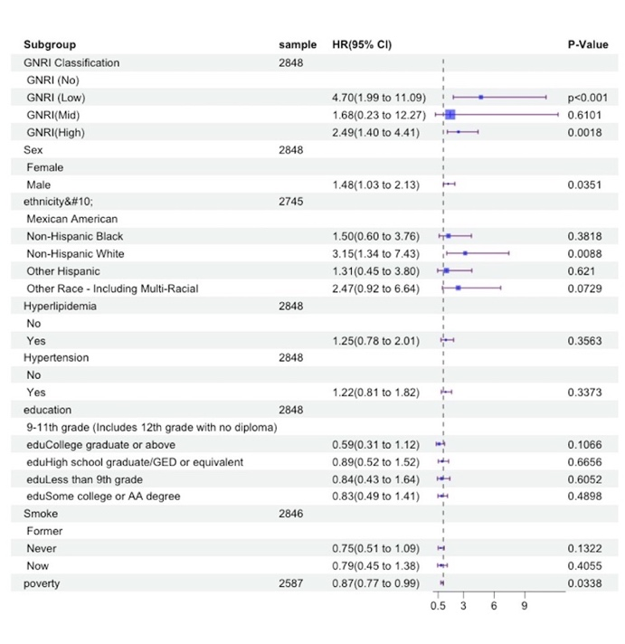
- Association of GNRI with Cardiovascular Mortality
Model 1
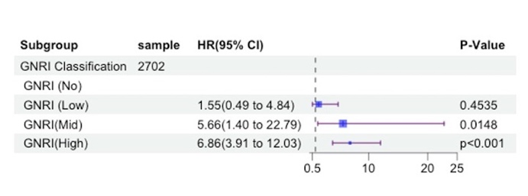
Model 2
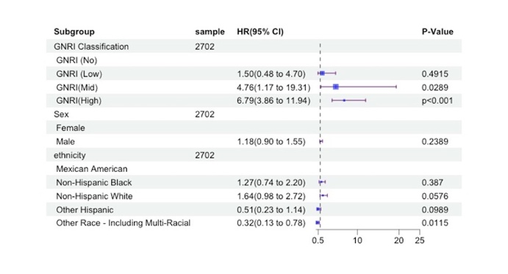
Model 3
