Supplementary Materials

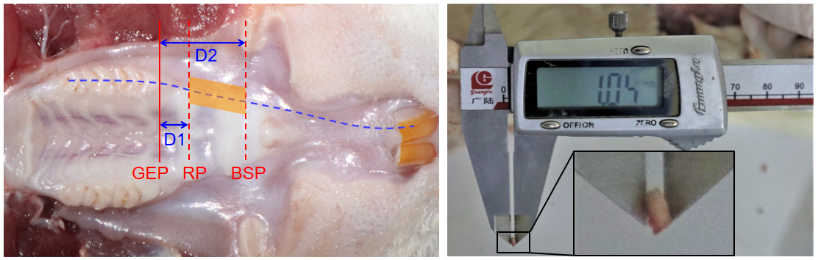
Figure S1. Extent and methods of soft tissue thickness measurement. The orange quadrangle shows the position and extent of the soft tissue acquired for measurement. The blue dash line is dentition extension line

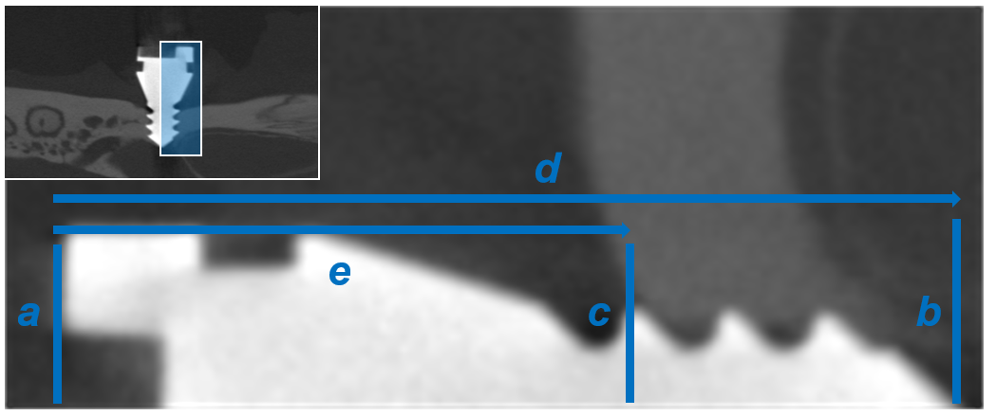
Figure S2. The graph depicts the reference lines used to measure bone levels at implants. a, coronal aspect of the implant head; b, most apical aspect of the implant tip; c, most coronal point of bone-implant contact; d, distance between a and b; and e, distance between a and c. The bone height was calculated using the following formula: 3.8 mm (length of the implant)/d × e; For each implant, buccal, palatal, mesial, and distal bone levels were measured (average of three technical replicates).

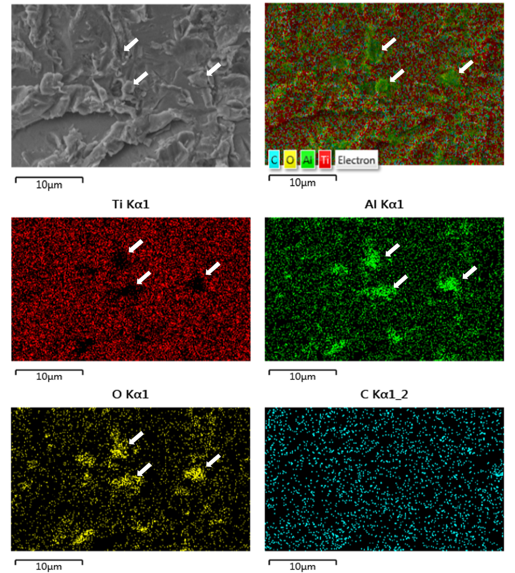
Figure S3. EDS mapping of implant sandblasting surface. EDS mapping showed that Al₂O₃ particles used in sandblasting were embedded on the surface of the implant, and white arrow indicate the Al₂O₃ particles remaining on the surface of the implant resulted in the locally high Al and O element contents.

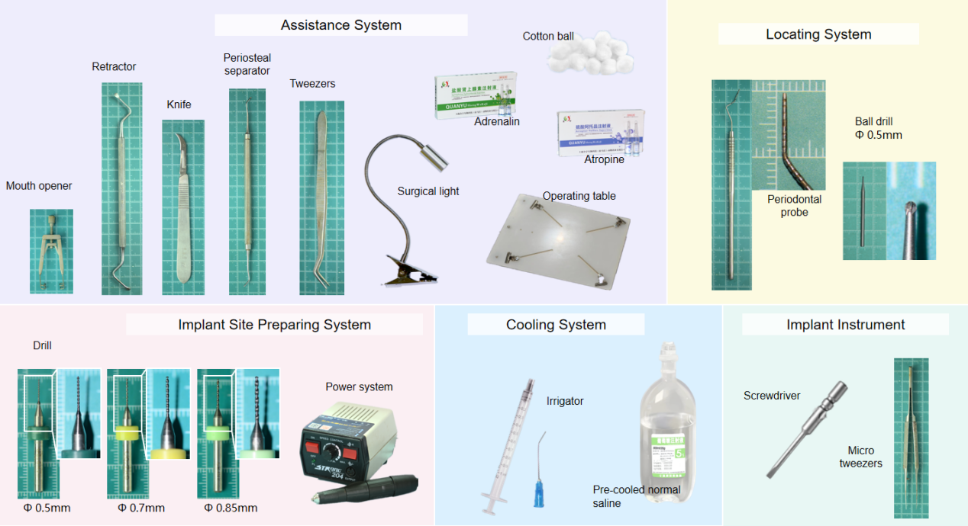
Figure S4. Instruments and drugs required for implant surgery.

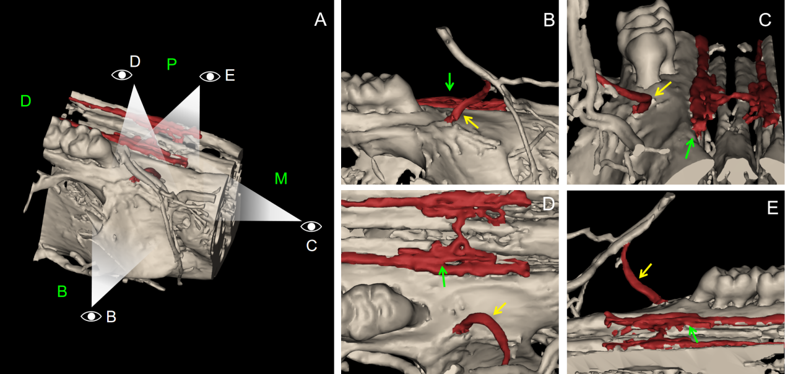

Figure S5. Vascular perfusion results in the maxillary region. B, C, D, and E are the pictures respectively observed from various direction showed in A. The vessel are marked in red. There is a large vessel shown on the buccal side of the alveolar ridge in pre-molar region (yellow arrow), and there are vessels on the superficial of palatal cleft (green arrow).

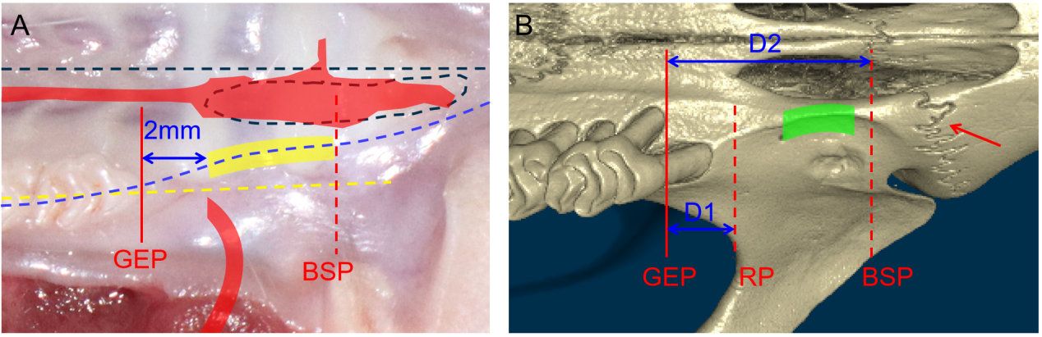
Figure S6. The position of incision and implant region. (A) The position of incision. The starting point of the incision is 2 mm mesial to the gingival entry point of the first molar and slightly palatal to the extension line of the dentition. Yellow zone: the ideal incision position; black dotted line: the maxillary midline; black dotted circle: palatal cleft, the blue dotted line: the alveolar ridge; the yellow dotted line: the dentition extended line; GEP: gingival entry plane; BSP: bone suture plane; red zone: the buccal and palatal vessels. (B) The position of implant region. Green zone: the ideal implant region; Red arrow: bone suture; D1 = 2mm, a certain distance reserved for the subgingival mesial root; D2 = 6mm to avoid bone suture.

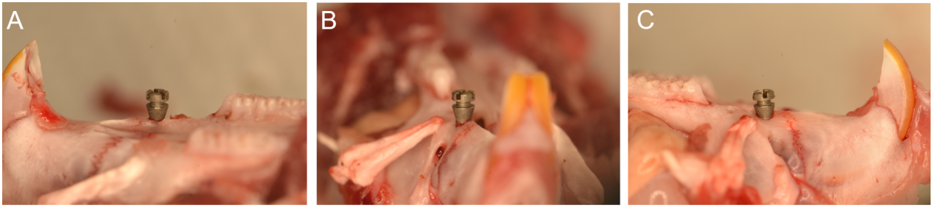

Figure S7. The positional relationship between the implant and the bone surface after implantation (palatal, mesial and buccal perspective from A to C).

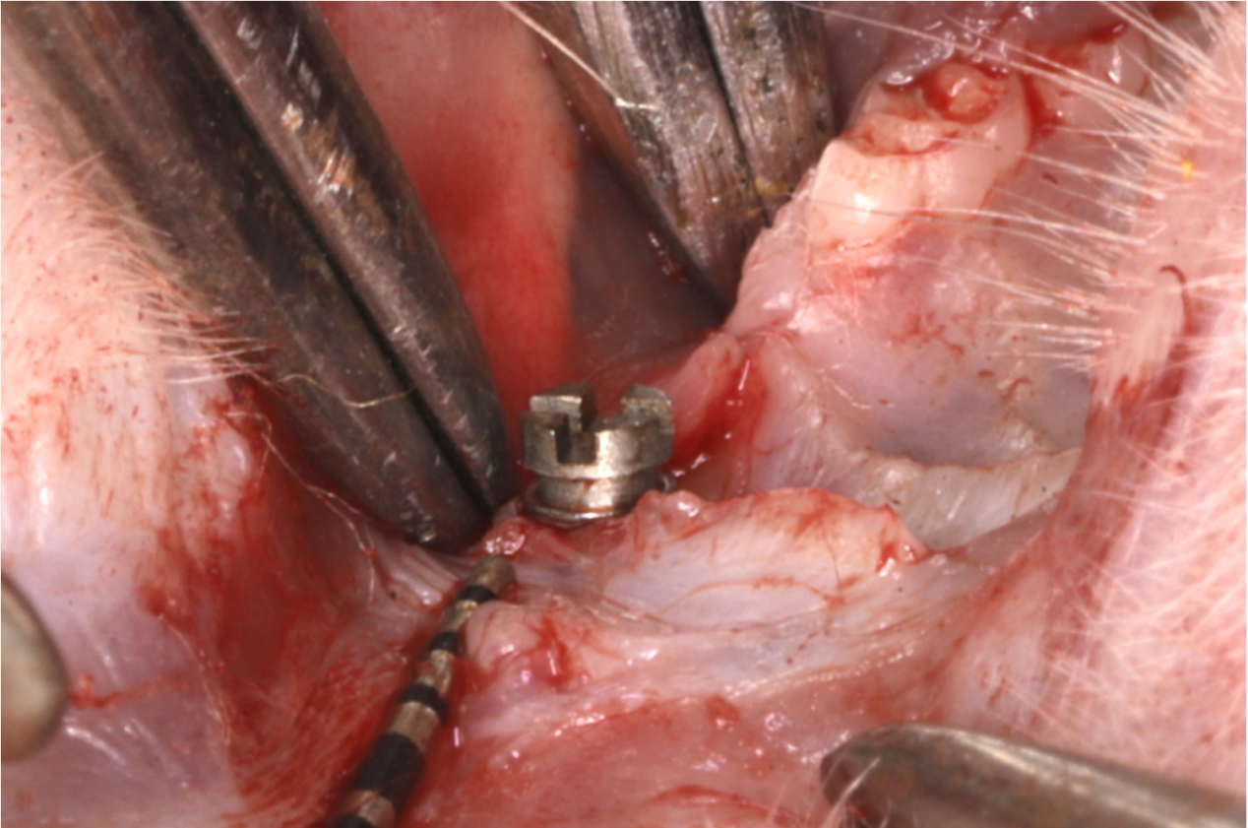
Figure S8. Immediate post-operative picture of implant. The transgingival segment allows the ligation groove to expose just above the soft tissue.

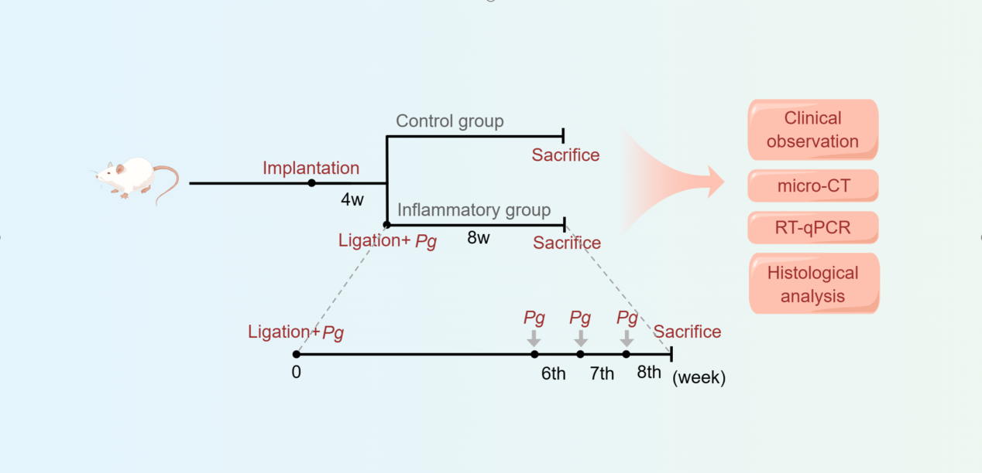
Figure S9. The entire model establishment process.

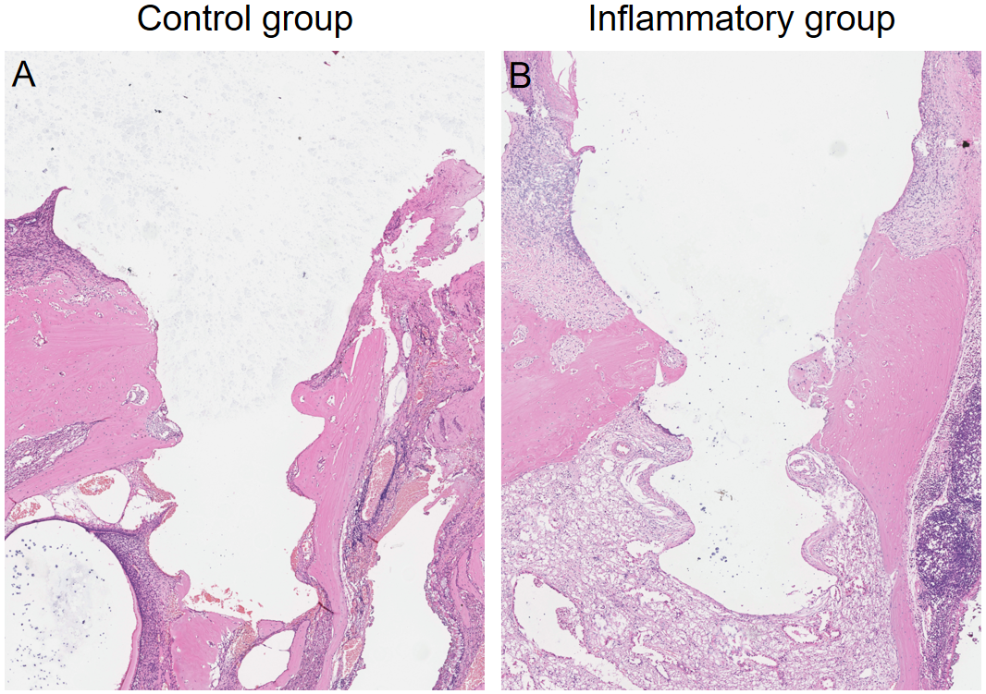

Figure S10. Representative histological image of H&E staining from buccopawlatal direction.

Table S1. The primers used for quantitative PCR.
Gene | Sequence
GAPDH | Forward 5’-ACTCCACGACGTACTCAGCG-3’
 | Reverse 5’-GGTCGGAGTCAACGGATTTG-3’
IL-1β | Forward 5’-TCTGTGACTCGTGGGATGAT-3’
 | Reverse 5’-CTTCTTTGGGTATTGTTTGG-3’
IL-18 | Forward 5’-CAACCGCAGTAATACGGAGC-3’
 | Reverse 5’-TCTGGTCTGGGATTCGTTGG-3’
IL-6 | Forward 5’-ACAGTGCATCATCGCTGTTC-3’
 | Reverse 5’-CCGGAGAGGAGACTTCACAG-3’
TNF-α | Forward 5’-GGATCTCAAAGACAACCAAC-3’
 | Reverse 5’-ACAGAGCAATGACTCCAAAG-3’

Table S2. Instruments and drugs required for implant surgery.
Tool name | Vendor (catalog number) | Purpose
Mouth opener | BIOFIVEN (HH04038) | Keep mouth open
Retractor | Kangqiao (E3) | Expose the surgical field
Tweezers | Kangqiao | Expose the surgical field
Knife | Zhuoyouyue (NO. 3) | Cut the mucosa
Periosteal separator | Weirong (6#) | Detach the mucoperiosteal flap
Surgical light | Boruida | Make a bright field
Operating table | Boruida | Fix the rat
Adrenaline | Quanyu | Topical Vasoconstrictors (1:10,000 U/ml)
Atropine | Quanyu | Inhibit salivary secretion（0.01ml/kg）
Cotton ball | Winner | Wipe away blood and saline
Periodontal probe | Shiying | Measure distance
Ball drill (Φ=0.5mm) | KOMET (F1) | Make a positioning hole
Drill (Φ=0.5/0.7/0.85mm) | UNION TOOL | Prepare the implant hole
Power system | Shixin (204) | Prepare the implant hole
Irrigator | Kangdelai | Cooling
Pre-cooled normal saline | Kelun | Cooling
Screwdriver | YUPEI | Screw in the implant
Micro tweezers | Kewuo | Fix the implant when screw into hole

