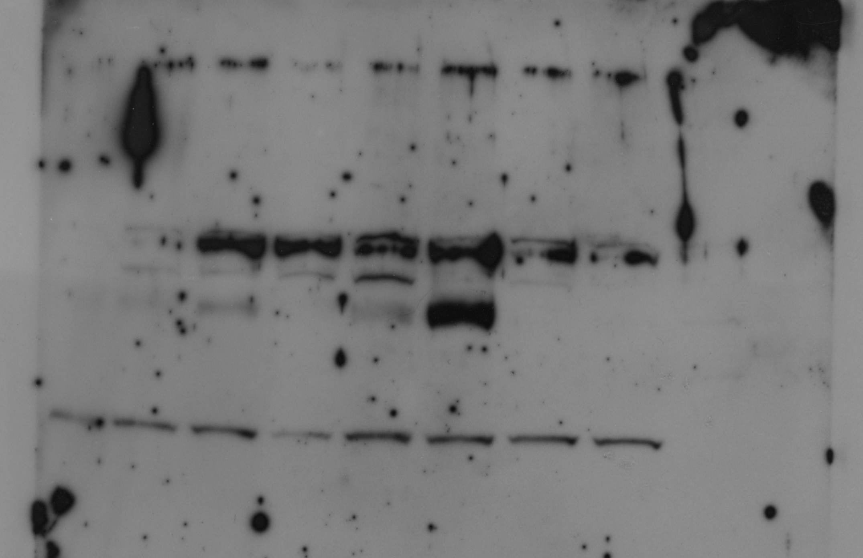
1 2 3 4 5 6 7 8
ATF-4 & CHOP [SKMEL23]
1 2 3 4 5 6 7 8
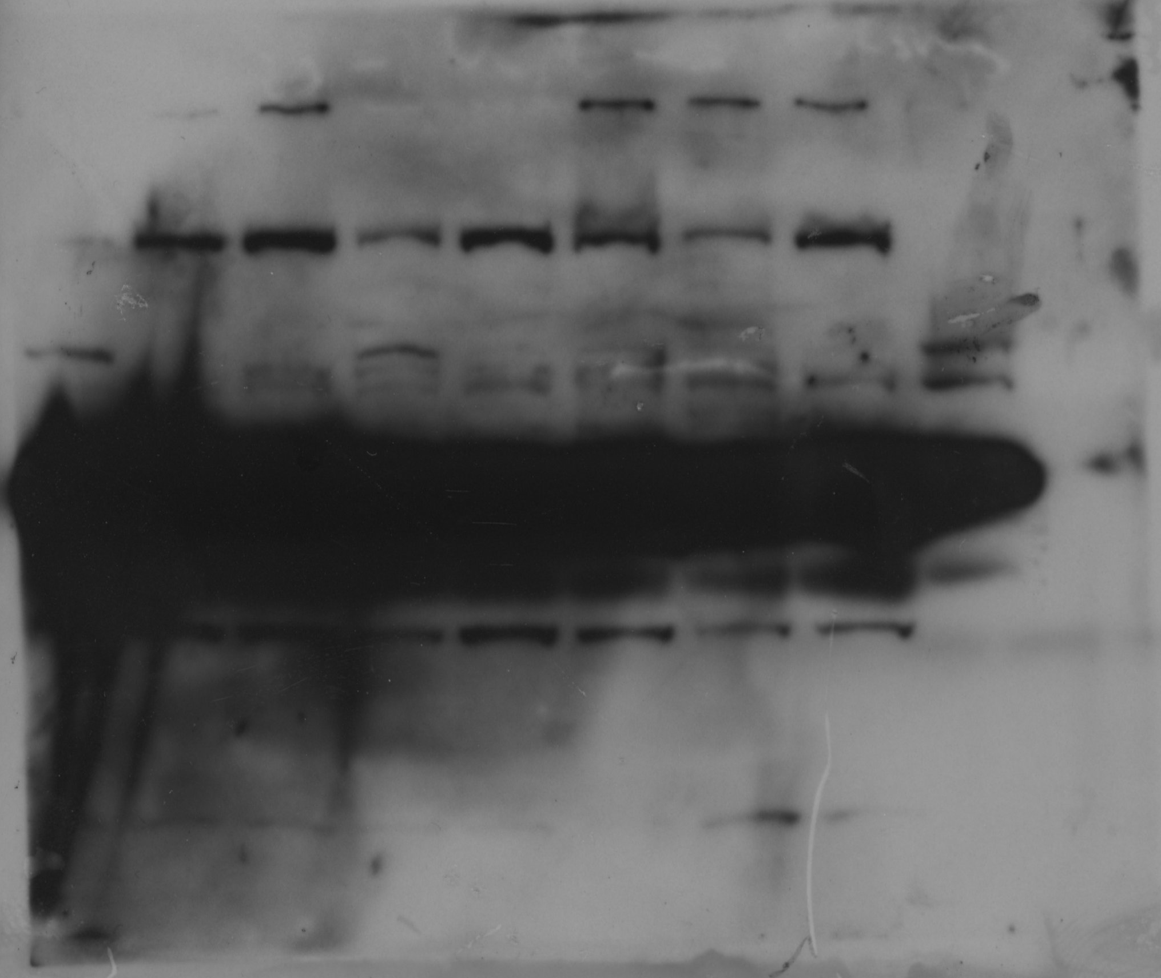
p8 [SKMEL23]
1 2 3 4 5 6 7 8

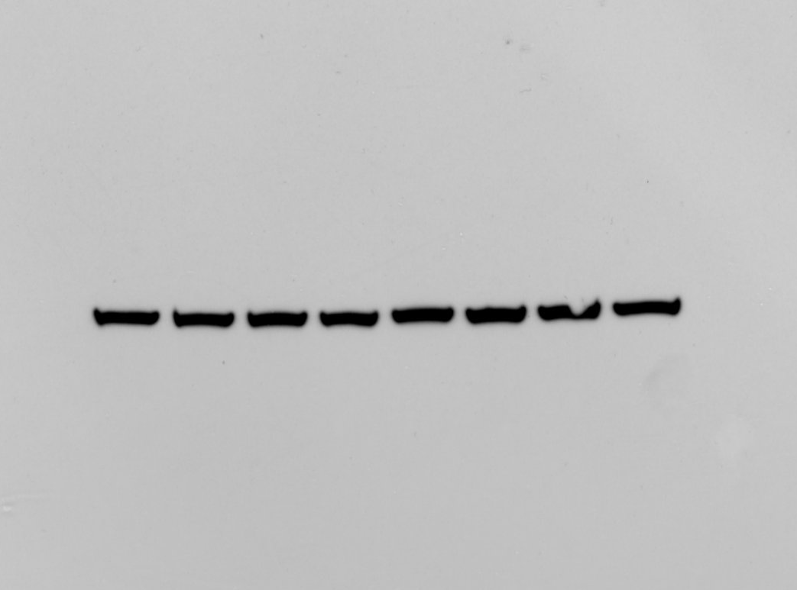
beta-Actin [SKMEL23]

Lanes:
1;7-8 not in the mansucript [1: untreated; 7: 25 µM bathocuproindisulfonic acid; 8: 50 µM bathocuproindisulfonic acid]
2-6: Figure 4D

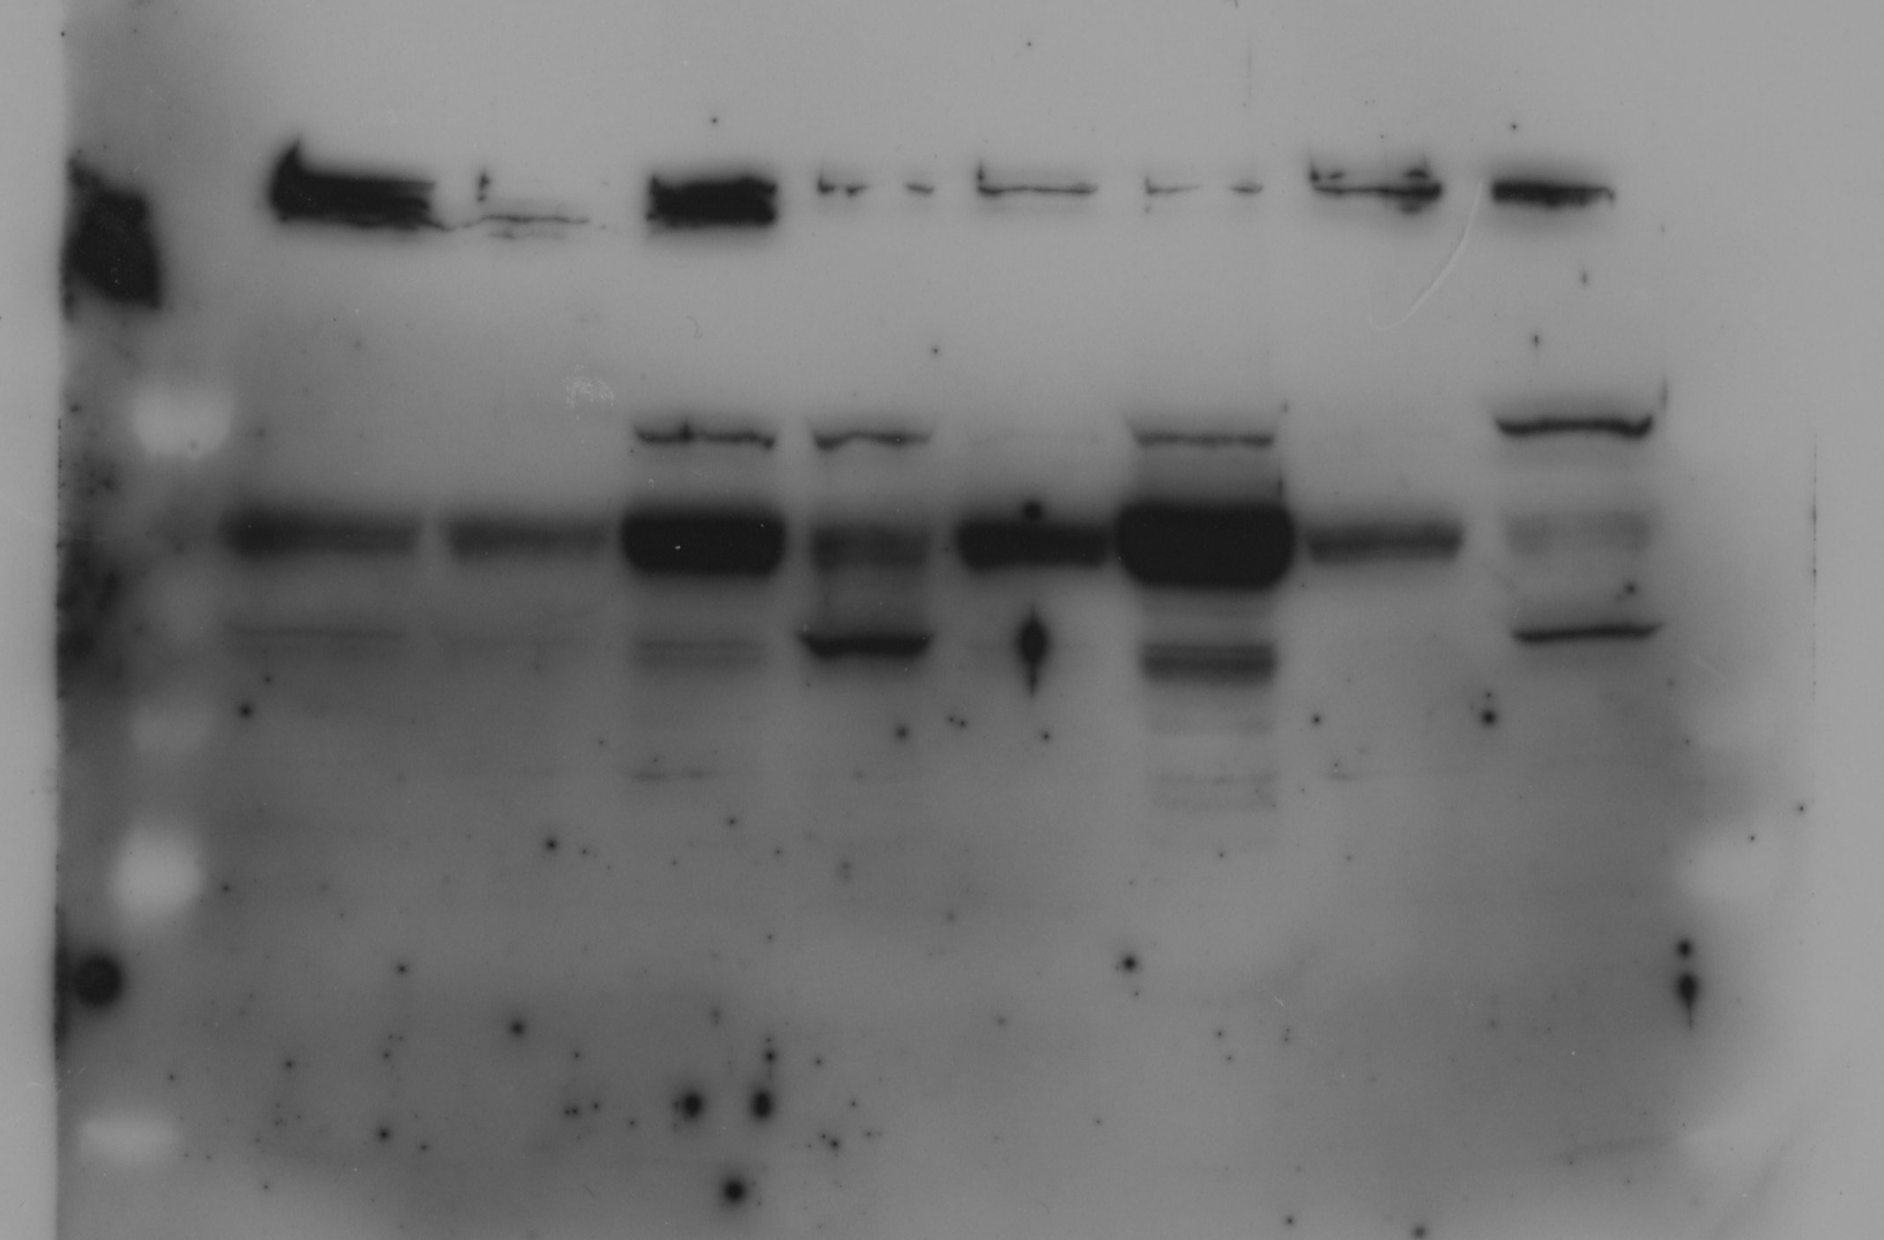
1 2 3 4 5 6 7 8
ATF-4 & CHOP [SKMEL113]
1 2 3 4 5 6 7 8

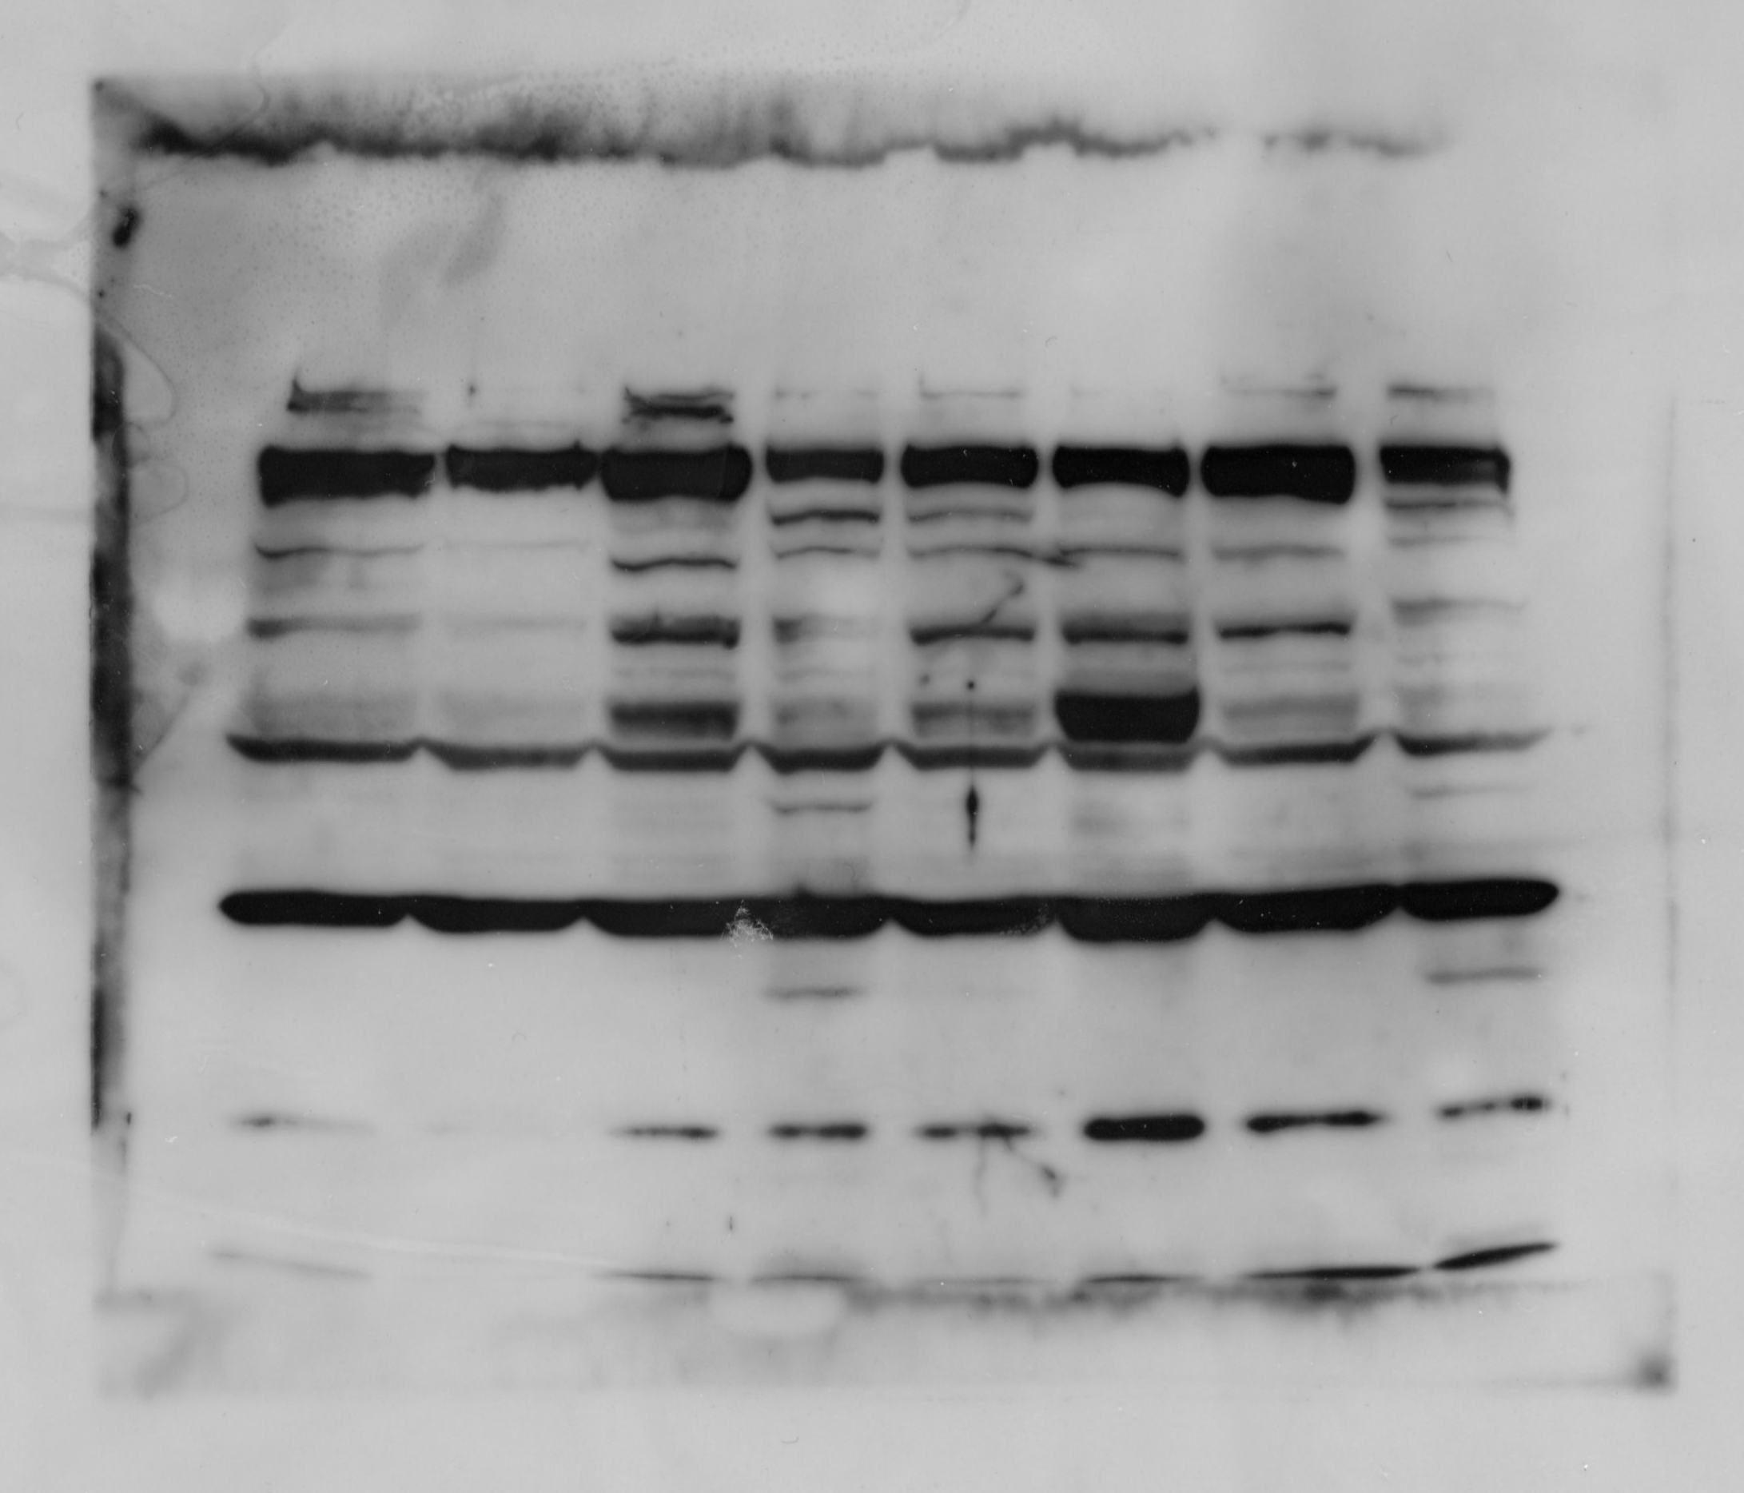
p8 [SKMEL113]
1 2 3 4 5 6 7 8
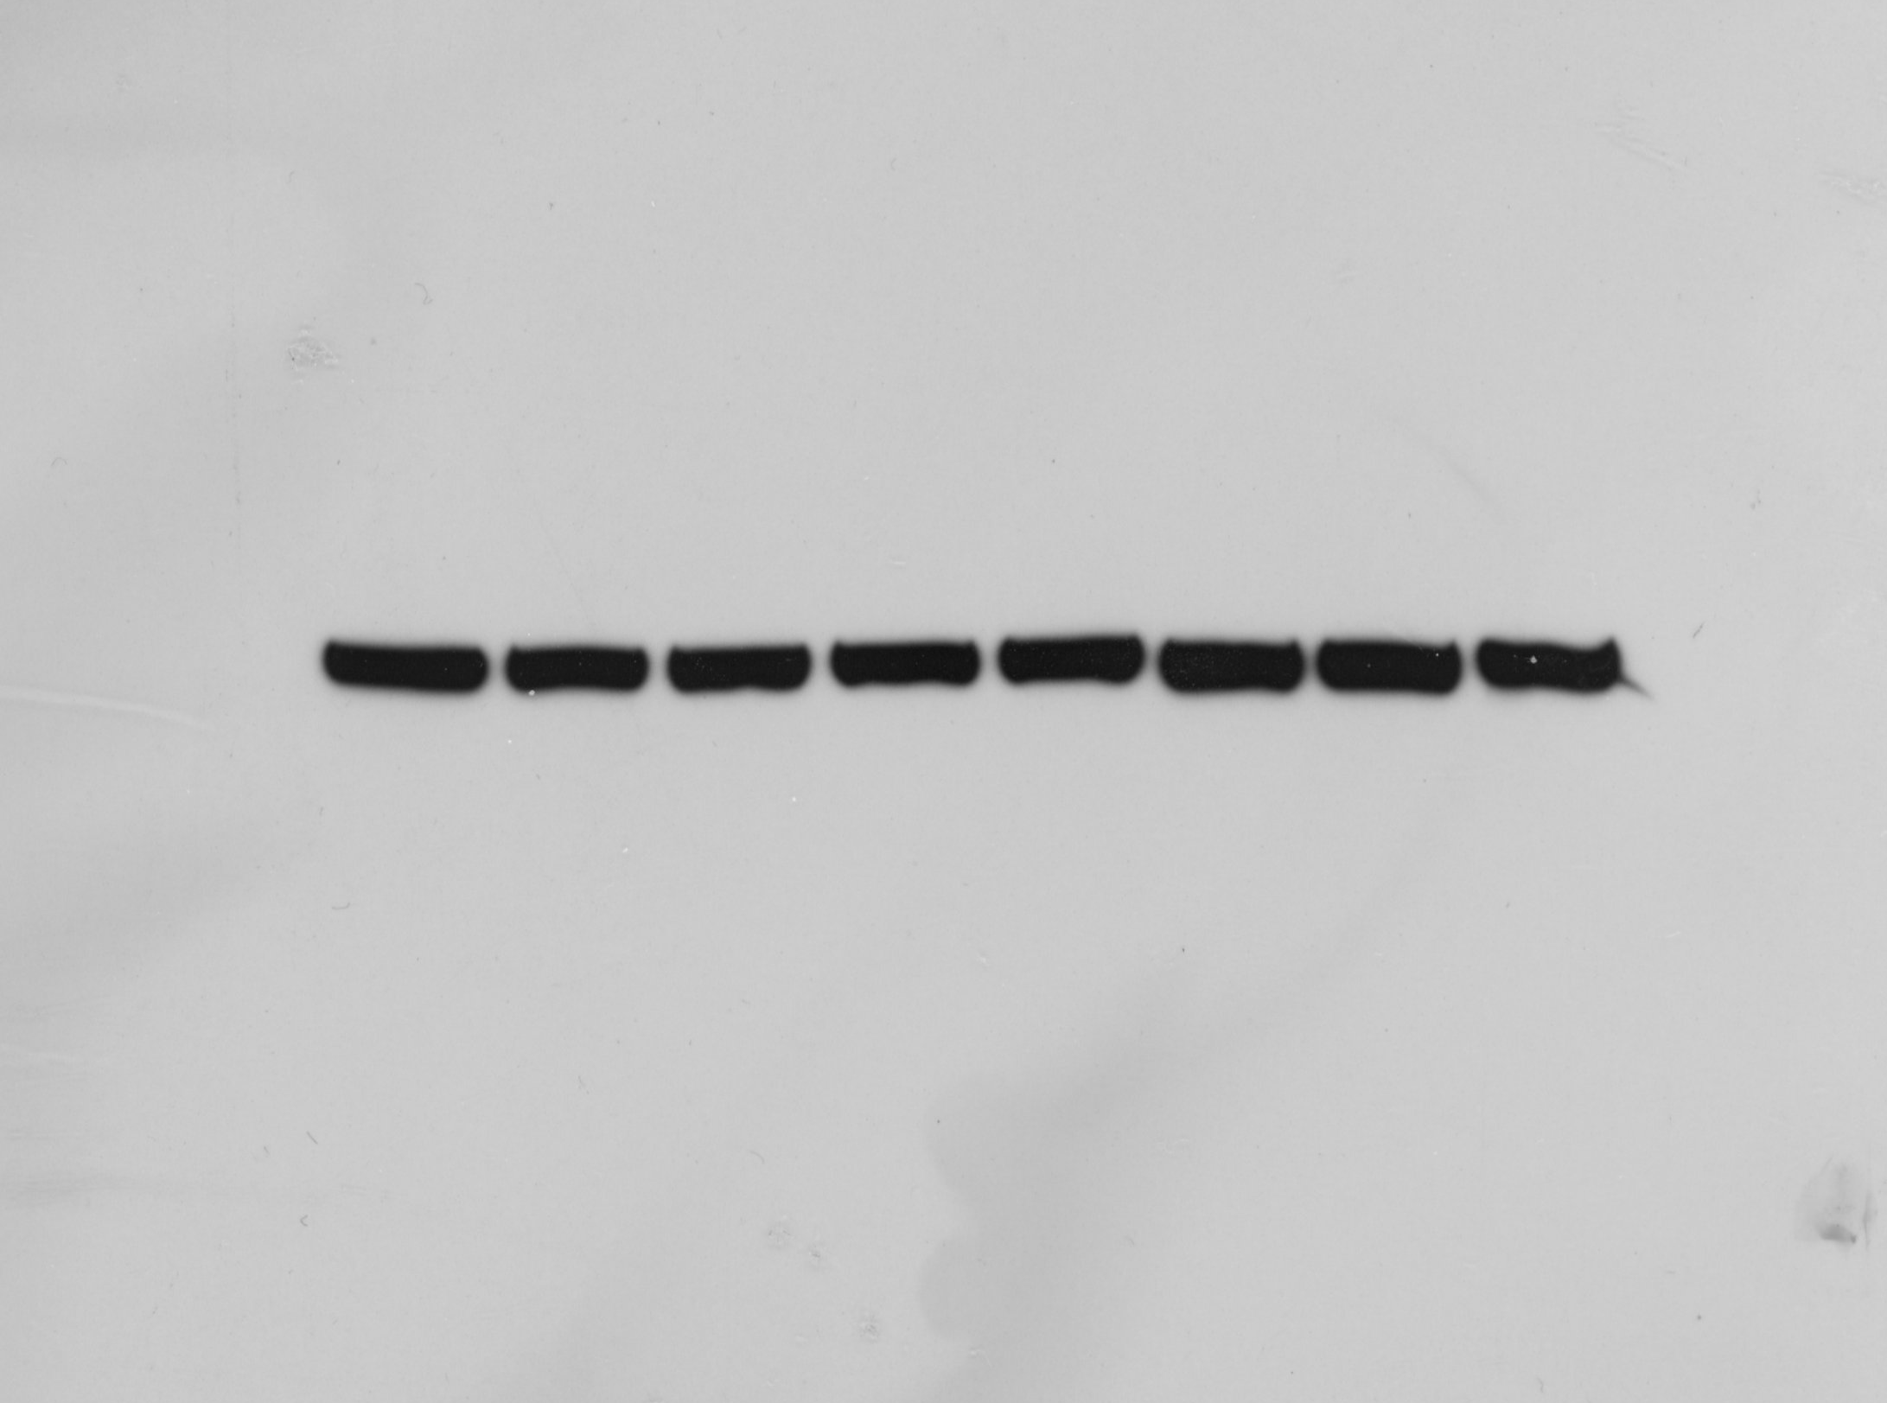
beta-Actin [SKMEL113]

