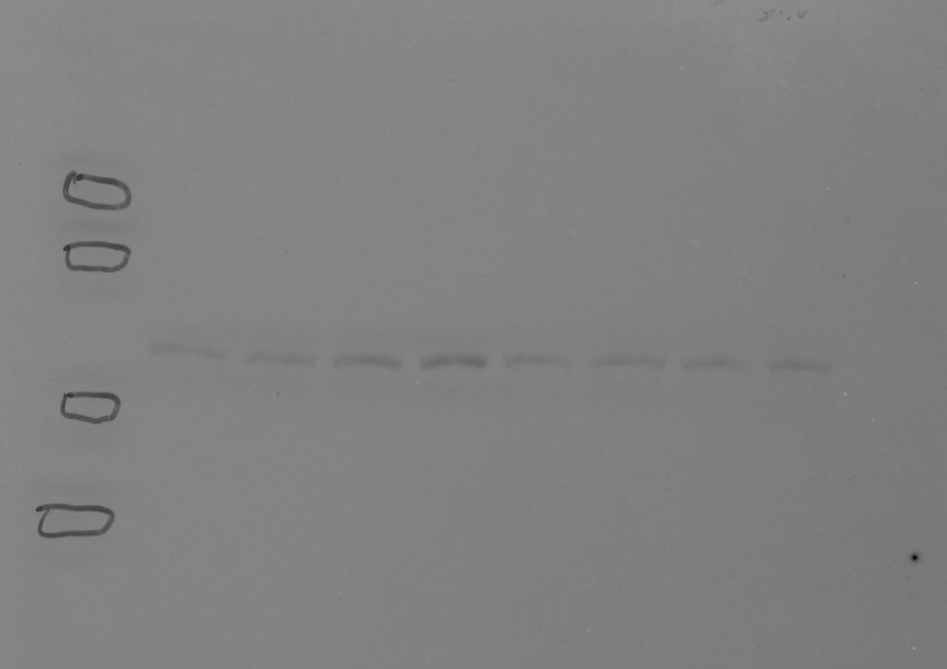
1 2 3 4 5 6 7 8
phospho-JNK [SKMEL23]
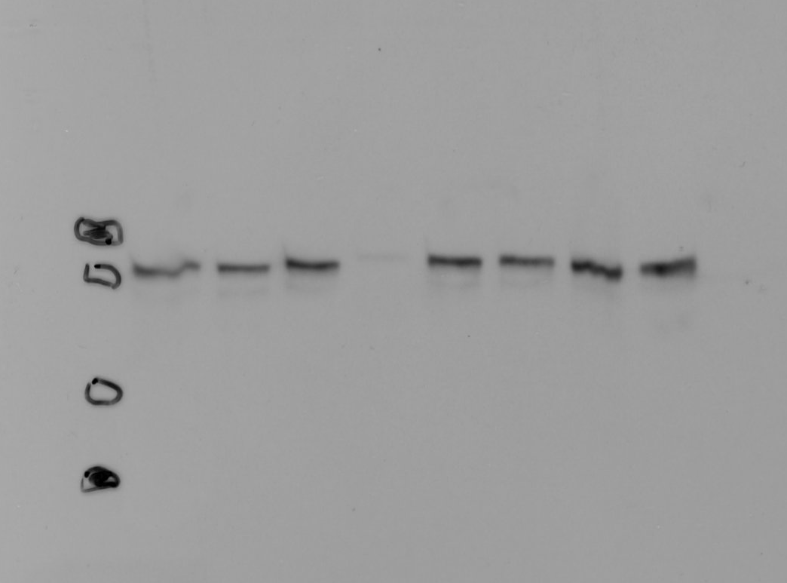
1 2 3 4 5 6 7 8
total JNK [SKMEL23]
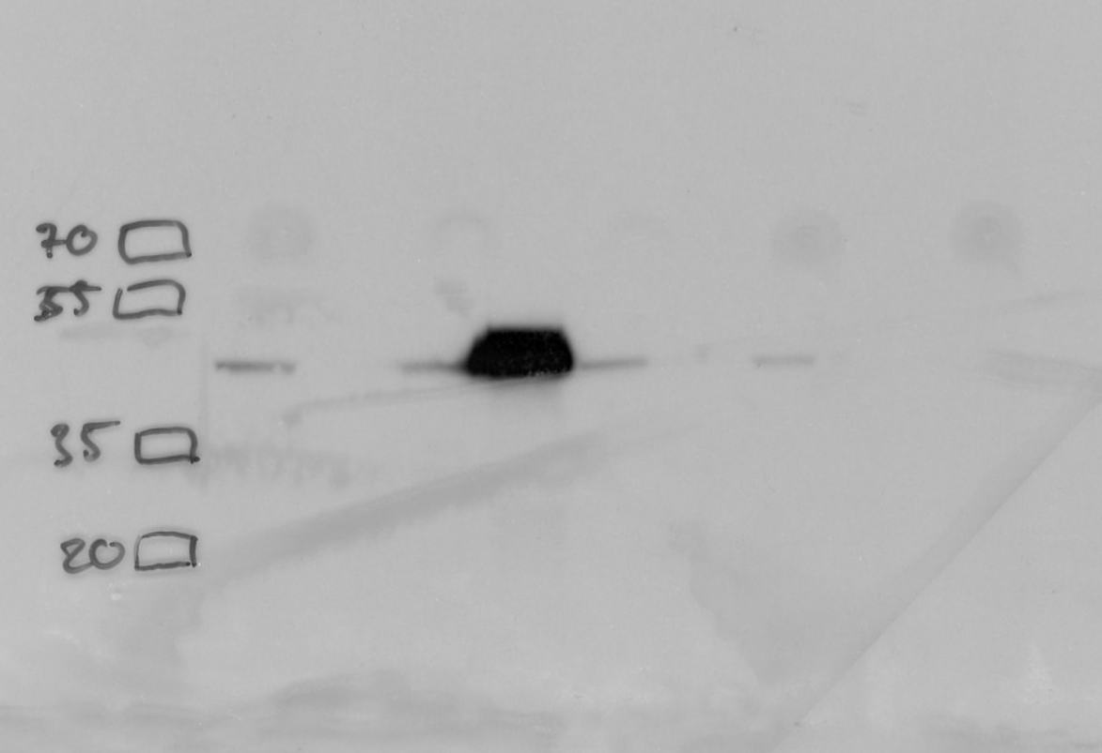
1 2 3 4 5 6 7 8
c-JUN [SKMEL23]
1 2 3 4 5 6 7 8
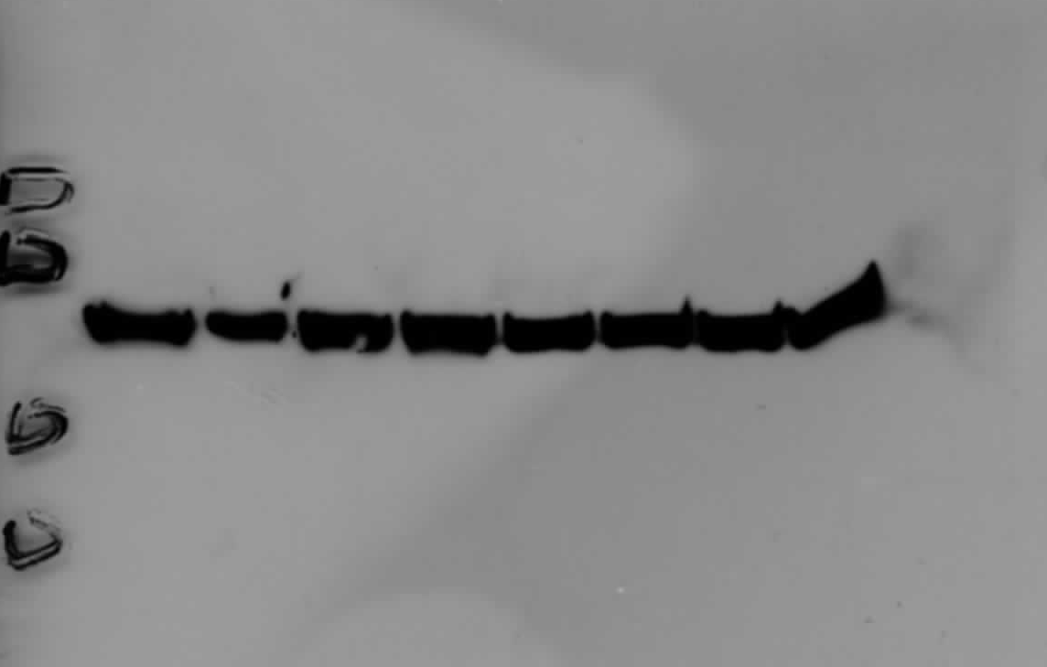
beta-Actin [SKMEL23]
Lanes: 1-8 in Figure 5A
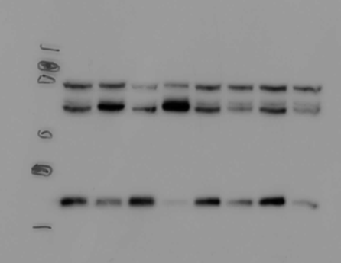
1 2 3 4 5 6 7 8
phospho-JNK [SKMEL113]
1 2 3 4 5 6 7 8
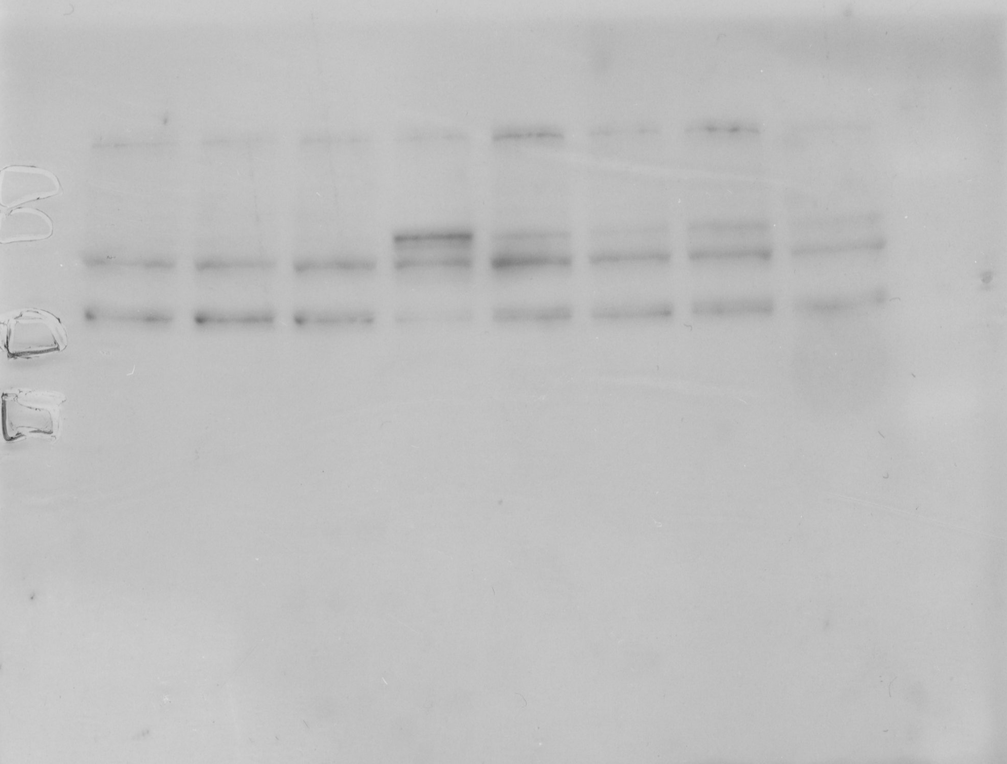
total-JNK [SKMEL113]
1 2 3 4 5 6 7 8
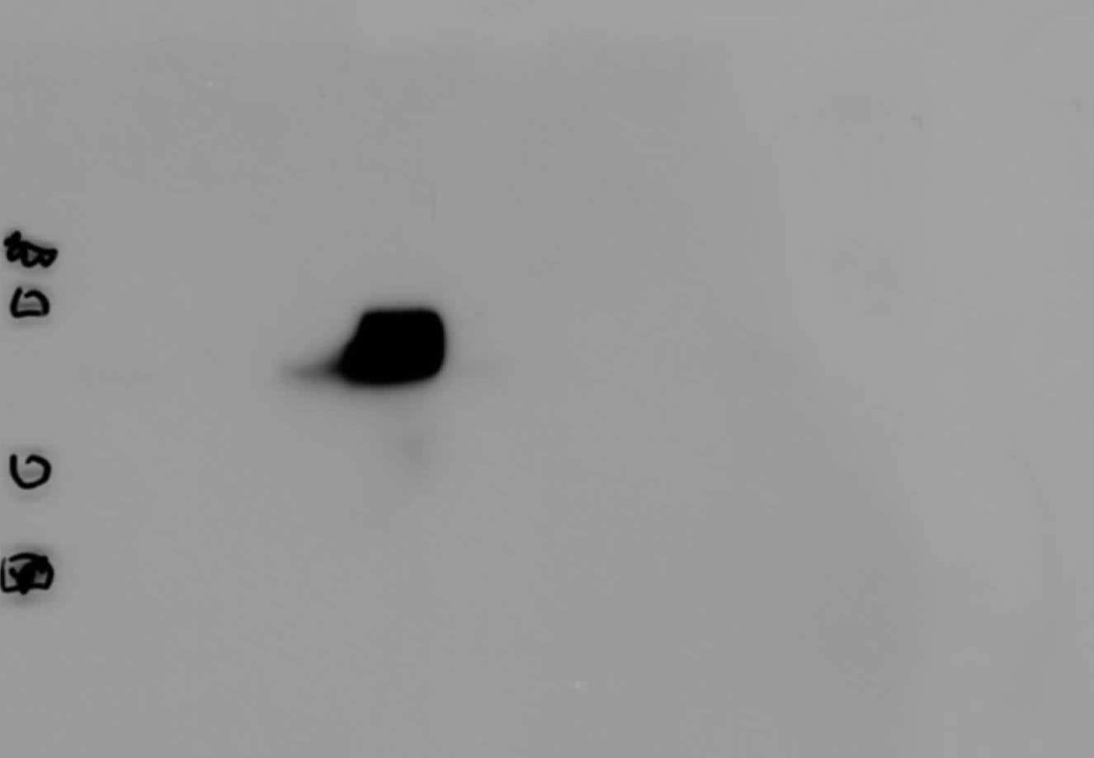
c-JUN [SKMEL113]
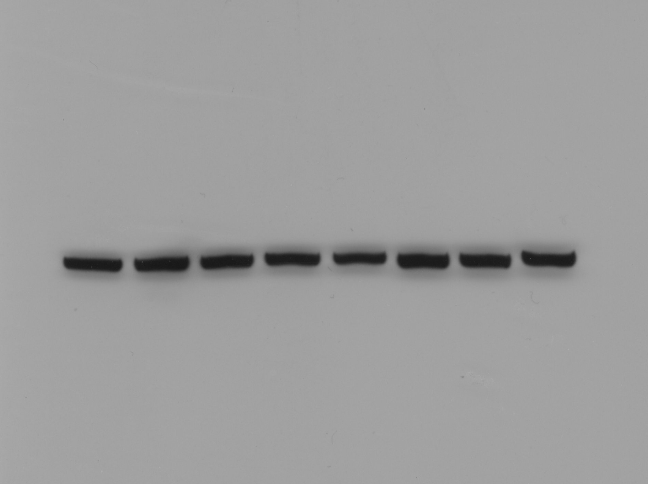
1 2 3 4 5 6 7 8
beta-Actin [SKMEL113]

