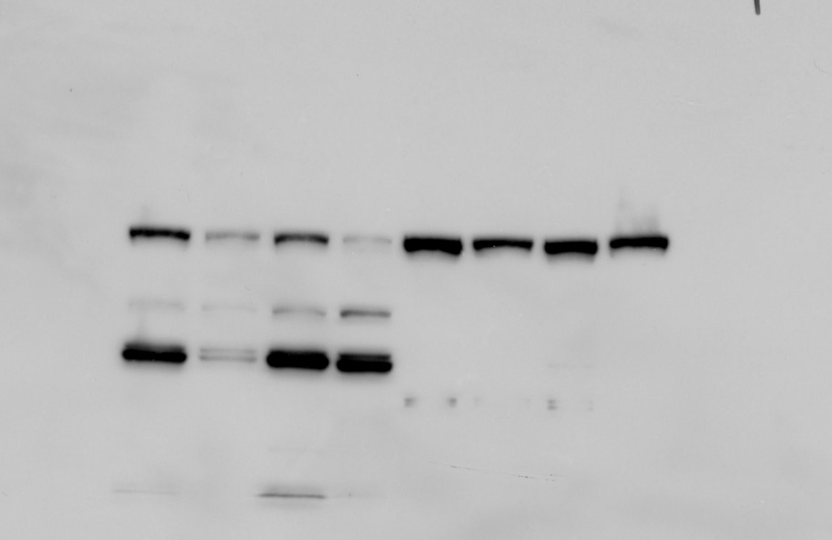
1 2 3 4 5 6 7 8
phospho-MEK1/2
1 2 3 4 5 6 7 8
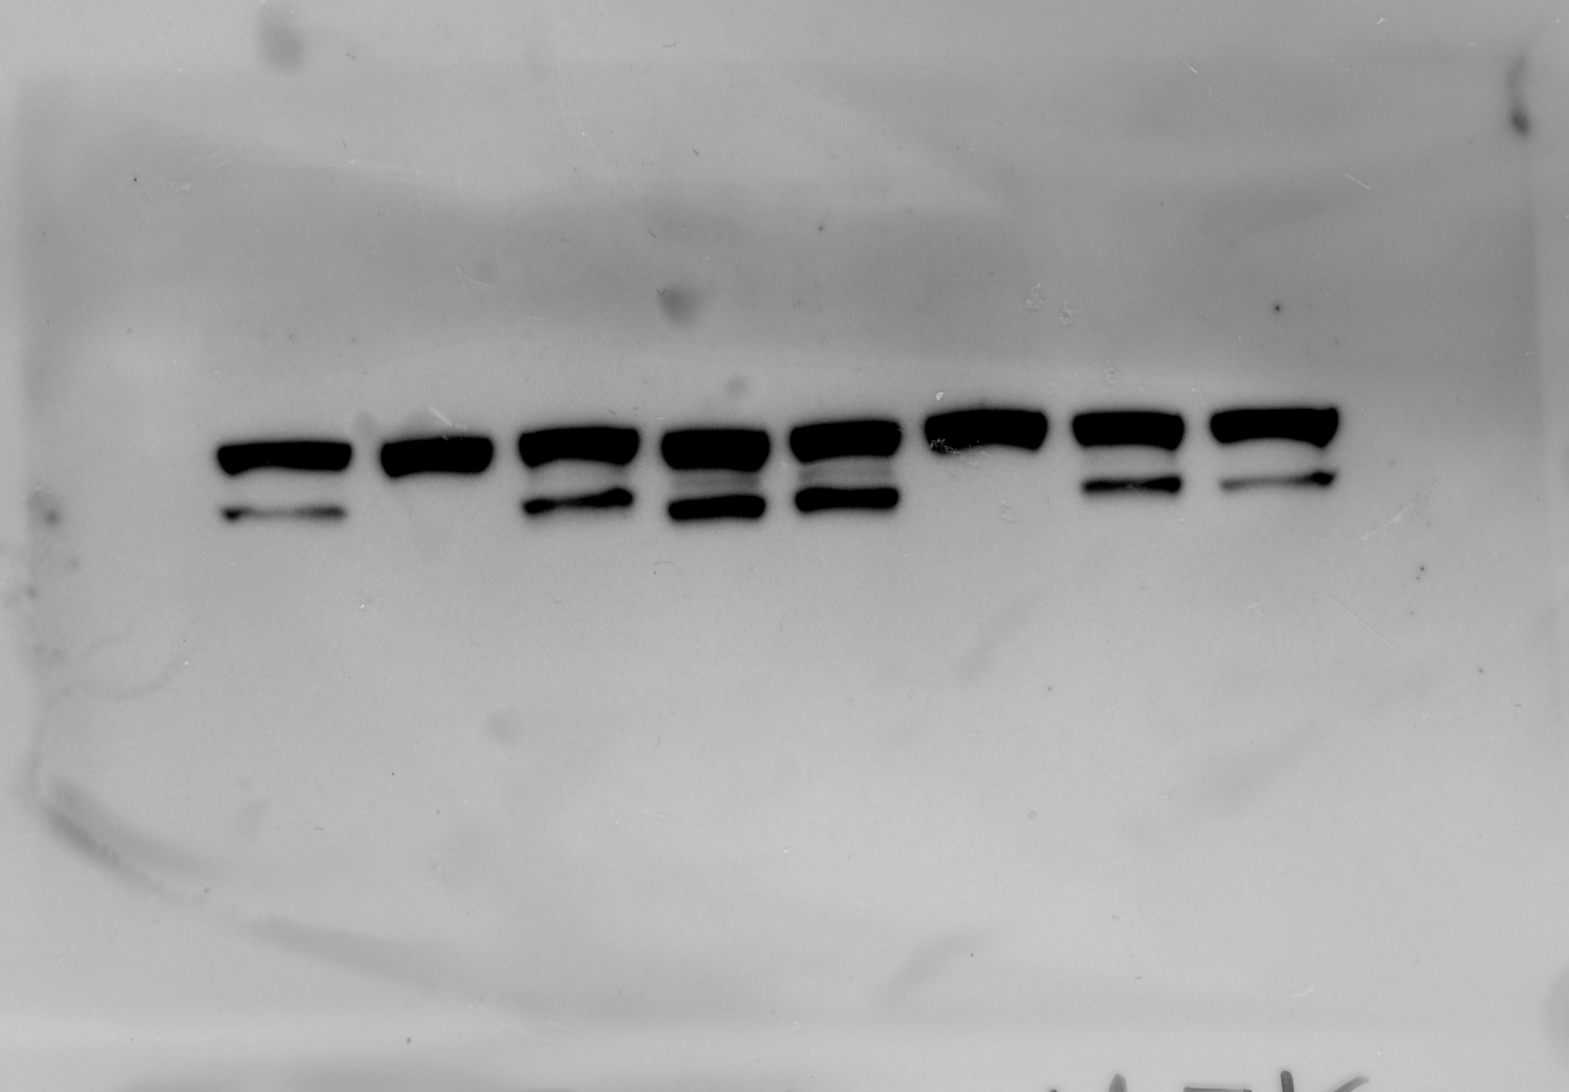
MEK1/2
1 2 3 4 5 6 7 8
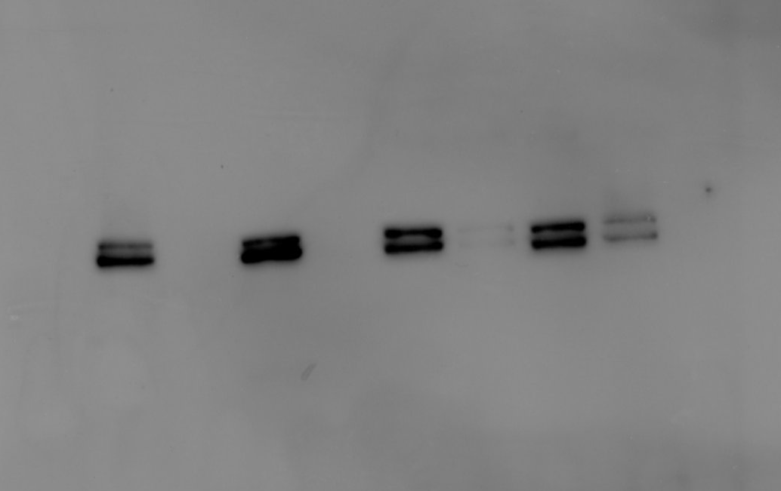
phospho-ERK1/2

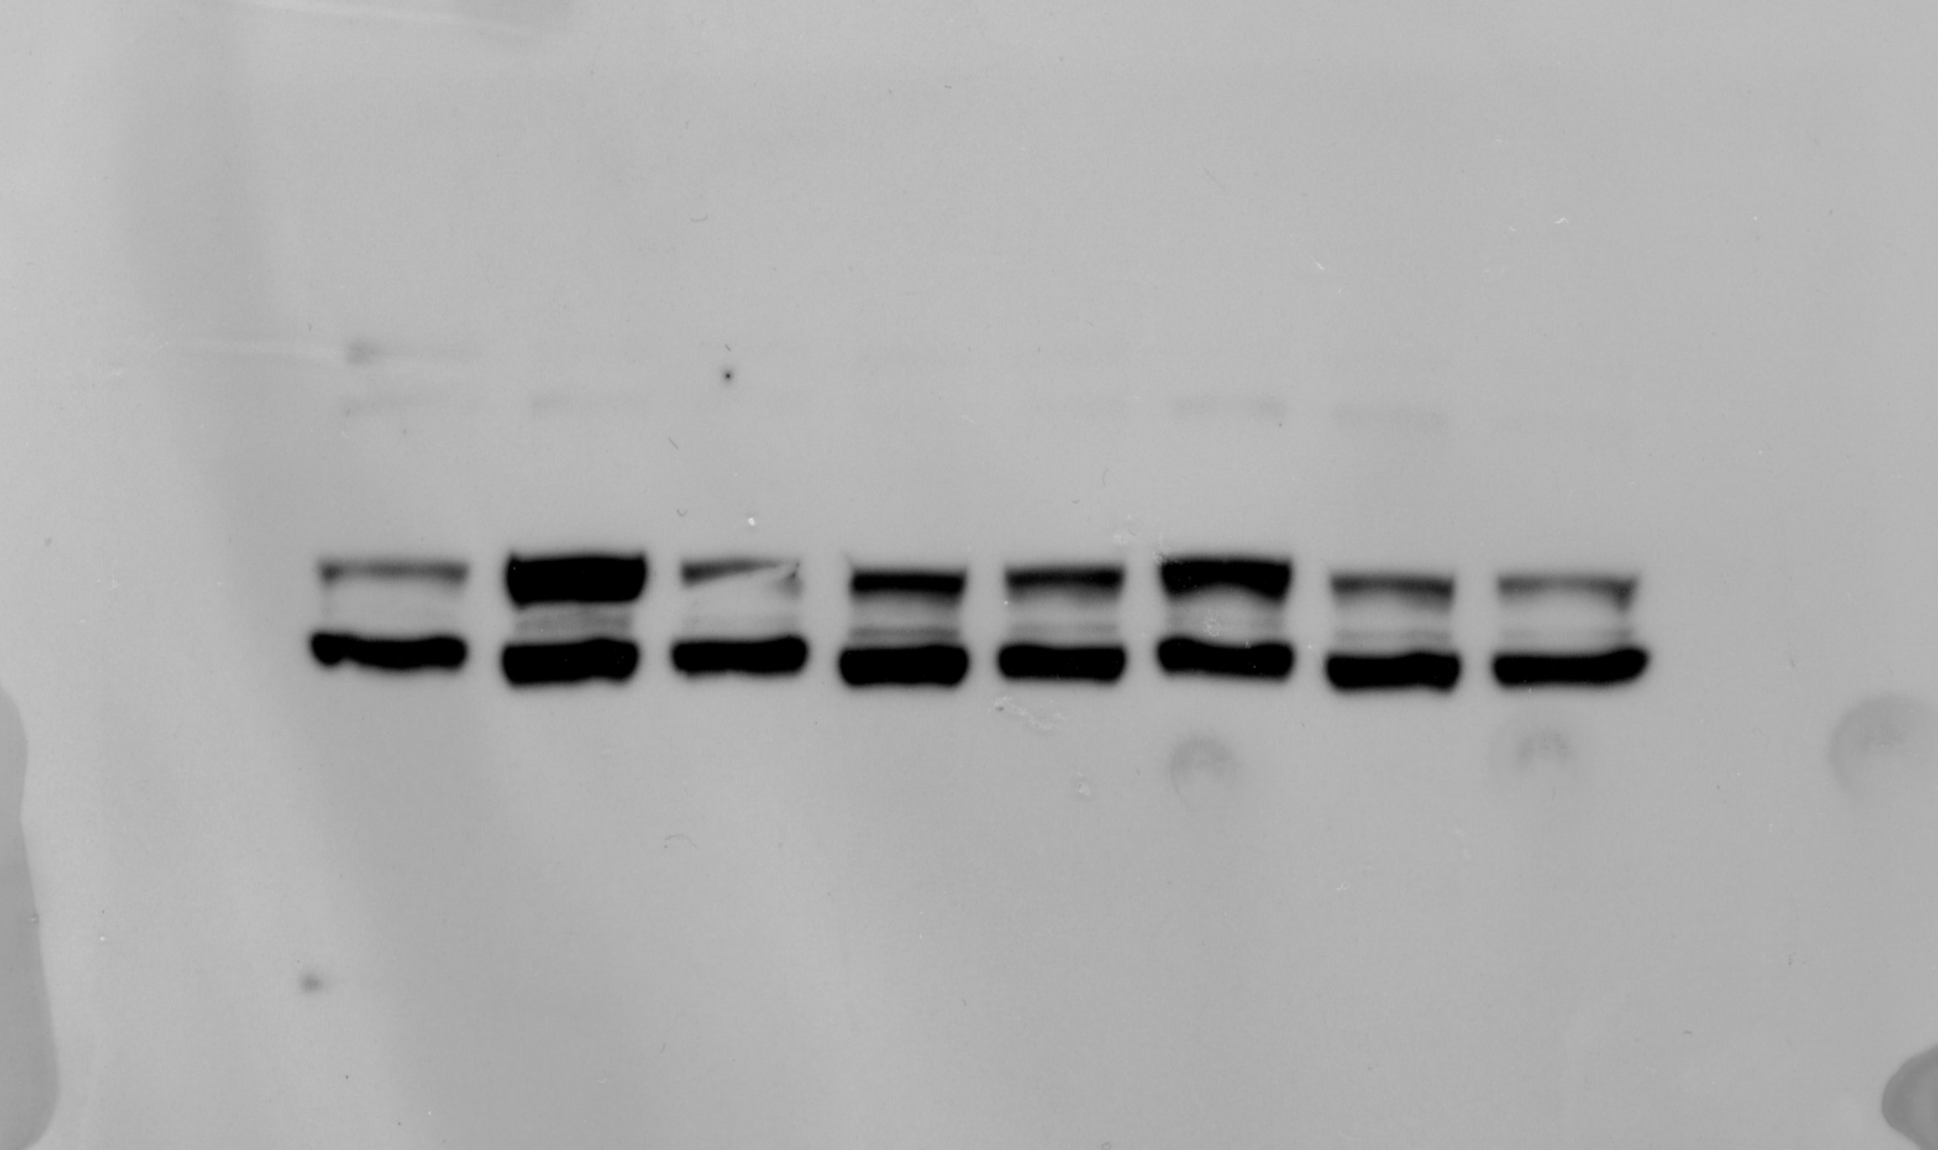
1 2 3 4 5 6 7 8

ERK1/2
1 2 3 4 5 6 7 8
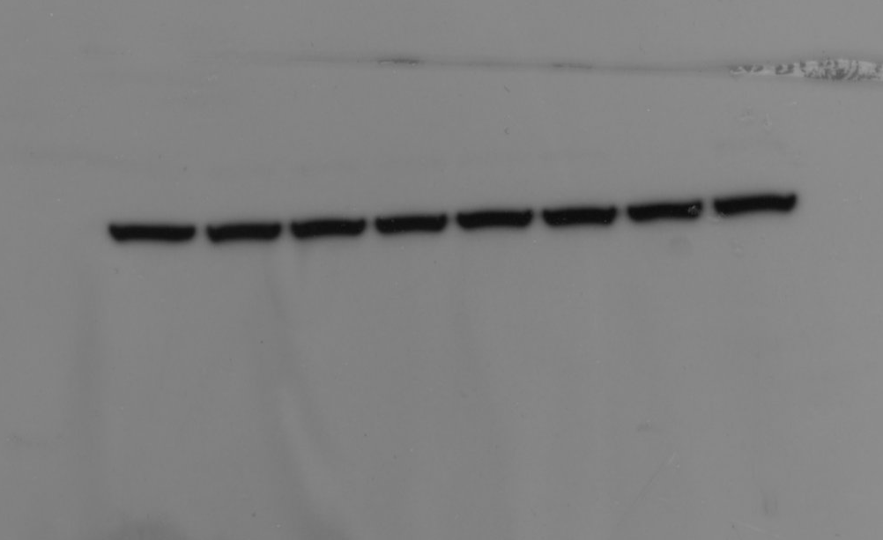
beta-Actin

Lanes:
1-8: Figure 2A

