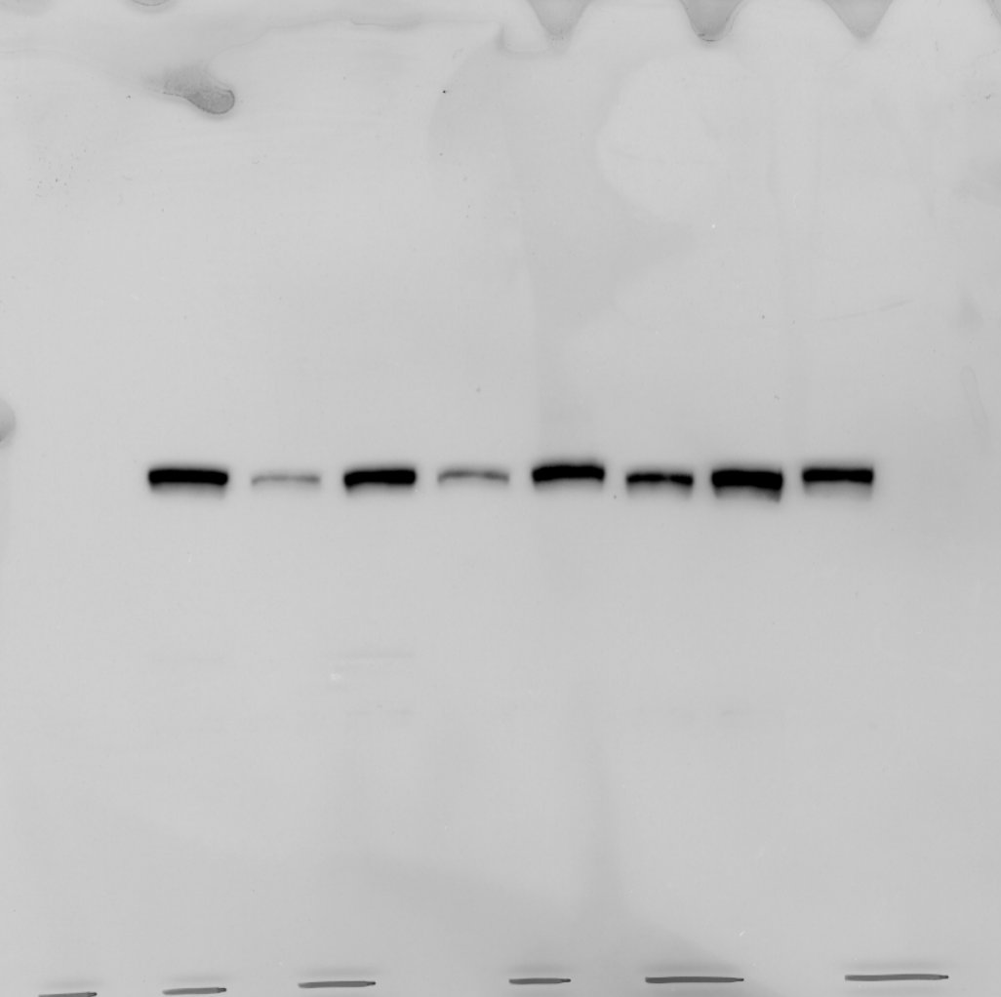
1 2 3 4 5 6 7 8
phospho-MEK1/2
1 2 3 4 5 6 7 8
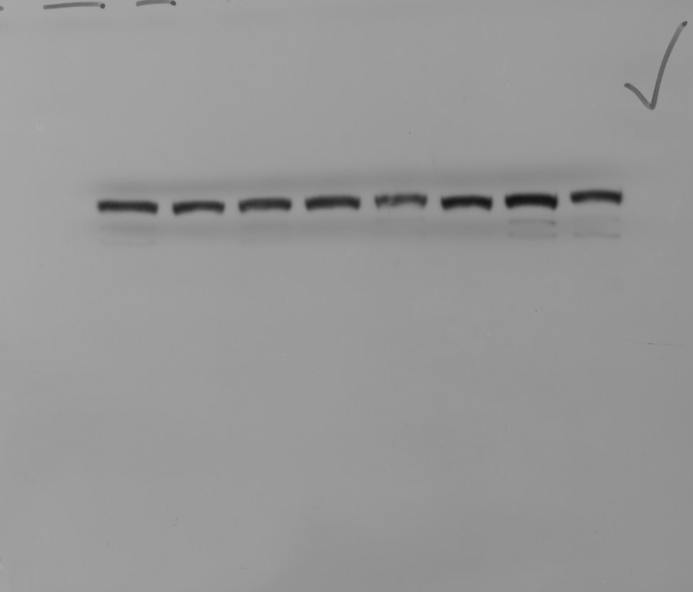
total MEK1/2
1 2 3 4 5 6 7 8
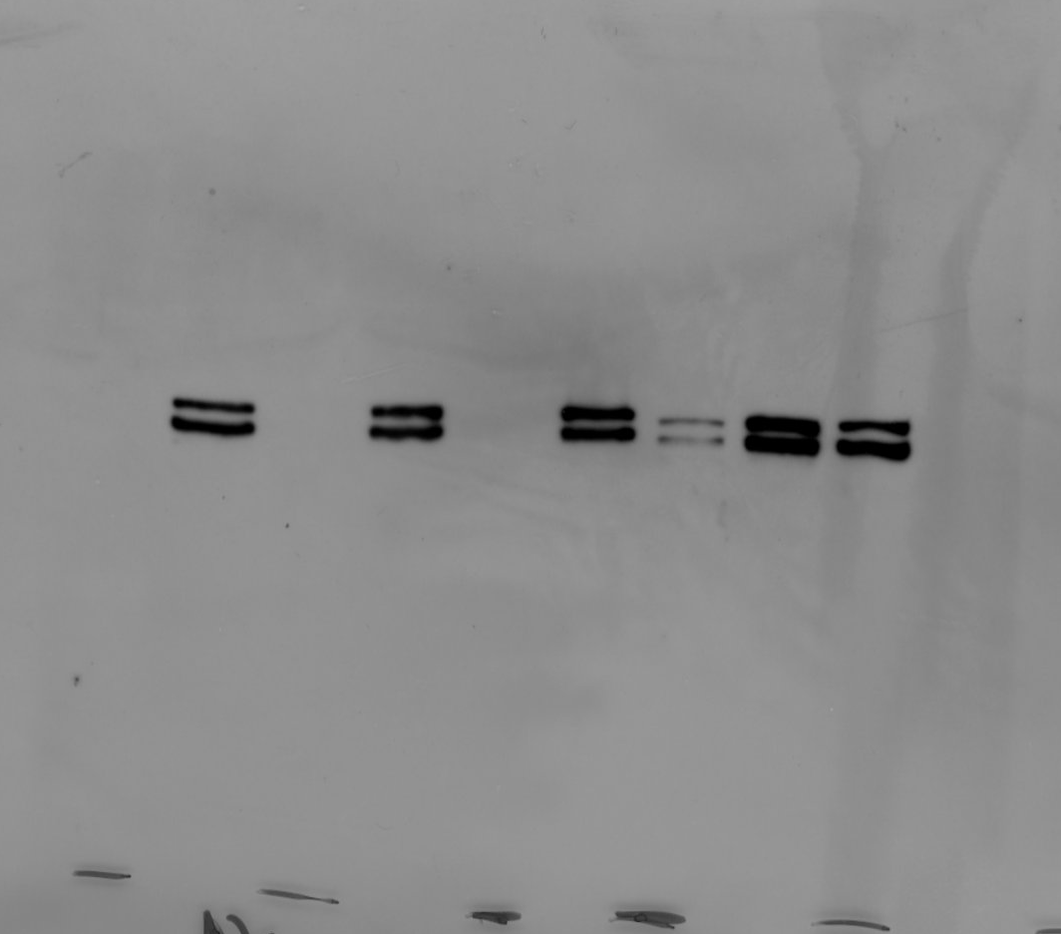
phospho-ERK1/2
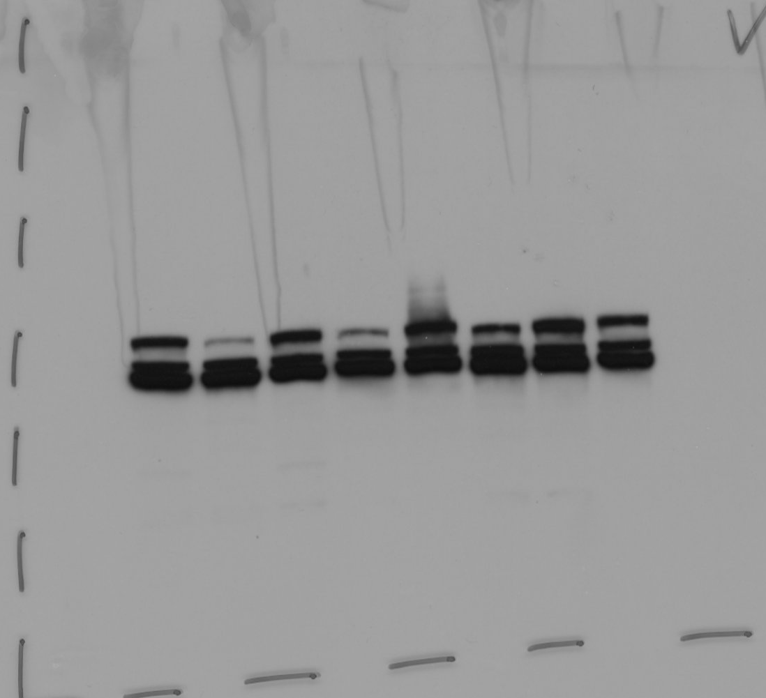
1 2 3 4 5 6 7 8
Total ERK1/2
1 2 3 4 5 6 7 8
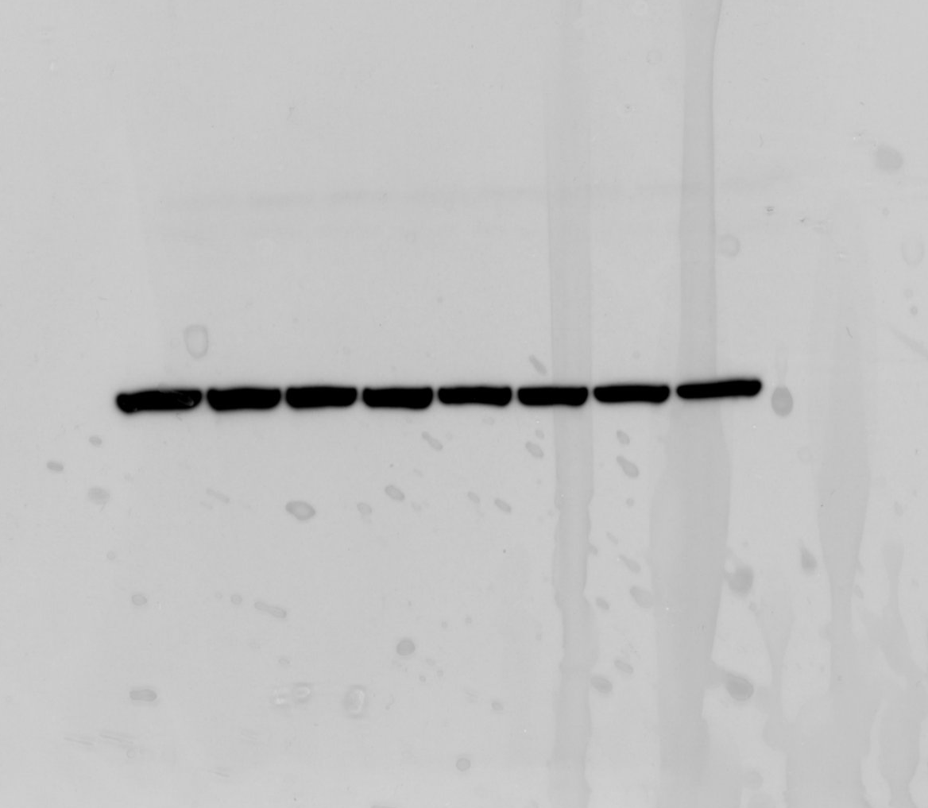
beta-Actin

Lanes:
1-4: Figure 1B
5-8: not in the manuscript (SKMEL23; CRISPR/Cas9 NF1 knockouts)
1,3,5,7: untreated
2,4,6,8: 10 nM Trametinib

