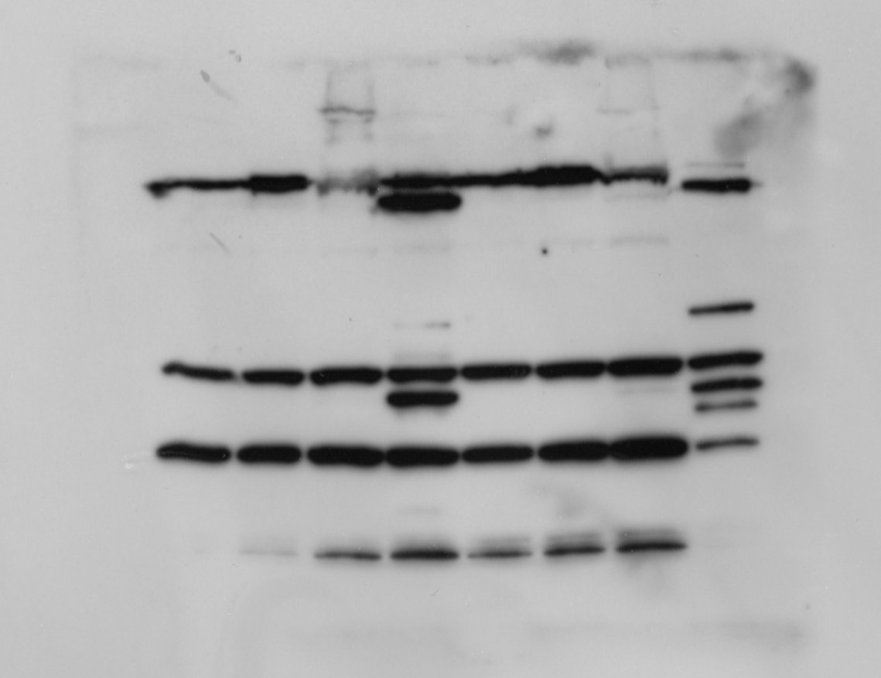
1 2 3 4 5 6 7 8
PARP [SKMEL23]
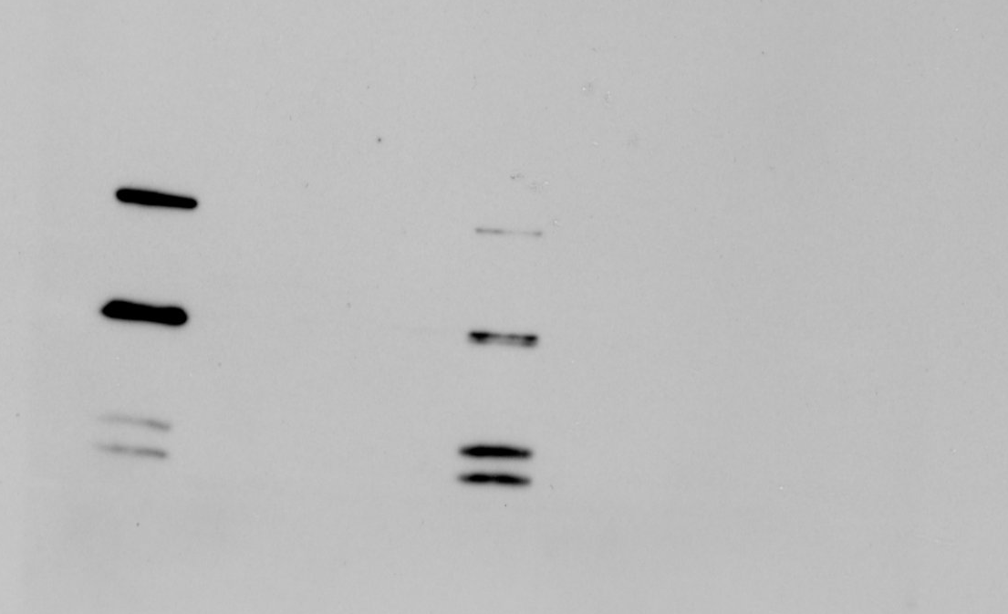
1 2 3 4 5 6 7 8
cleaved Caspase-3 [SKMEL23]
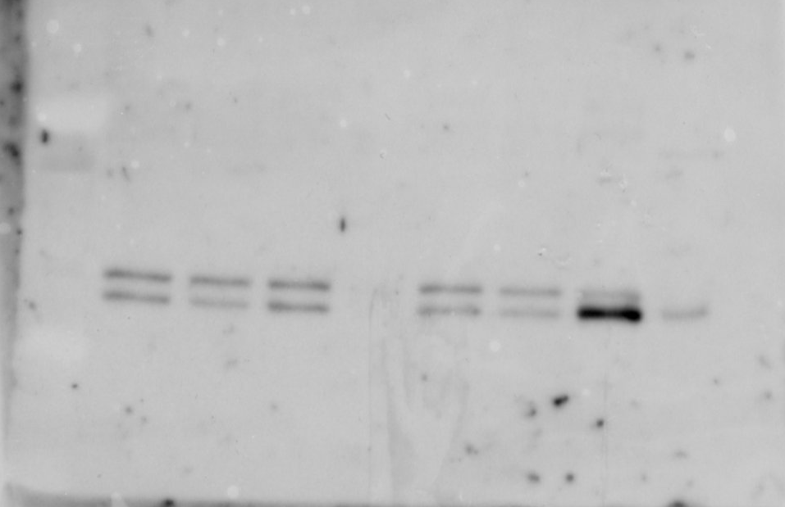
1 2 3 4 5 6 7 8
Caspase-3 [SKMEL23]
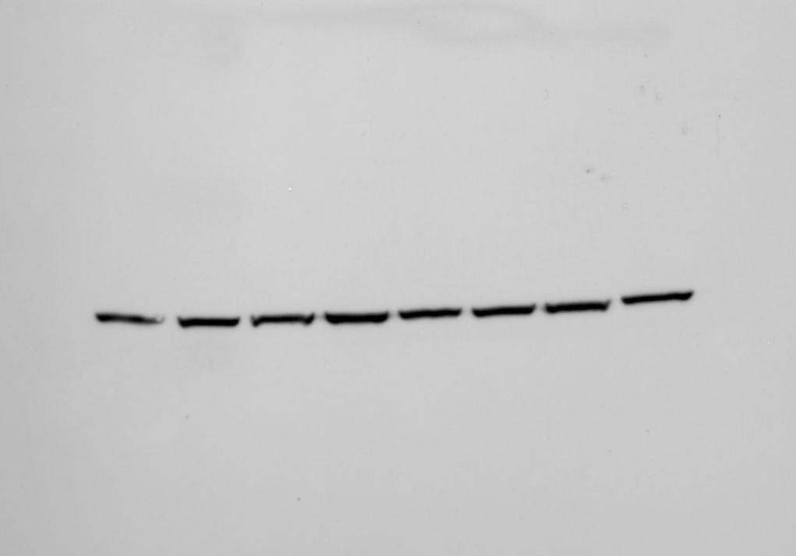
1 2 3 4 5 6 7 8
beta-Actin [SKMEL23]

Lanes: all lanes in Figure 3C
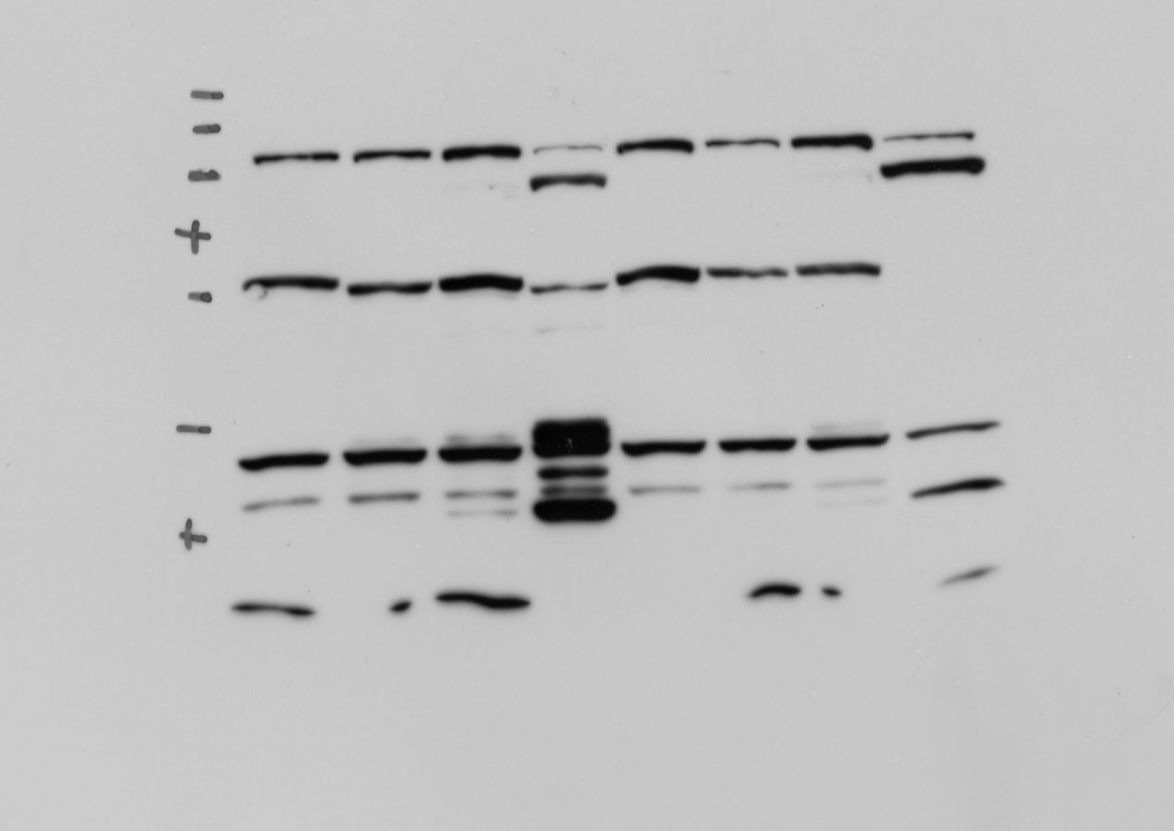
1 2 3 4 5 6 7 8
PARP [SKMEL113]
1 2 3 4 5 6 7 8
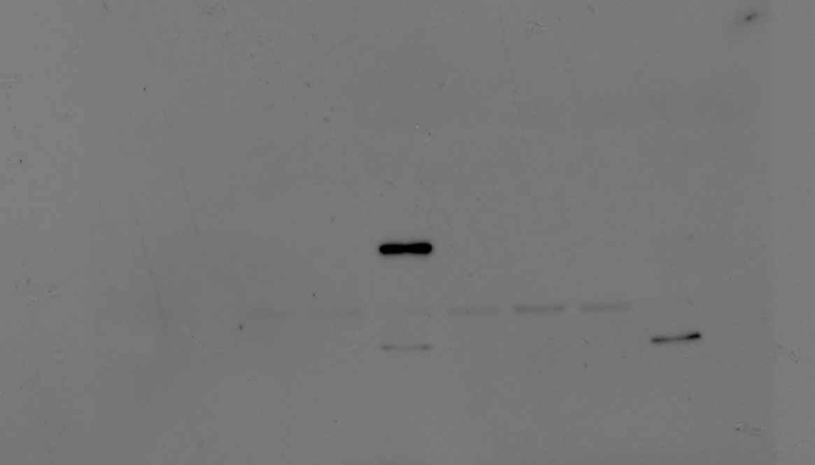
cleaved Caspase-3 [SKMEL113]
1 2 3 4 5 6 7 8
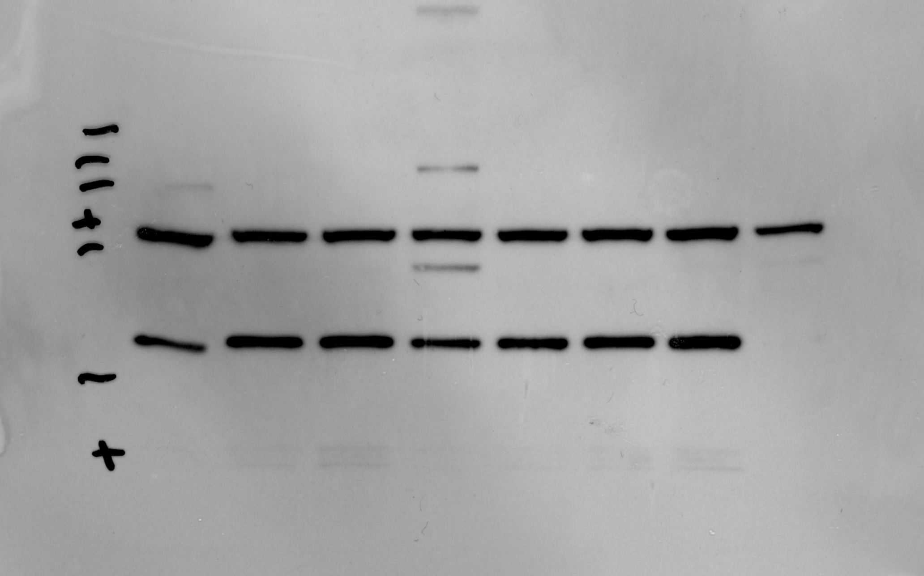
Caspase-3 [SKMEL113]
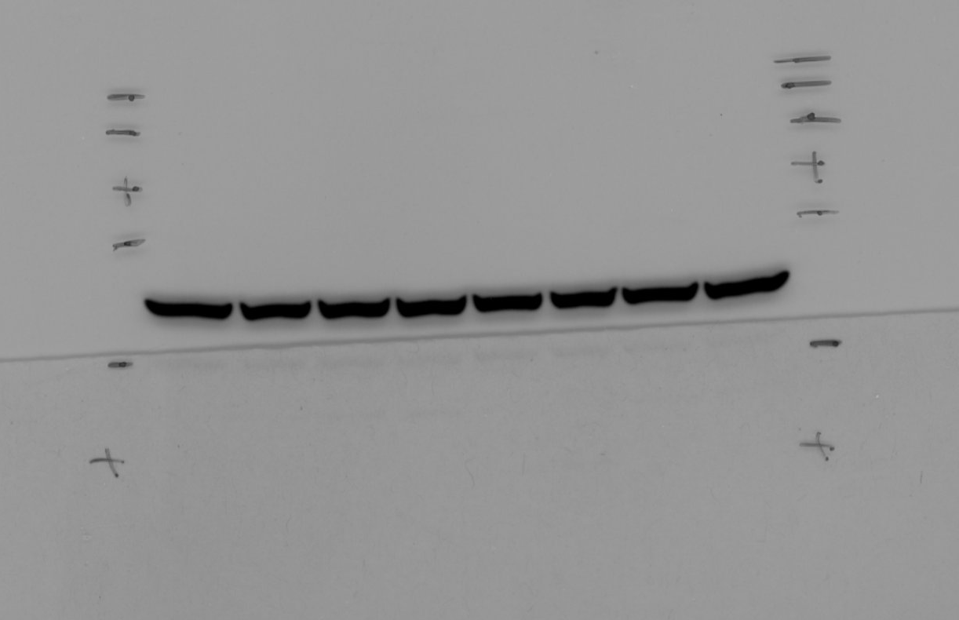
1 2 3 4 5 6 7 8
beta-Actin [SKMEL113]

