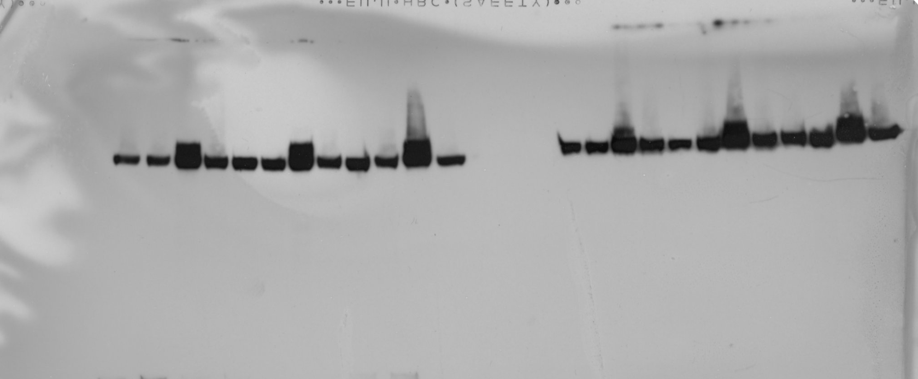
1 2 3 4 5 6 7 8 9 10 11 12
1 2 3 4 5 6 7 8 9 10 11 12
c-JUN (SKMEL23)

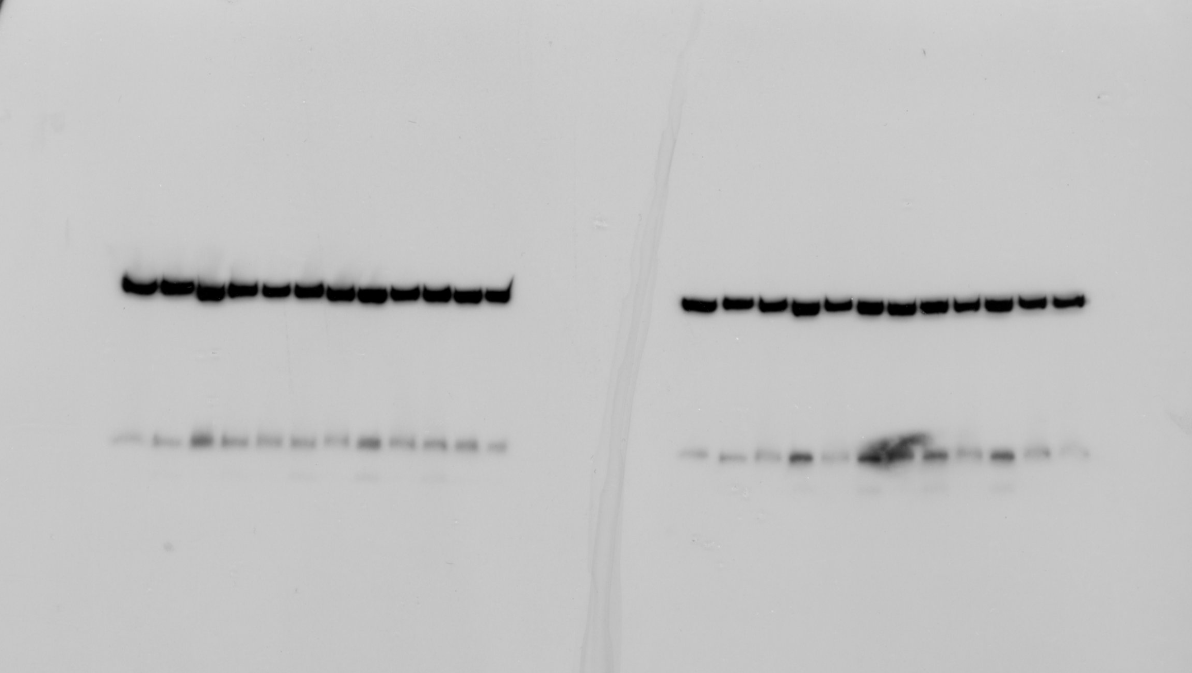
1 2 3 4 5 6 7 8 9 10 11 12
beta-Actin [+ c-JUN] (SKMEL23)

Lanes:
1-4: not in manuscript; [1: untreated, 2: Combi, 3: JNKi, 4: Combi + JNKi]
5-8: Figure 4E; [5: untreated, 6: Combi, 7: NAC, 8: Combi + NAC]
9-12: Figure 5C [9: untreated, 10: Combi, 11: TTM, 12: Combi + TTM]

c-JUN (SKMEL113)

1 2 3 4 5 6 7 8 9 10 11 12
beta-Actin [+ c-JUN] (SKMEL113)

