Supplementary material
Mitogenomic characterization of South African leopards (Panthera pardus) and the effect of past climatic events

Table S1. Complete mitochondrial genomes from the NCBI Genbank database used during this study.
Accession number | Location | Subspecies | Reference
Mpu1 | South Africa (SA) | P. p. pardus | This study
upon acceptance | -25.565, 25.565
Mpu2 | South Africa (CA) | P. p. pardus | This study
upon acceptance | -24.717, 30.411
Kru1 | South Africa (CA) | P. p. pardus | This study
upon acceptance | -25.447, 31.561
Kru2 | South Africa (CA) | P. p. pardus | This study
upon acceptance | -25.002, 31.582
Lp47 | South Africa (CA) | P. p. pardus | This study
upon acceptance | -25.565, 25.565
Pri | South Africa (CA) | P. p. pardus | This study
upon acceptance | -26.894, 30.838
MH588618 | Algeria | P. p. pardus | Paijmans et al., 2018
MH588619 | South Africa | P. p. pardus | Paijmans et al., 2018
MH588624 | Kenya | P. p. pardus | Paijmans et al., 2018
MH588625 | Kenya | P. p. pardus | Paijmans et al., 2018
MH588626 | Burundi | P. p. pardus | Paijmans et al., 2018
MH588629 | DRC | P. p. pardus | Paijmans et al., 2018
MH588630 | Zambia | P. p. pardus | Paijmans et al., 2018
MH588631 | Nigeria | P. p. pardus | Paijmans et al., 2018
MH588632 | Tanzania | P. p. pardus | Paijmans et al., 2018
MK043027 | Amur region | P. p. orientalis | Kim et al., 2018
KP001507 | Amur region | P. p. orientalis | Bertola et al., 2016
KX655614 | Amur | P. p. orientalis | Han et al., 2016
KJ866876 | Northern China | P. p. japonensis | Dou et al., 2014
NC010641* | China | P. p. japonensis | Wei et al., 2011
KP202265 | China | P. p. japonensis | Li et al., 2015
EF551002 | China | P. p. japonensis | Wei et al., 2011
MG932393 | China | unknown | Ren & Su, 2018
NC028302 | Africa | P. leo | Li et al., 2015
NC010642 | Asia | P. tigris | Wei et al., 2011
* Reference genome
Table S2. Cytochrome-B samples and Genbank sequences used for this study.
Location | Accession no. | Sample no. | Source | Clade
Mpumalanga |  | Kru1 | This study | Central
Mpumalanga |  | Kru2 | This study | Central
Mpumalanga |  | Mpu1 | This study | Southern
Mpumalanga |  | Mpu2 | This study | Central
Mpumalanga |  | Pri | This study | Central
Mpumalanga |  | Lp47 | This study | Central
Mpumalanga | n.a. | Lp48 | This study | Central
Waterberg | n.a. | 55 | Tensen et al. (2014) | Central
Waterberg | n.a. | 57 | Tensen et al. (2014) | Central
Waterberg | n.a. | 59 | Tensen et al. (2014) | Central
Waterberg | n.a. | 60 | Tensen et al. (2014) | Central
Waterberg | n.a. | 62 | Tensen et al. (2014) | Central
Waterberg | n.a. | 63 | Tensen et al. (2014) | Central
Waterberg | n.a. | 64 | Tensen et al. (2014) | Central
Waterberg | n.a. | 66 | Tensen et al. (2014) | Central
Waterberg | n.a. | 68 | Tensen et al. (2014) | Central
Waterberg | n.a. | 69 | Tensen et al. (2014) | Central
Waterberg | n.a. | 71 | Tensen et al. (2014) | Central
Waterberg | n.a. | 72 | Tensen et al. (2014) | Central
Waterberg | n.a. | 73 | Tensen et al. (2014) | Central
Waterberg | n.a. | 74 | Tensen et al. (2014) | Central
Waterberg | n.a. | 75 | Tensen et al. (2014) | Central
Mpumalanga | n.a. | Lp1 | Tensen et al. (2022) | Southern
Mpumalanga | n.a. | Lp3 | Tensen et al. (2022) | Central
Mpumalanga | n.a. | Lp6 | Tensen et al. (2022) | Central
Mpumalanga | n.a. | Lp10 | Tensen et al. (2022) | Central
Mpumalanga | n.a. | Lp17 | Tensen et al. (2022) | Central
Mpumalanga | n.a. | Lp25 | Tensen et al. (2022) | Central
Mpumalanga | n.a. | Lp26 | Tensen et al. (2022) | Central
Mpumalanga | n.a. | Lp28 | Tensen et al. (2022) | Central
Mpumalanga | n.a. | Lp33 | Tensen et al. (2022) | Southern
Mpumalanga | n.a. | Lp35 | Tensen et al. (2022) | Central
Mpumalanga | n.a. | Lp36 | Tensen et al. (2022) | Central
Mpumalanga | n.a. | Lp39 | Tensen et al. (2022) | Southern
Mpumalanga | n.a. | Lp40 | Tensen et al. (2022) | Central
Mozambique | JF720057 | Leo1 | Ropiquet et al. (2015) | Central
Mozambique | JF720058 | Leo2 | Ropiquet et al. (2015) | Central
Mozambique | JF720059 | Leo3 | Ropiquet et al. (2015) | Central
Mozambique | JF720060 | Leo4 | Ropiquet et al. (2015) | Central
Mozambique | JF720066 | Leo10 | Ropiquet et al. (2015) | Central
Kruger NP | JF720103 | Leo54 | Ropiquet et al. (2015) | Central
Eastern Cape | JF720112 | Leo66 | Ropiquet et al. (2015) | Southern
Mozambique | JF720125 | Leo82 | Ropiquet et al. (2015) | Central
Kruger NP | JF720130 | Leo41 | Ropiquet et al. (2015) | Central
Kruger NP | JF720131 | Leo42 | Ropiquet et al. (2015) | Central
Mozambique | JF720133 | Leo95 | Ropiquet et al. (2015) | Southern
Kruger NP | JF720136 | Leo54 | Ropiquet et al. (2015) | Central
Kruger NP | JF720140 | Leo55 | Ropiquet et al. (2015) | Central
Kruger NP | JF720155 | Leo56 | Ropiquet et al. (2015) | Southern
Kruger NP | JF720157 | Leo102 | Ropiquet et al. (2015) | Southern
Kruger NP | JF720161 | Leo104 | Ropiquet et al. (2015) | Southern
Kruger NP | JF720163 | Leo105 | Ropiquet et al. (2015) | Southern
Kruger NP | JF720178 | Leo106 | Ropiquet et al. (2015) | Southern
Mozambique | JF720179 | Leo157 | Ropiquet et al. (2015) | Southern
KZN | JF720181 | Leo159 | Ropiquet et al. (2015) | Southern
Eastern Cape | JF720185 | Leo167 | Ropiquet et al. (2015) | Southern
n.a. = not applicable. KZN = Kwazulu-Natal (province).
Table S3. NADH-5 samples and Genbank sequences used for this study.
Location | Sample no. | Haplotype | Source | Clade
Mpumalanga | Kru1 | n.a. | This study | Central
Mpumalanga | Kru2 | n.a. | This study | Central
Mpumalanga | Mpu1 | n.a. | This study | Southern
Mpumalanga | Mpu2 | n.a. | This study | Central
Mpumalanga | Pri | n.a. | This study | Central
Mpumalanga | Lp47 | n.a. | This study | Central
Waterberg | 54 | n.a. | Tensen et al. (2014) | Central
Waterberg | 55 | n.a. | Tensen et al. (2014) | Central
Waterberg | 57 | n.a. | Tensen et al. (2014) | Central
Waterberg | 60 | n.a. | Tensen et al. (2014) | Central
Waterberg | 63 | n.a. | Tensen et al. (2014) | Central
Waterberg | 65 | n.a. | Tensen et al. (2014) | Central
Waterberg | 68 | n.a. | Tensen et al. (2014) | Central
Waterberg | 72 | n.a. | Tensen et al. (2014) | Central
Waterberg | 74 | n.a. | Tensen et al. (2014) | Central
Waterberg | 75 | n.a. | Tensen et al. (2014) | Central
Waterberg | 76 | n.a. | Tensen et al. (2014) | Central
Mpumalanga | Leo1 | JF720187 | Ropiquet et al. (2015) | Southern
Kruger NP | Leo42 | JF720224 | Ropiquet et al. (2015) | Southern
Western Cape | Leo49 | JF720229 | Ropiquet et al. (2015) | Southern
Western Cape | Leo54 | JF720234 | Ropiquet et al. (2015) | Southern
Western Cape | Leo57 | JF720237 | Ropiquet et al. (2015) | Southern
Western Cape | Leo65 | JF720242 | Ropiquet et al. (2015) | Southern
Mozambique | Leo88 | JF720259 | Ropiquet et al. (2015) | Central
Mozambique | Leo95 | JF720264 | Ropiquet et al. (2015) | Southern
Mozambique | Leo98 | JF720266 | Ropiquet et al. (2015) | Central
Mozambique | Leo99 | JF720267 | Ropiquet et al. (2015) | Central
Mozambique | Leo96 | JF720268 | Ropiquet et al. (2015) | Central
Kruger NP | Leo101 | JF720269 | Ropiquet et al. (2015) | Central
Kruger NP | Leo105 | JF720273 | Ropiquet et al. (2015) | Central
Kruger NP | Leo106 | JF720274 | Ropiquet et al. (2015) | Central
KZN | Leo124 | JF720279 | Ropiquet et al. (2015) | Southern
KZN | Leo157 | JF720312 | Ropiquet et al. (2015) | Southern
Eastern Cape | Leo167 | JF720318 | Ropiquet et al. (2015) | Southern
Namibia | H20 | KY292252 | Anco et al. (2018) | Central
Angola | H20 | KY292258 | Anco et al. (2018) | Central
Mozambique | H27 | KY292259 | Anco et al. (2018) | Southern
South Africa | H20 | KY292267 | Anco et al. (2018) | Central
n.a. = not applicable

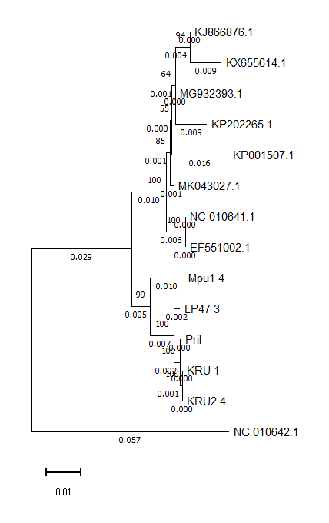
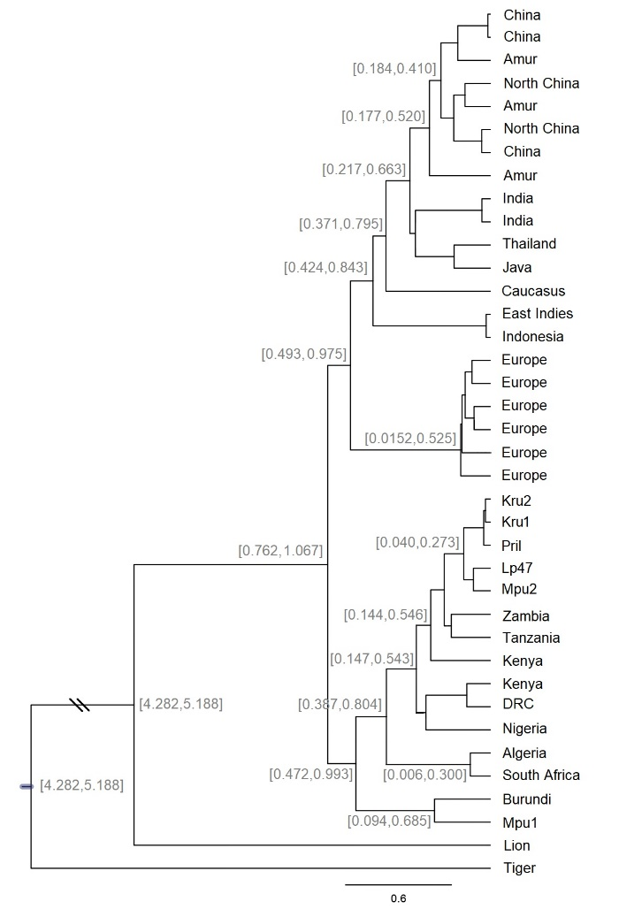
Figure S1. Phylogenetic relationships of African and Asian leopards. The trees show a consensus Maximum Likelihood (ML) phylogeny with the most common recent ancestor (MRCA) tree overlaid, inferred from a mitogenome dataset of 13 protein-coding genes. Numbers on the nodes correspond to ML divergence times measured with the Bayesian analysis method. All nodes had bootstrap values of >0.75. A. Phylogenetic tree of all available complete mitogenomes. The lion (Panthera leo) and tiger (Panthera tigris) were used as outgroup. B. Phylogenetic tree of partial mitogenomes, including ancient DNA samples from Africa.
B
A

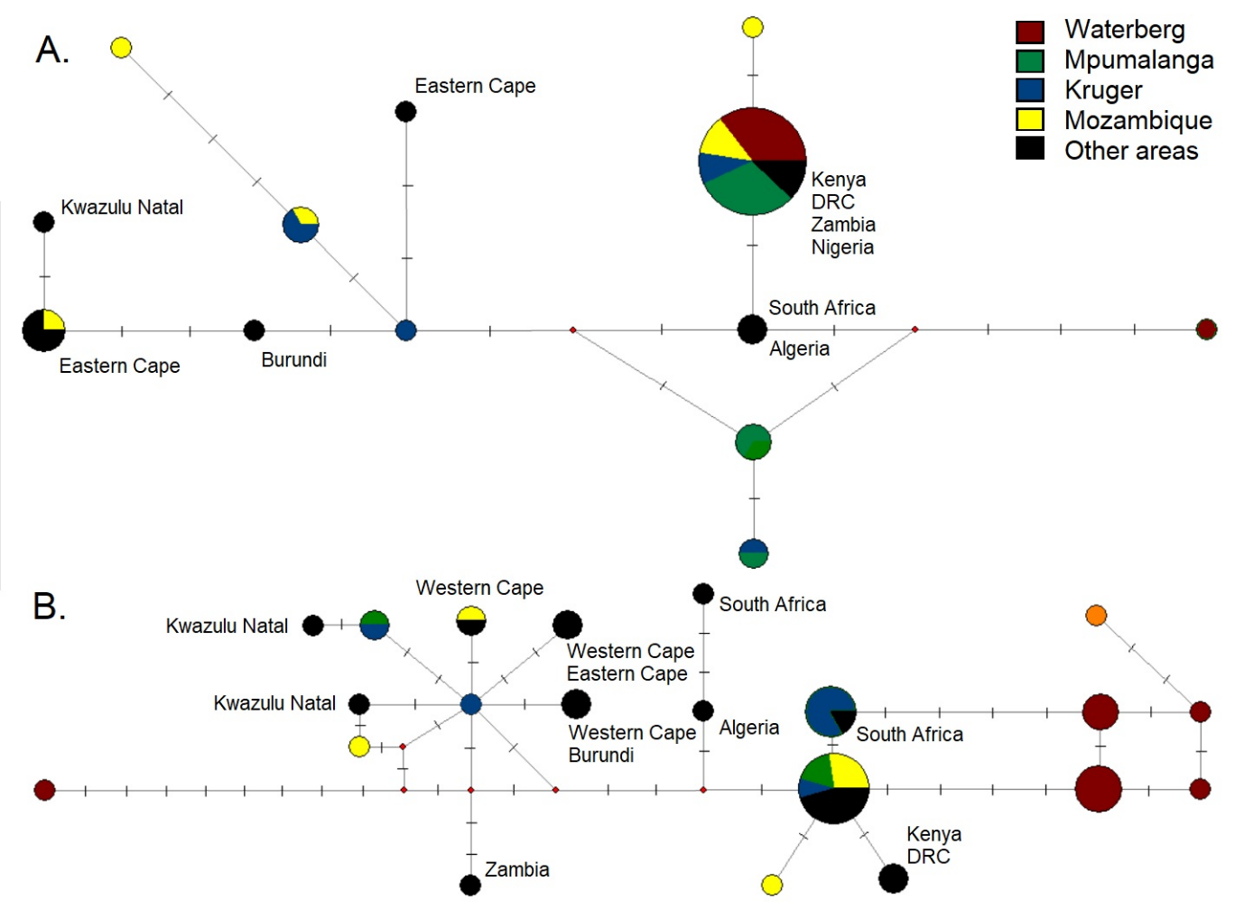
Figure S2. Median-joining haplotype networks of leopards (Panthera pardus). A. Mitochondrial Cytochrome B partial sequences (232 base pairs), including 16 leopards from the Waterberg region in South Africa. B. Mitochondrial NADH 5 partial sequences (260 bp), including 11 leopards from the Waterberg region. These sequences were made available by Tensen et al. (2014), and derived from Genbank (Anco et al., 2018; Ropiquet et al., 2015; Paijmans et al., 2018).

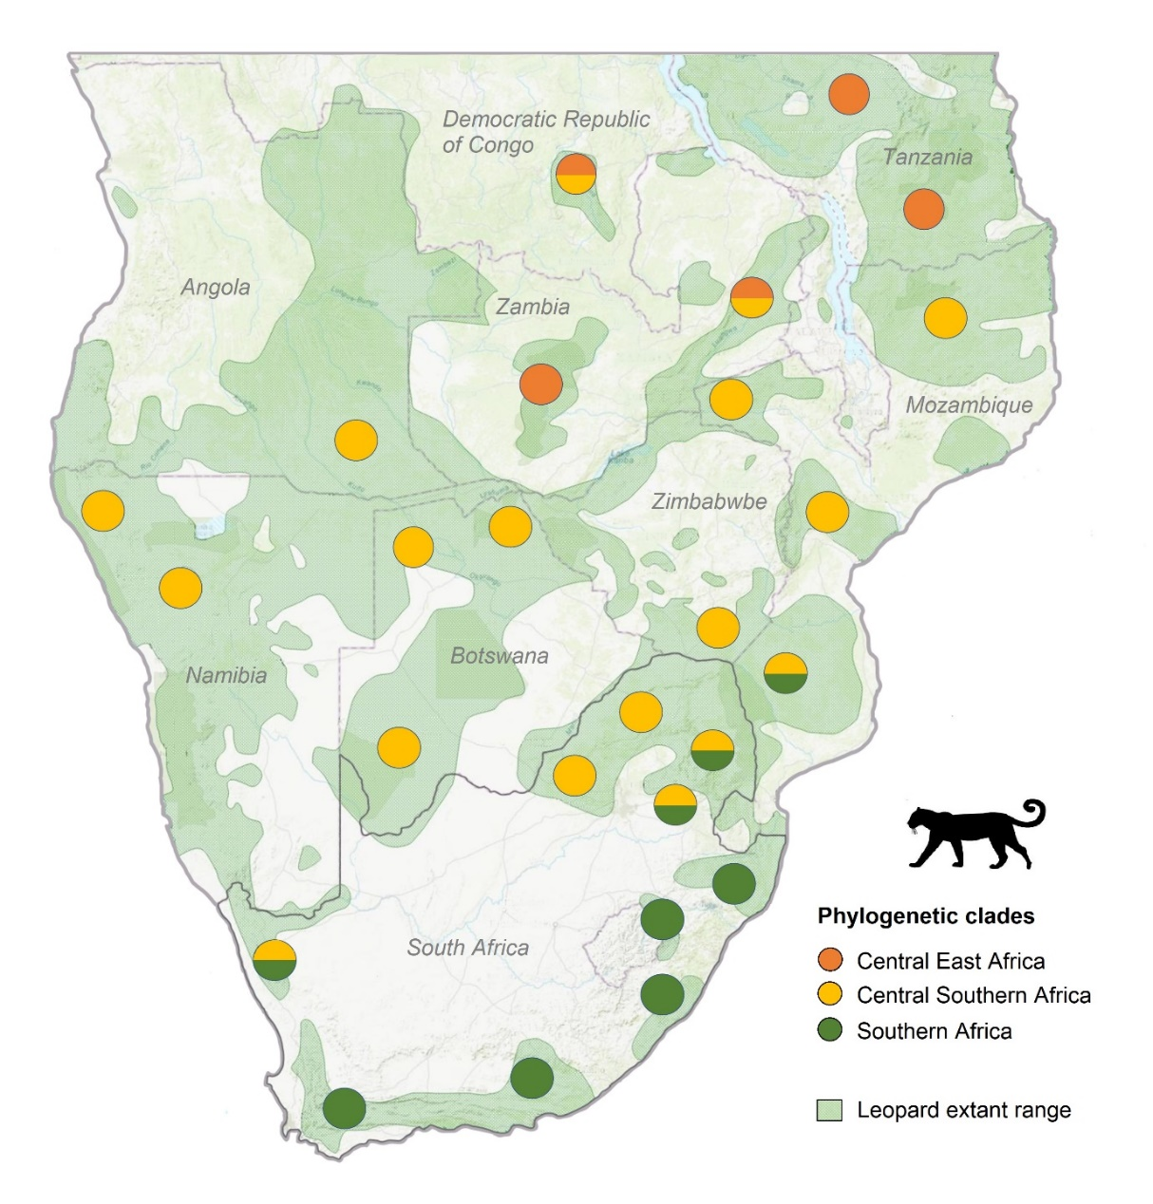
Fig S3. Map of leopard haplotypes across southern Africa. Circles indicate the sampling localities used in this study and previous studies (Tensen et al., 2014, Ropiquet et al., 2014; Anco et al., 2018). Green circles indicate the southern African (CA) haplotypes that can be found in from the Western and Eastern Cape of South Africa into Mozambique, and blue indicates the central African clusters (CA) that extends from northern South Africa far into the African continent.

References
Anco, C., Kolokotronis, S. O., Henschel, P., Cunningham, S. W., Amato, G., & Hekkala, E. (2018). Historical mitochondrial diversity in African leopards (Panthera pardus) revealed by archival museum specimens. Mitochondrial DNA Part A, 29(3), 455-473.

Bertola, L.D., Jongbloed, H., van der Gaag, K.J., de Knijff, P., Yamaguchi, N., Hooghiemstra, H., Bauer, H., Henschel, P., White, P.A., Driscoll,C.A., Tende,T., Ottosson,U., Saidu,Y., Vrieling,K. and de Iongh, H.H.(2016) Phylogeographic Patterns in Africa and High Resolution Delineation of Genetic Clades in the Lion (Panthera leo). Genbank submittion KP202265, Institute of Environmental Sciences, Leiden University, Einsteinweg 2, Leiden, Zuid Holland 2333CC, The Netherlands.

Dou, H., Feng, L., Xiao, W. and Wang, T. (2014) The complete mitochondrial genome of the North Chinese Leopard (Panthera pardus japonensis). Genbank submittion KJ866876, College of Life Science, Beijing Normal University, No. 19, Xinjiekou wai Street, Haidian District, Beijing.

Li, G., Davis, B.W., Eizirik, E. and Murphy, W.J. (2015) Pervasive signals of ancient hybridization in the genomes of living cats (Felidae). Submitted (25-NOV-2014) Department of Veterinary Integrative Biosciences, TAMU, College Station, TX 77840, USA.

Kim, J.A., Kim, S., Bhak, J., and An, J. (2018) The complete mitochondrial genome of the Amur leopard (Panthera pardus orientalis Schlegel, 1857). Genbank submission MK043027, Institute of Biological Resources, 42 Hwangyeong-ro, Seo-gu, Incheon 22689, Korea

Ropiquet, A., Knight, A. T., Born, C., Martins, Q., Balme, G., Kirkendall, L., ... & Matthee, C. A. (2015). Implications of spatial genetic patterns for conserving African leopards. Comptes Rendus Biologies, 338(11), 728-737.

Ren, Z. and Su, X.(2018) Complete mitochondrial genome of the Leopard. Genbank submission MG932393, School of Life Science, Shanxi University, No92, Wucheng Road, Taiyuan, Shanxi 030006, China

Tensen, L. (2010) Genetic diversity and gene flow of isolated populations of leopards (Panthera pardus) in South African and its implications for their conservation strategy. MSc thesis, Vrije Universiteit Amsterdam, Amsterdam.

Tensen, L., Power, J., Camacho, G., Godinho, R., Jansen van Vuuren, B., & Fischer, K. (2022). Molecular tracking and prevalence of the red colour morph restricted to a harvested leopard population in South Africa. Evolutionary Applications, 15(6), 1028-1041.

Wei, L., Wu, X., Zhu, L. and Jiang, Z.(2011) Mitogenomic analysis of the genus Panthera. Sci China Life Sci 54 (10), 917-930.

