Biochemical and structural basis of mercuric reductase, GbsMerA, from Gelidibacter salicanalis PAMC21136

Supporting Information
Index
Supplemental Table S1. Pairwise sequence identity of metal reductases
Supplemental Table S2. Primers used for site-directed mutagenesis
Supplemental Table S3. X-ray diffraction data collection and refinement statistics

Supplemental Figure S1. Purification of GbsMerA
Supplemental Figure S2. Stereo view of the FAD binding site in the GbsMerA monomer
Supplemental Figure S3. Comparison of the activity of GbsMerA with mutants

Supplemental Table S1. Pairwise sequence identity of metal reductases.
 | GbsMerA | EcRclA | MseMerA | LsMerA | Tn501
GbsMerA | 100  100
EcRclA | 28.4  48.3 | 100  100
MseMerA | 26.8  45.5 | 27.0  49.3 | 100  100
LsMerA | 24.0  37.3 | 25.8  45.3 | 32.6  49.9 | 100  100
Tn501 | 22.3  36.8 | 24.5  40.1 | 30.7  44.6 | 41.6  59.3 | 100  100

The Web-based EMBOSS Needle ¹ was used for pairwise alignment. Percentages of identity and similarity for each pair of enzymes are shown in the upper and lower halves of each box, respectively. The gap opening and gap extension penalties were set to 10 and 0.5, respectively.

Supplemental Table S2. X-ray diffraction data collection and refinement statistics.

Data set | GbsMerA with FAD | GbsMerA with FAD, NADPH
X-ray source | BL-5C beamline | BL-5C beamline
Space group | P2₁2₁2₁ | P3₁21
Unit-cell parameters (Å, °) | a = 78.19, b = 105.82, c = 126.82, α = β = γ = 90 | a = b = 102.33, c = 108.70, α = β = 90.00, γ = 120
Wavelength (Å) | 0.9794 | 0.9794
Resolution (Å) | 29.38–2.60 (2.72–2.60) | 29.57–2.39 (2.48–2.39)
Total reflections | 435,278 (55,692) | 525,372 (53,853)
Unique reflections | 33,032 (3,967) | 26,169 (2,695)
Average I/σ (I) | 15.5 (2.0) | 27.8 (2.7)
R_{merge}ª | 0.11 (1.60) | 0.09 (1.14)
Redundancy | 13.2 (14.0) | 20.1 (20.0)
Completeness (%) | 99.9 (99.9) | 99.0 (98.3)
Refinement
Resolution range (Å) | 29.38–2.60 (2.67–2.60) | 29.59–2.39 (2.45–2.39)
No. of reflections of working set | 33,022 (2,172) | 24,874 (1,785)
No. of reflections of test set | 2,000 (139) | 1,295 (94)
No. of amino acid residues | 6,904 | 3,349
No. of water molecules | 33 | 13
R_{cryst}^{b} | 0.20 (0.26) | 0.20 (0.32)
R_{free}^{c} | 0.24 (0.28) | 0.27 (0.39)
R.m.s. bond length (Å) | 0.006 | 0.007
R.m.s. bond angle (°) | 0.925 | 1.573
Average B value (Å²) (protein) | 85.09 | 57.64
Average B value (Å²) (solvent) | 63.57 | 46.06
Ramachandran plot
Favored (%) | 91.19 | 91.03
Allowed (%) | 7.09 | 6.96
Outliers (%) | 1.72 | 2.01
ª R_{merge} = ∑｜<I> - I｜/∑<I>.
^{b} R_{cryst} = ∑｜|Fo| - |Fc|｜/∑|Fo|.
^{c} R_{free} calculated with 5% of all reflections excluded from the refinement stages using high-resolution data.
The values in parentheses refer to the highest-resolution shells.

Supplemental Table S3. Primers used for site-directed mutagenesis
Mutants | Primer Sequence
Y174F_F | CAT CGG TGG TGG ATT CAT TGC GTT TGA ATT CGC AC
Y174F_R | GTG CGA ATT CAA ACG CAA TGA ATC CAC CAC CGA TG
Y437F_F | CAA TGA TTT TCT CAT TCC CAA CAT TGG CAT CGG AC
Y437F_R | GTC CGA TGC CAA TGT TGG GAA TGA GAA AAT CAT TG
F. forward primer, R. reverse primer

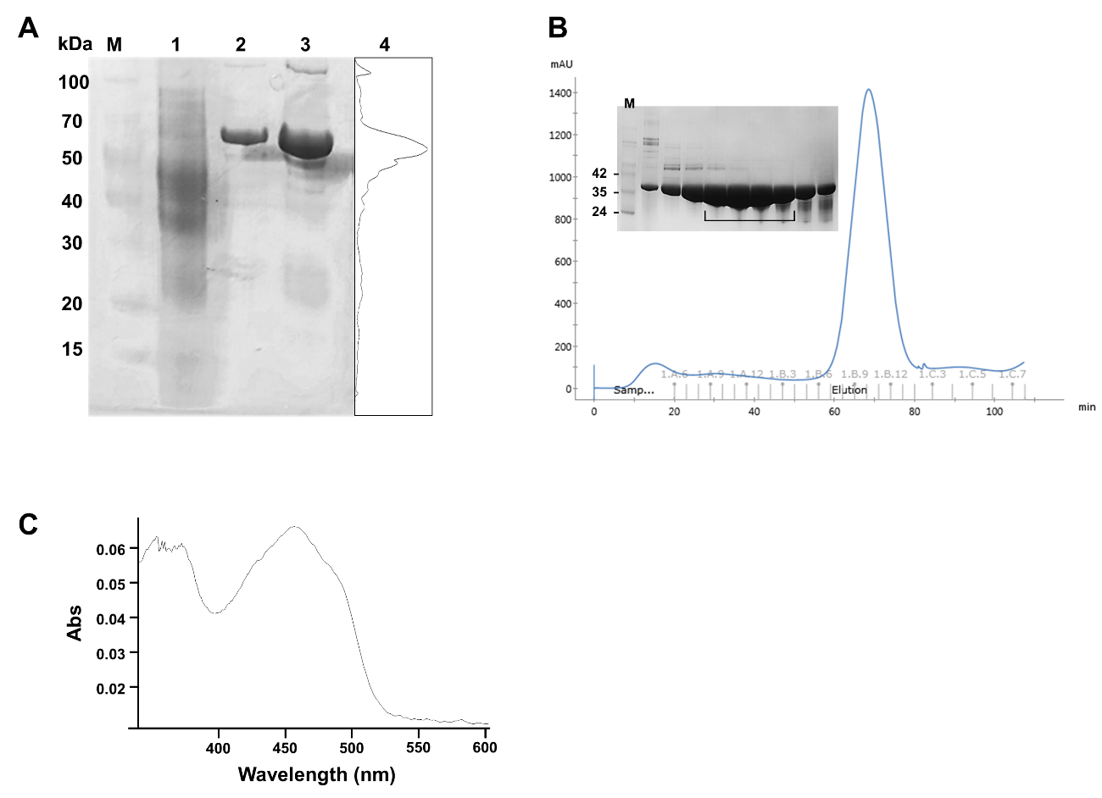

Supplemental Figure S1. Purification of GbsMerA. (A) sulfate–polyacrylamide gel electrophoresis (SDS–PAGE) analysis for GbsMerA during purification. M marker, 1; crude, 2; 10mM imidazole elution fraction; 3; 100mM imidazole elution fraction; 4, densitometric profile of line 3. GbsMerA was expressed using the pET32a(+) vector with a total 67kDa calculated molecular weight. (B) GbsMerA was loaded onto an SEC column following enterokinase cleavage. The fractions collected for specific activity and crystallization are marked with black lines. Superdex 200 10/300 GL column connected with ÄKTA Avant system (Cytiva, Marlborough, MA, USA) was used. (C). The UV-visible spectrum of GbsMerA.
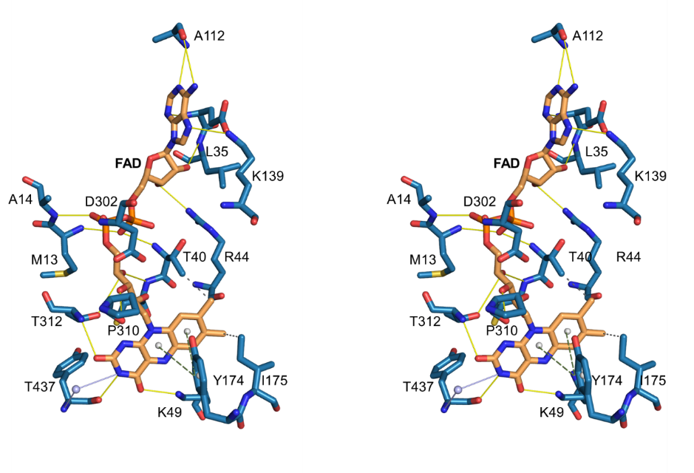

Supplemental Figure S2. Stereo view of the FAD binding site in the GbsMerA monomer. The FAD molecule is indicated by an orange stick. The selected hydrogen bonding interactions are shown as yellow lines. stacking interactions (long dotted line) and hydrophobic interactions (short dotted line) are also indicated.

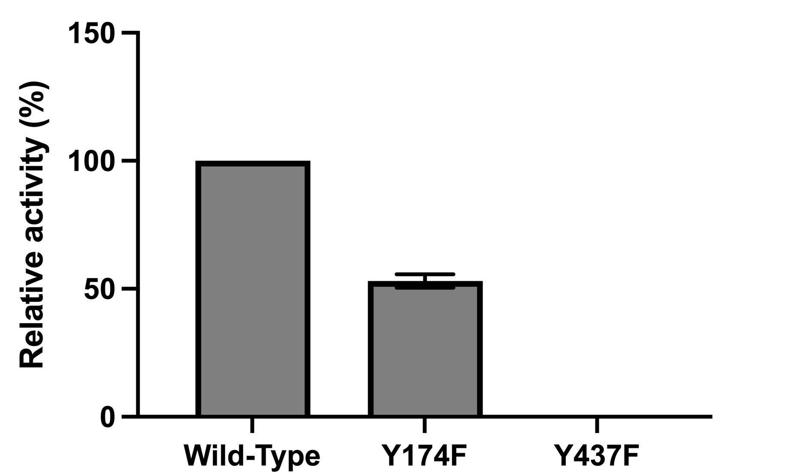

Supplemental Figure S3. Comparison of the activity of GbsMerA with mutants. The error bars represent the standard error of triplicate experiments.

