Supplementary material
Supplementary table 1
Microbiota detectability vs. | Fisher's test P-value
Age (<65 vs. ≥65 years) | 0.29
PSA (<2.5 vs. ≥2.5 ng/ml | 0.72
Prostate weight (<50 vs. ≥50 g) | 0.13
Post-voiding residual volume (<80 vs. ≥80 ml) | 0.63
Structural changes of the bladder | 0.27
Use of alpha-blockers | 0.71
Use of 5-α-reductase inhibitors | 1
Time between symptoms and treatment (<24 vs ≥24 months) | 1
Supplementary table 1: Associations between urinary microbiota detectability and clinicopathological parameters.

Supplementary figure 1
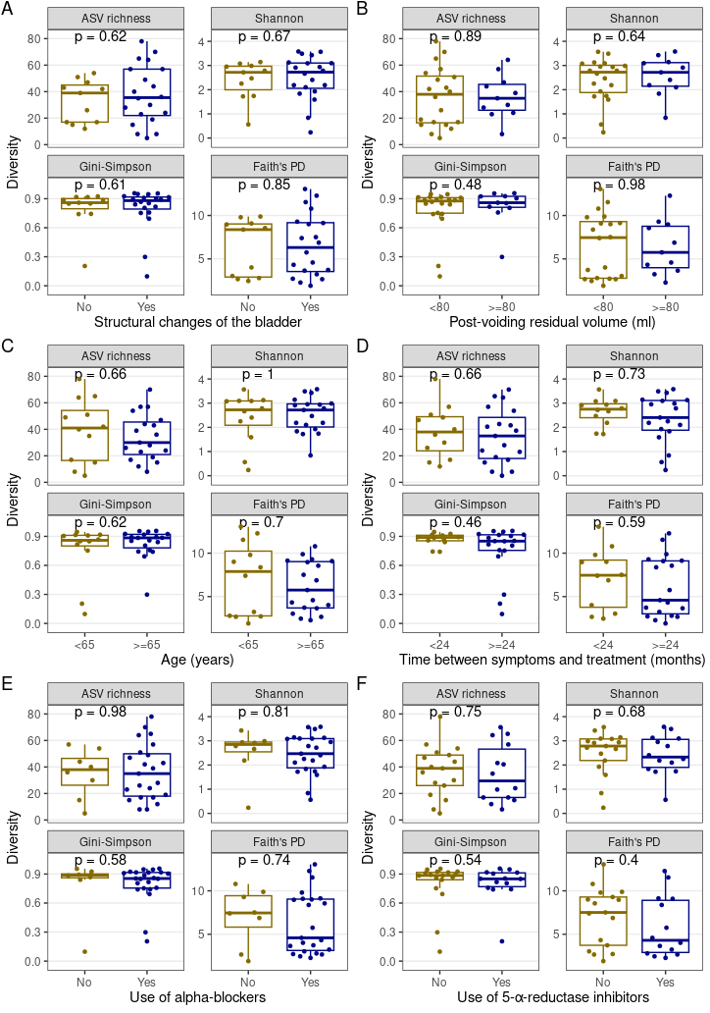
Supplementary figure 1: (A–F) Association between urinary microbiota alpha-diversity and clinicopathological parameters. Different alpha-diversity metrics were evaluated in each subplot. Mann-Whitney test was used.

