Supplementary appendix
Global Prevalence of Mental Disorders Due to Covid-19 In the Central Asia: A Systematic Analysis of The Global Burden of Disease Study From 1990 to 2019
Figure S1. Prevalence of major depressive disorder per 100 000 persons due to the COVID-19 pandemic, 1990 versus 2019
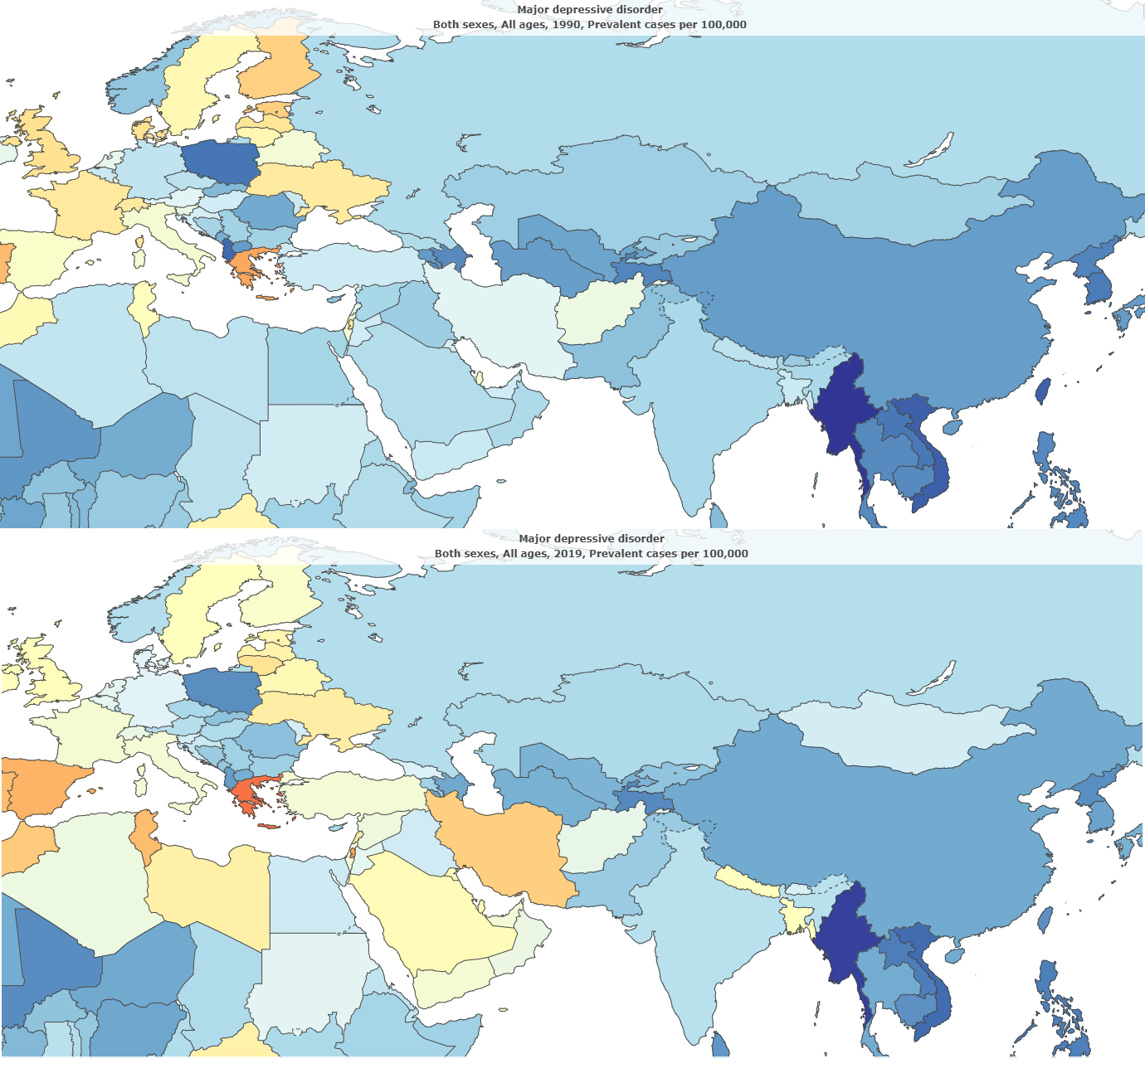

Figure S2. Prevalence of anxiety disorders per 100 000 persons due to the COVID-19 pandemic, 1990 versus 2019
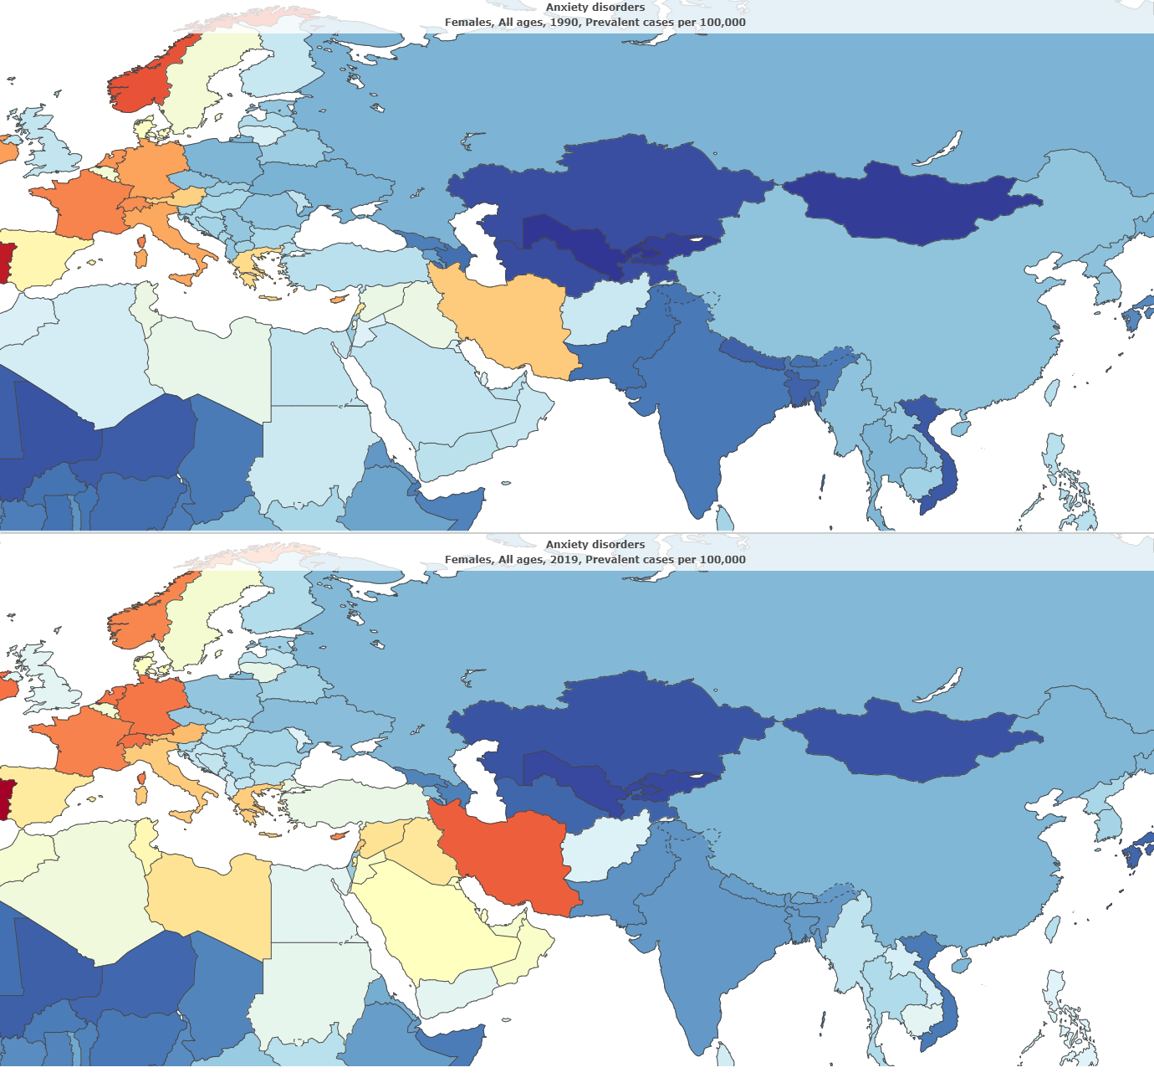

Figure S3. Annual % change of major depressive disorder per 100 000 persons due to the COVID-19 pandemic, 1990 versus 2019
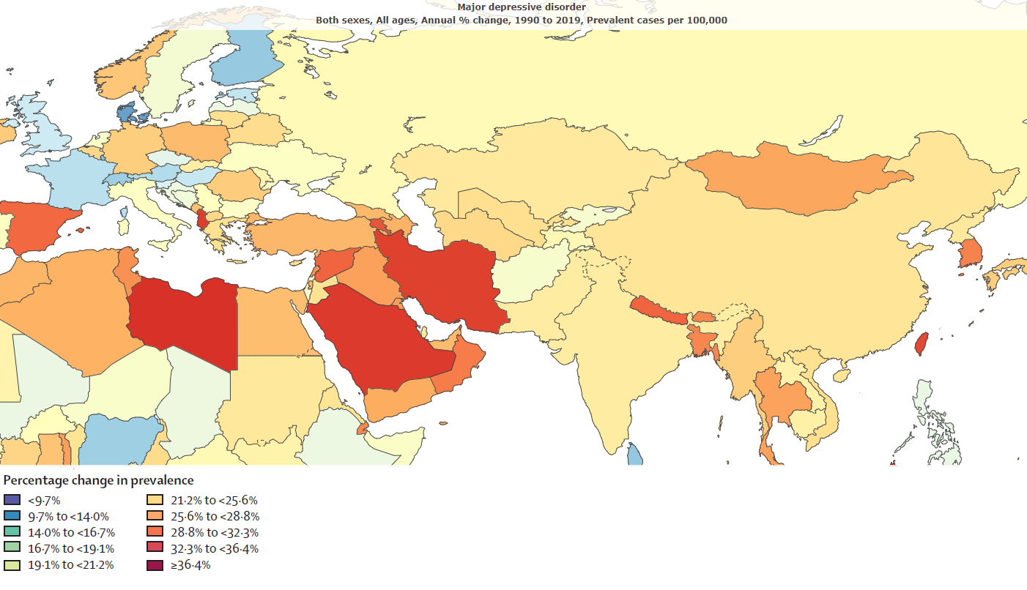
Figure S4. Annual % change of anxiety disorders per 100 000 persons due to the COVID-19 pandemic, 1990 versus 2019
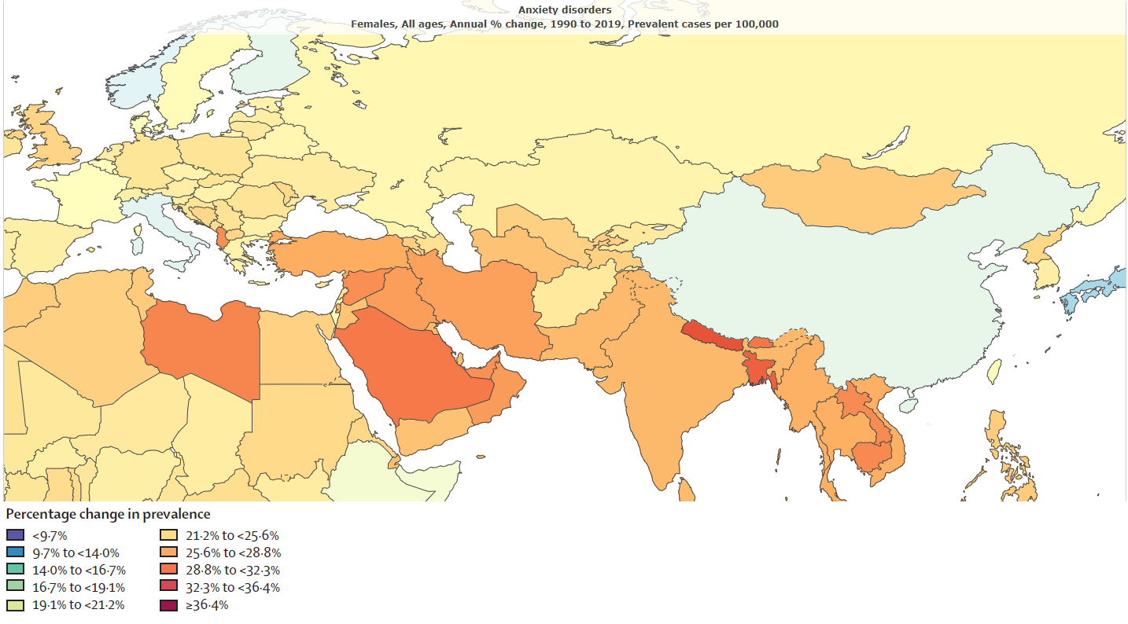
Figure S5. Pyramid illustration of the prevalence rate of Mental disorders per 100 000 persons due to the COVID-19 pandemic, 1990 versus 2019
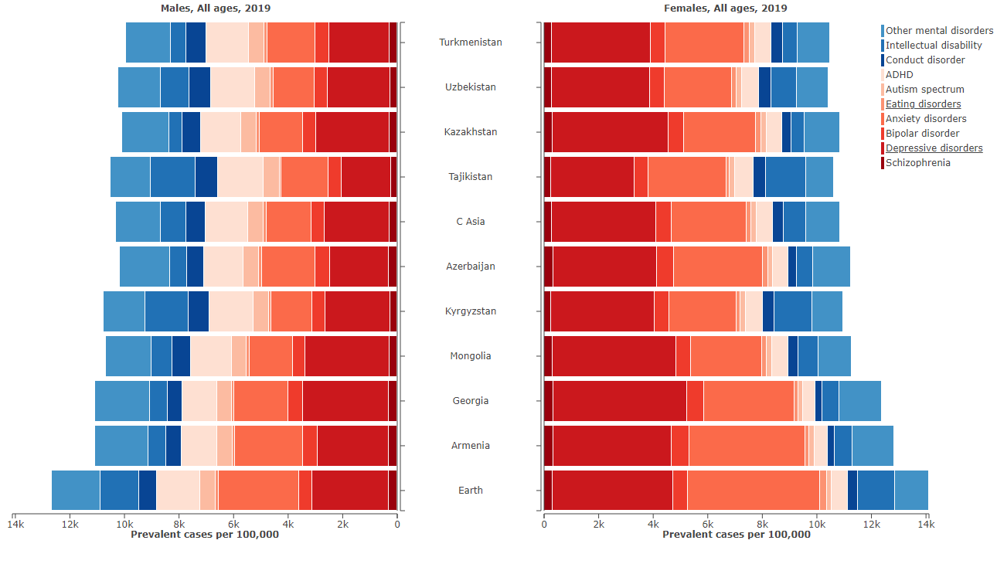
Figure S6. Pyramid illustration of the DALY rate of Mental disorders per 100 000 persons due to the COVID-19 pandemic, 1990 versus 2019
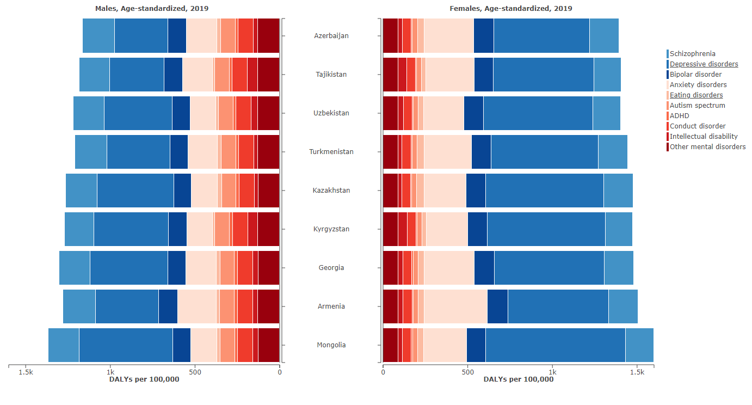

Figure S7. The trends of the prevalence rate of MDD per 100 000 persons due to the COVID-19 pandemic, both genders,1990 versus 2019
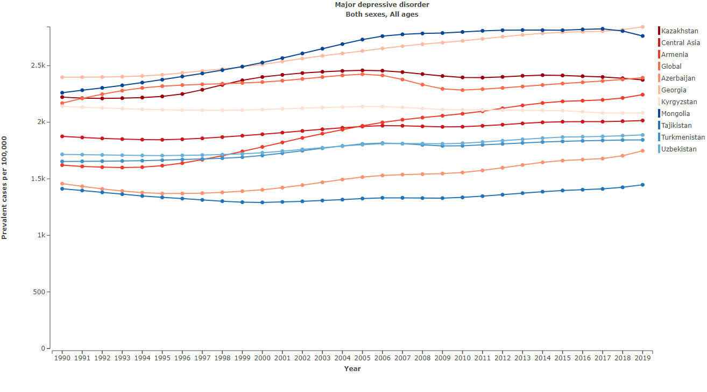
Figure S8. The trends of the prevalence rate of MDD per 100 000 persons due to the COVID-19 pandemic, Male gender,1990 versus 2019
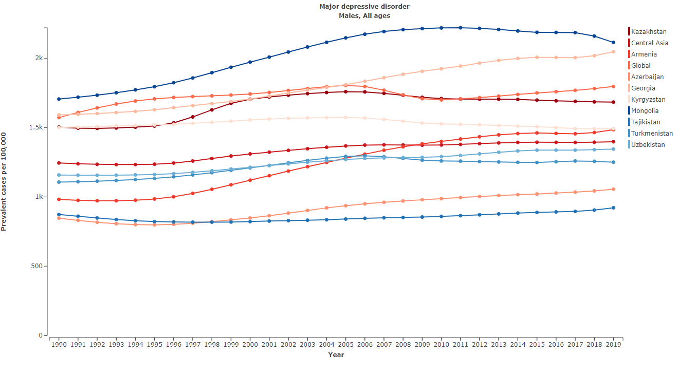

Figure S9. The trends of the prevalence rate of MDD per 100 000 persons due to the COVID-19 pandemic, Female gender,1990 versus 2019
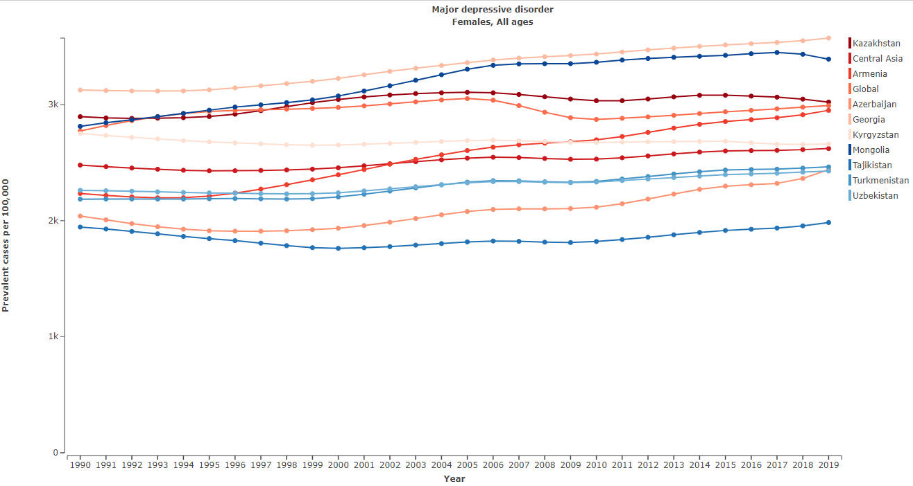
Figure S10. The trends of the prevalence rate of anxiety disorders per 100 000 persons due to the COVID-19 pandemic, both genders,1990 versus 2019
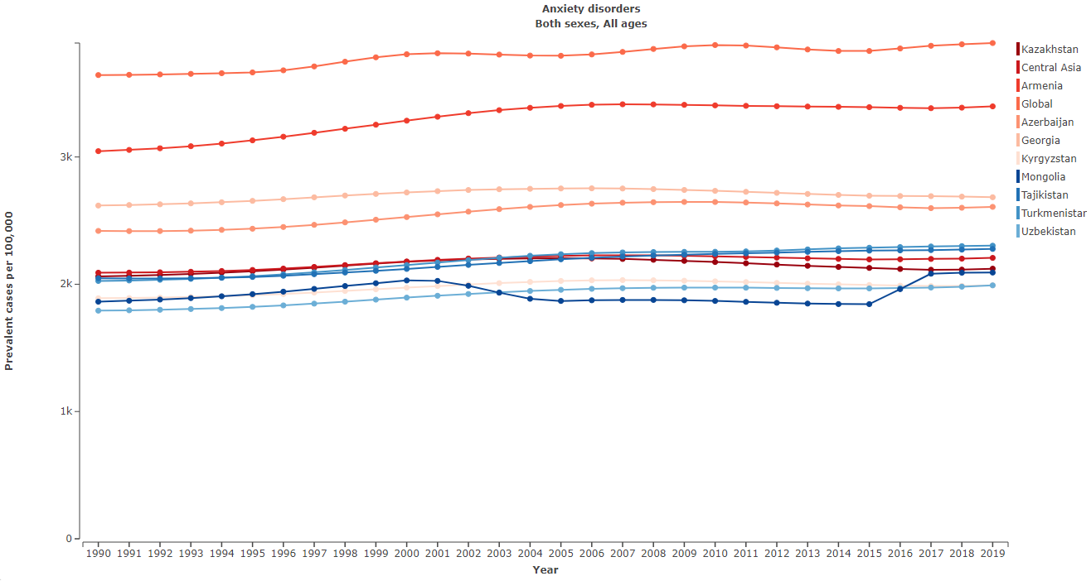

Figure S11. The trends of the prevalence rate of anxiety disorders per 100 000 persons due to the COVID-19 pandemic, Male gender,1990 versus 2019
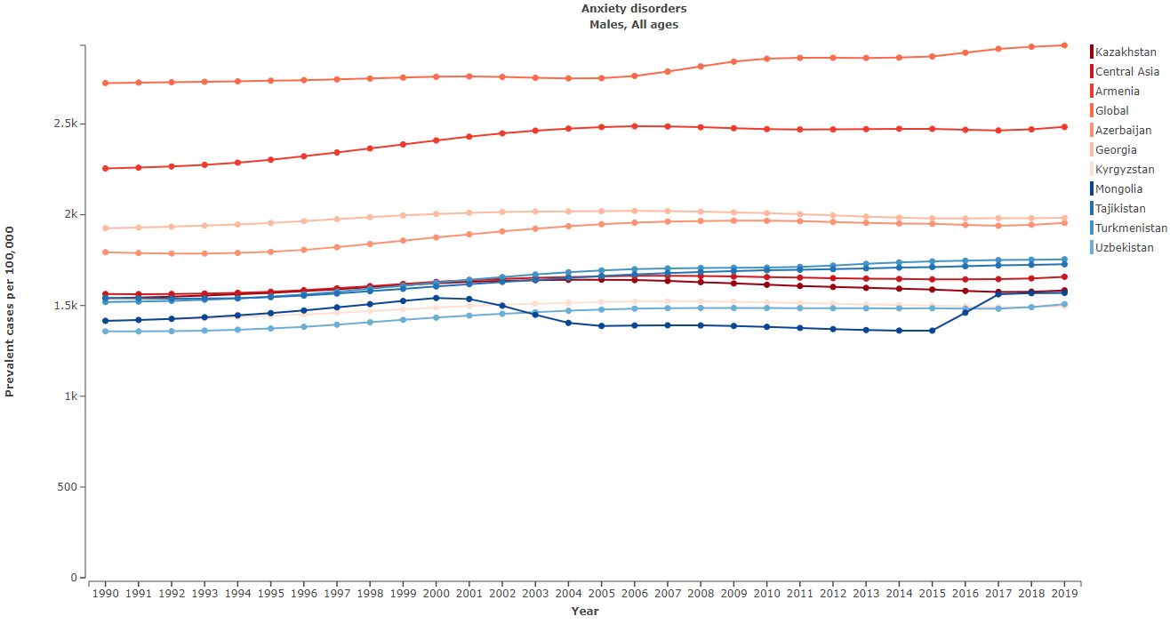
Figure S12. The trends of the prevalence rate of anxiety disorders per 100 000 persons due to the COVID-19 pandemic, Female gender,1990 versus 2019
