Investigating the Potential of 6-Substituted 3-Formyl Chromone Derivatives as Anti-Diabetic Agents Using DFT, Molecular
Docking and Molecular Dynamics Methods

Minhaz Zabin Saif¹, Nusrat Jahan Ikbal Esha¹, Syeda Tasnim Quayum¹, Shofiur Rahman²*, Mahmoud A. Al-Gawati², Ghadah Alsowygh², Hamad Albrithen^{2,3}, Abdullah Alodhayb^{2,3,}*, Raymond A. Poirier^{4,}* & Kabir M. Uddin¹*

¹Department of Biochemistry and Microbiology, North South University, Bashundhara, Dhaka-1217, Bangladesh
²Biological and Environmental Sensing Research Unit, King Abdullah Institute for Nanotechnology, King Saud University,
Riyadh 11451, Saudi Arabia
³Department of Chemistry, Memorial University,
St. John’s, Newfoundland,
Canada A1B 3X7

Tel.: +8801796585904
Fax: +8802-55668202

E-mail: mohammed.uddin11@northsouth.edu; kabirmuddin@gmail.com
E-mail: rpoirier@mun.ca
E-mail: mrahman1@ksu.edu.sa
E-mail: aalodhayb@ksu.edu.sa

_____________________

Table S1. Optimized structure for 3-Formylchromone (1) and Cartesian Z-matrix.
3-Formylchromone (1) |  |  | 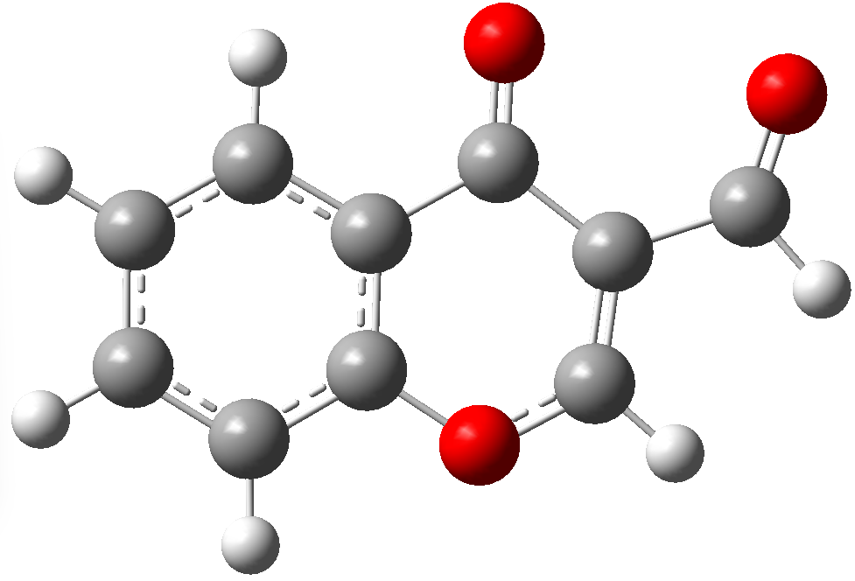
Center  Number | Atom | Standard orientation: Coordinates (Angstroms)
Center  Number | Atom | X |  | Y | Z
1 | O | -0.19739 |  | 1.904419 | 0.000019
2 | O | 1.218799 |  | -1.953924 | 0.000093
3 | O | 3.84733 |  | -0.63763 | -0.000157
4 | C | -0.642916 |  | -0.479051 | -0.000117
5 | C | -1.088953 |  | 0.847354 | -0.000013
6 | C | 0.810509 |  | -0.802065 | -0.00034
7 | C | -1.605098 |  | -1.501316 | -0.000082
8 | C | 1.677006 |  | 0.399723 | -0.000014
9 | C | -2.445002 |  | 1.175719 | 0.000109
10 | C | 1.113641 |  | 1.636082 | 0.000035
11 | C | -2.958471 |  | -1.196048 | 0.00004
12 | C | -3.37627 |  | 0.144164 | 0.000131
13 | C | 3.156663 |  | 0.356981 | 0.000234
14 | H | -1.245362 |  | -2.524793 | -0.000177
15 | H | -2.74099 |  | 2.218937 | 0.00019
16 | H | 1.700228 |  | 2.550644 | 0.000169
17 | H | -3.696264 |  | -1.99191 | 0.000061
18 | H | -4.435384 |  | 0.382275 | 0.000228
19 | H | 3.621218 |  | 1.372673 | -0.000003

Table S2. Optimized structure for 3-Formyl-6-methylchromone (2) and cartesian Z-matrix.
3-Formyl-6-methylchromone (2) |  |  | 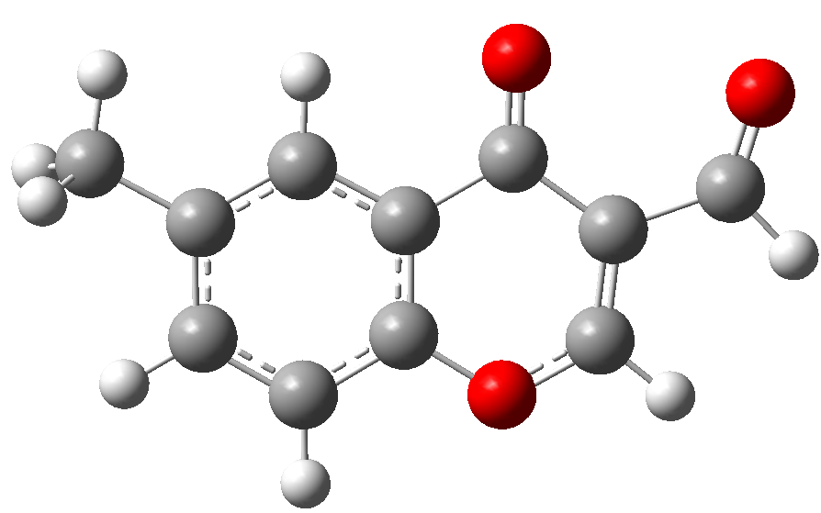
Center  Number | Atom | Standard orientation: Coordinates (Angstroms)
Center  Number | Atom | X |  | Y | Z
1 | O | -0.520774 |  | 2.049986 | -0.000005
2 | O | -1.214968 |  | -2.00198 | -0.000102
3 | O | -4.037496 |  | -1.182659 | 0.00012
4 | C | 0.349702 |  | -0.21411 | -0.000026
5 | C | 0.545718 |  | 1.169239 | -0.000006
6 | C | 2.769933 |  | -0.523687 | 0.000002
7 | C | 1.480645 |  | -1.045972 | -0.000022
8 | C | -1.020795 |  | -0.795004 | -0.00005
9 | C | 1.823959 |  | 1.729098 | 0.000006
10 | C | 2.920563 |  | 0.879225 | 0.000009
11 | C | -2.090444 |  | 0.230202 | -0.000015
12 | C | 3.984163 |  | -1.421036 | 0.000056
13 | C | -1.760918 |  | 1.548759 | -0.000008
14 | C | -3.537474 |  | -0.079551 | 0.000014
15 | H | 1.304745 |  | -2.117221 | -0.000049
16 | H | 1.93532 |  | 2.807923 | 0.000007
17 | H | 3.919501 |  | 1.307288 | 0.000005
18 | H | 3.698085 |  | -2.475362 | -0.000168
19 | H | 4.6104 |  | -1.242342 | -0.88129
20 | H | 4.610064 |  | -1.242646 | 0.881706
21 | H | -2.504283 |  | 2.341212 | -0.000004
22 | H | -4.178238 |  | 0.835392 | -0.000067

Table S3. Optimized structure for 6-Ethyl-3-formylchromone (3) and cartesian Z-matrix.
6-Ethyl-3-formylchromone (3) |  |  | 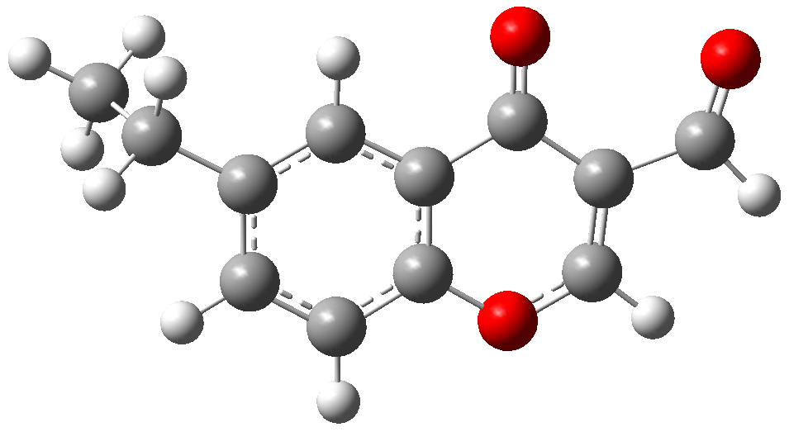
Center  Number | Atom | Standard orientation: Coordinates (Angstroms)
Center  Number | Atom | X |  | Y | Z
1 | O | 1.093826 |  | 2.073066 | 0.133441
2 | O | 1.362957 |  | -2.016312 | -0.193139
3 | O | 4.246438 |  | -1.515298 | 0.078322
4 | C | -2.43604 |  | -0.112783 | -0.329358
5 | C | -0.004112 |  | -0.074122 | -0.13217
6 | C | -1.210757 |  | -0.772751 | -0.287501
7 | C | -3.735819 |  | -0.878011 | -0.458749
8 | C | -0.055775 |  | 1.318488 | -0.018594
9 | C | -2.43988 |  | 1.292291 | -0.212421
10 | C | -1.263908 |  | 2.014077 | -0.057916
11 | C | 1.295263 |  | -0.799725 | -0.093961
12 | C | 2.461937 |  | 0.097904 | 0.073797
13 | C | -4.390426 |  | -1.178185 | 0.901422
14 | C | 2.271433 |  | 1.440057 | 0.172038
15 | C | 3.864632 |  | -0.367749 | 0.144439
16 | H | -1.147461 |  | -1.853046 | -0.378059
17 | H | -4.435841 |  | -0.305014 | -1.078688
18 | H | -3.549885 |  | -1.819403 | -0.987148
19 | H | -3.385801 |  | 1.826223 | -0.249053
20 | H | -1.261819 |  | 3.095268 | 0.027329
21 | H | -3.727927 |  | -1.781414 | 1.529879
22 | H | -5.327474 |  | -1.728043 | 0.768792
23 | H | -4.61408 |  | -0.254371 | 1.444959
24 | H | 3.090602 |  | 2.143187 | 0.295295
25 | H | 4.594638 |  | 0.468025 | 0.271535

Table S4. Optimized structure for 6-Isopropyl-3-Formylchromone (4) and cartesian Z-matrix.
6-Isopropyl-3-Formylchromone (4) |  |  | 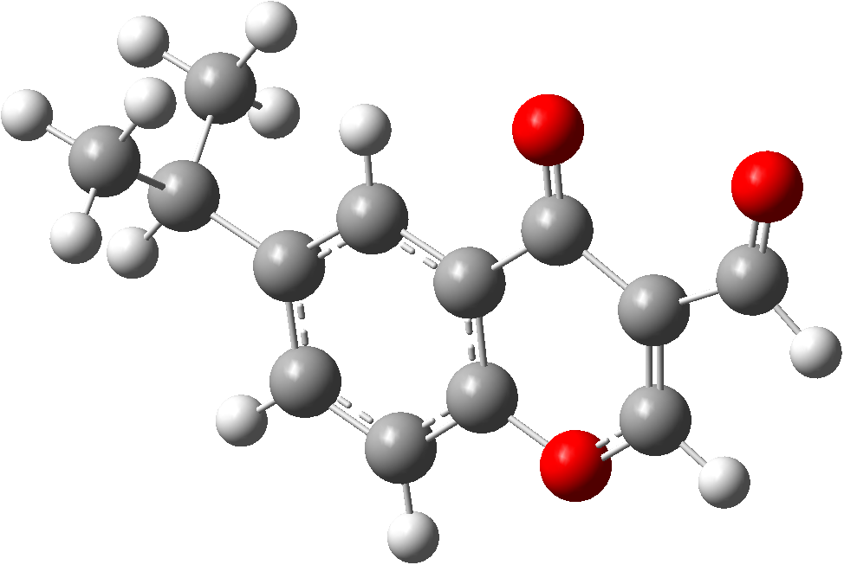
Center  Number | Atom | Standard orientation: Coordinates (Angstroms)
Center  Number | Atom | X |  | Y | Z
1 | O | 1.590579 |  | 2.092416 | -0.000263
2 | O | 1.378789 |  | -2.013624 | 0.000063
3 | O | 4.312217 |  | -1.833442 | 0.000121
4 | C | -3.5797 |  | -0.316688 | 0.000195
5 | C | -2.187422 |  | 0.300914 | 0.000082
6 | C | -1.039424 |  | -0.490639 | 0.000077
7 | C | 0.243474 |  | 0.073541 | -0.000039
8 | C | -3.832842 |  | -1.149874 | 1.270434
9 | C | -3.833016 |  | -1.149904 | -1.26999
10 | C | -2.024762 |  | 1.699837 | -0.000034
11 | C | 0.355833 |  | 1.468268 | -0.000151
12 | C | -0.767369 |  | 2.292209 | -0.000151
13 | C | 1.454024 |  | -0.793369 | -0.000051
14 | C | 2.722416 |  | -0.027978 | -0.00012
15 | C | 2.689922 |  | 1.330829 | -0.000237
16 | C | 4.066171 |  | -0.647518 | -0.000073
17 | H | -4.298733 |  | 0.513056 | 0.000236
18 | H | -1.093138 |  | -1.574837 | 0.000158
19 | H | -3.688525 |  | -0.550977 | 2.174858
20 | H | -4.85716 |  | -1.53694 | 1.277505
21 | H | -3.153034 |  | -2.006726 | 1.324684
22 | H | -3.153202 |  | -2.006747 | -1.324316
23 | H | -4.85733 |  | -1.536983 | -1.276907
24 | H | -3.688835 |  | -0.551025 | -2.174447
25 | H | -2.905814 |  | 2.335913 | -0.000031
26 | H | -0.642052 |  | 3.36951 | -0.000238
27 | H | 3.589341 |  | 1.940489 | -0.000316
28 | H | 4.891972 |  | 0.104691 | -0.000214

Table S5. Optimized structure for 6-hydroxy-3-formylchromone (5) and cartesian Z-matrix.

6-hydroxy-3-formylchromone (5) |  |  | 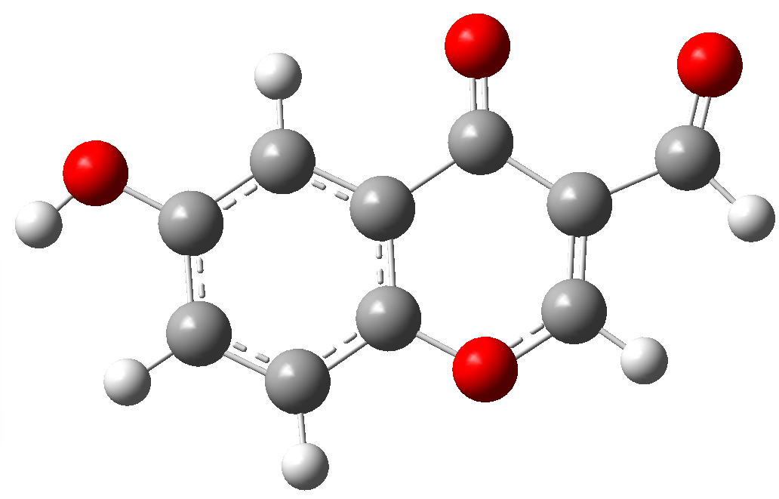
Center  Number | Atom | Standard orientation: Coordinates (Angstroms)
Center  Number | Atom | X |  | Y | Z
1 | O | -0.459815 |  | 2.04509 | 0.000187
2 | O | 3.795126 |  | -1.475112 | 0.000003
3 | O | -1.239494 |  | -1.992413 | -0.000341
4 | O | -4.042381 |  | -1.113433 | 0.000065
5 | C | 0.36587 |  | -0.240775 | -0.000073
6 | C | 0.589221 |  | 1.141889 | 0.000127
7 | C | 1.46637 |  | -1.103302 | -0.000109
8 | C | -1.02072 |  | -0.790283 | -0.000256
9 | C | 2.759874 |  | -0.58854 | 0.000049
10 | C | 1.877317 |  | 1.672768 | 0.000286
11 | C | -2.065783 |  | 0.257878 | -0.000149
12 | C | 2.96096 |  | 0.804281 | 0.000246
13 | C | -1.708433 |  | 1.570139 | 0.000058
14 | C | -3.518737 |  | -0.021282 | -0.000272
15 | H | 1.29221 |  | -2.173231 | -0.000265
16 | H | 2.01503 |  | 2.748355 | 0.000441
17 | H | 3.971224 |  | 1.206536 | 0.00037
18 | H | -2.435891 |  | 2.377214 | 0.000136
19 | H | -4.139816 |  | 0.907173 | 0.00043
20 | H | 4.634121 |  | -0.995737 | 0.000125

Table S6. Optimized structure for 3-Formyl-6-methoxychromone (6) and cartesian Z-matrix.

3-Formyl-6-methoxychromone (6) |  |  | 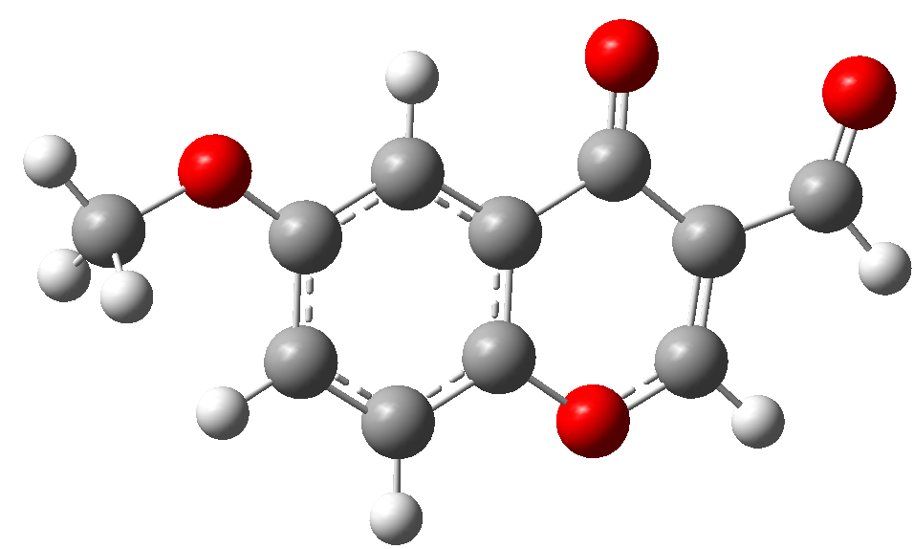
Center  Number | Atom | Standard orientation: Coordinates (Angstroms)
Center  Number | Atom | X |  | Y | Z
1 | O | -0.998161 |  | 2.062848 | 0.000249
2 | O | 3.457263 |  | -1.20202 | -0.000081
3 | O | -1.508695 |  | -2.01855 | -0.000208
4 | O | -4.364346 |  | -1.325893 | -0.000377
5 | C | -0.022729 |  | -0.163947 | 0.000003
6 | C | 0.109223 |  | 1.231492 | 0.000164
7 | C | 1.132862 |  | -0.94705 | -0.000074
8 | C | -1.369508 |  | -0.804558 | -0.000084
9 | C | 2.394957 |  | -0.35113 | 0.000007
10 | C | 1.358567 |  | 1.843213 | 0.000247
11 | C | -2.481859 |  | 0.172316 | -0.000015
12 | C | 2.503877 |  | 1.052947 | 0.000168
13 | C | -2.211996 |  | 1.505507 | 0.000156
14 | C | -3.913026 |  | -0.20181 | -0.000133
15 | C | 4.768273 |  | -0.65505 | -0.000004
16 | H | 1.032979 |  | -2.026503 | -0.000197
17 | H | 1.424277 |  | 2.925766 | 0.000372
18 | H | 3.473689 |  | 1.534784 | 0.000232
19 | H | -2.991816 |  | 2.26219 | 0.000232
20 | H | -4.593752 |  | 0.683983 | 0.000048
21 | H | 4.953491 |  | -0.047256 | -0.89468
22 | H | 5.447337 |  | -1.50817 | -0.000094
23 | H | 4.95347 |  | -0.047461 | 0.894816

Table S7. Optimized structure for 6-Ethoxy-3-Formylchromone (7) and cartesian Z-matrix.

6-Ethoxy-3-Formylchromone (7) |  |  | 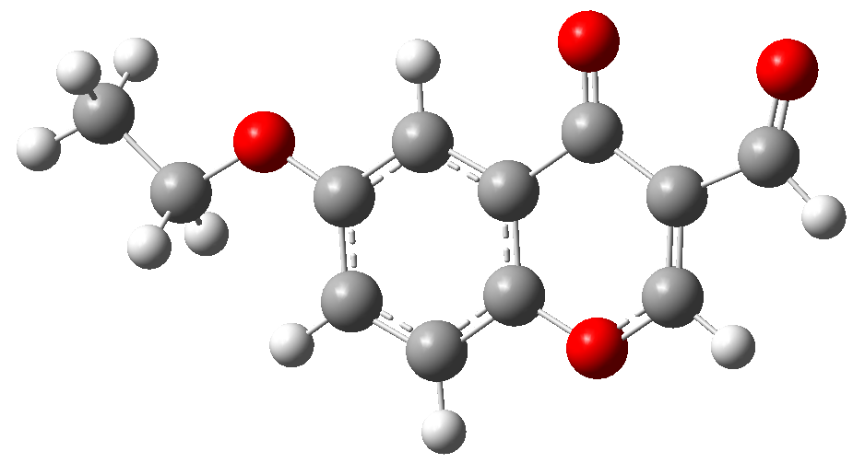
Center  Number | Atom | Standard orientation: Coordinates (Angstroms)
Center  Number | Atom | X |  | Y | Z
1 | O | 1.625409 |  | 2.049664 | -0.000199
2 | O | -3.135951 |  | -0.751319 | 0.000079
3 | O | 1.723141 |  | -2.062512 | 0.000179
4 | O | 4.634137 |  | -1.659977 | 0.000108
5 | C | 0.430941 |  | -0.067916 | 0.000122
6 | C | 0.439868 |  | 1.333628 | -0.000092
7 | C | -0.797655 |  | -0.730682 | 0.000165
8 | C | 1.70639 |  | -0.840609 | 0.000351
9 | C | -1.994506 |  | -0.011966 | 0.000014
10 | C | -0.741808 |  | 2.06752 | -0.000241
11 | C | 2.911338 |  | 0.019507 | 0.000041
12 | C | -1.960801 |  | 1.396529 | -0.000188
13 | C | 2.77688 |  | 1.373187 | -0.000149
14 | C | 4.29756 |  | -0.496299 | -0.000051
15 | C | -4.399995 |  | -0.083218 | -0.000066
16 | H | -0.806397 |  | -1.814697 | 0.000337
17 | H | -0.698563 |  | 3.151219 | -0.000408
18 | H | -2.87696 |  | 1.973592 | -0.000309
19 | H | 3.628908 |  | 2.04755 | -0.000325
20 | H | 5.063703 |  | 0.316788 | -0.000255
21 | H | -4.482767 |  | 0.558109 | 0.888684
22 | H | -4.4827 |  | 0.557852 | -0.889007
23 | C | -5.478868 |  | -1.150566 | 0.000049
24 | H | -6.468123 |  | -0.683308 | -0.000056
25 | H | -5.393491 |  | -1.784448 | -0.886467
26 | H | -5.393558 |  | -1.784191 | 0.886754

Table S8. Optimized structure for 6-Amino-3-Formylchromone (8) and cartesian Z-matrix.

6-Amino-3-Formylchromone (8) |  |  | 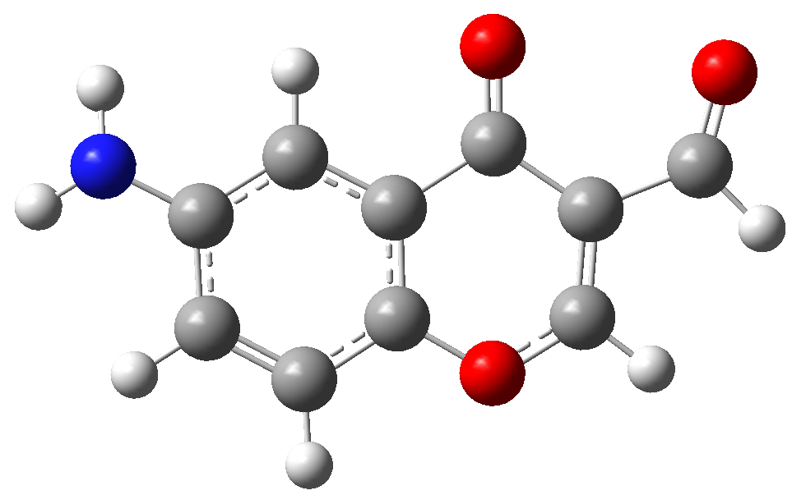
Center  Number | Atom | Standard orientation: Coordinates (Angstroms)
Center  Number | Atom | X |  | Y | Z
1 | O | 0.490182 |  | 2.051161 | 0.003163
2 | O | 1.221772 |  | -1.995751 | 0.002446
3 | O | 4.036141 |  | -1.147361 | 0.002214
4 | N | -3.878335 |  | -1.402945 | -0.067542
5 | C | -0.361843 |  | -0.22492 | -0.005898
6 | C | -0.568757 |  | 1.158264 | -0.001129
7 | C | -1.472137 |  | -1.075076 | -0.007664
8 | C | 1.016788 |  | -0.789822 | -0.000913
9 | C | -2.772905 |  | -0.562508 | -0.006358
10 | C | -1.854998 |  | 1.697593 | 0.002395
11 | C | 2.073936 |  | 0.245328 | 0.000661
12 | C | -2.945005 |  | 0.841828 | -0.00128
13 | C | 1.731924 |  | 1.563031 | 0.002294
14 | C | 3.522566 |  | -0.049905 | 0.001288
15 | H | -1.281805 |  | -2.143996 | -0.011768
16 | H | -1.984103 |  | 2.774473 | 0.00785
17 | H | -3.94953 |  | 1.255889 | -0.005835
18 | H | 2.469461 |  | 2.360976 | 0.003668
19 | H | -4.742735 |  | -1.027713 | 0.295821
20 | H | -3.71887 |  | -2.358312 | 0.219002
21 | H | 4.153753 |  | 0.872024 | 0.0011

Table S9. Optimized structure for 6-Fluoro-3-formylchromone (9) and cartesian Z-matrix.

6-Fluoro-3-formylchromone (9) |  |  | 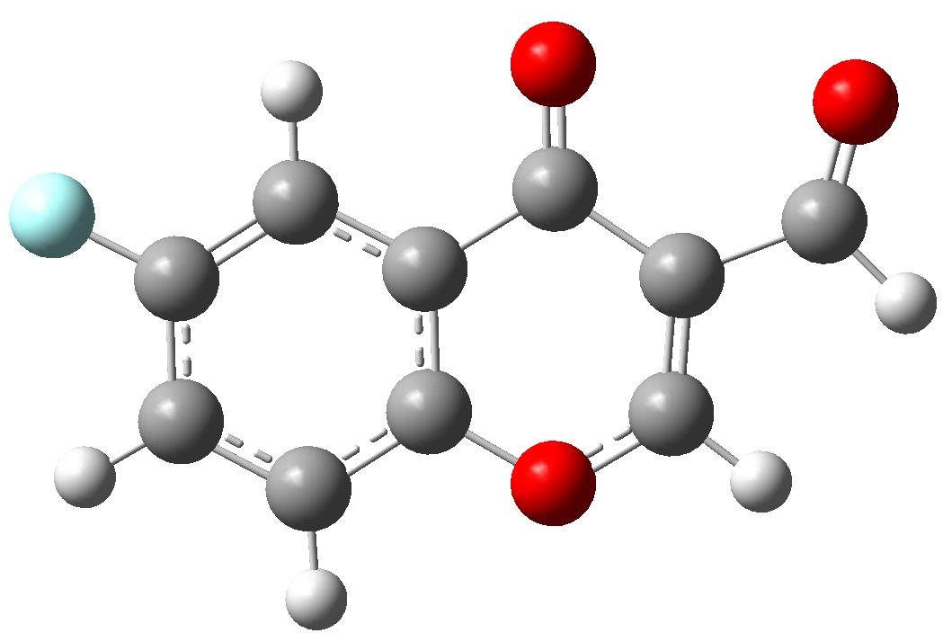
Center  Number | Atom | Standard orientation: Coordinates (Angstroms)
Center  Number | Atom | X |  | Y | Z
1 | F | -3.805255 |  | -1.417001 | 0.000109
2 | O | 0.435615 |  | 2.04086 | -0.000091
3 | O | 1.24256 |  | -1.989355 | 0.000039
4 | O | 4.039494 |  | -1.094404 | 0.00022
5 | C | -0.369547 |  | -0.246778 | -0.000153
6 | C | -0.606042 |  | 1.132596 | -0.000096
7 | C | 1.019419 |  | -0.788325 | -0.000379
8 | C | -1.467662 |  | -1.118722 | -0.000071
9 | C | 2.057205 |  | 0.266689 | -0.000059
10 | C | -1.898186 |  | 1.661753 | 0.000007
11 | C | -2.743966 |  | -0.589215 | 0.000042
12 | C | -2.978528 |  | 0.790165 | 0.000079
13 | C | 1.689863 |  | 1.575132 | -0.000028
14 | C | 3.513094 |  | -0.004102 | 0.000194
15 | H | -1.292205 |  | -2.188336 | -0.000127
16 | H | -2.036244 |  | 2.737151 | 0.00005
17 | H | -3.998878 |  | 1.1566 | 0.000168
18 | H | 2.409803 |  | 2.388718 | 0.000106
19 | H | 4.129568 |  | 0.926906 | 0.000253

Table S10. Optimized structure for 6-Chloro-3-formylchromone (10) and cartesian Z-matrix.

6-Chloro-3-formylchromone (10) |  |  | 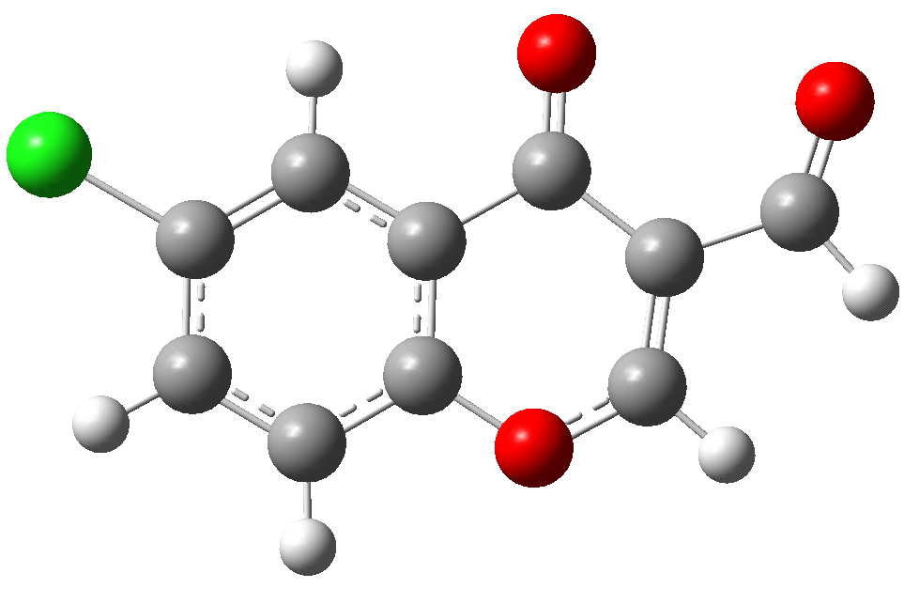
Center  Number | Atom | Standard orientation: Coordinates (Angstroms)
Center  Number | Atom | X |  | Y | Z
1 | Cl | 3.947685 |  | -1.069461 | -0.00079
2 | O | -1.02972 |  | 2.082733 | 0.000369
3 | O | -1.352027 |  | -2.014607 | -0.000002
4 | O | -4.235192 |  | -1.459876 | 0.000321
5 | C | 0.040585 |  | -0.091187 | 0.00017
6 | C | 0.111028 |  | 1.305541 | 0.000162
7 | C | 2.507105 |  | 1.244722 | -0.000406
8 | C | 1.33147 |  | 1.982559 | -0.000115
9 | C | 1.235303 |  | -0.825777 | -0.00014
10 | C | -1.273464 |  | -0.795955 | 0.000586
11 | C | 2.449261 |  | -0.157604 | -0.000422
12 | C | -2.429962 |  | 0.128355 | 0.000508
13 | C | -2.221016 |  | 1.47064 | 0.000496
14 | C | -3.843661 |  | -0.314428 | 0.000503
15 | H | 1.343432 |  | 3.066721 | -0.000117
16 | H | 1.171585 |  | -1.907821 | -0.000121
17 | H | -3.031767 |  | 2.193638 | 0.000525
18 | H | -4.56691 |  | 0.536038 | 0.000232
19 | H | 3.468641 |  | 1.745074 | -0.000632

Table S11. Optimized structure for 6-Bromo-3-formylchromone (11) and cartesian Z-matrix.

6-Bromo-3-formylchromone (11) |  |  | 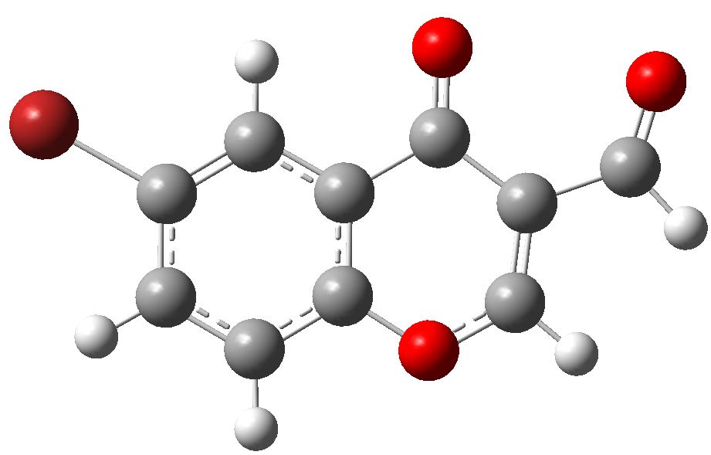
Center  Number | Atom | Standard orientation: Coordinates (Angstroms)
Center  Number | Atom | X |  | Y | Z
1 | Br | -3.547729 |  | -0.626457 | 0.000537
2 | O | 1.853057 |  | 2.088648 | -0.000391
3 | O | 1.773665 |  | -2.020727 | 0.000062
4 | O | 4.697098 |  | -1.75018 | -0.000746
5 | C | 0.575614 |  | 0.029793 | -0.000032
6 | C | 0.641912 |  | 1.426797 | -0.000174
7 | C | 1.814255 |  | -0.800245 | -0.000096
8 | C | -0.686141 |  | -0.58335 | 0.000184
9 | C | 3.055603 |  | 0.006749 | -0.000428
10 | C | -0.50646 |  | 2.220118 | -0.000103
11 | C | -1.828161 |  | 0.200052 | 0.000251
12 | C | -1.748657 |  | 1.60058 | 0.00011
13 | C | 2.978872 |  | 1.362978 | -0.000524
14 | C | 4.419309 |  | -0.57198 | -0.000675
15 | H | -0.727812 |  | -1.666302 | 0.000299
16 | H | -0.412307 |  | 3.300362 | -0.000216
17 | H | -2.655403 |  | 2.194043 | 0.000165
18 | H | 3.85646 |  | 2.003199 | -0.000726
19 | H | 5.222161 |  | 0.203825 | -0.000798

Table S12. Optimized structure 6-Cyano-3-formylchromone (12) and cartesian Z-matrix.

6-Cyano-3-formylchromone  (12) |  |  | 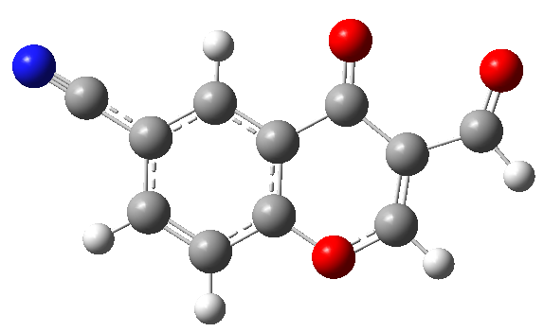
Center  Number | Atom | Standard orientation: Coordinates (Angstroms)
Center  Number | Atom | X |  | Y | Z
1 | O | 0.894274 |  | 2.0632 | 0.000029
2 | O | 1.246759 |  | -2.029489 | -0.000054
3 | O | 4.124706 |  | -1.458412 | -0.000166
4 | C | -0.157805 |  | -0.11567 | 0
5 | C | -0.238654 |  | 1.281534 | 0.00004
6 | C | 1.161959 |  | -0.812079 | -0.000057
7 | C | -1.347602 |  | -0.8526 | 0.000017
8 | C | 2.312475 |  | 0.120132 | -0.000071
9 | C | -1.46262 |  | 1.955602 | 0.000095
10 | C | 2.093424 |  | 1.459478 | -0.00003
11 | C | -2.580893 |  | -0.198699 | 0.00007
12 | C | -2.631854 |  | 1.213689 | 0.00011
13 | C | 3.730301 |  | -0.314532 | -0.000132
14 | H | -1.277057 |  | -1.934731 | -0.000012
15 | H | -1.47563 |  | 3.039576 | 0.000126
16 | H | 2.896789 |  | 2.190384 | -0.000035
17 | H | -3.59425 |  | 1.713166 | 0.000152
18 | H | 4.449161 |  | 0.539011 | -0.000119
19 | C | -3.801814 |  | -0.95169 | 0.000084
20 | N | -4.798061 |  | -1.551542 | 0.000095

Table S13. Optimized structure for 6-Nitro-3-formylchromone (13) and cartesian Z-matrix.

6-Nitro-3-formylchromone (13) |  |  | 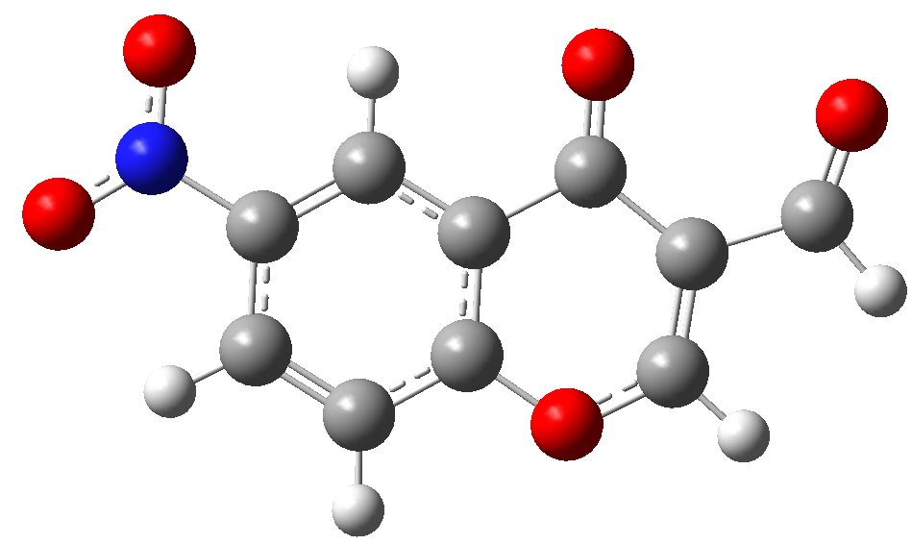
Center  Number | Atom | Standard orientation: Coordinates (Angstroms)
Center  Number | Atom | X |  | Y | Z
1 | O | -1.324616 |  | 2.100286 | 0.000089
2 | O | -1.516922 |  | -2.002568 | 0.000033
3 | O | 4.524788 |  | -0.051728 | -0.000073
4 | O | 3.456254 |  | -1.954146 | -0.000113
5 | O | -4.414106 |  | -1.546064 | 0.000071
6 | N | 3.49568 |  | -0.72667 | -0.000085
7 | C | -0.188395 |  | -0.035103 | -0.000089
8 | C | -0.1627 |  | 1.365633 | 0.000007
9 | C | 1.03035 |  | -0.724508 | -0.000107
10 | C | -1.479673 |  | -0.783379 | -0.000218
11 | C | 2.211788 |  | -0.002432 | -0.000052
12 | C | 1.03306 |  | 2.090977 | 0.000062
13 | C | -2.666424 |  | 0.103427 | 0.000037
14 | C | 2.232799 |  | 1.398755 | 0.000029
15 | C | -2.500504 |  | 1.449634 | 0.000126
16 | C | -4.066453 |  | -0.387359 | 0.000174
17 | H | 1.028268 |  | -1.807648 | -0.000185
18 | H | 1.000488 |  | 3.174448 | 0.000139
19 | H | 3.184901 |  | 1.913632 | 0.00007
20 | H | -3.331025 |  | 2.149392 | 0.000276
21 | H | -4.818663 |  | 0.436756 | 0.000427

Table S14. Optimized structure for 7-Bromo-3-formylchromone (14) and cartesian Z-matrix.

7-Bromo-3-formylchromone (14) |  |  | 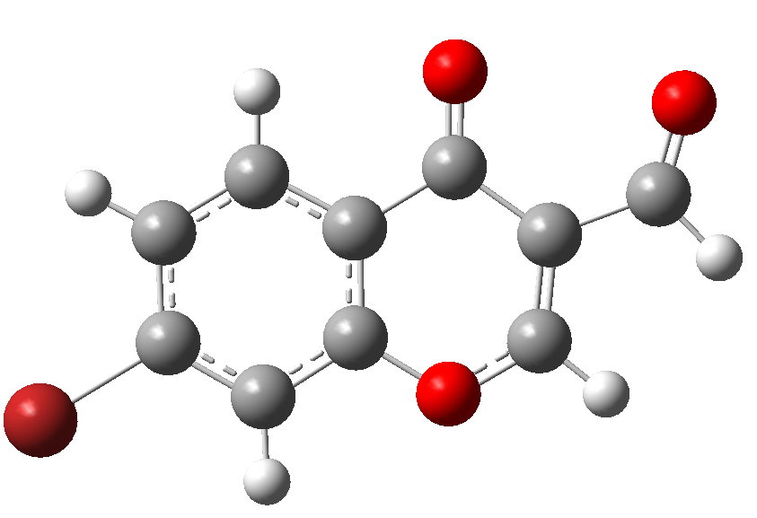
Center  Number | Atom | Standard orientation: Coordinates (Angstroms)
Center  Number | Atom | X |  | Y | Z
1 | Br | 3.803965 |  | -0.123959 | 0.000437
2 | O | -1.107537 |  | -1.836646 | -0.000336
3 | O | -2.801851 |  | 1.908127 | -0.000099
4 | O | -5.326032 |  | 0.407435 | -0.000332
5 | C | -0.840532 |  | 0.571509 | -0.000123
6 | C | -0.299199 |  | -0.718427 | -0.00016
7 | C | -2.312722 |  | 0.788524 | -0.000339
8 | C | 0.046605 |  | 1.659003 | 0.000091
9 | C | -3.088877 |  | -0.473538 | -0.000421
10 | C | 1.076507 |  | -0.95191 | -0.000001
11 | C | 1.418751 |  | 1.461635 | 0.000258
12 | C | 1.918821 |  | 0.151402 | 0.000209
13 | C | -2.437146 |  | -1.664605 | -0.000445
14 | C | -4.568949 |  | -0.537166 | -0.000503
15 | H | -0.382027 |  | 2.655684 | 0.000113
16 | H | 1.457868 |  | -1.965359 | -0.000033
17 | H | 2.103492 |  | 2.301265 | 0.000419
18 | H | -2.953699 |  | -2.62022 | -0.000538
19 | H | -4.960617 |  | -1.582682 | -0.000511

Table S15. Optimized structure for 6,8-dichloro-3-formylchromone (15) and cartesian Z-matrix.

6,8-dichloro-3-formylchromone (15) |  |  | 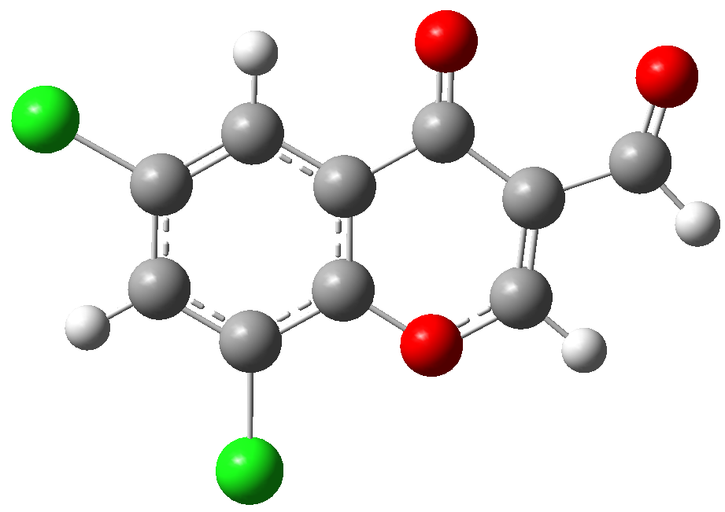
Center  Number | Atom | Standard orientation: Coordinates (Angstroms)
Center  Number | Atom | X |  | Y | Z
1 | Cl | 3.404141 |  | -2.23525 | -0.000302
2 | O | -0.902131 |  | 1.789089 | -0.000026
3 | O | -1.965333 |  | -2.174486 | 0.000282
4 | O | -4.698537 |  | -1.110206 | 0.000877
5 | C | -0.244322 |  | -0.540036 | -0.000304
6 | C | 0.072251 |  | 0.822798 | -0.000183
7 | C | 2.428043 |  | 0.301103 | -0.000168
8 | C | 1.409995 |  | 1.245594 | -0.000131
9 | C | 0.785415 |  | -1.489612 | -0.000319
10 | C | -1.66943 |  | -0.990478 | -0.000555
11 | C | 2.103361 |  | -1.062501 | -0.000251
12 | C | -2.638054 |  | 0.127117 | 0.000122
13 | C | -2.187225 |  | 1.407491 | 0.000173
14 | C | -4.109572 |  | -0.053038 | 0.000676
15 | H | 0.516079 |  | -2.539191 | -0.000432
16 | H | -2.847654 |  | 2.269559 | 0.000501
17 | H | -4.66782 |  | 0.913166 | 0.001195
18 | Cl | 1.793644 |  | 2.946349 | 0.000033
19 | H | 3.462302 |  | 0.62197 | -0.000118

Table S16. Optimized structure for 6,7-dichloro-3-formylchromone (16) and cartesian Z-matrix.

6,7-dichloro-3-formylchromone (16) |  |  | 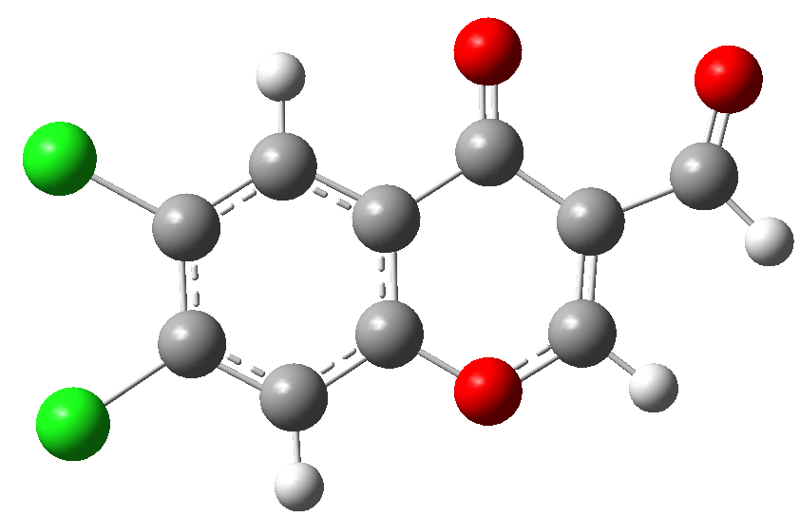
Center  Number | Atom | Standard orientation: Coordinates (Angstroms)
Center  Number | Atom | X |  | Y | Z
1 | Cl | -3.130891 |  | 1.911815 | -0.000267
2 | Cl | -3.738386 |  | -1.248 | -0.000112
3 | O | 1.247083 |  | -2.036988 | 0.000177
4 | O | 2.221852 |  | 1.957401 | -0.000024
5 | O | 4.978049 |  | 0.948987 | 0.000218
6 | C | 0.542519 |  | 0.279885 | 0.00001
7 | C | 0.249064 |  | -1.086577 | 0.000075
8 | C | 1.950639 |  | 0.767011 | 0.000049
9 | C | -0.523285 |  | 1.187569 | -0.000097
10 | C | -1.060854 |  | -1.560218 | 0.000039
11 | C | 2.943837 |  | -0.331554 | 0.000162
12 | C | -1.837463 |  | 0.743119 | -0.000133
13 | C | -2.106176 |  | -0.643234 | -0.000064
14 | C | 2.522818 |  | -1.622502 | 0.000217
15 | C | 4.4109 |  | -0.120119 | 0.000223
16 | H | -0.290766 |  | 2.246509 | -0.00015
17 | H | -1.255177 |  | -2.625654 | 0.000091
18 | H | 3.206154 |  | -2.466744 | 0.000301
19 | H | 4.989644 |  | -1.074456 | 0.000345

Table S17. Optimized structure for Myricetin (17) and cartesian Z-matrix.

Myricetin (17) |  |  | 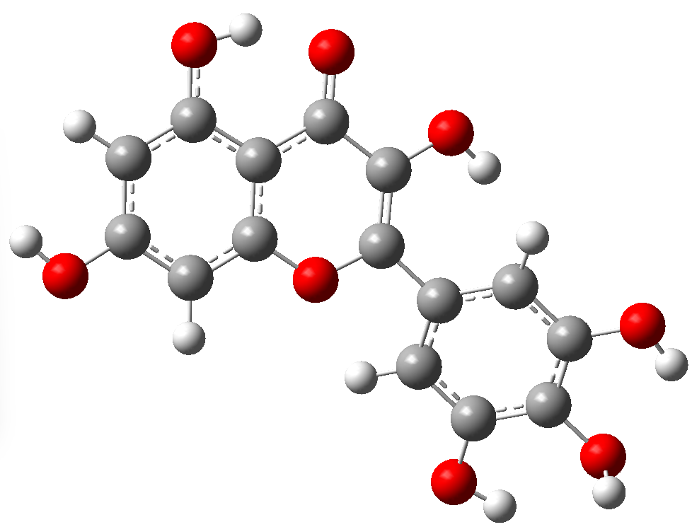
Center  Number | Atom | Standard orientation: Coordinates (Angstroms)
Center  Number | Atom | X |  | Y | Z
1 | O | 0.565043 |  | -0.7672 | -0.139044
2 | O | -0.298822 |  | 2.733007 | 0.498232
3 | O | 4.688201 |  | 1.658209 | 0.210537
4 | O | 2.398239 |  | 2.841966 | 0.428194
5 | O | 4.645751 |  | -3.060268 | -0.502598
6 | O | -3.934535 |  | -2.562958 | 1.0467
7 | O | -4.772698 |  | 1.627687 | -1.092902
8 | O | -5.732818 |  | -0.752731 | -0.041782
9 | C | 2.590414 |  | 0.511032 | 0.044875
10 | C | -0.187123 |  | 0.367876 | 0.027887
11 | C | 1.927801 |  | -0.71655 | -0.132996
12 | C | -1.63421 |  | 0.083413 | -0.001479
13 | C | 0.389068 |  | 1.586649 | 0.252351
14 | C | 1.847609 |  | 1.735081 | 0.252212
15 | C | 4.016813 |  | 0.515161 | 0.03912
16 | C | 2.606223 |  | -1.915114 | -0.317373
17 | C | -2.533119 |  | 1.017866 | -0.550529
18 | C | -2.103678 |  | -1.126347 | 0.534131
19 | C | 4.003628 |  | -1.875692 | -0.320163
20 | C | 4.711747 |  | -0.677768 | -0.144736
21 | C | -3.470118 |  | -1.401615 | 0.518146
22 | C | -3.900469 |  | 0.733274 | -0.560975
23 | C | -4.360418 |  | -0.481257 | -0.046542
24 | H | 2.074459 |  | -2.847175 | -0.456754
25 | H | -2.191174 |  | 1.92736 | -1.030855
26 | H | -1.422226 |  | -1.8471 | 0.967277
27 | H | 5.797293 |  | -0.657856 | -0.147516
28 | H | -1.223435 |  | 2.515073 | 0.689429
29 | H | 3.998448 |  | 2.371409 | 0.3299
30 | H | 5.600434 |  | -2.910127 | -0.487291
31 | H | -4.902795 |  | -2.500389 | 1.06861
32 | H | -5.666948 |  | 1.30331 | -0.900274
33 | H | -5.955956 |  | -1.232261 | -0.854808

Table S18. Optimized structure for Vitexin (18) and cartesian Z-matrix.

Vitexin (18) |  |  | 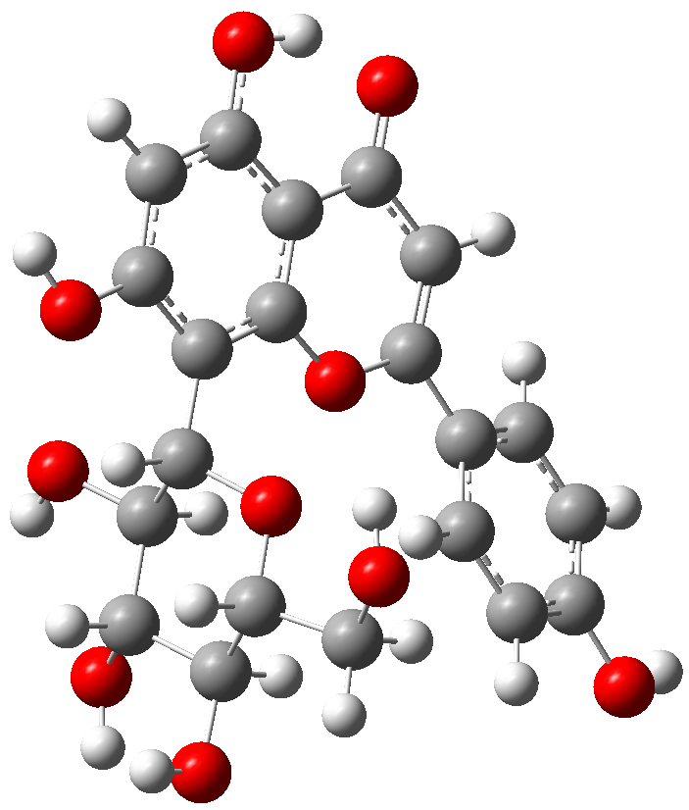
Center  Number | Atom | Standard orientation: Coordinates (Angstroms)
Center  Number | Atom | X |  | Y | Z
1 | O | -0.042847 |  | -1.730131 | -0.977243
2 | O | 1.015898 |  | -2.003735 | 2.510458
3 | O | -1.672172 |  | -2.911813 | 2.619615
4 | O | -2.725548 |  | -4.015378 | 0.168269
5 | O | 0.351794 |  | 0.958776 | 0.053026
6 | O | -0.877544 |  | -2.56247 | -3.489225
7 | O | 3.608121 |  | -2.459198 | -0.06818
8 | O | 5.00003 |  | 2.087191 | -0.212543
9 | O | 3.173672 |  | 3.895555 | -0.160414
10 | O | -5.639782 |  | 2.774965 | 0.025015
11 | C | 0.099575 |  | -1.839028 | 1.441954
12 | C | -0.916045 |  | -2.980308 | 1.419658
13 | C | 0.88976 |  | -1.849704 | 0.118095
14 | C | -1.810766 |  | -2.916085 | 0.182766
15 | C | -0.94564 |  | -2.835206 | -1.081004
16 | C | 1.947414 |  | -0.780209 | 0.005834
17 | C | -1.734313 |  | -2.615208 | -2.366509
18 | C | 1.671056 |  | 0.591757 | -0.010357
19 | C | 3.311035 |  | -1.130691 | -0.066073
20 | C | 2.664032 |  | 1.582297 | -0.081734
21 | C | 4.334709 |  | -0.179955 | -0.138629
22 | C | 4.02593 |  | 1.17742 | -0.144006
23 | C | 2.306038 |  | 2.992448 | -0.098994
24 | C | -0.025299 |  | 2.267682 | 0.016011
25 | C | 0.888316 |  | 3.272068 | -0.061854
26 | C | -1.485855 |  | 2.418005 | 0.04295
27 | C | -2.085738 |  | 3.61612 | 0.461429
28 | C | -2.317321 |  | 1.357718 | -0.365416
29 | C | -3.467984 |  | 3.758912 | 0.462894
30 | C | -3.698032 |  | 1.493544 | -0.36825
31 | C | -4.281733 |  | 2.697669 | 0.045721
32 | H | -0.447343 |  | -0.890551 | 1.530507
33 | H | -0.346092 |  | -3.928606 | 1.383251
34 | H | 1.395208 |  | -2.820031 | 0.046141
35 | H | -2.440833 |  | -2.022163 | 0.249601
36 | H | -0.362885 |  | -3.769407 | -1.184059
37 | H | -2.331951 |  | -1.693882 | -2.263744
38 | H | -2.429066 |  | -3.446033 | -2.515932
39 | H | 0.479992 |  | -2.145053 | 3.304182
40 | H | -2.414903 |  | -3.524196 | 2.511757
41 | H | -2.210389 |  | -4.825507 | 0.037543
42 | H | 5.376353 |  | -0.482117 | -0.190398
43 | H | -0.184703 |  | -1.925556 | -3.259605
44 | H | 0.57064 |  | 4.304068 | -0.130367
45 | H | 4.567409 |  | -2.568811 | -0.101645
46 | H | 4.542167 |  | 2.979651 | -0.206221
47 | H | -1.47076 |  | 4.438442 | 0.81151
48 | H | -1.861878 |  | 0.430063 | -0.69348
49 | H | -3.917487 |  | 4.690344 | 0.799089
50 | H | -4.342975 |  | 0.683668 | -0.69169
51 | H | -5.918287 |  | 3.650107 | 0.326425

Table S19. Optimized structure for Dapagliflozin (ref. drug) and cartesian Z-matrix.

Vitexin (18)
Center  Number | Atom | Standard orientation: Coordinates (Angstroms)
Center  Number | Atom | X |  | Y | Z
1 | O | -0.042847 |  | -1.730131 | -0.977243
2 | O | 1.015898 |  | -2.003735 | 2.510458
3 | O | -1.672172 |  | -2.911813 | 2.619615
4 | O | -2.725548 |  | -4.015378 | 0.168269
5 | O | 0.351794 |  | 0.958776 | 0.053026
6 | O | -0.877544 |  | -2.56247 | -3.489225
7 | O | 3.608121 |  | -2.459198 | -0.06818
8 | O | 5.00003 |  | 2.087191 | -0.212543
9 | O | 3.173672 |  | 3.895555 | -0.160414
10 | O | -5.639782 |  | 2.774965 | 0.025015
11 | C | 0.099575 |  | -1.839028 | 1.441954
12 | C | -0.916045 |  | -2.980308 | 1.419658
13 | C | 0.88976 |  | -1.849704 | 0.118095
14 | C | -1.810766 |  | -2.916085 | 0.182766
15 | C | -0.94564 |  | -2.835206 | -1.081004
16 | C | 1.947414 |  | -0.780209 | 0.005834
17 | C | -1.734313 |  | -2.615208 | -2.366509
18 | C | 1.671056 |  | 0.591757 | -0.010357
19 | C | 3.311035 |  | -1.130691 | -0.066073
20 | C | 2.664032 |  | 1.582297 | -0.081734
21 | C | 4.334709 |  | -0.179955 | -0.138629
22 | C | 4.02593 |  | 1.17742 | -0.144006
23 | C | 2.306038 |  | 2.992448 | -0.098994
24 | C | -0.025299 |  | 2.267682 | 0.016011
25 | C | 0.888316 |  | 3.272068 | -0.061854
26 | C | -1.485855 |  | 2.418005 | 0.04295
27 | C | -2.085738 |  | 3.61612 | 0.461429
28 | C | -2.317321 |  | 1.357718 | -0.365416
29 | C | -3.467984 |  | 3.758912 | 0.462894
30 | C | -3.698032 |  | 1.493544 | -0.36825
31 | C | -4.281733 |  | 2.697669 | 0.045721
32 | H | -0.447343 |  | -0.890551 | 1.530507
33 | H | -0.346092 |  | -3.928606 | 1.383251
34 | H | 1.395208 |  | -2.820031 | 0.046141
35 | H | -2.440833 |  | -2.022163 | 0.249601
36 | H | -0.362885 |  | -3.769407 | -1.184059
37 | H | -2.331951 |  | -1.693882 | -2.263744
38 | H | -2.429066 |  | -3.446033 | -2.515932
39 | H | 0.479992 |  | -2.145053 | 3.304182
40 | H | -2.414903 |  | -3.524196 | 2.511757
41 | H | -2.210389 |  | -4.825507 | 0.037543
42 | H | 5.376353 |  | -0.482117 | -0.190398
43 | H | -0.184703 |  | -1.925556 | -3.259605
44 | H | 0.57064 |  | 4.304068 | -0.130367
45 | H | 4.567409 |  | -2.568811 | -0.101645
46 | H | 4.542167 |  | 2.979651 | -0.206221
47 | H | -1.47076 |  | 4.438442 | 0.81151
48 | H | -1.861878 |  | 0.430063 | -0.69348
49 | H | -3.917487 |  | 4.690344 | 0.799089
50 | H | -4.342975 |  | 0.683668 | -0.69169
51 | H | -5.918287 |  | 3.650107 | 0.326425

Table S20. Selected Bond Distances (Å) and Angles (deg) for 3-Formyl Chromone Derivatives^{a,b}
Bond type | B3LYP/  6-31G  (d,p) | B3LYP/  6-311++ (d,p) | B3LYP/  6-311G  (d,p) | Exptl^{c}
14 | Bond Distances (Å)
C₇-Br  C₂-O₁  C₃-CHO | 1.905(0.010)  1.338(0.007)  1.480(0.006) | 1.905(0.010)  1.337(0.008)  1.482(0.008) | 1.911(0.016)  1.338(0.007)  1.483(0.009) | 1.895  1.345  1.474
14 | Bond Angles (deg)
C₇-C₆-Br  C₂-O₁-C₁₀  C₄-C₃-CHO  MD | 119.2(0.0)  118.5(0.5)  124.0(4.0)  0.753 | 119.3(0.1)  118.6(0.6)  124.6(4.6)  0.887 | 119.2(0.0)  118.5(0.5)  124.1(4.1)  0.772 | 119.2  118.0  120.0
15 | Bond Distances (Å)
C₆-Cl₁  C₃-CHO  C₂-O₁ | 1.751(0.011)  1.482(0.008)  1.340(0.004) | 1.751(0.011)  1.483(0.007)  1.336(0.008) | 1.751(0.011)  1.484(0.006)  1.338(0.006) | 1.740  1.490  1.344
 | Bond Angles (deg)
C₆-C₅-Cl₁  C₆-C₇-Cl₁  C₄-C₃-CHO | 120.0(0.3)  118.6(1.6)  123.9(3.8) | 120.0(0.3)  118.6(1.6)  124.5(3.8) | 120.0(0.3)  118.6(1.6)  124.0(3.3) | 120.3  117.0  120.7
MD | 0.953 | 0.954 | 0.870
16 | Bond Distances (Å)
C₆-Cl₁  C₃-CHO  C₂-O₁ | 1.743(0.028)  1.482(0.004)  1.341(0.003) | 1.743(0.028)  1.483(0.005)  1.337(0.007) | 1.744(0.029)  1.483(0.005)  1.339(0.005) | 1.715  1.478  1.344
16 | Bond Angles (deg)
C₆-C₅-Cl₁  Cl₁-C₆-C₇  C₄-C₃-CHO | 119.2(0.3)  121.1(0.7)  123.9(4.8) | 119.2(0.3)  121.1(0.7)  124.5(4.8) | 119.2(0.3)  121.1(0.7)  123.9(4.2) | 119.5  120.4  119.7
MD | 0.972 | 0.973 | 0.873

Table S21. Ligand-protein 2D interaction for 6-Isopropyl-3-formylchromone with different proteins.

Protein | Amino acid residue | Bond category | Bond type | Bond Distance | 2D diagram of interaction
CAD | PHE A:114  PHE A:114 | Hydrophobic | Pi-Pi Stacked  Pi-Pi Stacked | 6.03  4.51 | 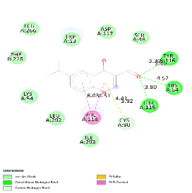
CAD | CYS A:90 | Miscellaneous | Pi-Sulfur | 4.41
CAD | THR A:115  HIS A: 64  TYR A: 116  TYR A: 116  CYS A:90 | Hydrogen  bond | Conventional Hydrogen bond  Conventional Hydrogen bond  Conventional Hydrogen bond  Carbon Hydrogen bond  Carbon Hydrogen bond | 3.80  4.52  3.40  3.30  3.92
IDE | TYR A:269  TYR A:269  LEU A:156  ALA A:434 | Hydrophobic | Pi-Pi Stacked  Pi-Pi Stacked  Pi-Alkyl  Alkyl | 4.63  5.00  4.43  5.03 | 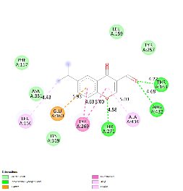
IDE | THR A:271  ARG A:432  THR A:163 | Hydrogen bond | Conventional Hydrogen bond  Conventional Hydrogen bond  Conventional Hydrogen bond | 4.58  4.68  4.22
IDE | GLU A:160 | Miscellaneous | Pi-Anion | 5.93
P53 | TRP B:146  TRP B:146  TRP B:146  PRO A:191 | Hydrophobic | Pi-Pi Stacked  Pi-Pi Stacked  Pi-Sigma  Pi-Alkyl | 6.81  5.00  5.42  4.10 | 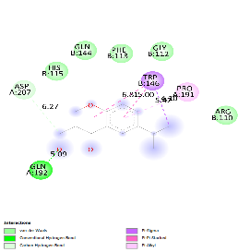
P53 | GLN A:192  ASP A:207 | Hydrogen bond | Conventional Hydrogen bond  Carbon Hydrogen bond | 5.09  6.27
BHK | TYR A:384  TYR A:384  LEU A:446  ILE A:416 | Hydrophobic | Pi-Pi Stacked  Pi-Pi Stacked  Pi-Alkyl  Pi-Alkyl | 5.48  4.19  4.89  4.98 | 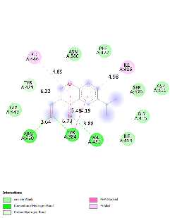
BHK | ARG A:430  TYR A:384  VAL A:431  TYR A:429 | Hydrogen bond | Conventional Hydrogen bond  Conventional Hydrogen bond  Conventional Hydrogen bond  Carbon Hydrogen bond | 3.64  6.73  3.88  6.33
HIF-α | HIS A:199  TYR A:102  LEU A:188  ILE A:281 | Hydrophobic | Pi-Sigma  Pi-Sigma  Pi-Alkyl  Pi-Alkyl | 4.90  4.26  5.95  6.03 | 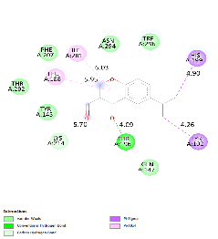
HIF-α | THR A:196  LYS A:214 | Hydrogen bond | Conventional Hydrogen bond  Carbon Hydrogen bond | 4.09  5.70
Mpro | THR A:111  GLN A:110  THR A:292 | Hydrogen bond | Conventional Hydrogen bond  Conventional Hydrogen bond  Conventional Hydrogen bond | 4.15  3.31  4.40 | 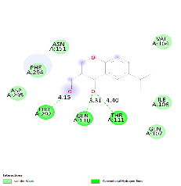
COX 1 | ALA A:202 | Hydrophobic | Amide-Pi Stacked | 5.04 | 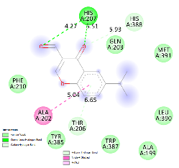
COX 1 | HIS A:207  HIS A:207  THR A:206  HIS A:388 | Hydrogen bond | Conventional Hydrogen bond  Conventional Hydrogen bond  Carbon Hydrogen bond  Pi-Donor Hydrogen bond | 4.27  5.51  6.65  5.93

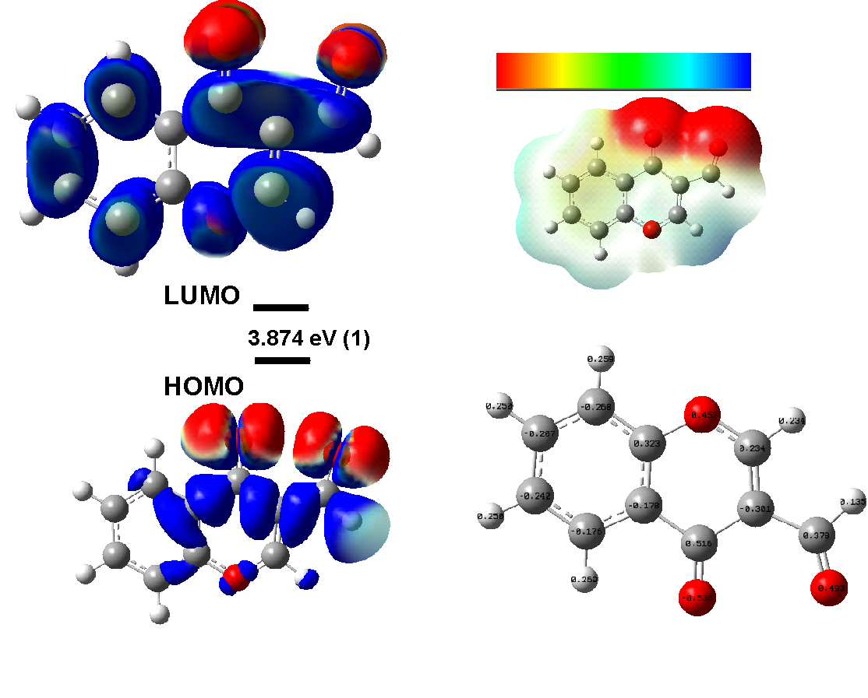

Figure S1. (a) The molecular orbitals of the HOMO and LUMO with Egap; (b) Maps of electrostatic potential (0.02 electrons Bohr−3 surface) (red = electron-rich, blue = electron-deficient) for compound 1. Regions of respective colours indicating electrophilic (blue) and nucleophilic (red) sites and partial nucleophilic sites (yellow regions); (c) NBO charges structures for compound 1.

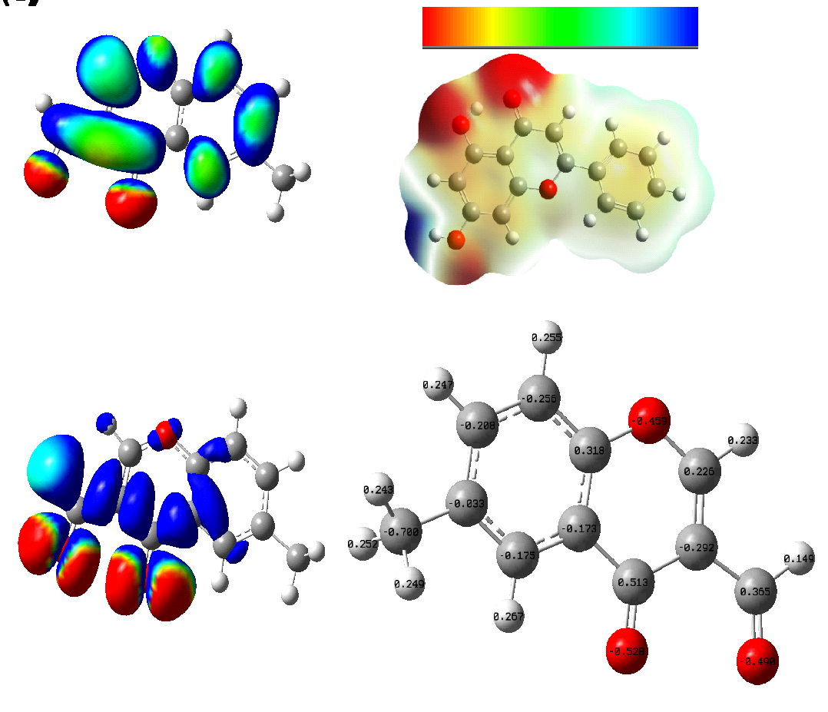

Figure S2. (a) The molecular orbitals of the HOMO and LUMO with Egap; (b) Maps of electrostatic potential (0.02 electrons Bohr−3 surface) (red = electron-rich, blue = electron-deficient) for compound 2. Regions of respective colours indicating electrophilic (blue) and nucleophilic (red) sites and partial nucleophilic sites (yellow regions); (c) NBO charges structures for compound 2.

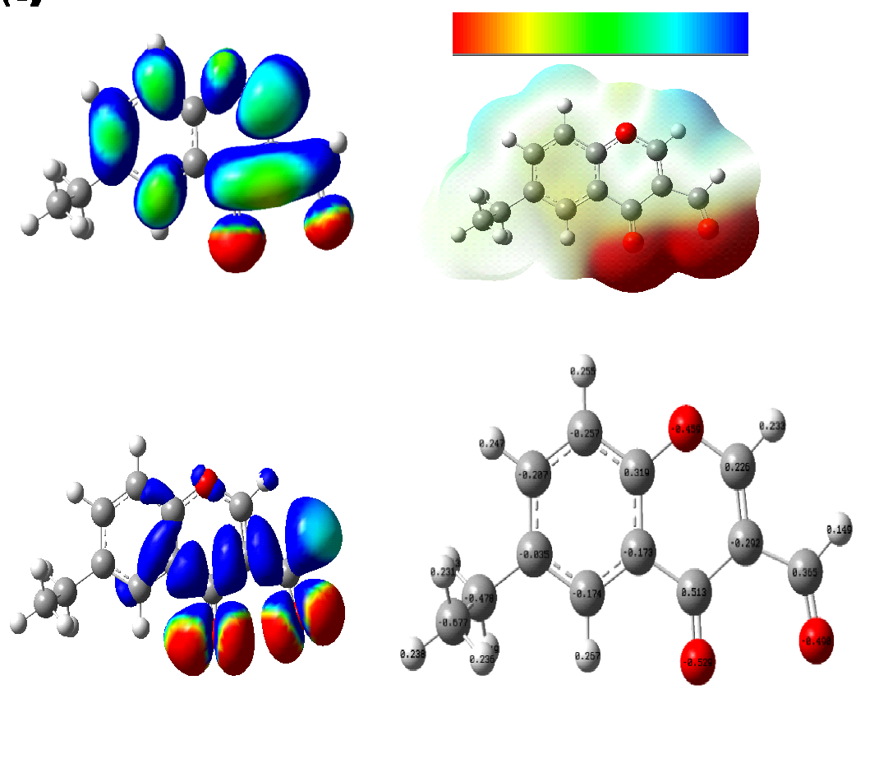

Figure S3. (a) The molecular orbitals of the HOMO and LUMO with Egap; (b) Maps of electrostatic potential (0.02 electrons Bohr−3 surface) (red = electron-rich, blue = electron-deficient) for compound 3. Regions of respective colours indicating electrophilic (blue) and nucleophilic (red) sites and partial nucleophilic sites (yellow regions); (c) NBO charges structures for compound 3.

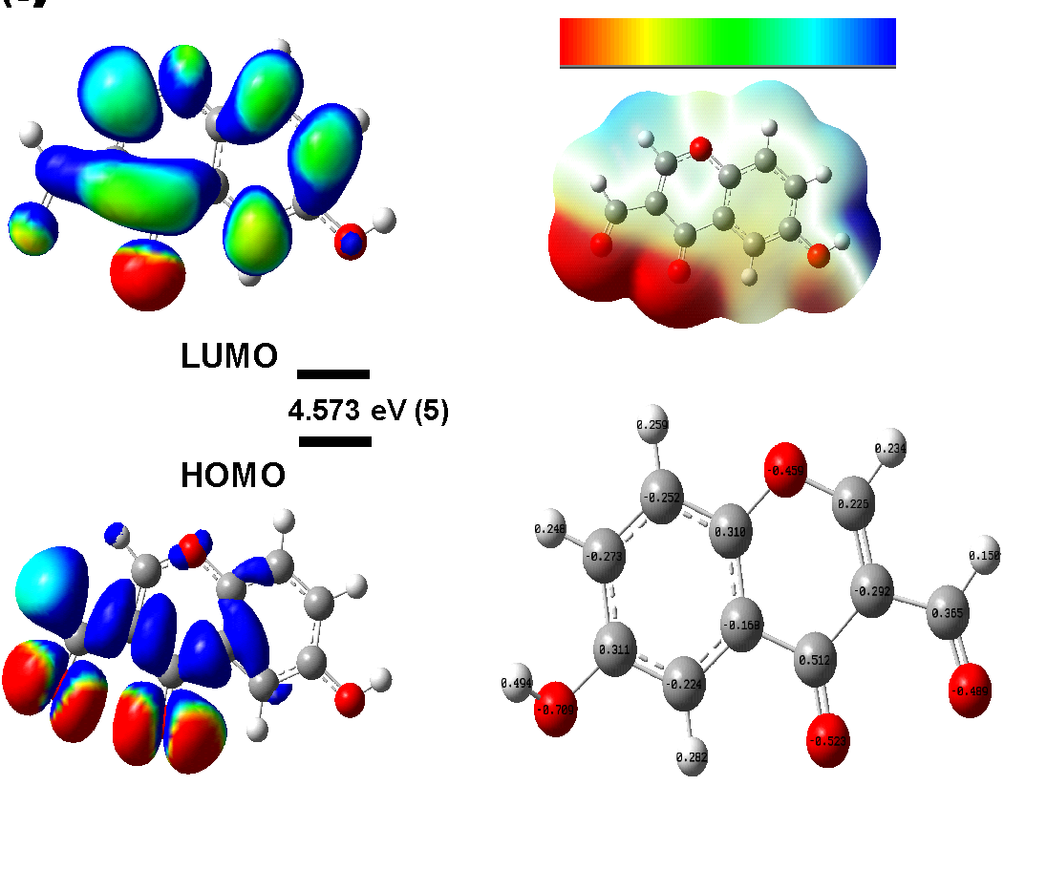

Figure S4. (a) The molecular orbitals of the HOMO and LUMO with Egap; (b) Maps of electrostatic potential (0.02 electrons Bohr−3 surface) (red = electron-rich, blue = electron-deficient) for compound 5. Regions of respective colours indicating electrophilic (blue) and nucleophilic (red) sites and partial nucleophilic sites (yellow regions); (c) NBO charges structures for compound 5.

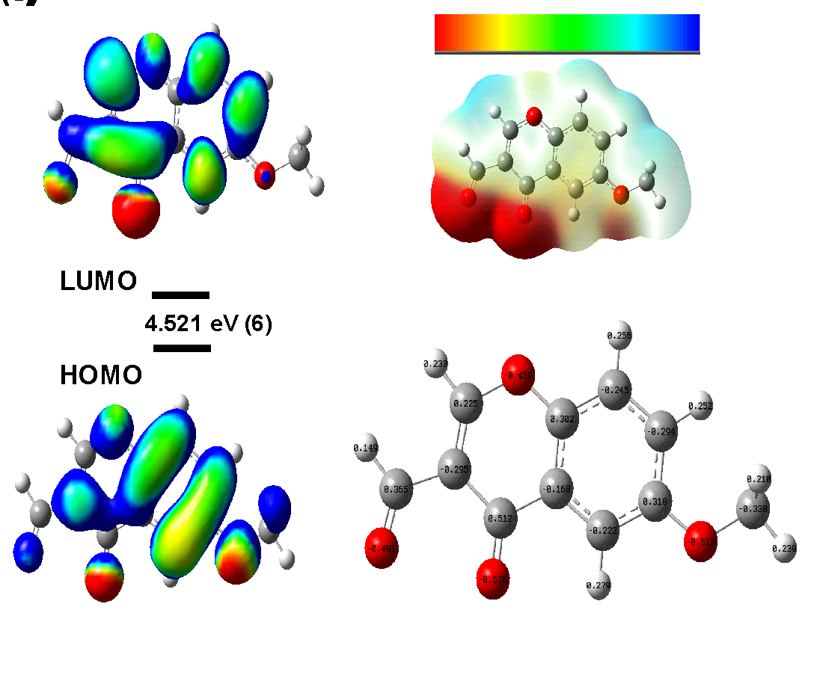
Figure S5. (a) The molecular orbitals of the HOMO and LUMO with Egap; (b) Maps of electrostatic potential (0.02 electrons Bohr−3 surface) (red = electron-rich, blue = electron-deficient) for compound 6. Regions of respective colours indicating electrophilic (blue) and nucleophilic (red) sites and partial nucleophilic sites (yellow regions); (c) NBO charges structures for compound 6.

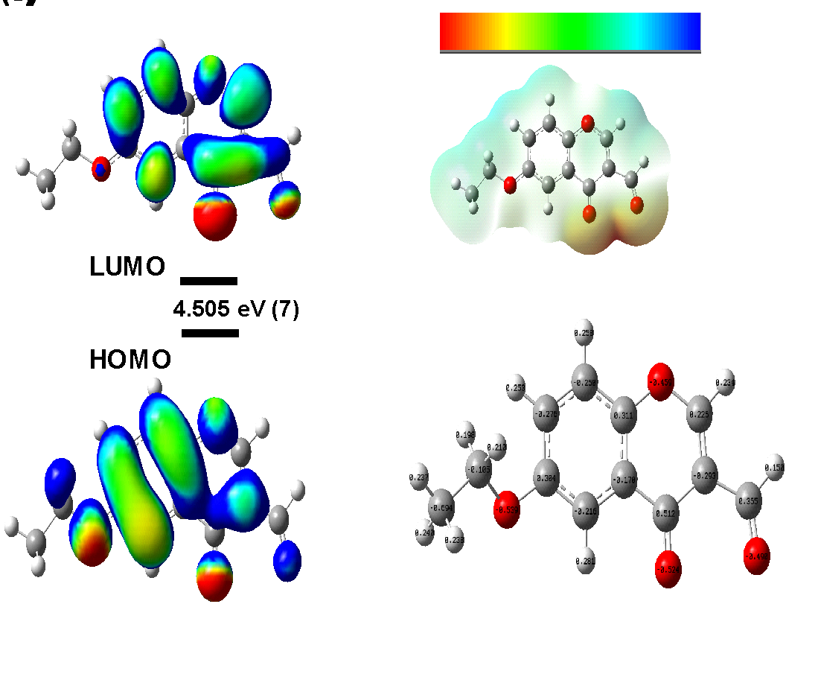
Figure S6. (a) The molecular orbitals of the HOMO and LUMO with Egap; (b) Maps of electrostatic potential (0.02 electrons Bohr−3 surface) (red = electron-rich, blue = electron-deficient) for compound 7. Regions of respective colours indicating electrophilic (blue) and nucleophilic (red) sites and partial nucleophilic sites (yellow regions); (c) NBO charges structures for compound 7.
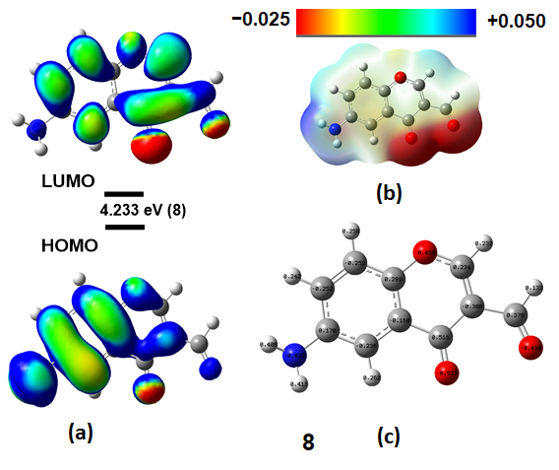

Figure S7. (a) The molecular orbitals of the HOMO and LUMO with Egap; (b) Maps of electrostatic potential (0.02 electrons Bohr−3 surface) (red = electron-rich, blue = electron-deficient) for compound 8. Regions of respective colours indicating electrophilic (blue) and nucleophilic (red) sites and partial nucleophilic sites (yellow regions); (c) NBO charges structures for compound 8.

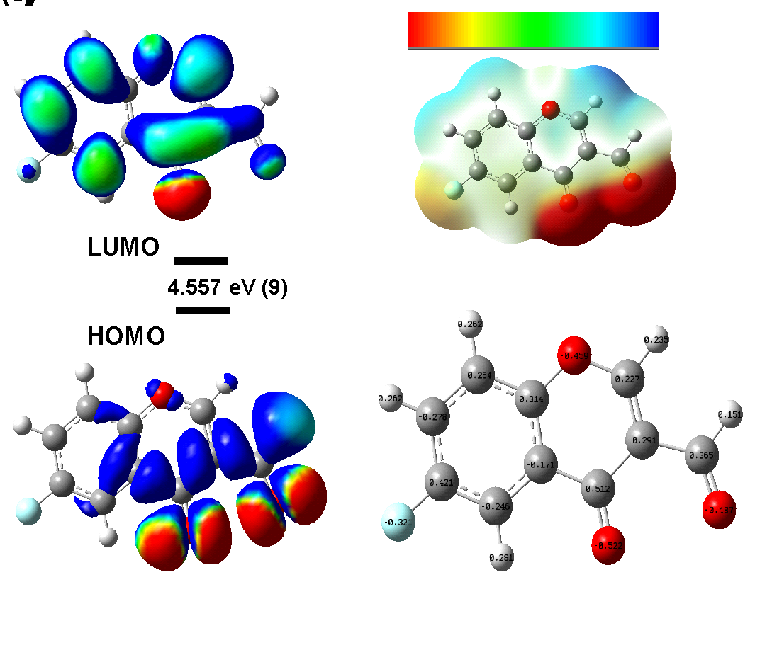
Figure S8. (a) The molecular orbitals of the HOMO and LUMO with Egap; (b) Maps of electrostatic potential (0.02 electrons Bohr−3 surface) (red = electron-rich, blue = electron-deficient) for compound 9. Regions of respective colours indicating electrophilic (blue) and nucleophilic (red) sites and partial nucleophilic sites (yellow regions); (c) NBO charges structures for compound 9.

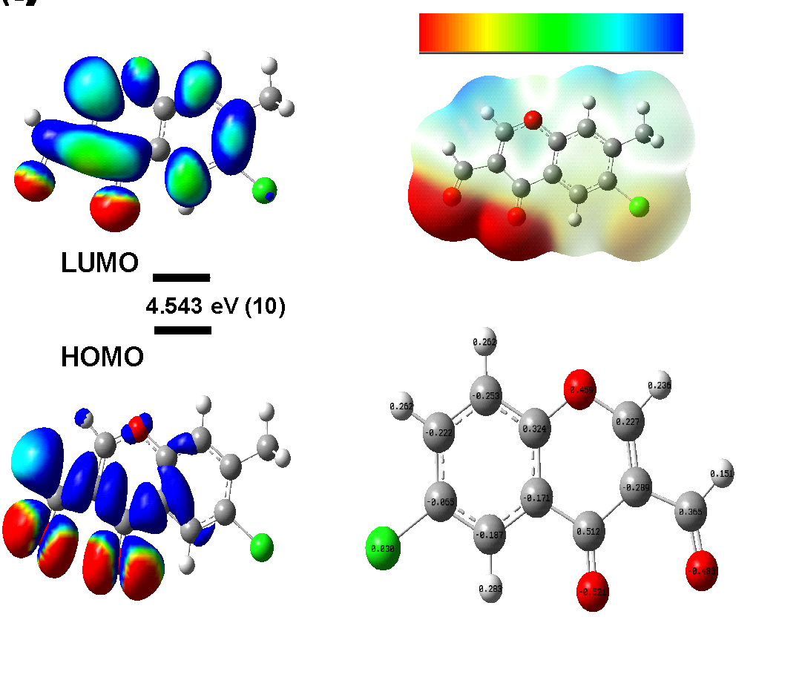

Figure S9. (a) The molecular orbitals of the HOMO and LUMO with Egap; (b) Maps of electrostatic potential (0.02 electrons Bohr−3 surface) (red = electron-rich, blue = electron-deficient) for compound 10. Regions of respective colours indicating electrophilic (blue) and nucleophilic (red) sites and partial nucleophilic sites (yellow regions); (c) NBO charges structures for compound 10.

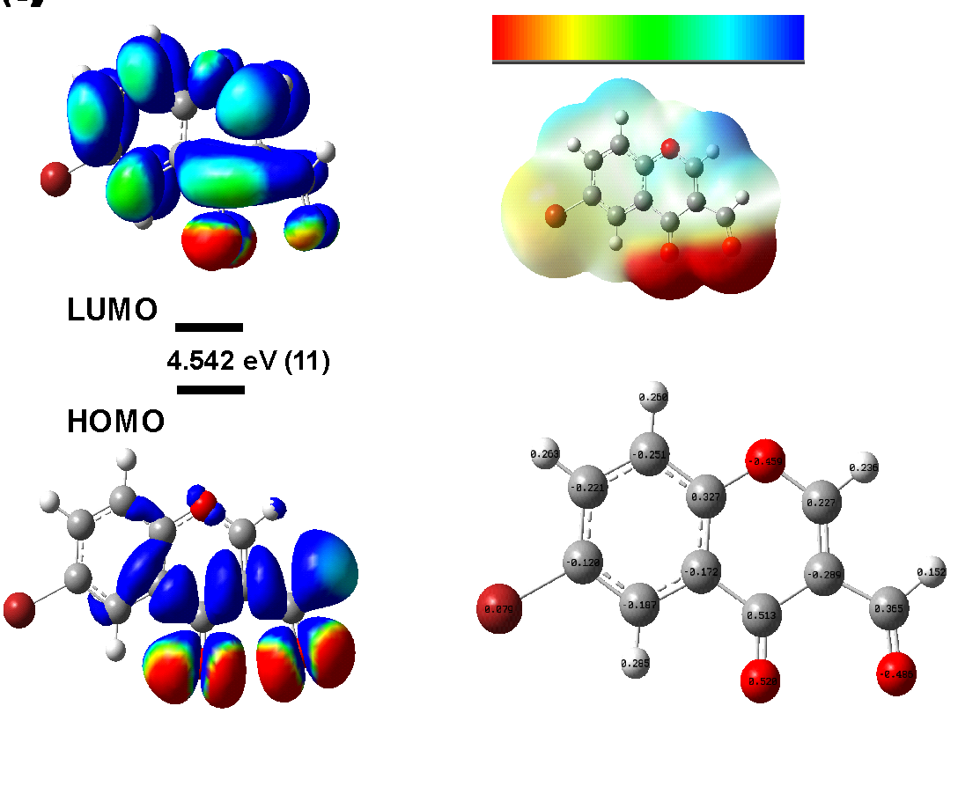

Figure S10. (a) The molecular orbitals of the HOMO and LUMO with Egap; (b) Maps of electrostatic potential (0.02 electrons Bohr−3 surface) (red = electron-rich, blue = electron-deficient) for compound 11. Regions of respective colours indicating electrophilic (blue) and nucleophilic (red) sites and partial nucleophilic sites (yellow regions); (c) NBO charges structures for compound 11.

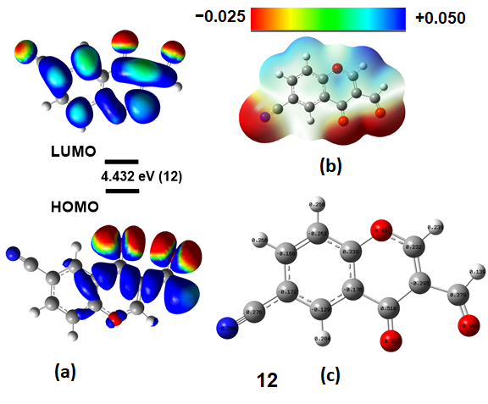
Figure S11. (a) The molecular orbitals of the HOMO and LUMO with Egap; (b) Maps of electrostatic potential (0.02 electrons Bohr−3 surface) (red = electron-rich, blue = electron-deficient) for compound 12. Regions of respective colours indicating electrophilic (blue) and nucleophilic (red) sites and partial nucleophilic sites (yellow regions); (c) NBO charges structures for compound 12.

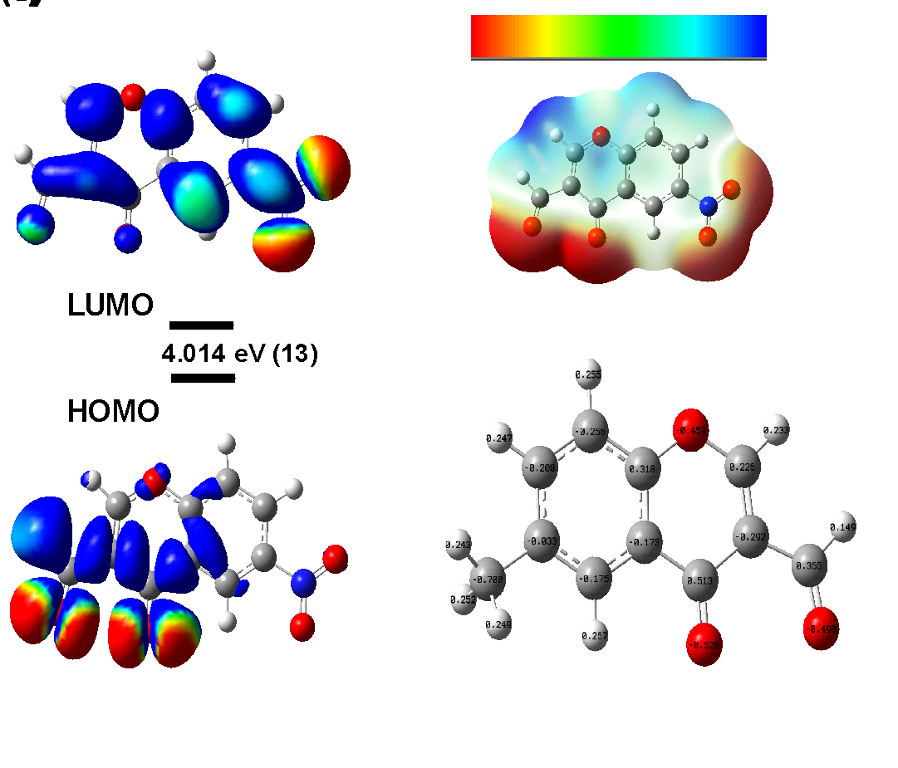

Figure S12. (a) The molecular orbitals of the HOMO and LUMO with Egap; (b) Maps of electrostatic potential (0.02 electrons Bohr−3 surface) (red = electron-rich, blue = electron-deficient) for compound 13. Regions of respective colours indicating electrophilic (blue) and nucleophilic (red) sites and partial nucleophilic sites (yellow regions); (c) NBO charges structures for compound 13.

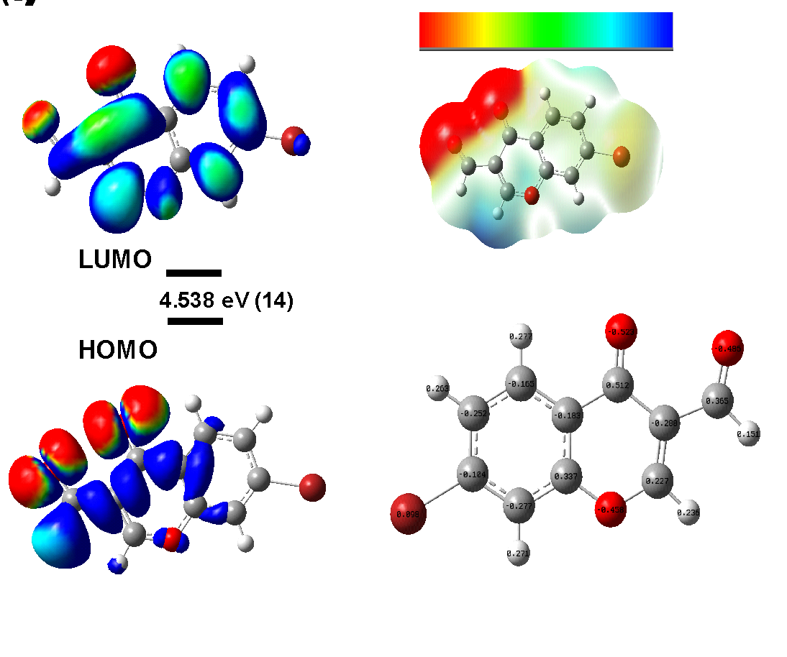

Figure S13. (a) The molecular orbitals of the HOMO and LUMO with Egap; (b) Maps of electrostatic potential (0.02 electrons Bohr−3 surface) (red = electron-rich, blue = electron-deficient) for compound 14. Regions of respective colours indicating electrophilic (blue) and nucleophilic (red) sites and partial nucleophilic sites (yellow regions); (c) NBO charges structures for compound 14.

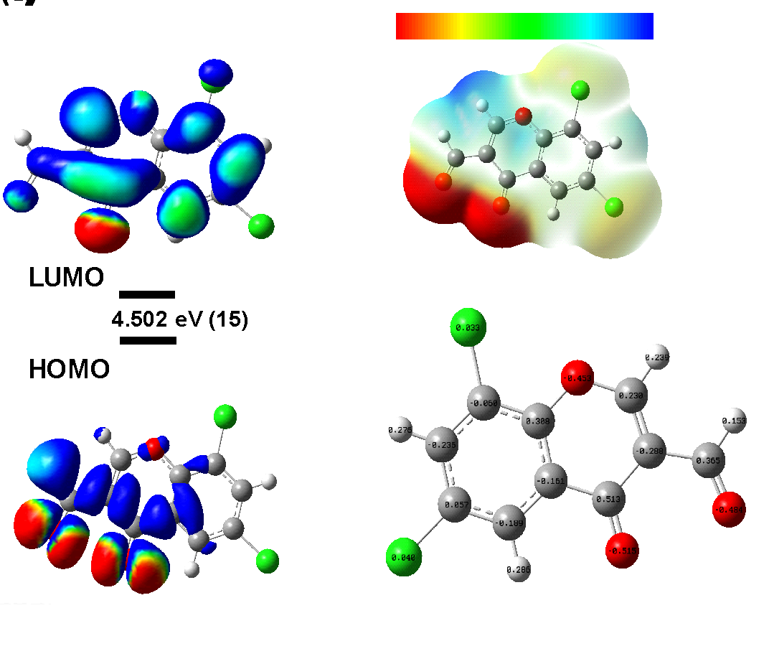
Figure S14. (a) The molecular orbitals of the HOMO and LUMO with Egap; (b) Maps of electrostatic potential (0.02 electrons Bohr−3 surface) (red = electron-rich, blue = electron-deficient) for compound 15. Regions of respective colours indicating electrophilic (blue) and nucleophilic (red) sites and partial nucleophilic sites (yellow regions); (c) NBO charges structures for compound 15.

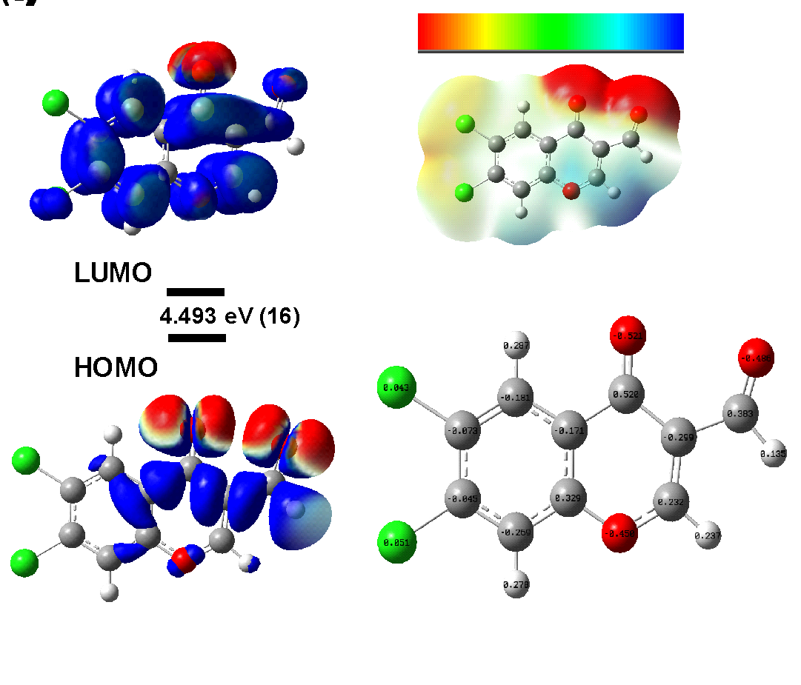
Figure S15. (a) The molecular orbitals of the HOMO and LUMO with Egap; (b) Maps of electrostatic potential (0.02 electrons Bohr−3 surface) (red = electron-rich, blue = electron-deficient) for compound 16. Regions of respective colours indicating electrophilic (blue) and nucleophilic (red) sites and partial nucleophilic sites (yellow regions); (c) NBO charges structures for compound 16.

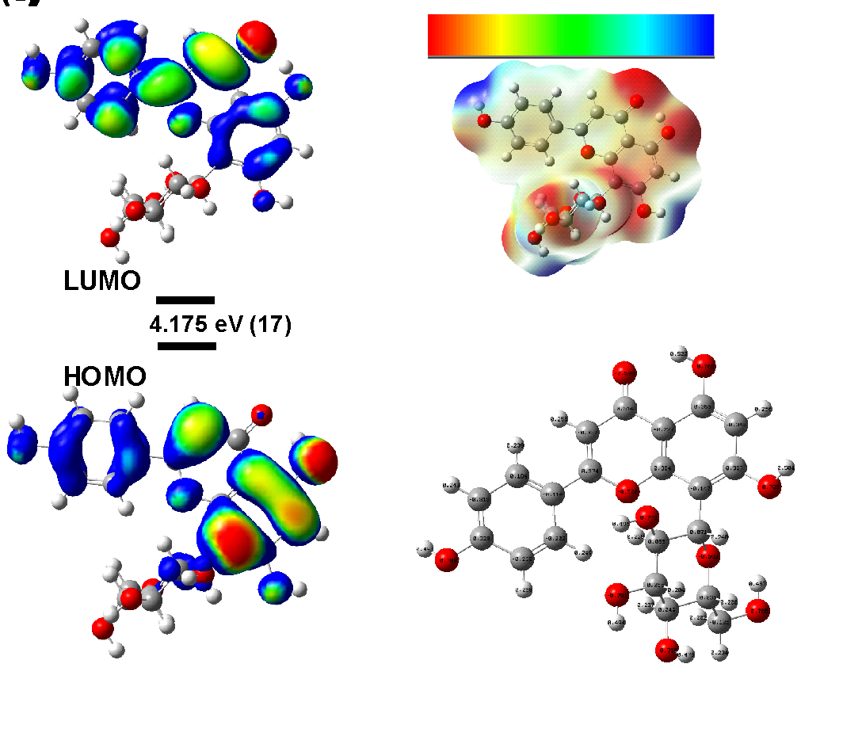
Figure S16. (a) The molecular orbitals of the HOMO and LUMO with Egap; (b) Maps of electrostatic potential (0.02 electrons Bohr−3 surface) (red = electron-rich, blue = electron-deficient) for compound vitexin (17). Regions of respective colours indicating electrophilic (blue) and nucleophilic (red) sites and partial nucleophilic sites (yellow regions); (c) NBO charges structures for compound vitexin (17).

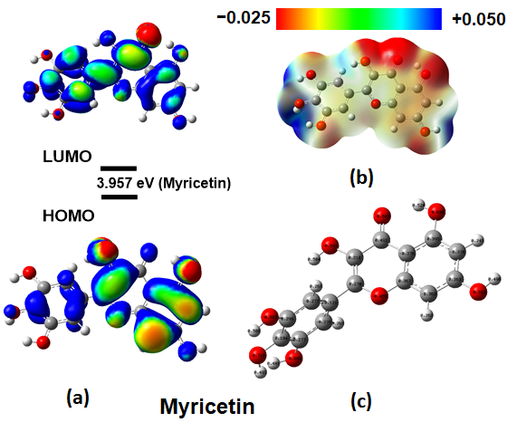
Figure S17. (a) The molecular orbitals of the HOMO and LUMO with Egap; (b) Maps of electrostatic potential (0.02 electrons Bohr−3 surface) (red = electron-rich, blue = electron-deficient) for compound myricetin (17). Regions of respective colours indicating electrophilic (blue) and nucleophilic (red) sites and partial nucleophilic sites (yellow regions); (c) NBO charges structures for compound myricetin (17).
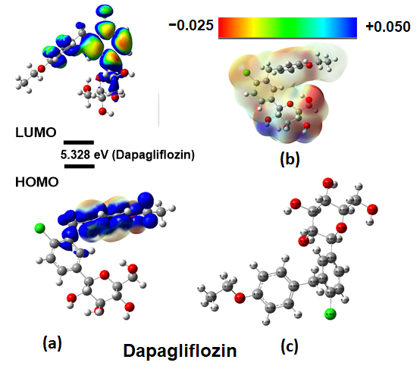
Figure S18. (a) The molecular orbitals of the HOMO and LUMO with Egap; (b) Maps of electrostatic potential (0.02 electrons Bohr−3 surface) (red = electron-rich, blue = electron-deficient) for compound dapagliflozin (18). Regions of respective colours indicating electrophilic (blue) and nucleophilic (red) sites and partial nucleophilic sites (yellow regions); (c) NBO charges structures for compound dapagliflozin (18).

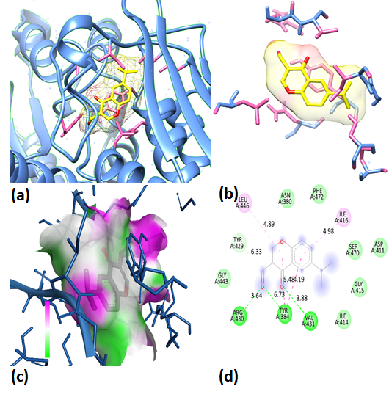

Figure S19. Molecular docking poses: (a) Ligand in protein pocket; (b) Active site; (c) Hydrogen bonding in solid; (d) Ligand-protein interaction for 2D diagram of compound 4 with PDB (3DGE).

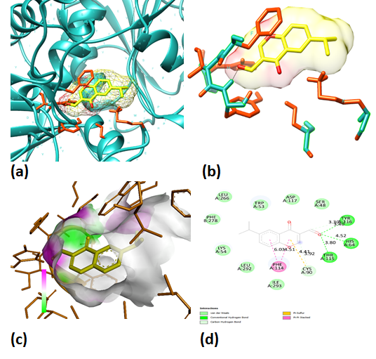
Figure S20. Molecular docking poses: (a) Ligand in protein pocket; (b) Active site; (c) Hydrogen bonding in solid; (d) Ligand-protein interaction for 2D diagram of compound 4 with PDB (3TWO).

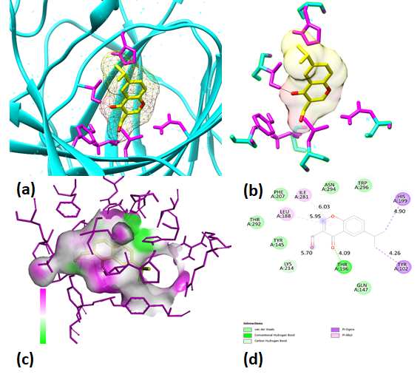
Figure S21. Molecular docking poses: (a) Ligand in protein pocket; (b) Active site; (c) Hydrogen bonding in solid; (d) Ligand-protein interaction for 2D diagram of compound 4 with PDB (2WA4).

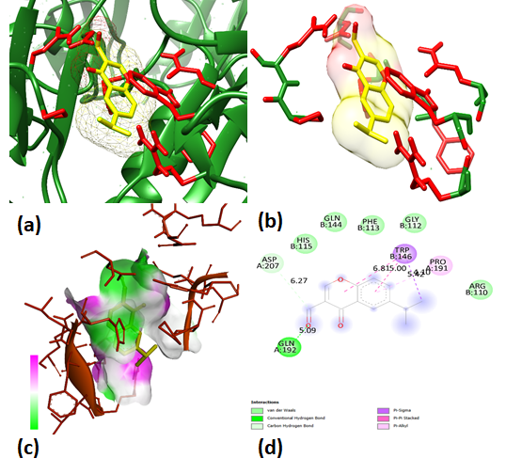

Figure S22. Molecular docking poses: (a) Ligand in protein pocket; (b) Active site; (c) Hydrogen bonding in solid; (d) Ligand-protein interaction for 2D diagram of compound 4 with PDB (7EAX).

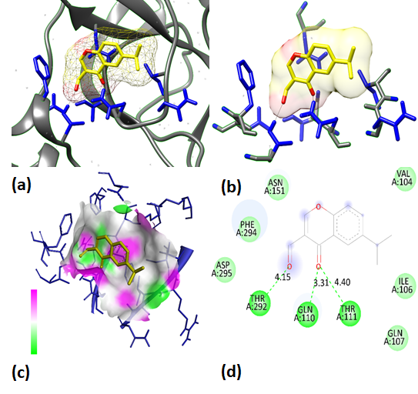

Figure S23. Molecular docking poses: (a) Ligand in protein pocket; (b) Active site; (c) Hydrogen bonding in solid; (d) Ligand-protein interaction for 2D diagram of compound 4 with PDB (6LU7).

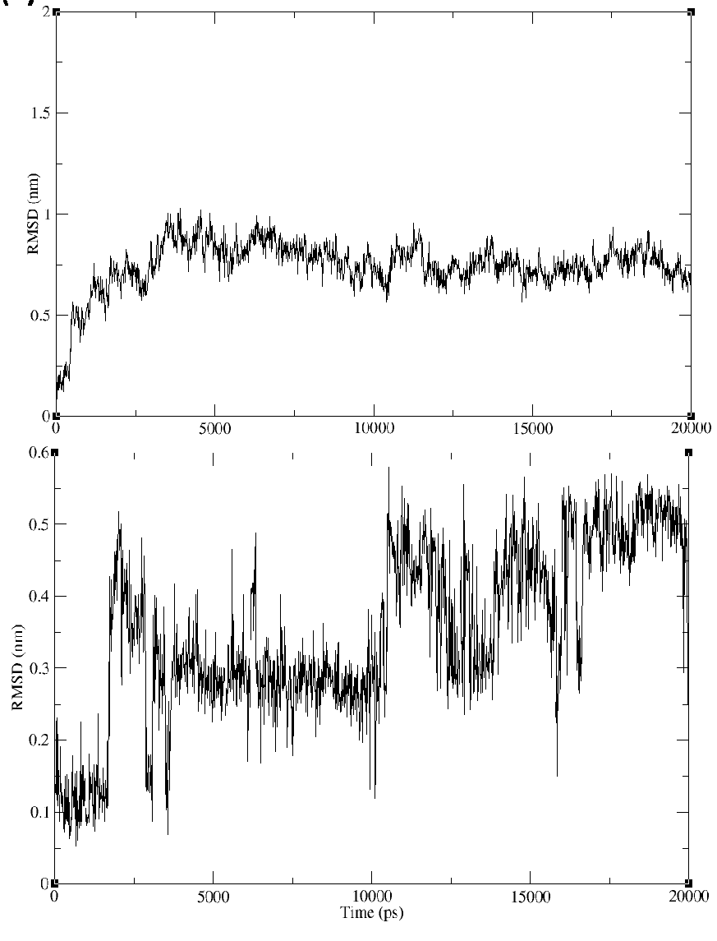
Figure S24. RMSD evolution (a) for docked IDE protein-ligand complex; (b) for docked complex COX protein-ligand complex (compound 4) during 100 ns MD simulation.

