Supplementary materials
Anisotropic carbon matrix derived from cellulose aerogel decorated wood plate serving as self-supporting hosts for cathodes in lithium sulfur batteries with enhanced cycling stability
Yinglin Yan • Xingsheng Zhang • Wei Jing • Pufang Liu • Muze Song • Chaojiang Fan • Rongfu Xu • Yiming Zou • Qijiu Deng • Xianhui Wang • Lisheng Zhong • Rong Yang • Yunhua Xu
Y. Yan (✉ ORCID: 0000-0002-9953-2933) • X. Zhang • M. Song • Y. Zou
School of Science, Xi’an University of Technology, Xi’an, People’s Republic of China
E-mail address: yyl3550@xaut.edu.cn.
W. Jing • P. Liu • C. Fan • R. Xu. Q. Deng • X. Wang • L. Zhong. • R. Yang (✉ ORCID: 0000-0001-7038-5493)
International Research Center for Composite and Intelligent Manufacturing Technology, Shaanxi Province Key Laboratory of Electrical Materials and Infiltration Technology, Materials and Engineering College, Xi’an University of Technology, Xi’an, People’s Republic of China
E-mail address: yangrong@xaut.edu.cn.
Y. Xu
School of Chemistry and Chemical Engineering, Yulin University, Yulin, Shaanxi People’s Republic of China.

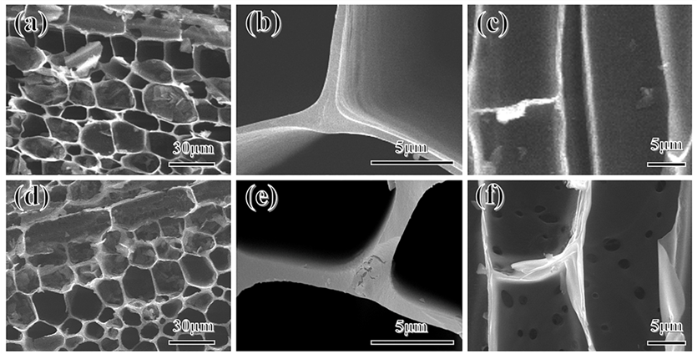
Fig. S1 SEM images of BWC ((a, b) top-view, (c) side-view) and DBWC ((d, e) top-view, (f) side-view).

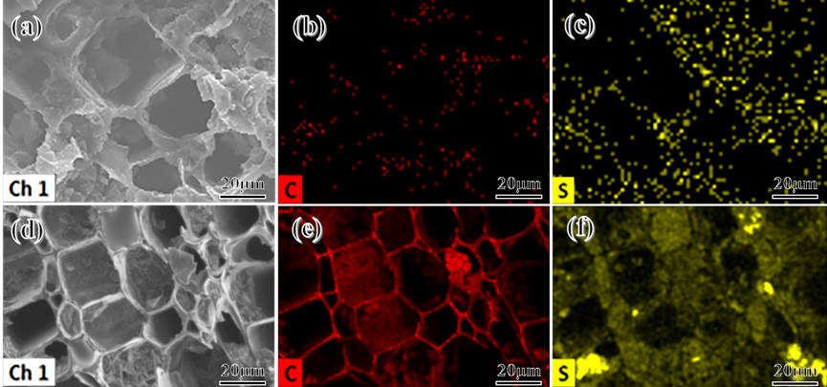
Fig. S2 (a-c) SEM and elemental mapping images of S/BWC cathode, (d-f) SEM and elemental mapping images of S/DBWC cathode.

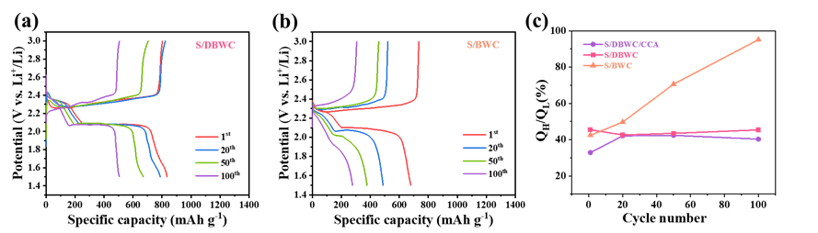
Fig. S3 Charge/discharge curves of (a) S/DBWC and (b) S/BWC at different cycle numbers. (c) Q_{H}/Q_{L} value of three cathodes at different cycle numbers.

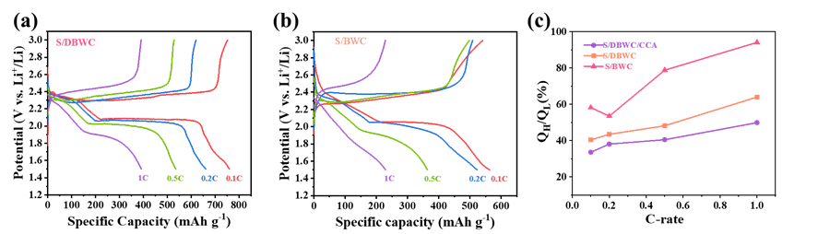
Fig. S4 Charge/discharge curves of (a) S/DBWC and (b) S/BWC at different C-rates. (c) Q_{H}/Q_{L} value of three cathodes at different C-rates.

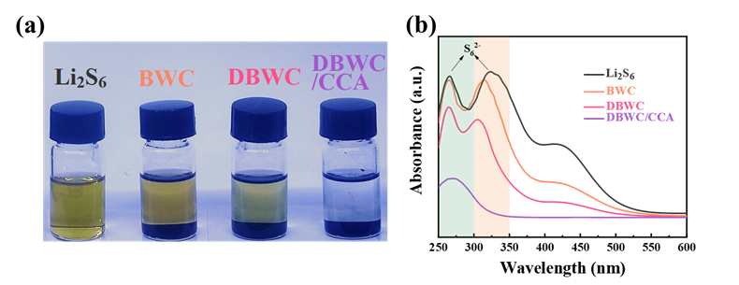
Fig. S5 (a) Digital photos of visualized adsorption experiment and (b) corresponding UV-Vis absorption spectrum.

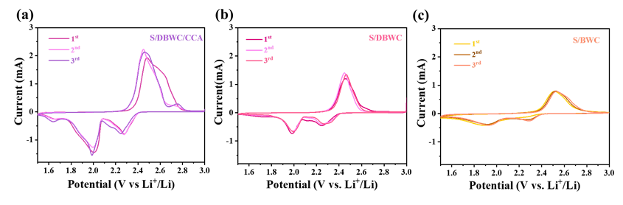
Fig. S6 CV curves for the first three cycles of (a) S/DBWC/CCA (b) S/DBWC and (c) S/BWC cathode.

Fig. S7 (a) CV curves of S/DBWC cathode and (b) capacitive-controlled contribution at different scan rates. (c) CV curves of S/BWC cathode and (d) capacitive-controlled contribution at different scan rates.

Fig. S8 E vs. t curves of S/DBWC/CCA cathode for a single GITT.

Table. S1 The conductivity and electrical resistivity of all samples
Sample | Conductivity (S cm⁻¹) | Electrical Resistivity (Ω·cm)
DBWC/CCA | 5 | 0.2
DBWC | 3.58 | 0.279
BWC | 3.03 | 0.33
S/DBWC/CCA | 2.5 | 0.38
S/DBWC | 1.12 | 0.89
S/BWC | 0.99 | 1.01

Table. S2 The Rct of all the samples before and after cycling
Sample | R_{ct} before cycling (Ω) | R_{ct} after cycling (Ω)
S/DBWC/CCA | 72.44 | 32.55
S/DBWC | 96.76 | 49.33
S/BWC | 115.93 | 105.50

