Complete plot for both figure 3 and 4

Figure 3:

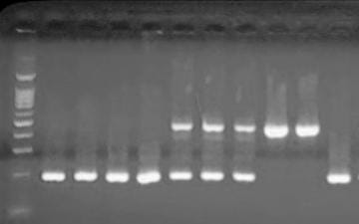

Figure 4:

